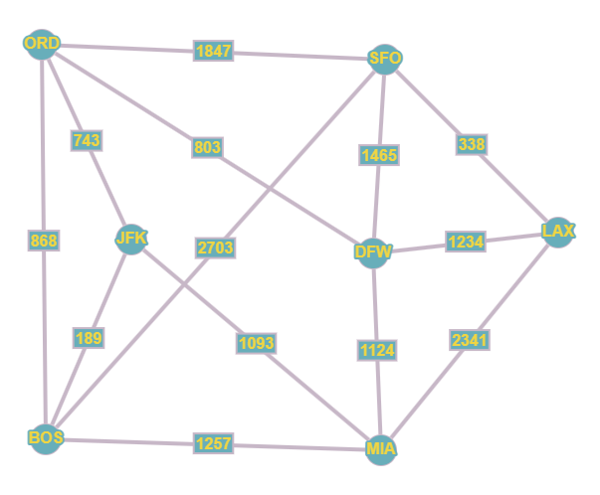

1. **Find the shortest distance between ORD and LAX**

We move from smallest to largest edge using Dijkstra’s Algorithm

PATH 1: ORD → JFK → BOS → MIA → DFW → LAX = 743+ 189 + 1257 +1124 + 1234 = 4547

PATH 2: ORD → JFK → MIA → DFW → LAX = 743 + 1093 +1124 + 1234 = 4,194

PATH 3: ORD → JFK → MIA → LAX = 743 + 1093 + 2341 = 4177

Path 3 is the shortest possible path going through JFK

PATH 4: ORD → SFO → LAX = 1847 + 338 = 2185

PATH 4 < PATH 3

Since PATH 4 is less than any possible path through JFK we drop those paths

PATH 5: ORD → DFW → MIA → LAX = 803 + 1124 + 2341 = 4268

PATH 4 < PATH 5

PATH 6 : ORD → DFW → LAX = 803 + 1234 = 2037

PATH 6 < PATH 4

PATH 7: ORD → BOS → JFK → MIA → DFW → LAX

Similar to path 1 ∴ PATH 6 < PATH 7

PATH 8: ORD → BOS → MIA → DFW → LAX

Similar to path 2 ∴ PATH 6 < PATH 8

Since 2037 is the smallest number possible, any path > 2037 can be eliminated.

∴ PATH 6 is the shortest path : **ORD → DFW → LAX**

1. **Find the shortest distance between JFK and SFO.**

**PATH 1: JFK → ORD → SFO = 743 + 1847 = 2590**

**PATH 2: JFK → ORD → DFW → SFO = 743 + 803 + 1465 = 3011**

**PATH 3: JFK → ORD → BOS → SFO = 743 + 868 + 2703 = 4314**

**Path 1 is the shortest possible path going through ORD**

**PATH 4: JFK → BOS → SFO = 189 + 2703 = 2892**

**PATH 5: JFK → BOS → ORD → SFO = 189 + 868 + 1847 = 2904**

**Path 4 is the shortest possible path going through BOS**

**PATH 1 < PATH 4**

**Since PATH 1 is less than any possible path through BOS we drop those paths**

**PATH 6: JFK → MIA → DFW → SFO = 1093 + 1124 + 1465 = 3682**

**PATH 7: JFK → MIA → BOS → SFO = 1093 + 1257 + 2703 = 5053**

**Path 6 is the shortest possible path going through MIA**

**Since 2590 is the smallest number possible, any path > 2590 can be eliminated.**

**∴ PATH 1 is the shortest path: JFK → ORD → SFO**

1. **Find the minimum spanning tree.**

Using Kruskal's Algorithm:

1. Sort all edges by weight (smallest to largest)

* JFK - BOS: 189
* SFO - LAX: 338
* ORD - JFK: 743
* ORD - DFW: 803
* ORD - BOS: 868
* JFK - MIA: 1093
* DFW - MIA: 1124
* LAX - DFW: 1234
* BOS - MIA: 1257
* SFO - DFW: 1465
* SFO - ORD: 1847
* LAX - MIA: 2341
* SFO - BOS: 2703

1. Find the shortest edge that doesn't create a cycle
2. JFK - BOS: 189
3. SFO - LAX: 338
4. ORD - JFK: 743
5. ORD - DFW: 803
6. ORD - BOS: 868 (creates cycle: ORD-JFK-BOS-ORD)
7. JFK - MIA: 1093
8. DFW - MIA: 1124 (creates cycle: DFW – MIA – JFK – ORD - DFW)
9. LAX - DFW: 1234
10. All other edges would create a cycle

∴ Minimum Spanning Tree Edges:

JFK - BOS: 189

SFO - LAX: 338

ORD - JFK: 743

ORD - DFW: 803

JFK - MIA: 1093

LAX - DFW: 1234

Total Minimum Spanning Tree Weight: **4400**