<MONESA>

Software Development Plan (Small Project)

Version <0.4>

Revision History

| **Date** | **Version** | **Description** | **Author** |
| --- | --- | --- | --- |
| <10/06/22> | <0.1> | Write introduction | Hà Huỳnh Đức Huy |
| <10/06/22> | <0.1> | Write project overview | Lu Phi Hùng |
| <10/06/22> | <0.1> | Write project organization | Nguyễn Tiến Lợi |
| <10/06/22> | <0.1> | Cooperate in writing management process and format document | Quách Vĩnh Khang |
| <10/06/22> | <0.1> | Write management process and confirm document | Huỳnh Thành Nguyên |
| <25/06/22> | <0.2> | Adding minor changes in document, give specific task detail in each sprint | Quách Vĩnh Khang |
| <16/07/22> | <0.3> | Adding Sprint 04 - PA3 | Huỳnh Thành Nguyên |
| <29/07/22> | <0.4> | Adding Sprint 05 - PA4 | Quách Vĩnh Khang |
| <12/08/22> | <0.5> | Adding Sprint 06 - PA6 | Nguyễn Tiến Lợi |

Table of Contents

**1.** **Introduction 4**

1.1 Purpose 4

1.2 Scope 4

1.3 Overview *4*

**2.** **Project Overview 4**

2.1 Project Purpose, Scope, and Objectives 4

2.2 Assumptions and Constraints 4

2.3 Project Deliverables *5*

**3.** **Project Organization 5**

3.1 Organizational Structure 5

3.2 Roles and Responsibilities  *5*

**4.** **Management Process 5**

*4.1* *Project Estimates 5*

*4.2* *Project Plan 5*

4.2.1 Phase Plan 5

4.2.2 Iteration Objectives 6

4.2.3 Releases 6

4.2.4 Project Schedule 6

4.2.5 Project Resourcing 6

*4.3* *Project Monitoring and Control 6*

4.3.1 Requirements Management 6

4.3.2 Reporting and Measurement 7

4.3.3 Risk Management 7

4.3.4 Configuration Management 7

Software Development Plan (Small Project)

# 

# Introduction

## Purpose

The main purpose of this document is to keep track of the project, providing information about the current phase which helps team leaders as well as team members to be aware of project progress and guidelines for individual tasks.

Person using this document:

* Leader: keep eyes on team information, provide a plan to ensure teamwork is progressive.
* Team member: members will know what work to do and arrange time reasonably through documents that leader showed
* Supervisor: Supervise each member's progress so that they may be reported to the management so that they can be changed or punished for those who don't follow the rules.

## Scope

* This document will provide statistics and an overview of member data, as well as project data that may be utilized to develop future products.

## Overview

This document includes:

* Project Overview: give specific details of project and current status of project.
* Project Organization: give specific details of development team members including activities, contribution, etc.

# Project Overview

## Project Purpose, Scope, and Objectives

* Web application that simplifies personal money management by integrating all accounts such as banks and cash in one location.
* Monesa allows customers to track and control their expenses. It has a user-friendly interface and is simple to use.

## Assumptions and Constraints

* Development team: 5 members, each team member has a PC which is installed with VS Code, has access to the internet to work together.
* Web development should be done before 01/08/2022 to match the deadline.

## Project Deliverables

* Website will be published on domain: [www.monesa.site](http://www.monesa.site)
* Documentation:
* Project Plan.
* Vision Document.

# Project Organization

## Organizational Structure

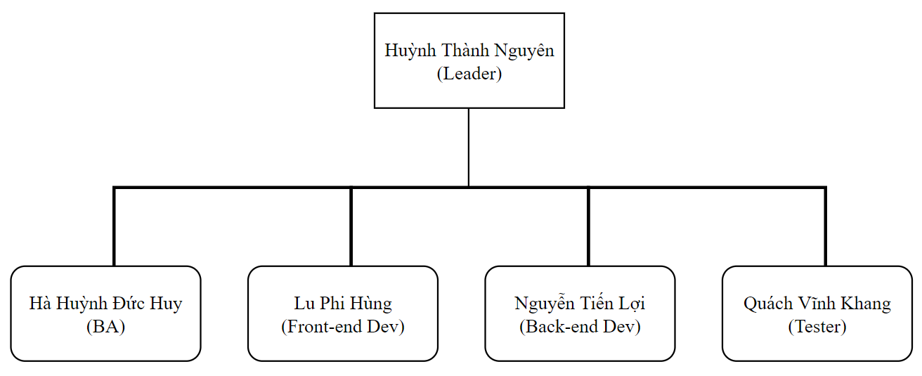

## Roles and Responsibilities

| **Person** | **Role** |
| --- | --- |
| Huỳnh Thành Nguyên  (Team leader, Full-stack Dev) | Assign tasks, motivate team members.  Design and build barebone of website |
| Hà Huỳnh Đức Huy  (BA, Front-end Dev) | Analyze and note requirements for Website and documentation.  Design UI and apply animation for Website. |
| Lu Phi Hùng (UI Designer, Front-end Dev) | Design UI and improve UX for Website. |
| Nguyễn Tiến Lợi  (Back-end Dev, Tester) | Design website behavior, build database.  Testing website function. |
| Quách Vĩnh Khang  (Back-end Dev, Tester) | Cooperate in designing website behavior, build database.  Testing website function. |

# Management Process

* 1. **Project Plan**

Sprint 01 - PA0:

* Initial time: 16/5/2022
* Ending time: 28/5/2022
* Task:
  + - Nguyên: Learning advanced HTML, CSS, JS.
    - Huy: Learning basic JS, advanced HTML, CSS.
    - Hùng: Learning basic JS, advanced HTML, CSS.
    - Lợi: Learning basic HTML, CSS, advanced JS.
    - Khang: Learning basic HTML, CSS, advanced JS.
* Chart:

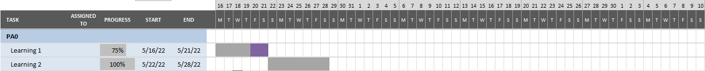

Sprint 02 - PA1:

* Initial time: 28/5/2022
* Ending time: 11/6/2022
* Task:
  + - Nguyên: Learning NodeJS, demo API call, configure DB. Writing project plan, vision document and weekly reports.
    - Huy: Learning ReactJS, and designing a homepage, dashboard. Cooperating in writing documents.
    - Hùng: Learning ReactJS, and designing a homepage, dashboard. Cooperating in writing documents.
    - Lợi: Learning NodeJS, routing and API call. Cooperating in writing documents.
    - Khang: Learning NodeJS, routing and API call. Cooperating in writing documents.
* Chart:

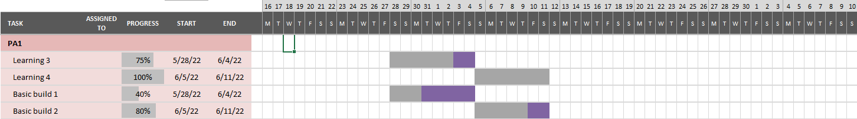

Sprint 03 - PA2:

* Initial time: 11/6/2022
* Ending time: 25/6/2022
* Task:
  + - Nguyên: Learning Axios. Designing use case models and writing documents, weekly reports.
    - Huy: Learning Axios. Cooperating in defining use case models.
    - Hùng: Learning Axios. Cooperating in defining use case models.
    - Lợi: Learning MongoDB. Cooperating in defining use case models.
    - Khang: Learning MongoDB. Cooperating in defining use case models. Modifying PA1 documents.
* Chart:

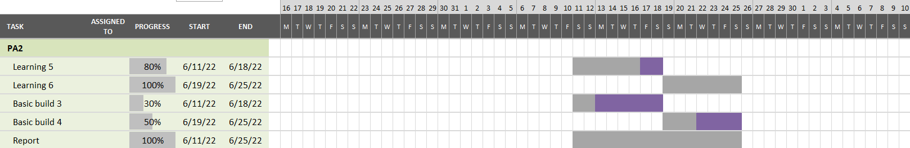

Sprint 04 - PA3:

* Initial time: 25/6/2022
* Ending time: 16/7/2022
* Task:
  + - Nguyên: Design, unified web design, PA4 (Class diagrams - View only, Architectural Goals and Constraints).
    - Huy: Design, unified web design, PA4 (Class diagrams - View only, Architectural Goals and Constraints)
    - Hùng: Design, unified web design, PA4 (Class diagrams - View only, Introduction)
    - Lợi: Set up the databases, PA4 (Logical View và Class diagrams - View only)
    - Khang: Set up the databases, PA4 (Logical View và Class diagrams - Controllers, Model only).
* Chart:

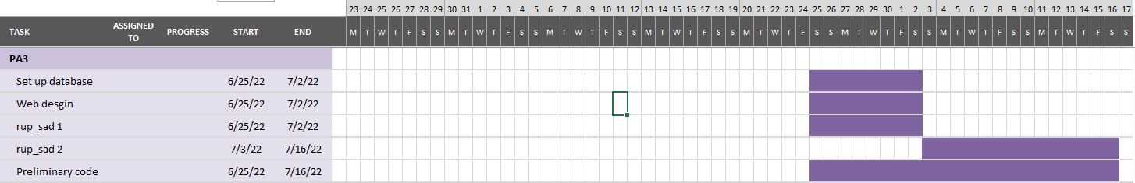

Sprint 05 - PA4:

* Initial time: 16/7/2022
* Ending time: 30/7/2022
* Task:
  + - Nguyên: Code web interface.
    - Huy: Design web layout, write script for video and do voiceover.
    - Hùng: Design web layout, editing video.
    - Lợi: Setup controller and router, review and finish RUP_SAD.
    - Khang: Setup models, review and finish RUP_SAD.
* Chart:

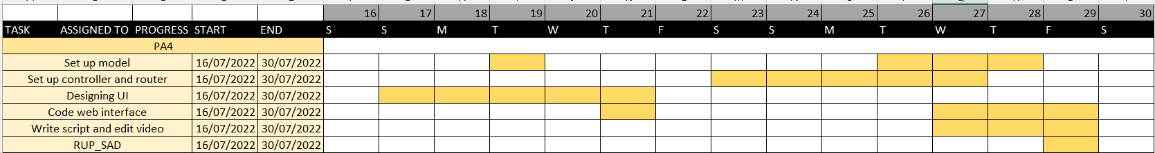

## Project Monitoring and Control

### Requirements Management

The vision document depicts and describes the system's and project's needed components.

### Reporting and Measurement

* Estimated hardware cost:
* The cost of renting a server is $2 per month.
* The cost of hosting a database is already added in the renting server fee.
* Members of the team:
* The team consists of five members, each of whom is free.
* The following is an estimate of the cost of designing an interface system:
* Designing the website interface took 72 hours and more.
* Designing the application architecture took 50 hours.
* 60-hour database design
* 10 hours to design a use-case diagram
* 20h for the rest.
* Costs to construct a website are estimated to be:
* 40 hours of operation
* 30 hours of testing
* 100 hours of upkeep
* 1 million in backup: utilized to prevent such unforeseen occurrences, as well as providing food and drinking water to the staff during the working process.
* The project's estimated progress is as follows:
* Total Time: 3 months.

### Risk Management

| **Risk Ranking (High, Medium, Low)** | **Risk Description and Impact** | **Mitigation Strategy  and/or Contingency Plan** |
| --- | --- | --- |
| High | Experience bugs which slow down team progress | The approach is to test the work as well as the system's operations in phases in order to find faults early and correct them as soon as feasible. |
| Medium | Team members can’t unify ideas in designing website behavior or UI . | To prevent stress, the manager provides particular software to team members and creates a comfortable, dynamic working environment. |
| High | Web behaviors and UX don’t meet expectations. | To minimize confusion, have a more in-depth discussion with team members to be able to offer recommendations and more information. |
| Low | Members give up on their tasks. | Examine each member's data so that they may assess their position and offer recommendations. |
| Medium | Web behavior requires newer technology. | The management evaluates each member before proposing a solution, allocating work that is appropriate for each member's level. |

### Configuration Management

Every code changes are committed to Github, document changes are committed to drive.