LA CARLOTA CITY COLLEGE Office of Student Affairs
An Educational Institution
Supported by the City Government
La Carlota City 6130
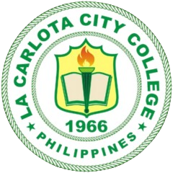
CERTIFICATE OF GOOD MORAL CHARACTER

To whom it may concern:
{student_name}
This is to certify that ___________________________________,
{course_major}
graduate of ______________________________________________ of La Carlota City College as of _________________, School Year ________________, is of good moral character;
{school_year}
{grad_date}

This is to certify further that while he/she was with us, he/she had never been involved in any incident which would otherwise mark his/her moral character on campus, and that he/she had never been known to be a member of any subversive organization;

This certification is issued upon the request of the above-named person for whatever lawful purpose it may serve him/her best.
{day_num}^{{day_suffix}}
{issue_month}
{issue_year}
Done this _____ day of _________________ , _______ at La Carlota City, Negros Occidental.

NOT VALID WITHOUT
COLLEGE SEAL

LAURENCE M. LACHICA, MPA
Head, Student Affairs

{or_number}
O.R. No.
{or_date}
Date: /25/2024

