Dream RAG — Reference Documentation
Dream is the autonomous graph-improvement loop in kwaai-knowledge. After initial ingestion and graph extraction, entities vary in completeness: some have rich descriptions and relations, others are stubs with just a name and type. Dream iterates over the lowest-scoring entities, enriches them via LLM inference, deduplicates near-duplicates, prunes zombies, and fixes relation integrity — all in one cycle that can be re-run until the graph score stabilises.
Key design principles: - Conservative acceptance — LLM output is only applied if it strictly improves the entity (type not yet set, description gets longer/better-tiered, relation target already exists in graph) - Evidence-first — the LLM receives the actual chunk text mentioning the entity, not just the entity name; completions are grounded in the source document - Load-balanced fan-out — concurrent tokio tasks distribute work round-robin across multiple inference URLs; GPU relay machines work in parallel - Graceful degradation — any LLM failure returns an empty completion; the cycle continues and records the error in the report

1. Component Diagram
Runtime components and their relationships.
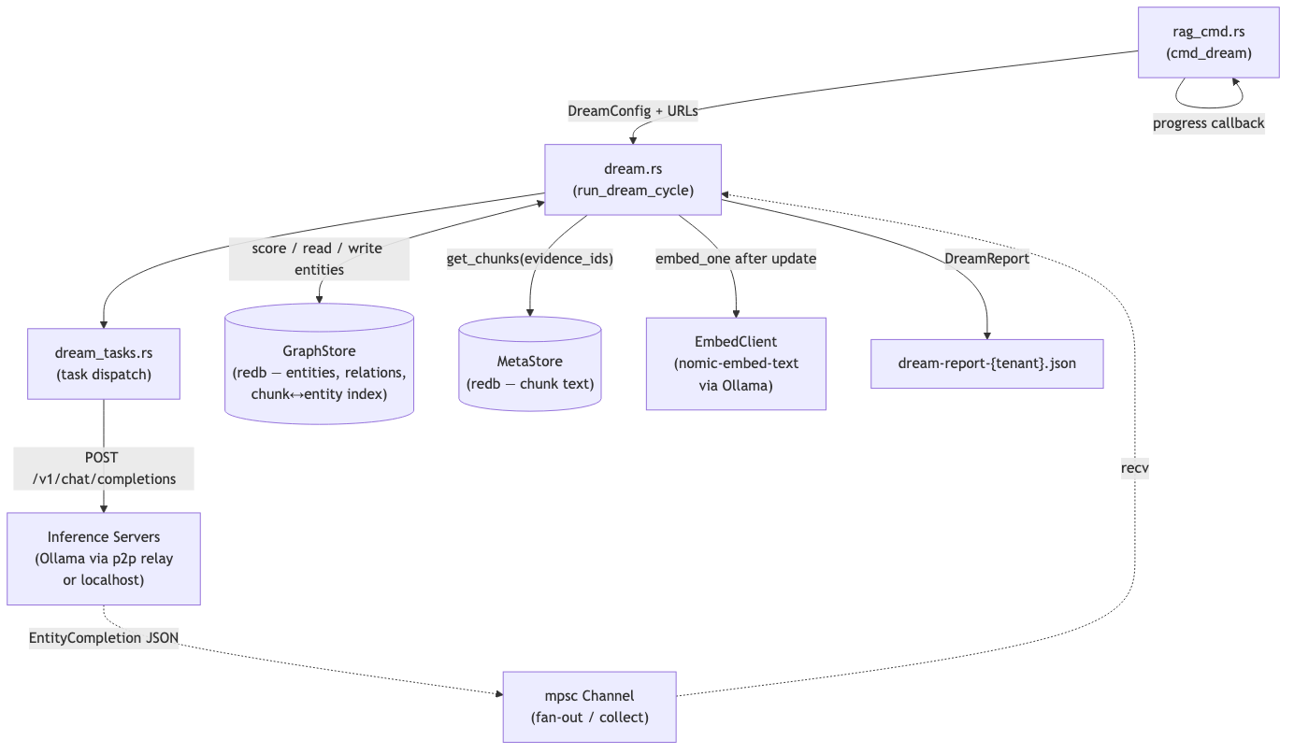
Component Diagram

2. DFD Level 0 — Context Diagram
Dream as a black box: what flows in and what comes out.
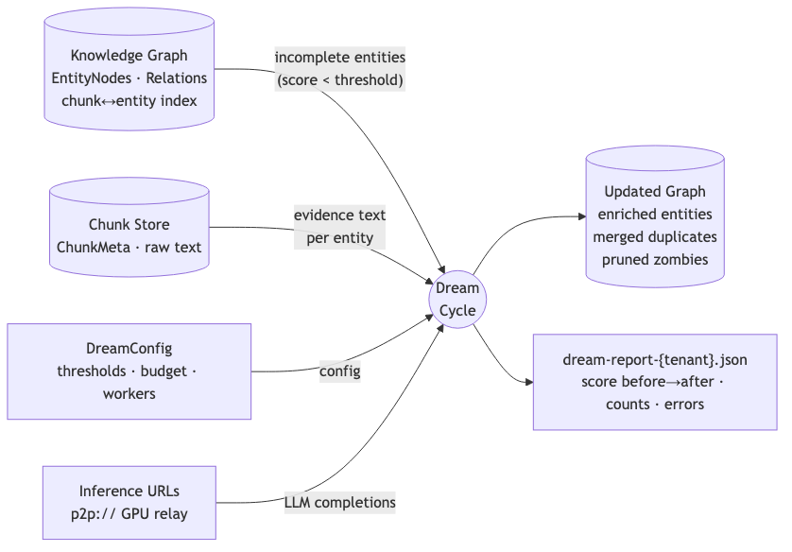
DFD Level 0 — Context Diagram

3. DFD Level 1 — 9-Step Cycle
Internal data flow through all nine steps. Steps 2–4 are the fan-out phase; they share one numbered block because the tokio spawn, channel send, and channel receive are interleaved.
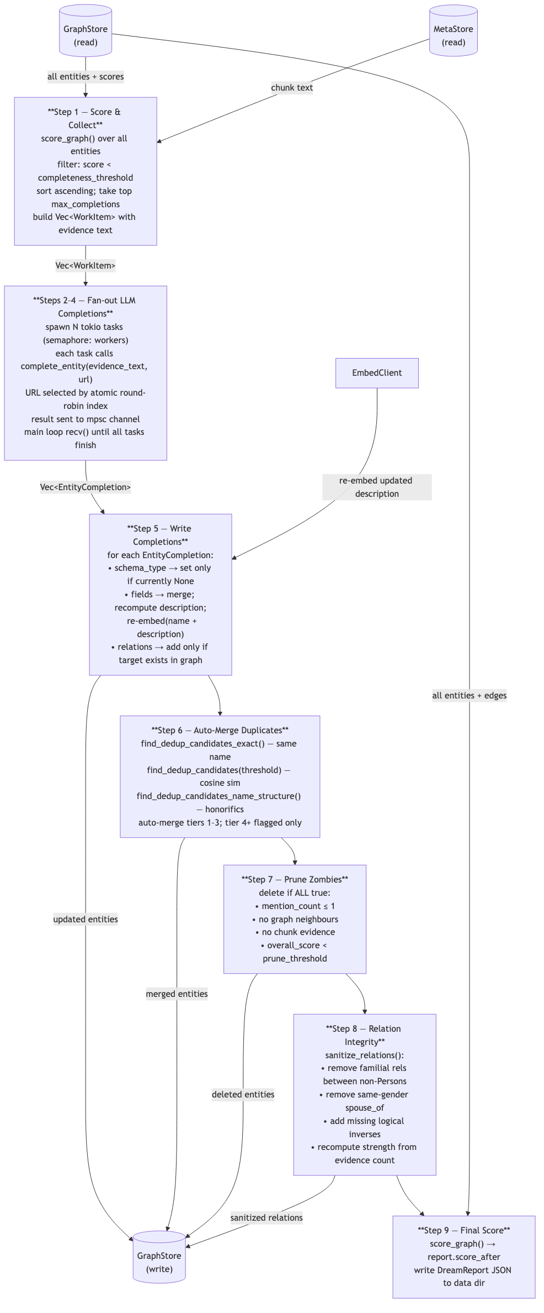
DFD Level 1 — 9-Step Cycle

4. Entity Scoring
Scoring lives in scorer.rs. Each entity gets three independent pillar scores; overall is their unweighted mean. The work queue in Step 1 targets entities with overall < completeness_threshold (default 0.6), sorted worst-first.

Pillars
Pillar | Range | Logic
type_score | 0.0 / 0.4 / 1.0 | 0.0 = Unknown (no schema type); 0.4 = schema:Thing (vague but valid); 1.0 = specific type
summary_score | 0.0 – 1.0 | Field-based if expected_fields() defined for type; otherwise description-length: empty=0.0, <50 chars=0.3, <150 chars=0.6, ≥2 sentences=1.0
relation_score | 0.0 – 1.0 | Fraction of expected relation groups (from expected_relation_groups()) that have ≥1 match. Peripheral entities (mention_count ≤ 2) only need 1 group. schema:Thing / no expectations → neutral 0.5
overall = (type_score + summary_score + relation_score) / 3.0

Expected relation groups by schema type (examples)
Schema type | Group 1 | Group 2 | Group 3
schema:Person | family rels | works_at / founded / manages | located_in / associated_with
schema:Organization | located_in / belongs_to | founded / part_of / contains | —
schema:Place | located_in / contains / part_of | — | —
schema:Event | occurred_on / started / ended | located_in / associated_with | —

5. Entity Relationship Diagram (ERD)
Data structures that Dream reads and writes. Arrows show foreign-key / containment relationships.
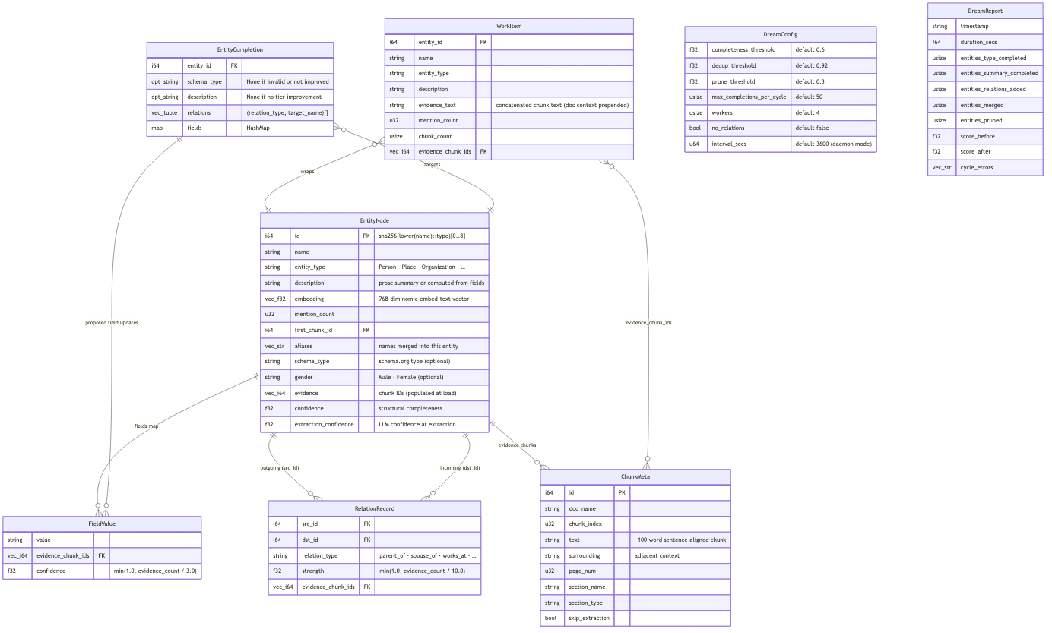
Entity Relationship Diagram (ERD)

6. Sequence Diagram — One Full Dream Cycle
Interactions between all participants for a single kwaainet rag dream run invocation. The fan-out phase (Steps 2–4) shows two parallel workers for illustration; real concurrency is governed by the --workers semaphore.
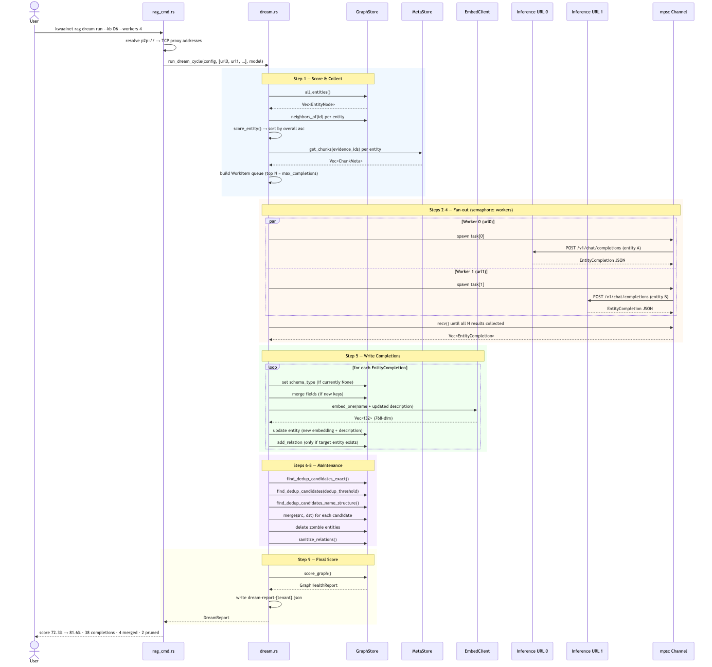
Sequence Diagram — One Full Dream Cycle

7. LLM Completion Call — What the Model Receives and Returns
Each complete_entity() call posts to /v1/chat/completions (OpenAI-compatible, temperature=0.25, max_tokens=700). The prompt structure:
[system]
You are a knowledge-graph enrichment assistant. Given entity information and source text,
output a JSON object with schema_type, description, relations, and fields.
[user]
ENTITY: {name} ({entity_type})
CURRENT DESCRIPTION: {description}
CURRENT SCHEMA TYPE: {schema_type or "none"}
CURRENT FIELDS: {fields as key: value}
DOCUMENT CONTEXT:
{doc_name} — {section_name} — {section_type}
---
EVIDENCE TEXT:
{evidence_text} ← actual chunk text from source document
Return JSON: {schema_type, description, relations: [{type, target}], fields: {key: value}}
Validation before acceptance:
Output field | Accepted if
schema_type | In the 14-type whitelist AND entity currently has None
description | Moves to a higher length tier OR is ≥20 chars longer in the same tier
relations[] | relation_type in RELATION_TYPES; target entity already exists in graph; no_relations=false
fields{} | Any new key-value pair; description recomputed from description_from_fields() after merge
Schema type whitelist (14 types): Person, Organization, Place, Event, Product, CreativeWork, SoftwareApplication, DefinedTerm, HowTo, Role, QuantitativeValue, Statement, Date, Thing

8. Deduplication Strategy
Three candidate-finding strategies run in sequence; all auto-merge in the same pass:
Tier | Strategy | Auto-merge?
1 — Exact | Same canonical name (case-insensitive) | Yes
2 — Fuzzy | Entity embedding cosine similarity > dedup_threshold (default 0.92) | Yes
3 — Structural | Honorific variant (“Dr. Abdulla” ↔ “Abdulla”) or name subset | Yes
4+ — Subset/fuzzy overlap | Partial name inclusion, lower similarity | Flag only — manual review
On merge: the lower-score entity’s chunks, aliases, relations, and fields are transferred to the higher-score entity; the source entity is deleted.

9. Configuration Reference

DreamConfig / kwaainet rag dream run flags
Flag | Default | Effect | Tuning guidance
--threshold | 0.6 | Entities with overall < threshold become candidates | Lower → more work per cycle; raise if cycle takes too long
--dedup-threshold | 0.92 | Cosine similarity above this triggers auto-merge | Raise to be more conservative; 0.95+ rarely auto-merges
--prune-threshold | 0.3 | Score below this + isolated → deleted | Lower to keep more stubs; raise to prune aggressively
--max-completions | 50 | Total LLM budget for the cycle | Increase for a bigger single-pass improvement
--workers | 4 | Max concurrent inference tasks (semaphore) | Match to OLLAMA_NUM_PARALLEL on the GPU machine
--no-relations | off | Disable relation extraction | Recommended on for 8B models (precision 0–17%)
--inference-urls | config | Comma-separated p2p:// URLs | Use all available GPU relays for parallel load balancing
--model | default | Ollama model name | llama3.1:8b is the tested model

10. Pipeline Integration Map
Where Dream sits in the full kwaai-knowledge pipeline:
kwaainet rag ingest ← PDF → chunks → embeddings → MetaStore + HNSW index
↓
kwaainet rag graph build ← LLM entity/relation extraction per chunk → GraphStore
↓
kwaainet rag graph score ← EntityScore per entity; print worst offenders
↓
kwaainet rag dream run ×N ← iterative enrichment until score stabilises
↓
kwaainet rag graph seed ← optional: inject trusted family-tree YAML
↓
kwaainet rag eval ← score against eval questions
Dream reads (never modifies): - MetaStore — chunk text and metadata - HNSW vector index — chunk embeddings (entity embeddings are stored separately in GraphStore)
Dream modifies: - GraphStore — entity fields, embeddings, schema types, descriptions, relations - dream-report-{tenant_id}.json — written to the data directory after every cycle
Dream does not touch: - Timeline events (TIMELINE_TABLE) — managed by kwaainet rag graph timeline build - Sequence interactions (INTERACTION_TABLE) — extracted during graph build - Chunk text / page numbers — read-only; never re-chunked by dream

11. Key Source Files
File | Role
core/crates/kwaai-rag/src/dream.rs | run_dream_cycle(), complete_entity(), DreamConfig, DreamReport, WorkItem, EntityCompletion
core/crates/kwaai-rag/src/dream_tasks.rs | Task-type dispatch: Biography (Person), General; constructs task-specific prompts
core/crates/kwaai-rag/src/scorer.rs | score_entity(), score_graph(), EntityScore, GraphHealthReport, expected_relation_groups()
core/crates/kwaai-rag/src/graph.rs | GraphStore, EntityNode, RelationRecord, FieldValue; all graph read/write
core/crates/kwaai-rag/src/meta_store.rs | MetaStore, ChunkMeta; chunk text storage
core/crates/kwaai-rag/src/embedder.rs | EmbedClient; embed_one(), embed_batch()
core/crates/kwaai-cli/src/rag_cmd.rs | cmd_dream(): URL resolution, progress callback, report printing

