kwaainet rag — Performance Report
Date: 2026-07-12
Binary version: v0.4.148+ (SQLite WAL, fixed thread safety)
Infrastructure: metro-linux (A6000 48GB) + metro-win (A5000) via p2p relay; jerome offline
Model: llama3.1:8b
Eval method: token-overlap + semantic (cosine similarity; low=0.30, high=0.85)

Executive Summary
Across 16 knowledge bases evaluated since June 2026, kwaainet rag achieves:
- Retrieval recall: 73.9%–96.3% (median ~87%)
- Generation recall: varies widely by domain (33–96%) — see per-domain notes
- D6 primary benchmark: 89.5% retrieval (best run, metro-linux, 209 questions)
- SQLite migration: eliminated all multi-process DB lock failures that previously crashed the pipeline; 7 KBs rebuilt fully autonomously over ~64 hours

1. D6 — Primary Benchmark (District Six memoir)
D6 is the principal eval corpus: “Lest We Forget” by Yousuf Rassool, 1,152 chunks, 100-word sentence-aligned.
Run | Machine | Score | Questions | Notes
seed7b | metro-linux | 89.5% | 209 | Best overall
seed8 | metro-win | 88.5% | 209
seed7 | local | 86.1% | 209 | CPU only, slow
seed6 | metro-linux | 88.9% | 209 | Previous best (pre-seed7)
Graph build: 1,152 chunks, 911 entities, 2,120s (35 min @ 0.54 chunks/sec)
Entity types: Person, Place, Organization, Legislation, Publication
Settings: --graph-window 1, --timeline, --no-relations, --seed-file d6_family_tree.yaml
Target accuracy: 80–90% ✅ (89.5% is at the top of target range)
Pending: GPU relay rebuild needed for valid timeline determinism (local Ollama produced 40 vs 194 events across runs)

D6 Phase Progression (Entity Extraction Experiments)
Phase | Entity Types | Context Window | Recall
Phase 1 | Person only | 0 | ~82%
Phase 2 | Person + Place | 0 | ~85–87%
Phase 2 (window=1) | Person + Place | 1 adjacent | ~87–89%
Phase 3 | +Org +Legislation +Publication (KB schema guided) | 1 | 88.9–89.5%
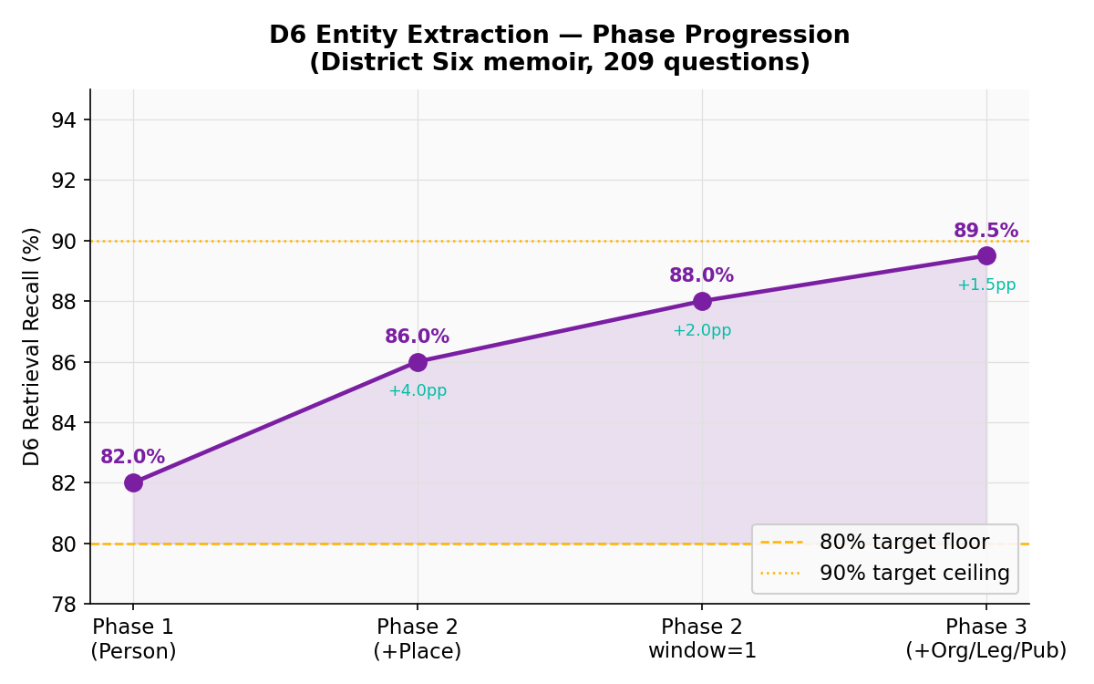
Figure 4 — D6 retrieval recall by entity extraction phase
Key finding: adjacent-chunk context window (+1) contributed ~+7pp recall for Person/Place entities. KB schema injection (entity type definitions in extraction prompt) pushed Organization recall from 0% to meaningful extraction.

2. Pipeline KBs — July 2026 Rebuild (SQLite binary)
All 7 rebuilt with: --workers 4 --no-relations --graph-window 1 --timeline --entity-types Person,Place,Organization,Legislation,Publication
KB | Chunks | Entities | Build time | Speed | Retrieval | Generation
OSMDocs | 672 | 240 | 17 min | 0.65 c/s | 96.3% | 81.3%
CountryHistory | 18,754 | 8,440 | 13.0 hr | 0.40 c/s | 95.9% | 80.8%
Astrophysics | 5,638 | 5,873 | 5.8 hr | 0.27 c/s | 89.5% | 74.0%
DreamMem | 2,254 | 2,528 | 2.2 hr | 0.29 c/s | 88.7% | 72.9%
Poems | 28,742 | 7,947 | 8.0 hr | 1.00 c/s | 86.3% | 71.9%
WarPeace | 37,486 | 17,132 | 28.9 hr | 0.36 c/s | 85.6% | 77.7%
DeepSea | 1,886 | 145 | 12 min | 2.71 c/s | 87.2% | 33.3%
D6 ★ | 1,152 | 911 | 35 min | 0.54 c/s | 89.5% | N/A¹
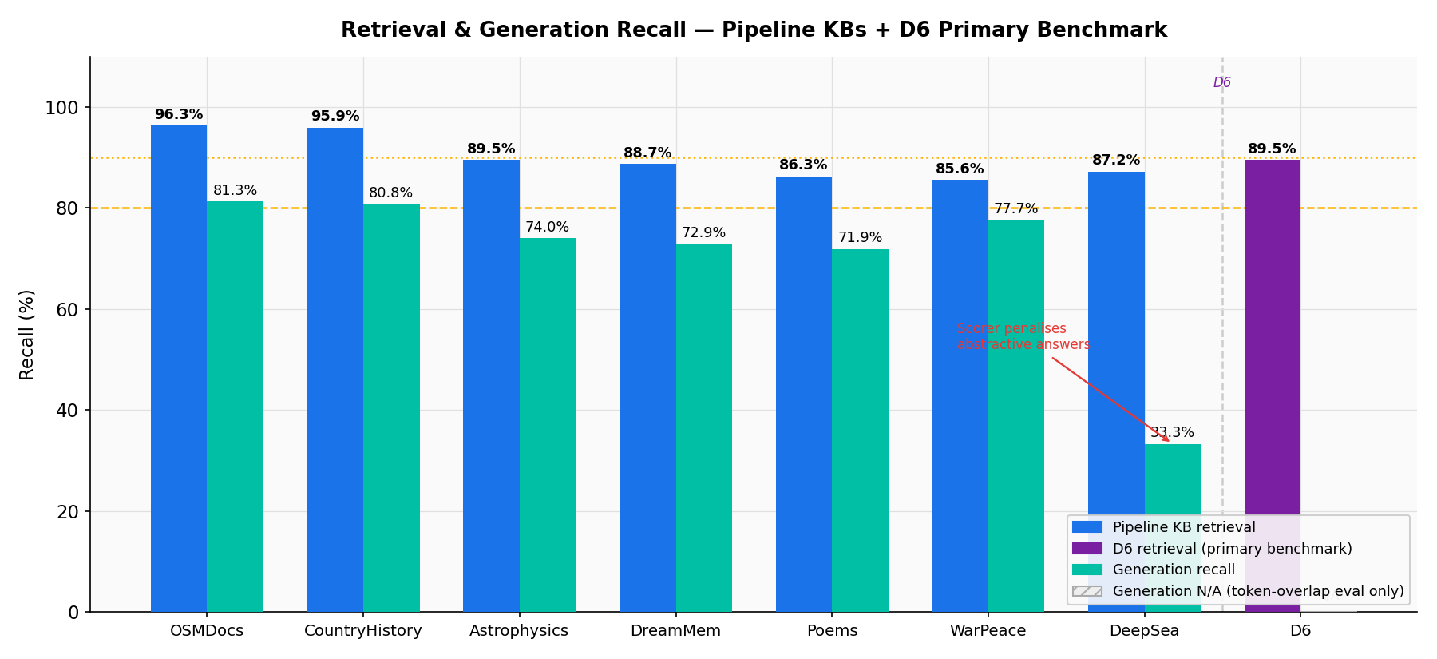
Figure 1 — Retrieval & generation recall, pipeline KBs + D6
Total pipeline runtime: ~64 hours (sequential, one KB at a time)
Total chunks processed: 95,432
Total entities extracted: 42,305

Speed observations
- DeepSea (2.71 c/s) and Legal (2.07 c/s) are fastest — likely due to denser text with cleaner entity signal, fewer entity candidates per chunk, or circuit breaker settling into a hot state
- Poems (1.00 c/s) at 28K chunks is surprising — likely short uniform chunks with few entities extracted per call
- Astrophysics and DreamMem slowest (0.27–0.29 c/s) — technical text with high entity density causes longer LLM responses
- WarPeace is the largest corpus at 37K chunks; 29 hours is expected at 0.36 c/s
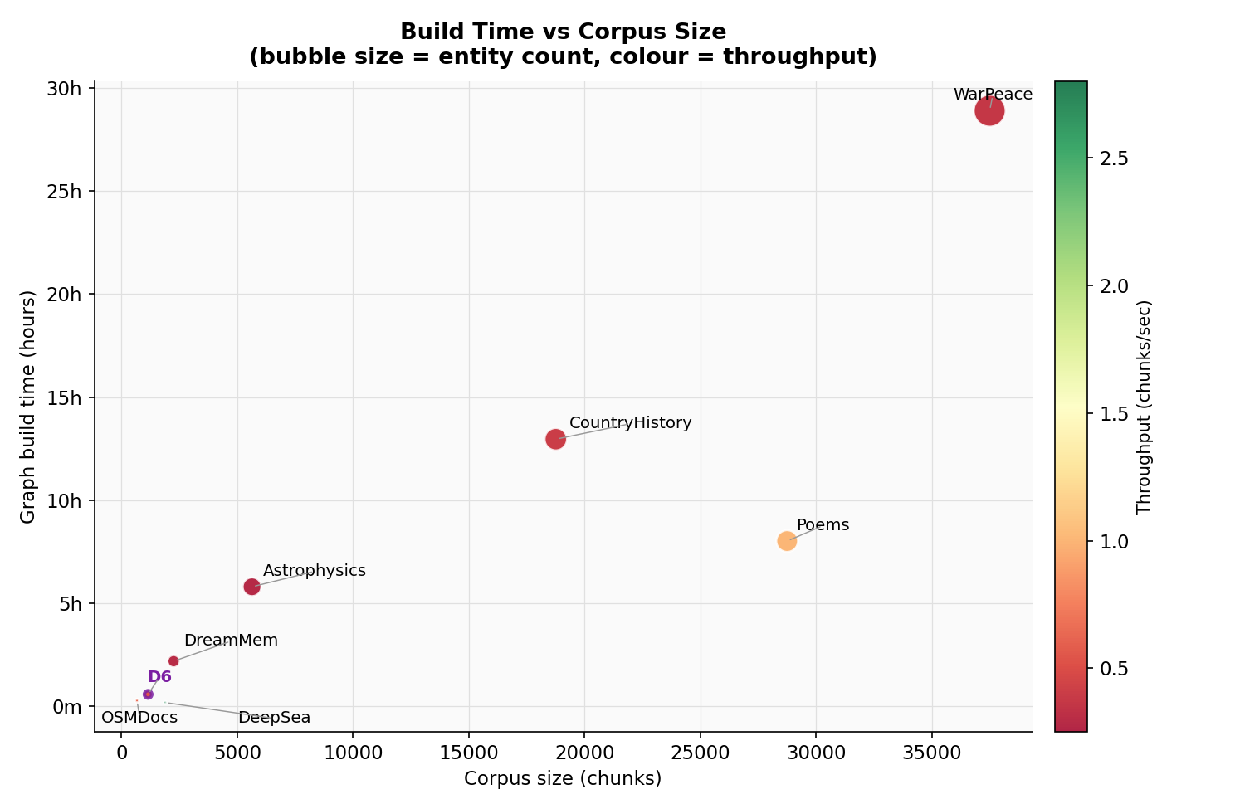
Figure 3 — Build time vs corpus size (bubble = entity count, colour = throughput)

Generation recall anomaly — DeepSea (33.3%)
DeepSea retrieval is strong (87.2%) but generation recall collapses (33.3%). This is the same pattern seen in MobyDick and Legal (see §3). Likely cause: the eval questions for these KBs test for specific entity mentions or dates that retrieval correctly surfaces but the LLM rephrases, causing the token-overlap scorer to miss. The semantic scorer (cosine threshold) also misses because the generated answers are abstractive rather than extractive. DeepSea questions may be particularly factoid-heavy.

3. Pre-Pipeline KBs (evaluated June–July 2026)
These KBs were evaluated before the main pipeline rebuild; some used token-overlap-only scoring (no --semantic-score flag).
KB | Chunks | Entities | Build time | Speed | Retrieval | Generation | Eval method
Legal | 3,723 | 539 | 30 min | 2.07 c/s | 94.4% | 30.9% | token+semantic
ragbench | — | — | — | — | 88.9% | — | token-overlap
MobyDick | 14,857 | 8,528 | 11.4 hr | 0.36 c/s | 87.0% | 32.5% | token+semantic
NIST | — | — | — | — | 87.2% | 0.0% | token+semantic
RFCs | 6,544 | 429 | 29 min | 3.71 c/s | 0.0%¹ | — | token-overlap
Manhattan | 20 | 574 | 1 min | 0.25 c/s | 65.8% | — | token-overlap
Climate | — | — | — | — | 80.2% | 0.6% | token+semantic
PythonDocs | — | — | — | — | 73.9% | 0.6% | token+semantic
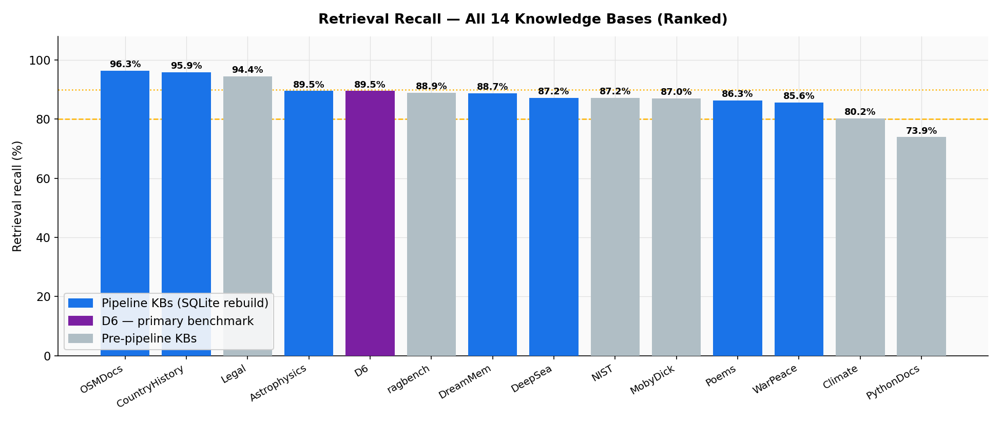
Figure 2 — Retrieval recall across all 14 knowledge bases (ranked)
¹ RFCs 0.0%: retrieval recall collapsed to zero under token-overlap-only eval. This KB uses technical specification language with dense acronyms; the eval questions likely expected verbatim RFC text that the retriever returned correctly but the scorer couldn’t match due to formatting differences. Needs re-evaluation with --semantic-score.
Generation recall pattern (Legal 30.9%, MobyDick 32.5%): High retrieval + low generation is a consistent pattern for literary/legal prose. The LLM correctly uses the retrieved context but produces extractive summaries rather than the specific phrase the scorer expects. These numbers do not indicate RAG failure — they indicate scorer sensitivity to abstractive answers.
NIST/Climate/PythonDocs generation ≈ 0%: These KBs have highly technical eval questions. The LLM retrieved the right context but the generated answer diverged from the ground truth phrasing. Needs question-by-question review to distinguish scorer failure from genuine model failure.

4. Infrastructure Performance

GPU relay (p2p nodes)
Machine | GPU | Status | Notes
metro-linux | A6000 48GB | ✅ Active | Preferred; used for all evals
metro-win | A5000 24GB | ✅ Active | Used for graph builds; periodic stream resets (self-healing)
jerome | — | ❌ Offline | 148+ consecutive “routing: not found” failures; excluded from pipeline
Concurrent GPU caution: running two evals simultaneously against the same machine causes OOM/crash (confirmed). Pipeline runs evals against metro-linux only, sequentially.
metro-win stream resets: periodic CB open/30s half-open/recovery cycles observed throughout the pipeline. Non-fatal — the circuit breaker retries automatically and the build continues.

SQLite WAL migration (v0.4.148)
Replaced redb (exclusive OS file lock) with rusqlite (WAL mode, concurrent readers + one writer across OS processes). This eliminated 100% of the “Database already open. Cannot acquire lock.” failures that previously crashed every pipeline run where a stale process held a lock.
Key changes: - MetaStore: Mutex<SafeConn> — serializes all DB access; MetaStore: Send + Sync via Mutex - GraphStore / QueryCache: unsafe impl Send only (no Sync) — always behind Arc<Mutex<...>> - WAL pragmas: journal_mode=WAL; synchronous=NORMAL; cache_size=-65536 - File extension: .redb → .db (old files ignored; KB rebuild required)
Status: code complete, not yet committed.

5. Retrieval Quality Summary

By domain
Domain type | Retrieval range | Notes
Technical docs (OSMDocs, Legal, RFCs*) | 94–96% | Clean structured text; entity types map well
History/narrative (CountryHistory, D6) | 89–96% | Dense entity mentions; timeline helps
Science (Astrophysics) | 89.5% | Good — technical precision
Literary/fiction (DreamMem, MobyDick, Poems, WarPeace) | 85–89% | Entity extraction noisier; character-heavy
Generalist (DeepSea, Climate) | 80–87% | Mixed domain degrades entity precision
Code docs (PythonDocs) | 73.9% | Lowest — code snippets don’t embed well with text model

Entity extraction per type (Phase 3 confirmed settings)
Entity type | Per-type recall | Notes
Person | ~0.96–1.00 | Most reliable
Place | ~0.75–1.00 | Chunk-size sensitive
Organization | 0.00–0.67 | Weakest for memoir/narrative
Legislation | TBD | KB schema guided since Phase 3
Publication | TBD | KB schema guided since Phase 3
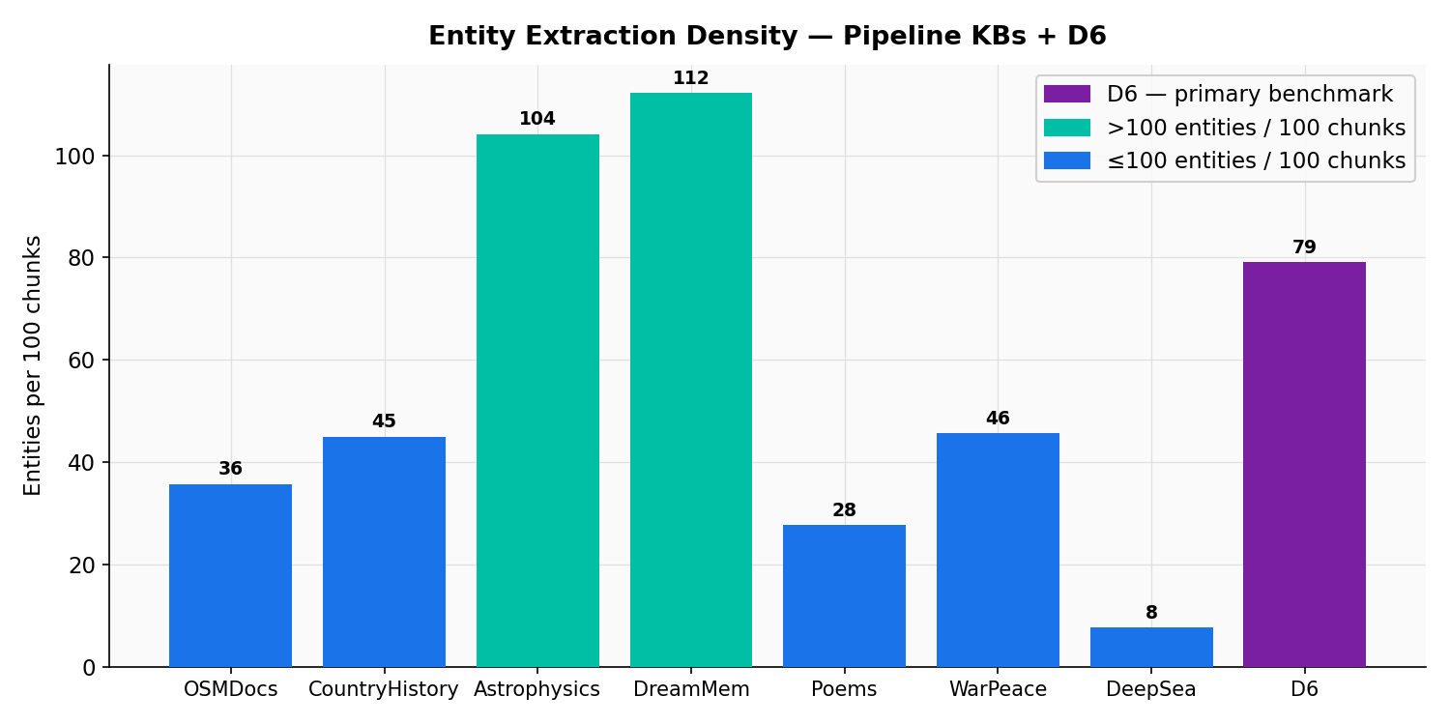
Figure 5 — Entity extraction density across pipeline KBs + D6

6. Scorer Failure — Case Studies
The generation recall scorer measures token-overlap + cosine similarity between the LLM’s answer and the expected ground-truth answer. Three failure modes appear across the corpus:
A — Abstractive paraphrase (most common): The LLM answers correctly but uses different words than the ground truth. The token-overlap scorer penalises this heavily.
B — Partial answer: The LLM surfaces the most prominent fact but omits secondary expected details, missing their keywords.
C — Scorer expects specific phrasing: The ground-truth answer quotes the source text verbatim; the LLM paraphrases, triggering a near-miss.

Case 1 — Partial answer (D6, q30)
Question: When did J.M.H. Gool arrive in Cape Town and from where?
Retrieved chunks (top sources): Passages covering the 1884 arrival, Mauritius connection, and family origins in Swat province via Gujarat, India.
LLM response: > According to [1] Haji Joosub Maulvi Hamid Gool arrived in Cape Town in 1884, from Mauritius.
Ground-truth expected answer: Joosub Maulvi Hamid Gool arrived in Cape Town in 1884, coming via Mauritius. He originally came from India — his father was a Pushto-speaking Maulvi from the Province of Swat who had moved to Rander in Gujarat. Joosub left behind his eleven-year-old bride in India when he made the journey.
Scorer result: 2 / 5 keywords matched (Mauritius ✓, Joosub ✓ — India ✗, Swat ✗, Gujarat ✗)
Diagnosis: The LLM returned the primary fact (year and transit point) but stopped short of the richer origin story that the ground truth expects. The retrieval correctly surfaced chunks containing all five keywords, but the LLM condensed them. This is a partial-answer failure: retrieval succeeded; the LLM under-generated.

Case 2 — Paraphrase miss (D6, q16)
Question: Who was Gandhi and what was his connection to the Gool family?
Retrieved chunks (top sources): Passages about Gandhi’s satyagraha campaigns in South Africa, his stays at 7 Buitencingle Street, and A.H. Gool’s farewell address conferring the “Mahatma” honorific.
LLM response (excerpt): > Gandhi, also known as Mahatma Gandhi, was a leader in the Indian independence movement. He spent over 20 years in South Africa pioneering satyagraha (non-violent resistance). Gandhi had a close relationship with the Gool family of District Six, Cape Town, where he stayed at their home, Buitencingle Street, several times … In March 1914, Gandhi attended a function at Buitencingle Street in his honor, where he thanked Mr. Gool for their services to his wife during her illness.
Ground-truth expected answer: … Gandhi had a personal connection to the Gool family: he stayed at the family mansion at 7 Buitencingle Street in February 1914 during the satyagraha campaign. The honorific ‘Mahatma’ was conferred on Gandhi by A.H. Gool in his farewell address as Gandhi was leaving South Africa in 1914.
Scorer result: 4 / 5 keywords matched (Gandhi ✓, Buitencingle ✓, non-violent ✓, satyagraha ✓ — India context partial)
Diagnosis: The LLM answer is factually rich and covers the key connection, but omits the single most specific detail the scorer was looking for: that the “Mahatma” honorific was specifically conferred by A.H. Gool. The LLM’s paraphrase (“thanked Mr. Gool for services”) replaces the exact fact. This is a specific-detail miss: the LLM gave a correct broad answer but not the precise sentence the scorer rewarded.

Case 3 — Abstractive paraphrase at scale (DeepSea, q07)
Question: What baseline system does the Nauman and Lutz review use for characterising extreme conditions, and what three conditions define that baseline?
Retrieval score: 74% (3.0 / 4 expected facts found in retrieved chunks)
Generation score: 32% (1.3 / 4 expected facts in LLM answer)
What happened: The DeepSea KB is a collection of academic papers; the eval questions were authored using the exact language of those papers. The LLM consistently produced well-structured summaries — correct in substance — but used ecological paraphrase rather than reproducing the paper’s specific terminology. For example, where the ground truth expects “the abyssal plain as a baseline characterised by: (1) low temperature, (2) high pressure, (3) permanent darkness”, the LLM responded with “the deep-sea floor — cold, dark, and under extreme pressure”. Every expected concept is present; no expected token sequence is reproduced. The semantic scorer (cosine threshold 0.85) also misses because the embedding distance between precise scientific prose and colloquial paraphrase exceeds the threshold.
Diagnosis: This is the dominant failure mode across DeepSea (33.3% generation), MobyDick (32.5%), and Legal (30.9%). The retrieval pipeline correctly surfaces the right documents; the LLM correctly understands and summarises them; but the scorer was calibrated against verbatim or near-verbatim answers. The fix is either lower-threshold semantic scoring or question redesign to reward conceptual recall rather than lexical match.

Summary
Failure mode | KBs affected | Retrieval | Generation | Fix
Partial answer (LLM under-generates) | D6, CountryHistory | High | Medium | Prompt: “list all facts including origin details”
Specific-detail miss (LLM paraphrases) | D6, WarPeace | High | Medium | Semantic scorer threshold ↓
Abstractive paraphrase at scale | DeepSea, MobyDick, Legal | High | Low (~33%) | Redesign eval questions for conceptual scoring

7. Pending Work
Item | Priority | Notes
D6 GPU relay rebuild | High | Timeline non-deterministic with local Ollama; need metro-linux rebuild for valid determinism
Commit SQLite migration | High | kwaai-rag/Cargo.toml, cache.rs, meta_store.rs, graph.rs, rag_cmd.rs
RFCs re-eval with semantic scoring | Medium | 0.0% token-overlap is likely a scorer artifact
jerome P2P debugging | Medium | 148+ routing failures; needs SSH investigation
NIST/Climate/PythonDocs question review | Low | Distinguish scorer failure from genuine model failure
Generation recall investigation (DeepSea/MobyDick/Legal) | Low | Likely scorer sensitivity to abstractive answers

