TABLE ONE AND PLOTS

Asabere Asante

[1] 2839 79

### **Table One**

|  | **Sex** | | |
| --- | --- | --- | --- |
| **Characteristic** | **Overall** N = 2,839*1* | **Female** N = 1,824*1* | **Male** N = 1,015*1* |
| **Age (years)** | 38 (11) | 37 (11) | 39 (9) |
| **Age group** |  |  |  |
| *<30* | 437 (15%) | 347 (19%) | 90 (9%) |
| *30-39* | 1,229 (43%) | 809 (44%) | 420 (41%) |
| *40-49* | 1,173 (41%) | 668 (37%) | 505 (50%) |
| **Current marital status** |  |  |  |
| *Never married* | 142 (5%) | 96 (5%) | 46 (5%) |
| *Currently married* | 1,720 (61%) | 1,036 (57%) | 684 (67%) |
| *Previously married* | 977 (34%) | 692 (38%) | 285 (28%) |
| **Educational attainment** |  |  |  |
| *No formal education* | 266 (9%) | 174 (10%) | 92 (9%) |
| *Primary* | 1,931 (68%) | 1,193 (65%) | 738 (73%) |
| *Secondary* | 406 (14%) | 287 (16%) | 119 (12%) |
| *Technical/University* | 236 (8%) | 170 (9%) | 66 (7%) |
| **Primary Occupation** |  |  |  |
| *Agriculture/Homebrewing* | 709 (25%) | 529 (29%) | 180 (18%) |
| *Trading or shopkeeping* | 543 (19%) | 430 (24%) | 113 (11%) |
| *Bar work or waitressing* | 282 (10%) | 278 (15%) | 4 (0%) |
| *Fishing-related occupation* | 504 (18%) | 3 (0%) | 501 (49%) |
| *House work* | 287 (10%) | 283 (16%) | 4 (0%) |
| *Other* | 514 (18%) | 301 (17%) | 213 (21%) |
| **Migration** |  |  |  |
| *In-migrant* | 637 (22%) | 464 (25%) | 173 (17%) |
| *Long-term resident* | 2,202 (78%) | 1,360 (75%) | 842 (83%) |
| **Community type** |  |  |  |
| *Inland Community* | 1,284 (45%) | 943 (52%) | 341 (34%) |
| *Fishing community* | 1,555 (55%) | 881 (48%) | 674 (66%) |
| **Time on ART** |  |  |  |
| *<1 year* | 222 (8%) | 152 (8%) | 70 (7%) |
| *1-2 years* | 79 (3%) | 50 (3%) | 29 (3%) |
| *2-5 years* | 750 (26%) | 446 (24%) | 304 (30%) |
| *>5 years* | 1,788 (63%) | 1,176 (64%) | 612 (60%) |
| *1*Median (IQR); n (%) | | | |

### **Viral Load Suppression**

| time | n | viral_load | n_suppressed | proportion | se | lower | upper |
| --- | --- | --- | --- | --- | --- | --- | --- |
| Before Covid-19 | 2779 | Viraemia | 135 | 0.0485786 | 0.0040782 | 0.0405854 | 0.0565718 |
| Before Covid-19 | 2779 | Viral Load Sppression | 2644 | 0.9514214 | 0.0040782 | 0.9434282 | 0.9594146 |
| After Covid-19 | 2780 | Viraemia | 135 | 0.0485612 | 0.0040767 | 0.0405707 | 0.0565516 |
| After Covid-19 | 2780 | Viral Load Sppression | 2645 | 0.9514388 | 0.0040767 | 0.9434484 | 0.9594293 |

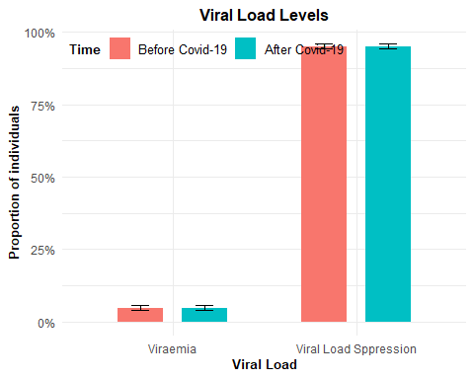

### **Proportion taking ART pills less frequently / in smaller amounts by Sex**

| sex | artstrbc | n |
| --- | --- | --- |
| Female | No | 1799 |
| Female | Yes | 21 |
| Male | No | 1003 |
| Male | Yes | 11 |

| sex | artstrac | n |
| --- | --- | --- |
| Female | No | 1775 |
| Female | Yes | 45 |
| Male | No | 985 |
| Male | Yes | 29 |

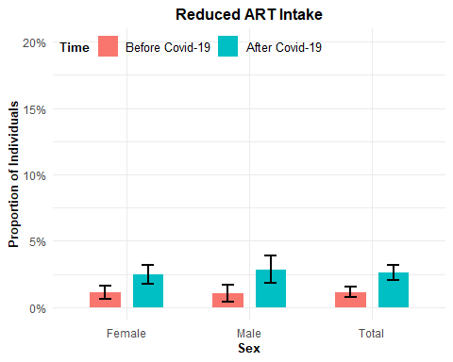

### **Run out of ART before next refill by Sex**

| sex | artrunbc | n |
| --- | --- | --- |
| Female | No | 1777 |
| Female | Yes | 43 |
| Male | No | 990 |
| Male | Yes | 24 |

| sex | artrunac | n |
| --- | --- | --- |
| Female | No | 1714 |
| Female | Yes | 106 |
| Male | No | 968 |
| Male | Yes | 46 |

| time | n_yes | n |
| --- | --- | --- |
| After Covid-19 | 152 | 2834 |
| Before Covid-19 | 67 | 2834 |

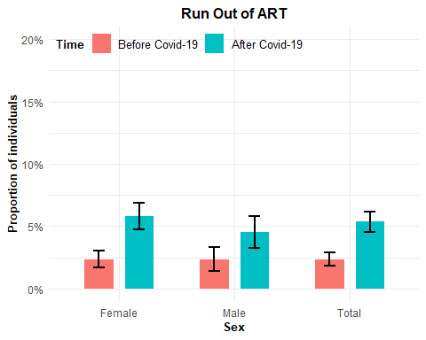

### **Missed Scheduled Visits by Sex**

| sex | hivbc | n |
| --- | --- | --- |
| Female | No | 1763 |
| Female | Yes | 57 |
| Male | No | 976 |
| Male | Yes | 38 |

| sex | hivac | n |
| --- | --- | --- |
| Female | No | 1642 |
| Female | Yes | 178 |
| Male | No | 917 |
| Male | Yes | 97 |

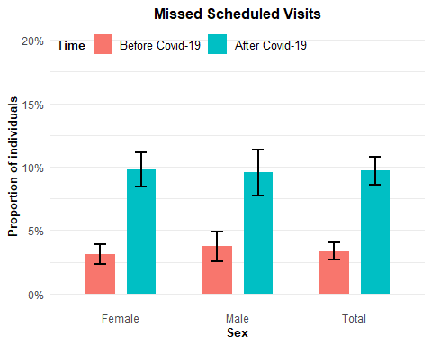

### Combined Plots



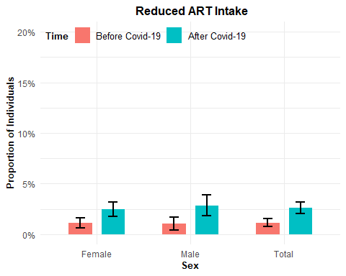



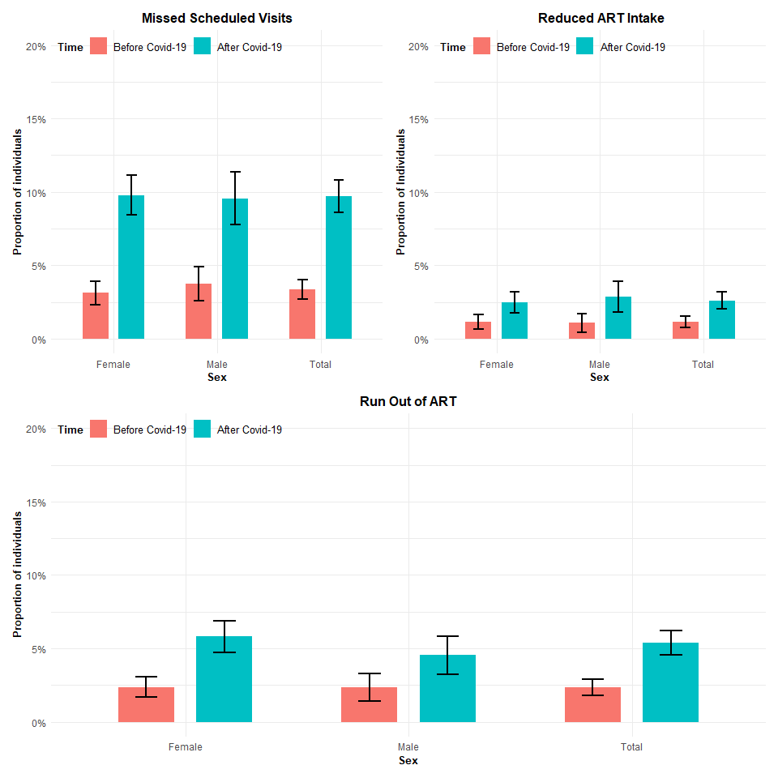

# SUBPLOTS

### Community Type

### Reduced ART intake by Community

| community_type | artstrbc | n |
| --- | --- | --- |
| Inland Community | No | 1272 |
| Inland Community | Yes | 11 |
| Fishing community | No | 1530 |
| Fishing community | Yes | 21 |

| community_type | artstrac | n |
| --- | --- | --- |
| Inland Community | No | 1268 |
| Inland Community | Yes | 15 |
| Fishing community | No | 1492 |
| Fishing community | Yes | 59 |

| time | community_type | n_yes | n | proportion | se | lower | upper |
| --- | --- | --- | --- | --- | --- | --- | --- |
| After Covid-19 | Inland Community | 15 | 1283 | 0.0116913 | 0.0030010 | 0.0058094 | 0.0175733 |
| After Covid-19 | Fishing community | 59 | 1551 | 0.0380400 | 0.0048573 | 0.0285197 | 0.0475602 |
| Before Covid-19 | Inland Community | 11 | 1283 | 0.0085737 | 0.0025739 | 0.0035287 | 0.0136186 |
| Before Covid-19 | Fishing community | 21 | 1551 | 0.0135397 | 0.0029345 | 0.0077880 | 0.0192913 |
| After Covid-19 | Total | 74 | 2834 | 0.0261115 | 0.0029955 | 0.0202403 | 0.0319827 |
| Before Covid-19 | Total | 32 | 2834 | 0.0112915 | 0.0019848 | 0.0074013 | 0.0151816 |

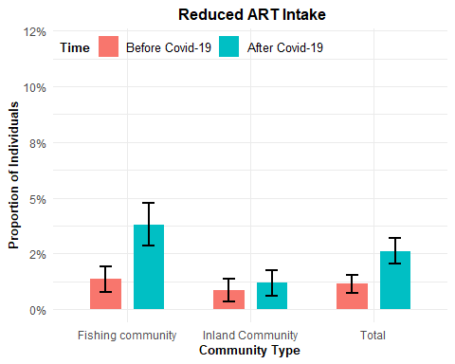

### Missed Scheduled Visits by Community

| community_type | hivbc | n |
| --- | --- | --- |
| Inland Community | No | 1257 |
| Inland Community | Yes | 26 |
| Fishing community | No | 1482 |
| Fishing community | Yes | 69 |

| community_type | hivac | n |
| --- | --- | --- |
| Inland Community | No | 1198 |
| Inland Community | Yes | 85 |
| Fishing community | No | 1361 |
| Fishing community | Yes | 190 |

| time | community_type | n_yes | n | proportion | se | lower | upper |
| --- | --- | --- | --- | --- | --- | --- | --- |
| After Covid-19 | Inland Community | 85 | 1283 | 0.0662510 | 0.0069438 | 0.0526411 | 0.0798608 |
| After Covid-19 | Fishing community | 190 | 1551 | 0.1225016 | 0.0083251 | 0.1061845 | 0.1388188 |
| Before Covid-19 | Inland Community | 26 | 1283 | 0.0202650 | 0.0039338 | 0.0125547 | 0.0279753 |
| Before Covid-19 | Fishing community | 69 | 1551 | 0.0444874 | 0.0052352 | 0.0342265 | 0.0547484 |
| After Covid-19 | Total | 275 | 2834 | 0.0970360 | 0.0055603 | 0.0861377 | 0.1079343 |
| Before Covid-19 | Total | 95 | 2834 | 0.0335215 | 0.0033811 | 0.0268946 | 0.0401485 |

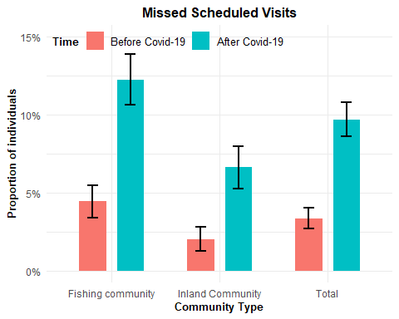

### Run out of ART by Community

| community_type | artrunbc | n |
| --- | --- | --- |
| Inland Community | No | 1253 |
| Inland Community | Yes | 30 |
| Fishing community | No | 1514 |
| Fishing community | Yes | 37 |

| community_type | artrunac | n |
| --- | --- | --- |
| Inland Community | No | 1225 |
| Inland Community | Yes | 58 |
| Fishing community | No | 1457 |
| Fishing community | Yes | 94 |

| time | community_type | n_yes | n | proportion | se | lower | upper |
| --- | --- | --- | --- | --- | --- | --- | --- |
| After Covid-19 | Inland Community | 58 | 1283 | 0.0452065 | 0.0058002 | 0.0338382 | 0.0565749 |
| After Covid-19 | Fishing community | 94 | 1551 | 0.0606061 | 0.0060587 | 0.0487311 | 0.0724810 |
| Before Covid-19 | Inland Community | 30 | 1283 | 0.0233827 | 0.0042189 | 0.0151137 | 0.0316517 |
| Before Covid-19 | Fishing community | 37 | 1551 | 0.0238556 | 0.0038748 | 0.0162610 | 0.0314501 |
| After Covid-19 | Total | 152 | 2834 | 0.0536344 | 0.0042321 | 0.0453396 | 0.0619293 |
| Before Covid-19 | Total | 67 | 2834 | 0.0236415 | 0.0028539 | 0.0180478 | 0.0292352 |

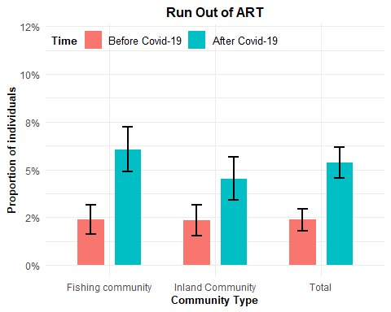

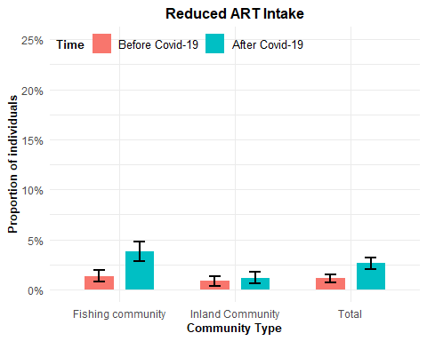

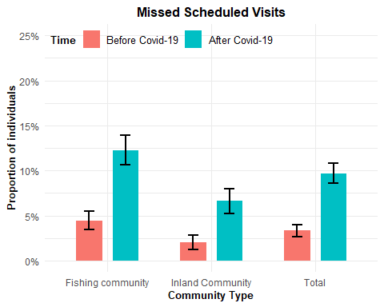

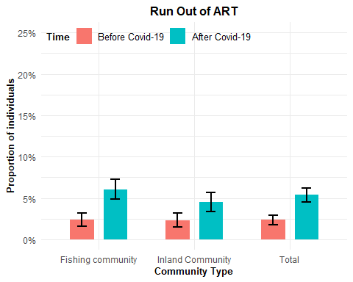

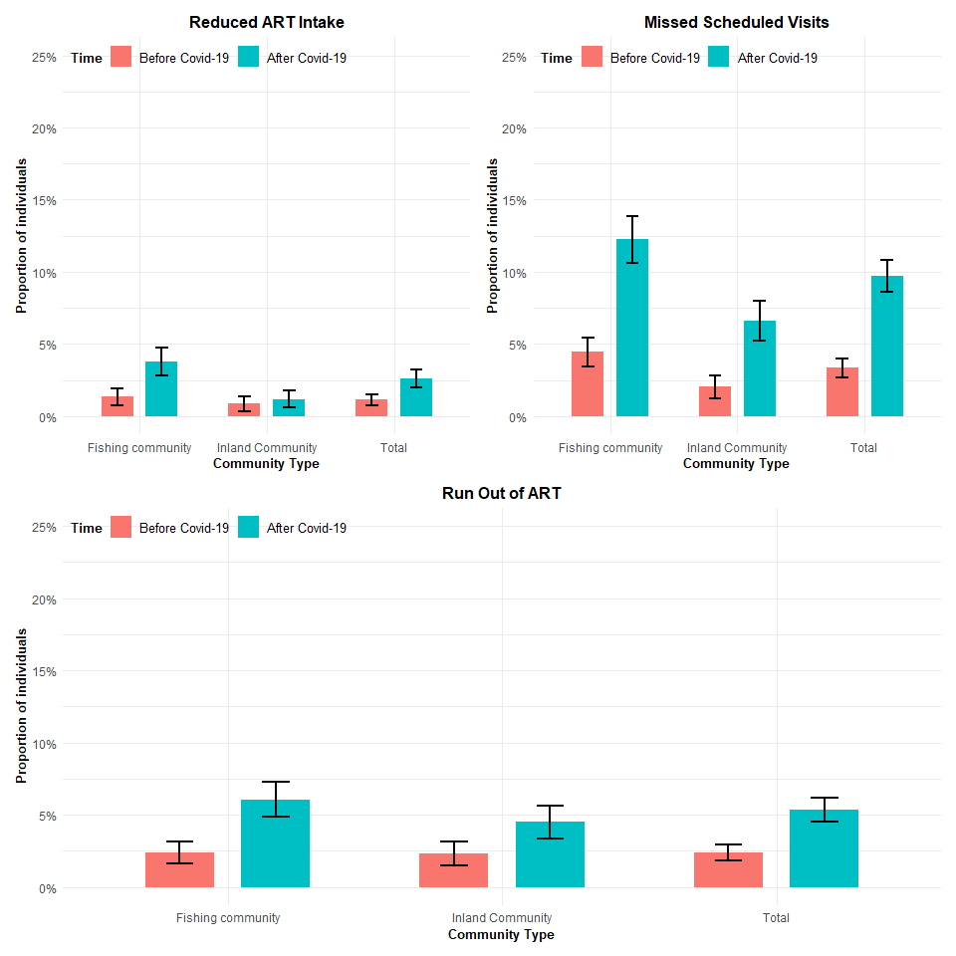

### Mobility

### Run Out of ART by mobility

| mobility | artrunbc | n |
| --- | --- | --- |
| In-migrant | No | 610 |
| In-migrant | Yes | 22 |
| Long-term resident | No | 2157 |
| Long-term resident | Yes | 45 |

| mobility | artrunac | n |
| --- | --- | --- |
| In-migrant | No | 582 |
| In-migrant | Yes | 50 |
| Long-term resident | No | 2100 |
| Long-term resident | Yes | 102 |

| time | mobility | n_yes | n | proportion | se | lower | upper |
| --- | --- | --- | --- | --- | --- | --- | --- |
| After Covid-19 | In-migrant | 50 | 632 | 0.0791139 | 0.0107367 | 0.0580700 | 0.1001579 |
| After Covid-19 | Long-term resident | 102 | 2202 | 0.0463215 | 0.0044790 | 0.0375426 | 0.0551004 |
| Before Covid-19 | In-migrant | 22 | 632 | 0.0348101 | 0.0072912 | 0.0205193 | 0.0491009 |
| Before Covid-19 | Long-term resident | 45 | 2202 | 0.0204360 | 0.0030151 | 0.0145263 | 0.0263456 |
| After Covid-19 | Total | 152 | 2834 | 0.0536344 | 0.0042321 | 0.0453396 | 0.0619293 |
| Before Covid-19 | Total | 67 | 2834 | 0.0236415 | 0.0028539 | 0.0180478 | 0.0292352 |

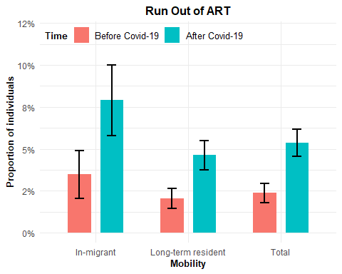

### reduced ART Intake by mobility

| mobility | artstrbc | n |
| --- | --- | --- |
| In-migrant | No | 625 |
| In-migrant | Yes | 7 |
| Long-term resident | No | 2177 |
| Long-term resident | Yes | 25 |

| mobility | artstrac | n |
| --- | --- | --- |
| In-migrant | No | 611 |
| In-migrant | Yes | 21 |
| Long-term resident | No | 2149 |
| Long-term resident | Yes | 53 |

| time | mobility | n_yes | n | proportion | se | lower | upper |
| --- | --- | --- | --- | --- | --- | --- | --- |
| After Covid-19 | In-migrant | 21 | 632 | 0.0332278 | 0.0071294 | 0.0192542 | 0.0472015 |
| After Covid-19 | Long-term resident | 53 | 2202 | 0.0240690 | 0.0032661 | 0.0176675 | 0.0304706 |
| Before Covid-19 | In-migrant | 7 | 632 | 0.0110759 | 0.0041631 | 0.0029163 | 0.0192356 |
| Before Covid-19 | Long-term resident | 25 | 2202 | 0.0113533 | 0.0022577 | 0.0069282 | 0.0157785 |
| After Covid-19 | Total | 74 | 2834 | 0.0261115 | 0.0029955 | 0.0202403 | 0.0319827 |
| Before Covid-19 | Total | 32 | 2834 | 0.0112915 | 0.0019848 | 0.0074013 | 0.0151816 |

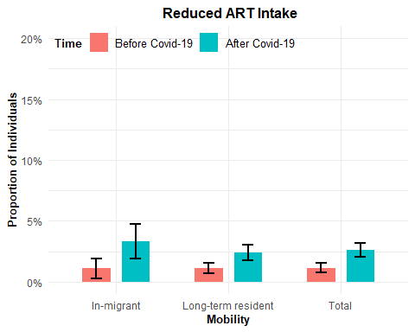

### Missed scheduled visits by mobility

| mobility | hivbc | n |
| --- | --- | --- |
| In-migrant | No | 595 |
| In-migrant | Yes | 37 |
| Long-term resident | No | 2144 |
| Long-term resident | Yes | 58 |

| mobility | hivac | n |
| --- | --- | --- |
| In-migrant | No | 534 |
| In-migrant | Yes | 98 |
| Long-term resident | No | 2025 |
| Long-term resident | Yes | 177 |

| time | community_type | n_yes | n | proportion | se | lower | upper |
| --- | --- | --- | --- | --- | --- | --- | --- |
| After Covid-19 | Inland Community | 85 | 1283 | 0.0662510 | 0.0069438 | 0.0526411 | 0.0798608 |
| After Covid-19 | Fishing community | 190 | 1551 | 0.1225016 | 0.0083251 | 0.1061845 | 0.1388188 |
| Before Covid-19 | Inland Community | 26 | 1283 | 0.0202650 | 0.0039338 | 0.0125547 | 0.0279753 |
| Before Covid-19 | Fishing community | 69 | 1551 | 0.0444874 | 0.0052352 | 0.0342265 | 0.0547484 |
| After Covid-19 | Total | 275 | 2834 | 0.0970360 | 0.0055603 | 0.0861377 | 0.1079343 |
| Before Covid-19 | Total | 95 | 2834 | 0.0335215 | 0.0033811 | 0.0268946 | 0.0401485 |

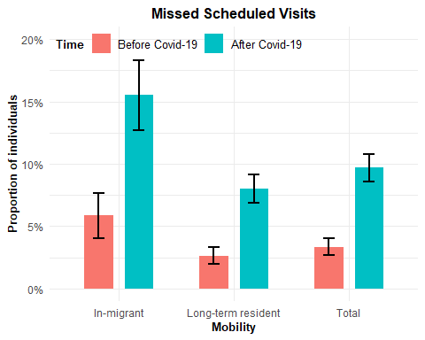

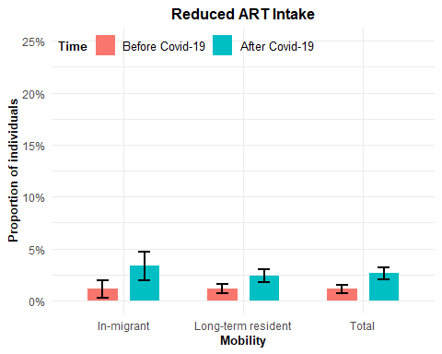

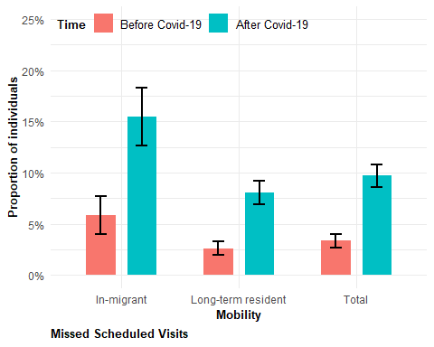

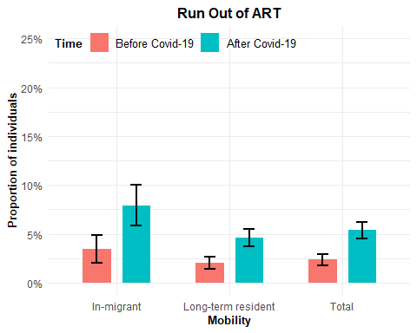

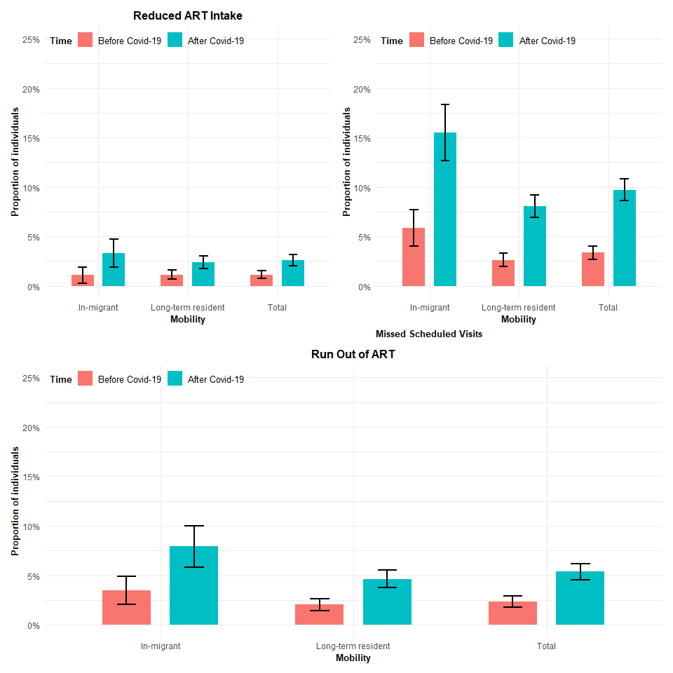

### Age Categories

### Run out of ART by Age Category

| age_cat | artrunbc | n |
| --- | --- | --- |
| <30 | No | 421 |
| <30 | Yes | 12 |
| 30-39 | No | 1198 |
| 30-39 | Yes | 31 |
| 40-49 | No | 1148 |
| 40-49 | Yes | 24 |

| age_cat | artrunac | n |
| --- | --- | --- |
| <30 | No | 401 |
| <30 | Yes | 32 |
| 30-39 | No | 1158 |
| 30-39 | Yes | 71 |
| 40-49 | No | 1123 |
| 40-49 | Yes | 49 |

| time | age_cat | n_yes | n | proportion | se | lower | upper |
| --- | --- | --- | --- | --- | --- | --- | --- |
| After Covid-19 | <30 | 32 | 433 | 0.0739030 | 0.0125723 | 0.0492613 | 0.0985447 |
| After Covid-19 | 30-39 | 71 | 1229 | 0.0577705 | 0.0066551 | 0.0447265 | 0.0708146 |
| After Covid-19 | 40-49 | 49 | 1172 | 0.0418089 | 0.0058465 | 0.0303497 | 0.0532680 |
| Before Covid-19 | <30 | 12 | 433 | 0.0277136 | 0.0078886 | 0.0122520 | 0.0431753 |
| Before Covid-19 | 30-39 | 31 | 1229 | 0.0252238 | 0.0044728 | 0.0164570 | 0.0339905 |
| Before Covid-19 | 40-49 | 24 | 1172 | 0.0204778 | 0.0041370 | 0.0123693 | 0.0285863 |
| After Covid-19 | Total | 152 | 2834 | 0.0536344 | 0.0042321 | 0.0453396 | 0.0619293 |
| Before Covid-19 | Total | 67 | 2834 | 0.0236415 | 0.0028539 | 0.0180478 | 0.0292352 |

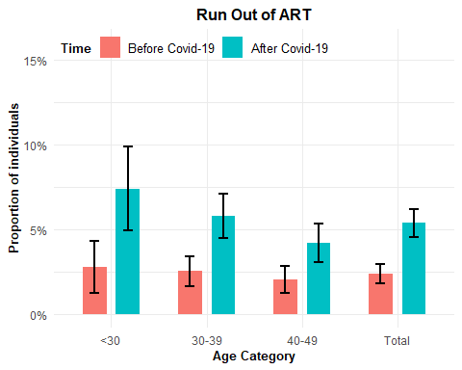

### Missed Scheduled Visits by Age Category

| age_cat | hivbc | n |
| --- | --- | --- |
| <30 | No | 411 |
| <30 | Yes | 22 |
| 30-39 | No | 1186 |
| 30-39 | Yes | 43 |
| 40-49 | No | 1142 |
| 40-49 | Yes | 30 |

| age_cat | hivac | n |
| --- | --- | --- |
| <30 | No | 383 |
| <30 | Yes | 50 |
| 30-39 | No | 1095 |
| 30-39 | Yes | 134 |
| 40-49 | No | 1081 |
| 40-49 | Yes | 91 |

| time | age_cat | n_yes | n | proportion | se | lower | upper |
| --- | --- | --- | --- | --- | --- | --- | --- |
| After Covid-19 | <30 | 50 | 433 | 0.1154734 | 0.0153586 | 0.0853705 | 0.1455764 |
| After Covid-19 | 30-39 | 134 | 1229 | 0.1090317 | 0.0088906 | 0.0916061 | 0.1264573 |
| After Covid-19 | 40-49 | 91 | 1172 | 0.0776451 | 0.0078170 | 0.0623237 | 0.0929664 |
| Before Covid-19 | <30 | 22 | 433 | 0.0508083 | 0.0105536 | 0.0301233 | 0.0714934 |
| Before Covid-19 | 30-39 | 43 | 1229 | 0.0349878 | 0.0052414 | 0.0247146 | 0.0452610 |
| Before Covid-19 | 40-49 | 30 | 1172 | 0.0255973 | 0.0046132 | 0.0165554 | 0.0346391 |
| After Covid-19 | Total | 275 | 2834 | 0.0970360 | 0.0055603 | 0.0861377 | 0.1079343 |
| Before Covid-19 | Total | 95 | 2834 | 0.0335215 | 0.0033811 | 0.0268946 | 0.0401485 |

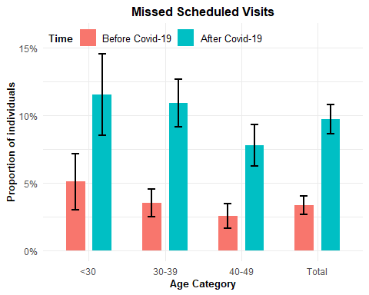

### Reduced ART Intake by Age Category

| age_cat | artstrbc | n |
| --- | --- | --- |
| <30 | No | 426 |
| <30 | Yes | 7 |
| 30-39 | No | 1213 |
| 30-39 | Yes | 16 |
| 40-49 | No | 1163 |
| 40-49 | Yes | 9 |

| age_cat | artstrac | n |
| --- | --- | --- |
| <30 | No | 418 |
| <30 | Yes | 15 |
| 30-39 | No | 1190 |
| 30-39 | Yes | 39 |
| 40-49 | No | 1152 |
| 40-49 | Yes | 20 |

| time | age_cat | n_yes | n | proportion | se | lower | upper |
| --- | --- | --- | --- | --- | --- | --- | --- |
| After Covid-19 | <30 | 15 | 433 | 0.0346420 | 0.0087882 | 0.0174171 | 0.0518670 |
| After Covid-19 | 30-39 | 39 | 1229 | 0.0317331 | 0.0050001 | 0.0219329 | 0.0415333 |
| After Covid-19 | 40-49 | 20 | 1172 | 0.0170648 | 0.0037831 | 0.0096499 | 0.0244798 |
| Before Covid-19 | <30 | 7 | 433 | 0.0161663 | 0.0060607 | 0.0042873 | 0.0280452 |
| Before Covid-19 | 30-39 | 16 | 1229 | 0.0130187 | 0.0032334 | 0.0066812 | 0.0193562 |
| Before Covid-19 | 40-49 | 9 | 1172 | 0.0076792 | 0.0025499 | 0.0026814 | 0.0126769 |
| After Covid-19 | Total | 74 | 2834 | 0.0261115 | 0.0029955 | 0.0202403 | 0.0319827 |
| Before Covid-19 | Total | 32 | 2834 | 0.0112915 | 0.0019848 | 0.0074013 | 0.0151816 |

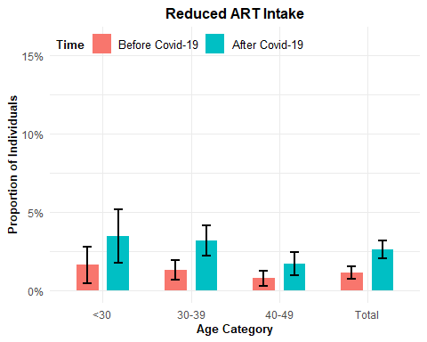

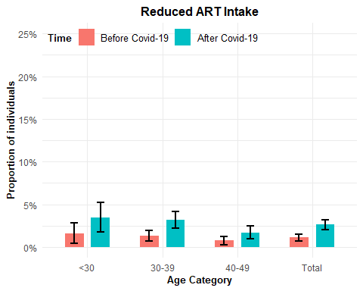

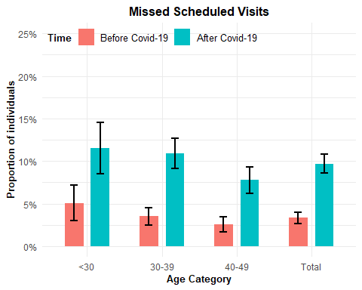

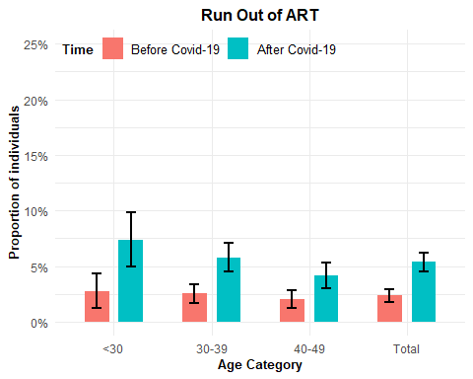

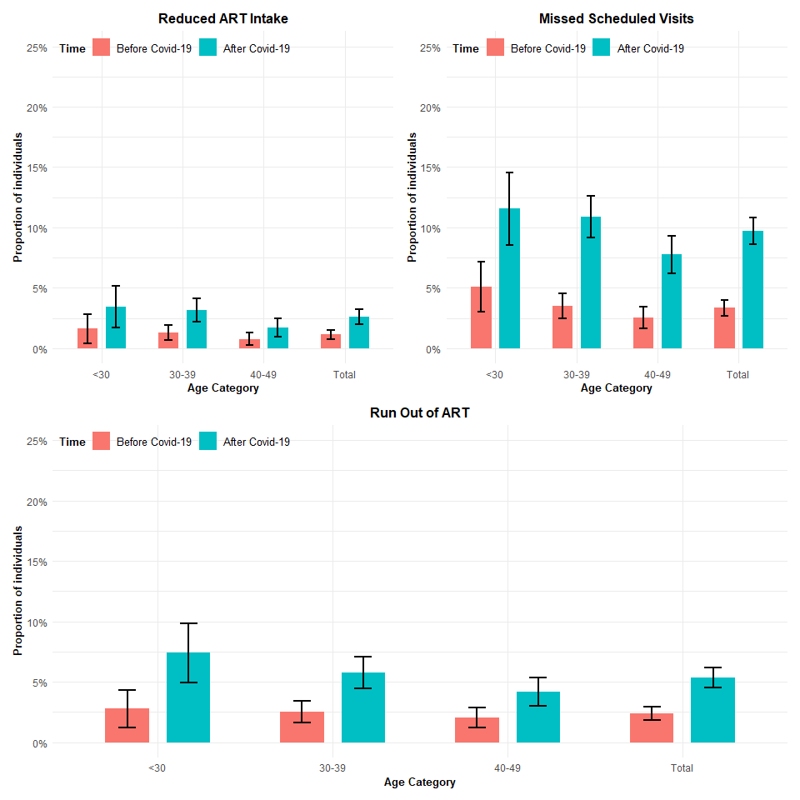

# ART Duration

| art_duration | artstrbc | n |
| --- | --- | --- |
| <2 years | No | 166 |
| <2 years | Yes | 1 |
| 2-5 years | No | 868 |
| 2-5 years | Yes | 12 |
| >5 years | No | 1768 |
| >5 years | Yes | 19 |

| art_duration | artstrac | n |
| --- | --- | --- |
| <2 years | No | 163 |
| <2 years | Yes | 4 |
| 2-5 years | No | 852 |
| 2-5 years | Yes | 28 |
| >5 years | No | 1745 |
| >5 years | Yes | 42 |

### Reduced ART intake by ART duration

| time | art_duration | n_yes | n | proportion | se | lower | upper |
| --- | --- | --- | --- | --- | --- | --- | --- |
| After Covid-19 | <2 years | 4 | 167 | 0.0239521 | 0.0118318 | 0.0007619 | 0.0471423 |
| After Covid-19 | 2-5 years | 28 | 880 | 0.0318182 | 0.0059166 | 0.0202216 | 0.0434148 |
| After Covid-19 | >5 years | 42 | 1787 | 0.0235031 | 0.0035837 | 0.0164790 | 0.0305272 |
| Before Covid-19 | <2 years | 1 | 167 | 0.0059880 | 0.0059701 | 0.0000000 | 0.0176894 |
| Before Covid-19 | 2-5 years | 12 | 880 | 0.0136364 | 0.0039095 | 0.0059737 | 0.0212991 |
| Before Covid-19 | >5 years | 19 | 1787 | 0.0106323 | 0.0024262 | 0.0058769 | 0.0153877 |
| After Covid-19 | Total | 74 | 2834 | 0.0261115 | 0.0029955 | 0.0202403 | 0.0319827 |
| Before Covid-19 | Total | 32 | 2834 | 0.0112915 | 0.0019848 | 0.0074013 | 0.0151816 |

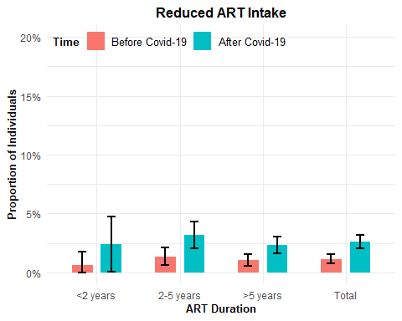

### Run out of ART by ART Duration

| art_duration | artrunbc | n |
| --- | --- | --- |
| <2 years | No | 165 |
| <2 years | Yes | 2 |
| 2-5 years | No | 864 |
| 2-5 years | Yes | 16 |
| >5 years | No | 1738 |
| >5 years | Yes | 49 |

| art_duration | artrunac | n |
| --- | --- | --- |
| <2 years | No | 157 |
| <2 years | Yes | 10 |
| 2-5 years | No | 826 |
| 2-5 years | Yes | 54 |
| >5 years | No | 1699 |
| >5 years | Yes | 88 |

| time | art_duration | n_yes | n | proportion | se | lower | upper |
| --- | --- | --- | --- | --- | --- | --- | --- |
| After Covid-19 | <2 years | 10 | 167 | 0.0598802 | 0.0183601 | 0.0238944 | 0.0958660 |
| After Covid-19 | 2-5 years | 54 | 880 | 0.0613636 | 0.0080903 | 0.0455067 | 0.0772206 |
| After Covid-19 | >5 years | 88 | 1787 | 0.0492445 | 0.0051186 | 0.0392121 | 0.0592770 |
| Before Covid-19 | <2 years | 2 | 167 | 0.0119760 | 0.0084175 | 0.0000000 | 0.0284743 |
| Before Covid-19 | 2-5 years | 16 | 880 | 0.0181818 | 0.0045039 | 0.0093541 | 0.0270095 |
| Before Covid-19 | >5 years | 49 | 1787 | 0.0274203 | 0.0038631 | 0.0198486 | 0.0349919 |
| After Covid-19 | Total | 152 | 2834 | 0.0536344 | 0.0042321 | 0.0453396 | 0.0619293 |
| Before Covid-19 | Total | 67 | 2834 | 0.0236415 | 0.0028539 | 0.0180478 | 0.0292352 |

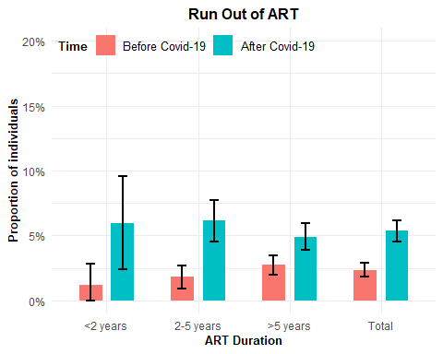

### Missed Scheduled visit by ART Duration

| art_duration | hivbc | n |
| --- | --- | --- |
| <2 years | No | 164 |
| <2 years | Yes | 3 |
| 2-5 years | No | 849 |
| 2-5 years | Yes | 31 |
| >5 years | No | 1726 |
| >5 years | Yes | 61 |

| art_duration | hivac | n |
| --- | --- | --- |
| <2 years | No | 149 |
| <2 years | Yes | 18 |
| 2-5 years | No | 788 |
| 2-5 years | Yes | 92 |
| >5 years | No | 1622 |
| >5 years | Yes | 165 |

| time | art_duration | n_yes | n | proportion | se | lower | upper |
| --- | --- | --- | --- | --- | --- | --- | --- |
| After Covid-19 | <2 years | 18 | 167 | 0.1077844 | 0.0239969 | 0.0607506 | 0.1548183 |
| After Covid-19 | 2-5 years | 92 | 880 | 0.1045455 | 0.0103141 | 0.0843297 | 0.1247612 |
| After Covid-19 | >5 years | 165 | 1787 | 0.0923335 | 0.0068483 | 0.0789109 | 0.1057561 |
| Before Covid-19 | <2 years | 3 | 167 | 0.0179641 | 0.0102780 | 0.0000000 | 0.0381089 |
| Before Covid-19 | 2-5 years | 31 | 880 | 0.0352273 | 0.0062146 | 0.0230467 | 0.0474078 |
| Before Covid-19 | >5 years | 61 | 1787 | 0.0341354 | 0.0042953 | 0.0257165 | 0.0425543 |
| After Covid-19 | Total | 275 | 2834 | 0.0970360 | 0.0055603 | 0.0861377 | 0.1079343 |
| Before Covid-19 | Total | 95 | 2834 | 0.0335215 | 0.0033811 | 0.0268946 | 0.0401485 |

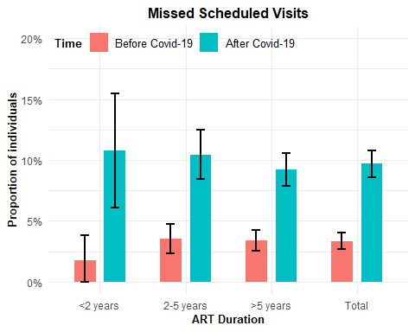

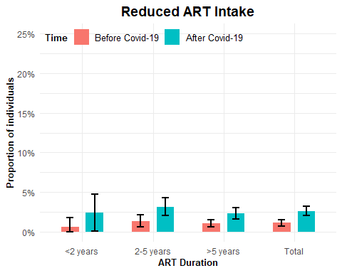

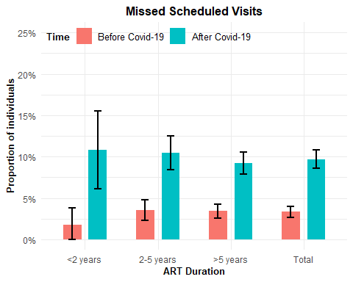

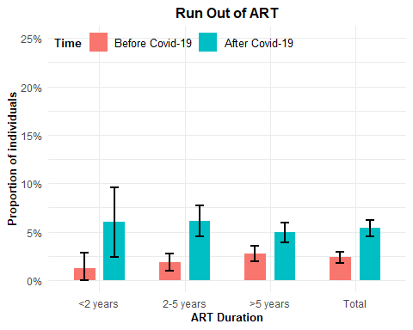

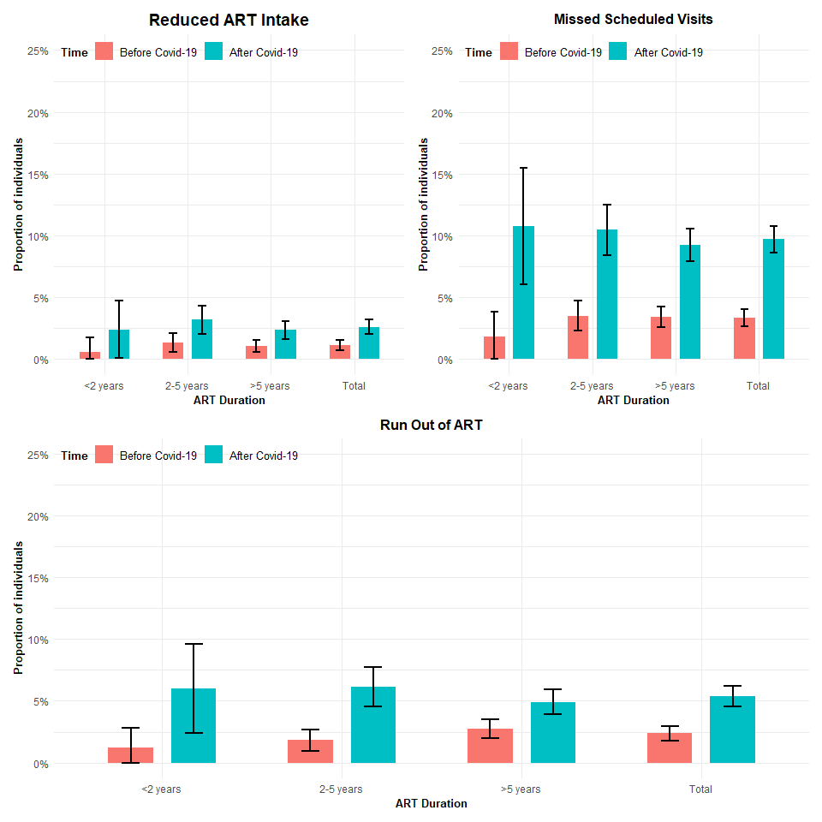

# Any disruption subplots

0 1   
2699 140

0 1   
2457 382

### Any Disruption by Sex

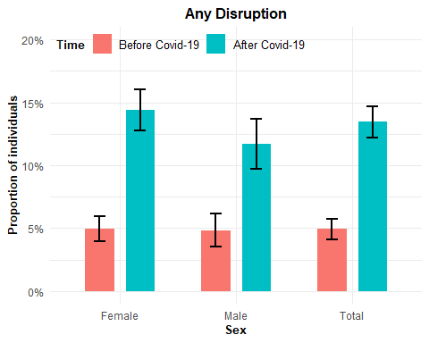

### Any disruption by community type

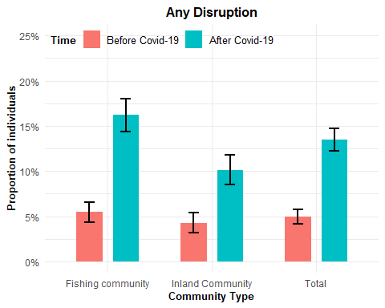

### Any disruption by age category

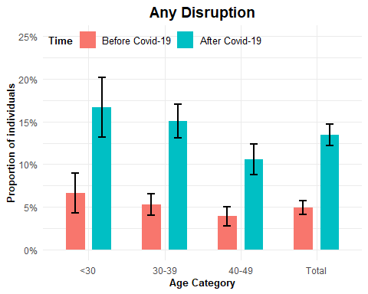

### Any Disruption By Mobility

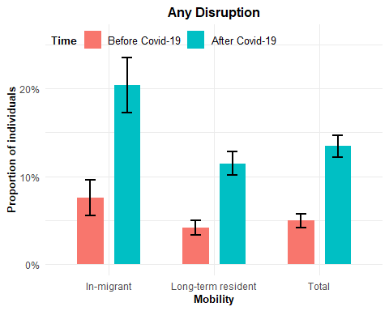

### Any Disruption by ART duration

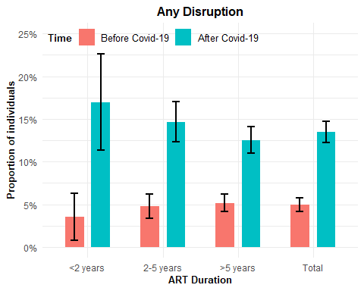

### Combined Plots

#### Age category

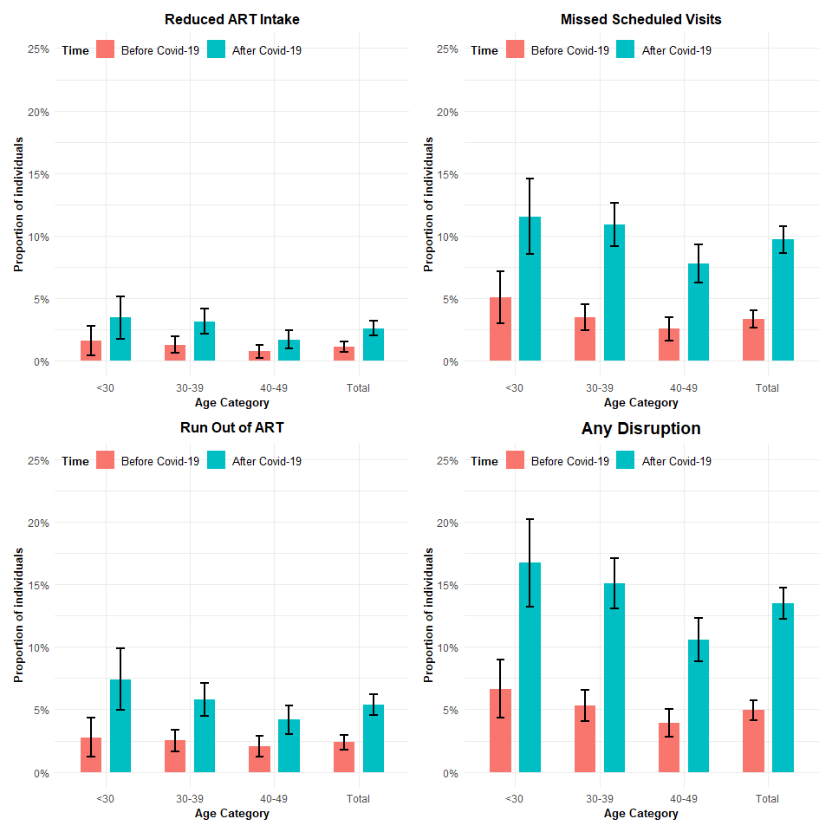

### Community type

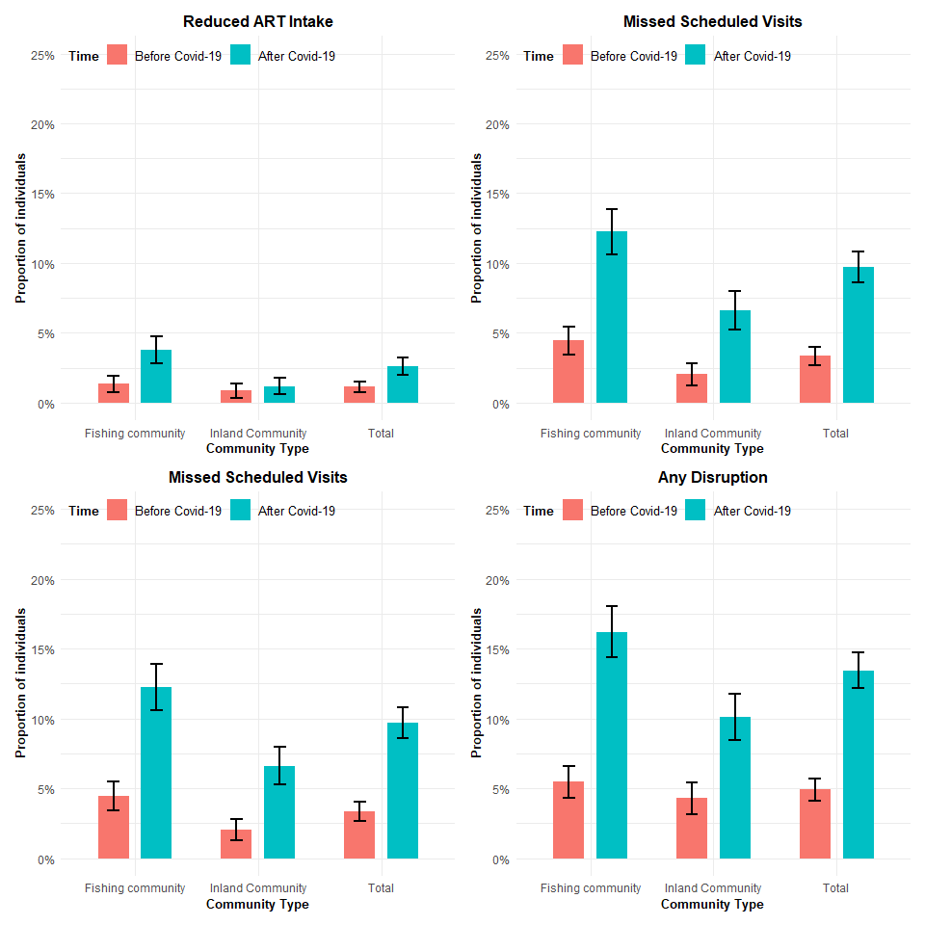

### Mobility

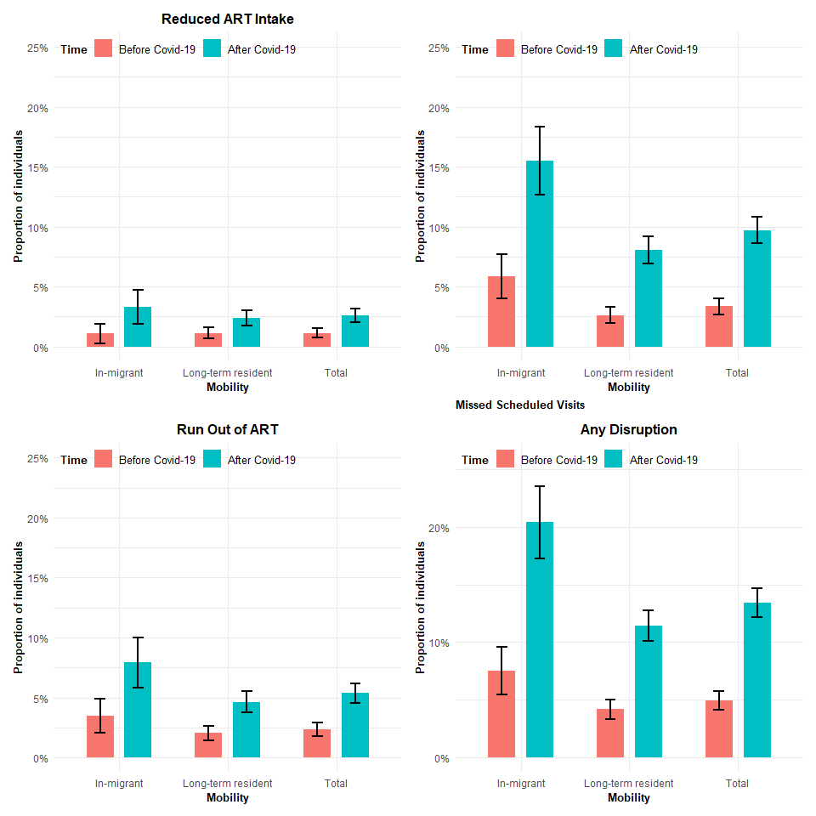

### ART Duration

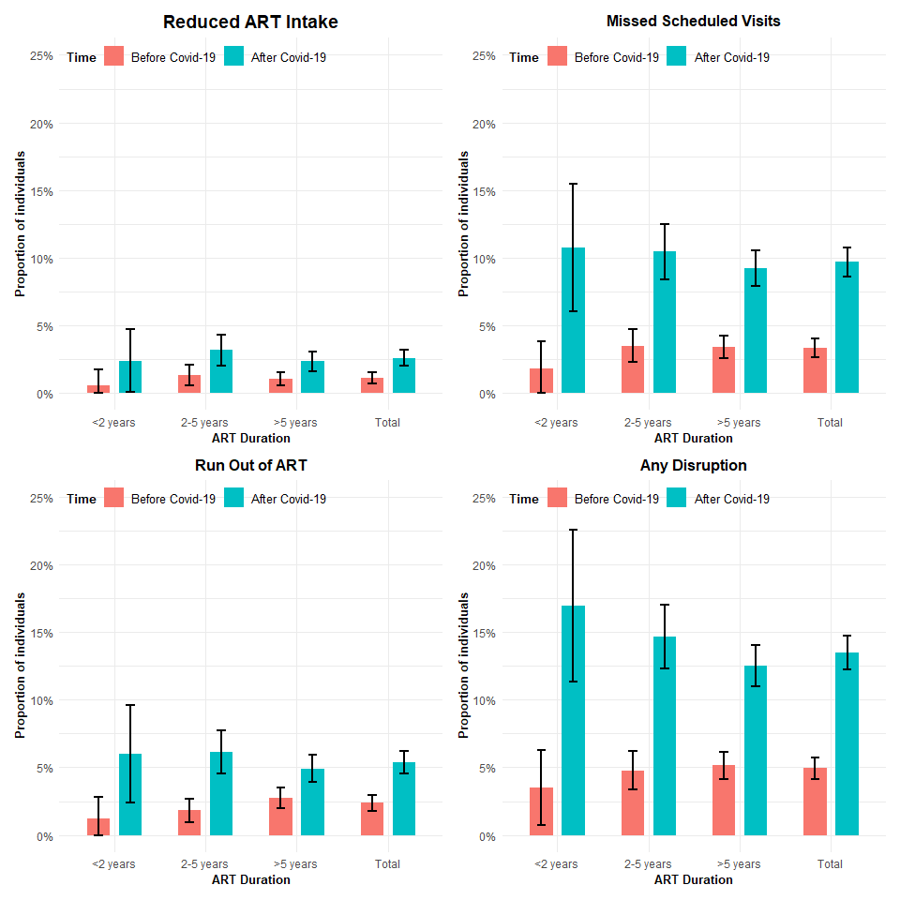

### Sex

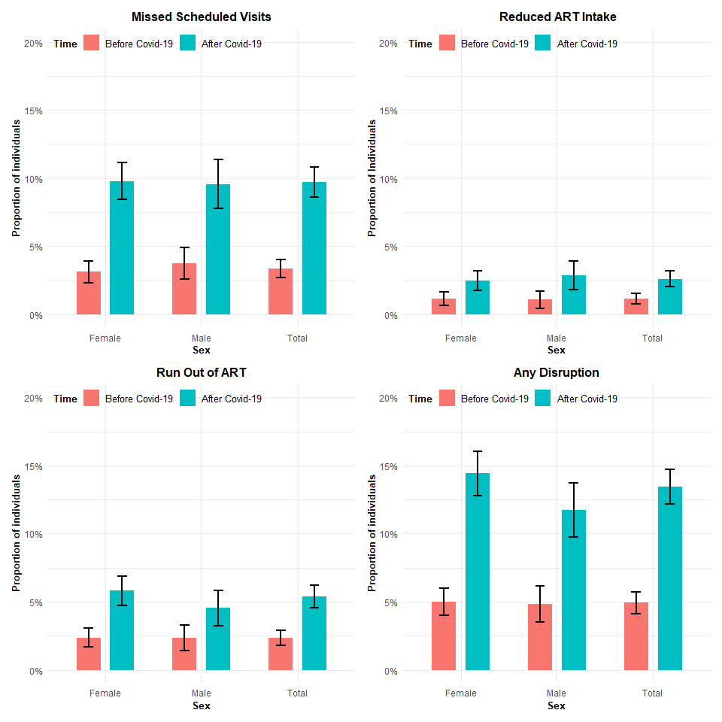

### VIRAEMIA PREVALENCE

|  | **Viraemia After COVID** | |
| --- | --- | --- |
| **Characteristic** | **No** N = 2,650*1* | **Yes** N = 135*1* |
| Any ART Disruption post-covid | 347 (93%) | 28 (7.5%) |
| Any ART Disruption pre-covid | 115 (91%) | 11 (8.7%) |
| Sex |  |  |
| Female | 1,714 (96%) | 66 (3.7%) |
| Male | 936 (93%) | 69 (6.9%) |
| Age group |  |  |
| <30 | 390 (90%) | 44 (10%) |
| 30-39 | 1,136 (94%) | 67 (5.6%) |
| 40-49 | 1,124 (98%) | 24 (2.1%) |
| Migration |  |  |
| In-migrant | 596 (95%) | 34 (5.4%) |
| Long-term resident | 2,054 (95%) | 101 (4.7%) |
| Community type |  |  |
| Inland Community | 1,212 (96%) | 48 (3.8%) |
| Fishing community | 1,438 (94%) | 87 (5.7%) |
| Time on ART |  |  |
| <2 years | 160 (95%) | 8 (4.8%) |
| 2-5 years | 810 (93%) | 57 (6.6%) |
| >5 years | 1,680 (96%) | 70 (4.0%) |
| *1*n (%) | | |

| **Characteristic** | **N** | **IRR***1* | **95% CI***1* |
| --- | --- | --- | --- |
| Any ART Disruption post-covid | 2,785 |  |  |
| No |  | — | — |
| Yes |  | 1.68 | 1.09, 2.51 |
| Sex | 2,785 |  |  |
| Female |  | — | — |
| Male |  | 1.85 | 1.32, 2.60 |
| Age group | 2,785 |  |  |
| <30 |  | — | — |
| 30-39 |  | 0.55 | 0.38, 0.81 |
| 40-49 |  | 0.21 | 0.12, 0.34 |
| Migration | 2,785 |  |  |
| In-migrant |  | — | — |
| Long-term resident |  | 0.87 | 0.60, 1.30 |
| Community type | 2,785 |  |  |
| Inland Community |  | — | — |
| Fishing community |  | 1.50 | 1.06, 2.15 |
| Time on ART | 2,785 |  |  |
| <2 years |  | — | — |
| 2-5 years |  | 1.38 | 0.70, 3.13 |
| >5 years |  | 0.84 | 0.43, 1.89 |
| Any ART Disruption pre-covid | 2,785 |  |  |
| No |  | — | — |
| Yes |  | 1.87 | 0.95, 3.31 |
| *1*IRR = Incidence Rate Ratio, CI = Confidence Interval | | | |

|  | **Viraemia After COVID** | | **Prevalence Risk Ratios** | | |
| --- | --- | --- | --- | --- | --- |
| **Characteristic** | **No** N = 2,650*1* | **Yes** N = 135*1* | **N** | **IRR***2* | **95% CI***2* |
| Any ART Disruption post-covid | 347 (93%) | 28 (7.5%) | 2,785 |  |  |
| No |  |  |  | — | — |
| Yes |  |  |  | 1.68 | 1.09, 2.51 |
| Any ART Disruption pre-covid | 115 (91%) | 11 (8.7%) | 2,785 |  |  |
| No |  |  |  | — | — |
| Yes |  |  |  | 1.87 | 0.95, 3.31 |
| Sex |  |  | 2,785 |  |  |
| Female | 1,714 (96%) | 66 (3.7%) |  | — | — |
| Male | 936 (93%) | 69 (6.9%) |  | 1.85 | 1.32, 2.60 |
| Age group |  |  | 2,785 |  |  |
| <30 | 390 (90%) | 44 (10%) |  | — | — |
| 30-39 | 1,136 (94%) | 67 (5.6%) |  | 0.55 | 0.38, 0.81 |
| 40-49 | 1,124 (98%) | 24 (2.1%) |  | 0.21 | 0.12, 0.34 |
| Migration |  |  | 2,785 |  |  |
| In-migrant | 596 (95%) | 34 (5.4%) |  | — | — |
| Long-term resident | 2,054 (95%) | 101 (4.7%) |  | 0.87 | 0.60, 1.30 |
| Community type |  |  | 2,785 |  |  |
| Inland Community | 1,212 (96%) | 48 (3.8%) |  | — | — |
| Fishing community | 1,438 (94%) | 87 (5.7%) |  | 1.50 | 1.06, 2.15 |
| Time on ART |  |  | 2,785 |  |  |
| <2 years | 160 (95%) | 8 (4.8%) |  | — | — |
| 2-5 years | 810 (93%) | 57 (6.6%) |  | 1.38 | 0.70, 3.13 |
| >5 years | 1,680 (96%) | 70 (4.0%) |  | 0.84 | 0.43, 1.89 |
| *1*n (%) | | | | | |
| *2*IRR = Incidence Rate Ratio, CI = Confidence Interval | | | | | |

|  |  |  |  |  |
| --- | --- | --- | --- | --- |
|  | **Viraemia Post Covid-19 (n, %)** |  |  |  |
| **Characteristic** | **No (N = 2,650)** | **Yes (N = 135)** | **PRR** | **95% CI** |
| Any ART Disruption post-covid | 347 (93%) | 28 (7.5%) | 1.68 | (1.09, 2.51) |
| Any ART Disruption pre-covid | 115 (91%) | 11 (8.7%) | 1.87 | (0.95, 3.31) |
| **Sex** |  |  |  |  |
| Female | 1,714 (96%) | 66 (3.7%) | __ | __ |
| Male | 936 (93%) | 69 (6.9%) | 1.85 | (1.32, 2.60) |
| **Age group** |  |  |  |  |
| <30 | 390 (90%) | 44 (10%) | __ | __ |
| 30-39 | 1,136 (94%) | 67 (5.6%) | 0.55 | (0.38, 0.81) |
| 40-49 | 1,124 (98%) | 24 (2.1%) | 0.21 | (0.12, 0.34) |
| **Migration** |  |  |  |  |
| In-migrant | 596 (95%) | 34 (5.4%) | __ | __ |
| Long-term resident | 2,054 (95%) | 101 (4.7%) | 0.87 | (0.60, 1.30) |
| **Community type** |  |  |  |  |
| Inland Community | 1,212 (96%) | 48 (3.8%) | __ | __ |
| Fishing community | 87 (5.7%) | 1438 (94.3%) | 1.50 | (1.06, 2.15) |