Table of Contents

1. Introduction 2

2. Aims 5

3. Objective 8

4. Methodology used 11

5. Legal, Social, Ethical and Professional issues 13

6. Planning 14

7. Conclusion 21

References 22

**Undergraduate Final Year Project Proposal**

**An Analysis of Waste Management Systems to produce a web-based system to help in the collection, transportation and dumping of waste at a site.**

**(Eco-Waste Solutions Company Limited case study).**

**Kwabena Sarkodieh**

**Final Year Report**

**COMP1682 Final Year Project**

**001353760**

# **Introduction**

* 1. **Background**

Waste management is a critical aspect of environmental sustainability and public health. Today, waste management is a growing concern due to an increase in population, urbanization and overall increase in waste. Waste management companies play an important role in efficiently collecting, transporting, disposing of waste in order to reduce its negative impact on our environment.

However, waste management companies often face daily challenges when operating. The term “waste management” is often scrutinized by governments and individuals. This is because, there are certain regulatory processes that must be followed in order to dispose waste properly. These processes are complex and ever-changing. To make waste management more efficient and reliable from collection to dumping, requires an innovative system that relies on real time data to minimise cost and optimize labour force.

A business process tracker is a software system that helps streamline operations within businesses. It is capable of capturing real time information, provide data analysis, enforce regulatory compliances and improve overall efficiency.

The project aims to develop a business project tracker specifically designed to handle the collection, transportation and dumping of waste to a site. The data collected from these procedures will be visualized using a Dashboard interface which will provide insights into all the stages. Furthermore, such data will be visualised in different forms to gain a better understanding of the process. From this, they can make informed decisions to further improve their operations

**Keywords**: [Process Tracker, Waste Management, Dashboard, Data Visualisation, Vehicle Management, GPS Tracking]

* 1. **Existing Waste Management System Used by Eco-Waste Solutions Company Limited**

Eco-Waste Solutions Company Limited currently employs a traditional waste management system that relies heavily on manual book records to track and manage their operations. The system is primarily paper-based, requiring employees to maintain physical records of vehicle details, fuel logs, garbage collector information, waste collection locations, and other critical data.

* 1. **Challenges of the Current System**

The use of book records in the existing waste management system poses several challenges for Eco-Waste Solutions Company Limited:

* **Inefficiency and Time Consumption:**

The manual recording and retrieval of information from physical books are time-consuming and prone to errors. This inefficiency hampers the overall productivity of the waste management processes.

* **Limited Accessibility:**

Physical records limit accessibility, making it challenging for multiple employees to access and update information simultaneously. This lack of real-time collaboration hinders effective communication within the organization.

* **Data Integrity and Accuracy:**

The reliance on manual data entry increases the risk of inaccuracies and data inconsistencies. This compromises the overall integrity of the waste management data and may lead to decision-making based on outdated or incorrect information.

* **Lack of Centralized Reporting:**

Extracting meaningful insights or generating comprehensive reports is a cumbersome task due to the absence of a centralized digital system. This limitation inhibits the company's ability to analyse trends, track performance, and make informed decisions.

# **Aims**

The aim of the project is to produce a web application to help in the collection, transportation and dumping to waste to a site. The project will incorporate features for monitoring vehicles, garbage collectors and collection locations which will provide insights that align with the changing landscape of waste management and environmentally conscious waste collection and disposal process.

* 1. **The Proposed System**

The core system will be built in several part. This is because of its architecture of having two user roles. This being the Administrative side and Garbage Collector side. This system will be a web application built using latest technologies such as React JS, NodeJS and MySQL.

Below are the technologies that will be used to build the system;

* **React-JS** – This is one of the best frameworks for building web applications because of its dynamic react component which is efficient for developments (Roldan, , 2018.).
* **Node-JS**- This backend frame work, is fast with its event driven architecture makes it flexible for building server-side applications (Wexler, [2019])
* **MySQL**- This ensures scalable data storage for the relational database.
  1. **Functional Requirements of the Proposed System**

1. **Admin:**

• Add, edit, and remove vehicles from the system. (Model, Vehicle type, registration number, and maintenance history.)

•Add, edit and delete Fuel log (date, Cost, notes)

•assign vehicle to driver

•Add, edit, and remove Garbage Collectors from the system. (driver's license information, contact information, and employment history)

•Create and manage waste collection locations.

•Monitor vehicle issues

•Track Garbage collection progress

•Track GPS location of the vehicle / Garbage Collector

1. **Garbage Collector**

• Access to waste collection Locations (list view or map view).

• Record waste collection at each location.

• Report safety incidents or issues (including the ability to attach photos or descriptions of the incident.)

* record information such as type of waste, quantity (interms of bin type), locations and timestamp
* Record time of disposal
* Record Fuel Logs
  1. **Non-Functional Requirements of the Proposed System**
* **Performance –** The system should be able to handle large numbers of data which performance degradation.
* **Security –**The system should implement user authentication and authorization mechanisms to control access to different system functionalities.
* **Reliability-** The system should be available and reliable, with minimal downtime or failure.
* **Data Integrity -** The system should ensure the integrity of data, preventing errors or inconsistencies in data such as vehicle information, fuel logs, garbage collector details, and waste collection locations.

# **Objective**

**Research [3.1]**

* 1. **Conduct a Feasibility Study [0.3]**
     1. Investigate current trends and challenges in the waste management processes [0.3]
     2. Examine the need for efficient waste collection, transportation and disposal at a site [0.3]
  2. **Research Technologies and Tools**
     1. Explore existing waste management systems and their functionalities
     2. Investigate the advantages and disadvantages of GPS tracking in waste management
     3. Investigate legal and ethical of implementing waste management technologies

**Outcome:** In doing so, the research aims to inform strategic decisions and actions to optimize waste management processes

**Analysis [2.4]**

* 1. **Define System Requirements [1.4]**
     1. Produce Business requirements specific to ECO-WASTE SOLUTIONS COMPANY LIMITED waste management [0.5]
     2. Produce Functional requirements [0.3]
     3. Produce Non-Functional Requirements [0.3]

**Outcome:**  This analysis will yield comprehensive system requirements for ECO-WASTE SOLUTIONS COMPANY LIMITED waste management system

**Design & Implementation [7.2]**

**3.9. Design Waste Management System Architecture [1.4]**

3.9.1. Develop a conceptual framework for the waste management system [1.3]

3.9.2. Plan the integration of GPS tracking for the Driver side and other technologies [0.1]

**3.10.** **Architecture of the MySQL Database [2.2]**

3.10.1. Design the database schema for efficient storage and retrieval of waste management data [0.1]

3.10.2. Establish data relationships and constraints [0.2]

**3.11.** **Create Final Implementations [3.3]**

3.11.1 Implement Admin and Driver management features [0.2]

3.11.2. Integrate Database and UI components

3.11.3. Display different kind of data reports on the Dashboard

**Outcome:**  This will result a finalized system with administrative and driver management features

**Testing [1.4]**

**3.12. Produce Testing Documentation [1.4]**

3.12.1 Test MySQL Database for the waste management system [0.3]

3.12.2 Test GPS for the waste management system [0.4]

3.12.3 Test the interface for the waste management system [0.4]

3.12.4. Make refinements [0.5]

**Outcome:** This will yield a capable system that has been well tested and refined for optimal performance

**Conclusion**

3.13 **Evaluation and conclusion for Project [1.3]**

3.13.1 Summarize the key findings from the project [0.3]

3.13.2 Produce recommendations using the information gathered from the waste management system [0.4]

3.13.3 Write a conclusion for the project [0.2]

3.13.4 Write about the future development of the system [0.1]

**Outcome:** This will result in comprehensive evaluation of the project and offer potential future development for the system

# **Methodology used**

The project will employ Agile methodology, offering flexibility throughout development. Utilizing techniques like Scrum to ensure on-time delivery of only essential features crucial for waste management. With an adaptable approach, it will accommodate any evolving requirements during the project. Following Agile Scrum principles will guarantee timely delivery without compromising quality. This iterative development and timeboxing strategy will result in a visual dashboard tool tailored to streamline waste management, along with key functions and features, all delivered on schedule (Rivera S., 2023).

While Agile Scrum has numerous advantages, it's important to note that tailoring the methodology to the project will help overcome potential challenges. By adopting this approach, we can produce a minimum viable system in just a few months, providing early benefits and insights into the system's potential (Sasmoko Indrianti, 2022).

* 1. **Techniques and Practices**

Using Agile methodology with a focus on Scrum, several techniques and practices will be employed to ensure the successful development of the waste management system. Here are some key techniques and practices:

1. **Creating Backlogs:**

This ensures specific features and functionalities of the system are outlines in order to guide its development.

1. **Iterations:**

This defines the development workflow, making sure goals for each iteration is set, Such as completing a feature at a set date.

1. **Sprint Planning:**

Having each sprint (iteration) outlined, will help create a clear roadmap for the upcoming development cycle.

1. **Incremental Development:**

This concept will allow for gradual and regular development of components for the system.

1. **Continuous Integrations**

Integrate code regularly, even if it's just you working on it. This practice helps catch integration issues early and maintains code consistency.

1. **MVP Approach**

Prioritizing the development of a Minimum Viable Product to get a functional version of your system sooner. This allows you to gather feedback and make improvements iteratively.

1. **Task Management Tools;**

The use of task management tools to visualize workflow, track tasks, and maintain transparency in your progress

1. **Test Driven Development (TDD)**

Writing tests before implementing features can help ensure the reliability of the code. Hence the system.

(Raicevic, 2023)

# **Legal, Social, Ethical and Professional issues**

* 1. **Legal issues**

Legal issues pertain to matters governed by law and regulations.

Data collected from stakeholder to keep track of procedures will comply with data privacy laws such as the GDPR. Users and stakeholders will be required to provide consent for the collection and use of their data, aligning with data privacy regulations. And only allowing authorized users to edit such information. Furthermore, personal information relating to passwords will be encrypted

* 1. **Social Issues**

Social issues refer to concerns related to the impact of actions, policies, or technologies on society at large.

The project will prioritize waste management practices that are environmentally responsible and aim to reduce the negative impacts on local communities

* 1. **Ethical issues**

Ethical issues involve considerations of what is morally right or wrong.

Robust data security measures will be implemented to safeguard against data breaches and unauthorized access, adhering to ethical standards.

* 1. **Professional issues**

Professional issues relate to the conduct and standards within a particular profession or industry.

The project will allocate resources efficiently and ethically, ensuring that waste management resources are used effectively and responsibly.

# Planning

* 1. **Plan**

|  |  |  |  |
| --- | --- | --- | --- |
| **Objective Plan** | **Start Date** | **End Date** | **Duration** |
| **Research** |  |  |  |
| **Conduct a Feasibility Study** |  |  |  |
| Investigate current trends and challenges in the waste management processes [0.3] | **1st January, 2024** | **5th January 2024** | **5 Days** |
| Examine the need for efficient waste collection, transportation and disposal at a site [0.3] | **6th January 2024** | **10th January 2024** | **5 Days** |
| **Research Technologies and Tools** |  |  |  |
| Explore existing waste management systems and their functionalities | **11th January 2024** | **15th January 2024** | **5 Days** |
| Investigate the advantages and disadvantages of GPS tracking in waste management | **16th January 2024** | **20th January 2024** | **5 Days** |
| investigate legal and ethical of implementing waste management technologies | **21st January 2024** | **25th January 2024** | **5 Days** |
| **Analysis** |  |  |  |
| **Define System Requirements** |  |  |  |
| Produce Business requirements specific to ECO-WASTE SOLUTIONS COMPANY LIMITED waste management | **26th January 2024** | **31st January 2024** | **6 Days** |
| Produce Functional requirements | **1st February 2024** | **7th February 2024** | **7 Days** |
| Produce Non-Functional Requirements | **8th February 2024** | **11th February 2024** | **4 Days** |
| **Design & Implementation** |  |  |  |
| **Design Waste Management System Architecture** |  |  |  |
| Develop a conceptual framework for the waste management system | **12th February 2024** | **20th February 2024** | **9 Days** |
| Plan the integration of GPS tracking for the Driver side and other technologies | **21st February 2024** | **25th February 2024** | **5 Days** |
| **Architecture of the MySQL Database** |  |  |  |
| Design the database schema for efficient storage and retrieval of waste management data | **26th February 2024** | **29th February 2024** | **4 Days** |
| Establish data relationships and constraints | **1st March 2024** | **5th March 2024** | **5 Days** |
| **Create Final Implementations** |  |  |  |
| Implement Admin and Driver management features | **7th March 2024** | **14th March 2024** | **8 Days** |
| Integrate Database and UI components | **15th March 2024** | **22nd March 2024** | **8 Days** |
| Display different kind of data reports on the Dashboard | **23rd March 2024** | **25th March 2024** | **3 Days** |
| **Testing** |  |  |  |
| **Produce Testing Documentation** |  |  |  |
| Test MySQL Database for the waste management system | **26th March 2024** | **27th March 2024** | **2 Days** |
| Test GPS for the waste management system | **28th March 2024** | **30th March 2024** | **3 Days** |
| Test the interface for the waste management system | **31st march 2024** | **2nd April 2024** | **3 Days** |
| Make refinements | **3rd April 2024** | **4th April 2024** | **2 Days** |
| **Evaluation and conclusion for Project** |  |  |  |
| Summarize the key findings from the project | **5rd April 2024** | **11th April 2024** | **7 Days** |
| Produce recommendations using the information gathered from the waste management system | **12th April 2024** | **17th April 2024** | **6 Days** |
| Write a conclusion for the project | **18th April 2024** | **20th April 2024** | **3 Days** |
| Write about the future development of the system | **21st April 2024** | **22nd April 2024** | **2 Days** |

* 1. **Gantt Chart**

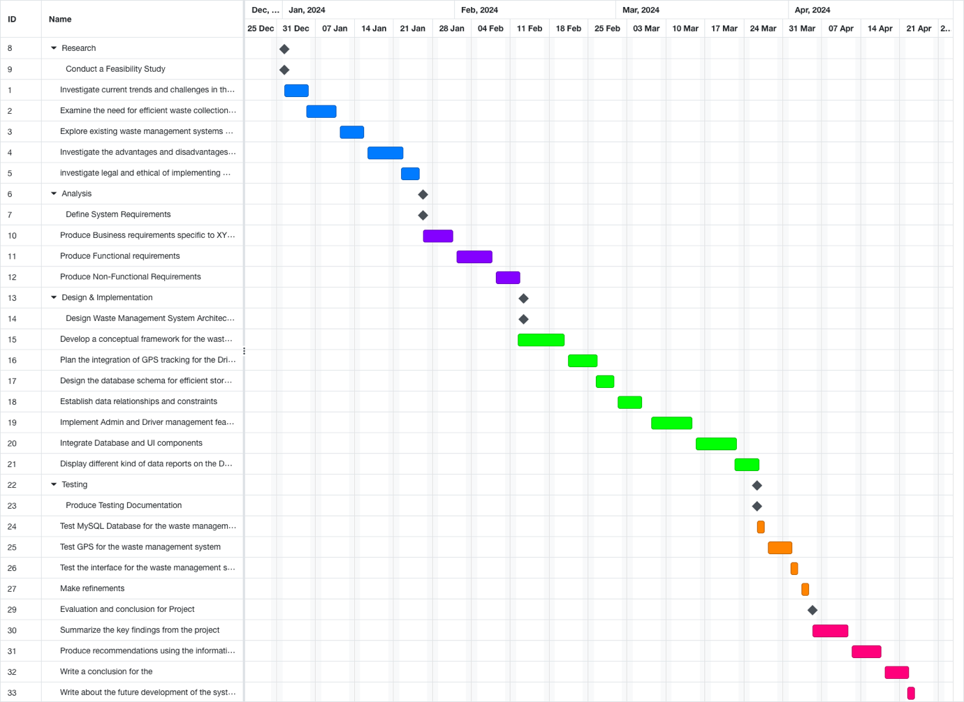

Figure

* + 1. **Gantt chart in Detail**

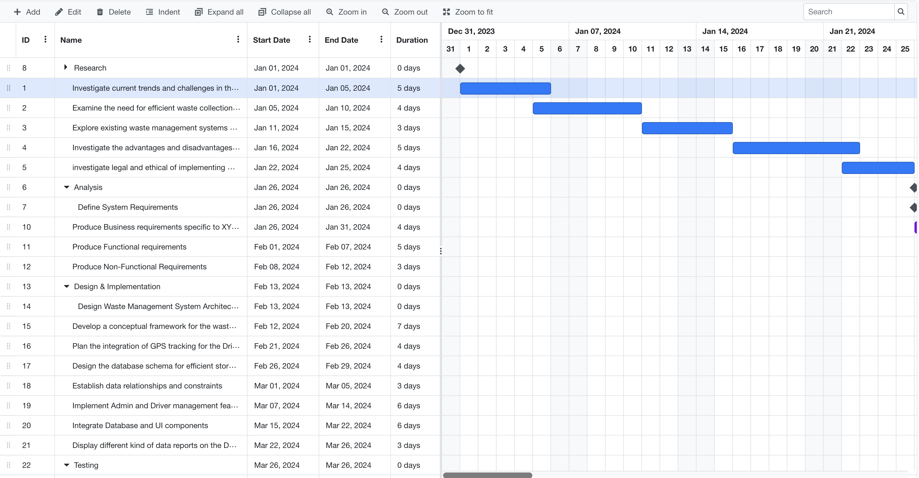

Figure

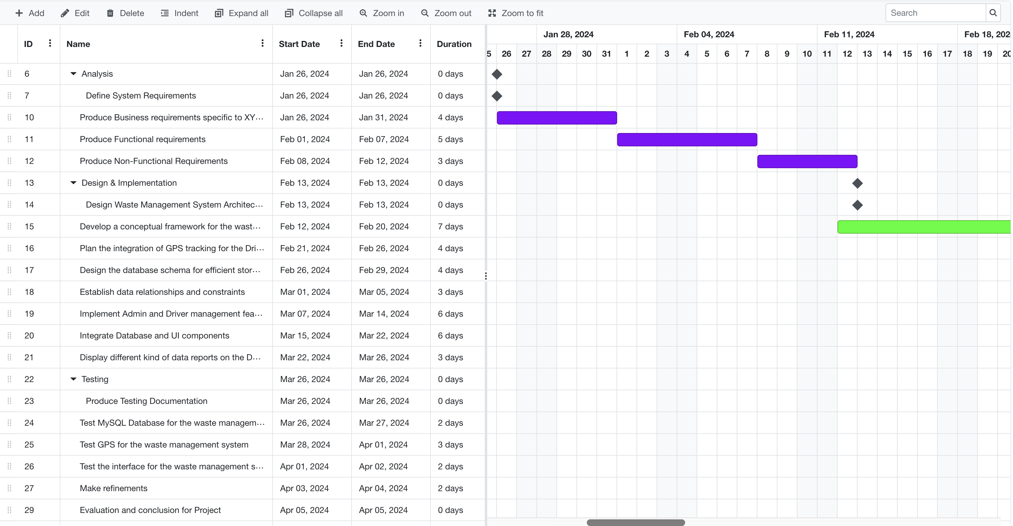

Figure

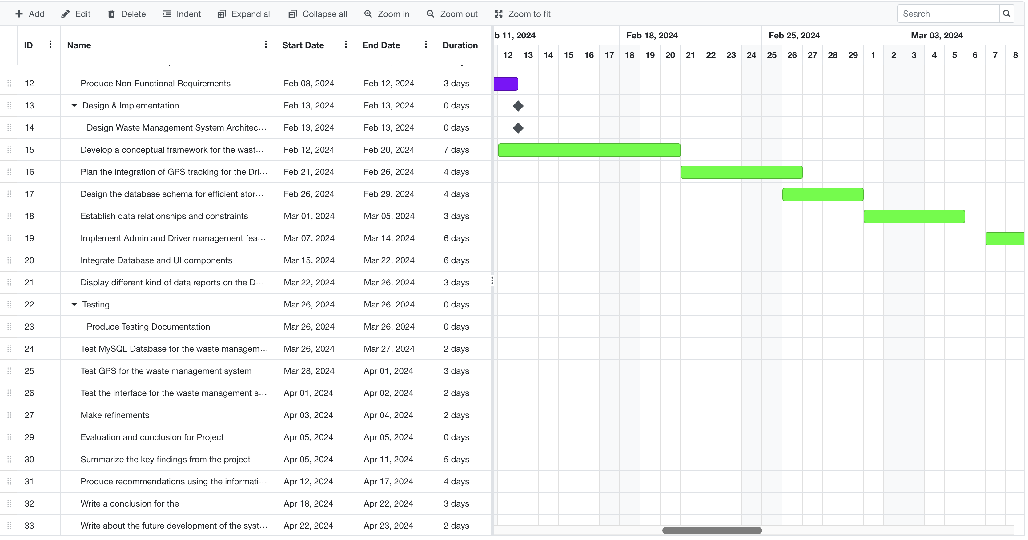

Figure

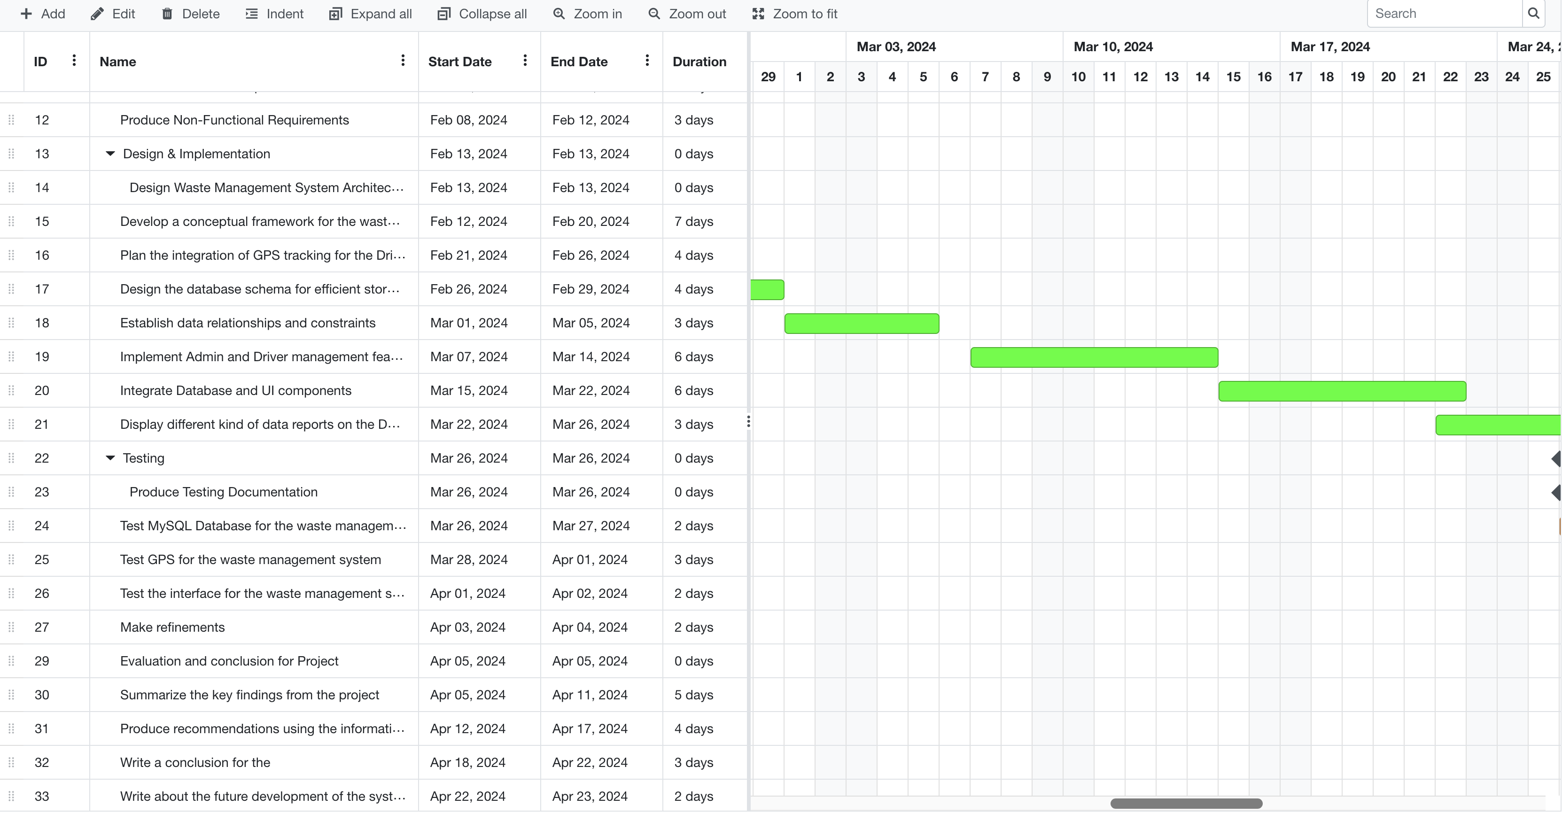

Figure

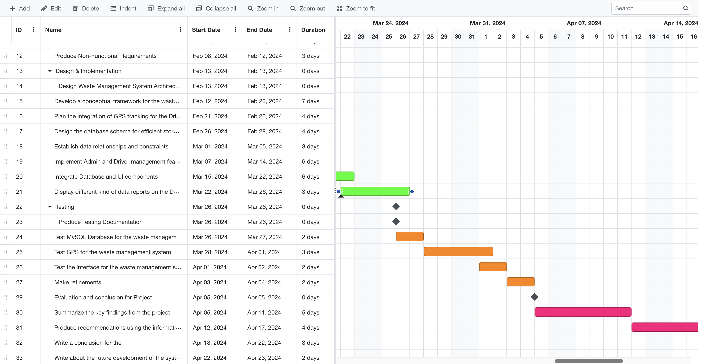

Figure

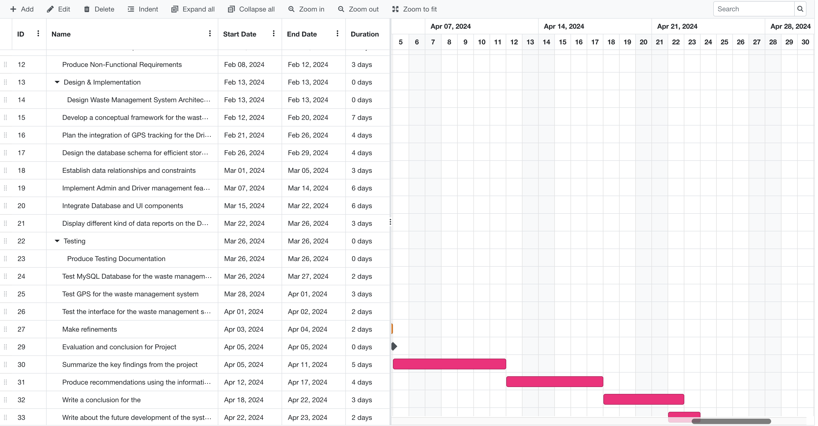

Figure

# Conclusion

The proposed system will transition Eco -Waste Solutions Limited from manual record keeping to a web-based systems in order to streamline its operations with real -time tracking and enhanced reporting / communication.

After successful developments and implementations, Eco waste solution limited will be able to overcome some its challenges which will mark a significant step towards sustainable waste management.

# References

Rivera S., G. A. (2023). Management of Software Projects in Degree Projects using an Agile Methodology. *2023 18th Iberian Conference on Information Systems and Technologies (CISTI).* Iberian : ISBN.

Sasmoko Indrianti, Y. M. (2022). Implementation of Agile Scrum Methodology in P4AI Application Development. *2022 8th International HCI and UX Conference in Indonesia (CHIuXiD) HCI and UX Conference in Indonesia (CHIuXiD), 2022 8th International.* (pp. 1:25-29). ISBN.

Raicevic, S. G. (2023). Planning Implementation of Agile and Scrum techniques in medium-sized IT companies. *2023 22nd International Symposium INFOTEH-JAHORINA (INFOTEH) INFOTEH-JAHORINA (INFOTEH), 2023 22nd International Symposium.* (pp. 1-6 ). ISBN.

Roldan, C. S. (, 2018.). *eact cookbook create dynamic web apps with React using Redux, Webpack, Node.js, and GraphQL.* Packt Publishing.

Wexler, Y. ([2019]). *Get programming with Node.js.* Shelter Island, NY: : Manning Publication Co., .