Table of Contents

**Task 1** 3

**Introduction** 3

Task2 7

**ER diagram for AMC** 7

**Data Dictionary** 7

Task3 10

Task4 12

**Task 5** 14

**Task 6** 19

Task 7 25

Task 8 27

Task 9 31

**Factors that might lead AMC theatre into data warehouse** 31

**Benefit of data warehouse to AMC theatre** 32

Task 10 32

References 33

# **Task 1**

# **Introduction**

AMC (American Multi- Cinema) is a movie theatre chain which was established in 1920 by Maurice Edward and Barney Dubinsky. AMC is the largest movie theatre chain in the world with over 353 theatres in Europe and 600 in North America. The company hosts around 200 million customers each year in its industry leading theatres which is accompanied with an amazing customer service from its employees. AMC, amongst with its parent company The Wanda Group also offer foods and drinks for the customer, all forms of payments are done at the counter.

AMC has continued to revolutionize the cinema industry with its introduction of online tickets whereby customers can make reservations to the showings of any movie they want to watch , the systems also allows AMC to scheduled their movies. Furthermore, the introduction of 3D and augmented reality technologies has enabled AMC to invest in new cinema watching experiences such as 4D seats, which immerse the customers into the movie.

AMC also offer special screening for big Hollywood studios such as Disney and Universal studios

By concentrating on its customers and offering the greatest possible movie-going experience, AMC has maintained its position as the industry leader.

**Entities**

Customers

Tickets

Reservation

Movies

Schedule

Special screening

Employees

Seats

Theatre

Payments

**Data Requirements of AMC**

Below is some of the data required by AMC;

* Booking details of all customer at AMC
* Storing details of all movies being showed at AMC

**Transaction carried out by AMC**

* Allocation of employee duties
* Adding customer booking details
* Keeping and tracking payment details
* Recording movie start and end time
* Recording movies details

**AMC theatre ticket**

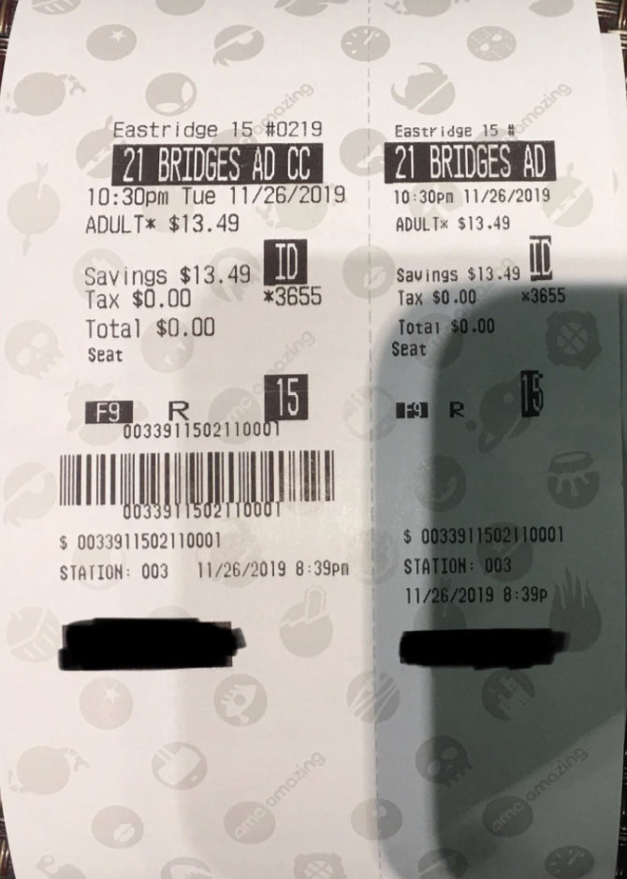

The AMC theatre ticket are issued to each customer. It contains information like;

* Movie name
* Ticket price
* Age

All which are present as entities in my database

# Task2

## **ER diagram for AMC**

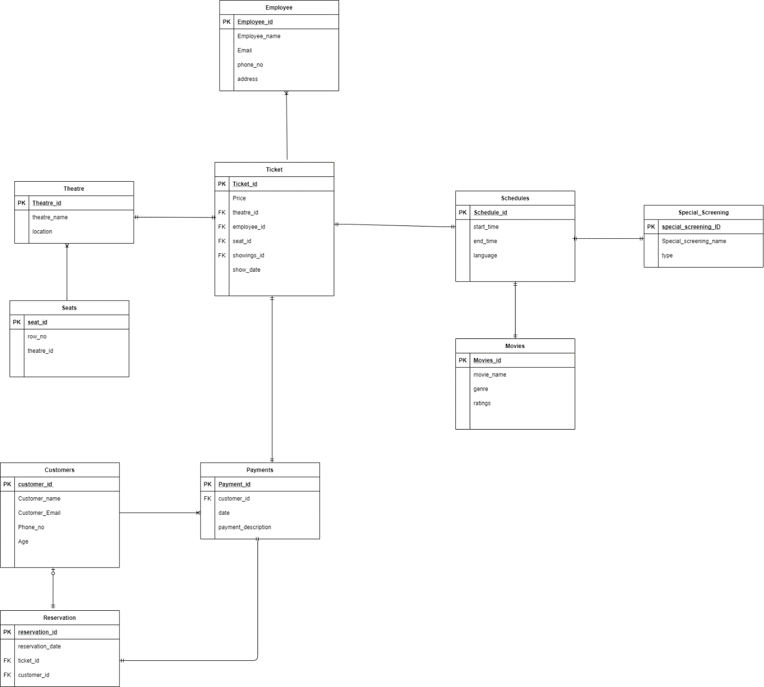

# **Data Dictionary**

**Customers**

|  |  |  |  |
| --- | --- | --- | --- |
| **Column** | **Data Type** | **Null Default** | **Default** |
| Customer_ID *(PK)* | Int(11) | No |  |
| Customer_email | Varchar(30) | Yes | Null |
| Phone_no | Varchar(30) | Yes | Null |
| Age | Varchar(30) | Yes | Null |

**Tickets**

|  |  |  |  |
| --- | --- | --- | --- |
| **Column** | **Datatype** | **Null Default** | **Default** |
| Ticket_ID *(PK)* | Int(11) | No |  |
| Price | Varchar(30) | Yes | Null |
| Theatre_ID *(FK)* | Int(11) | No |  |
| Employee_ID *(FK)* | Int(11) | No |  |
| Seat_ID *(FK)* | Int(11) | No |  |
| Showing_ID *(FK)* | Int(11) | No |  |
| Show_date | Varchar(30) | Yes | Null |

**Reservation**

|  |  |  |  |
| --- | --- | --- | --- |
| **Column** | **Datatype** | **Null Default** | **Default** |
| Reservation_ID *(PK)* | Int(11) | No |  |
| Reservation_date | Date | Yes | Null |
| Ticket_ID | Int(11) | No |  |
| Customer_ID | Int(11) | No |  |

**Movies**

|  |  |  |  |
| --- | --- | --- | --- |
| **Column** | **Datatype** | **Null Default** | **Default** |
| Movies_ID *(PK)* | Int(11) | No |  |
| Movie_name | Varchar(30) | Yes | Null |
| Genre | Varchar(30) | Yes | Null |
| Ratings | Varchar(30) | Yes | Null |

**Schedules**

|  |  |  |  |
| --- | --- | --- | --- |
| **Column** | **Datatype** | **Null Default** | **Default** |
| Schedule_ID *(PK)* | Int(11) | No |  |
| Start_time | Time | Yes | Null |
| End_time | Time | Yes | Null |
| Language | Varchar(30) | Yes | Null |

**Special screening**

|  |  |  |  |
| --- | --- | --- | --- |
| **Column** | **Datatype** | **Null Default** | **Default** |
| Special_screening_ID *(PK)* | Int(11) | No |  |
| SS_Name | Varchar(30) | Yes | Null |
| Type | Varchar(30) | Yes | Null |

**Employees**

|  |  |  |  |
| --- | --- | --- | --- |
| **Column** | **Datatype** | **Null Default** | **Default** |
| Employee_ID *(PK)* | Int(11) | No |  |
| Employee_name | Varchar(30) | Yes | Null |
| Email | Varchar(30) | Yes | Null |
| Phone_no | Varchar(30) | Yes | Null |
| Address | Varchar(30) | Yes | Null |

**Seats**

|  |  |  |  |
| --- | --- | --- | --- |
| **Column** | **Datatype** | **Null Default** | **Default** |
| Seat_ID *(PK)* | Int(11) | No |  |
| Row_no | Varchar(30) | Yes | Null |
| Theatre_ID *(FK)* | Int(11) | No |  |

**Theatre**

|  |  |  |  |
| --- | --- | --- | --- |
| **Column** | **Datatype** | **Null Default** | **Default** |
| Theatre_ID *(PK)* | Int(11) | No |  |
| Theatre_name | Varchar(30) | Yes | Null |
| Location | Varchar(30) | Yes | Null |

**Payments**

|  |  |  |  |
| --- | --- | --- | --- |
| **Column** | **Datatype** | **Null Default** | **Default** |
| Payment_ID *(PK)* | Int(11) | No |  |
| Customer_ID *(FK)* | Int(11) | No |  |
| Date | Date | Yes | Null |
| Payment_desc | Varchar(30) | Yes | Null |

# Task3

Normalization is a database technique used to reduce data redundancy and improve data integrity. This is important because, it removes anomalies that make a database inconsistent and ensures only related data is stored in each table of the database.

1. 1st Normalization form (1NF) – The goal of this stage is to place all repeating fields into separate files and assign appropriate keys. All the entities listed previously are in the 1NF because;

* Each table has a primary key
* No single column has more than one value
* All non-primary key elements are dependent on the primary key

1. 2nd Normalization form (2NF)- In this stage, all non-key elements, that are fully specified by something other than the complete keys are placed in a separate table. These non-key elements are normally dependent. All the entities listed previously are in the 2NF because;

* The tables complies with the 1NF (1st normalization table)
* All composite key’s qualities affect non-primary key attributes

1. 3rd Normalization form (3NF) – This stage enables for the eliminating redundant data elements and tables that are subsets of other tables. All the entities listed previously are in the 2NF because;

* The tables complies with the 2NF (2nd normalization table)
* An entry in one key column does not affect any of the nonprimary key attributes in a row.

**How normalisation is used to check tables are well-structured**

By ensuring that each table meets the criteria for "well-formed relational structures" normalization aims to achieve the following results:

* Every table depicts a single entity
* No unnecessarily repetition of data items.
* All nonprimary key element are functionally dependent on the primary key
* No insertion, update, or delete irregularities exist in any of the tables.
* Elimination of repeating data

**how normalisation solves the problem of update anomalies**

When data in a single row of a table is modified, and it becomes incompatible with its identical data in another row, as a result of this an update anomaly has occurred.

“For example, if an **Employee** changes **address**, AMC would have to update all rows referring to that address.”

Normalization solves this problem by breaking down tables to remove anomalies and redundant data. The data is organized such that, there are no unnecessary duplicates and that it is easy to find all relevant information. Data is transformed into tabular form using a multi-step procedure that also purges relational tables of redundant data and anomalies.

# Task4

**Evalaution on how the database met the data requirements and possible transactions of AMC Theatre**

1. The database will allow AMC keep records on its employees and customers
2. The database will allow AMC to keep track of payments
3. Booking details of all customer at AMC
4. Storing details of all movies being showed at AMC

**how the logical and physical design processes have been implemented**

|  |  |
| --- | --- |
| **Logical design** | **Physical Design** |
| The AMC theatre database is made with a specific goal in mind, such as;   1. Meeting AMC transaction requirements      1. Identifying entities, attributes and the relationships between then 2. ER diagram   Such information is used in the initial stage of the logical design representing the task that will be performed with the database and also structures the database | From the logical design ,it provides a data model implementation tailored for AMC theatre physical design. This being the;   1. Primary key and foreign key 2. Datatypes ,lengths assigned and default values 3. Tables and columns   It is employed to depict the underlying logical structure of the databases and data files. |

**logical database design to physical design mapping**

* Entities are converted into tables
* Attributes are converted into columns
* creating data types and constraints from domains

**How tables have been designed for AMC database**

The database tables of AMC theatre are designed by the following process;

1. Finding the purpose of the database- for AMC the purpose of its database is to keep records of its processes
2. Gather information on AMC - All kinds of information about AMC theatre is gather for the next step
3. The information gathered is separated into entities such as employees, tickets etc.
4. The entities are now given attributes. Each attribute is converted to a field and shown as a column in the table.
5. Each table is given a primary key and appropriate foreign key
6. If more information is needed to understand the relationships between the tables, more fields are added to the tables or new once are made.
7. Lastly the normalization rules is used to ensure all the tables are appropriate.

**Identified derived data**

To provide fresh insights, existing data points are transformed to produce derived data. For example combining Ticket sales data to customer data .

**Represented below**

Select tickets.ticket_id, customers.id, customers.age

From tickets

Inner join customers

On tickets.ticket_id =customers.customer_id

Order by age;

# **Task 5**

**SQL Queries for creating tables ;**

* **Customers**

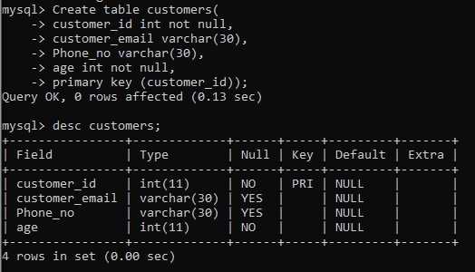

* **Tickets**

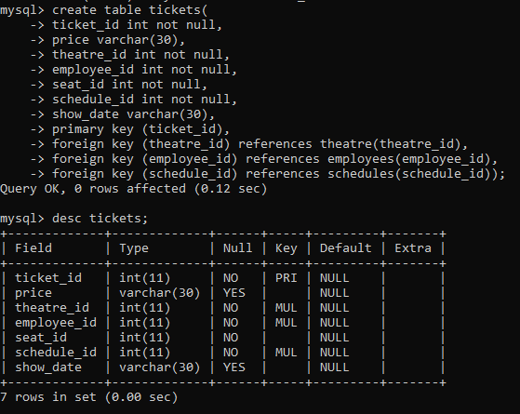

* **Reservation**

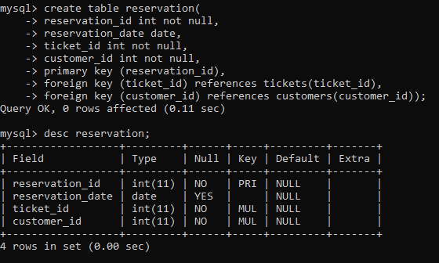

* **Movies**

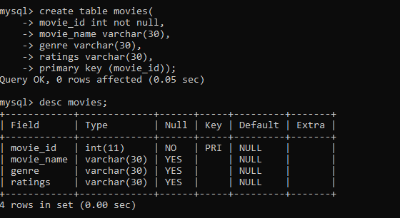

* **Schedules**

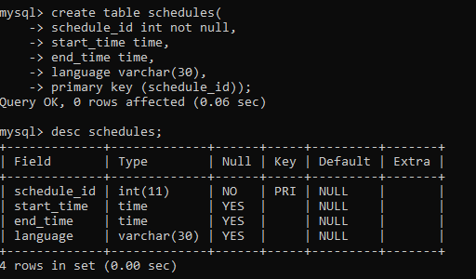

* **Special screening**

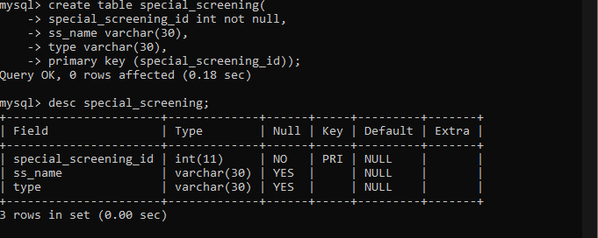

* **Employees**

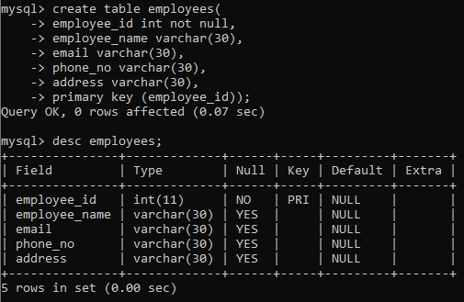

* **Seats**

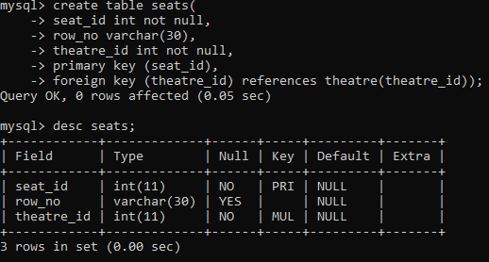

* **Theatre**

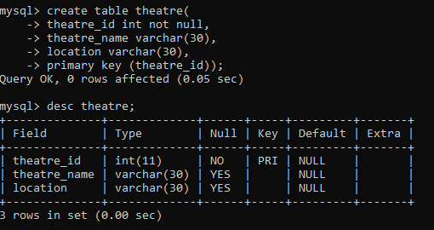

* **Payments**

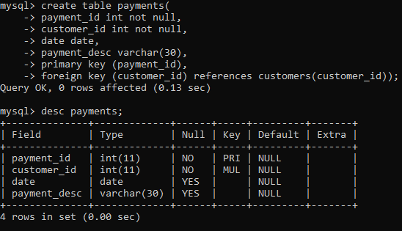

# **Task 6**

* **Customers**

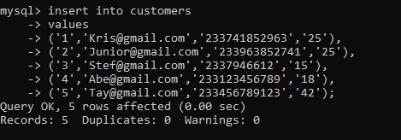

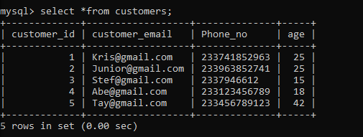

* **Tickets**

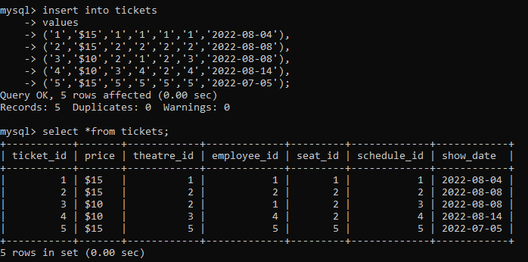

* **Reservation**

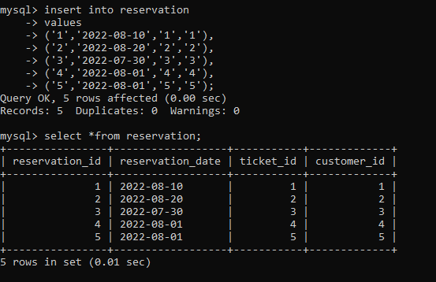

* **Movies**

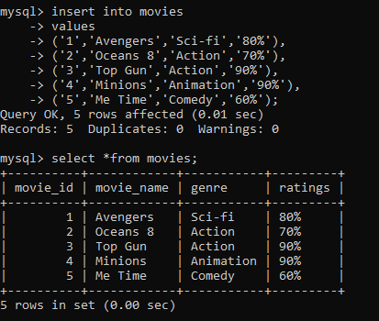

* **Schedule**

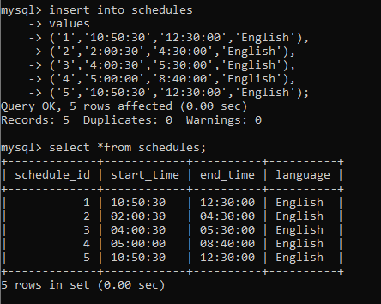

* **Special screening**

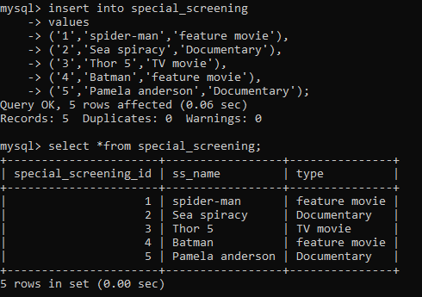

* **Employees**

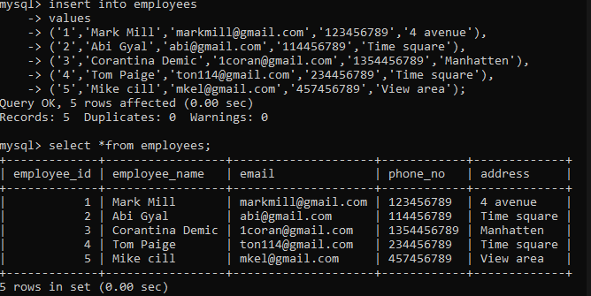

* **Seats**

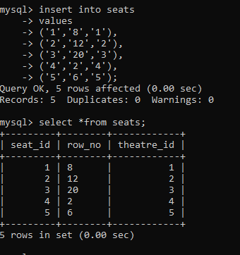

* **Theatre**

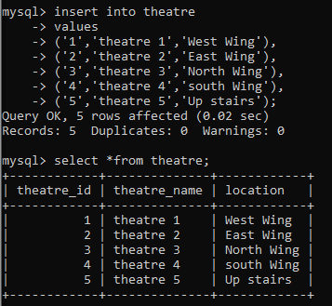

* **Payments**

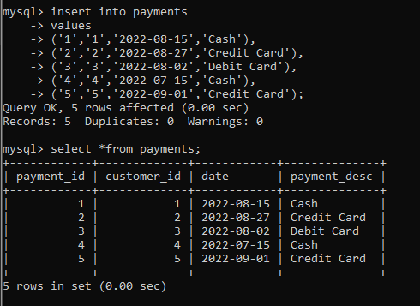

# Task 7

**Potential Change that could be implemented into AMC theatre database;**

As the Covid-19 vaccination are being administrated to the public, AMC should be able to keep track of which customers are vaccinated and which ones are not, so as to not further spread the virus. As a result of this, vaccinated customers can enjoy the theatre without a mask and unvaccinated will have to proceed with a mask. By Adding an extra column to the customers table in the AMC database, they will be able to keep records of Vaccinated and unvaccinated customers.

**Rationale**

Adding a ‘**Vaccination**’ column to the customers table will enable AMC to easily categorize their vaccinated and unvaccinated customers in the database of AMC and also for their safety.

**Demonstration**

using the **alter** command to change the initial database tables

**Alter Table** customers

Add **vaccination** varchar(30);

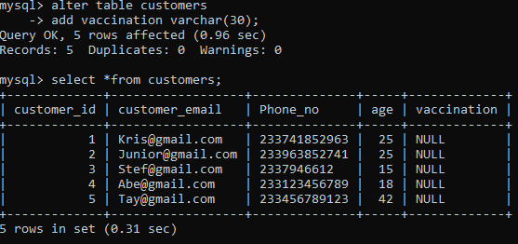

**Inserting a values into the new altered database table**

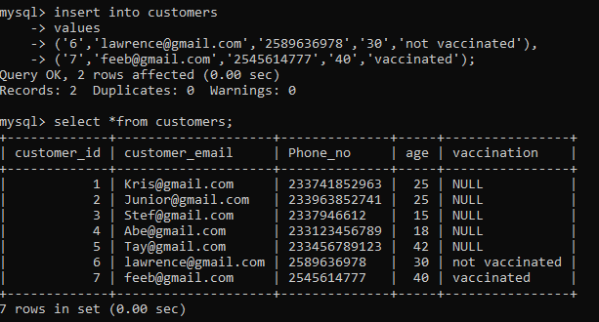

# Task 8

1. **Inner Join**

It compares 2 tables rows to see if any of them fit the condition specified in the ‘ON’ clause.

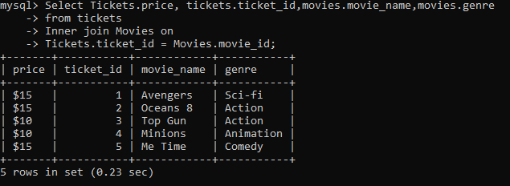

1. **Having syntax**

The results can be filtered by conditions you set to determine which group results are displayed.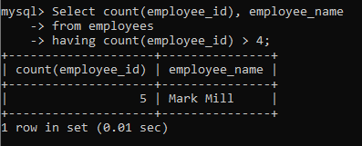

1. **When , Then, Else (Case expression)**

It evaluates each condition in turn before stopping at the first one that is satisfied.

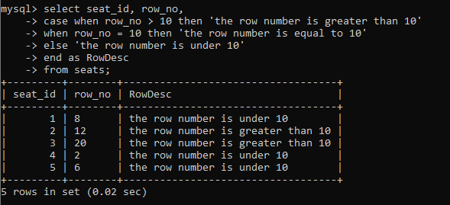

1. **‘%’ wildcard**

When changing one or more characters in a string, a wildcard character is utilized.

It is often used with the ‘LIKE’ operator,

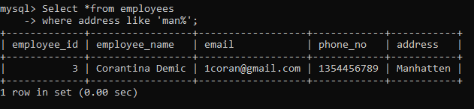

1. **Exists**

is employed to check whether any record in a subquery exists. If the subquery produces one or more records, the ‘EXISTS’ operator returns TRUE.

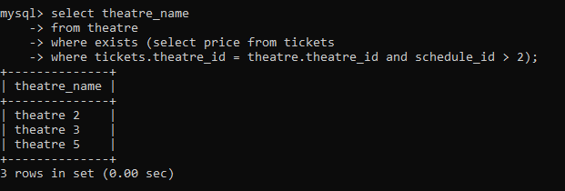

1. **Limit**

**It is used to determine how many records to return, use the LIMIT clause.**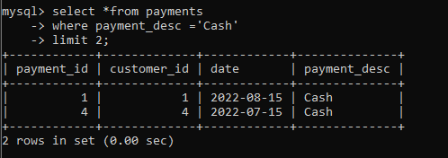

1. **Left join**

links two tables and retrieves data based on a condition that matches in both tables.

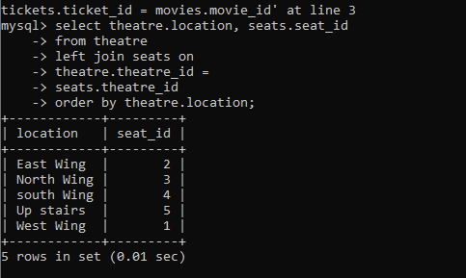

1. **Count**

enables you to count both rows and just the rows that match a certain condition.

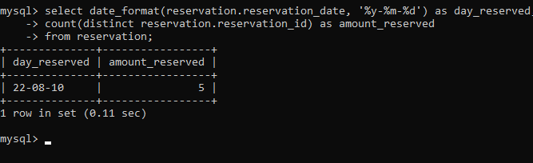

1. **Avg, Min, Sum**

When a table field is selected, the ‘**MIN**’ function returns the value that is the lowest.

‘**SUM**’,returns the total of all the values in the chosen column

‘ **AVG**’ computes the average of the values in a given column.

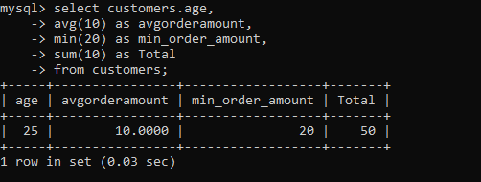

1. **Min, Max**

In contrast to the ‘MIN’ function, there is the MAX function,the greatest value from the selected table field is returned.

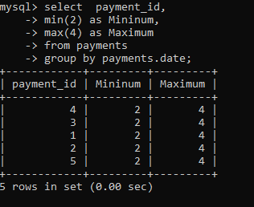

# Task 9

**Factors that might lead AMC theatre into data warehouse**

* **Scalability** – This is an important fact, that can determine AMC theatre’s financial feasibility in the near future. Cloud data warehouse will enable AMC theatre to scale up depending on how much computing is required. Because of how large and multi-national AMC is, scalability is one of its prime concern and a data warehouse will be able to handle the typical large data shift.
* **Easy accessibility and speed** – This is a crucial factor that can determine how information can be retrieved from the database for the operations of AMC. A data warehouse will be able to store large amounts of data and still be fast and reliable (Sarad, 2022).
* **Capabilities and technology –**  Data warehouse will enable AMC theatre seamlessly integrate data. As a result of this, all AMC branch can all use the same cloud data warehouse instead of independent localized databases. Furthermore, some extra features that comes with a data warehouse like pushdown optimization and data profiling will significantly boost the capabilities of AMC theatre (DATAVERSITY, 2021).

**Benefit of data warehouse to AMC theatre**

* **Enhances Efficiency** - By making this data easily accessible and in the right format, a data warehouse will increase the effectiveness of the entire data analysing procedure for AMC theatre.
* **Increased performance** - A data warehouse is designed to manage enormous amounts of data and several complicated queries. As a result of this time and money is saved because they won't squander time gathering information from various sources.
* **Intellectual insight** - By outlining all the major performance trends in AMC’s database, a data warehouse may provide context for this past data. As a result of this, AMC theatre would be able to make future predictions for the benefit of the company (Lakey, 2022).

# Task 10

A critical evaluation of what I’ve learnt using the Rolfe D model

**What**(Description)

Considering all the factors for this, I was required to demonstrate my understanding of this model by producing a database for a company of my choosing. My chosen company ‘AMC theatre’ is theatre chain company. An example of the type of data it holds are; customers, payments and tickets. Some of its transactions are; Recording movies details and Keeping and tracking payment details.

Information was gathered from multi- sources to identify its data, transactions and entities. Furthermore, an ER diagram was produced to structure how the database will be designed and finally, data was inputted into the created database.

**So What**(Analysis)

An analysis on AMC theatre is that its database transaction enables it to carry out and group tasks that permit precise data recovery in the event of system failures and to offer separation between various programs that might attempt to access the data concurrently.

**Now What**(Action plan)

AMC theatre is still growing and expanding into more countries across the world, the best course of action is to have cloud data warehouse that will be able to keep up with the demand and still be fast and reliable.

# References

DATAVERSITY, 2021. *DATAVERSITY.* [Online]   
Available at: https://www.dataversity.net/5-critical-factors-to-consider-when-choosing-a-data-warehouse-solution/  
[Accessed 12 9 2022].

Lakey, E., 2022. *The TIBCO Blog.* [Online]   
Available at: https://www.tibco.com/blog/2022/06/02/top-5-benefits-of-a-data-warehouse-for-your-data-driven-organization/  
[Accessed 12 9 2022].

Sarad, 2022. *Hevo Blog - Transformative ideas and real insights on all things Data.* [Online]   
Available at: https://hevodata.com/blog/data-warehouse-best-practices/  
[Accessed 12 9 2022].