Anisotropic Perez model with terms: Beam, isotropic diffuse, circumsolar diffuse, horizon diffuse, ground reflection

$$I_{T}=I_{b}R_{b}+I_{d}\left(1-F1\right)\left(\frac{1+\cos{β}}{2}\right)+I_{d}F_{1}\frac{a}{b}+I_{d}F_{2}\sin{β}+Iρ_{g}\left(\frac{1-\cos{β}}{2}\right) \left[2.16.14\right]$$

Where:

* $R_{b}=\frac{G_{b,T}}{G_{b}}=\frac{\cos{θ}}{\cos{θ_{z}}} \left[1.8.1\right]$ v
* $a=\max\left(0,\cos{θ}\right), b=\max\left(\cos{85},\cos{θ_{z}}\right) \left[2.16.9\right]$ v
* $ε=\frac{\frac{I_{d}+I_{b,n}}{I_{d}}+5.535*{10}^{-6}θ_{z}^{3}}{1+5.535*{10}^{-6}θ_{z}^{3}} \left[2.16.10\right]$ v
* $Δ=m\frac{I_{d}}{I_{on}} \left[2.16.11\right]$ v
* $F_{1}=\max\left[0,\left(f_{11}+f_{12}Δ+\frac{πθ_{z}}{180}f_{13}\right)\right] \left[2.16.12\right]$ v
* $F_{2}=\left(f_{21}+f_{22}Δ+\frac{πθ_{z}}{180}f_{23}\right) \left[2.16.13\right]$ v
* $θ={\cos\left(\cos{θ_{z}}\cos{β}+\sin{θ_{z}}\sin{β}\cos\left(γ_{s}-γ\right) \right)}^{-1}$ [1.6.3]v

And:

* $I_{b}$ = beam component radiation
* $I_{d}$ = diffuse component radiation
* $I$ = total radiation

$ρ_{g}$\*
* = ground reflection component (depends on state of ground, snow ~ 0.7 normal ~0.2-0.3)
* $I_{on}$ = Extraterrestial radiation incident on horizontal plane

$m$\*
* = air mass ratio, the ratio between $θ_{z}=0$ and current $θ_{z}$

$θ$\*
* = angle between beam and normal to surface

$θ_{z}$\*
* = zenith angle

$β$ \*
* = angle between plane in question and horizontal surface.
* $γ$ = deviation from local meridian
* $γ_{s}$ = solar azimuth angle\*

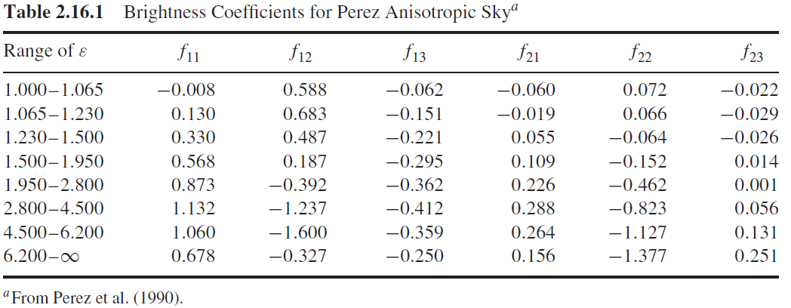

\*Methods are supplied within Pysolar to calculate indicated variables.

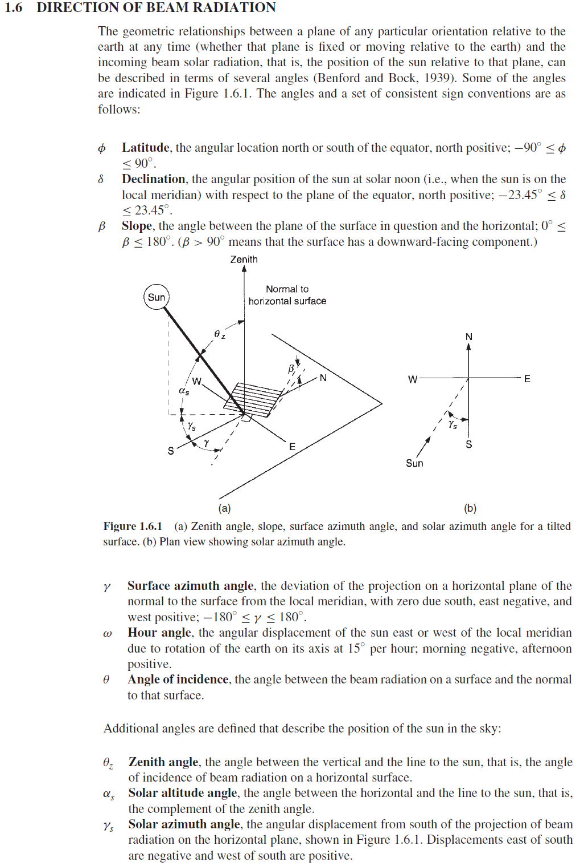

Standard $ρ_{g}→$

0 , 1, 2, 3, 4, 5, 6, 7, 8, 9, 10, 11, 12

0.7, 0.7,0.4, 0.2, 0.2, 0.2, 0.2, 0.2, 0.2, 0.4, 0.7,