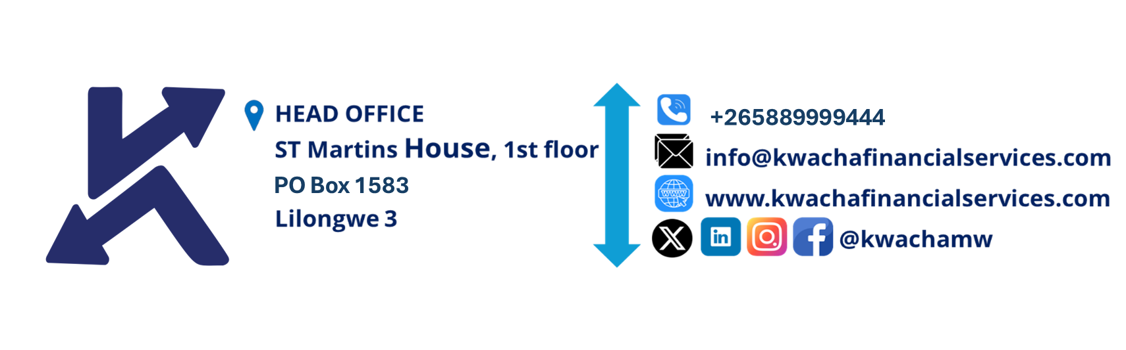

­**NOTICE OF CONVENING THE FIRST MEETING OF THE BOARD OF DIRECTORS OF KWACHA ACCESS FINANCE LIMITED**

TAKE NOTICE that the first meeting of the Board of Directors of Kwacha Access Finance Limited will be held **VIRTUALLY** on Thursday 24 July 2025 from 18:00 hours for the purpose of transacting the following business:

AGENDA

1. Opening Remarks
2. Governance Matters

* Quorum
* Apologies
* Declaration of Interest
* Review and Adoption of the Agenda

1. Board Chair, Committee Assignments and Chairperson Appointments
2. Board Charter, Chart of Authority
3. Company Vision and Non Negotiables
4. Traction and Performance Snapshot
5. Date of Next Meeting and Closure

By Order of the Board

Company Secretary