System Architecture and Integration
FINAL PROJECT PROPOSAL
PickleBook: A Containerized Court Reservation System
with Automated CI/CD using Docker and Jenkins
Group: Team PickleBook
Course / Section: ______________________________
Group Members
Corpuz, Jirek K.
De Guzman, Francis Jeremiah A.
Fajardo, Margaret Anne O.
Imperial, Tyrone Ralf R.
Verona, Francis Charles P.

1. Group and Project Information
Item | Details
Group name | Team PickleBook
Project title | PickleBook: A Containerized Court Reservation System with Automated CI/CD
Short description | PickleBook is a web-based reservation system for a pickleball facility. Players view the available courts and their hourly rates, then book a court for a date and time slot. The system prevents double booking and automatically computes the price, with peak hours (5:00 PM onwards) charged 20% more.  Staff can confirm, complete, or cancel reservations, add new courts, and view a summary of bookings and revenue. The application is split into five containers behind one Nginx reverse proxy. A Jenkins pipeline automatically tests, builds, and deploys every change pushed to GitHub.
Repository URL | https://github.com/________________/picklebook
Project Lead / Scrum Master | De Guzman, Francis Jeremiah A.
DevOps / CI-CD Engineer | Corpuz, Jirek K.
Infrastructure Engineer | Fajardo, Margaret Anne O.
Backend and Database Engineer | Imperial, Tyrone Ralf R.
Frontend, QA, and Documentation Lead | Verona, Francis Charles P.

Role Responsibilities
Member | Role | Owns These Deliverables
De Guzman, Francis Jeremiah A. | Project Lead / Scrum Master | Project proposal, task board and timeline, Git repository management (branches, pull requests), final demo flow, contribution log
Corpuz, Jirek K. | DevOps / CI-CD Engineer | Jenkins in Docker (infra/jenkins), plugins and credentials, Poll SCM trigger, Jenkinsfile and rollback pipeline
Fajardo, Margaret Anne O. | Infrastructure Engineer | Architecture diagram, Dockerfiles, docker-compose.yml, Nginx reverse proxy, networks, volumes, health checks
Imperial, Tyrone Ralf R. | Backend and Database Engineer | courts-api and reservations-api, PostgreSQL schema and seed data (init.sql), automated unit tests
Verona, Francis Charles P. | Frontend, QA, and Documentation Lead | Frontend module, smoke test script, README, technical documentation, presentation slides

2. Modules, Containers, and Technology Stack
Module / Container | Technology | Purpose | Justification
proxy | Nginx 1.28 (nginx-unprivileged, Alpine) | Single public entry point on port 8080. Routes / to frontend, /api/courts to courts-api, /api/reservations to reservations-api. | Industry-standard reverse proxy with a tiny Alpine image and simple path-based routing. The unprivileged image runs as a non-root user.
frontend | Static HTML, CSS, JavaScript served by Nginx | Booking form, court list, reservation board with status actions, staff "add court" form. Shows the current build number. | No build step or framework needed, so the image is small and fast to build. The build number is injected at image build time to prove which version is deployed.
courts-api | Node.js 22 + Express | REST API for courts: list, get by id, create, update (rate, surface, availability). GET /health. | One language (JavaScript) across the whole group, so every member can read, test, and explain all modules. Express is lightweight and quick to build REST APIs with.
reservations-api | Node.js 22 + Express | Creates reservations, blocks overlapping bookings, computes totals with peak pricing, manages status (pending → confirmed → completed / cancelled), summary report. GET /health. | Same stack as courts-api for consistency. Business rules are pure functions, making them easy to unit test with Jest.
db | PostgreSQL 16 (Alpine) | Stores the courts and reservations tables. Data kept in the named volume pg-data. Port not published. | Our data is relational (a reservation belongs to a court), so we use foreign keys and CHECK constraints. The official image has a built-in pg_isready health check.
jenkins (separate compose) | Jenkins LTS (JDK 21) + Docker CLI | CI/CD server at localhost:8081. Runs the pipeline and controls Docker through the host socket. | Required by the project. Kept in its own compose file so the pipeline never redeploys Jenkins itself.

Notes
- Three application modules written by the group (frontend, courts-api, reservations-api), each in its own container, plus a reverse proxy and a database.
- Testing: Jest and Supertest (API tests with a fake database; no real database needed), run inside Docker through a multi-stage "test" target.
- Configuration: environment variables from a .env file (not committed); .env.example with placeholder values is committed; Jenkins stores the real .env as a Secret file credential.

3. Pipeline Plan
Pipeline Plan | Details
Git hosting | GitHub (one shared repository, main branch deploys; members work on feature branches and merge through pull requests)
Trigger (webhook / polling) | Poll SCM every minute (pollSCM('* * * * *') in the Jenkinsfile). Jenkins checks GitHub for new commits and builds automatically, with no manual "Build Now".  Reason: Jenkins runs on a laptop with no public URL, so polling works on any network. A GitHub webhook through ngrok is an optional upgrade for instant builds.
Planned stages | 1. Checkout: get the pushed commit from GitHub.  2. Test: docker build --target test for both APIs. A failing test stops the pipeline before Deploy (quality gate).  3. Build Images: docker compose build; every image tagged with the Jenkins build number (picklebook/<service>:<BUILD_NUMBER>).  4. Deploy: copy .env from Jenkins Credentials, then docker compose up -d --no-build. The database volume is preserved.  5. Smoke Test: through the proxy, check both /health endpoints (including database connectivity) and that the new build number is live.  post: report the result, archive a deployment report, and always delete the .env file.
Tests to be run | courts-api: health endpoint (200 / 503), list and filter courts, get by id (404), create (201, 400 validation, 409 duplicate), partial update.  reservations-api: price computation with peak hours, overlap detection, allowed status transitions, date and time validation, booking creation (201), double-booking rejection (409), summary report.  Smoke test (scripts/smoke-test.sh): health of both APIs and the deployed build number, checked through the reverse proxy.
Planned bonus features (optional) | Parameterized Jenkins rollback job (Jenkinsfile.rollback) that redeploys any earlier build number.  Automatic rollback to the last successful build if the post-deploy smoke test fails.  Network segmentation: the database is on an internal backend network reachable only by the two APIs.  Non-root containers with HEALTHCHECK for every module we wrote.

4. Draft Architecture Diagram
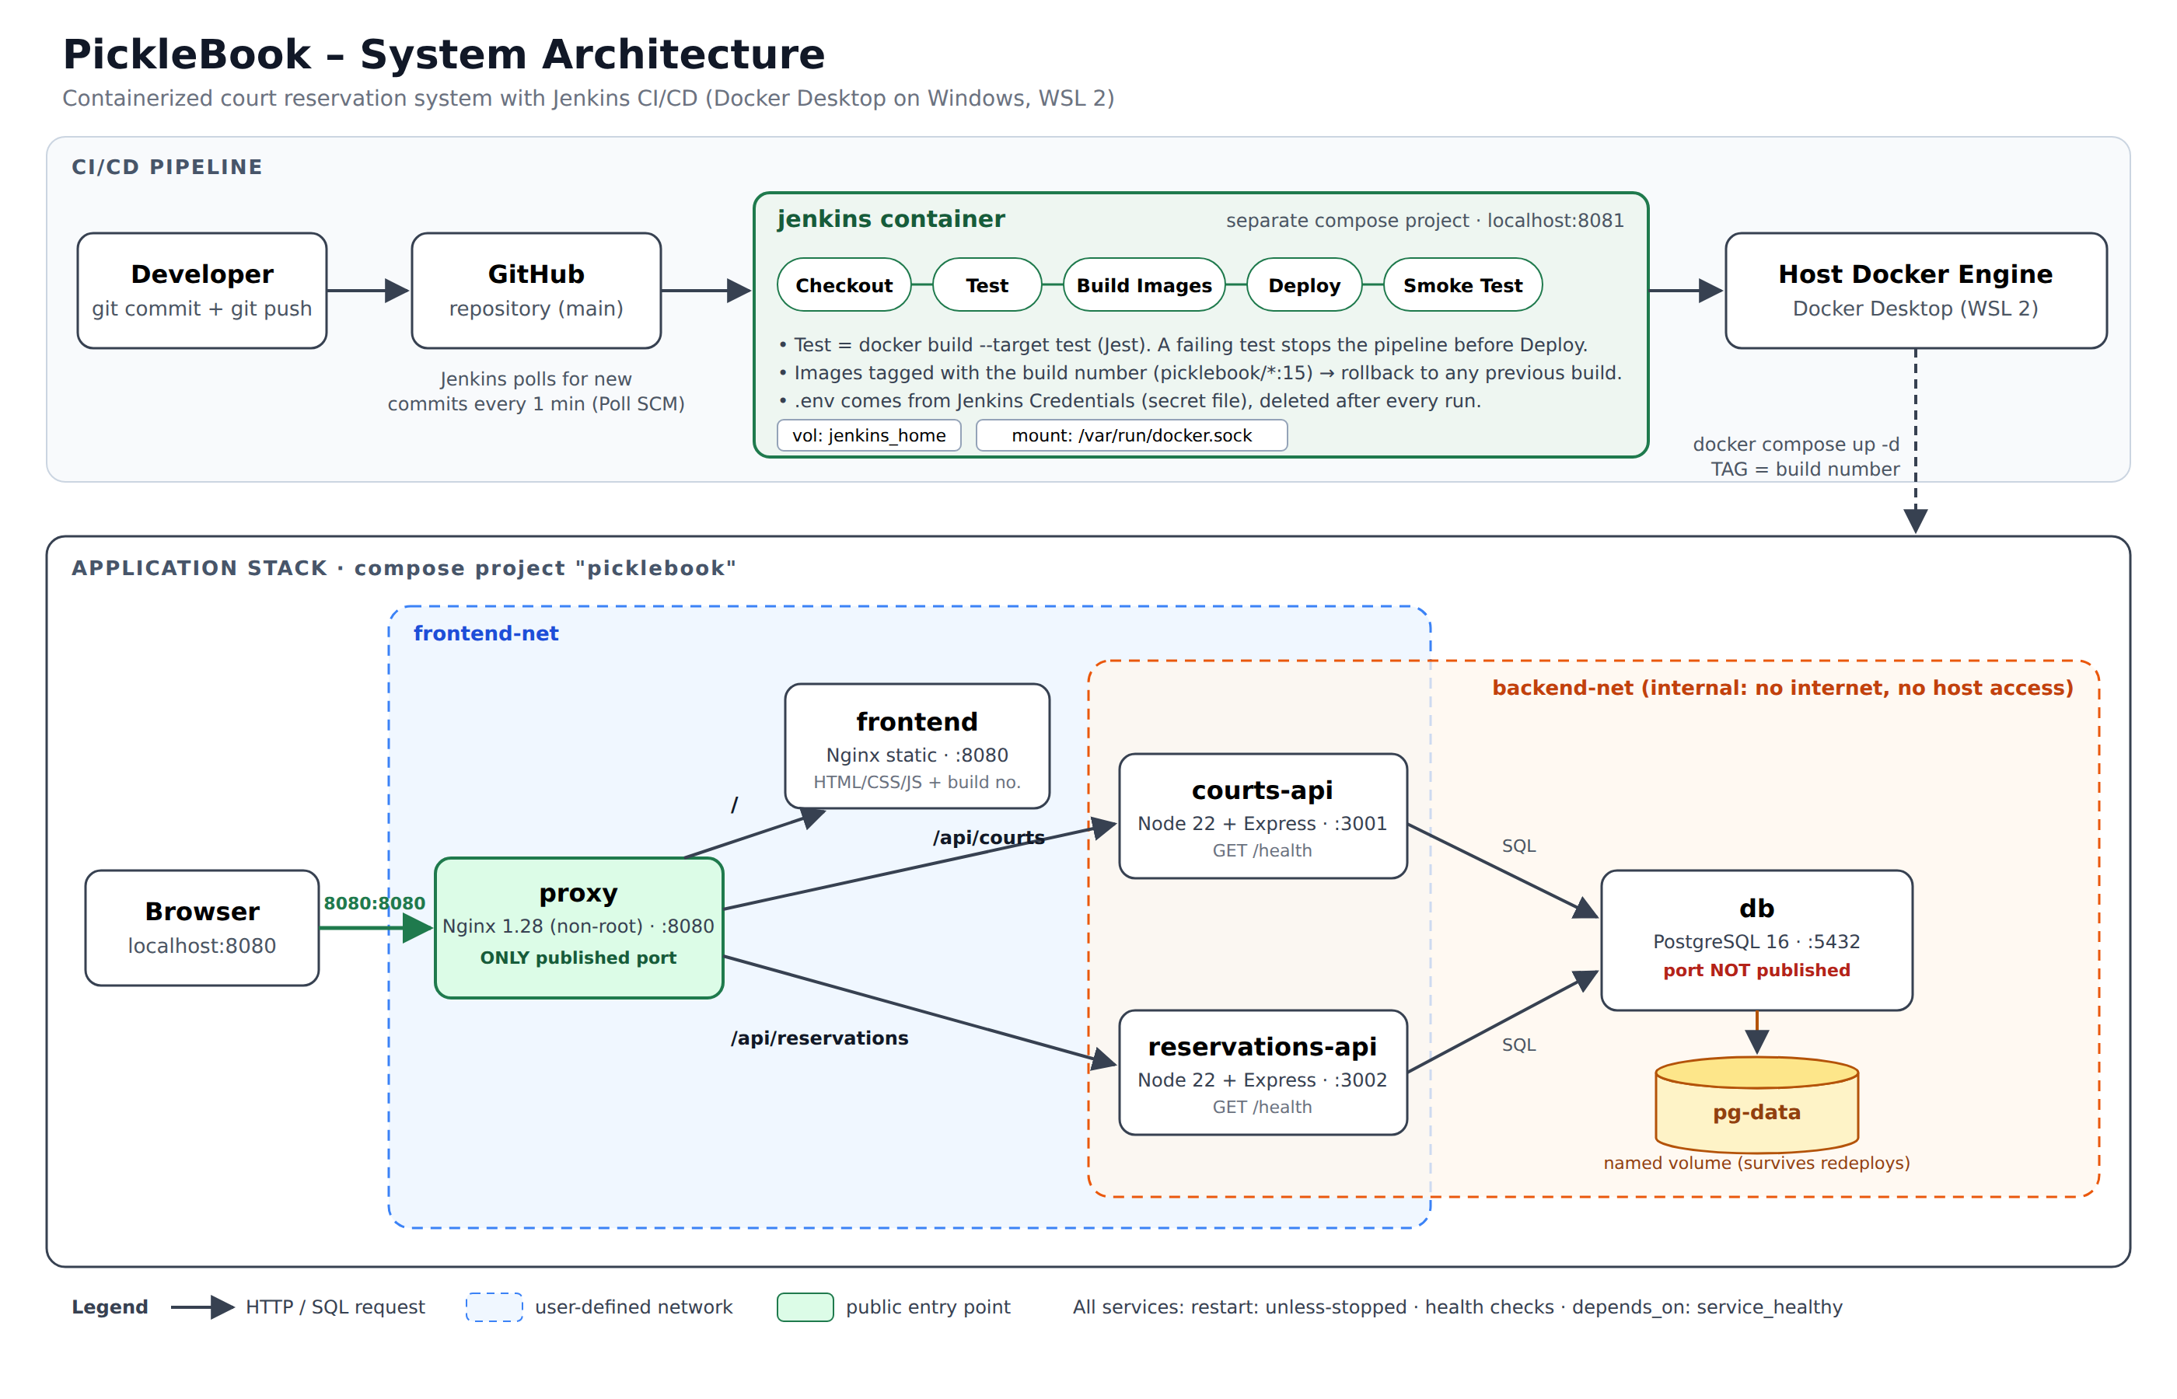

Request Flow
- The browser opens http://localhost:8080. Only the proxy container publishes a port.
- The proxy forwards / to the frontend, /api/courts to courts-api, and /api/reservations to reservations-api over the user-defined network frontend-net.
- Both APIs read and write PostgreSQL over backend-net, an internal network. The database is not reachable from the proxy, the frontend, or the host.
- Database data lives in the named volume pg-data, so it survives container restarts, redeployments, and rollbacks.

Deployment Flow
- A member pushes to GitHub. Jenkins detects the new commit (Poll SCM) and runs Checkout, Test, Build Images, Deploy, and Smoke Test.
- Jenkins uses the Docker CLI through the mounted host socket to build images and run docker compose. This is acceptable in a lab; for production we would use dedicated build agents, rootless Docker, or Kaniko.

