

Personal information
  - how developers prevent personal infromation leaking
곽민석 | 상승p47 3번 | 10301

personal information leaking
There are two kinds of personal information leaking. One is corporations like facebook and google lending to government and the other is leaking by hakers. The first one was introduced in the book, so I will introduce the second one today.

How system worked before 2014
Lets suppose there is a web like Facebook, Facebook is a huge company, so they always make their copy code in case of emergency. when emergency occurs, the copied code will revive the original. Before this emergency happeneds, developers make a safety device called “watch dog”

Watch dog
Watch dog is a safety system that askes to the program that if its ok. Before talking about watch dog, there is a thing that you should know. The computer designate the files as number. Lets suppose that there is a red carpet selling in the website, we call it red carpet, but the computer remembers it like “(redcarpet,5)” This means that computer knows the red carpet as ‘number 5’ they save the code with (name,number). Now back the top, the watch dog will send a ramdom message with one of the codes already specified in the program. Like (red carpet,5). If the program is not attacked and stay still, the program will retransmit to the sender that they are ok. This asking will last until the programs are down, and this is called heart beat.

Heart beat
Heart beats are similar as the meaning of the word, It describes watchdog and program sending message each other as beating. But when the programs are down, we call it “Heart bleed”. Cause there will be no more beats the transmit.

how Hakers break the program
I first thought it was hard but, until 2014, nobody knew that it a simple message will break the code.

Step1
Hakers send the message to the program as if they are watch dog, like (red carpet,100). Did you notice? The name was still same but the number have changed. It means that it’s a wrong code, a code that doesn’t exist in the program.

Step2
After sending false message, the program know the code was wrong. but transmit back to the hacker, not the message that they are ok, but as a number. Hackers replaced the number 5 with 100 to create that much free space, and between that empty space, they can find the key to breaking the program. The keys were in every names so, if they know one of the name is the program, the games over.

examples
This was a big issue in 2014, the Korean web site “YAHOO” was hacked in the same way and 500 million personal information was stolen. “YAHOO” tired to hide but they then admitted that this kind of hack was the thing they haven’t expected.

solutuon

Adding knew program
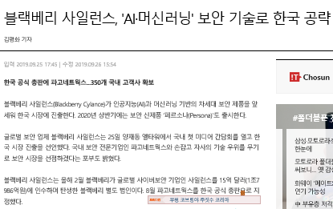
The first solution was to add new program that identifies if the number and the name was same. If its wrong, the program will not answer.

AI security
Recently the AI program that protects the program from attacking was invented. So, there’s no need to make new program.

