CHAPTER ONE
INTRODUCTION
1.0 Background
Social relationships shape how information, opinion, and influence move through any community, and a university campus is no exception. Beyond the formal structures of departments, colleges, and academic years, students belong to informal networks of friendship that decide who talks to whom, whose opinion gets trusted, and how fast an idea, or a candidate's message, spreads from one group to the next. This matters most in student politics, where elections are usually won or lost on peer influence and word of mouth rather than mass media. Even so, these networks are rarely mapped or measured in any systematic way. Campaign organisers and student leaders still lean on intuition, personal familiarity, and vague impressions of who is popular or who can reach a lot of people, instead of any real evidence of how the network is actually shaped.
Social Network Analysis (SNA) is the field, drawn from graph theory and sociology, that tackles exactly this gap. It represents a set of actors, students in this case, as nodes, and the relationships between them, friendship in this case, as edges, then applies mathematical measures to the resulting graph to reveal patterns that casual observation misses. Measures such as degree centrality, betweenness centrality, closeness centrality, eigenvector centrality, and PageRank show which nodes are most connected, which sit on the most communication paths, which can reach the rest of the network fastest, and which draw influence from being tied to other influential nodes. Community-detection algorithms uncover clusters of tightly-knit students that may line up with cliques or shared-interest groups. Bridge-node identification, meanwhile, exposes the handful of individuals whose removal would split the network into isolated pieces.
The UTAS Social Network Analysis (SNA) System, built for the University of Technology and Applied Sciences (UTAS), applies these techniques to student friendship networks, with particular attention to the two competing student political parties on campus, TESCON and TEIN. It is a full-stack web application. On the backend, a Flask/Python service stores student and connection records in a relational database and uses the NetworkX graph library to compute centrality, community, and bridge-node metrics. On the frontend, a React/TypeScript interface presents these results through an interactive dashboard, a force-directed network visualisation, and a set of management pages for students, connections, and analysis results. Data comes from a structured survey: each respondent names their friends within a defined class or cohort, along with attributes such as college, department, year of study, tribe, religion, hometown, and political-party affiliation. The resulting spreadsheet is imported into the system, which rebuilds the friendship graph and runs the analysis automatically, then turns the output into a campaign-planning feature that recommends, in plain language, which students a party should prioritise for outreach and why.
1.1 Problem Statement
Decisions about running a student political campaign at UTAS, who to approach first, which students can carry a message to groups a campaign would otherwise never reach, which parts of the student body a campaign's outreach keeps missing, are currently made with no structured evidence of the underlying friendship network behind them. Campaign organisers have no concrete way to see who the most connected students are, which students bridge otherwise separate friend groups, or what communities exist within the cohort and how they line up politically. Manual observation only goes as far as a handful of personal acquaintances, and it cannot pick up on indirect structural properties like betweenness centrality or community boundaries. As a result, campaign effort often goes toward students who were already reachable some other way, while the students who are genuinely well placed, or who bridge otherwise disconnected groups, get missed. What is needed is a system that captures the real structure of student friendship networks and applies established social-network-analysis techniques to bring these hidden patterns out into a form a non-technical campaign organiser can actually use.
1.2 Objectives
1.2.1 Main Objective
To design and implement a web-based Social Network Analysis system that models student friendship networks at UTAS and applies graph-theoretic metrics to support evidence-based student political campaign planning.
1.2.2 Specific Objectives
i. To design a relational data model and a survey-based import pipeline capable of capturing student attributes and friendship connections from spreadsheet data.
ii. To implement algorithms for computing degree, betweenness, closeness, and eigenvector centrality, PageRank, community detection, and bridge-node identification on the resulting network.
iii. To develop a role-based web interface that visualises the friendship network and presents the computed analytical results through dashboards, rankings, and exportable reports.
iv. To provide a campaign-planning feature that translates the computed analytics into concrete, named outreach recommendations for student political parties.
1.3 Significance of Study
This study matters for a few reasons. It replaces guesswork in campaign planning with evidence drawn from the measurable structure of the student friendship network, giving student political parties at UTAS something concrete to base outreach decisions on. It also leaves behind a documented, working case study of applying established social-network-analysis techniques, centrality measures, community detection, bridge-node identification, to a real, bounded university population, which future students tackling similar final-year projects can build on. And it shows, in one deployable system, how graph algorithms can sit inside a modern full-stack web application, giving the university a low-cost, purpose-built alternative to commercial social-media-analytics tools built for public platforms rather than internal campus populations. This is backed up by a growing body of recent research applying social network analysis to political campaigning and civic participation (Khan et al., 2020; Liu et al., 2026; Mameli et al., 2022; Paulis, 2020; Stier et al., 2018), reviewed in full in Chapter Two, which confirms that a network-centred approach has real practical value in exactly this kind of setting.
1.4 Scope of Study
The study is limited to a defined student cohort and to friendship data gathered through one structured survey instrument. It does not attempt to collect or scrape data from external social-media platforms such as Facebook, X (formerly Twitter), or LinkedIn, both because those platforms restrict automated data collection in their terms of service, and because doing so would raise privacy and research-ethics concerns that do not apply to consented survey data. Friendship ties are treated as undirected, mutual relationships rather than directional ones such as follows. The system supports batch import and on-demand analysis, not continuous, real-time monitoring of the network. Access is restricted by role: administrators and campaign managers can add, edit, and import student and connection data and run analysis, while everyone else who is logged in can only view dashboards, analytical results, and reports.
1.5 Structure of Dissertation
The rest of this dissertation is organised as follows. Chapter Two looks at existing literature on social network analysis and its use in political and civic settings, and sets out the key concepts and methodological tools the study relies on. Chapter Three covers the system analysis and design: the development tools adopted and the software development life cycle followed. Chapter Four walks through the system's implementation and testing, its use-case diagram, database schema, user interfaces, and reporting tools. Chapter Five closes the dissertation with a summary of the work done and recommendations for extending the system in future.

CHAPTER TWO
LITERATURE REVIEW
2.0 Introduction
This chapter looks at literature relevant to using social network analysis in political and civic settings. It opens with the key concepts the rest of the study depends on, graph structures, centrality measures, community detection, and bridge nodes, before turning to five related studies: what each one did, and how this system's approach differs. It ends with a short discussion of the methodological tools referenced later in the design and implementation chapters.
2.1 Background
Social Network Analysis (SNA) draws on both graph theory and sociology to study social structures: actors become nodes, and the relationships between them become edges in a graph. Rather than looking at individuals in isolation, SNA treats the pattern of relationships itself as the main unit of analysis, on the premise that an actor's position in a network can explain outcomes, influence, access to information, susceptibility to persuasion, that individual attributes alone cannot.
A graph can be undirected or directed. In an undirected graph, an edge between two nodes represents a symmetric, mutual relationship, such as two students who both consider each other friends. In a directed graph, an edge has a direction and represents an asymmetric relationship, such as one account following another on a platform like X (formerly Twitter) without the reverse necessarily being true. This choice affects which analytical measures make sense: directed graphs support separate in-degree and out-degree calculations and directional variants of centrality, while undirected graphs treat every connection as reciprocal. This study models student friendship as an undirected graph, since the underlying survey instrument records mutual friendship nominations rather than one-way follower relationships.
Centrality measures quantify how important a node is within a network. Freeman's (1978) conceptual clarification of centrality is still the reference point most later measures get checked against, and it is what settles the question of what "important" is even supposed to mean here: he distinguished a node that simply has many connections from one that sits on the paths between other nodes, and from one that can reach the rest of the network in the fewest steps, treating these as three genuinely different kinds of prominence rather than three ways of measuring the same thing. Degree centrality counts the number of direct connections a node has, and is the simplest measure of local prominence. Betweenness centrality counts how many shortest paths between other pairs of nodes pass through a given node, which identifies actors who act as brokers or bridges between otherwise separate parts of the network. Closeness centrality measures how few steps, on average, a node needs to reach every other node in the network, which identifies actors who can spread information quickly. Eigenvector centrality extends degree centrality by weighting a node's importance according to the importance of its neighbours, so a connection to an already-influential node counts for more than a connection to a peripheral one. PageRank, which Brin and Page (1998) built to rank web pages by treating a hyperlink as a vote weighted by the importance of the page casting it, applies that same recursive logic and is commonly used in social-network contexts as a robust alternative to eigenvector centrality.
Community-detection algorithms split a network into groups of nodes that are more densely connected to each other than to the rest of the network. The Louvain method, used in this study and introduced by Blondel et al. (2008), is a widely-adopted, computationally efficient algorithm that iteratively groups nodes to maximise modularity, a measure of how strongly a network divides into such communities; the original paper validated it on a Belgian mobile-phone network of two million subscribers, which is a considerably larger test than the university cohort this system works with, but the underlying optimisation is the same either way. Bridge nodes, or cut vertices, are nodes whose removal would increase the number of disconnected components in the network, and they are really just the structural version of what Granovetter (1973) had already identified decades earlier as weak ties: the loose, cross-cutting connections that, his classic study of job-seekers found, carry new information across a network far more reliably than the strong ties confined within one tight-knit group. In a social context, bridge nodes are individuals who uniquely connect otherwise separate communities, which makes them of particular strategic interest to any actor, a political campaign included, trying to reach multiple communities through as few points of contact as possible. Borgatti (2006) formalised this same intuition more rigorously, splitting it into two distinct problems, finding the smallest set of nodes that best spreads something through a network versus the smallest set whose removal would best fragment it, and showed that the obvious centrality measures do not automatically solve either one on their own. This system's bridge-node identification and campaign-planning feature sit closer to the first of those two problems: the goal is to name the students best placed to carry a message outward, not simply the students who happen to score highest on any single centrality measure.
A few of the studies reviewed below also draw on concepts from computational social science more broadly. Information diffusion is the process by which content or influence spreads across a network's edges over time, typically studied through interaction networks such as replies or retweets; in one of the largest field experiments run on the question, Bakshy et al. (2012) randomised what 253 million Facebook users saw about their friends' sharing activity and found that, although any single strong tie is more persuasive than any single weak one, it is the sheer number of weak ties an average user has that ends up carrying most new information through the network, not the smaller number of close ones. Homophily is the tendency of connected actors to share similar attributes or opinions, which can cause a messaging strategy to reach an already-aligned audience rather than a broader one. An ego-network is the sub-network formed by a single focal actor together with that actor's direct connections, often used to study recruitment or influence at the level of an individual rather than the whole network. Sentiment analysis is the automated classification of text, or, in multimodal systems, images, as positive, negative, or neutral, frequently done with classifiers such as Naive Bayes, k-Nearest Neighbours, or Support Vector Machines, or with deep-learning models such as BERT. Ensemble machine-learning methods such as XGBoost and random forests combine many simple predictive models into one classifier or predictor, and are commonly evaluated using the Area Under the ROC Curve (AUC), a value between 0 and 1 that summarises how well a model tells outcome classes apart.
2.2 Related Work
A growing body of work has applied social network analysis, often paired with machine learning and sentiment analysis, to political and civic settings. Most of it, though, looks at public social-media platforms, or is descriptive and predictive research rather than an operational system built for internal campus use.
One of the more complete examples is SocMINT, a cross-platform social-media analytics system built by Mameli et al. (2022). It pulls data from Facebook, Instagram, and Twitter through APIs and keyword or hashtag queries, stores it in MongoDB, and combines graph metrics, degree centrality, closeness centrality, entropy, with multimodal deep-learning sentiment analysis: VGG16 for images, CRAFT and STAR-Net for text pulled out of images, BERT for text itself. Tested on the 2020 Marche regional election in Italy, it tracked opinion trends that lined up with, and in places beat, traditional polling, and picked up influencer-amplification effects and meme-driven engagement. UTAS's system borrows the same graph-centred instinct for finding influential and bridging actors, but the resemblance stops at public commercial platforms and deep-learning sentiment fusion. Here, the metrics run over a closed, survey-consented friendship network of a known student cohort, with no text, image, or sentiment analysis involved.
Khan et al. (2020) took a similar structural approach to a narrower question: predicting how strong three Pakistani political leaders' Twitter supporter networks actually were. They built reply and retweet networks to capture interaction and diffusion, ran community detection to find supporter clusters, filtered out fake accounts, and classified sentiment with Naive Bayes, k-Nearest Neighbours, and Support Vector Machine classifiers. Supporter communities turned out to vary a lot in strength and cohesion between leaders, genuine supporters showed low isolation across groups, and the sentiment results backed up the structural picture of network strength. The premise carries over here, that community detection and network position can reveal a candidate's real support base, but the data and methods do not: this system works from consented, mutual friendship survey data rather than scraped Twitter interactions, skips the reply and retweet diffusion networks and fake-account filtering entirely, and leaves out machine-learning sentiment classification, relying on structural centrality and community metrics alone.
Closest to this project's own setting is Liu et al. (2026), who looked at how structural position, centrality, cross-community connectivity, overall network topology, within student self-governance networks predicts civic-participation outcomes, using 237 students at a Chinese regional university. Multivariate regression and ensemble machine-learning classifiers, XGBoost, random forest, Support Vector Machines, both went into the analysis. Students in high-centrality or bridging positions ended up with measurably better civic-participation outcomes, a pattern invisible to any conventional role-based analysis, and the XGBoost model came out on top for predictive accuracy (AUC of about 0.842), picking up non-linear relational effects the other models missed. Both studies analyse a university student network using centrality and community measures, which is what makes this the closest comparison of the five. But Liu et al.'s work is a predictive, statistical study of an existing governance-network dataset. This system, by contrast, is operational: it collects its own friendship data through survey import, computes the same broad family of structural metrics live, and feeds them straight into a campaign-planning feature, rather than fitting a supervised model to predict participation after the fact.
Paulis (2020) makes a broader methodological case for using SNA to study political parties, applying it across three layers in a Belgian context: a bibliographic network of the academic literature itself, ego-network data on members' interpersonal ties to explain recruitment, and members' positions in local branch networks to explain why some stay passive and others become active. Interpersonal ties, it turns out, significantly raise the odds of party membership, and members who are more embedded in their local branch network are more likely to be active rather than passive, which suggests relational position matters more than formal role. The same basic idea carries over to this project, that a student's position in their friendship network shapes whether they engage or get engaged, but it plays out differently in practice: rather than collecting ego-network recruitment histories or treating activism as something to model statistically, this system computes centrality and bridge-node metrics across the whole observed network and hands well-embedded students straight to campaign organisers as outreach and volunteer-activation targets.
Stier et al. (2018) looked at how politicians' Facebook and Twitter communication is shaped by their networked audience, pairing network-layer analysis of follower and interaction structure with content-layer analysis of issue salience across politicians', survey respondents', and audience networks. Politicians, they found, tend to tailor messaging to their immediate, often skewed network audience rather than to the electorate at large, and homophily and diffusion patterns inside the network noticeably affect which messages land. That finding matters directly for this system's campaign-planning feature. Rather than studying, after the fact, how politicians adapted their messaging to their audience, this system tries to surface a student cohort's community structure and bridge students in advance, so a campaign can deliberately reach past an echo chamber of already-aligned supporters instead of narrowing its message without meaning to, which is what Stier et al. found happens naturally on commercial platforms.
Two further studies sit a bit further from campus survey data, but close enough in spirit to what the campaign-planning feature is trying to do that they belong here too. Aral and Walker (2012) ran a large randomised experiment across a Facebook application's twelve-million-user network and found that influence and susceptibility to influence are not spread evenly through a population: older users, women, and married users each showed distinctly different patterns, and, tellingly, influential people turned out to cluster together in the network rather than sit scattered through it, while susceptible people did not cluster at all. Valente (2012) took a step back and reviewed what he called network interventions more broadly, deliberate uses of network data to speed up behaviour change or information spread, and grouped them into four recurring strategies: picking well-connected individuals as seeds, segmenting a network into groups for a tailored approach, deliberately inducing peer-to-peer influence along existing ties, and reshaping the network itself by adding or removing connections. This system's campaign-planning feature sits squarely inside Valente's first strategy, using computed centrality and bridge-node status to pick seed students for outreach, and Aral and Walker's clustering finding is a reasonable argument for checking a recommended student's position relative to other high-centrality students rather than reading off a single centrality score in isolation.
2.3 Methodological Issues
A few methodological tools come up again in the design and implementation chapters, and it helps to define them before they do. A Software Development Life Cycle (SDLC) is a structured process for planning, building, and delivering a software system, usually split into phases such as requirements gathering, design, implementation, testing, and deployment. SDLC models differ in how strictly these phases are sequenced: the Waterfall model runs each phase once, in strict order, while Agile and other iterative models repeat short cycles of design, implementation, and testing, letting requirements get refined as the system takes shape. The model adopted for this project, and what was done within it, is stated in Chapter Three.
An Entity-Relationship (ER) model represents the entities in a system, Student, Connection, or User, for example, and the relationships between them, and underlies the relational database schema presented in Chapter Four. A RESTful Application Programming Interface (API) is an architectural style for exposing a system's functionality over HTTP using a fixed set of verbs, GET, POST, PUT, DELETE, applied to resource-oriented endpoints; it is how this system's React frontend talks to its Flask backend. JSON Web Tokens (JWT) are a compact, signed data format used to authenticate users and carry their role, administrator, campaign manager, or student, between frontend and backend on every request, without the server needing to store session state. Finally, an Object-Relational Mapper (ORM) is a library, SQLAlchemy in this project, that lets the application read and write database rows as ordinary programming-language objects rather than hand-written SQL, and a Single-Page Application (SPA) is a web-application architecture, adopted for this system's React frontend, in which navigation between pages is handled by client-side JavaScript rather than by requesting a fresh HTML document for every page.

CHAPTER THREE
METHODOLOGY
3.0 Introduction
This chapter covers the system analysis and design behind the UTAS Social Network Analysis System. It states the development tools adopted for the backend and frontend, and the database structure employed, then describes the software development life cycle followed in building the system and what was done at each phase.
3.1 Development Tool
The backend of the system was built with the following tools:
• Python 3 — the programming language used to implement the server-side application logic.
• Flask — the web framework used to build the system's RESTful API and route incoming requests to the appropriate handlers.
• Flask-JWT-Extended — used to issue and verify JSON Web Tokens for authenticating users and enforcing role-based access to protected endpoints.
• Flask-SQLAlchemy — used to define the system's data models and to read from and write to the database without hand-written SQL statements.
• SQLite — the database management system used to store all student, connection, user, campaign, and analysis-result records for the system.
• NetworkX — used to construct the friendship graph from stored connection records and to compute degree, betweenness, closeness, and eigenvector centrality, and PageRank.
• python-louvain — used to detect communities within the friendship graph through the Louvain modularity-optimisation method.
• pandas and openpyxl — used to read and validate uploaded CSV and Excel survey files during the student-data import process.
• ReportLab — used to generate the downloadable PDF network-analysis report.
• Werkzeug — used to hash and verify user passwords and to sanitise uploaded file names.
The frontend of the system was built with the following tools:
• React with TypeScript — used to build the system's single-page user interface as a set of reusable, type-checked components.
• Vite — used as the frontend build tool and development server.
• Tailwind CSS — used to style all pages and components according to the system's defined colour palette and layout.
• React Router — used to handle client-side navigation between the system's pages (Dashboard, Students, Connections, Analysis, Network Graph, Reports, Campaigns, Users, and Settings).
• Axios — used as the HTTP client through which the frontend communicates with the backend's REST API.
• Recharts — used to render the bar charts on the Dashboard and Analysis pages.
• react-force-graph-2d — used to render the interactive, force-directed network-graph visualisation.
• Framer Motion — used to implement the interface's page-transition and loading animations.
• xlsx (SheetJS) — used to generate downloadable Excel exports of student, connection, and centrality data.
• Lucide React — used to supply the icon set used throughout the interface.
A relational database structure was used, made up of seven core tables, Role, User, Student, Connection, NetworkMetric, Campaign, and ActivityLog, linked through foreign-key relationships. Each Connection record, for instance, references two Student records through a from-student and a to-student foreign key, and each NetworkMetric record references a single Student in a one-to-one relationship. The full schema is presented in Chapter Four.
3.2 Development Life Cycle
The system was built using the Agile, or iterative, model: rather than trying to nail down every requirement up front, it was developed in successive cycles of planning, design, implementation, and testing, with each cycle refined based on a review of the one before it. What happened at each phase is described below.
Planning. In each iteration, planning meant identifying whatever feature or fix came next. The first iteration prioritised user authentication and student and connection data management. Later iterations added the network-analysis engine and the campaign-planning feature. Still later ones brought in role-based access restrictions, once it became clear that letting non-administrative users freely edit student and connection data was not appropriate.
Design. Design work meant specifying the data model each new feature needed, the Campaign and ActivityLog tables, for example, defining the REST endpoints to support it, and designing the matching user-interface screens. The visual design itself went through several passes, moving from an initial functional layout to a more refined, enterprise-style interface built around a fixed colour palette, a fixed sidebar and top navigation bar, and a consistent set of reusable components: cards, buttons, badges, tables.
Implementation. Each iteration was built by extending the Flask backend first, adding or changing data models, API endpoints, and access-control decorators, then extending the React frontend to use the new or changed endpoints. Backend and frontend changes went in together within the same iteration, so each cycle left the system in a usable state rather than a half-finished one.
Testing. Every increment was tested before being called done. Backend changes were tested by sending live requests to the running API, authentication, successful and rejected requests, role-based access checks, and checking the responses that came back. Frontend changes were tested through TypeScript compilation checks and full production builds to catch type errors, then checked against the data the API actually returned.
Review. Each iteration's outcome was checked against the requirement that started it, and any issues found, a wrong calculation in an analytical metric, or a missing role check on a data-editing endpoint, were logged and fixed in the next iteration rather than left for later.
This cycle, plan, design, build, test, review, repeated across every major part of the system: authentication and role-based access control, student and connection management, the network-analysis engine, the network-graph visualisation, the campaign-planning feature, and the reporting module, until the system reached its present, fully-functional state.

CHAPTER FOUR
SYSTEM IMPLEMENTATION AND TESTING
4.0 Introduction
This chapter presents the implementation and testing of the UTAS Social Network Analysis System. It sets out the use-case diagram showing how each category of user interacts with the system, the database schema underlying it, a walkthrough of the system's user interfaces in the order a user would normally move through them, and the reporting tools through which the system's analytical output is generated and downloaded.
4.1 Use Case Diagram
Figure 4.1 shows the use-case diagram for the system. Four actors interact with it. A Guest, meaning anyone who has not yet logged in, can only register a new account or log into an existing one. Once logged in, every user, regardless of role, becomes at least a Student: this is the default role assigned on registration, and it can view the dashboard and its key performance indicators, view analysis results, view the network graph, and generate or download reports, all in a read-only capacity. A Campaign Manager inherits everything a Student can do and, in addition, can manage student records, manage connections, import survey data, run network analysis, and plan campaign strategy. An Administrator inherits everything a Campaign Manager can do and, in addition, can manage user accounts and view system information. This layered structure, rather than a flat list of unrelated permissions per role, keeps the access model easy to reason about: a role only ever adds capabilities on top of the one below it, and every restriction is enforced on the backend, not only hidden in the interface, so a Student account cannot reach a Campaign Manager's endpoints simply by guessing a URL.
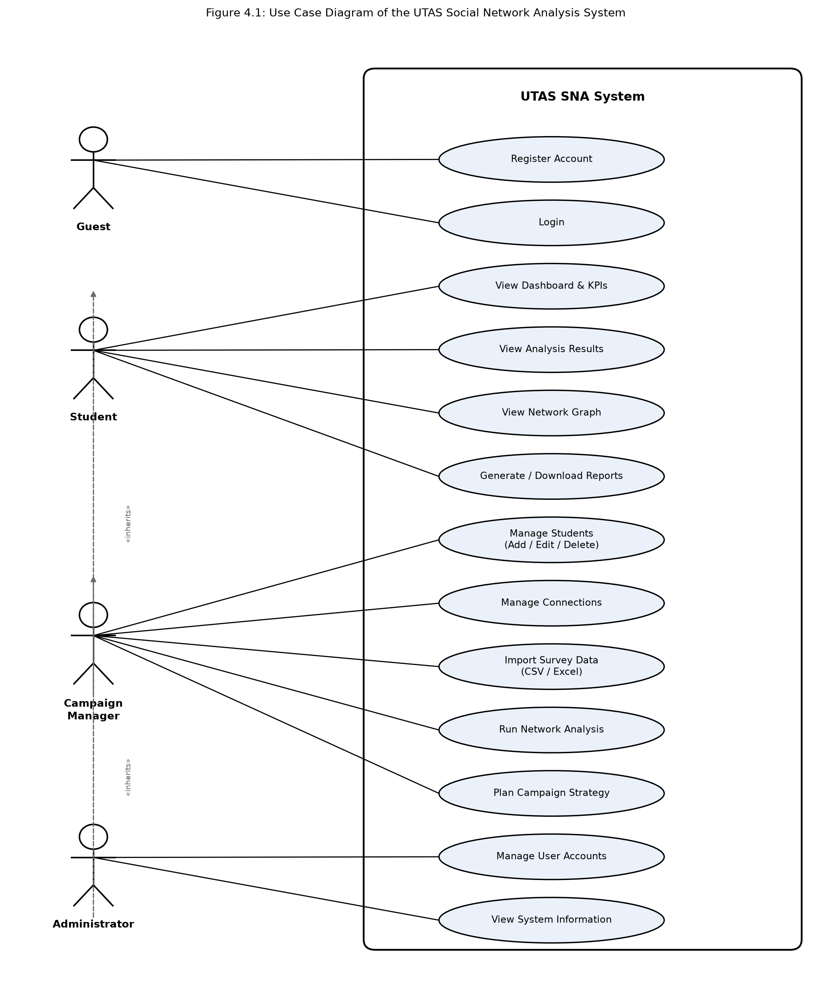
Figure 4.1: Use case diagram of the UTAS Social Network Analysis System
4.2 Database Schema
Figure 4.2 shows the entity-relationship diagram of the system's database, matching the relational structure introduced in Chapter Three. Role and User capture accounts and permissions: every User belongs to exactly one Role, and every action a User takes that changes data is written to ActivityLog for audit purposes. Student holds the survey-derived profile of each student in the network, and is the table every other analytical entity hangs off. Connection is a self-referencing link on Student, recording a friendship between a from-student and a to-student together with its strength and relationship type; taken together, all Connection rows form the edge list of the friendship graph. NetworkMetric holds the computed analytical output for a student, degree, betweenness, closeness, and eigenvector centrality, PageRank score, community identifier, influence tier, and bridge-node flag, in a one-to-one relationship with Student, and is recalculated whenever analysis is re-run. Campaign records a political-outreach campaign and the student appointed to manage it, linking back to Student through its manager_id foreign key.
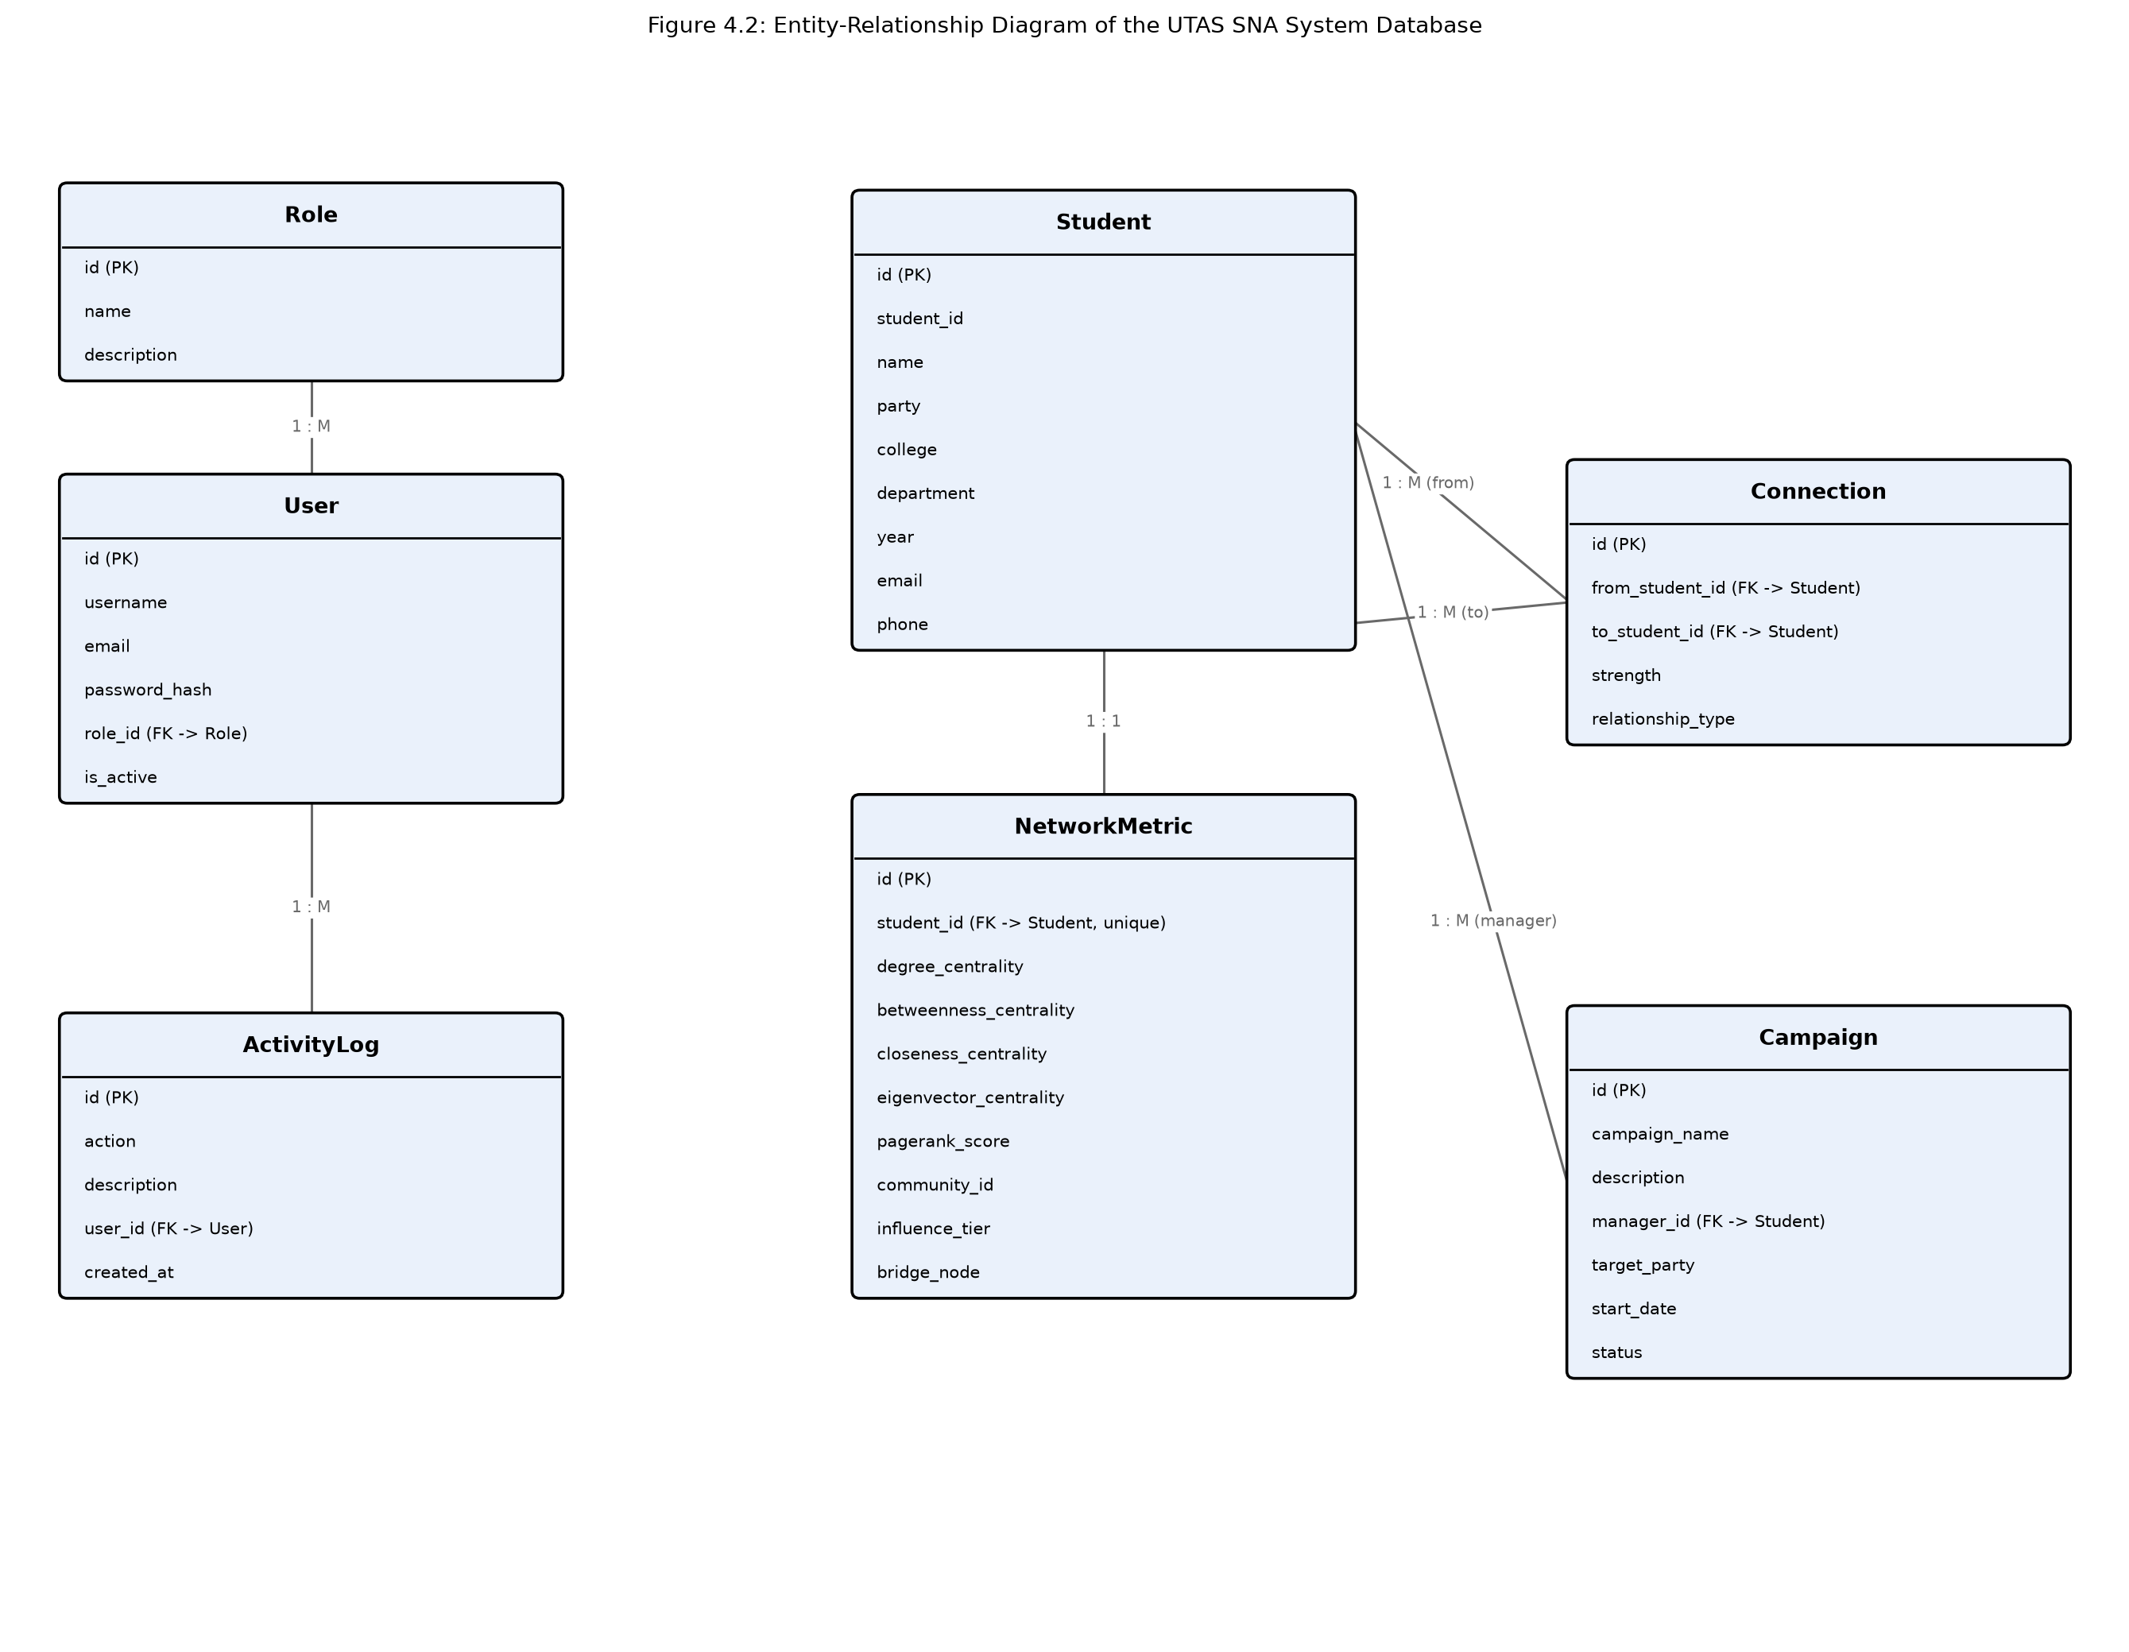
Figure 4.2: Entity-relationship diagram of the UTAS SNA System database
4.3 System User Interface
This section walks through the system's interfaces, illustrated with screenshots captured from the running application, in the order a user would typically encounter them.
Login and Registration
The Login page is the system's entry point for a Guest: a username and password field, a remember-me option, and a link through to Registration for anyone without an account yet. Registration collects the new user's basic profile (username, email, full name, password) and assigns the Student role by default; an administrator can later promote an account to Campaign Manager or Administrator. A successful login on either screen redirects to the Dashboard.
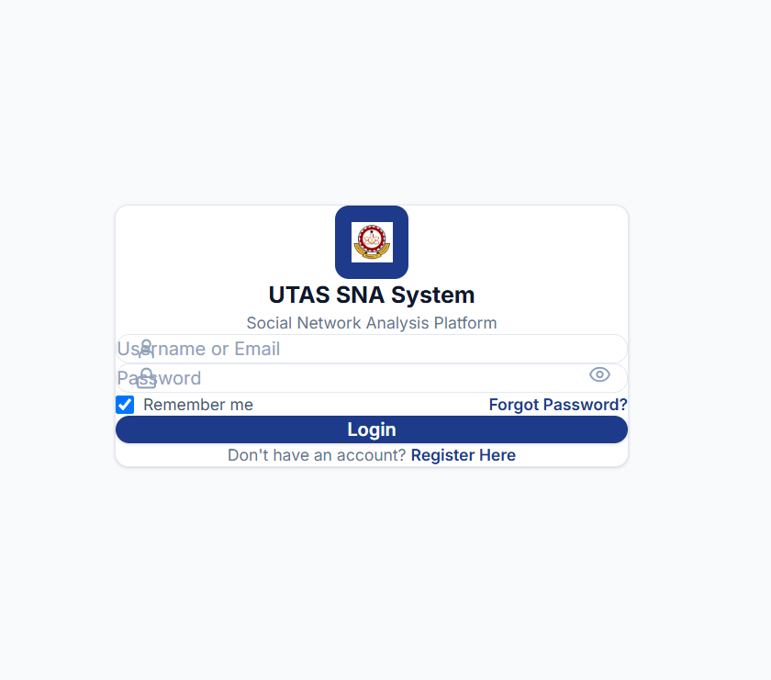
Figure 4.3: Login page
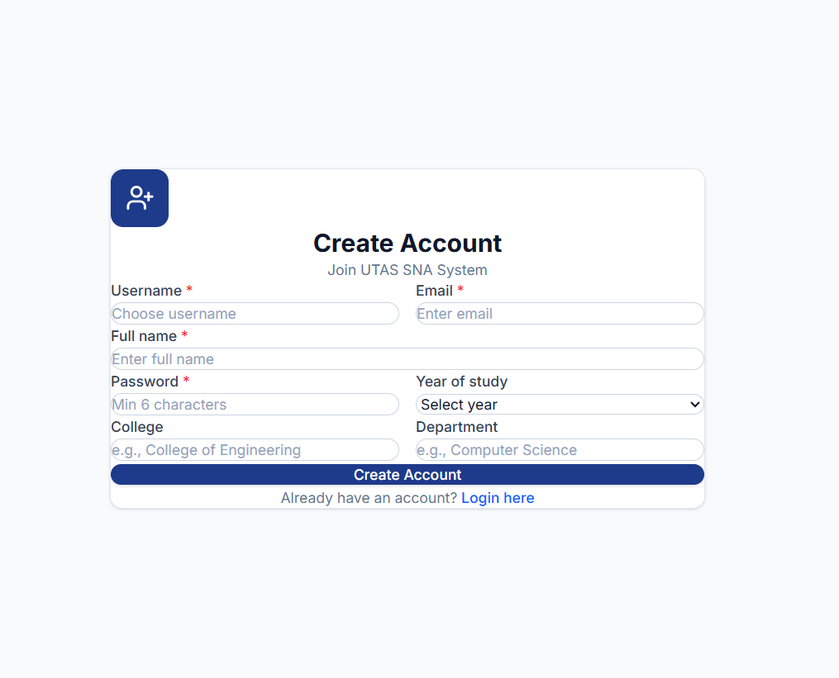
Figure 4.4: Registration page
Dashboard
The Dashboard is the first screen a logged-in user sees. It shows key performance indicators, total students, total connections, top influencers, communities, average degree, and bridge nodes, alongside charts summarising student distribution and centrality, a set of quick-action shortcuts to the system's other pages, and a recent-activity feed drawn from ActivityLog. It acts as the hub from which every other page in the system is reached, either through the sidebar navigation or through its own quick-action shortcuts.
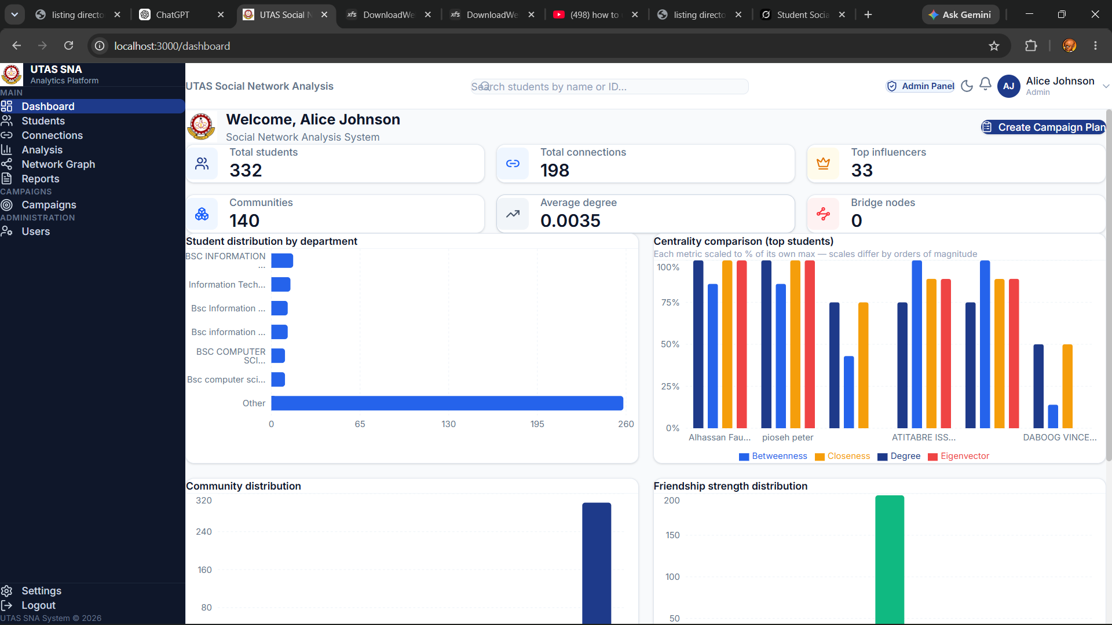
Figure 4.5: Dashboard page
Students and Connections
The Students page lists every student in the system in a searchable, filterable, paginated table, with add, edit, and delete actions available to Campaign Managers and Administrators only; a Student-role user sees the same table without those controls. The Connections page works the same way for friendship records, with a filter panel for relationship type and strength. Both pages feed directly into the network-analysis engine described in Chapter Two: any change made here changes the graph the next time analysis is run.
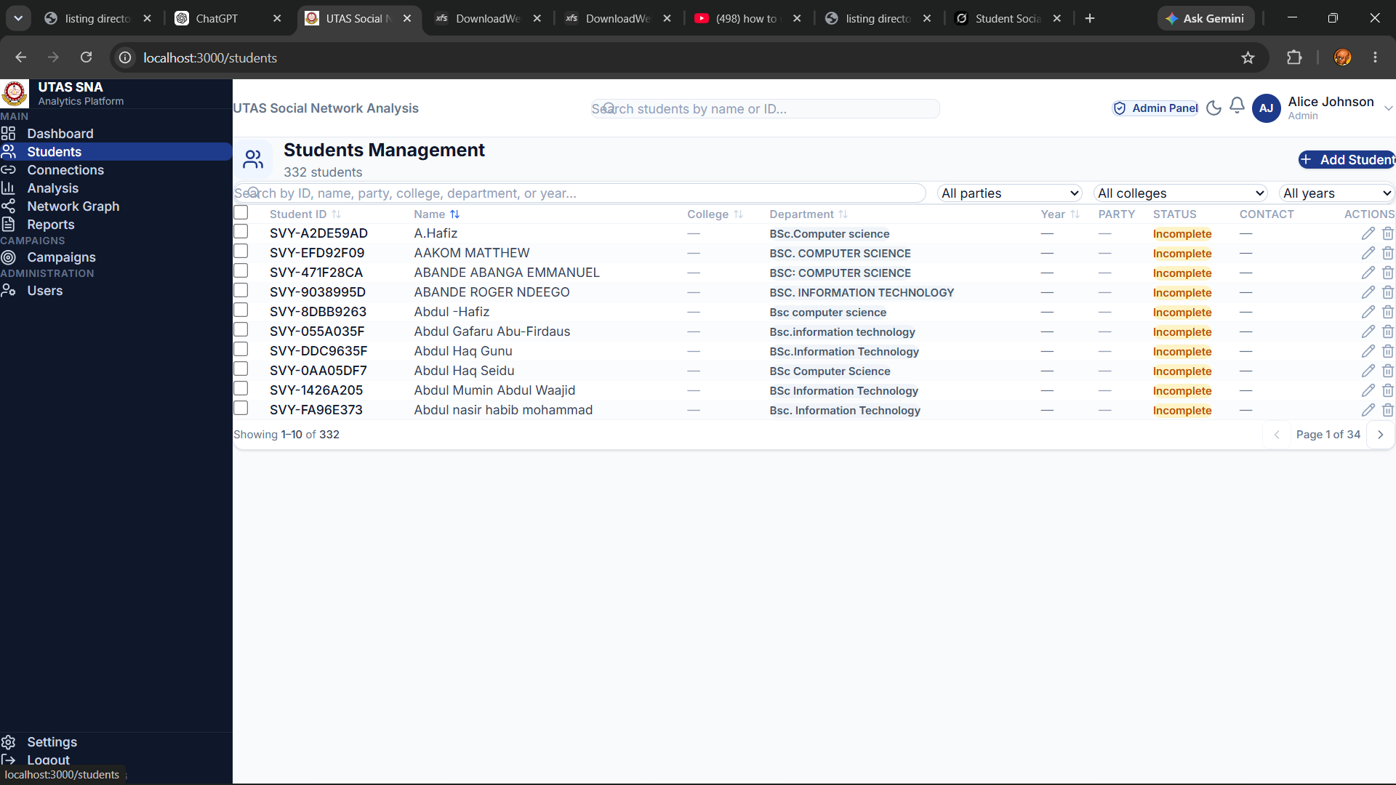
Figure 4.6: Students page
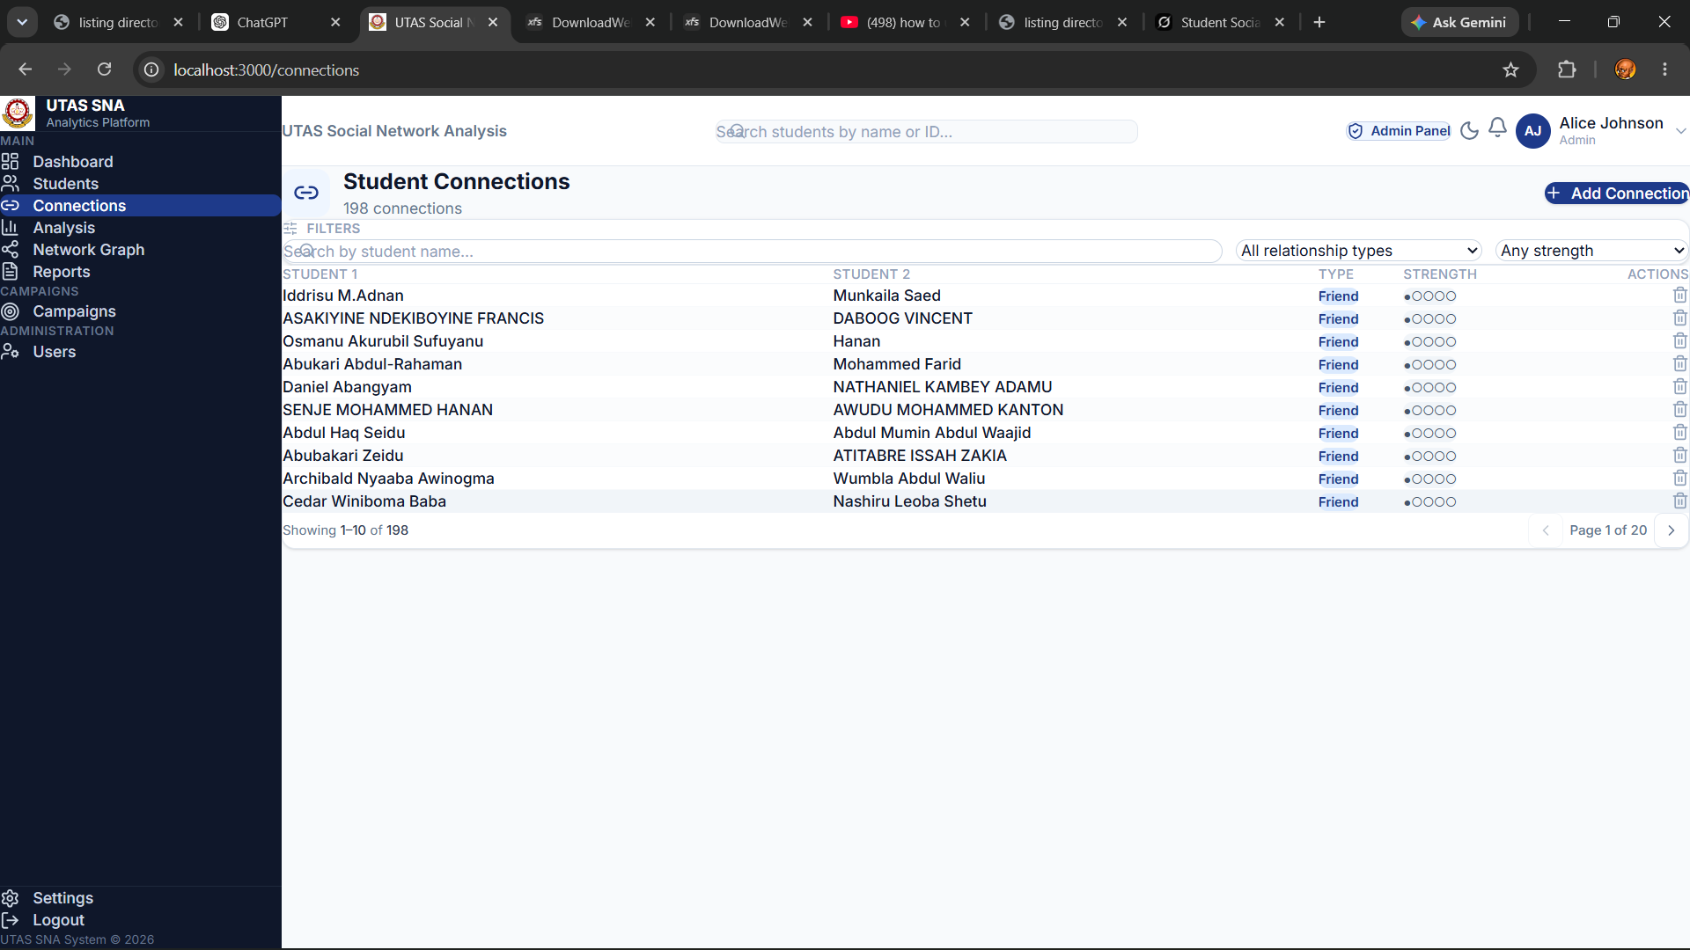
Figure 4.7: Connections page
Analysis and Network Graph
The Analysis page presents the system's computed metrics: a card for each of degree, betweenness, closeness, and eigenvector centrality and PageRank, each with a short description, a ranked bar chart, and a CSV export button, alongside cards for bridge nodes and detected communities. Campaign Managers and Administrators additionally see controls here to import new survey data and re-run the analysis. The Network Graph page takes the same underlying data and renders it as an interactive, force-directed graph, with nodes coloured by party or community, sized by PageRank, and filterable by department, year, political affiliation, and community, linked directly from the Analysis page for anyone who wants to see the structure rather than the numbers.
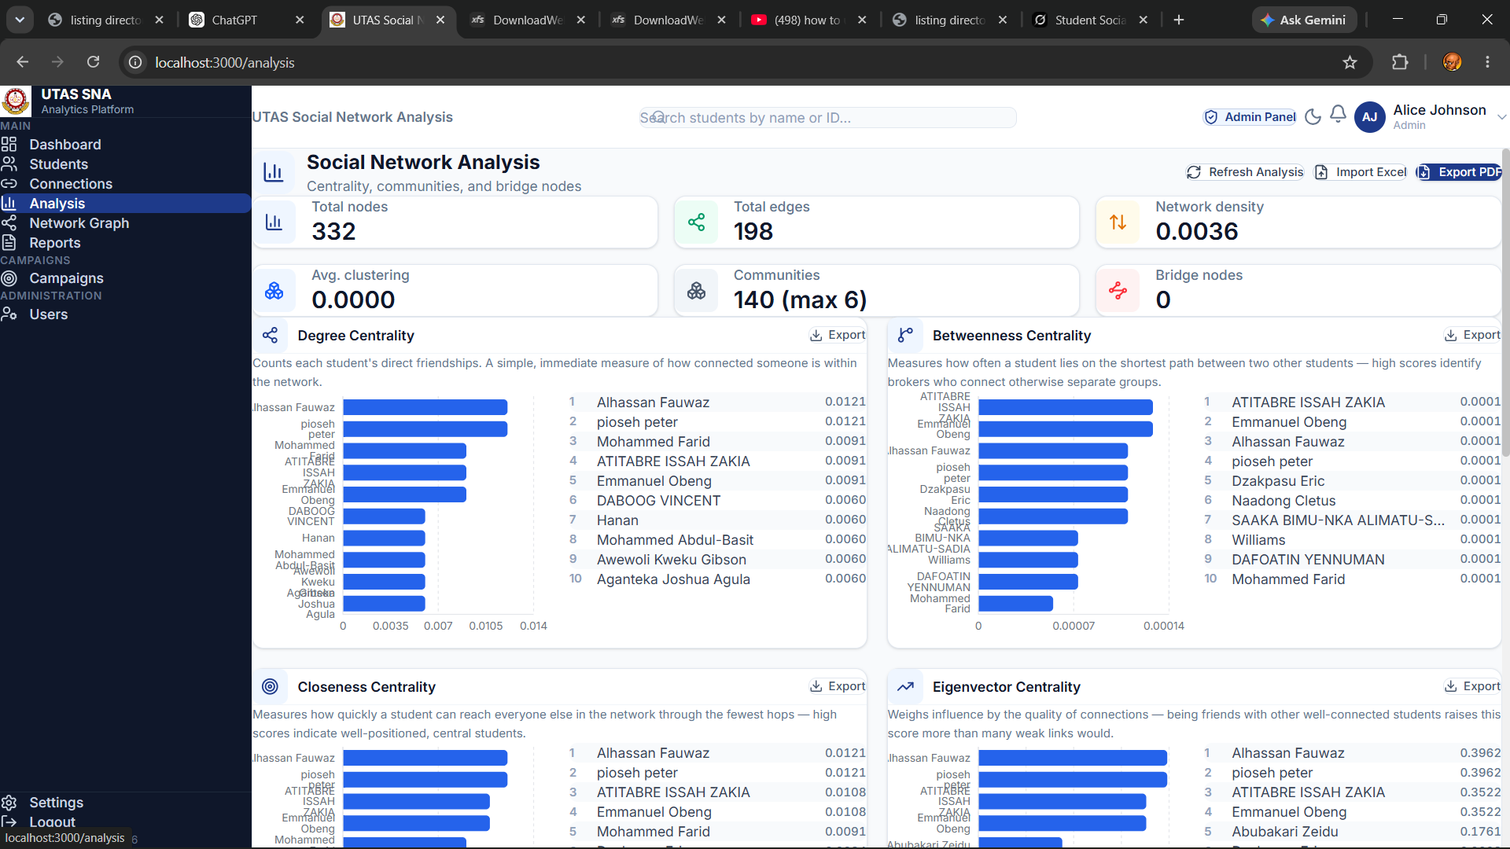
Figure 4.8: Analysis page
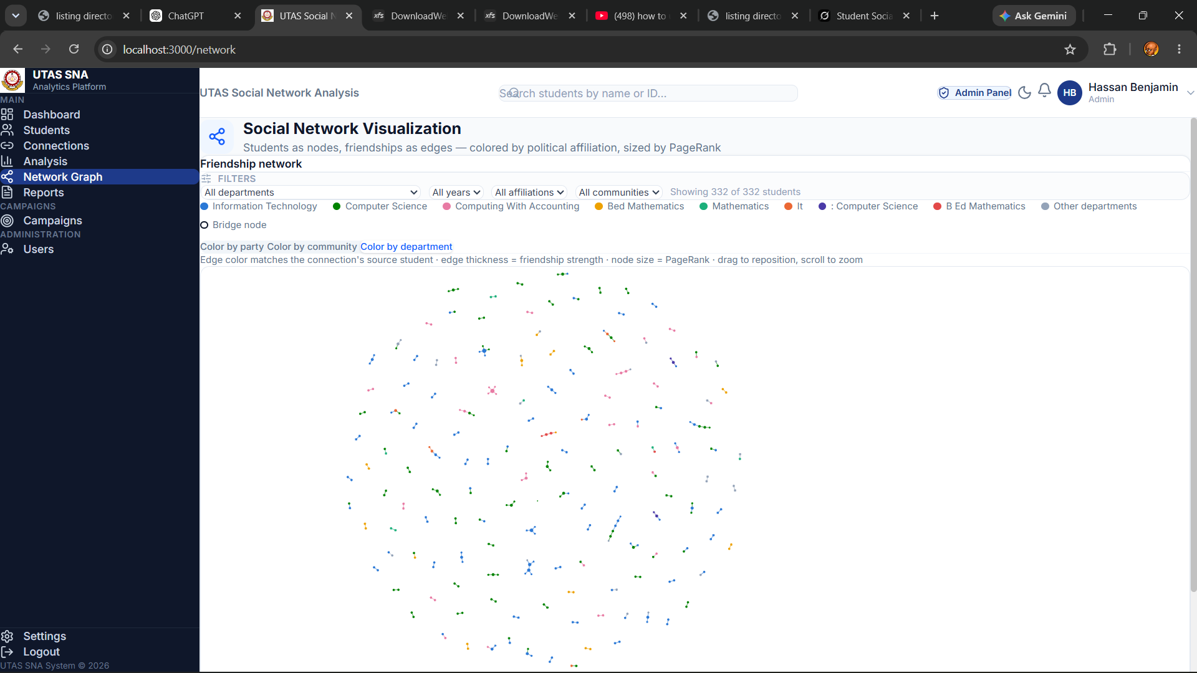
Figure 4.9: Network Graph page
Campaigns and Reports
The Campaigns page, restricted to Campaign Managers and Administrators, lists campaigns and lets a user create one, optionally pre-filled with a suggested manager and target party generated from the current analysis, as described in Chapter Three. The Reports page, open to every logged-in role, is where the PDF, CSV, and Excel outputs described in Section 4.4 are generated and downloaded.
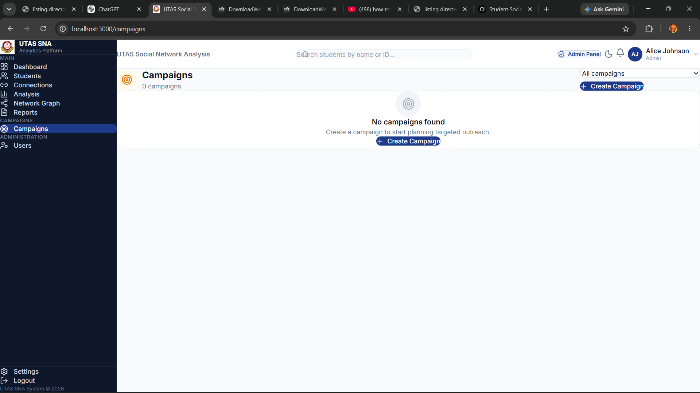
Figure 4.10: Campaigns page
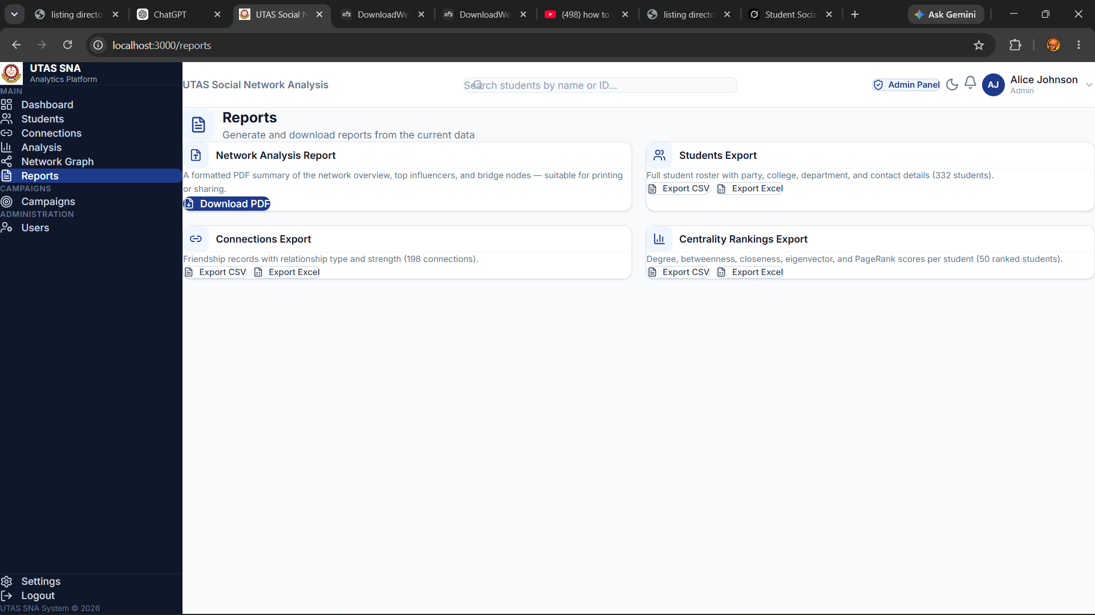
Figure 4.11: Reports page
Administration
The Users page, visible to Administrators only, lists system accounts and lets an administrator change a user's role. The Profile page lets any logged-in user view and edit their own details and change their password. The Settings page holds theme preferences and, for Administrators, a system-information panel showing the application version, the logged-in user, and the API endpoint the frontend is talking to.
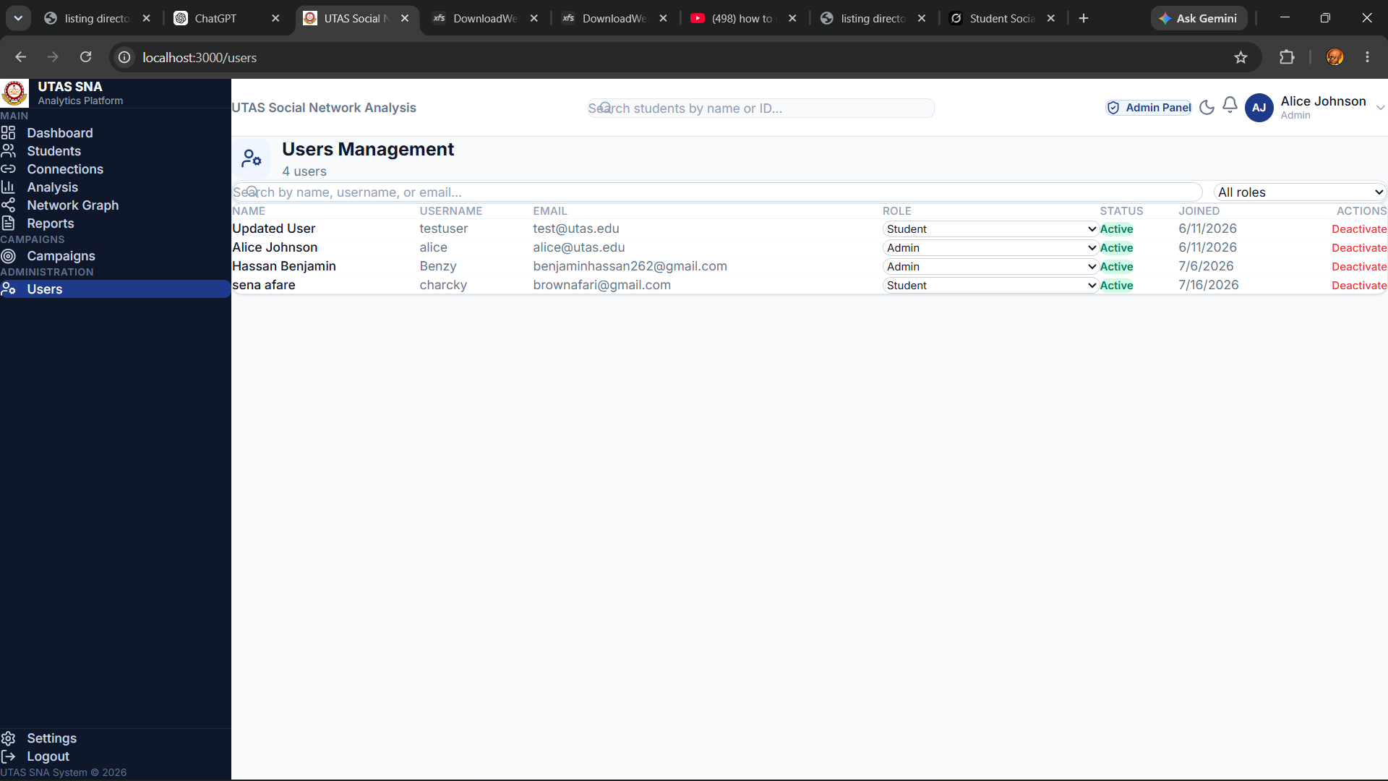
Figure 4.12: Users page
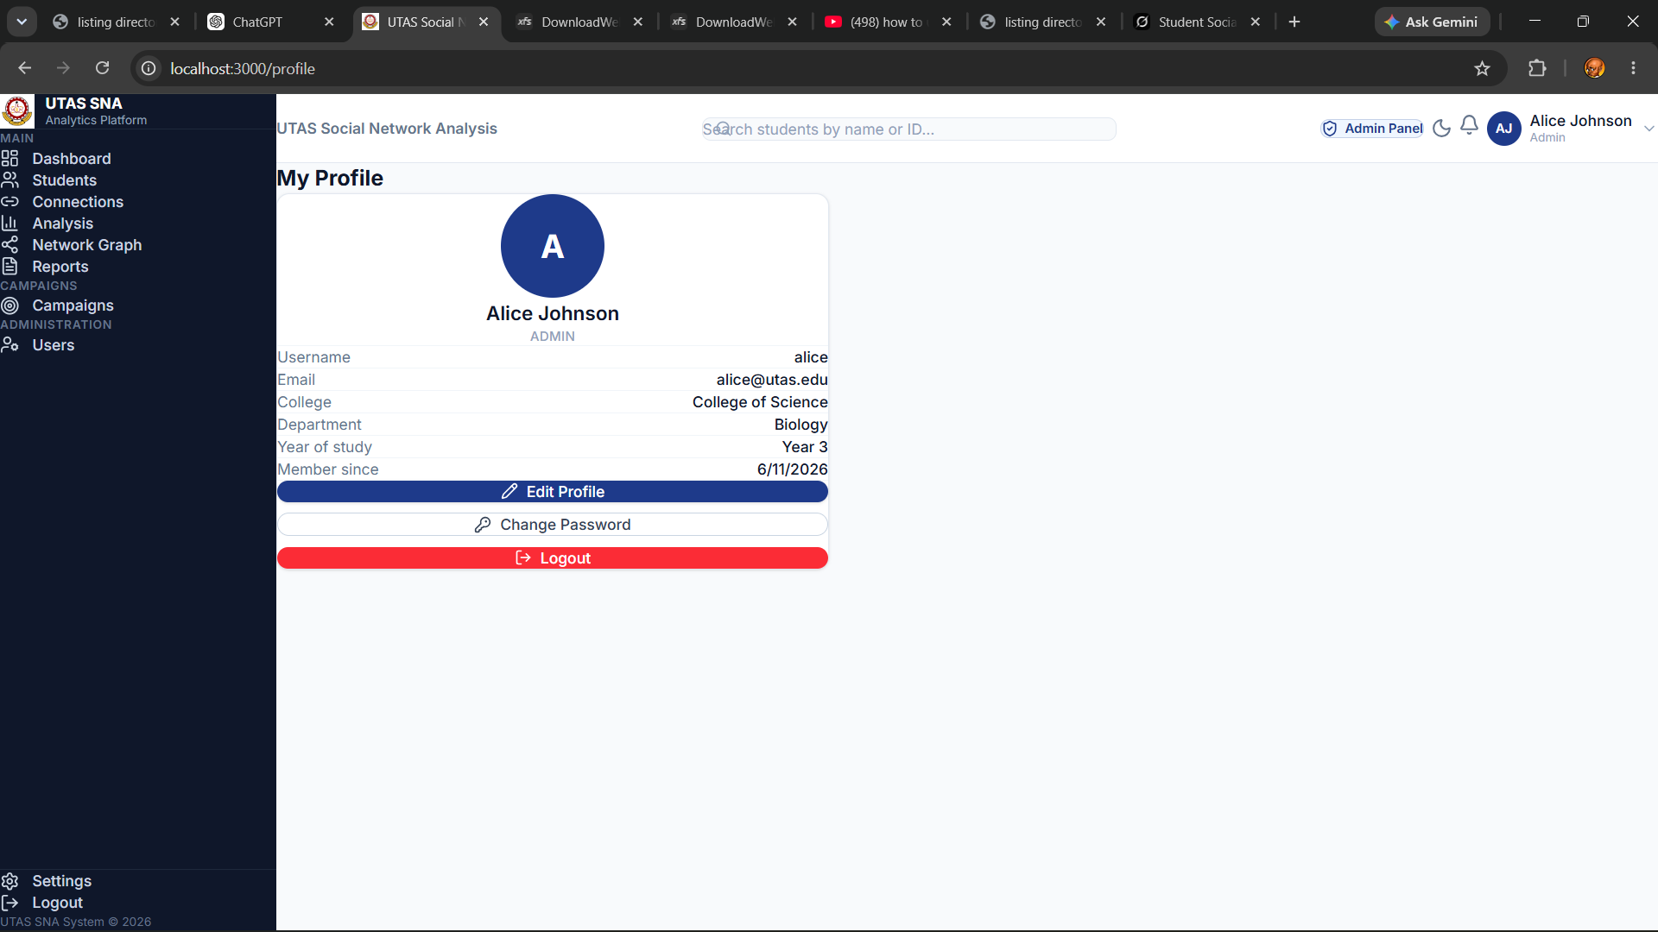
Figure 4.13: Profile page
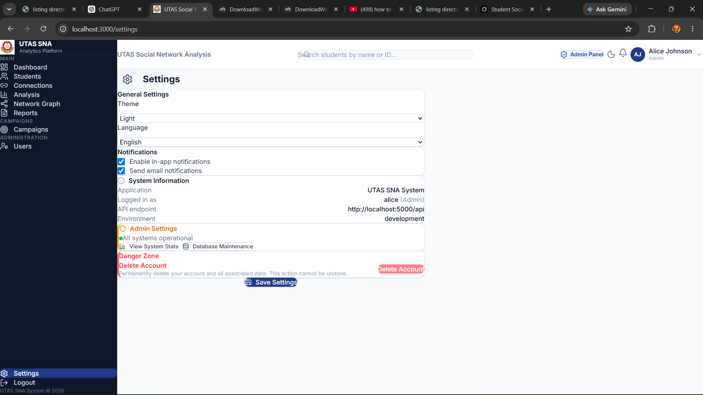
Figure 4.14: Settings page
4.4 Reporting Tools
The system generates three kinds of report, all reachable from the Reports page (and, for the PDF report, from the Analysis page as well).
The PDF report is generated on the backend using ReportLab: a request to the report endpoint assembles the current network overview, a table of the top influencers, and a table of bridge nodes into a formatted, downloadable PDF document. Figure 4.15 shows the first page of an actual report generated from the system's current data, 332 students and 198 connections at the time it was produced.
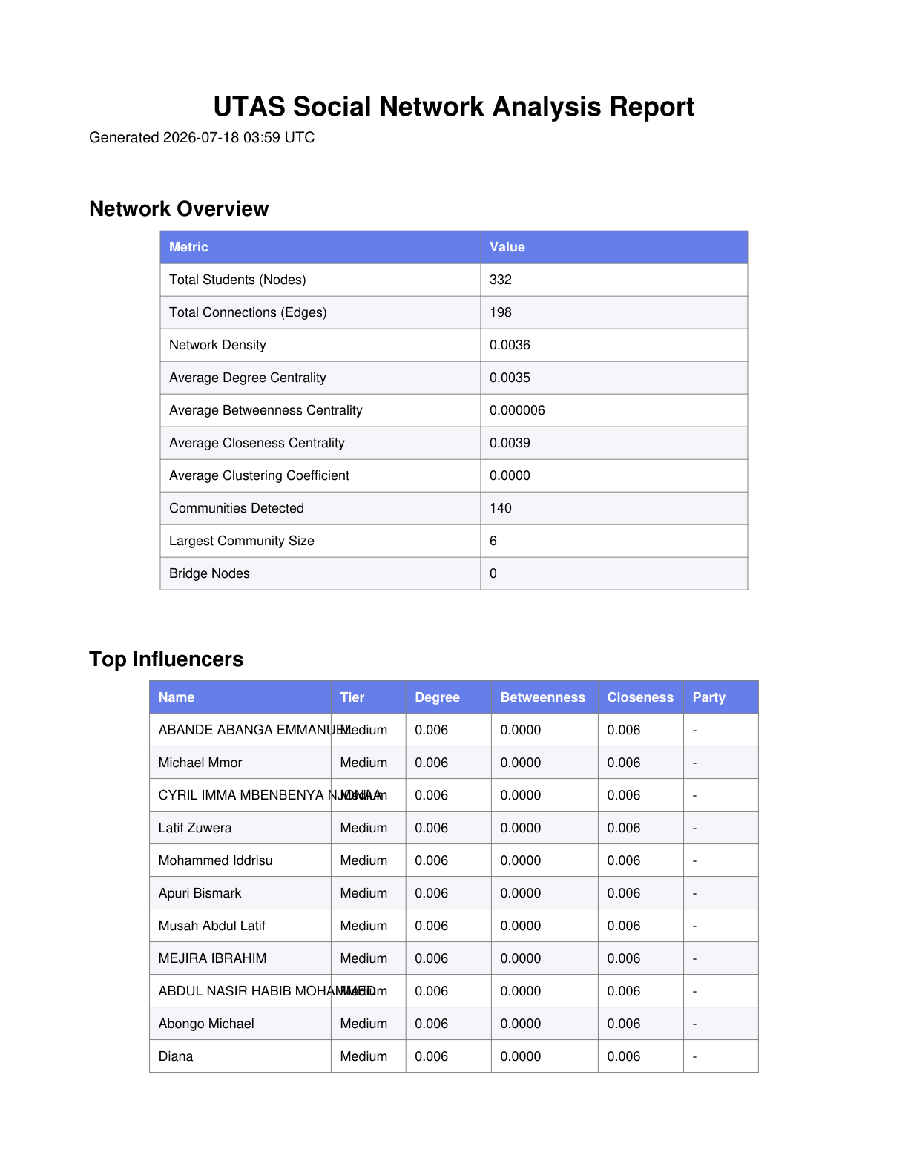
Figure 4.15: Sample PDF network-analysis report, page 1
The CSV and Excel reports are generated on the frontend: the Reports page reads whichever dataset the user selects, students, connections, or centrality rankings, and writes it out either as a plain CSV file or, using the xlsx (SheetJS) library, as a real .xlsx workbook, triggering a browser download. Table 4.1 shows an excerpt of a students export in this format, generated from the system's live data.
Student ID | Name | Party | College | Department | Year
20220404262 | Hassan Benjamin | TESCON | Applied Sciences | Computer Science | 4
20220404030 | Charky | TESCON | Applied Sciences | Computer Science | 4
SVY-403C375B | Iddrisu M.Adnan |  |  | Bsc Computer Science
SVY-1ECFEDA2 | Munkaila Saed |  |  | Bsc Computer Science
SVY-9CE01A1E | ASAKIYINE NDEKIBOYINE FRANCIS |  |  | COMPUTING WITH ACCOUNTING
SVY-748F9354 | DABOOG VINCENT |  |  | COMPUTING WITH ACCOUNTING

Note that Figure 4.15 and Table 4.1 were generated from the project's real working dataset, which includes actual students' names. Consider whether this data should be anonymised before the dissertation is submitted or shared beyond its examiners.

CHAPTER FIVE
CONCLUSION AND RECOMMENDATION
5.0 Introduction
This chapter closes the dissertation. It draws together what the study set out to do, what was actually built, and what a future version of the system might still need, then ends with a short set of recommendations for anyone continuing this work.
5.1 Conclusion
This study set out to build a web-based Social Network Analysis system that models student friendship networks at UTAS and turns that structure into concrete guidance for student political campaign planning. That system now exists: a Flask and Python backend stores the data and uses NetworkX to compute degree, betweenness, closeness, and eigenvector centrality, PageRank, Louvain community detection, and bridge-node identification, while a React and TypeScript frontend presents the results through a dashboard, student and connection management, a per-metric analysis view, an interactive network graph, and a reporting module exporting PDF, CSV, and Excel output.
Data enters the system through a structured survey rather than through scraping any external platform, a deliberate choice reinforced by the literature reviewed in Chapter Two, where every comparable study worked either with public social-media data or with an existing research dataset, rather than an operational tool built for one institution's own use. Access is controlled by role, so a plain student account can view the network but cannot edit it, and only a campaign manager or administrator can add data, import surveys, or run analysis.
Each of the four specific objectives set out in Chapter One was met: a data model and import pipeline that turns a spreadsheet into a live friendship graph, the full set of centrality, community, and bridge-node algorithms running against it, a role-based interface presenting the results, and a campaign-planning feature that turns those results into named, actionable recommendations rather than raw numbers. Taken together, the system replaces guesswork about who to approach in a campaign with an answer grounded in the actual shape of the network.
5.2 Recommendation
A few things this study did not attempt should be flagged for anyone extending the system. The friendship graph is undirected throughout, since the survey instrument records mutual nominations rather than one-way ties; a future version aiming to model something more asymmetric, such as who first reached out to whom, or ties gathered from a platform with a genuine directional follow relationship, would need a directed graph and a different set of centrality calculations from the ones used here. Along the same line, the system currently only supports batch import and on-demand analysis rather than continuous monitoring, so a real- or near-real-time recomputation pipeline is a natural next step if the underlying data starts changing more often than an administrator is willing to click Run Analysis.
Several studies reviewed in Chapter Two point toward directions this system does not yet cover. Sentiment analysis of campaign messaging, along the lines of what Mameli et al. (2022) and Khan et al. (2020) applied to social-media posts, could be added here too, provided any text data is collected with the same consent as the friendship survey rather than scraped from a platform, consistent with the boundary set out in Chapter One. Liu et al.'s (2026) use of ensemble machine-learning models to predict civic-participation outcomes from network position also suggests a predictive layer this system could grow into, rather than the purely descriptive metrics it reports now. There is also room to grow beyond Valente's (2012) first network-intervention strategy, seeding outreach through well-connected individuals, which is the only one this system currently supports. Segmenting the student body into tailored messaging groups, or explicitly modelling peer-to-peer influence the way Aral and Walker (2012) did, are both strategies the same underlying network data could support with further development.
A handful of smaller items are also left unfinished. The Users page has a Deactivate control that only updates the interface, since no backing endpoint for it exists on the backend yet. The frontend's JavaScript bundle is close to 1.3 megabytes, which would be worth trimming through code-splitting if the system ever needed to scale past a class-sized cohort. The system was also verified throughout by hand, live API calls, TypeScript checks, and manual review, rather than by an automated test suite, so writing one would make future changes to it considerably safer to make. Finally, given how much of this dissertation's sample data turned out to include real students' names and, in places, real email addresses, building a proper anonymisation step into the system, rather than relying on someone remembering to redact it by hand, would be a sensible piece of unfinished work to pick up first.

REFERENCES

Aral, S., & Walker, D. (2012). Identifying influential and susceptible members of social networks. Science, 337(6092), 337–341. https://doi.org/10.1126/science.1215842
Bakshy, E., Rosenn, I., Marlow, C., & Adamic, L. A. (2012). The role of social networks in information diffusion. In Proceedings of the 21st International Conference on World Wide Web (pp. 519–528). Association for Computing Machinery. https://doi.org/10.1145/2187836.2187907
Blondel, V. D., Guillaume, J.-L., Lambiotte, R., & Lefebvre, E. (2008). Fast unfolding of communities in large networks. Journal of Statistical Mechanics: Theory and Experiment, 2008(10), Article P10008. https://doi.org/10.1088/1742-5468/2008/10/P10008
Borgatti, S. P. (2006). Identifying sets of key players in a social network. Computational and Mathematical Organization Theory, 12(1), 21–34. https://doi.org/10.1007/s10588-006-7084-x
Brin, S., & Page, L. (1998). The anatomy of a large-scale hypertextual web search engine. Computer Networks and ISDN Systems, 30(1–7), 107–117. https://doi.org/10.1016/S0169-7552(98)00110-X
Freeman, L. C. (1978). Centrality in social networks conceptual clarification. Social Networks, 1(3), 215–239. https://doi.org/10.1016/0378-8733(78)90021-7
Granovetter, M. S. (1973). The strength of weak ties. American Journal of Sociology, 78(6), 1360–1380. https://doi.org/10.1086/225469
Khan, A., Zhang, H., Shang, J., Boudjellal, N., Ahmad, A., Ali, A., & Dai, L. (2020). Predicting politician's supporters' network on Twitter using social network analysis and semantic analysis. Scientific Programming, 2020, Article 9353120. https://doi.org/10.1155/2020/9353120
Liu, J., Nitiasih, P. K., Santosa, M. H., & Riastini, P. N. (2026). Network based analysis of student self-governance networks and predictive role in civic participation outcomes. Scientific Reports, 16, Article 4141. https://doi.org/10.1038/s41598-025-34205-x
Mameli, M., Paolanti, M., Morbidoni, C., Frontoni, E., & Teti, A. (2022). Social media analytics system for action inspection on social networks. Social Network Analysis and Mining, 12, Article 33. https://doi.org/10.1007/s13278-021-00853-w
Paulis, E. (2020). Using social network analysis (SNA) to study members and activists of political parties. Bulletin of Sociological Methodology/Bulletin de Méthodologie Sociologique, 147-148(1-2), 13–48. https://doi.org/10.1177/0759106320939886
Stier, S., Bleier, A., Lietz, H., & Strohmaier, M. (2018). Election campaigning on social media: Politicians, audiences, and the mediation of political communication on Facebook and Twitter. Political Communication, 35(1), 50–74. https://doi.org/10.1080/10584609.2017.1334728
Valente, T. W. (2012). Network interventions. Science, 337(6090), 49–53. https://doi.org/10.1126/science.1217330

