To: {{TENANT_NAMES}}

THREE (3) DAY NOTICE TO PAY OR QUIT
(Estimated CCP Section 1161.1)

Tenants in possession of the premises herein referred to are situated at:

COUNTY OF {{COUNTY}}
[hereinafter called the "Premises"] and all notices thereafter:

PLEASE TAKE NOTICE that pursuant to the terms of tenancy for the above-referenced agreement by which you hold the possession of the Premises described in this Notice, there is now due, unpaid, and delinquent rent in the following amounts for the following specified periods:

DUE DATE
{{RENT_DUE_DATE}}
AMOUNT DUE
{{AMOUNT_DUE}}

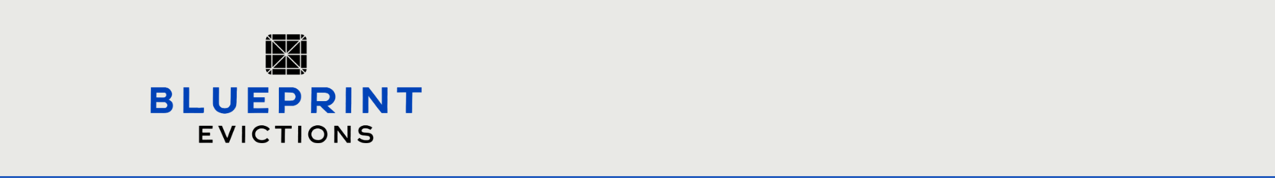

RESET FORM

TOTAL AMOUNT DUE: {{TOTAL_AMOUNT_DUE}}
You are further notified that within three (3) days after service of this notice on you, not including Saturdays, Sundays or other judicial holidays, you must pay the total amount of rent stated in this Notice in full or quit the Premises, meaning to deliver up possession of the Premises and vacate.

This notice was served to you on . You have three (3) days after the date the notice was served to you, excluding Saturdays, Sundays, and other judicial holidays, to pay the rent due or vacate the property.
Payment of the above total amount due should be tendered to, or possession of the premises delivered to:

Rent or possession of the Premises may be tendered between normal business hours of 9:00AM to 5:00PM, Monday through Friday.

Only the total amount due and made prior to the expiration of this Notice may be made using cash or certified funds (e.g., cashier's check, money order, etc.). No other forms of payment are acceptable. Landlords, and the attorney on behalf of the Landlords, will not accept any payments after the expiration of this Notice. Further, be advised that Landlords will not accept any partial payments for the amounts outlined in this notice nor will they accept payments made to others ostensibly on their behalf: all payments must be made to the above-stated address.



You are further notified by this Notice the Landlords elect to and therefore do declare a forfeiture of the rental agreement if the rent stated in this notice is not paid in full within the 3 (three) days.

NOTICES FROM THE STATE OF CALIFORNIA:

- NOTICE regarding possible credit consequences: Pursuant to Civil Code § 1785.26, you are hereby notified that a negative credit report reflecting on your credit record may be submitted in the future to a credit reporting agency if you fail to fulfill the terms of your rental obligation or if you default in those obligations in any way. This is the only notice that you will receive in this regard.

- NOTICE regarding abandoned property: "State law permits former tenants to reclaim abandoned personal property left at the former address of the tenant, subject to certain conditions. You may or may not be able to reclaim property without incurring additional costs, depending on the cost of storing the property and the length of time before it is reclaimed. In general, these costs will be lower the sooner you contact your former landlord after being notified that property belonging to you was left behind after you moved out." California Civil Codes §1946.1; §1983- 1989 et seq.

Please be advised that any tenant under the above-stated agreement that remains in the unit after the termination date may result in the Landlords seeking to enforce the termination in Court, in an action for Unlawful Detainer at which time the occupant(s) may appear and present a defense.

Finally, any Notice to Pay or Quit served prior to this one is hereby superseded and canceled. Any notice served in conjunction with or subsequent to this one is not designed to supersede or cancel this present notice. You are still required to oblige by the terms outlined in this Notice.

Date: {{DATE_SERVED}} (Original signed by agent/owner)

Landlord's Address: {{LANDLORD_ADDRESS}}

Phone: {{LANDLORD_PHONE}}

