Kabacu Platform Testing Report
KABACU Test Platform
Reviewed on 31 August 2026 using the mobile & desktop experience at test.kabacu.com
The following issues were observed during testing of the platform

Country Code List Not Visible on the Sign-Up Page
Observation: On the sign-up page, the dropdown list of countries code is set in white font on a white or near white background. As a result, the list of countries cannot be read by the user.

Privacy Policy and Terms and Conditions Pages Hard to Read in Dark Mode
Observation: When the site theme is switched to dark mode or system theme, the text on the Privacy Policy and Terms and Conditions pages is difficult to read because the background color and the font color do not provide enough contrast.

History Pages Hover Effect Hides Content in Dark Mode
Observation: At top ups, conversion and order history, in dark mode, hovering over a row containing the information such as wallet, time, and amount causes the section to turn white, which then makes the text unreadable against the now light background.

Close Button on Pop-Up Messages Not Visible Unless Hovered
Observation: On pop up messages, the close button is not visible by default and only becomes visible when the user hovers over it.

Review of the Privacy Policy and Terms of Use
The Terms of Use, section 1, states that a user must be at least 18 years old, or the age of majority in their country, to use Kabacu. The Privacy Policy, section 8, states that Kabacu is not directed at children under 13 and refers to the platform not knowingly collecting data from children under that age. These are two different age thresholds describing who the platform is meant for. This inconsistency should be resolved so that both documents state the same minimum age.
Below are features I couldn’t test
Referral code doesn’t copy the referral link
Recommendations
- Registration shows Nigeria’s +234 phone code but defaults the Country field to Afghanistan.
“Default both fields to Nigeria and keep them synchronized.
- Chat Widget
The chat widget opens automatically and can cover page content.
“Keep it collapsed initially or delay opening until the visitor has spent time on the page.”
- The FAQ
The FAQ contains 26 questions without search.
“Add a “Search help articles” field and filter questions instantly.”
- The claim button of reward points needs a green label.

BELOW ARE SOME VISUALS REFERENCES
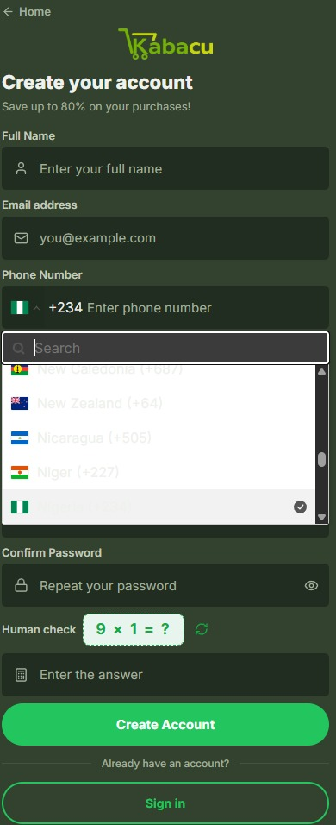


OVERALL UI/UX COMMENT
The new KABACU testing platform represents a significant improvement compared with the previous version. Much has been upgraded across the platform, including the overall design, page organization, navigation, product presentation, registration interface and accessibility of information.
The new interface is cleaner, more modern and better aligned with the KABACU brand identity. Data plans are presented more clearly, prices and rewards are easier to understand, and the FAQ section provides users with better guidance on the platform’s services. The addition of country selection, improved product categories, wallet information, reward-point explanations and upcoming service pages also demonstrates considerable development.
From a user-experience perspective, the platform is now easier to navigate and more professional. Users can understand the major services without needing extensive guidance, and the structure provides a strong foundation for the planned rollout of additional KABACU features.
However, some areas still require refinement before the final public release. These include correcting the broken homepage banner, fixing the country mismatch during registration, making purchase buttons clearer and resolving the remaining accessibility and mobile-usability concerns.
Overall, the development team has made substantial progress. The remaining recommendations should therefore be treated as final-stage improvements intended to strengthen an already significantly upgraded platform, rather than an indication that the entire interface requires redesigning.

