Comparative Visualization Evaluation
Formal Marks & Channels Analysis, Interactivity Review, and Design Critique across Seven Data Visualizations

This report evaluates seven data visualizations about incarceration using Tamara Munzner’s marks and channels framework. For each visualization, it identifies the purpose of the chart, the chart type, the data being encoded (marks and channels), any interactive features, and the design features used to communicate the message. The final section compares the designs and explains which one is the most effective.

Visualization 1: Proportional Symbol Map (Bubble Map) with Inset Bar Chart
Source: Unavailable
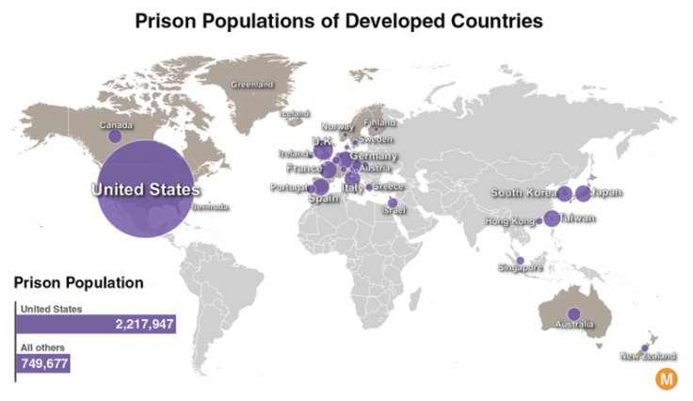
Q1. What appears to be the purpose of the chart?
The visualization compares the total prison populations of selected developed countries and highlights the United States as an extreme outlier. The inset bar chart reinforces this by comparing the U.S. prison population (2,217,947) with the combined total of all other developed countries shown (749,677).
Q2. What kind of chart is this?
A Proportional Symbol Map (Bubble Map) combined with an inset Horizontal Bar Chart for aggregated comparison.
Q3. What data does it appear to be encoding and how is it encoding it (marks and channels)?
- Marks:
  - Points / Circles (Bubbles): Placed over geographic coordinates on the world map.
  - Areas / Polygons: Geographic boundary shapes representing world landmasses.
  - Bars (Rectangles): In the bottom-left summary chart.
- Channels:
  - Spatial Position (2D coordinates): Encodes geographic location (country centroids / boundaries on the world map).
  - Size (Circle Area / Radius): Encodes quantitative magnitude (total prison population per country).
  - Length / Horizontal Position: Encodes total count in the inset bar chart (United States vs. "All others").
  - Color Hue & Saturation: Purple highlights the quantitative data marks (bubbles and comparison bars) against a muted, neutral gray/beige base map; brownish-gray shading differentiates selected developed countries from non-selected regions.
Q4. Are there any interactive features? If so, what are they and how are they used?
I can’t make any conclusion for this graph because I was only given a static graphic and the website is inaccessible.
Q5. What features does it use to try to get its message across?
- Dramatic Visual Scale Contrast: The circle over the United States dwarfs all other country markers combined, immediately drawing the viewer's eye.
- Direct Aggregate Bar Inset: A paired horizontal bar chart at the bottom-left provides exact numeric values ($2,217,947$ vs. $749,677$), showing that the US alone has nearly triple the prison population of all other developed nations listed.
- Direct Text Labeling: Country names are directly positioned next to their respective bubble marks.
- Figure-Ground Separation: Highly saturated purple elements pop strongly against a low-contrast, desaturated geographic background.

Visualization 2: Choropleth Map (Binned Sequential Color Map)
Source: https://www.pewresearch.org/short-reads/2021/08/16/americas-incarceration-rate-lowest-since-1995/
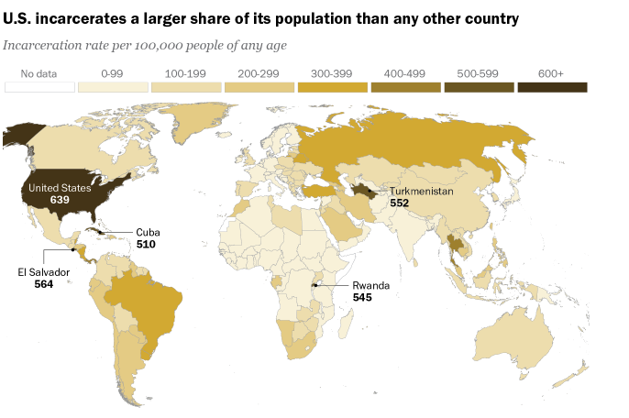
Q1. What appears to be the purpose of the chart?
To compare incarceration rates (prisoners per 100,000 people) across countries worldwide and to show that the United States (639) has the highest rate in the world, ahead of countries such as El Salvador, Turkmenistan, Rwanda and Cuba.
Q2. What kind of chart is this?
A Choropleth Map (binned/stepped geographic thematic map).
Q3. What data does it appear to be encoding and how is it encoding it (marks and channels)?
- Marks:
  - Areas / Polygons: Geometric land boundaries representing individual nations and administrative territories across a world map projection.
  - Points / Leader Dots: Black dots highlighting small or geographically dense territories (e.g., El Salvador, Cuba, Rwanda, Turkmenistan).
- Channels:
- Spatial Position (2D coordinates): Encodes geographic spatial location (latitude and longitude boundaries of countries on the globe).
- Color Luminance / Saturation (Sequential Palette): Encodes quantitative ranges of incarceration rates per 100,000 individuals—transitioning from very light cream/tan ($0\text{–}99$) through progressively darker golden-brown shades up to dark espresso brown ($600+$).
- Color Hue (Neutral White): Encodes the categorical missing-data state ("No data").
Q4. Are there any interactive features? If so, what are they and how are they used?
None. It is a flat, static graphic with no clickable elements, tooltips, dynamic filtering, or panning/zooming controls.
Q5. What features does it use to try to get its message across?
- Direct Takeaway Headline: Uses an explicit editorial title ("U.S. incarcerates a larger share of its population than any other country") to ensure the core insight is immediately understood before analyzing the data.
- Perceptual Contrast via Darkest Bin: The darkest color value ($600+$) is visually dominant, instantly drawing the viewer's eye directly to the United States (value $639$).
- Callout Labels with Direct Values: Uses leader lines and bold numerical callouts for the top-ranking nations (United States: 639, El Salvador: 564, Turkmenistan: 552, Rwanda: 545, Cuba: 510) so readers do not have to estimate exact numbers solely from the color legend.
- Ordered Discrete Legend: A horizontal color scale at the top segments data into intuitive, standardized 100-person intervals ($0\text{–}99$, $100\text{–}199$, etc.) to simplify interpretation.

Visualization 3: Interactive Thematic Choropleth Map (Web Dashboard with Inset Summary Cards)
Source: https://worldpopulationreview.com/country-rankings/incarceration-rates-by-country
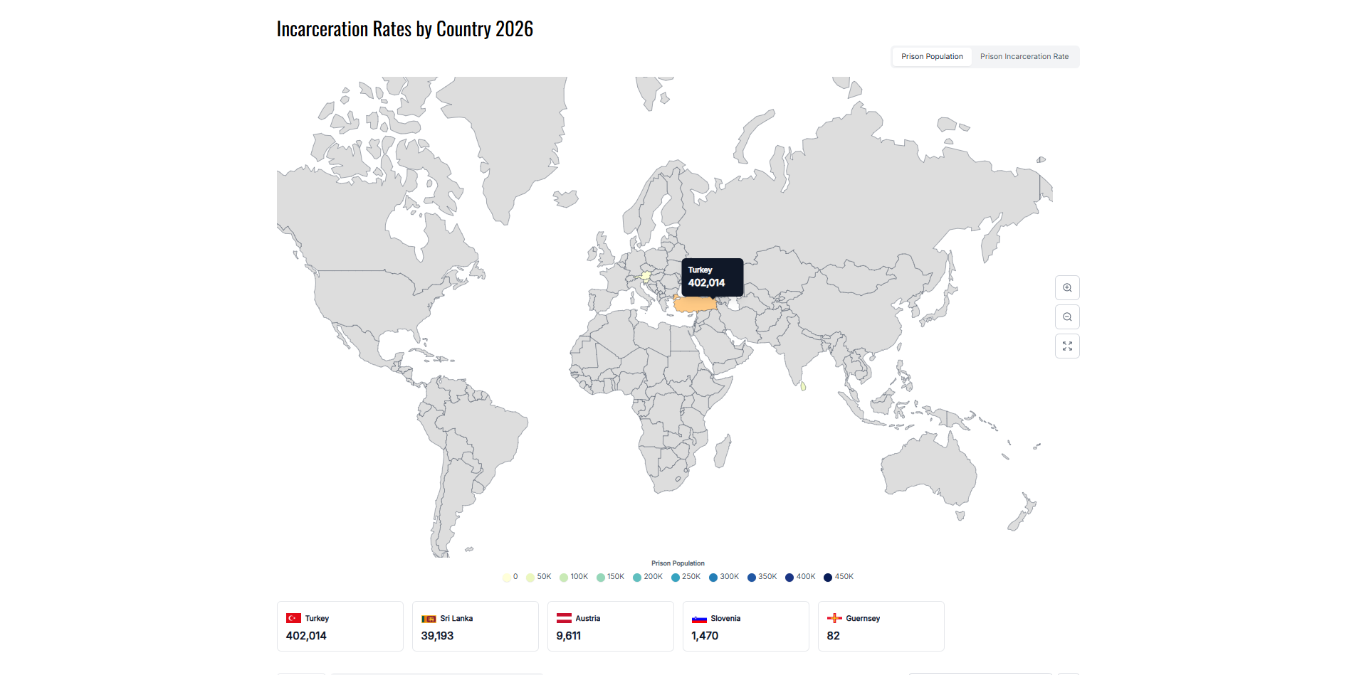
Q1. What appears to be the purpose of the chart?
To present global incarceration metrics across countries-either by raw volume (Prison Population) or relative density (Prison Incarceration Rate per 100k). However, temporal comparability is severely compromised: the historical 2025 view provides broad, worldwide coverage, while the 2026 view is virtually empty due to incomplete reporting, populating only a handful of nations (e.g., Turkey, Sri Lanka, Austria, Slovenia, Guernsey).
Q2. What kind of chart is this?
An Interactive Choropleth (Thematic Boundary) Map paired with floating UI metric toggles and supplemental ranked highlight cards / data table.
Q3. What data does it appear to be encoding and how is it encoding it (marks and channels)?
- Marks:
  - Areas / Polygons: National borders and coastlines projected onto a 2D world map.
  - Text / Cards: Floating tooltip callout boxes and bottom stat cards for granular numeric inspection.
- Channels:
  - Area Size (2D spatial extent): Encodes absolute quantitative magnitude (e.g., expenditure, file size, or portfolio asset valuation).
  - Spatial Containment / Nesting: Encodes parent-child structural hierarchies (parent sectors contain child divisions).
  - Color Hue: Encodes top-level nominal categories (e.g., parent industry sectors).
Color Luminance / Diverging Palette: Encodes an orthogonal secondary quantitative rate (e.g., year-over-year % growth or margin delta: red to green).
Q4. Are there any interactive features? If so, what are they and how are they used?
- Hover Tooltips: Hovering a cursor over an active nation reveals a dark pop-up card displaying the country's name and exact numerical value.
- Metric Switching Buttons (Tabs): A top-level toggle lets users switch between Prison Population and Prison Incarceration Rate (plus gender breakdowns in the 2025 table view).
- Manual Zoom and Reset Controls: Fixed buttons ($+$, $-$, and expand/reset) in the bottom-right corner let users adjust viewport scale; mouse-wheel scrolling directly on the map surface is disabled, required holding Control button while the mouse is on the map.
- Disconnected Data Table Controls: A separate table view features year-toggles (2019–2026) and search filtering, but these controls do not dynamically update or drive the map graphic.
- No Integrated Time-Slider on Map: Users cannot scrub through or toggle years directly within the map view, locking the map strictly to the selected view's year.
Q5. What features does it use to try to get its message across?
- Dynamic Palette Rescaling: Automatically remaps color bins depending on whether the user views raw headcounts (up to 450K) or per capita rates (up to $500$ or $1,800$).
- Highlight / Quick-Access Stat Cards: Anchored cards along the bottom showcase the top-reporting countries with national flags and values (e.g., Turkey: 402,014 / 468 per 100k) to prevent small nations from being missed visually.
- Strong Figure-Ground Contrast: The hovered country is highlighted in orange and paired with a dark tooltip, so it stands out clearly against the light-gray basemap.
- Comparative Weakness (Limitation): Due to strict year segregation and sparse 2026 data entry, the map communicates the state of incomplete data collection far more strongly than true comparative international trends.

Visualization 4: Ranked Horizontal Bar Chart (Dense Comparative Bar Chart / Scrollytelling Bar Chart)
Source: https://www.prisonpolicy.org/global/2024.html
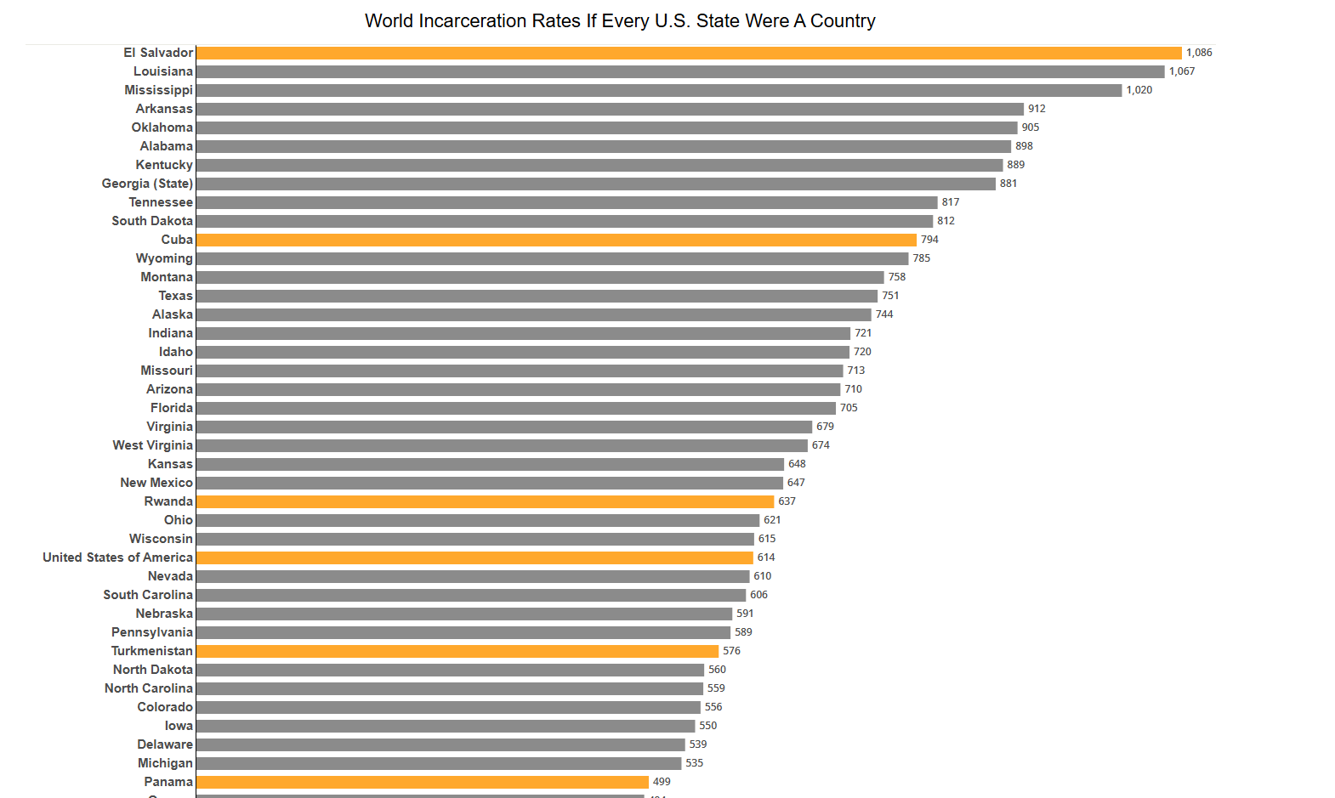
Q1. What appears to be the purpose of the chart?
To demonstrate how individual U.S. states compare to all sovereign nations globally by treating every U.S. state as an independent country. It illustrates that dozens of individual U.S. states have higher incarceration rates than nearly every country on Earth, placing them side-by-side with international outliers like El Salvador, Cuba, and Rwanda.
Q2. What kind of chart is this?
A dense, vertically extended Ranked Horizontal Bar Chart.
Q3. What data does it appear to be encoding and how is it encoding it (marks and channels)?
- Marks:
  - Bars (Rectangles): One bar for each jurisdiction (U.S. state or independent country).
- Channels:
  - Length / Horizontal Position: Encodes the primary quantitative variable—total incarceration rate per 100,000 population.
  - Vertical Position (Y-axis): Encodes discrete categorical entities (states and countries), arranged in descending rank order from highest to lowest rate.
  - Color Hue: Encodes entity type (orange/yellow denotes sovereign nations, while gray denotes individual U.S. states).
  - Direct Text Labels: Displays entity names on the left axis and exact quantitative rate figures directly to the right of each bar.
Q4. Are there any interactive features? If so, what are they and how are they used?
- Hover Tooltips: Hovering a cursor over a bar reveals a floating white-and-gray tooltip card echoing the entity's name and its exact incarceration rate (e.g., hovering over Cuba displays "Cuba / Incarceration Rate: 794").
- No Dynamic Filter, Sorting, or View Controls: The visualization lacks toggle filters, search bars, or interactive sorting buttons.
- Vertical Page Scroll: Users must manually scroll through a lengthy, tall webpage layout to traverse the full dataset from top-ranking outliers down to the lowest-ranking entities.
Q5. What features does it use to try to get its message across?
- Disaggregation Framing Strategy: By splitting the United States into its 50 individual states alongside sovereign nations, it visually reveals that high U.S. incarceration is not uniform, but concentrated in states like Louisiana (1,067) and Mississippi (1,020) that rival or surpass international peaks.
- Pre-attentive Color Separation: Bright orange/yellow highlights international benchmarks (and the national U.S. aggregate) against a sea of gray state bars, allowing viewers to quickly scan how many states sit above or between major world nations.
- Direct Value Labeling: Exact numeric values are placed at bar endpoints, removing visual ambiguity and eliminating the need to estimate lengths against an X-axis grid.
- Usability & Design Limitations:
  - Missing Color Legend: The chart fails to provide an explicit legend explaining that yellow represents nations and gray represents U.S. states, forcing readers to deduce the color logic from entity names alone.
  - Extreme Scroll Length / High Cognitive Load: Spanning every state and qualifying nation creates a massive vertical footprint, requiring sustained scrolling and making direct comparisons between top-ranked and bottom-ranked entities difficult.

Visualization 5: Interactive Horizontal Bar Chart (Ranked Benchmark Bar Chart with Dynamic State Comparison)
Source: https://www.prisonpolicy.org/global/2024.html
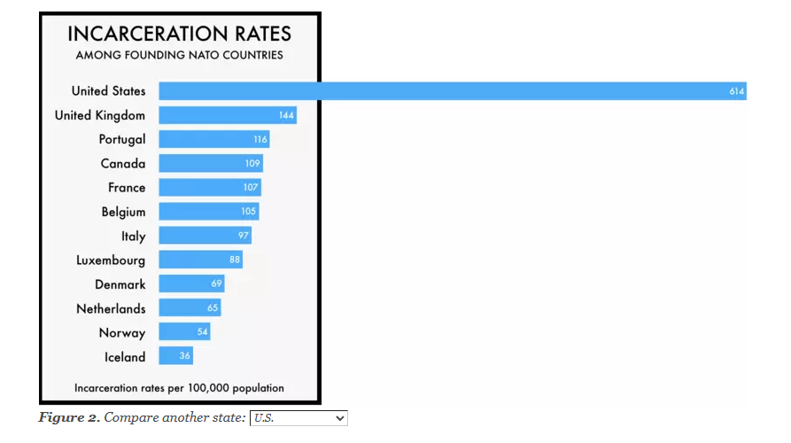
Q1. What appears to be the purpose of the chart?
To demonstrate how individual U.S. states compare to founding NATO member nations regarding incarceration rates per 100,000 population, proving that even compared to the already high U.S. national average (614), specific states (such as Georgia at 881 or West Virginia at 674) exhibit incarceration levels that dwarf international democratic allies.
Q2. What kind of chart is this?
A Ranked Horizontal Bar Chart with an integrated dynamic comparison baseline and state-selection dropdown.
Q3. What data does it appear to be encoding and how is it encoding it (marks and channels)?
- Marks:
  - Bars (Rectangles): Encodes each country or selected U.S. state.
  - Enclosing Frame / Border: Encodes the expected visual range boundary of the chart.

- Channels:
  - Length / Horizontal Position: Encodes the quantitative variable—incarceration rate per 100,000 population.
  - Vertical Position (Y-axis): Encodes categorical nominal entities (founding NATO nations and selected U.S. state/national baseline), sorted in descending order of rate.
  - Color Hue & Luminance:
- Distinct warm amber/orange highlights the dynamically selected state.
- Neutral dark charcoal/gray differentiates the overall U.S. national baseline.
- Muted mid-gray encodes all international comparison peers (or uniform light blue when only displaying the national U.S. baseline).
- Direct Text Labels: Explicitly displays the exact numeric rate at the tip of every bar.
Q4. Are there any interactive features? If so, what are they and how are they used?
- State Selection Dropdown Menu: A <select> dropdown positioned below the graphic allows readers to choose any specific U.S. state to benchmark against founding NATO members.
- Dynamic Text & Header Binding: Selecting a state from the dropdown updates the editorial paragraph above the graphic and the chart's subheader in real time to contextualize the chosen state (e.g., changing the prose to reference Georgia, Louisiana, or West Virginia).
- Quick-Reset Hyperlink: A text shortcut below the dropdown ("just the U.S. with its peers") resets the graphic back to the default national view.
Q5. What features does it use to try to get its message across?
- Literal "Off the Charts" Visual Metaphor: When an outlier state like Georgia (881) or West Virginia (674) is selected, its bar extends past the right border of the chart frame into open space, visually embodying the idiom "off the charts" used in the text.
- Intentional Benchmark Grouping: Compares U.S. jurisdictions specifically to founding NATO allies (stable Western democracies with comparable legal/economic baselines), eliminating arguments that the disparity is due to developing-nation governance differences.
- Selective Pre-attentive Color Pop: Graying out the peer nations while painting the selected state in bright orange instantly directs the reader's focus to the magnitude of the gap.
- Sorted Descending Rank: Arranging bars from highest to lowest establishes an immediate rank order, showing that even the lowest U.S. benchmark significantly exceeds the highest-ranking European founding ally (United Kingdom at 144).

Visualization 6: Hierarchical Sunburst Chart (Multi-Level Radial / Nested Donut Chart)
Source: https://www.prisonpolicy.org/reports/pie2024women.html
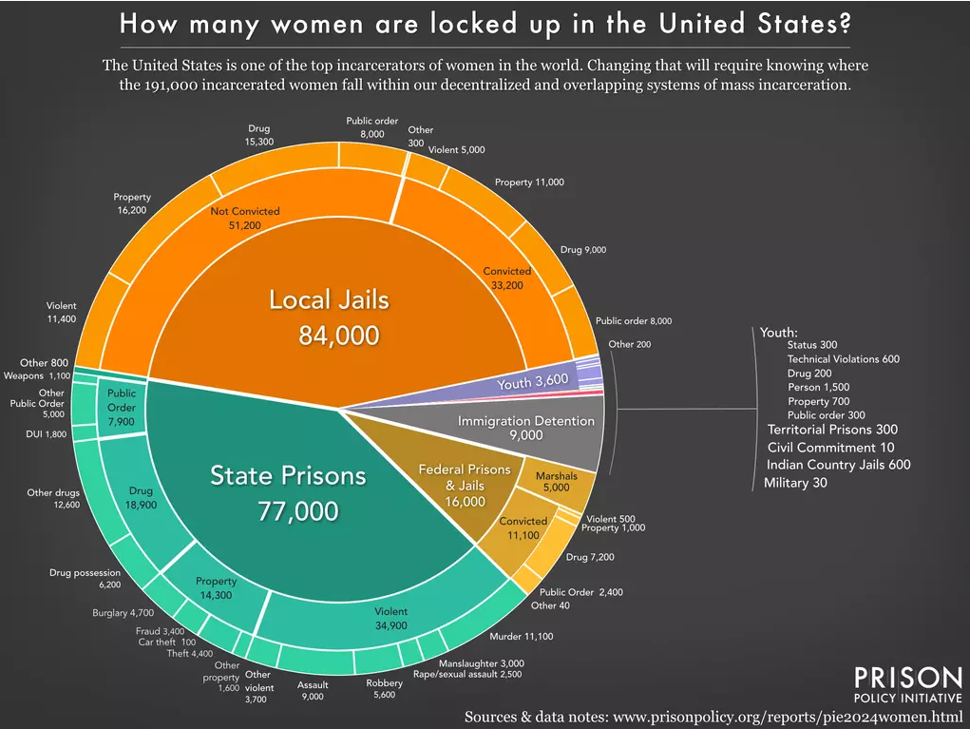
Q1. What appears to be the purpose of the chart?
To break down the total population of incarcerated women in the United States ($191,000$) across decentralized systems of confinement (local jails, state prisons, federal facilities, youth facilities, and immigration detention), exposing both their legal status (convicted vs. not convicted) and underlying offense types to show where reform efforts need to be directed.
Q2. What kind of chart is this?
A Hierarchical Sunburst Chart (Multi-Level Radial / Nested Donut Chart) accompanied by an itemized text callout list for small sub-categories.
Q3. What data does it appear to be encoding and how is it encoding it (marks and channels)?
- Marks:
  - Radial Sectors / Arcs: Nested angular slices forming concentric rings around the central point.
  - Text Marks & Dividing Lines: Radial boundary dividers and numerical labels placed directly inside or along the outer perimeter of each slice.
- Channels:
  - Angle / Arc Length: Encodes quantitative values (the relative share and headcount of incarcerated women in each category).
  - Radial Distance / Hierarchy (Concentric Layers): Encodes nested categorical levels—the innermost ring shows primary facility type, the middle ring shows conviction/adjudication status, and the outermost ring shows specific offense classifications (violent, property, drug, public order).
  - Color Hue: Encodes top-level confinement systems (orange for Local Jails, teal/cyan for State Prisons, yellow-gold for Federal Prisons & Jails, dark slate for Immigration Detention, and lavender/purple for Youth).
  - Color Luminance / Ring Borders: White borders visually separate nested sub-slices and crime categories within each parent segment.
Q4. Are there any interactive features? If so, what are they and how are they used?
- None (0 interactive features). It is a flat, static infographic image without clickable drill-downs, zoom capabilities, or dynamic hover tooltips.
Q5. What features does it use to try to get its message across?
- Hierarchical Slice Nesting: Seamlessly traces a broad total down to granular specifics within a single circular graphic (for example: Local Jails (84,000) $→$ Not Convicted (51,200) $→$ Property (16,200)).
- Visual Shock Value on Pretrial Detention: Visualizing the "Not Convicted" slice ($51,200$) as significantly larger than the "Convicted" slice ($33,200$) in local jails immediately highlights that a major portion of incarcerated women are locked up before even standing trial.
- Distinct Color Branching: Uses clear, contrasting hues for the major sectors so viewers can instantly distinguish local, state, and federal jurisdictions.
- Sidebar Offload for Micro-Categories: Categories with counts too small to display legibly as narrow wedges (such as Military: 30, Civil Commitment: 10, or Youth sub-offenses) are pulled out into a clean, text-based sidebar to prevent visual clutter while preserving data completeness.

Visualization 7: Hierarchical Semicircular Sunburst Chart (Multi-Level Nested Semicircle / Half-Donut Chart)
Source: https://www.prisonpolicy.org/reports/pie2024women.html
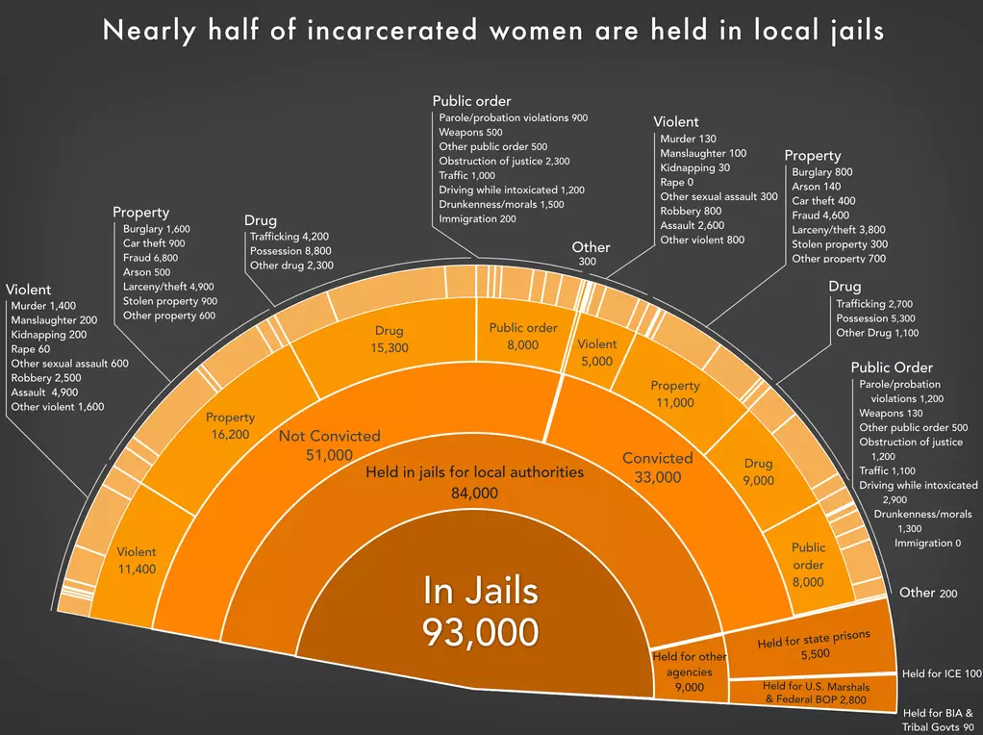
Q1. What appears to be the purpose of the chart?
To break down the population of women confined in local jails in the United States ($93,000$), demonstrating that the vast majority are held for local authorities ($84,000$) rather than other agencies, and that more than 60% of those women ($51,000$) are unconvicted and held pretrial, primarily for non-violent property and drug offenses.
Q2. What kind of chart is this?
A Hierarchical Semicircular Sunburst Chart (Nested Radial Semicircle Chart) with external callout annotations.
Q3. What data does it appear to be encoding and how is it encoding it (marks and channels)?
- Marks:
  - Radial Sectors / Arcs: Semicircular nested rings radiating outward from the central total.
  - Text Blocks & Leader Lines: Radial segment labels inside arcs, with fine-grained sub-offense itemizations arrayed around the outer curve.
- Channels:
  - Angle / Arc Length: Encodes quantitative magnitude (the number of incarcerated women in each jurisdiction, conviction tier, and broad offense category).
  - Radial Depth / Concentric Rings: Encodes nested categorical hierarchy:
    - Core: Total jail population ($93,000$).
    - Ring 1: Authority jurisdiction (Local authorities vs. Other agencies).
    - Ring 2: Legal status (Not Convicted vs. Convicted; or specific holding agency like State Prisons, U.S. Marshals/BOP, ICE, Tribal Govts).
    - Ring 3: Broad offense class (Violent, Property, Drug, Public order, Other).
  - Color Luminance & Hue: Monochromatic orange palette where subtle tint shifts and white stroke borders delineate adjacent wedges.
  - Text Labels: Encodes exact numerical counts and specific offense subcategories (e.g., fraud, possession, assault) directly along the perimeter.
Q4. Are there any interactive features? If so, what are they and how are they used?
- None (0 interactive features). It is a static editorial infographic with no interactive filtering, hover tooltips, click-to-expand segments, or zoom controls.
Q5. What features does it use to try to get its message across?
- Explicit Takeaway Headline: Leads with a clear editorial thesis ("Nearly half of incarcerated women are held in local jails") to frame the entire graphic before the reader dives into details.
- Pretrial Disparity Framing: Splitting the local authority arc into "Not Convicted" ($51,000$) versus "Convicted" ($33,000$) makes the disproportionate scale of pretrial detention visually unmistakable.
- Progressive Detail Unpacking: Guides the eye naturally from high-level institutional totals in the core outward to granular, specific statutory charges (e.g., Property $→$ Fraud 6,800, Drug $→$ Possession 8,800).
- Perimeter Callout Offloading: Moves dozens of small, detailed crime categories outside the chart arcs as text lists, preserving proportional accuracy in the slices without overcrowding the interior rings.
- Contrasting Background: Employs vibrant warm orange slices over a dark slate/charcoal background, maximizing contrast and visual pop.

Which design do you think is best and why?
In my view, Visualization 5, the interactive bar chart comparing U.S. incarceration rates with founding NATO countries (Prison Policy Initiative), is the most effective design among the seven. Visualization 2 (the Pew Research choropleth) is a close second.
Why Visualization 5 is the most effective
- Most effective channel for the key variable: The incarceration rate is encoded with bar length on a common, aligned scale, which Munzner ranks as the most accurate channel for magnitude. Readers can directly see that 614 is more than four times 144. In contrast, the maps (Visualizations 1–3) rely on area or color luminance, and the sunbursts (Visualizations 6–7) rely on angle, all of which are judged less precisely.
- Fair, normalized comparison: It uses rates per 100,000 rather than raw counts (unlike Visualization 1 and the default view of Visualization 3), so the differences are not simply a result of population size. Choosing founding NATO members as the peer group also gives a meaningful benchmark of similar democracies.
- Clear focus and low cognitive load: With only about a dozen bars, sorted in descending order and labelled with exact values, the chart can be read in seconds without a legend or scrolling. Visualization 4 shows similar data but requires scrolling through more than 60 bars.
- Interactivity that supports the message: The state dropdown lets readers compare their own state with the same peers, and the surrounding text and subtitle update to match. Unlike Visualization 3, whose map, table and year controls are disconnected, every interaction here strengthens the main story.
- Memorable visual metaphor: The U.S. bar breaking through the chart frame turns the phrase “off the charts” into a visual, which makes the message easy to remember.
Limitations of Visualization 5
The design is not perfect. It covers only twelve countries, so it cannot show the global picture that the maps provide. The state dropdown sits below the chart and is easy to miss, and the bar extending beyond the frame could be mistaken for a rendering error by some readers. When a state is selected, there is also no legend explaining the highlight colors.
Comparison with the other designs
- Visualization 2: Best for a global overview, with a clear takeaway headline, an ordered sequential palette and callouts for small countries, but area bias and 100-wide bins make precise comparison difficult.
- Visualizations 6 and 7: Strong storytelling about where women are held and why, but very dense and dependent on angle, so readers rely heavily on text labels.
- Visualization 4: Same accurate encoding as Visualization 5, but its length and missing color legend increase cognitive load.
- Visualization 1: Shows raw counts with no size legend, so it exaggerates the comparison without normalization.
- Visualization 3: Sparse 2026 data and a mismatch between title and metric weaken its message, despite having the richest interactivity.
Conclusion
Overall, Visualization 5 best follows the principle that the most important attribute should be encoded with the most effective channel, and it combines that accurate encoding with a focused comparison and purposeful interaction. An ideal design could combine the global overview of Visualization 2 with the ranked bar comparison of Visualization 5, linked so that selecting a country on the map highlights its bar in the chart.

