Lab Guide
LIDAR Point Cloud
Content Description
The following document describes a LiDAR point cloud implementation in either python or MATLAB software environments.

Lab Guide 1
Running the example 2
Details 3
Running the Example 4
Details 4

MATLAB
In this example, we will capture LIDAR data from the RP LIDAR A2 on the QCar platform, send the data to a polar plot, and generate a point cloud map. The process is shown in Figure 1.

Generate Point Cloud
Capture LIDAR data
Display Map
Figure 1. Component diagram

In addition, a timing module will be monitoring the entire application’s performance. The Simulink implementation is displayed in Figure 2 below.

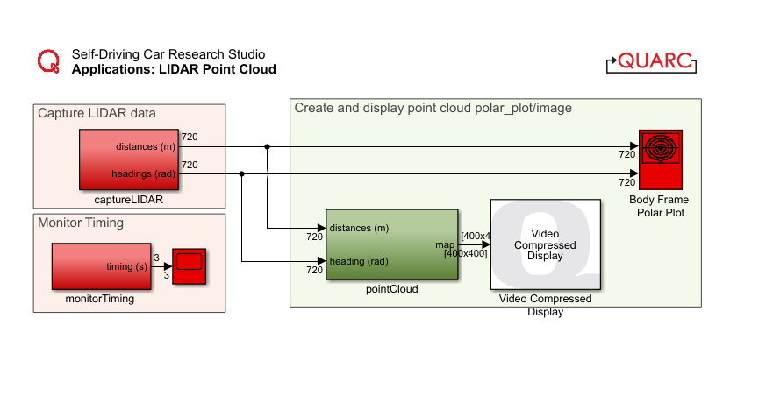
Figure 2. Simulink implementation of Lidar Point Cloud

Running the example
- Check User Manual – Software Simulink for details on deploying Simulink models to the QCar as applications.
- As your room size may vary, change the maximumDistance (m) parameter within the pointCloud subsystem accordingly, up to a maximum of 4m (corresponding to an 8 x 8 m room). Figure 3 shows the typical output expected when running this example.
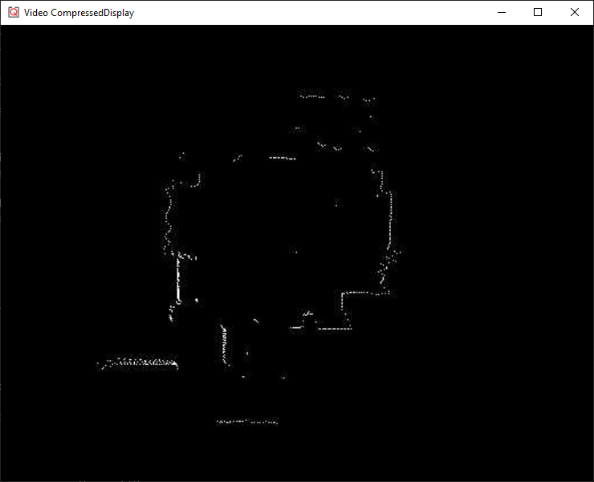
Figure 3. Point cloud map generated in a room.

Details
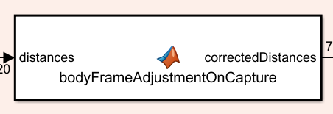
- Capturing LIDAR data
The RP LIDAR A2 reads data in a clockwise manner, starting from a position opposite to the data cable attached to it. On the QCar platform, this corresponds to the +y axis. To correct this, the captureLIDAR subsystem corrects the order of the data to start at the front and orient counterclockwise to follow standard convention in the bodyFrameAdjustmentOnCapture function.
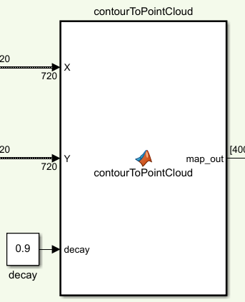
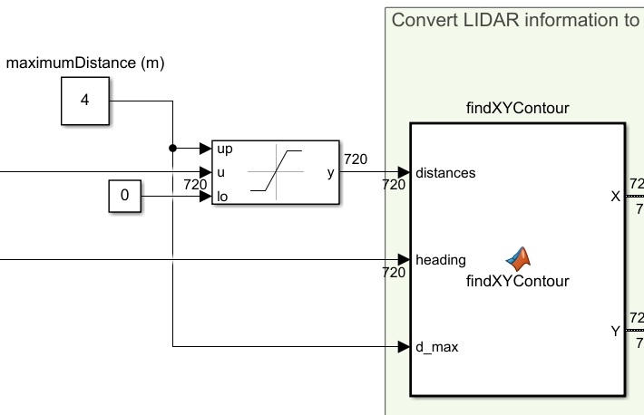
- Saturating the distances data meaningfully
To limit the scope of the data to a range, the distances data is dynamically saturated using the maximumDistance parameter. The findXYContour function then converts the distance/heading data pairs to X Y pairs. However, we would like the X Y points corresponding to the maximumDistance to not show up within the point cloud itself, as they simply correspond to a maximum range and not physical obstacles. To do so, the findXYContour also drops data points that are equal to the maximumDistance parameter.
- Generating the point cloud
This function first decays the existing map to 90%, thereby slowly erasing older data. The X Y data points in meters are converted to pixel scale pX and pY using a gain of 50 px/m for a map of size dim up to 400 pixels wide and tall (or 8m x 8m). Check out the documentation of MATLAB’s sub2ind for information on how the (row, col) pairs in (pX, pY) are converted to indices where the point cloud map will be set to 1. Adjust the decay parameter to change the rate of update of the map. Note that you can do this online while the application is deployed.

- Performance considerations
To improve performance, we only create a blank map on the first call by the use of persistent MATLAB variables. The variable map_internal holds its value at any given iteration into the next call. At the end of the function, the mapOut is updated and then displayed.

Python

In this example, we will capture LIDAR data from the RP LIDAR A2 on the QCar platform, and generate a point cloud map. The process is shown in Figure 4.
Generate Point Cloud
Capture LIDAR data
Display Map
Figure 4. Component diagram

Running the Example
Check User Manual – Software Python for details on deploying python scripts to the QCar platform. As your room size may vary, change the parameters dim and gain as you see fit. Figure 5 shows the typical output expected when running this example (via XLaunch).
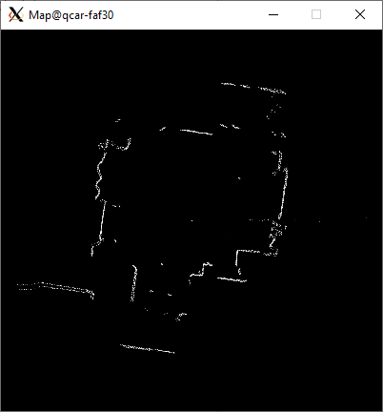
Figure 5. Point cloud map generated in a room.

Details
- Capturing LIDAR data
The data available using the LIDAR class is already adjusted to be presented counterclockwise starting at the positive X axis of the lidar frame (right direction). The LIDAR class object has two attributes, distances and angles, that correspond to the data. The first line below shows the initialization step, and the second shows how to read the data.

myLidar = Lidar(
type='RPLidar',
numMeasurements=numMeasurements,
rangingDistanceMode=lidarMeasurementMode,
interpolationMode=lidarInterpolationMode)

myLidar.read()

- Converting distances/angles to x y
After heading angles are converted from lidar frame to QCar body frame, the distance/heading data pairs are converted to x y pairs (in meters) using the lines below, and then to pX pY pairs (in pixels) for the image.

x = myLidar.distances[idx]*np.cos(anglesInBodyFrame[idx])
y = myLidar.distances[idx]*np.sin(anglesInBodyFrame[idx])

pX = (sideLengthScale/2 - x*pixelsPerMeter).astype(np.uint16)
pY = (sideLengthScale/2 - y*pixelsPerMeter).astype(np.uint16)

- Generating the point cloud
Note that the map is set to zeros at the beginning.
map = np.zeros((dim, dim), dtype=np.float32)

It is then decayed slowly using the decay parameter at the start of the loop.
map = decay*map
A line below updates the map at the locations pX pY near the end of the loop.
map[pX, pY] = 1

- Performance considerations
To improve performance, we only create a blank map when initializing the code. Within the main loop, older map data is slowly decayed. The module opencv provides the waitKey() method for pausing in this case. See User Manual – Software Python for more information on timing.

