Lab Guide

360 Vision

Content Description
The following document describes a image stitching example in both MATLAB and Python software environments utilizing the virtual QCar.

Content Description 1
Lab Description 1
MATLAB 2
Running the example 2
Details 3
Python 3
Running the example 3
Details 3

Prior to starting the example please go to the Cityscape Lite workspace and run the qlabs_setup_applications.py python script to configure the virtual world.

Lab Description
In this example, we will capture images from the four CSI cameras at the same resolution and frame rate. These will be stitched together, and passed to a display module.
Capture image from CSI
(right)
Stitch
together
Display
Monitor Timing
Capture image from CSI
(rear)
Capture image from CSI
(left)
Capture image from CSI
(front)
Figure 1. Component diagram

MATLAB
The Simulink implementation is displayed in Figure 2 below.
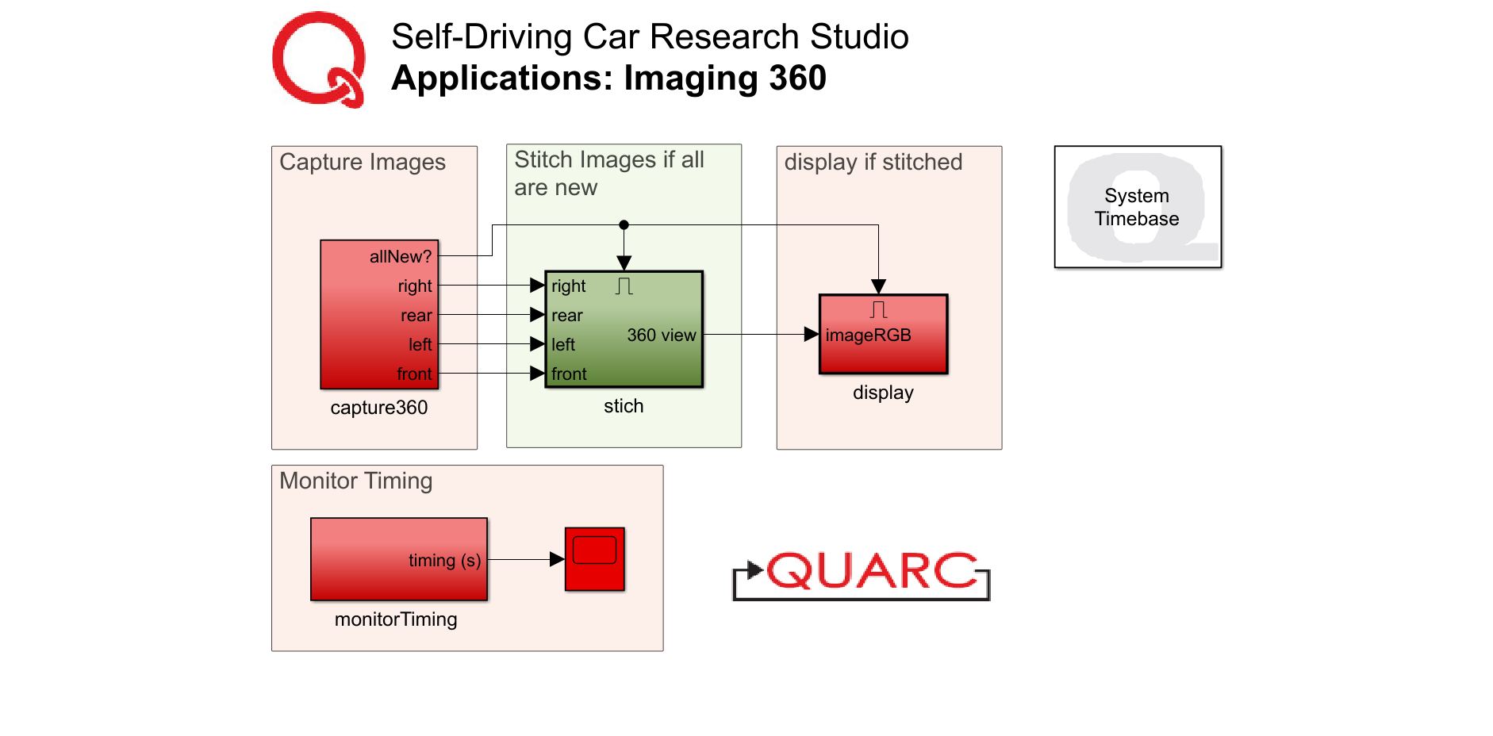
Figure 2. Simulink implementation of 360 Vision

Running the example
To run examples for virtual QCar please go to the SIMULATION tab in the ribbon interface and click on the Run icon.

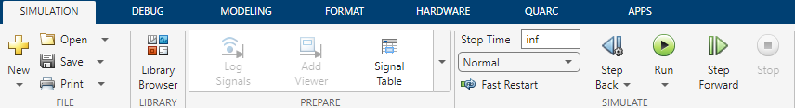

The output in the Video Display block should look like Figure 3. (The order of stitching is Right, Rear, Left, and Front)
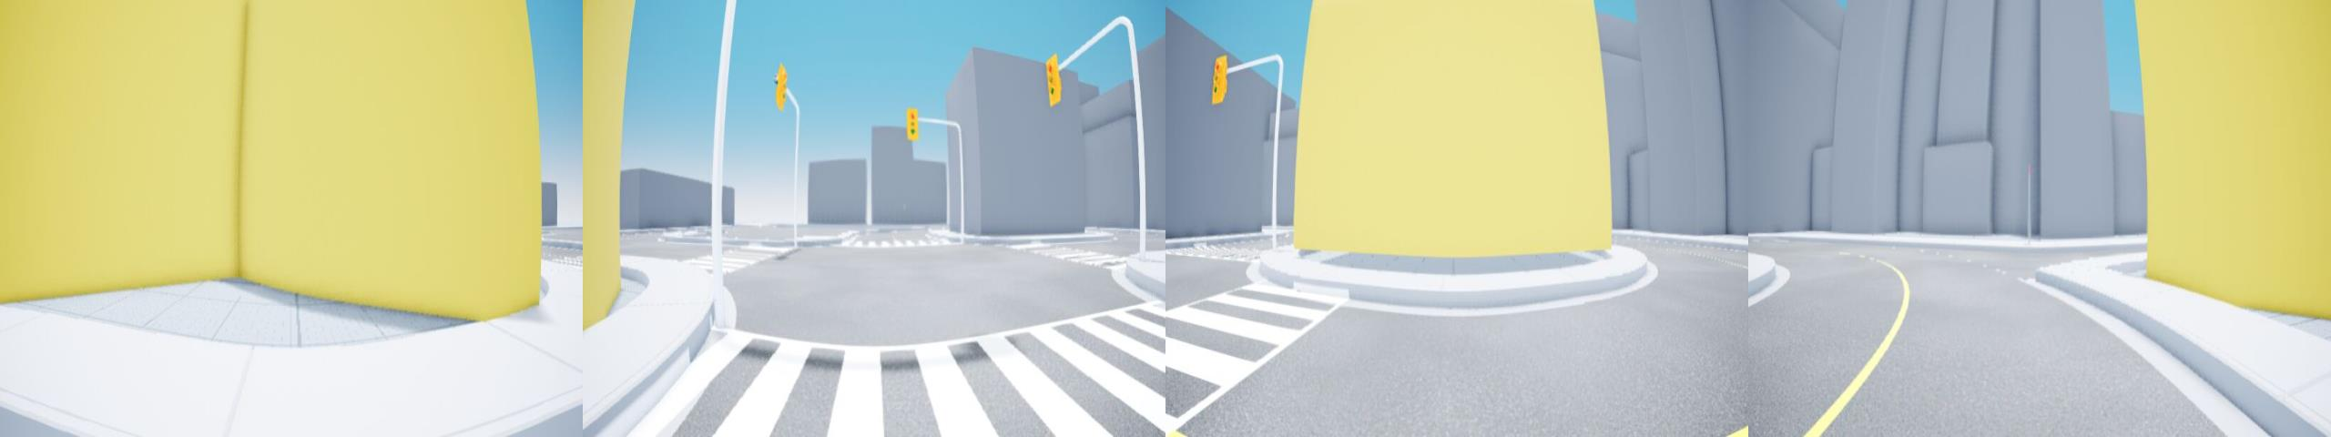
Figure 3. 360 view output showing images stitched together

Details
The implementation has a few important elements that help boost performance. The model is deployed at 30 Hz with each camera streaming a 640 x 480 RGB (3 channels) unsigned integer image (8 bits or 1 byte per data sample). The data rate can be estimated as,

In the implementation provided, the images are stitched together only when all the images are new. The Video Capture block in the capture360 module also outputs a new signal that is high (1) when the image is new. The four new signals are passed into a logical AND, which is then used to stitch images and display them, improving performance.

Note that a simple matrix concatenate method is used here to stitch the images together side by side. Alternatively, you may consider lens distortion correction on the raw images first, and using feature matching to remove translational and rotational discrepancies in the placements of the 4 cameras.

Python

Running the example
Check User Manual – Software Python for details on deploying python applications. Run the imaging_360.py example on your local machine. The output in the cv2.imshow() function should look like Figure 2. Just like before the order of stitching the images is still Right, Rear, Left, and Front.
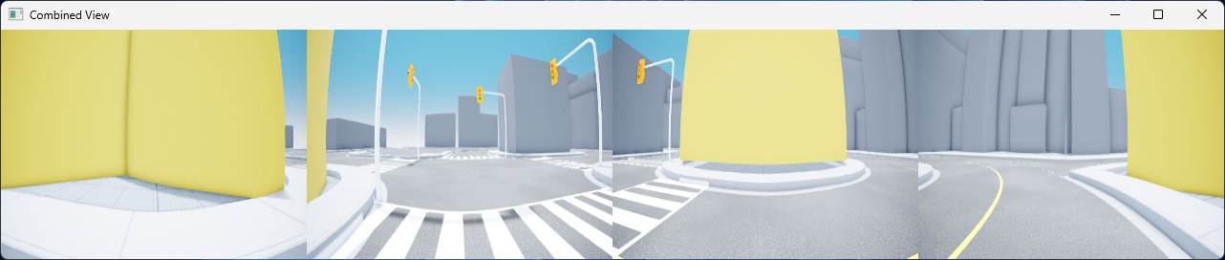
Figure 4. 360 view output showing images stitched together

Details
The implementation maintains the same structure as the simulink example by combining all 4 images into a single displayed image.

# Creating a combined 360 view
imageBuffer360 = np.concatenate((cameras.csiRight.imageData,
cameras.csiBack.imageData,
cameras.csiLeft.imageData,
cameras.csiFront.imageData),
axis = 1)

Note that a simple matrix concatenate method is used here to stitch the images together side by side. The script runs in a while loop at 30Hz The cv2.waitKey(msSleepTime) will pause the loop for the time difference between the sample time and computation time.

