Lab Guide

Manual Drive

Content Description
The following document describes a Manual Drive implementation in either python or MATLAB software environments utilizing the virtual QCar.

Content Description 1
MATLAB 1
Running the example 2
Guide 2
Python 3
Running the example 3
Guide 3

Prior to starting the example please go to the Cityscape Lite workspace and run the qlabs_setup_applications.py python script to configure the virtual world. The MATLAB example will use the user keyboard to drive the virtual QCar while the python example will utilize the Logitech gamepad which comes with the SDCS studio.

MATLAB
In this example, we will capture commands from a Gamepad and use it to manually drive the QCar platform. The application will also display the percentage battery remaining, power consumption in Watts as well as the car’s speed in m/s. The process is shown in Figure 1.
Monitor Timing
Interpret to Application Context
Capture Gamepad Commands
QCar I/O
Indicators and Lamps
Speed Estimation
Power Monitor
Figure 1. Component diagram

In addition, a timing module will be monitoring the entire application’s performance. The Simulink implementation is displayed in Figure 2 below.
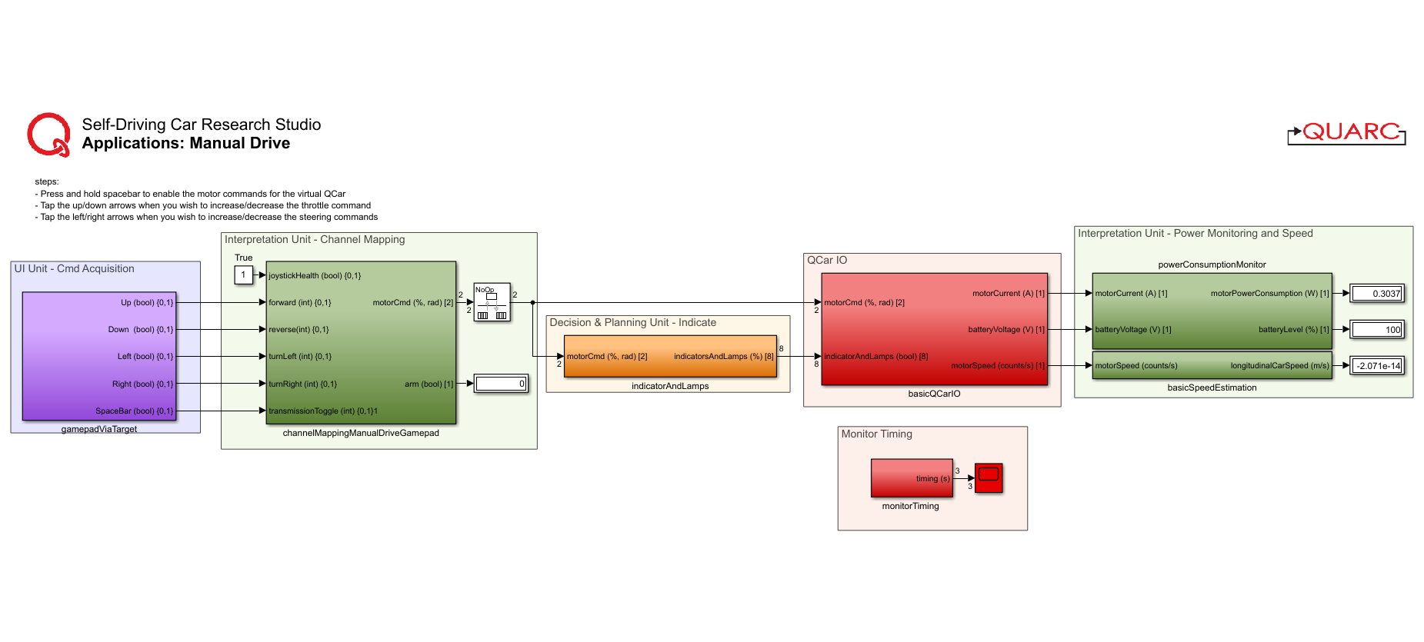

Figure 2. Simulink implementation of Manual Drive

Running the example
To run examples for virtual QCar please go to the SIMULATION tab in the ribbon interface and click on the Run icon.

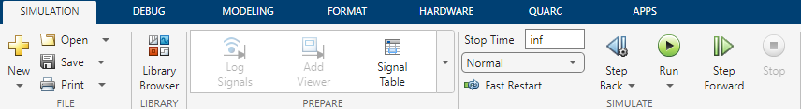

Guide

- Driving manually is mapped to the following keyboard commands:

a. Press and hold spacebar to enable the motor commands for the virtual QCar
b. Tap the up/down arrows when you wish to increase/decrease the throttle command
c. Tap the left/right arrows when you wish to increase/decrease the steering commands

- The LEDs are in the following states
  - Headlamps are always on. The reverse indicators (white) are on in Reverse.
  - Brake lamps are on when the absolute speed of the vehicle is decreasing.
  - Left/right indicators turn on when the corresponding steering is over a threshold

Python

The application will also calculate the car’s speed from encoder counts. The process is shown in Figure 3.
Interpret to Application Context
Capture Gamepad Commands
QCar I/O
Indicators and Lamps
Estimate Speed
Figure 3. Component diagram

Running the example
- Check User Manual – Software Python for details on deploying python applications. Run the task_manual_drive.py example on your local machine. Please make sure the Logitech gamepad is connected to the host computer prior to running the example.
- There are two ways to drive the car. If users set the configuration to 3 in the script, the Gamepad’s right stick longitudinal axis is used for the throttle, the left stick lateral axis is used for steering, and the LB button is used to arm the QCar. If users set the configuration to 4 in the script, the right trigger RT is used to provide positive throttle in the forward/reverse directions based on the state of the button A.

Note: If the steering does not appear to work, please ensure the mode light on the gamepad is off.

Guide

- Encoder counts to linear speed
The pal.utilities.math module contains the differentiator_variable method within the Calculus class. This module is used to calculate counts/s as the virtual QCar drives in the environment. Initialized with the sampleTime, you can set the actual step size within the main loop when calling the differentiator, accounting for variable sample time. The constant CPS_TO_MPS lets us convert the count/s value to meter/s used to estimate the linear speed of the Virtual QCar.
Note: Don’t forget to initialize the differentiator using the next method!

# Set up a differentiator to get encoderSpeed from encoderCounts
diff = Calculus().differentiator_variable(sampleTime)
_ = next(diff)
timeStep = sampleTime

# ============== Inside main while loop ==============
## Estimate linear speed in m/s
encoderCounts = myCar.motorEncoder # Get encoder data from DAQ
encoderSpeed = diff.send((encoderCounts[0], timeStep))
# Convert from counts/s to meter/s
linearSpeed = encoderSpeed*myCar.CPS_TO_MPS

- Performance considerations
We run the example at 50 Hz. The os module is used here to clear the terminal screen whenever new gamepad updates are received. Although this is expensive and isn’t the best thing to do, we account for the slower sample rates by using the variable sample time differentiator instead of a static one. Without accounting for the variable sample times, the differentiator will underestimate sample times and thereby overestimate the speed. Comment out the system screen clear as well as the print statement (similar to the snippet below) to improve performance up to 500 Hz.

if new:
os.system('cls')
print(...)

