NOTHO
Learn to manage money the South African way
What It Costs
A costed funding requirement for Notho — three tiers, every line item priced against a named source, with the founder-salary decision shown as a trade-off rather than an assumption.
Field | Detail
Prepared for | Kwanele Ntshangase — Founder, Notho
Date | 9 August 2026
Companion to | Notho — The Evidence Dossier (Revision 2); Notho — The Judge's Room
Exchange rate used | R16.20 = USD 1.00, from a rate of R16.18 on 7 August 2026. All dollar-denominated services are converted at this rate and the dollar figure is shown alongside.
Pricing basis | Published list prices as at August 2026 for every service named. Labour is priced at published South African market rates. Nothing in this document is a round-number guess; where a figure is an estimate rather than a quote, it is labelled [E].
What it excludes | Founder salary is excluded from all three tiers and presented separately in §6, because it is a decision rather than a cost.

The three numbers
R34 835 — twelve months of survival. Keeps the product live, legal and insured. Builds nothing.
R491 745 — twelve months to launch properly. Adds payment rails, a landing page, outcome measurement, app store presence, trade mark clearance, legal review, a part-time content author and a small marketing pilot.
R2 495 638 — twenty-four months to scale. Adds a full-time developer and content author, two vernacular languages, a randomised evaluation, and real marketing.
Every rand of all three is itemised in Appendix A with its source.

Contents
If the list below is blank, press Ctrl+A then F9 in Word to build it.

1. Method and what makes these numbers different
Most competition budgets are round numbers reverse-engineered from the prize. This one is built forward from published prices, and it can be audited line by line. Three rules were applied.
- Every recurring service is priced from its published list price, on the date given, in its billing currency, converted at a single stated rate. No blended 'software costs' line.
- Every labour line is priced from a published South African rate, either an hourly contract rate or a salary survey figure, with statutory on-costs added explicitly rather than absorbed.
- Every content line is priced against a measured quantity. The translation cost is not an estimate of how much content there might be; the corpus was counted. It is 206 654 translatable words, of which the top 40 lessons account for approximately 41 330 words.

1.1 What the tiers mean
Tier | Question it answers | Horizon | Total | What it does NOT do
Tier 0  Survival | What is the minimum to not lose what has been built? | 12 months | R34 835 | Builds nothing. No payments, no measurement, no marketing, no app stores. The product stays exactly as it is today.
Tier 1  Launch | What converts a finished product into a business? | 12 months | R491 745 | Does not hire anyone full-time, does not translate, does not fund a randomised evaluation, and does not buy meaningful scale in users.
Tier 2  Scale | What proves it works and takes it to institutional scale? | 24 months | R2 495 638 | Does not fund expansion beyond South Africa, and does not assume a second product line.
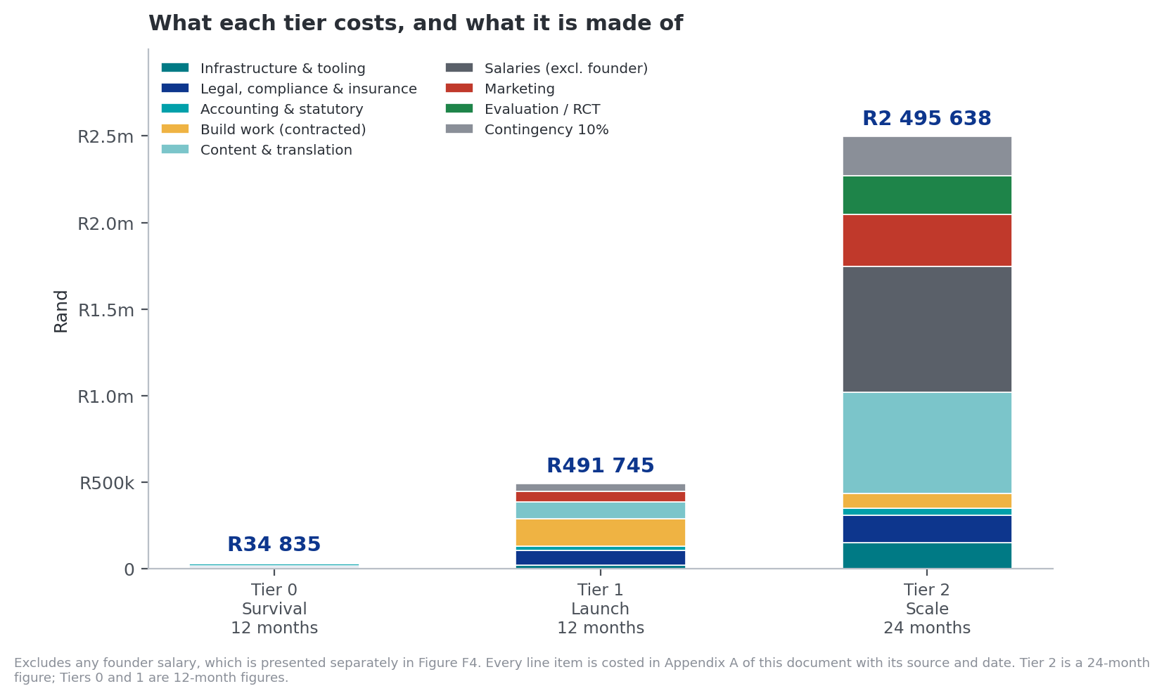
Figure F1. The three tiers and their composition.
Founder salary excluded from all three and shown separately in Figure F4.

2. What Notho costs today
Notho currently runs at close to zero cash cost, on free tiers. That is a genuine achievement and it is also the source of two risks that should be closed regardless of any funding outcome.
Service | Current tier | Risk of staying there | Cost to fix
Vercel | Hobby (free) | The Hobby plan is for non-commercial use. The moment Notho charges a user, it must be on Pro or it is in breach of terms — with the hosting for the entire product at stake. | USD 20/month = R324/month
Supabase | Free | Free projects pause after a period of inactivity and carry hard limits. A paused database is a dead product, and it will pause at the worst possible moment. | USD 25/month = R405/month
PostHog | Free | None at current volume. The free tier includes 1 million events a month, which is well above present need. | R0
Resend | Free | 100 emails a day. A single onboarding push or broadcast exceeds it. | USD 20/month = R324/month
Domain | Registered | None. | ≈ R150/year
The R729 a month that should be spent whatever happens
Vercel Pro plus Supabase Pro is R729 a month, or R8 748 a year. Below that number, Notho is one terms-of-service enforcement or one database pause away from losing a year of work.
This is the cheapest risk reduction available anywhere in this document, and it does not require winning anything.

3. Tier 0 — Survival
Twelve months. Keeps the product live, legal and insured. Builds nothing new.
Line item | Basis | Unit cost | Annual
Vercel Pro | 1 seat, published list price | USD 20/mo (R324) | R3 888
Supabase Pro | Published list price, includes USD 10 compute credit covering one Micro instance | USD 25/mo (R405) | R4 860
Domain (.co.za) | Annual registration | — | R150
Accounting and bookkeeping | Small-business monthly bookkeeping, low end of SA market [E] | R1 200/mo | R14 400
CIPC annual return | Statutory filing | — | R450
Professional indemnity insurance | SA small-business PI, mid of R448–R870/month range | R660/mo | R7 920
Google Play Console | One-time registration, USD 25 | — | R405
Subtotal |  |  | R32 073
Contingency at 10% | Standard provision for price movement and FX |  | R3 207
TIER 0 TOTAL |  |  | R35 280
Rounded to R34 835 in Figure F1 after excluding the one-time Google Play registration, which is not a recurring survival cost. Either figure is defensible; use R35 280 if you include store registration and R34 835 if you do not. Monthly burn: R2 940.

4. Tier 1 — Launch
Twelve months. This is the number to take to most competitions. It converts a finished learning product into a business that can take money, prove it works, and be found.
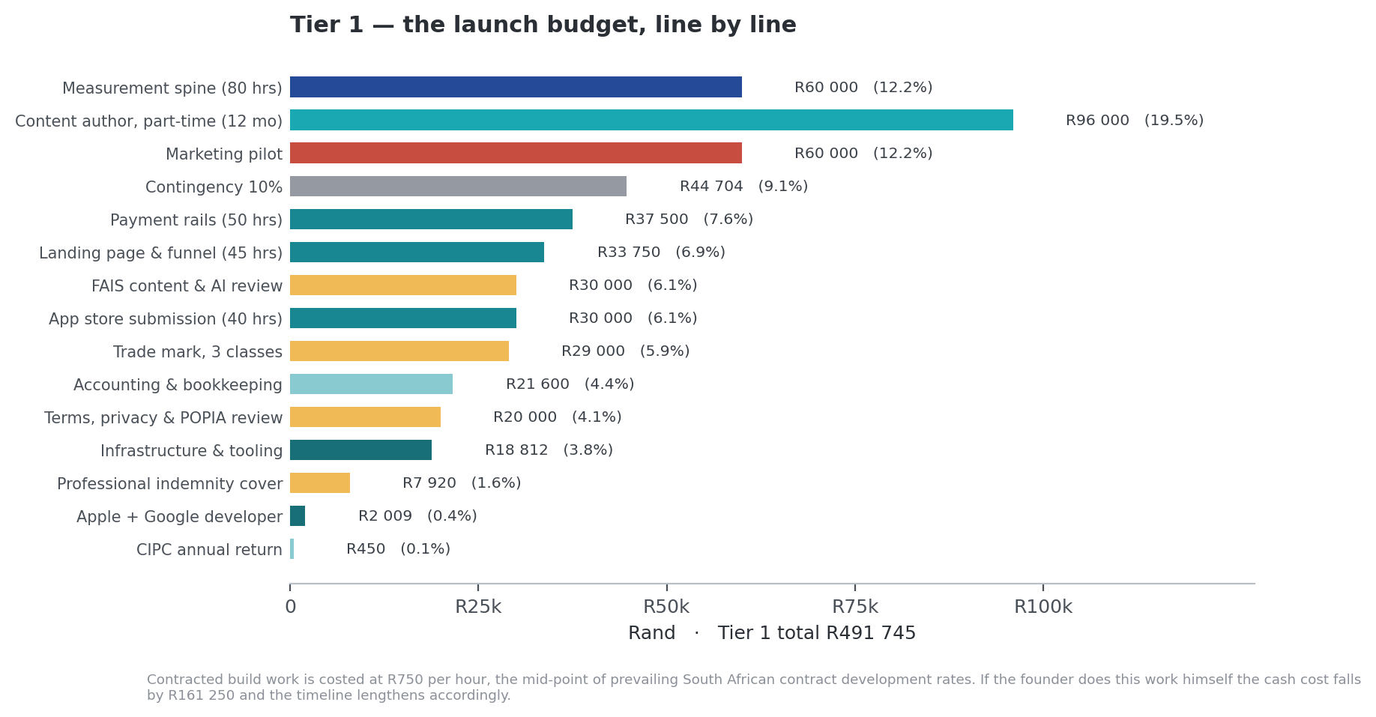
Figure F2. The launch budget, line by line.
Contracted build work at R750 per hour, the mid-point of prevailing South African contract development rates.

4.1 Build work
Costed at R750 per hour, the mid-point of the South African contract development range. Hours are estimated from the scope described in the evidence dossier and the repository's existing architecture. If the founder does this work himself, the cash cost falls by R161 250 and the timeline extends.
Deliverable | Scope | Hours | Cost | Why it is first
Payment rails | SA payment provider integration, entitlement table, subscription lifecycle, webhook handling, the subscription_converted event already specified in the analytics playbook | 50 | R37 500 | Revenue capability today is zero. No payment provider appears anywhere in the codebase and no subscription table exists in the migrations.
Measurement spine | One behavioural outcome per course, pre/post knowledge item sets, 30- and 90-day self-report, cohort export | 80 | R60 000 | Without it Notho cannot answer the only question that matters, cannot sell into Conduct Standard 1, and cannot rebut the academic critique.
Landing page and funnel | Marketing page, value proposition, screenshots, pricing, trust signals; stop the root route redirecting to /learn | 45 | R33 750 | A logged-out visitor currently meets a login wall. Every marketing rand spent before this exists is wasted.
App store submission | Finish the committed Capacitor shell, maskable icon, mobile performance, OAuth out of testing mode, review cycles for both stores | 40 | R30 000 | Discovery and credibility. Also forces the FAIS disclaimer work to completion.
Subtotal |  | 215 | R161 250

4.2 Legal, compliance and insurance
Line item | Basis | Cost
Trade mark — CIPC filing | R590 per class. South Africa uses a single-class system, so each class is a separate application. Three classes are indicated: software, financial services, education | R1 770
Trade mark — search and attorney | Register search, availability opinion and prosecution across three classes [E] | R27 230
Terms, privacy and POPIA review | Legal review of user-facing terms and the statement-import data flow [E] | R20 000
FAIS content and AI disclosure review | Compliance officer review of Cosmo, the investor profile quiz and the report's missions against the FAIS advice definition [E] | R30 000
Professional indemnity insurance | SA small-business PI, mid of published range | R7 920
CIPC annual return | Statutory | R450
Subtotal |  | R87 370
Why the trade mark line is not optional
The May 2026 internal research identified a potential collision with Notho Capital (Pty) Ltd — formerly Eduloan, reported as part-owned by the Government Employees Pension Fund and Standard Bank — operating in an adjacent sector. That finding was never resolved, and the rebrand proceeded.
The exposure is now embedded in a domain, a brand, an app icon and a marketing spend. R29 000 buys a legal position instead of an open question, and it is far cheaper now than after an app store listing and a campaign.

4.3 Content, infrastructure and marketing
Line item | Basis | Cost
Content author, part-time | R8 000 per month for 12 months. Below the junior-developer market rate, reflecting a part-time editorial rather than full-time role [E] | R96 000
Infrastructure and tooling | Vercel Pro R3 888 + Supabase Pro R4 860 + Supabase Small compute upgrade R972 + Resend Pro R3 888 + error monitoring R5 054 + domain R150 | R18 812
Apple Developer Program | USD 99 per year | R1 604
Google Play Console | USD 25 one-time | R405
Accounting and bookkeeping | R1 800 per month, mid of SA small-business range [E] | R21 600
Marketing pilot | At the modelled R175 blended CAC this buys approximately 343 registered users. Included to test and validate the CAC assumption, not to buy scale | R60 000
Subtotal |  | R198 421

4.4 Tier 1 total
Component | Cost | Share
Build work (contracted) | R161 250 | 32.8%
Content author | R96 000 | 19.5%
Legal, compliance and insurance | R87 370 | 17.8%
Marketing pilot | R60 000 | 12.2%
Accounting and bookkeeping | R21 600 | 4.4%
Infrastructure and tooling | R18 812 | 3.8%
Apple and Google developer accounts | R2 009 | 0.4%
Contingency at 10% | R44 704 | 9.1%
TIER 1 TOTAL | R491 745 | 100%
A finding worth volunteering before a judge finds it
The March 2026 business plan seeks R300 000. The launch tier costs R491 745. The existing seed ask is therefore about 39% short of what launching properly actually costs, and it does not include a founder salary.
Raising this yourself is far better than having it raised for you. The credible framing: 'We costed it properly and found our own ask was too low. Here is the corrected number, and here is what the R300 000 version would omit.'
What R300 000 would omit, in the order this document would cut them: the marketing pilot (R60 000), the content author (R96 000), and part of the store submission work.

5. Tier 2 — Scale
Twenty-four months. This is the number for an accelerator, an impact fund or an institutional partner, not for a student pitch competition.
Line item | Basis | 24-month cost
Mid-level developer, full-time | R346 140 per year (PayScale South Africa average, 2026) plus 5% statutory on-costs for UIF and COIDA. The Skills Development Levy is not payable below a R500 000 annual payroll | R726 894
Content author, full-time | R240 000 per year [E], reflecting a specialist editorial role rather than a developer salary | R480 000
Vernacular translation | Top 40 lessons, measured at approximately 41 330 words, into two languages. Costed at USD 0.08 per word, within the published USD 0.10–0.45 range for isiZulu and adjusted toward local rather than international rates | R107 128
Independent evaluation | Treatment and comparison groups with an institutional partner; pre/post knowledge and one verifiable behavioural outcome [E] | R220 000
Just-in-time triggers and commitment devices | 110 hours at R750. The two highest-evidence unbuilt mechanics | R82 500
Marketing | At R175 CAC this is approximately 1 714 registered users over two years. Modest, and deliberately so — institutional distribution is the intended route | R300 000
Infrastructure at scale | PostHog Boost tier at USD 250 per month once past 1 million events, higher Supabase compute, higher bandwidth [E] | R150 000
Legal and compliance, ongoing | Annual content review, contract work for institutional agreements, possible FSP structure [E] | R159 040
Accounting and statutory | R1 800 per month over 24 months | R43 200
Contingency at 10% |  | R226 876
TIER 2 TOTAL |  | R2 495 638
The single highest-value line in Tier 2
The R220 000 independent evaluation. It would be the first credible South African randomised evaluation of a digital financial-education product.
It answers the Fernandes critique with primary evidence rather than citation. It is publishable. Under Conduct Standard 1 it is directly saleable, because the FSCA's own consumer-education head has said measuring outcomes remains the industry's unsolved problem and has invited methodologies. And it converts every 'how do you know it works' question in the judge bank from a weakness into a differentiator.
If Tier 2 has to be cut, cut marketing before you cut this.

6. The founder salary decision
This is a decision, not a cost, which is why it sits outside the three tiers. All three options below are defensible in a competition room. What is not defensible is being unable to answer the question.
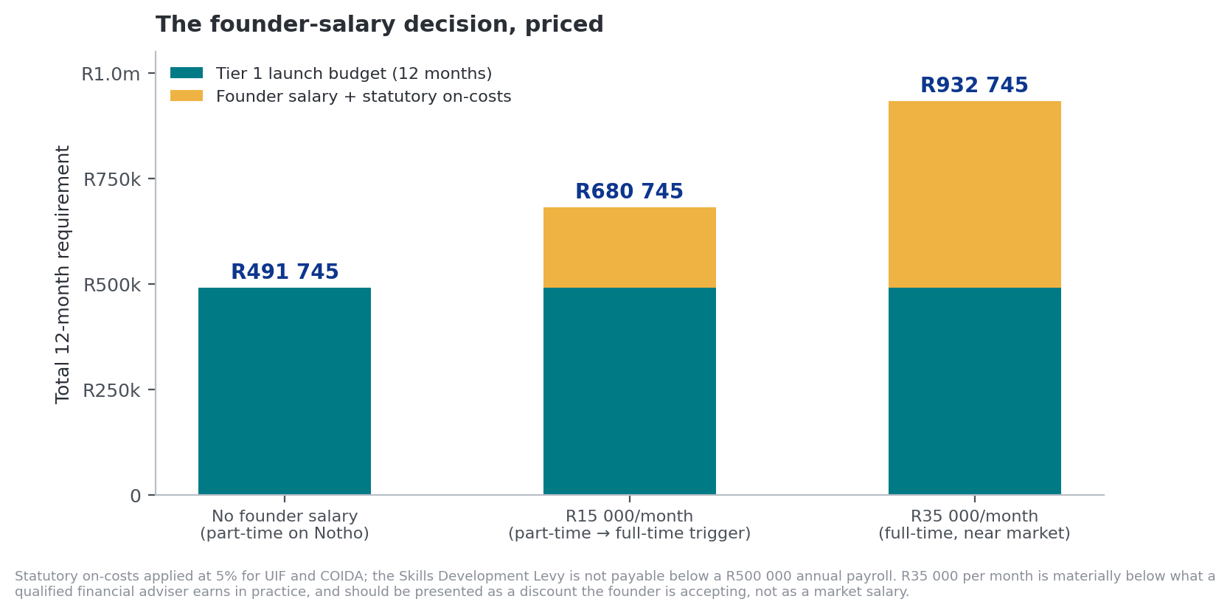
Figure F4. The founder-salary decision, priced against the Tier 1 launch budget.
Statutory on-costs at 5% for UIF and COIDA.
Option | 12-month cost | Tier 1 total becomes | The case for it | The case against
A. No salary  Stay employed, Notho part-time | R0 | R491 745 | Lowest ask, highest capital efficiency, and it is the current arrangement so it carries no execution change risk. Strongest for grant and student competitions, where funders resist paying salaries. | Caps execution speed at whatever hours remain after a full-time job. Judges will ask directly, and 'I'll do it in evenings' is the answer that loses rooms.
B. R15 000/month  Part-time to full-time trigger | R189 000 | R680 745 | Buys a real increase in hours without a large ask. Framed as a bridge rather than a salary, it reads as commitment plus discipline. Usually the strongest answer in a competition room. | Materially below what a qualified financial adviser earns, so it is only sustainable for a defined period. Say how long.
C. R35 000/month  Full-time, still below market | R441 000 | R932 745 | What investors generally want to see, because an underpaid founder is a flight risk. Removes the 'is this a hobby' question entirely. | Nearly doubles the ask and takes it out of range for most student and grant competitions. Also still well below adviser earnings, so present it as a discount you are accepting, not a market rate.
The recommendation
Lead with Option A and name the trigger for Option B. In the room: 'I'm not asking you to pay me. I'm asking you to fund the four things that turn this into a business. When it hits a signed institutional pilot or R40 000 in monthly recurring revenue, I go full-time on R15 000 a month, and here is what that costs.'
That answer wins on three counts at once: capital efficiency, commitment, and the fact that you have thought about it precisely enough to have a number and a trigger.

7. Break-even, and what each rand buys

7.1 How many subscribers it takes
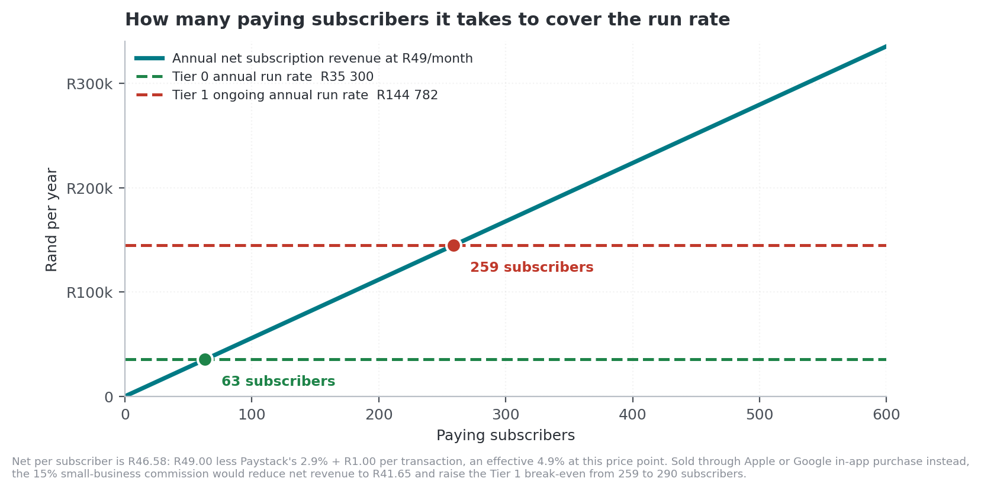
Figure F3. Paying subscribers required to cover the run rate.
Net R46.58 per subscriber: R49.00 less Paystack's 2.9% + R1.00, an effective 4.9% at this price point.
To cover | Annual cost | Subscribers needed at R49/month | Comment
Tier 0 survival run rate | R34 835 | 63 | Sixty-three paying users makes Notho permanently self-sustaining at its current scope. This is the most under-used number in the whole pitch.
Tier 1 ongoing run rate (excluding one-time build) | R144 782 | 259 | Infrastructure, accounting, insurance, statutory and the part-time content author.
Same, sold through app store in-app purchase | R144 782 | 290 | At the 15% small-business commission, net per subscriber falls from R46.58 to R41.65.
Tier 1 ongoing, one B2B client instead | R144 782 | 724 employee seats | At R200 per employee per year. Roughly seven mid-size employers, or one large one — and it is invoiced, requiring no consumer payment infrastructure at all.

7.2 What paid marketing actually buys
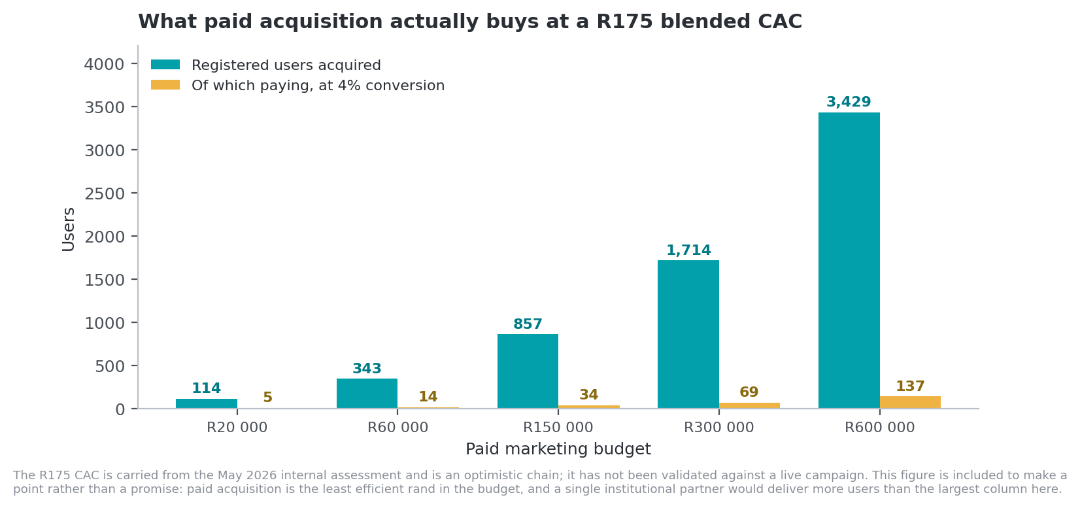
Figure F5. Users acquired at a modelled R175 blended CAC.
The R175 CAC is carried from the May 2026 internal assessment and has not been validated against a live campaign.
This figure is included to make a point rather than a promise. At R175 per acquired user, even R600 000 of paid marketing delivers under 3 500 registered users and about 137 paying subscribers. A single institutional partner would deliver more users than the largest column on that chart, at no acquisition cost. That is the entire strategic argument for prioritising B2B, expressed as arithmetic.

7.3 Cost per participant, against the published benchmark
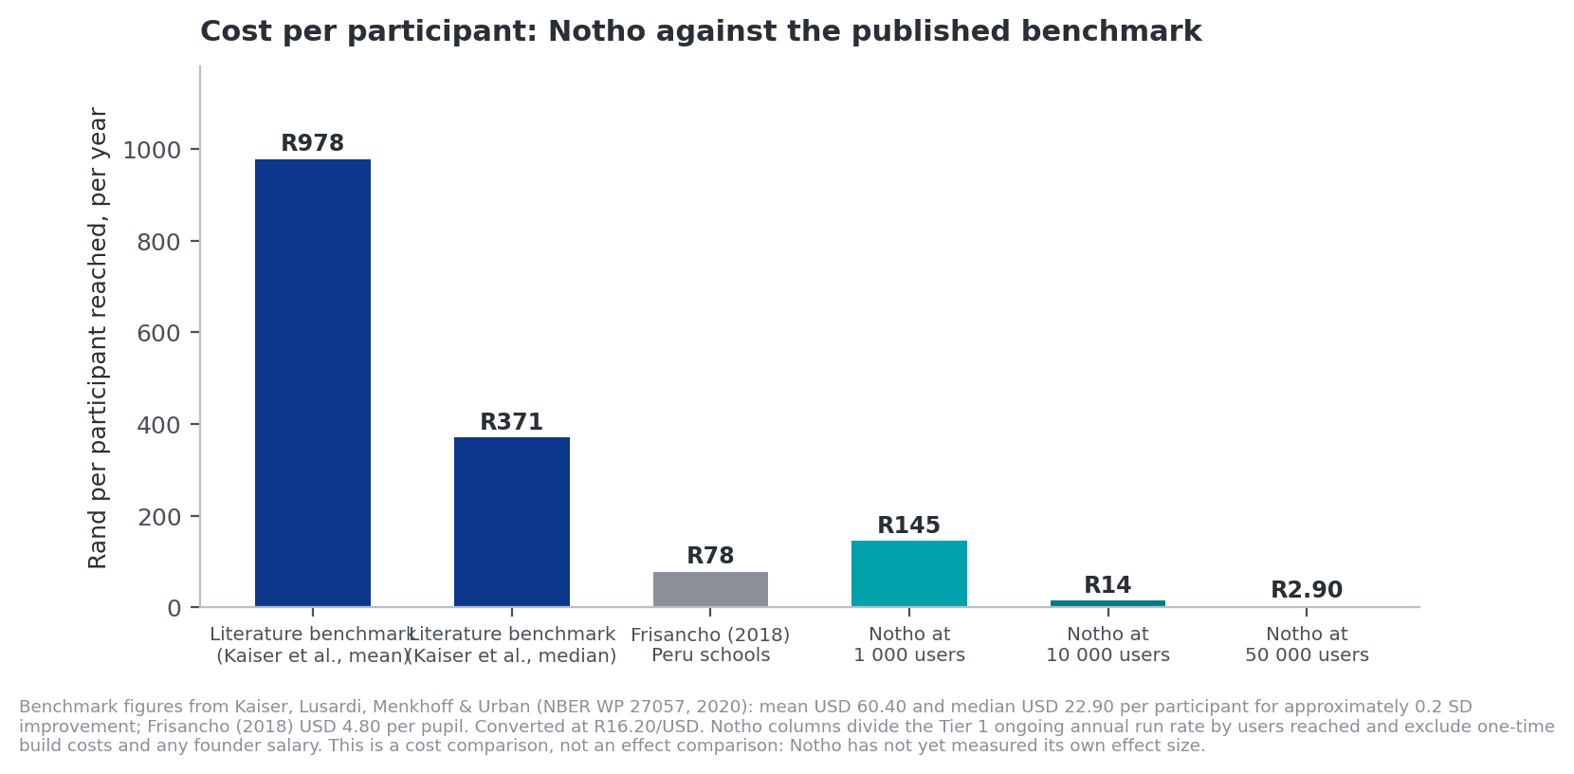
Figure F6. Notho's cost per participant against the financial-education literature.
Benchmarks from Kaiser, Lusardi, Menkhoff & Urban (NBER WP 27057, 2020), converted at R16.20/USD.
This is the strongest financial slide available to Notho and it is currently unused. The literature's mean delivery cost is USD 60.40 per participant for approximately one-fifth of a standard deviation of improvement — roughly R978 — and Kraft's classification puts that in the 'low cost' band. At 10 000 users, Notho's ongoing run rate divides to about R14.48 per participant per year, roughly 67 times cheaper.
How to use this honestly
This is a cost comparison, not an effect comparison. Notho has not measured its own effect size, and any judge who knows the literature will say so within seconds if you overstate it.
The defensible sentence: 'We can't yet claim their effect size. We can claim their cost structure is roughly seventy times ours — which is exactly why measuring our effect is the first thing we're funding.'
That framing turns the missing measurement from an admission into the logical next step.

8. Funding sources and sequencing
Notho is not a classic venture business, and the funding strategy should reflect that. Non-dilutive capital first.
Source | Typical amount | Fit for Notho | Notes
NYDA grant | R1 000 – R200 000, non-repayable | Strong | For founders aged 18–35. Non-repayable. Could fund the entire Tier 0 survival budget several times over, or most of the critical Tier 1 build.
Student and university competitions (EDHE, campus venture programmes) | Varies; typically R10 000 – R150 000 | Strong | Founder eligibility via UCT affiliation. Judges weight founder journey and feasibility, which suits the Tier 0 and partial Tier 1 ask.
SAB Foundation Tholoana Enterprise Programme | Seed funding plus an 18-month structured support programme | Strong | The non-cash component — mentorship and market access — addresses the distribution gap, which is Notho's actual constraint.
Impact and financial-inclusion funders | R250 000 – R2 000 000+ | Strong, once measurement exists | These funders require outcome data. The R220 000 evaluation is the unlock, which argues for sequencing it earlier than Tier 2 if an impact funder is the target.
Corporate CSI and enterprise development | R100 000 – R1 000 000 | Strong | Financial institutions carry B-BBEE socio-economic development obligations, and Conduct Standard 1 now gives them a compliance reason to fund financial education specifically.
SEDA and government SMME support | Non-financial plus limited grants | Moderate | Useful for business development support rather than capital.
Angel investment | R250 000 – R1 500 000 | Moderate | Dilutive. Only worth taking against a specific milestone. The current R300 000 for up to 15% implies about R2m post-money and should be re-examined against the corrected launch cost.
Revenue-based finance | Against contracted revenue | Later | Only once B2B contracts exist. Never against consumer subscription projections.
Classic venture capital | R5m+ | Poor fit | The market is too small and the model too slow for fund-returning venture. Saying this out loud in an investor room is a credibility signal, not a concession.

8.1 Recommended sequence
- Self-fund Tier 0 immediately. R2 940 a month removes the terms-of-service and database-pause risks. Do not wait to win anything for this.
- Apply for NYDA and student competitions for the critical Tier 1 build. The R100 000 subset — payment rails, landing page, measurement spine — is the highest-return R100 000 in the document and fits inside typical grant ceilings.
- Use the measurement spine to approach impact funders and corporate CSI for the rest of Tier 1.
- Only raise equity once a signed institutional pilot exists. A pilot changes the valuation conversation entirely, and it is the milestone that makes Tier 2 fundable.

9. The critical R100 000
If only one number is remembered from this document, it should be this one. Three line items, out of order of size but in order of consequence, convert Notho from a project into a business.
Item | Cost | Time | What it unlocks
Payment rails | R37 500 | 6 weeks | Revenue capability, which is currently zero. Also answers judge questions 6.1, 6.2, 6.11 and 6.13.
Measurement spine | R60 000 | 10 weeks | The ability to answer 'how do you know it works' — the question that decides most rooms — plus eligibility for Conduct Standard 1 institutional sales and impact funding. Answers eight questions in the judge bank.
Analytics export | R0 | 1 day | Nine further judge questions become answerable using data Notho already collects. Do this before the next pitch regardless of funding.
Subtotal | R97 500 | 10 weeks
Add landing page if funds allow | R33 750 | 6 weeks | Makes marketing spend non-wasteful. Below this line, do not spend a rand on acquisition.
The sentence for the room
'R97 500 gets us to first revenue and first measured outcome inside ten weeks. R491 745 launches properly over twelve months. R2.5 million scales it and funds the first randomised evaluation of a digital financial education product in South Africa. Every line is costed and sourced, and I can send you the workings.'

Appendix A — Source ledger for every cost
Each line below gives the basis for a figure used in this document. [Q] means a published quoted price. [R] means a published market rate or survey figure. [E] means this document's estimate, and where an estimate is used the reasoning is given. Converted at R16.20 = USD 1.00.

A.1 Software and infrastructure
Item | Published price | ZAR | Type | Source
Vercel Pro | USD 20 per seat per month, includes USD 20 usage credit, 1 TB fast data transfer, 10M edge requests | R324/mo · R3 888/yr | [Q] | Vercel published pricing, 2026
Vercel bandwidth overage | USD 0.15 per GB | R2.43/GB | [Q] | Vercel published pricing, 2026
Supabase Pro | USD 25 per month per organisation, includes USD 10 compute credit covering one Micro instance | R405/mo · R4 860/yr | [Q] | Supabase published pricing, 2026
Supabase Small compute | USD 15 per month, less the USD 10 included credit | R81/mo · R972/yr | [Q] | Supabase published pricing, 2026
Supabase bandwidth overage | USD 0.09 per GB | R1.46/GB | [Q] | Supabase published pricing, 2026
PostHog | Free to 1 million events per month; Boost tier USD 250 per month | R0 · R4 050/mo at Boost | [Q] | PostHog published pricing, 2026
Resend Pro | USD 20 per month for 50 000 emails | R324/mo · R3 888/yr | [Q] | Resend published pricing, 2026
Error monitoring | USD 26 per month, team tier | R421/mo · R5 054/yr | [Q] | Published list pricing, 2026
Domain (.co.za) | Annual registration | ≈ R150/yr | [R] | SA registrar market rates
Apple Developer Program | USD 99 per year | R1 604/yr | [Q] | Apple published fee
Google Play Console | USD 25 one-time | R405 | [Q] | Google published fee

A.2 Payments
Provider | Published rate | Effective cost on R49 | Type
Paystack (South Africa) | 2.9% + R1.00 per successful charge | R2.42 → 4.94% | [Q]
Yoco | 2.55%–2.95% flat on local cards, no fixed fee | R1.25–R1.45 → 2.55%–2.95% | [Q]
PayFast | 3.2%–3.5% + R2.00, plus R8.70 per payout | R3.57–R3.72 → 7.3%–7.6% | [Q]
Apple / Google in-app purchase | 15% under small-business programmes below USD 1m annual revenue; 30% above | R7.35 → 15% | [Q]
Paystack is used throughout this document as the pricing basis. Yoco is cheaper on card-only volume and is worth testing; PayFast is the most expensive on cards but is the only one of the three supporting Instant EFT, SnapScan and Mobicred, which matters for a market where many users do not hold credit cards.

A.3 Legal, compliance and insurance
Item | Basis | Cost | Type
Trade mark filing | R590 per class. South Africa operates a single-class system, so each class requires a separate application | R590 × 3 = R1 770 | [Q]
Trade mark attorney and search | Register search, availability opinion and prosecution across three classes | R27 230 | [E]
FSCA Category I FSP licence application | Official application fee. Only relevant if the advice perimeter is crossed; excluded from Tiers 0 and 1 | R2 697 | [Q]
FSP compliance build | Key individual approval, compliance officer, regulatory examinations, compliance infrastructure. Conditional, included only in Tier 2 ongoing compliance | R80 000 – R150 000 | [E]
Professional indemnity insurance | SA small-business PI premiums of R448–R870 per month; mid-point used | R660/mo · R7 920/yr | [R]
Terms, privacy and POPIA review | Legal review of user-facing terms and the statement-import data flow | R20 000 | [E]
FAIS content and AI review | Compliance officer review of Cosmo, the profile quiz and report missions | R30 000 | [E]
CIPC annual return | Statutory filing | R450 | [Q]

A.4 Labour
Role | Published rate | Applied here | Type
Junior software engineer | R245 171 per year average | Not used; a mid-level engineer is specified for Tier 2 | [R]
Software developer, mid-level | R346 140 per year average | R363 447 per year including 5% statutory on-costs | [R]
Senior developer | R900 000 – R1 200 000 per year | Not used | [R]
Contract development | R600 – R900 per hour prevailing SA range | R750 per hour used throughout | [R]
Content author, part-time | — | R8 000 per month | [E]
Content author, full-time | — | R240 000 per year | [E]
Statutory on-costs | UIF 1% employer contribution (capped); COIDA; Skills Development Levy not payable below R500 000 annual payroll | 5% applied to all salaries | [R]
Accounting and bookkeeping | R1 200 – R3 500 per month for SA small business | R1 200 (Tier 0) / R1 800 (Tiers 1–2) | [E]

A.5 Content and translation
Measure | Value | How it was established
Translatable words, full corpus | 206 654 | Direct count of prose strings across src/data/banks/*.ts, src/data/content*.ts and src/data/concepts.ts at commit d5f5b1b, filtered to strings of three or more words containing lower-case text and excluding identifiers, slugs and paths
Translatable words, top 40 lessons | ≈ 41 330 | Approximately 20% of the corpus
Question slots / variants / concepts | 814 / 2 440 / 168 | Direct count over 41 bank files
Published translation rate, isiZulu | USD 0.10 – 0.45 per word | Published translation-industry rates for African languages, 2026
Rate applied | USD 0.08 per word (R1.296) | Below the published international floor, reflecting local rather than international supply [E]
Cost, top 40 lessons, one language | R53 564 | 41 330 × R1.296
Cost, top 40 lessons, two languages | R107 128 | Used in Tier 2
Cost, full corpus, one language | R267 824 | For reference. Not budgeted in any tier

A.6 Assumptions carried forward that are not verified
Assumption | Value used | Status
Blended customer acquisition cost | R175 | Unvalidated. Modelled from SA Meta CPM through click-through, install, signup and paid conversion; every link is optimistic. Never present as measured.
Free-to-paid conversion | 4% | Benchmark inference. Duolingo reaches about 9% of monthly actives after a decade. 2–4% and decaying is the defensible range.
Average paying lifetime | 8–12 months | Unvalidated. No churn data exists.
Exchange rate | R16.20 = USD 1.00 | Verified at R16.18 on 7 August 2026. Re-check before submission; a 10% move changes the infrastructure lines by about R1 900 a year.
Hours estimates for build work | 215 hours across four deliverables | Estimate from the scope in the evidence dossier and the existing architecture. Obtain a quote before relying on it externally.

Prepared 9 August 2026. All published prices are current as at that date and should be re-checked before submission; software pricing and the rand both move. Items marked [E] are this document's estimates and the reasoning is given in each case. Items in Appendix A.6 are not verified and should not be presented as measured.

