NOTHO
Learn to manage money the South African way
The Evidence Dossier
An adversarial research assessment of the problem, the theory of change, the learning science, the competition, the unit economics and the regulatory perimeter — with the case against Notho stated as strongly as the case for it.
Field | Detail
Prepared for | Kwanele Ntshangase — Founder, Notho
Date | 9 August 2026
Supersedes | Notho: Honest Market and Academic Assessment, 13 May 2026 (Research/Notho Market Analysis.docx)
Product state assessed | Repository at commit d5f5b1b; production https://www.notho.co.za
Scope | Eleven parts: problem validation · theory of change · learning science and product validation · competitive teardown · market sizing and unit economics · regulatory perimeter · honest audit · rebuttal pack · growth recommendations · research gaps · references
Stance | Adversarial by design. Where the evidence does not support a claim Notho currently makes, this document says so.

A note on how to read this
This dossier is deliberately unbalanced in one direction only: it spends more words on what is wrong than on what is right. That is not a verdict on the product. It is the correct allocation of effort for a document whose purpose is to survive hostile questioning.
Every strength claimed here is one that survived an attempt to kill it. Every weakness listed is one this dossier could not argue away. Sections marked Assessment are judgement, not evidence, and are labelled as such.

Contents
If the list below is blank, press Ctrl+A then F9 in Word (or right-click → Update Field) to build it. Word will normally offer to update fields automatically when the document is opened.

0. Method, evidence grading and limitations

0.1 What this dossier did
Four evidence streams were combined. First, a codebase and document audit of the Notho repository — 41 lesson-bank files, the spaced-repetition and mastery engines, the Supabase migration history, the analytics specification, the internal UX and security audits, the business plan and the store-readiness assessment. Second, a literature review of the peer-reviewed evidence on financial education, gamification and the learning-science mechanics Notho actually implements, prioritising meta-analyses and randomised trials over single studies and over commentary. Third, a market and regulatory refresh using official statistics (Stats SA, SARB, SARS, NCR, ICASA, FSCA) and company disclosures current to August 2026. Fourth, the prior internal assessment of 13 May 2026, whose sourced findings were retained where they could be re-verified or where no newer source contradicts them.
The organising question throughout is the one the May 2026 assessment ended on, and which this dossier treats as the only question that matters: what does a user do differently after ninety days of Notho that they would not have done otherwise, and how would we know?

0.2 Evidence grading
Every substantive claim in this document carries an implicit grade. Where a claim is contested, the grade is stated explicitly.
Grade | Source type | How it is treated here
A | Peer-reviewed meta-analysis or randomised controlled trial | Treated as the strongest available claim. Effect sizes quoted with confidence intervals and publication-bias adjustment where the original reports them.
B | Official statistics or regulator publication (Stats SA, SARB, SARS, NCR, ICASA, FSCA, National Treasury) | Treated as authoritative for the period stated. Vintage always given, because several key SA series lag by two to six quarters.
C | Industry survey or company disclosure (Sanlam Benchmark, Old Mutual Monitor, 10X, JSE-listed results) | Treated as directionally reliable but sponsor-interested. Sample frames noted where they matter.
D | Trade press or secondary reporting | Used only for facts of record (a launch, a rebrand, a funding round), never for effect claims.
E | This dossier's own assessment | Explicitly labelled. Includes all product scoring, all competitor depth ratings, and every figure whose caption says so.

0.3 Limitations you should know about before quoting this
- Web research was truncated. The research session hit its search quota on 9 August 2026 partway through the competitive refresh. Franc, Discovery Vitality Money and South African paid-acquisition cost benchmarks could not be re-verified to August 2026 and are carried forward from the May 2026 assessment. They are flagged in place. Treat them as Grade D until refreshed.
- Several official SA series are stale by construction. The NCR Credit Bureau Monitor figure used here is Q3 2024; the FSCA/HSRC financial-literacy baseline is 2020. Where a secondary source offers a newer number that conflicts, both are shown rather than the more convenient one.
- Notho has no published user count. Every figure in this document that requires Notho's scale uses a placeholder of the correct order of magnitude and says so. No conclusion in this dossier depends on Notho's current user number.
- Product scoring is judgement. Figures 5, 6, 7 and 12 encode this dossier's assessment of implementation quality and competitor depth. They are reproducible from the codebase and from public product surfaces, but they are not measurements.
- The name-collision analysis could not be refreshed. The May 2026 finding on Notho Capital (Pty) Ltd could not be re-verified in this session. It is restated with that caveat and escalated to a legal action item rather than resolved here.

0.4 What this dossier deliberately does not do
It does not produce a revenue forecast. It produces a stress test of the forecast that already exists in Business/Notho-business-plan.docx, which is a different and more useful thing. It does not recommend a valuation. It does not attempt to adjudicate the trademark question, which requires an attorney. And it does not assume the reader is friendly.

1. Executive summary

1.1 The verdict in one paragraph
The problem Notho addresses is real, large, measurable and worsening, and the product Notho has built is, on the learning-science evidence, better designed than anything else currently serving South African consumers. Those two sentences are the entire strength of the case, and they are strong. Against them: the academic literature will not let Notho claim that teaching people finance changes their behaviour much; the largest competitor ships a comparable product to a distribution base four orders of magnitude larger; the company has no payment infrastructure, no signed distribution, no landing page, no measurement of behavioural outcome, and no revenue capability whatsoever as at the commit assessed. Notho is a finished learning product bolted to an unbuilt business. The research does not say the idea is wrong. It says the risk has moved almost entirely out of the product and into distribution, monetisation and proof.

1.2 Eight findings, ordered by how much they should change your behaviour
# | Finding | Grade | So what
1 | A new regulation has made Notho's product legible to buyers for the first time. FSCA Conduct Standard 1 of 2025 took full effect on 26 March 2026. Any financial institution that chooses to run financial education is now bound to governance, targeting, monitoring, evaluation and reporting requirements, and must keep education demonstrably separate from marketing. The FSCA's own consumer-education head has publicly said that measuring outcomes remains the industry's unsolved problem. | B | This is the single most important new fact since May 2026. Notho's structural weakness has been that banks and insurers already run literacy programmes. Those programmes are now a compliance obligation with an evidence requirement attached. Notho should stop selling 'a financial literacy app' and start selling instrumented, auditable financial education infrastructure to institutions that now have to prove impact. See §7.2 and §10.
2 | The behaviour-change evidence is small but real, and the honest argument for Notho is economic, not psychological. Kaiser, Lusardi, Menkhoff and Urban's random-effects estimate across 76 RCTs is 0.100 SD on behaviour (95% CI 0.071–0.129) and 0.204 SD on knowledge (95% CI 0.152–0.255). The same paper reports a mean delivery cost of USD 60.40 per participant for roughly one-fifth of a standard deviation. | A | Stop pitching transformation. Pitch cost per unit of effect at scale. The literature has a published cost benchmark and Notho's marginal cost per additional learner is a rounding error against it. That argument is defensible, arithmetically checkable, and no competitor is making it. See §3.5.
3 | Notho's pedagogy is genuinely ahead of the field, and this is verifiable. Retrieval-practice-first lessons, a mastery gate that will not let a lesson finish until every item is right, SM-2 spaced repetition over 168 concepts, and 814 question slots carrying 2 440 authored variants. | E | No SA competitor implements retrieval practice, mastery completion or spaced repetition. This is Notho's only durable moat and it is currently unmarketed. See §4 and Figure 5.
4 | Notho cannot take money. No payment provider (PayFast, Paystack, Yoco, Stripe, RevenueCat) appears anywhere in the codebase, and no subscription or entitlement table exists in the Supabase migrations — although the paywall analytics events are already fully specified. | E | Revenue capability today is R0, against a Year 1 plan of R626 000. Every week of content authoring before payment rails exist is a week of building inventory for a shop with no till. See §6.6 and Figure 12.
5 | The hearts mechanic is regressively designed and conflicts with the mission. Hearts gate learning behind waiting or payment, and they bite hardest on users who answer incorrectly most often — which is to say, the least financially literate users, who are the stated beneficiaries. | E | This is the clearest internal contradiction in the product. Self-determination theory predicts it will also suppress intrinsic motivation. Recommend re-specifying hearts as pacing feedback, not scarcity. See §4.6.
6 | The stokvel feature was removed. Commit 8f37d3d deleted group savings. Stokvels are ~800 000 groups, ~11 million members and roughly R50 billion a year, and FNB alone has 119 000 groups on its digital platform. | E | This deleted the one feature that connected Notho to South Africa's existing savings infrastructure rather than asking users to adopt a new behaviour. Reconsider — but as a commitment device (see §3.4), not as a leaderboard. See §5.5.
7 | Pricing is at or above the market's comfort band. Notho Pro at R79/month sits above Netflix Mobile (R59) and at the level of a typical monthly 1GB prepaid data bundle (about R79 in 2025). Capitec's competing product is free and pays users vouchers to use it. | B/D | The realistic SA ladder is a free core, R29–R49 paid, R299–R399 annual prepay. In-app purchase on iOS or Android removes a further 15–30%. See §6.3 and Figure 9.
8 | The retention target in the business plan is roughly twelve times the education-app benchmark. Education apps retain ~2.1% at Day 30; finance apps ~11.6%. The plan targets 40% at Day 7. | D | Not impossible — Duolingo-class products beat category benchmarks — but it must be stated as an aspiration with a mechanism behind it, not as a projection. See §6.4 and Figure 10.

1.3 What changed since the May 2026 assessment
Then (13 May 2026) | Now (9 August 2026) | Direction
Financial education was voluntary for institutions; Notho's B2B2C case rested on goodwill. | FSCA Conduct Standard 1 of 2025 in force since 26 March 2026; Financial Education Commitment Charter and a National Treasury policy in development. | Materially better
Two-pot: R43.42bn withdrawn, 2.66m applications (to 31 Jan 2025). | R79.3bn approved and R21.4bn in tax to 28 Feb 2026, across 5.6m tax directives. | Problem larger
Unemployment 31.4% (Q4 2025), youth 43.8%. | 32.7% (Q1 2026), youth 45.8%, ages 15–24 at 60.9%. | Worse
Household debt-to-income 62.0% (Q4 2024). | 62.2% (Q1 2026); debt-service cost steady at 8.4%. | Flat
Lesson banks partially authored; ~84 lessons outstanding. | 41 bank files, 814 slots, 2 440 variants, 168 concepts; rotating banks shipped for every lesson. | Materially better
Stokvel feature shipped. | Stokvel feature removed (8f37d3d). | Worse
No app-store path. | Capacitor shell and submission assets committed (472a23a); nothing submitted. | Slightly better
No AI-disclosure compliance surface. | Persistent AI disclosure on Cosmo; expanded privacy policy (7b21c26). | Better
No payment infrastructure. | No payment infrastructure. | Unchanged — critical
No marketing landing page (root redirects to /learn). | No marketing landing page (root still redirects to /learn). | Unchanged — critical

1.4 The minimum thesis the evidence will actually support
Defensible thesis statement
Notho is an instrumented financial-behaviour-change system for South Africa, built on retrieval practice, mastery learning and spaced repetition — the three mechanics with the strongest evidence in the learning sciences — delivered at a marginal cost approaching zero, and designed from the outset to measure whether a specific behaviour changed rather than whether a lesson was completed.
It is distributed primarily through institutions that are now regulatorily obliged to run and evidence financial education, and secondarily direct to consumers. It fires its content at decision moments rather than on a curriculum schedule. It pairs every lesson with a commitment device. And it treats its game layer as informational feedback, not as the product.
Every clause in that paragraph is a design commitment this dossier can defend with citations. Notho currently satisfies about half of them.

2. Part I — Is there a real problem?
This is the part of the case that is not in doubt, so it is dealt with efficiently and with attention to where the numbers are weaker than they are usually presented.

2.1 Financial literacy is low, but 'the' literacy rate does not exist
Four credible instruments measure South African financial literacy and produce four different answers. This is not a flaw in the evidence; it is a property of the construct. Notho's business plan currently quotes only the most convenient figure (42%, attributed to the World Bank), which is a citation error worth fixing before an investor catches it — 42% is the S&P Global FinLit Survey figure, published by GFLEC with World Bank involvement, not a World Bank Financial Capability Survey result.
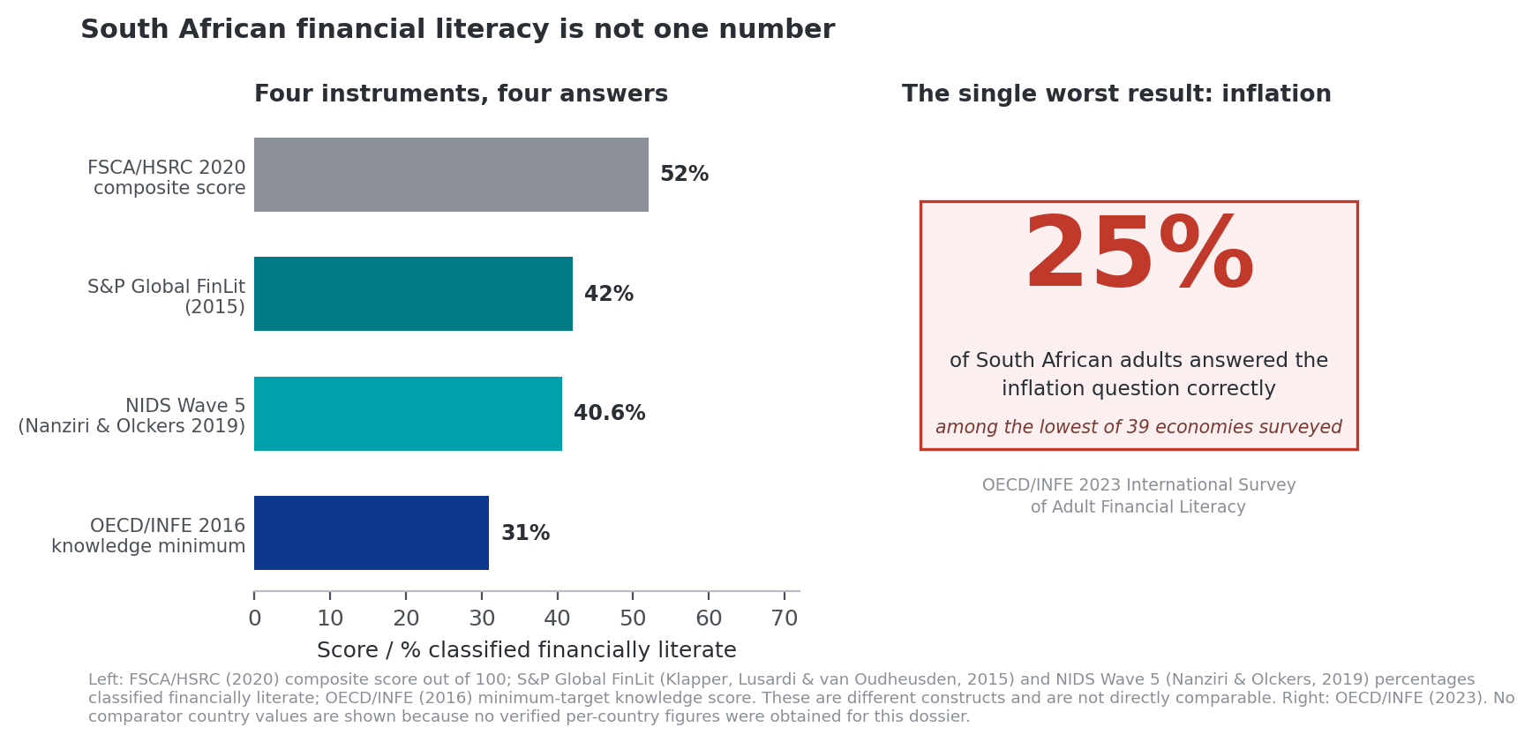
Figure 2. South African financial literacy under four measurement instruments, and the inflation-question result that matters most.
Grade B/A. Instruments measure different constructs: FSCA/HSRC is a composite of knowledge, attitudes and behaviour; S&P FinLit and NIDS are knowledge-threshold measures; OECD/INFE reports item-level correctness.
Instrument | Vintage | Result | What it actually measures | Caveat for Notho
FSCA / HSRC Baseline Survey | 2020 | 52 / 100 composite; ~51% classed financially illiterate | Knowledge + attitudes + behaviour composite | Six years old. Pre-dates two-pot entirely. The 'illiterate' share and the composite score are different statistics and should never be quoted in the same breath.
S&P Global FinLit Survey (Klapper, Lusardi & van Oudheusden) | 2015 | 42% financially literate | Threshold: 3 of 4 topic areas correct | Highest in BRICS, about half the G7 average. Eleven years old.
NIDS Wave 5 (Nanziri & Olckers) | 2019 | 40.57% literate | Independent replication on national panel data | Cross-validates S&P almost exactly — the two strongest points of agreement in the evidence.
OECD / INFE International Survey | 2023 | 25% answered the inflation question correctly — among the lowest of 39 economies | Item-level financial knowledge | The most damning single statistic available, and the most useful one for Notho. A country that has lived with structurally high inflation for fifty years does not understand it.
The strongest single fact in Notho's problem statement
Twenty-five per cent inflation literacy in a high-inflation economy is not a knowledge gap; it is a knowledge gap in exactly the concept that silently destroys household wealth. It is specific, it is recent, it is from a body no one will dispute, and it maps onto a lesson Notho already ships. Lead with it. Retire the '42%' framing.

2.2 The downstream damage
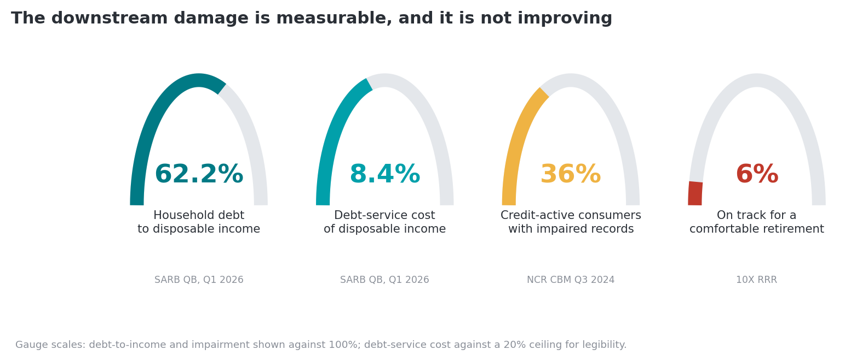
Figure 3. Four measures of South African household financial stress.
Grade B/C. Debt figures SARB Quarterly Bulletin (Q1 2026); impairment NCR Credit Bureau Monitor Q3 2024; retirement readiness 10X Retirement Reality Report.
Household debt to nominal disposable income rose to 62.2% in Q1 2026 from 61.8% in Q4 2025, with the cost of servicing that debt steady at 8.4% of disposable income. The aggregate looks stable. The arrears picture underneath it does not: the National Credit Regulator's Credit Bureau Monitor records 10.19 million of 28.32 million credit-active consumers (35.98%) holding impaired records. A secondary source circulating in 2026 puts the figure at over 42% of 23 million credit-active consumers; this dossier uses the NCR primary series and flags the discrepancy rather than picking the larger number.
DebtBusters' quarterly index of people entering debt counselling shows the tail: applicants spending roughly 71% of take-home pay on debt service, 96% holding a personal loan, and high earners above R35 000 a month carrying debt at around 210% of net annual income. This is a self-selected sample of people already in distress, and should be presented as such — it is the shape of the tail, not the shape of the population.
On retirement, the 10X Retirement Reality Report finding that only 6% of South Africans are on track to retire comfortably has held across multiple editions. It derives from Brand Atlas survey data covering roughly 15.4 million economically active South Africans. Sanlam's internal modelling is bleaker still, putting the age at which South Africans can actually afford to retire comfortably nearer 80 against a member-believed retirement age of 58.
The Old Mutual Savings & Investment Monitor 2026 adds the most recent texture and complicates the picture in a way Notho should not hide. Forty per cent of working South Africans describe themselves as highly or overwhelmingly financially stressed, with stress rising most sharply below R30 000 a month, and reporting in July 2026 found more workers turning to debt and to gambling. But 57% now run multiple income streams, up from 50% in 2023, 47% own a business, 47% are confident about the economy — the highest since 2020 — and 75% expect their own position to improve within six months.
An uncomfortable read of the Old Mutual data
South Africans are not passive. They are actively, energetically managing money — with side hustles, businesses, stokvels and multiple income streams. A large share of the population is already doing the thing financial education tells people to do.
That undermines the 'people don't know what to do' framing and strengthens a different one: people are making a high volume of consequential financial decisions with poor information and no decision support. Notho's Business Finance and Money Psychology courses are better aligned to that reality than its Money Basics course is. So is the budget pillar. The content mix should follow the evidence.

2.3 Two-pot: the largest involuntary financial-literacy event in South African history
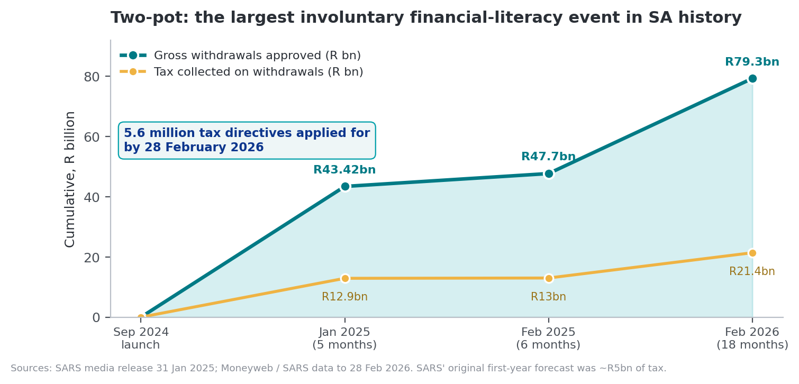
Figure 4. Cumulative two-pot savings-pot withdrawals and the tax collected on them, September 2024 to February 2026.
Grade B. SARS media release 31 January 2025; SARS/Treasury data reported to 28 February 2026.
Between the system's introduction on 1 September 2024 and 28 February 2026, R79.3 billion was approved for withdrawal from savings pots, generating R21.4 billion in tax liability across 5.6 million tax directive applications. SARS' original first-year forecast was approximately R5 billion of tax. The realised figure exceeded it by a wide margin, and repeat claims have since surged — by 2026 National Treasury was publicly considering further access to retirement savings to ease household pressure.
Two features of this event matter more than the headline number. The first is who withdrew: Sanlam Corporate data places the 35–44 band at 42% of withdrawers, 45–54 at 28%, and 25–34 at only 22%, concentrated in the R15 000–R40 000 monthly income band, with roughly 80% of withdrawals coming from members whose net replacement ratio was already below 50%. The second is what they did with it: 44% to debt, 33% to school fees, 28% to supporting family.
The demographic finding directly contradicts the beachhead defined in the business plan — 'black South African first-salary earners aged 21–30'. The people making the largest, most consequential, most tax-inefficient retirement decisions in the country are fifteen years older than that. This is dealt with in §6.2.
The demand signal is equally sharp. The SARS website two-pot calculator was used 952 403 times and the WhatsApp version 90 283 times, and 'How to apply for the two-pot system online withdrawal' entered Google's South African year-in-search 'How to' list. Hundreds of thousands of South Africans actively sought plain-language financial explanation the moment a consequence attached to not having it. That is the single cleanest demand proof available, and it is a proof of just-in-time demand, not of curriculum demand.

2.4 The hard question: is literacy the binding constraint?
It is not, for a large share of the population, and Notho's materials should concede this before someone else raises it.
Stats SA's Quarterly Labour Force Survey for Q1 2026 records official unemployment at 32.7%, youth unemployment at 45.8%, and unemployment among 15–24 year olds at 60.9%, with employment falling by 345 000 to 16.8 million. SARS' annual tax statistics record roughly 7.7 million people expected to submit returns, with nearly half of assessed taxpayers earning under R95 750.
Cole, Sampson and Zia (2011, Journal of Finance) is the load-bearing citation here. Their randomised financial-education programme in Indonesia produced no statistically significant effect on bank-account opening for the full sample. A modest price subsidy moved take-up from 3.5% to 12.7%. In low-income markets, the binding constraint is usually money, not knowledge.
And South Africans already save without being taught to. The stokvel sector runs roughly R50 billion a year through about 800 000 groups and 11 million members — around one in four South African adults. In 2025 alone, digitised stokvels earned R256 million in interest and avoided R211 million in withdrawal fees. Old Mutual's data shows 59% of black households contributing monthly, and over 70% of black households earning above R40 000 a month still using them.
The question Notho must be able to answer in one sentence
What does this app add for a stokvel-running mother of two earning R6 000 a month?
If the answer is 'lessons about compound interest', the thesis is mis-targeted. If the answer is 'it tells her, on the day her debit orders hit, which one to cancel first and why, and then helps her commit to it', the thesis is sound. The evidence supports the second answer and not the first. This is the distinction that runs through the rest of this document.

3. Part II — Does financial education actually work?
This is the section that decides whether Notho is a company or a hobby, and it is the section most founders in this category skip. An investor who reads one paper before the meeting will read Fernandes, Lynch and Netemeyer. Notho must arrive having read all of them.
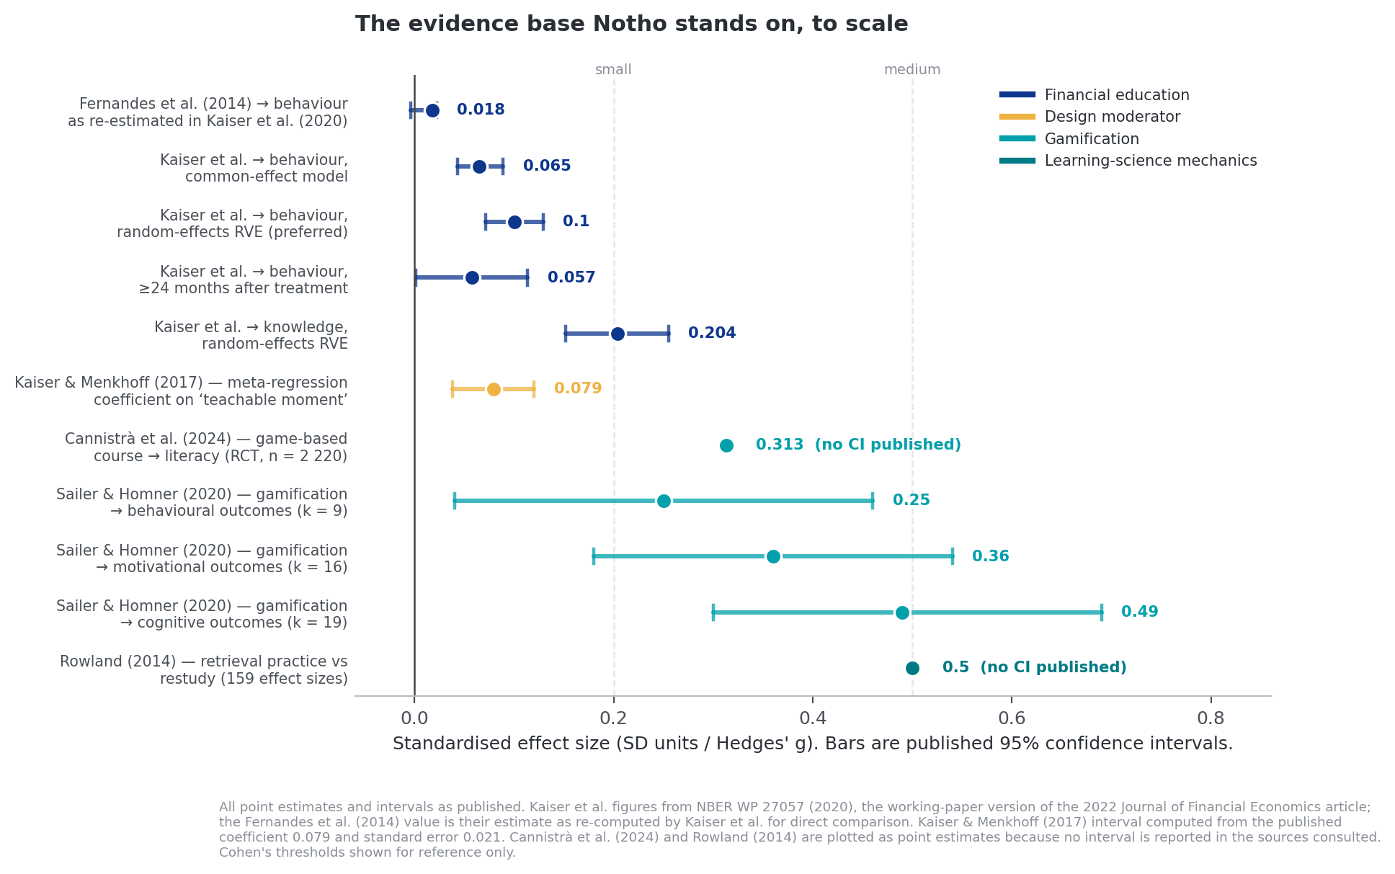
Figure 1. Standardised effect sizes across the literature Notho depends on, plotted on a common scale.
Grade A. Confidence intervals as reported in the source meta-analyses; where a source reports a range rather than an interval, the range is plotted. Conventional thresholds: 0.2 small, 0.5 medium, 0.8 large (Cohen).

3.1 The case against — and it is strong

Fernandes, Lynch & Netemeyer (2014), Management Science 60(8): 1861–1883
The most-cited paper in the field. A meta-analysis of 168 papers covering 201 prior studies found that interventions to improve financial literacy explain only 0.1% of the variance in the financial behaviours studied, with weaker effects in low-income samples, and that even large interventions involving many hours of instruction have negligible effects on behaviour twenty months or more after delivery. This is the single sentence that will be quoted back at Notho.
Expressed on the same scale as everything else in Figure 1, Kaiser and colleagues re-compute the Fernandes et al. result as 0.018 SD units, 95% CI −0.004 to 0.022 (Kaiser, Lusardi, Menkhoff & Urban, 2020, NBER WP 27057, p. 20). An interval that includes zero is the fair reading of the original finding, and Notho should quote it that way rather than paraphrasing '0.1% of variance', which most audiences cannot interpret.
It also contains the escape hatch, and Notho should quote it as often as critics quote the headline: the authors identify 'a real but narrower role for just-in-time financial education tied to specific behaviors it intends to help.' That clause is the only academically defensible perch for a product like this, and building toward it is the central product recommendation of this dossier.

Willis (2008, Iowa Law Review 94:197; 2011, American Economic Review 101(3): 429–434)
Willis argues that the predicate belief in financial-literacy education lacks empirical support, and makes a sharper claim: for some consumers, financial education increases confidence without improving ability, producing worse decisions. This is the 'you might make users worse off' risk, published in top-tier law and economics venues. For a gamified product that awards XP, levels and badges for correct answers, this is not an abstract concern — Notho's entire feedback architecture is a confidence-manufacturing machine. §4.7 proposes the specific instrumentation that would detect it.

Bruhn, Leão, Legovini, Marchetti & Zia (2016), AEJ: Applied Economics 8(4): 256–295
A randomised evaluation of a financial-education programme across 892 Brazilian high schools. Financial proficiency rose by 0.25 SD — a good result. The same programme also increased students' use of expensive credit for consumer purchases. Unintended consequences in this field are empirically documented, not hypothetical. Any Notho lesson that explains how credit works must be paired with a measurement of whether credit use went up.

Cole, Sampson & Zia (2011), Journal of Finance 66(6): 1933–1967
Covered in §2.4. Knowledge did not move account opening; price did. In a country with 32.7% unemployment, this is the most structurally threatening paper of the four.

3.2 The rehabilitation

Kaiser, Lusardi, Menkhoff & Urban (2022), Journal of Financial Economics 145(2): 255–272
The most important counterweight. A meta-analysis of 76 randomised experiments with a total sample exceeding 160 000 individuals, using only RCTs and therefore avoiding the selection problems that depressed earlier estimates. The figures below are taken from the working-paper version (NBER WP 27057, 2020), which reports the point estimates and intervals in full.
Estimate | Value (SD units) | 95% CI | Note
Effect on financial behaviour, random-effects RVE — the authors' preferred estimate | 0.1003 | 0.071 – 0.129 | Described as approximately 5.5× the Fernandes et al. estimate
Effect on financial knowledge, random-effects RVE | 0.204 | 0.152 – 0.255 | Comparable to educational interventions in other domains
Effect on behaviour, common-effect model | 0.065 | 0.043 – 0.089 | Clearly rules out a null effect even under the restrictive assumption
Effect on behaviour, measured ≥ 6 months after treatment | 0.0710 | 0.0425 – 0.0995 | Decay is present but modest
Effect on behaviour, measured ≥ 24 months after treatment | 0.0574 | 0.0013 – 0.1136 | Still positive; interval barely excludes zero
Effect on behaviour, low-income participants | 0.0993 | 0.0600 – 0.1387 | Not distinguishable from the general population (0.1035, CI 0.0571–0.1500)
Effect on behaviour, developing economies | 0.0928 | 0.0660 – 0.1195 | Directly relevant to the South African case
Mean cost per participant across studies reporting costs | USD 60.40 | median USD 22.90 | 2019 dollars; classified 'low cost' on the Kraft (2019) scheme
Three points deserve emphasis, and the second is one Notho's materials currently miss.
- The decay claim is weaker than Fernandes et al. suggest. Effects at twenty-four months and beyond remain positive at 0.0574 SD, though the interval is wide and nearly touches zero.
- The low-income penalty is not confirmed. Fernandes et al. (2014) reported weaker effects in low-income samples, and Kaiser and Menkhoff (2017) also found financial education less effective for low-income clients and in low- and lower-middle-income economies. The 2022 RCT-only meta-analysis finds no statistically distinguishable difference between low-income participants and the general population. This is a live disagreement in the literature, and it matters directly to Notho's mission. The honest framing is that the question is unsettled, not that it is resolved in Notho's favour.
- Publication-bias correction does not overturn the result. The authors report that accounting for publication selection bias 'does not qualitatively change the result of positive average effects of financial education'. An earlier draft of this dossier stated a bias-corrected estimate of 0.057 SD; that figure is in fact the ≥24-month decay estimate and has been corrected here.
David McKenzie's reading at the World Bank remains the fair summary and should be quoted rather than hidden: these estimates are still small in absolute terms, and 'unless you get individuals right before they are about to make big financial decisions that they don't understand, then most financial education programs are not very popular, lead to small changes in knowledge, and even smaller changes in outcomes.'

3.3 What the evidence says makes education work
Moderator | Evidence | Effect | Does Notho do it?
Just-in-time delivery at a teachable moment | Kaiser & Menkhoff (2017), World Bank Economic Review 31(3): 611–630, meta-analysis of 126 studies; the mechanism is explicitly endorsed by Fernandes et al. (2014) | Meta-regression coefficient 0.079 (SE 0.021, p < 0.01); 0.064–0.079 across specifications. Verified against the meta-regression table in the primary source | Partially. Push and lifecycle crons exist and fire on a schedule, not on a decision moment. The single highest-leverage unbuilt feature.
Rules of thumb over comprehensive curriculum | Drexler, Fischer & Schoar (2014), AEJ: Applied Economics 6(2): 1–31 | Rule-of-thumb training significantly outperformed full accounting training for micro-entrepreneurs, with the largest gains among the least skilled | No. Notho is curriculum-shaped: 22 courses, ~199 lessons. The heuristics exist inside lessons but are not the unit of delivery.
Education plus goal-setting or personal follow-up | Carpena, Cole, Shapiro & Zia (2019), Management Science 65(1): 346–369 | Education alone moved nothing. Education + goal-setting moved simple actions; education + counselling enabled poorer participants to take costly actions | Partially. Goals exist as gamified quests. Cosmo provides follow-up but is not directed at a target behaviour.
Commitment devices | Ashraf, Karlan & Yin (2006), Quarterly Journal of Economics 121(2): 635–672 | Clients offered a commitment savings account had saved 81% more than controls after twelve months | No. This is the largest single effect in the whole evidence base and Notho implements none of it.
Intensity and duration of exposure | Kaiser et al. (2022); Kaiser & Menkhoff (2017) | Effects scale with contact hours; brief one-off exposure is close to useless | Yes, structurally. Daily micro-sessions with spaced return is the correct dose-delivery architecture.

3.4 Commitment devices: the biggest missed opportunity in the product
Ashraf, Karlan and Yin's SEED experiment with Green Bank of Caraga in the Philippines is worth stating in full because it is the largest effect anywhere in this dossier and because Notho could implement a version of it in weeks. Of 710 clients offered a voluntary commitment savings account that restricted withdrawals until a self-chosen date or amount, 202 (28.4%) took it. Twelve months later, those offered the account had saved 81% more than controls. No education was involved. The mechanism is pure self-binding.
The design implication is uncomfortable for a learning product: the intervention with the strongest evidence in personal finance is not a lesson. It is a switch that a person flips on themselves. Notho has the infrastructure to offer soft commitment devices today — a declared savings target with scheduled check-ins, a spending rule the user writes and the app enforces socially, a pre-commitment made before payday about what happens to the money. None of these require a banking licence and all of them are measurable.
The deleted stokvel feature was a commitment device
A stokvel is, structurally, exactly what Ashraf, Karlan and Yin built: a voluntary self-binding savings arrangement with social enforcement, chosen by the saver. South Africa has eleven million people already using one.
Commit 8f37d3d removed it from Notho. Whatever the engineering reason, this dossier's assessment is that it deleted the highest-evidence mechanic in the product. Recommend rebuilding it as a commitment device with lesson integration, not as a social leaderboard. See §10.2.

3.5 Synthesis: the claim Notho is allowed to make
Claim | Defensible? | Why
'Financial education transforms behaviour' | No | Contradicted by Fernandes et al. (2014) and only weakly supported by Kaiser et al. (2022). Do not say this.
'Gamified micro-lessons make people financially literate' | Partly | Cannistrà et al. (2024) found 0.313 SD on literacy in a 2 220-participant multi-country RCT. Literacy, not behaviour. Say it precisely.
'Financial education produces small but real, measurable improvements in knowledge and behaviour' | Yes | Kaiser et al. (2022), 76 RCTs, n > 160 000. This is the defensible headline.
'Delivered at a decision moment, financial education works measurably better' | Yes | Kaiser & Menkhoff (2017): +0.079 SD from timing alone. Endorsed as the legitimate role for education by the field's harshest critics.
'A commitment device attached to a lesson beats the lesson alone' | Yes | Ashraf, Karlan & Yin (2006): +81% savings. Carpena et al. (2019): goal-setting is the active ingredient.
'At near-zero marginal cost, a small effect delivered at national scale can beat a large effect delivered to a room' | Yes — and underused | This is an arithmetic claim, not an empirical one, and it is the argument the whole category has been failing to make. See below.

The cost-effectiveness argument nobody in this category is making
The financial-education literature is written by economists evaluating programmes that cost money per participant: classroom hours, counsellors, printed workbooks, venue hire. Under that cost structure, an effect of 0.10 SD is genuinely disappointing, because the denominator is large.
Kaiser and colleagues do the arithmetic and publish it, which most commentary on this literature ignores. Across the studies in their sample that report costs, the mean cost is USD 60.40 per participant and the median USD 22.90 (2019 dollars). Their summary ratio is USD 60.40 per person for one-fifth of a standard deviation improvement in outcomes, which they note is classified as a low cost educational intervention on Kraft's (2019) scheme. At the efficient end of the distribution, Frisancho's (2018) Peruvian school trial reports USD 4.80 per pupil, with a one-dollar increase in programme spending yielding a 3.3-point improvement on the PISA financial-literacy assessment.
A digital product inverts the denominator. Once the content exists, the marginal cost of the ten-thousandth learner is a few cents of bandwidth. Notho's architecture makes this concrete: the lesson corpus is statically compiled TypeScript served from a CDN, and the app is a PWA with a service worker and offline-capable content. The correct comparison is therefore not 'is 0.10 SD a big effect?' but 'what does one standard-deviation-unit of behaviour change cost to produce, per rand, in each channel?' — and the literature has now published the number to beat.
The slide Notho should build
Benchmark: USD 60.40 (roughly R1 100 at August 2026 rates) per participant for 0.2 SD, from the largest RCT meta-analysis in the field.
Notho's comparable figure is total annual cost divided by active learners. At even a few thousand users, hosting and content amortisation put it one to two orders of magnitude below the benchmark — before any partner subsidy.
This is an arithmetic claim that a corporate buyer, a retirement-fund administrator or the FSCA's consumer-education department can check, and all three are structurally optimising cost per member reached. It converts Notho's small-effect problem into a cost-per-outcome advantage. Compute it, source it to Kaiser et al., and put it in the deck.

4. Part III — Is Notho's learning engine actually right?
This is the deepest section of the dossier, at the founder's request, and it is also where Notho comes out best. The question is narrow and answerable: of the mechanics the learning sciences have shown to work, which ones does Notho implement, how well, and where does its implementation diverge from the evidence?
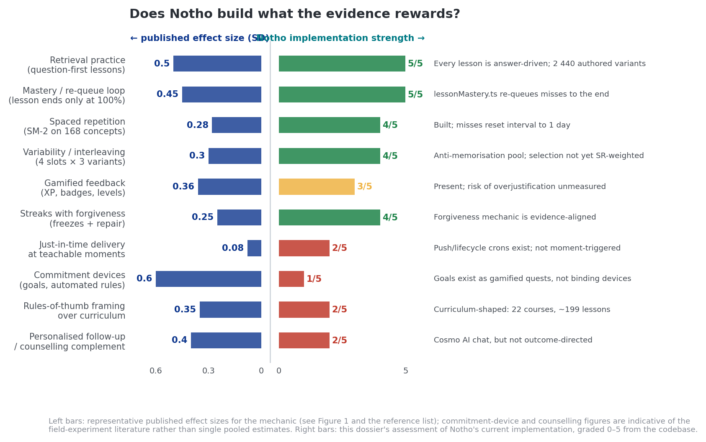
Figure 5. Published effect size against Notho's implementation strength, for ten learning mechanics.
Left bars Grade A (published effect sizes). Right bars Grade E (this dossier's assessment, scored 0–5 from the codebase at commit d5f5b1b).

4.1 Retrieval practice — Notho's strongest and least-marketed asset
The testing effect is one of the most robust findings in cognitive psychology: retrieving information from memory produces better long-term retention than re-studying it. Meta-analytic estimates comparing retrieval practice to re-reading cluster around g = 0.50 across 159 effect sizes (Rowland, 2014, Psychological Bulletin 140(6): 1432–1463), with 81% of comparisons favouring retrieval over restudy, though the effect is smaller and less certain in some domains — a mathematics-specific meta-analysis found only g = 0.18 with a confidence interval crossing zero, which is worth knowing before over-claiming.
Notho's lesson architecture is retrieval-first by construction. A lesson is a sequence of answerable steps, not a passage followed by a quiz. The QuestionSlot / QuestionVariant type system in src/data/content.ts makes the answerable position the primitive unit of content: information steps exist, but the lesson's spine is retrieval. Across 41 bank files the repository carries 814 question slots and 2 440 authored variants over 168 concepts.
Assessment (Grade E): 5 / 5
This is textbook-correct implementation of the single best-evidenced mechanic in learning science, at a scale no South African competitor approaches. It is also completely absent from Notho's marketing, which currently sells 'Duolingo-style' — a brand comparison — rather than 'every lesson is a retrieval task', which is a mechanism claim that happens to be true and that a corporate buyer's L&D team will recognise.

4.2 Mastery learning — correctly implemented, over-claimed by the field
Notho's mastery loop, shipped in src/lib/lessonMastery.ts, does something most consumer learning apps do not: a wrong answer re-queues a fresh copy of that question to the end of the session, and the lesson cannot complete until every question has been answered correctly at least once. 'Perfect' was correspondingly redefined as zero first-try mistakes. This is a genuine mastery gate, not a score.
The evidence here needs care. Bloom's 'two sigma problem' — the 1984 claim that mastery learning combined with individual tutoring produced a two-standard-deviation gain — is the citation everyone reaches for and is not a safe number to quote. The 2 SD effect has never been replicated at that magnitude. A 2020 meta-analysis covering 96 tutoring studies produced a mean effect of approximately 0.37 SD, with none reaching two sigma; systematic reviews put mastery learning on its own nearer 0.5 SD; and Nickow and colleagues report tutoring effects in the 0.36–0.59 SD range depending on who delivers it. Part of the original gap is now understood to be an artefact of design: Bloom's tutoring condition used a 90% mastery threshold against 80% for the classroom mastery condition, so the tutors were holding students to a higher standard.
Notho should cite the direction of the finding and the modern magnitudes, never Bloom's figure. An investor or an academic reviewer who knows this literature will treat a '2 sigma' claim as a signal that the founder has read the blog posts and not the papers.
The stronger justification for Notho's gate is mechanistic rather than meta-analytic: requiring correct retrieval before completion converts every lesson into a criterion-referenced assessment rather than a norm-referenced one, and forces additional retrieval attempts precisely on the items a given learner is weakest on. That is a per-learner adaptive dose of the §4.1 mechanic, which is the right thing to build.
Assessment (Grade E): 5 / 5, with a caveat
Correctly built and rare. The caveat is motivational: a gate that will not release a struggling learner is exactly the condition under which a low-confidence user quits. Notho currently has no instrumentation that distinguishes 'abandoned because bored' from 'abandoned because trapped'. The lesson_abandoned event carries completionPercent but not first-try accuracy at the point of abandonment. That is a one-line analytics change with high diagnostic value.

4.3 Spacing and the SM-2 implementation
The spacing effect — distributed practice beating massed practice — is one of the oldest and most replicated findings in psychology, but the magnitude reported depends heavily on the synthesis, and an honest citation gives the range rather than the most flattering number.
Synthesis | Scope | Reported effect | Relevance to Notho
Cepeda, Pashler, Vul, Wixted & Rohrer (2006), Psychological Bulletin 132(3): 354–380 | 839 assessments across 317 experiments in 184 articles, verbal recall | Robust spacing benefit; optimal inter-study interval grows with retention interval | The foundational result, and the source of the scheduling logic SM-2 implements
Donoghue & Hattie (2021), Frontiers in Education | 242 studies, 1 619 effects, 169 179 participants; meta-analysis of ten learning techniques | d = 0.85 for distributed practice; distributed practice and practice testing rank as the two most effective techniques | The most favourable estimate available. It is a synthesis of syntheses and should be read as an upper bound
Applied classroom meta-analyses (mathematics and course-embedded settings, 2024–2025) | 27 studies, 53 effect sizes | g = 0.28 overall; g = 0.43 isolated learning, g = 0.24 course-embedded | The conservative estimate. Notho sits in the isolated-learning condition, which is the more favourable of the two
The defensible statement for Notho is therefore: spacing is well-evidenced, with effect estimates ranging from roughly g = 0.28 in applied classroom settings to d = 0.85 in the broadest synthesis, and Notho operates in the delivery mode associated with the larger end of that range. Quoting 0.85 alone would be selective; quoting 0.28 alone would understate it.
src/lib/spaced-repetition.ts implements SM-2 faithfully: interval_days, ease_factor floored at 1.3, repetitions, next_review_date, with the standard EF′ = EF + (0.1 − (5−q)(0.08 + (5−q)·0.02)) update and the 1 / 6 / interval×EF progression. Notho maps a correct answer to quality 4 and a wrong answer to quality 1, and a lesson miss resets the concept's interval to one day so it resurfaces. State is persisted per (user_id, concept_id) in concept_mastery.
Two divergences from best practice are worth naming honestly.
- The binary quality mapping discards information. SM-2 was designed for a six-point self-rated recall scale. Collapsing it to {1, 4} means a hesitant correct answer and an instant one update the interval identically. Response latency is already implicitly available in the client. Mapping fast-correct → 5, slow-correct → 3–4 would materially improve interval calibration at low engineering cost.
- Selection is not yet spaced-repetition-weighted. docs/LESSON-BANK-ARCHITECTURE.md is explicit that biasing variant selection toward due or weak concepts is deliberately deferred. Resurfacing currently happens through the standalone review system and the within-session re-queue. This means the spacing engine and the question bank — the two most valuable pieces of the product — are not yet wired to each other. This is the highest-value engineering task in the learning stack.
Assessment (Grade E): 4 / 5
Correct algorithm, correctly persisted, wired to lesson outcomes. Held back from full marks by the binary quality mapping and by selection not yet being SR-weighted. Both are known and documented, which is a good sign about the team's self-awareness.

4.4 Variability, interleaving and the anti-memorisation bank
The lesson-bank design — four slots per lesson, three hand-authored South African variants each, seeded per (user, lesson, attempt) with a local anti-repeat set — is unusual and defensible. Its stated purpose is anti-memorisation and freshness: two users rarely see the same questions, and a replay differs from the first attempt.
The learning-science justification is stronger than the anti-cheating one. Bjork's 'desirable difficulties' framework holds that variation in the surface features of practice items improves transfer, at the cost of feeling harder during learning. A learner who has answered the same TFSA question three times has learned that question; a learner who has answered three different TFSA questions has learned the TFSA rule. For financial concepts — where the exam is real life and the surface features always differ — this is the correct trade.
The architecture document is admirably honest about the constraint that shapes everything: roughly 76% of Notho's questions have no numeric values to vary, so parameterisation cannot be the primary mechanism and an authored variant pool must be. That is a content-cost decision, not an engineering one, and 2 440 authored variants is the evidence that it was actually paid for.
One risk the document itself identifies and this dossier endorses: difficulty invariance across variants is not automatic and is currently unfalsifiable. Per-question right/wrong logging (question_attempts) is marked optional and appears unbuilt. Without it, 'the variants are equally hard' is an assertion. Recent content work — commits 6c0fbae and ac59248, finding and fixing answer options that gave themselves away — suggests the team already knows this empirically matters.
Assessment (Grade E): 4 / 5
A genuinely differentiated asset with a sound theoretical basis, held back by the absence of per-item difficulty logging. Turning on question_attempts would convert a design assertion into a measurable content-quality system, and would also give Notho item-response data that no SA competitor has.

4.5 Gamification: the evidence is thinner than the industry admits
Sailer and Homner's 2020 meta-analysis in Educational Psychology Review is the reference point. Random-effects estimates: cognitive g = 0.49 (95% CI 0.30–0.69, k = 19, N = 1 686), motivational g = 0.36 (0.18–0.54, k = 16, N = 2 246), behavioural g = 0.25 (0.04–0.46, k = 9, N = 951).
Three things about those numbers deserve emphasis. The cognitive effect was stable in a sub-analysis restricted to high-methodological-rigour studies. The motivational and behavioural effects were not stable. And the behavioural estimate — the one that matters most for a financial-behaviour product — rests on nine studies and 951 subjects, with a lower confidence bound of 0.04, which is indistinguishable from nothing. Sailer and Homner also found that game fiction and social interaction were significant moderators of behavioural outcomes, and that combining competition with collaboration was particularly effective.
The most directly relevant single study is Cannistrà, De Beckker, Agasisti, Amagir, Põder, Vartiak and De Witte (2024, Journal of Comparative Economics): a multi-country randomised trial with 2 220 students in which a game-based online financial-education course raised financial literacy by 0.313 SD, well above the meta-analytic average for financial education. Two caveats: the outcome was literacy, not behaviour, and cross-country effect heterogeneity was large.

The overjustification risk, stated properly
Deci, Koestner and Ryan's 1999 meta-analysis of 128 studies in Psychological Bulletin established that tangible, expected, task-contingent rewards undermine intrinsic motivation. XP awarded for completing a lesson is the canonical example of a tangible, expected, task-contingent reward.
Hanus and Fox (2015, Computers & Education 80: 152–161) is the empirical demonstration in an education setting: over sixteen weeks, students in a gamified course showed less motivation, satisfaction and empowerment over time, and scored lower on the final exam than the non-gamified class. This is the paper that should worry Notho most, because its design is closest to Notho's and its duration is long enough to capture decay.
Self-determination theory offers the design resolution rather than a prohibition. The distinction is between informational feedback, which signals competence and supports autonomy, and controlling feedback, which signals that behaviour is being directed by an external contingency. XP that communicates 'you have mastered 14 of 22 concepts in this course' is informational. Hearts that stop a learner from continuing until they wait or pay are controlling. Notho contains both.

4.6 Streaks and hearts: one is right, one is a mission contradiction

Streaks — correctly designed
Notho implements streaks with freezes and streak repair, and the analytics specification tracks streak_freeze_used, streak_freeze_exhausted and streak_broken as first-class events. Forgiveness mechanics are the evidence-aligned choice: a strict streak converts a single missed day into a total loss, which is a maximally demotivating framing for exactly the users most likely to miss a day. Notho's forgiveness design is correct and should be kept.
A caution on the industry statistics circulating about streaks — claims that streaks lift retention 'from 12% to 55%' or that streak users are 'three times more likely to reach intermediate proficiency' are vendor marketing, not research, and are confounded by the most obvious selection effect available: motivated users maintain streaks. Do not put these numbers in a pitch deck. They will not survive one question.

Hearts — the clearest internal contradiction in the product
Notho's premium tier is defined in the business plan as, first and foremost, 'unlimited hearts'. That means the monetisation model is: charge users to stop being interrupted for getting answers wrong.
Consider who gets answers wrong most often. It is, by construction, the users with the lowest financial literacy — the population Notho exists to serve, and the population least able to pay R79 a month. The paywall therefore binds hardest on the intended beneficiary, and the users with the highest willingness and ability to pay are the ones who least need the product. This is a regressive design, and it is not a subtle one: a critic will find it in ten minutes.
Beyond the mission problem, hearts are a textbook controlling contingency under self-determination theory, applied at the exact moment a learner has just experienced failure. The overjustification literature predicts this is where the damage is done.
Recommendation: re-specify hearts before launch (Grade E)
Keep a pacing mechanic — session limits genuinely help spacing, and 'come back tomorrow' is defensible pedagogy. Remove the failure-contingency and the payment escape.
Concretely: replace 'lose a heart for a wrong answer' with a daily session budget that everyone has and that regenerates on a schedule, and move Pro's value to things that are additive rather than restrictive — the wellness report, the advanced courses, statement-import history depth, RE5 exam prep, downloadable summaries. Nobody is made worse off by not paying, and Pro stops being a fee for being bad at money.
This also removes the strongest available line of attack from a journalist or a regulator: 'an app that charges poor people to keep learning when they get it wrong.'

4.7 The Duolingo comparison, taken seriously
Notho's positioning is 'Duolingo-style'. It is worth looking at what Duolingo's numbers actually say in 2026, because the comparison cuts both ways.
Duolingo metric (Q1 2026 unless stated) | Value | Implication for Notho
Monthly active users | 137.8 million | Scale is the product. Notho's mechanics are comparable; its distribution is not.
Daily active users | 56.5 million (~41% of MAU) | A DAU/MAU ratio of 41% is world-class and is the benchmark Notho's streak design is implicitly chasing.
Paying subscribers | ~12.5 million (~9% of MAU) | Nine per cent is the global ceiling for a category-defining brand with a decade of compounding. Notho's plan assumes 3–5% of active monthly users, which is the right order of magnitude — but Duolingo's 9% took ten years and hundreds of millions in marketing.
Net paid subscriber adds | ~300 000 in Q1 2026, down from a 600 000–900 000 quarterly run rate | Freemium conversion is decaying even for the best operator in the category. Do not model conversion as constant.
Strategic action | Gave up ~$50m in bookings to improve the free experience; increased performance-marketing spend as organic virality stalled | Two lessons. Free experience quality is a growth lever, not a cost. And virality alone did not sustain growth even for Duolingo — Notho should not plan on it at all.
Efficacy evidence base | The 2012 Vesselinov & Grego study was company-commissioned with a self-selected sample; independent work (Loewen et al., 2020) documents persistence problems | Duolingo's pedagogical authority is weaker than its brand suggests. Notho can plausibly out-evidence Duolingo in its own category — which is a real, defensible differentiator if Notho publishes its outcome data.

4.8 Product validation scorecard
Mechanic | Evidence strength | Notho | Verdict
Retrieval practice | Strong (Rowland 2014: g = 0.50) | 5/5 | Ahead of every SA competitor
Mastery completion gate | Moderate, direction well-supported | 5/5 | Ahead; instrument the abandonment case
Spaced repetition (SM-2) | Strong (g ≈ 0.28; 0.43 isolated) | 4/5 | Built; binary quality mapping and unwired selection
Variability / desirable difficulties | Moderate | 4/5 | Built at real cost; needs item-level logging
Streaks with forgiveness | Weak-moderate (g ≈ 0.25 behavioural, k = 9) | 4/5 | Correctly designed; do not over-claim externally
XP / badges / levels | Moderate on motivation, unstable | 3/5 | Overjustification risk unmeasured
Hearts as failure contingency | Contraindicated (Deci et al. 1999; Hanus & Fox 2015) | — | Re-specify. Regressive and evidence-contrary.
Just-in-time / teachable moment | Strong (+0.079 SD from timing) | 2/5 | Highest-leverage unbuilt feature
Commitment devices | Very strong (+81% savings, AKY 2006) | 1/5 | Largest missed opportunity in the product
Rules of thumb over curriculum | Strong (Drexler et al. 2014) | 2/5 | Structural: the product is curriculum-shaped
Personalised follow-up | Moderate (Carpena et al. 2019) | 2/5 | Cosmo exists but is not outcome-directed
Behaviour-outcome measurement | n/a — this is the proof layer | 1/5 | Nothing in the product measures behaviour change
The pattern in that table
Notho scores 4–5 on everything that makes learning work, and 1–2 on everything that makes behaviour change. The product was built by someone who understood pedagogy and had not yet read the behavioural-economics literature.
That is a good problem. The pedagogy is the part that is expensive, slow and hard to copy — 2 440 hand-authored variants cannot be bought. The behavioural layer is comparatively cheap: a moment trigger, a commitment prompt, a follow-up measurement. Notho has done the hard half first.

5. Part IV — The competitive landscape
The May 2026 assessment's central competitive finding stands and should be internalised rather than argued with: the whitespace is not 'a gamified financial literacy app for South Africa'. Capitec already ships one. The whitespace is narrower, more defensible, and harder to occupy.
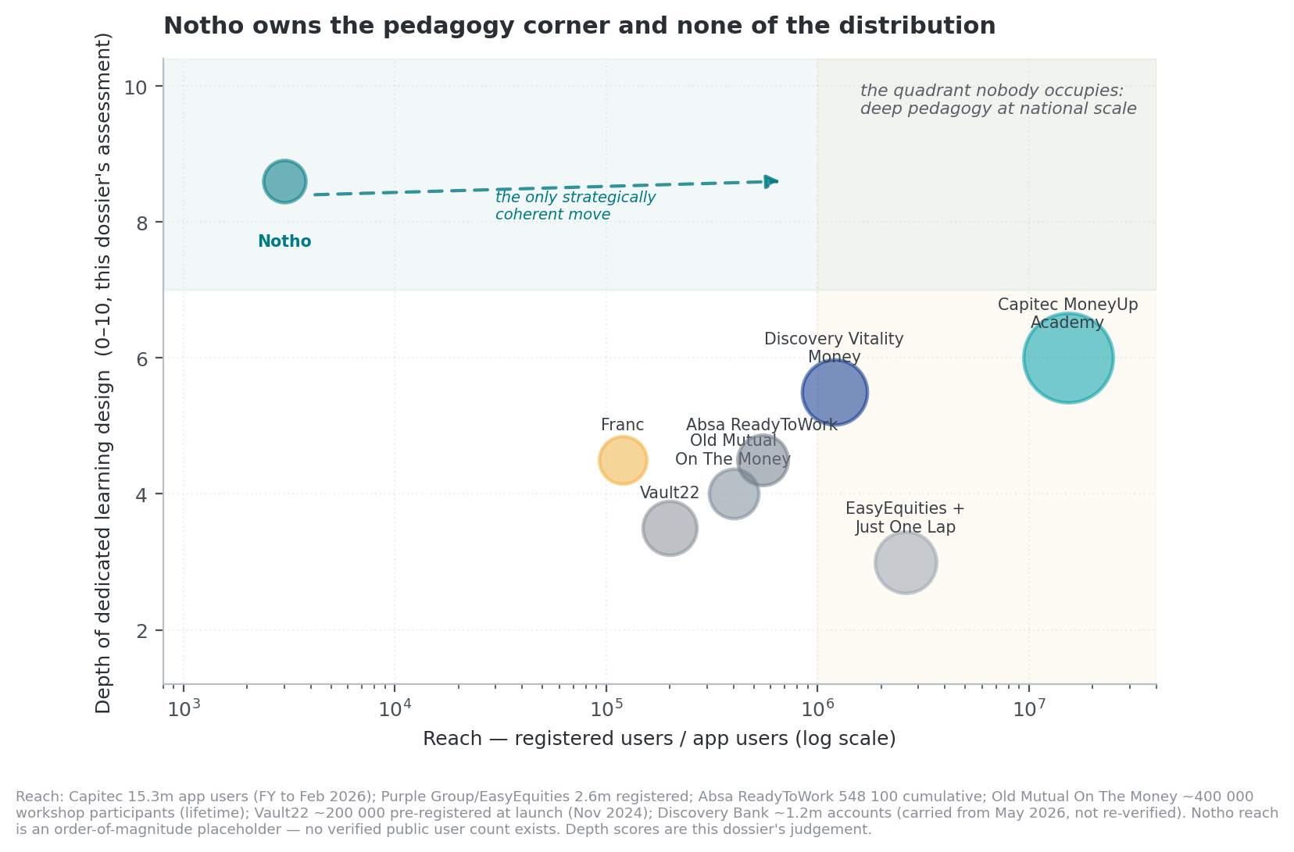
Figure 6. Depth of dedicated learning design against distribution reach.
Reach Grade C/D from public disclosures. Depth scores Grade E — this dossier's assessment. Notho's reach is an order-of-magnitude placeholder; no verified public user count exists.

5.1 Capitec MoneyUp Academy — the competitor that decides the pitch
Capitec launched MoneyUp Academy as an explicitly gamified learning platform. Its current public description includes short lessons, points earned as you learn, levels with trophies, badges for mastering content, and a weekly points target that earns an entry to win a Capitec Flexi Voucher worth up to R200. It runs at moneyup.co.za and learn.moneyup.co.za, and sits inside a banking app with 15.3 million banking-app clients as at the February 2026 financial year end, up 19% year on year, within a base of 26 million active clients, with Live Better reporting around 6.5 million active users. Capitec also runs MoneyUp Chat ('Moola'), a WhatsApp chatbot teaching budgeting, compound interest, inflation, savings and retirement.
Any Notho pitch that does not name Capitec in the first five minutes will lose credibility the moment the investor searches. But the honest competitive read is more favourable than the headline suggests, in three specific ways.
Dimension | Capitec MoneyUp Academy | Notho | Who wins
Distribution | 15.3m app users within 26m active clients; in-app placement; bank-grade trust | PWA, no landing page, no partner | Capitec, by four orders of magnitude
Learning architecture | Points, levels, trophies, badges — an engagement layer over content | Retrieval-first lessons, mastery gate, SM-2 spacing, 2 440 variants | Notho, decisively
Reward structure | Extrinsic voucher lottery (weekly points target → R200 voucher entry) | Intrinsic-leaning XP with forgiveness mechanics | Notho on evidence (Deci et al. 1999); Capitec on short-run engagement
Product neutrality | A bank teaching about banking. Structurally conflicted. | Product-agnostic in principle; founder's Liberty role is the live conflict (§7.5) | Notho, if it fixes the founder conflict
Content breadth | Personal and business money management | 22 courses including tax, estate, crypto, RE5 exam prep, faith-based stewardship | Notho
Behaviour measurement | Not publicly evidenced | Not built | Nobody
Cost to user | Free, and pays users to participate | Free core, R79/month Pro planned | Capitec
Assessment: three ways Notho is not competing with Capitec
One — Capitec cannot be product-neutral. A bank's financial education is structurally unable to advise against its own products. Under FSCA Conduct Standard 1 of 2025, education must be objective, impartial, and must not promote specific financial products or services (§7.2). That constraint is far easier for an independent to satisfy than for a bank, and it is now a regulatory constraint, not a reputational one.
Two — Capitec serves Capitec clients. MoneyUp's distribution advantage is also its ceiling. An employer, a retirement fund administrator or an insurer cannot deploy a Capitec-branded programme to a workforce banking across five institutions.
Three — Capitec is not trying to win the learning-design argument. Vouchers for weekly points is engagement design, not pedagogy. Notho's mechanics are genuinely better and that difference is defensible to an expert audience — which happens to be exactly who buys B2B.

5.2 Vault22, Franc and the standalone-PFM cautionary tale
Vault22 is the amalgamation of Standard Chartered's SC Ventures wealth app Autumn with 22seven, backed by Old Mutual's NEXT176. It launched on 5 November 2024 addressing roughly 200 000 pre-registered and linked-account users, with financial-fitness levels (Rookie → Enthusiast → Competitor → Expert → Elite). It is a wealth-management and budgeting product that surfaces educational nudges, not a literacy-first product — but it is the heaviest-funded incumbent in the adjacent category.
The 22seven history is the most important precedent in South African consumer fintech and Notho's plan should address it explicitly. Launched 2012 at R70/month; cut to R25; went free in September 2014 because, in the founder's own words, paying a subscription was an obstacle; absorbed in-house by Old Mutual in 2017; lost investment functionality in 2021; rebranded in 2024. Thirteen years, two corporate owners, and it never reached escape velocity as a standalone subscription business. The standalone paid-PFM model has been tested in South Africa and it did not work. Notho's R79/month plan is a more aggressive price than the one 22seven abandoned twelve years ago, in a market with lower real incomes.
Franc raised R8 million in 2022 and is the closest like-for-like — bite-sized in-app tips, streaks, challenges, and the Franc Academy content platform — except that it sells an investment product alongside, which is how it monetises. (Grade D; carried from the May 2026 assessment and not re-verified in this session.)
Bettr is the failure case: founded 2015 as a creator-economy neobank with financial-literacy ambitions, effectively shut down in 2022 without a formal announcement, app and website removed, no annual returns filed for 2022–23.

5.3 Discovery Vitality Money and the bank programmes
Discovery Vitality Money is the most sophisticated bank-led behavioural-finance system in South Africa, described by the UN Secretary-General's Special Advocate for Inclusive Finance as using behavioural economics, gamification and incentives to encourage customers to adopt and sustain healthy financial habits, across roughly 1.2 million Discovery Bank accounts. It is gated behind a premium credit product, which is both its strength and its addressable-market ceiling. (Grade C/D; not re-verified August 2026.)
The institutional literacy programmes are broadcast content gated to existing customers, and they are the direct competitors for Notho's B2B revenue line: Old Mutual On The Money (~400 000 through workshops, ~15 million via media, lifetime), Absa ReadyToWork (548 100 youth across African markets since 2016), Standard Bank WalletWise, FNB nav» Money, and — importantly — Liberty's own Mind My Money programme, running since 2020. The founder's employer already has a financial-literacy product. That is either a conflict or the warmest available first B2B conversation, and the difference depends entirely on how it is handled (§7.5).

5.4 International players and the RE5 flank
No major international gamified-financial-literacy app serves South Africa in a localised way. Zogo is B2B for US banks with US gift-card rewards; Greenlight and Step are US teen banking; Cleo states it is available only in the United States; Long Game was acquired by Truist in 2022 and discontinued. Several global 'Duolingo for finance' attempts exist without meaningful traction. This is genuine whitespace — but it is whitespace for the reason that matters: no one has found the distribution model.
One flank in Notho's product is competitively distinct and under-discussed internally: the RE5 regulatory exam course, with two full 50-question mock exams. RE5 is the first-level regulatory examination every South African financial-services representative must pass. It is 50 multiple-choice questions in two hours at a 66% pass mark, costs roughly R1 226 per attempt in 2026, and is administered in person through Moonstone as the FSCA-accredited exam body. There is an established paid market of study-material vendors and prep courses around it.
Assessment: RE5 is the fastest available path to first revenue (Grade E)
Unlike Notho's consumer proposition, RE5 prep has all four properties of an easy sale: a captive audience (you cannot practise without passing), a hard deadline, a known cost of failure (R1 226 per re-attempt plus lost earnings), and an existing willingness to pay for study material.
It is also the use case where Notho's spaced-repetition-plus-question-bank architecture is most obviously superior to a PDF study pack — which is what most of the market currently sells. And the buyer set (FSPs, insurers, brokerages onboarding representatives) is the same buyer set as the B2B financial-wellness line.
This dossier's recommendation is to treat RE5 not as a course inside Notho but as a separately positioned, separately priced product that funds the consumer mission. See §10.1.

5.5 The stokvel decision, revisited
Notho removed group savings in commit 8f37d3d. The market context: roughly 800 000 stokvels, 11 million members — about one in four South African adults — and about R50 billion a year in flows. FNB alone has over 119 000 stokvel groups and 358 000 members on its digital platform, and reports that in 2025 digitised stokvels earned R256 million in interest and avoided R211 million in withdrawal fees.
Two readings are available. The engineering reading is that a social feature with low usage and high maintenance cost was correctly cut. The strategic reading is that Notho deleted its only bridge to the financial behaviour eleven million South Africans already perform, and — per §3.4 — its only structural commitment device.
This dossier's assessment is that both are true, and the resolution is to rebuild it differently. The removed feature appears to have been a social/gamified surface. What the evidence supports is not a stokvel leaderboard but a commitment layer: a declared contribution, a scheduled reminder tied to the group's cycle, a lesson fired at the moment of the payout decision, and a measurable outcome. That is a smaller build than a social feature and a much stronger claim.

5.6 Feature coverage
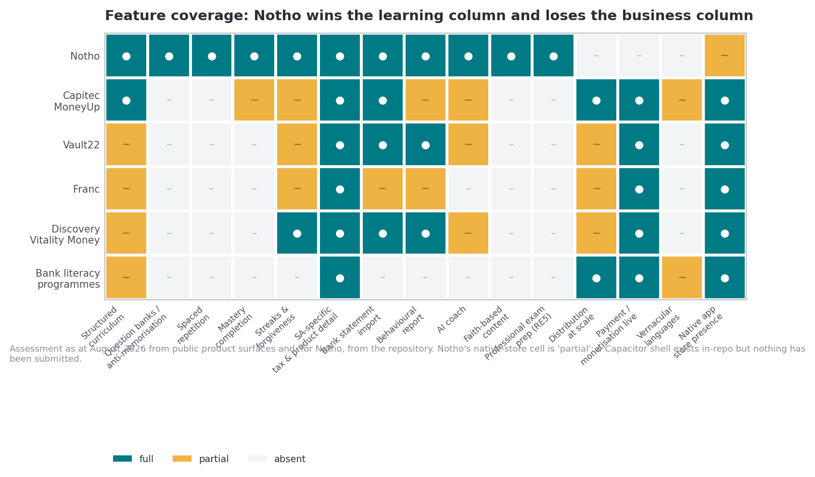
Figure 7. Feature coverage across Notho and its principal South African competitors, August 2026.
Grade E. Assessed from public product surfaces and, for Notho, from the repository at commit d5f5b1b.
The pattern is unambiguous and is the thesis of this dossier in one image. Notho is the only product with a full row on the left half of the matrix — the learning column — and the only product with an empty row on the right half — the business column. Every competitor is the mirror image. Nobody is competing with Notho on pedagogy, and Notho is not competing with anybody on distribution, payments or language coverage.

6. Part V — Market sizing and unit economics

6.1 The funnel, with its assumptions exposed
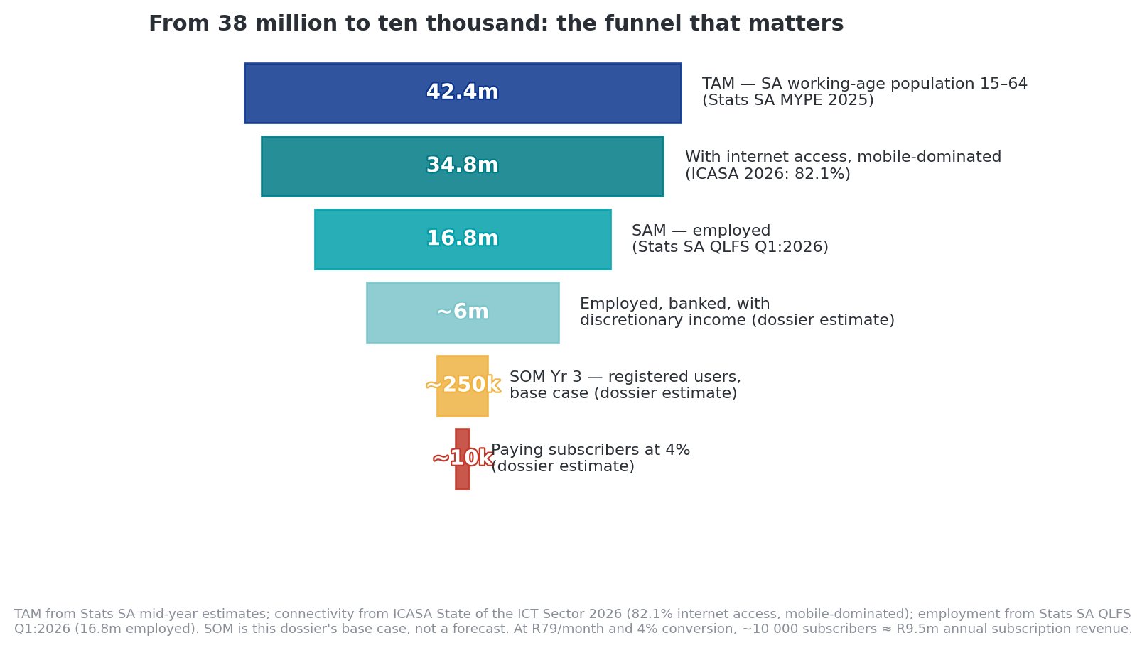
Figure 8. From total addressable population to paying subscribers.
TAM Grade B (Stats SA); connectivity Grade B (ICASA State of the ICT Sector 2026); employment Grade B (QLFS Q1:2026). SOM Grade E — this dossier's base case, not a forecast.
Two constraints collapse the funnel faster than most consumer models assume. Employment: 16.8 million people are employed, down 345 000 quarter-on-quarter, against 8.1 million unemployed. Connectivity cost: ICASA's 2026 State of the ICT Sector reports 82.1% internet access, overwhelmingly mobile, with average 1GB prepaid pricing around R20.50 by one 2025 measure and prepaid 1GB 30-day bundles historically clustering near R79. South Africa ranks around 67th of 100 countries on mobile data affordability, with 27 African countries cheaper.
Data cost is a regressive tax on Notho's engagement model
A daily-habit app charges its users, in data, every day. For a prepaid user — the majority — every megabyte Notho consumes is money. The product implications are concrete and mostly already achievable in the existing stack:
(a) Hard budget of well under 5MB per session, measured and regression-tested in CI. (b) Aggressive service-worker precaching so a lesson costs zero data on repeat. (c) A WhatsApp delivery channel for the lowest-data segment — which is precisely what Capitec built with Moola. (d) Pursue zero-rating: Vodacom, MTN, Telkom, rain and Liquid are obliged under their March 2022 spectrum licence conditions to zero-rate Public Benefit Organisation mobile content, and ICASA publishes an application process. A PBO structure for Notho's free educational tier would make the core product free to reach — a material and under-explored strategic option.

6.2 The ICP problem the data has not stopped raising
The business plan's beachhead is 'black South African first-salary earners aged 21–30 in metros, earning R10 000–R35 000 per month'. Three independent data series argue against it as a first market, and the May 2026 assessment reached the same conclusion:
- Income. Youth unemployment is 45.8%, and 60.9% for 15–24 year olds. A large fraction of the segment has no surplus on which to act.
- Behavioural urgency. Two-pot withdrawals — the best available revealed-preference measure of who is making consequential money decisions — put 35–44 at 42%, 45–54 at 28%, and 25–34 at only 22%.
- Acquisition economics. Youth segments are the highest-CAC, lowest-LTV cohorts for any South African digital subscription business.
The evidence points to formally employed 28–45 year-olds earning R15 000–R45 000 a month who are facing a specific decision — two-pot, debt review, a first child, retrenchment, a new job, an inheritance — reached through employers, retirement-fund administrators and insurers rather than direct-to-consumer. That is not a rejection of the founder's mission; the 21–30 cohort remains the right eventual audience and the right brand story. It is a sequencing argument: the older cohort has the money, the urgency and the institutional access that make the younger cohort reachable later.

6.3 Price: R79 is above the ceiling
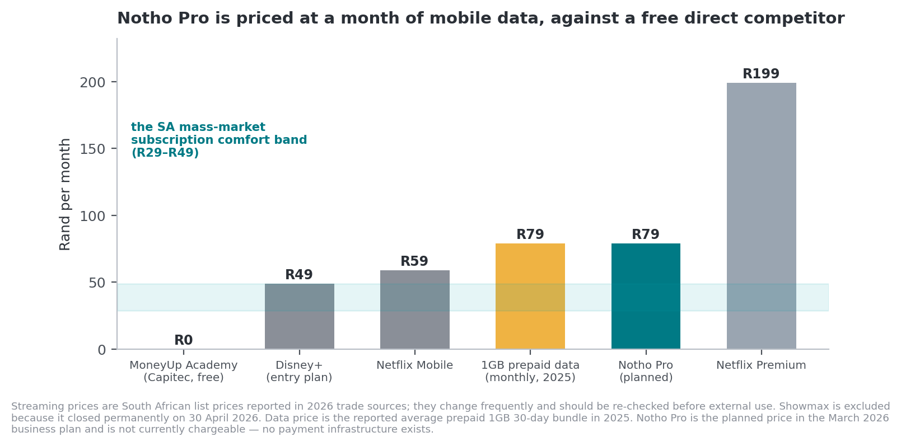
Figure 9. Notho Pro's planned price against South African comparators and against a month of mobile data.
Grade B/C/D. Comparator prices are indicative August 2026 list prices.
Notho Pro at R79/month prices above Netflix Mobile (R59) and at the level of a typical monthly 1GB prepaid data bundle (about R79 in 2025). Its nearest competitor in category — Capitec MoneyUp Academy — is free and pays users vouchers. Old Mutual's 2026 Monitor records 40% of working South Africans as highly or overwhelmingly financially stressed, with stress rising fastest below R30 000 a month, which is the middle of the target band.
22seven's history is the direct precedent: R70/month, then R25, then free within two years because the subscription itself was the obstacle. Notho proposes R79 in a market with lower real disposable income than 2012–14.
Element | Business plan | This dossier's recommendation | Reasoning
Free tier | Free core with hearts limit | Free core with a daily session budget, no failure penalty | Removes the regressive contingency (§4.6) and improves the free experience, which Duolingo treats as a growth lever
Monthly price | R79 | R39–R49 | Below the data-cost anchor and below Netflix Mobile at R59; survives the free-competitor comparison
Annual prepay | R699 (R58/month effective) | R349–R399 (~R30/month effective) | Annual prepay is disproportionately effective in SA because it removes the monthly renewal decision; price it as a genuine discount
Pro value | Unlimited hearts, advanced courses, monthly report | Additive only: wellness report, statement-import depth, advanced courses, RE5 prep, downloadable summaries, household/family seats | Nobody is worse off for not paying. Removes the mission contradiction and the strongest external line of attack
Store commission | Not modelled | Model 15–30% | Apple and Google require in-app purchase for digital content. A R49 in-app subscription nets R34–R42. Web checkout with app-store parity pricing needs deliberate design
Realistic conversion | 3–5% of active monthly users | 2–4%, decaying | Duolingo reaches ~9% of MAU after a decade and its net adds fell from 600–900k to ~300k per quarter in Q1 2026

6.4 Retention: the number that decides everything
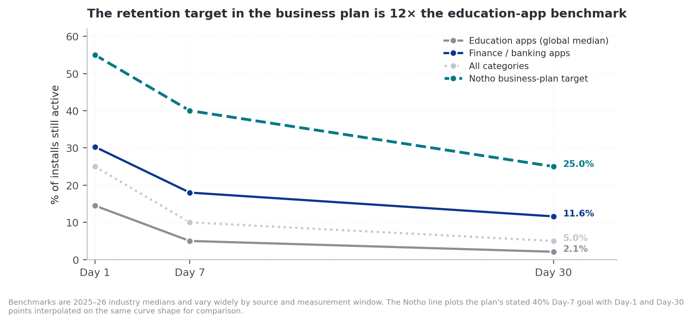
Figure 10. Day 1, 7 and 30 retention: category benchmarks against the Notho business-plan target.
Grade D. Industry medians vary widely by source and measurement window.
Education apps are among the worst-retaining categories measured, at roughly 14–15% Day 1 and 2–3% Day 30. Finance and banking apps do markedly better, at roughly 30% Day 1 and 11.6% Day 30, with fintech Day-30 figures often quoted between 15% and 25%. The all-category Day-30 average is around 5%.
Notho's plan targets 40% Day 7 retention. That is roughly eight times the education-app Day-7 benchmark. It is not impossible — this is exactly the gap Duolingo-class products close, and Notho's forgiveness mechanics and daily-habit design are the right tools — but it must be presented as a design goal with a named mechanism, never as a projection. Presented as a projection it invites the correct response: on what basis?
The more useful framing, and the one that suits Notho's actual pillars: Notho is not purely an education app. The budget pillar — statement import, categorisation, reconciliation, health score — puts it partly in the finance-app retention regime, which is five times better. Retention strategy should therefore lean on the budget pillar as the recurring reason to open the app, with learning as the thing that happens while you are there. That is close to the inverse of how the product currently presents itself, and it is worth testing.

6.5 Unit economics
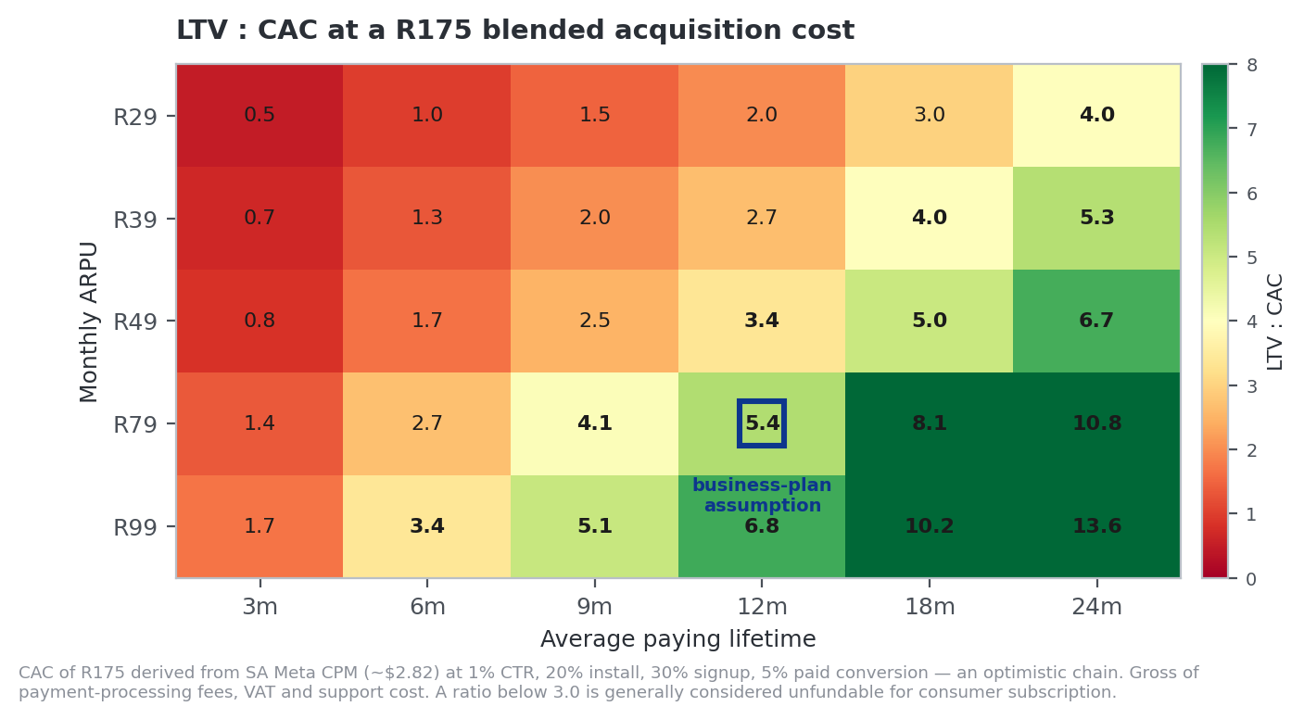
Figure 11. LTV:CAC sensitivity at a R175 blended acquisition cost.
Grade E, built on Grade D inputs. Gross of payment-processing fees, VAT and support cost.
The R175 CAC estimate derives from South African Meta CPM of roughly $2.82 — about a sixth of the global Facebook CPM — chained through a 1% click-through rate, 20% install rate, 30% signup rate and 5% free-to-paid conversion. Every link in that chain is optimistic. At R49 ARPU and twelve months of paying life, LTV is roughly R588 and LTV:CAC roughly 3.4:1, which is marginally fundable only if retention holds. At the more realistic combination of R49 and six months, the ratio falls to 1.7:1, which is not.
The TymeBank comparison is the one that matters and it is sobering: TymeBank's customer acquisition cost sits around $3–$4, but only because it acquires through Pick n Pay and Boxer retail kiosks. Pure-app South African fintech does not achieve $4 CAC. Partnerships are not a growth accelerator for Notho; they are the precondition for the unit economics working at all.

6.6 The revenue plan, stress-tested
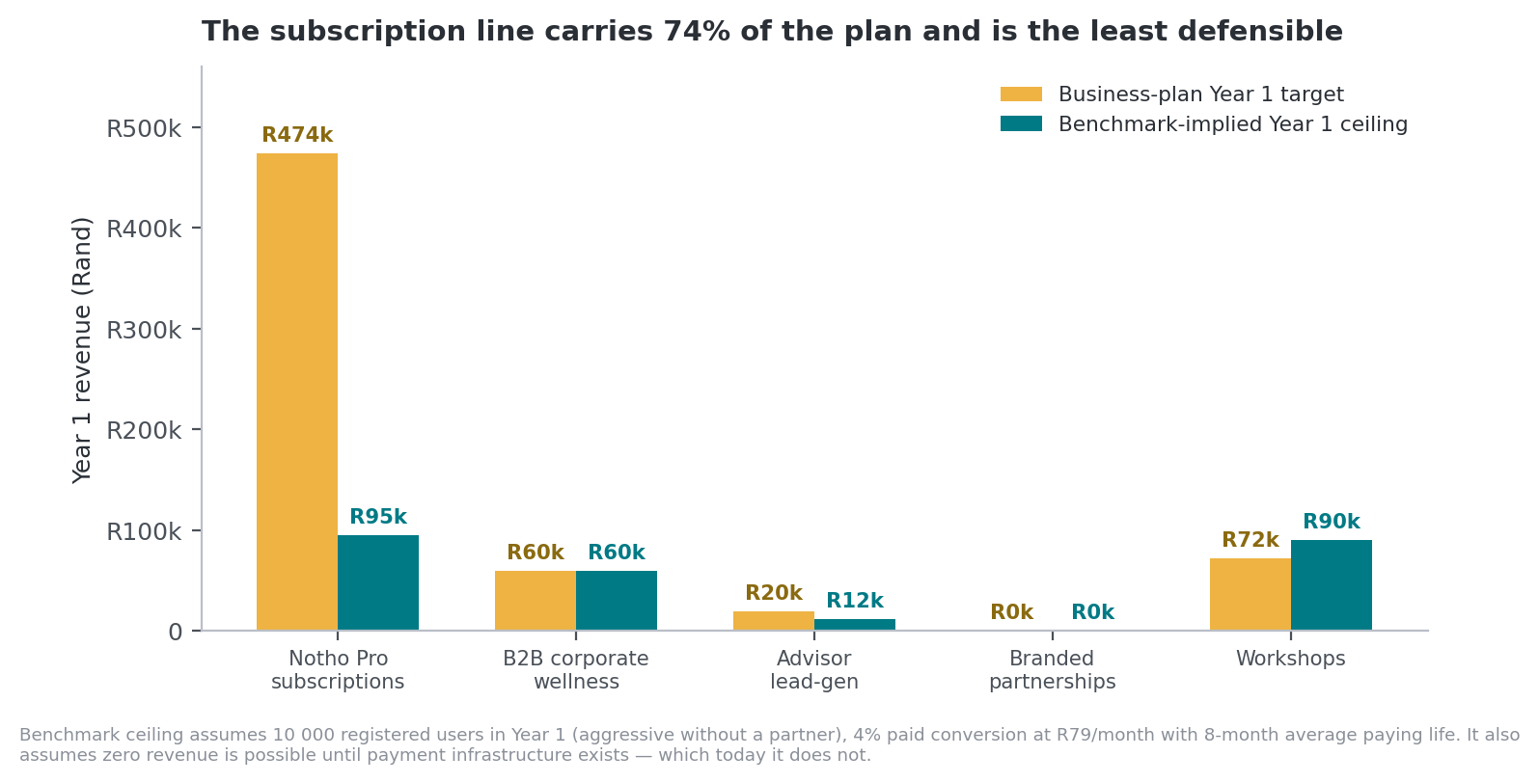
Figure 13. Business-plan Year 1 revenue targets against benchmark-implied ceilings.
Grade E. Benchmark ceiling assumes 10 000 registered users in Year 1 without a partner, 4% paid conversion at R79/month, eight-month average paying life.
Stream | Plan Yr 1 | Assessment | Grade
Notho Pro subscriptions — 500 subscribers, R474 000 | R474 000 | Requires 10 000–17 000 active monthly users at 3–5% conversion, plus payment infrastructure that does not exist, plus retention far above category benchmark. 74% of Year 1 revenue rests on the least defensible line. | Unlikely without a partner
B2B corporate wellness — 3 clients × 100 seats at R200/employee/year | R60 000 | The most achievable line and the most under-resourced. R200/seat/year is R16.67/month, which is credible against SA corporate wellness benchmarks. Now strongly tailwinded by FSCA Conduct Standard 1 (§7.2). Three clients is a conservative target; the constraint is sales capacity, not demand. | Achievable, and understated
Advisor lead generation — 20 referrals at ~R1 000 | R20 000 | Small revenue, disproportionate risk. This is the line that converts Notho from 'education' into 'distribution' in a regulator's eyes and hands every critic the 'it was always lead-gen' argument. See §7.5. | Defer. Not worth R20 000.
Branded partnerships | R0 (Yr 1) | Correctly deferred. Note that under Conduct Standard 1, a sponsoring institution's education must remain objective and free of product promotion — which constrains how 'branded' a branded module may be. Design the format for that constraint now. | Correctly sequenced
Workshops — 4 × 30 × R600 | R72 000 | Highest-certainty revenue in the plan because the founder already does this. Also the highest-value research channel: workshops are where behaviour-change measurement can be piloted with consent. | Achievable; under-valued strategically
The finding that should reorder the roadmap
The two most achievable revenue lines in the plan — B2B corporate wellness and workshops — together target R132 000 and require no payment infrastructure at all. They are invoiced.
The least achievable line, consumer subscriptions, targets R474 000 and requires a payment stack that does not exist, a landing page that does not exist, an app-store presence that has not been submitted, and retention eight times the category benchmark.
Notho has been building for the hard revenue line and neglecting the easy ones. Reordering this is the single highest-return decision available and costs nothing but attention.

7. Part VI — Regulatory perimeter and risk

7.1 The FAIS advice boundary
The Financial Advisory and Intermediary Services Act 37 of 2002 defines 'advice' broadly. The carve-out is narrow and specific: advice does not include factual advice about procedures, the description of financial products, answering routine questions, objective information about financial products, or the display or distribution of promotional material. Where content constitutes a recommendation in relation to a financial product, it is financial advice and requires FSP authorisation. Disclaimers do not cure the position where advice is in substance being given.
Three surfaces in Notho sit close to the line and should be reviewed by a FAIS compliance officer before any scale-up:
- Cosmo, the AI coach. A free-text conversational agent answering money questions is the highest-risk surface in the product, because the user controls the prompt and the model controls the answer. The persistent AI disclosure shipped in 7b21c26 is necessary and not sufficient. The mitigation is a hard refusal layer for product-specific and personal-recommendation requests, logged and auditable — not a disclaimer.
- The investor profile quiz. A quiz that outputs a risk profile from conservative to aggressive is one step from a recommendation. Keep it descriptive ('this is what a conservative profile means'), never prescriptive ('you should hold X').
- The interactive report's what-if sliders and missions. Personalised, transaction-data-driven prompts toward specific actions are the exact fact pattern the FSCA has in mind. Keep outputs at the level of category behaviour, not product selection.
The FSCA is also actively monitoring finfluencers, and has stated that they are not exempt from the same framework as any other market participant. The founder's @wealth.with.kwanele presence on TikTok and LinkedIn is inside that perimeter, and the connection between the personal brand and the app makes them a single regulatory surface.

7.2 FSCA Conduct Standard 1 of 2025 — the most important development since May 2026
What changed on 26 March 2026
FSCA Conduct Standard 1 of 2025 on financial education completed its twelve-month transition and is now in full force. The Standard does not require financial institutions to provide financial education. But where an institution chooses to, full compliance becomes mandatory, covering governance and oversight, appropriate design and targeting, monitoring, evaluation, and reporting to the FSCA.
It applies across banks, insurers, retirement funds and other FSCA-supervised institutions. It requires a clear delineation between education and marketing: initiatives must be objective and impartial and may not promote specific financial products or services. And it narrows the definition — activities must form part of a structured programme or systematic initiative, not once-off efforts.
Alongside it, the FSCA and National Treasury are finalising a Financial Education Commitment Charter under which institutions adopt a board-approved financial education plan at least annually and make it publicly available, with delivery aligned to that plan and targeted at defined groups. A National Treasury financial education policy is expected to complete the framework.
Notho is not a financial institution and is therefore not directly bound. Every institution Notho would sell to is bound. That inversion is the strategic opportunity of this dossier.
The FSCA's department head for consumer education, Lyndwill Clarke, has said publicly that measuring outcomes remains a key challenge for the industry, that the FSCA is exploring baseline data collection and ongoing monitoring, and that he has encouraged industry participants to engage where they have practical methodologies for measuring impact. The regulator has, in effect, announced an unmet need and invited proposals.
Conduct Standard requirement | What an institution now needs | What Notho can supply
Governance and oversight of the initiative | A documented programme with defined owners and board-level visibility | A structured 22-course curriculum with versioned content, a documented voice and quality standard, and a content-quality test suite enforcing item validity
Appropriate design and targeting | Evidence the programme suits the target group | Cohort-level targeting by course, plus SA-specific content built on a source-controlled regulatory figures document (docs/SA-REGULATORY-FIGURES.md)
Monitoring and evaluation of effectiveness | Measurement that goes beyond attendance | The gap and the opportunity. Notho already has concept-level mastery data per user. Adding pre/post knowledge assessment and a behavioural outcome measure would make it the only SA vendor that can hand an institution an evaluation report.
Reporting to the FSCA | Periodic structured reporting | Exportable cohort reporting is a small build on the existing admin dashboard
Education strictly separated from marketing | Objective, impartial content with no product promotion | Notho's structural advantage. An independent product-neutral provider satisfies this by construction; a bank's own programme has to work at it.
Reposition the B2B pitch (Grade E)
Notho should stop selling 'a financial literacy app for your employees' and start selling 'a Conduct-Standard-compliant financial education programme with an evaluation report attached.'
The buyer changes from an HR wellness budget to a compliance and conduct budget, which is larger, less discretionary and less seasonal. The competitive set changes from other wellness apps to consultancies. And the objection changes from 'we already have a wellness benefit' to 'show me your evaluation methodology' — which is a question Notho can win on §4 alone.
Timing matters: the Standard came into force five months ago and institutions are building these programmes now.

7.3 POPIA and the budget pillar
Notho's bank statement import — CSV, OFX and PDF with SA-specific parsers for Capitec, FNB and Discovery — makes it a processor of transaction-level financial behaviour data. Under the Protection of Personal Information Act 4 of 2013 this attracts the full weight of the conditions for lawful processing, with penalties up to R10 million for serious offences plus the possibility of criminal liability.
The repository already has the right surfaces: POPIA consent, privacy, terms and security pages, account data export and account deletion via an edge function, plus a documented docs/DATA-SAFETY.md and two 2026 security reviews covering authorisation and row-level security. That is materially better than most early-stage products.
An under-appreciated regulatory advantage
South Africa has no PSD2 equivalent. Open banking is being pursued collaboratively through SARB and the Intergovernmental Fintech Working Group, and in the meantime aggregation has generally relied on screen scraping, which carries recognised privacy and data-protection concerns and, at minimum, credential-handling risk.
Notho takes an uploaded file. No credentials, no scraping, no third-party aggregator in the data path. That is a lower-risk architecture than Vault22's or any aggregator-backed competitor's, and it is a POPIA and information-security selling point in a B2B conversation — where the buyer's own risk function will ask exactly this question. Notho currently treats file upload as a limitation. It should be presented as a design choice.

7.4 App store constraints
The store-readiness assessment dated 4 August 2026 is candid: Notho is a web-only Next.js application and cannot be submitted to either store in that form, with a 6–12 week path depending on approach. A Capacitor shell and submission assets have since been committed (472a23a), which shortens the path considerably. Remaining blockers named internally include a Play Store TWA with assetlinks.json, Google Play and Apple developer accounts, a maskable icon, mobile Lighthouse performance, Google and Facebook OAuth still in testing mode, and a prominent 'educational content, not financial advice' disclaimer.
Two commercial consequences deserve to be modelled and currently are not. First, in-app purchase commission: both stores require IAP for digital content, taking 15–30%. A R49 subscription nets R34–R42. Second, financial app review scrutiny: apps handling financial data face additional review, and any content that could be read as investment advice risks rejection — which makes the FAIS work in §7.1 a store-submission dependency, not just a legal one.
Set against this, the PWA choice has real merit for the South African market: no install friction, no store gatekeeper, no storage cost on cheap devices, and instant updates. Pinterest and Twitter Lite both built PWAs specifically for low-connectivity markets and reported large engagement gains. The honest position is that PWA is the right primary channel for South Africa and store presence is a credibility and discovery channel, not a replacement.

7.5 The founder conflict, and how to make it an asset
The founder is a qualified financial advisor at Liberty Group. Liberty runs its own financial-literacy programme, Mind My Money. The business plan includes an advisor lead-generation revenue line that refers users to financial advisers 'including the founder's Liberty practice'. FAIS section 16 imposes conflict-of-interest obligations, and Conduct Standard 1 requires education to be objective and impartial and free of product promotion.
The reputational exposure is sharper than the legal one. Vault22's own Google Play reviews contain the criticism that the product pushes its owner's financial products, and it is the first criticism any independent reviewer will reach for. A Liberty-tied founder running a 'neutral' education app will face it immediately, and the R20 000 lead-generation line in the Year 1 plan is the exhibit.
Exposure | Mitigation | Priority
Advisor lead-gen creates a direct financial interest in users being referred | Remove the line from Year 1 entirely. R20 000 is not worth the positioning cost. If reintroduced later, use a blind panel of independent FSPs with no founder participation and published referral economics. | Immediate
Founder's Liberty role is undisclosed in-product | Disclose prominently and permanently on an About page and in onboarding. Disclosure that is volunteered reads as integrity; disclosure that is discovered reads as concealment. | Immediate
Content could favour Liberty-adjacent products | Formal content-neutrality policy; the existing source-controlled regulatory figures document is the right foundation. Add an independent reviewer sign-off on any product-comparison content. | Before B2B sales
No independent oversight | Constitute an independent advisory board with at least one compliance professional and one consumer-education academic. This is also a Conduct Standard governance asset when selling B2B. | Before fundraising
FSP infrastructure absent | Vault22 operates as a juristic representative of an FSP. Take advice on whether Notho needs equivalent cover before Cosmo or the report modules scale. | Before scale

7.6 The name
The May 2026 assessment identified Notho Capital (Pty) Ltd — formerly Eduloan, founded 1996, reported as 40% owned by the Government Employees Pension Fund and 16.5% by Standard Bank, with over 900 000 education loans issued and more than R10 billion in administered bursary funds — as a direct collision in the same sector. This dossier could not re-verify that finding in August 2026 because of the research session limit, and it is restated as a live risk rather than a confirmed one.
What is certain is that the risk was identified, the rebrand from Fundi Finance to Notho proceeded anyway, and the exposure is now embedded in a domain, a brand, a mark and an app icon. The correct next step is not more desk research. It is a trademark attorney opinion and a CIPC and trade-mark register search, obtained before any funding round or store submission, so that the answer is a legal position rather than an open question. If the collision is real, it is cheaper to resolve now than after an app-store listing and a marketing spend.

7.7 Gamifying financial decisions
Massachusetts regulators sued Robinhood in 2020 over the gamification of financial decision-making. The relevant distinction for Notho is that gamifying learning is a pedagogical question, while gamifying decisions with monetary stakes is a conduct-supervision question under the FSCA's Twin Peaks mandate. Notho is currently on the safe side of that line. Missions, what-if sliders and any future feature that rewards a user for taking a real financial action move it toward the line, and should be designed with that in mind from the start.

8. Part VII — Honest audit: where Notho leads and where it falls short
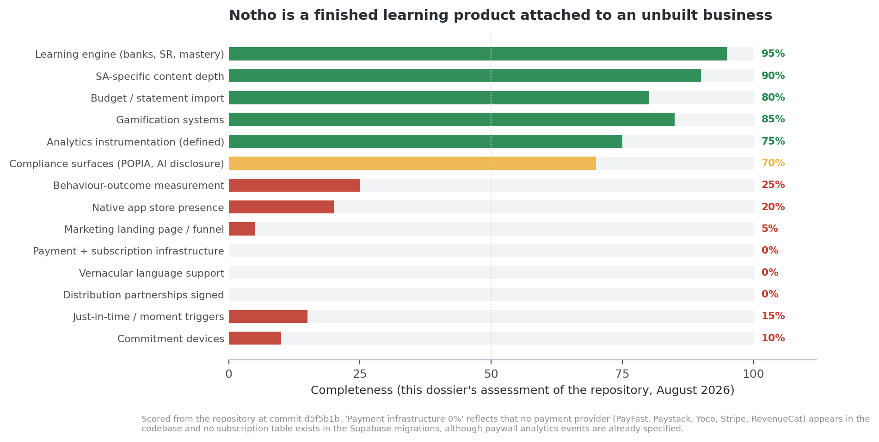
Figure 12. Completeness across fourteen dimensions of the business.
Grade E. Scored from the repository at commit d5f5b1b.

8.1 Where Notho is genuinely ahead
Advantage | Evidence | How durable?
Learning architecture | Retrieval-first lessons, mastery completion gate, SM-2 spacing over 168 concepts, 814 slots and 2 440 authored variants. No SA competitor implements any of the three best-evidenced mechanics. | High. Hand-authored content at this volume cannot be bought or quickly copied, and the architecture is documented and tested.
Content depth and locality | 22 courses covering tax, estate planning, crypto, business finance, property, scams and the rand — plus RE5 exam prep and faith-based stewardship. Figures are source-controlled to a web-verified regulatory document with a rule against inventing numbers. | High. Depth compounds and the discipline around figures is unusual.
Product neutrality by construction | No product to sell. Under Conduct Standard 1 this is now a regulatory qualification, not just a positioning claim. | High, conditional on removing the advisor lead-gen line and disclosing the Liberty role.
Two working pillars, not one | Learn plus Budget — statement import for CSV, OFX and PDF with bank-specific parsers, auto-categorisation, dupe and transfer detection, reconciliation, and an interactive report with health score, behavioural patterns and snapshots. | Medium-high. Puts Notho partly in the finance-app retention regime, which is ~5× the education-app regime.
Lower-risk data architecture | File upload rather than credential-based aggregation or screen scraping. No credentials in the data path. | Medium. Erodes if SA open banking arrives, but is a live POPIA advantage in B2B today.
Engineering discipline | 240 passing unit tests, Playwright e2e, a content-quality test enforcing unique IDs and minimum variant counts, two documented security reviews, an analytics playbook with a single instrumented entry point, ~39 migrations. | Medium. Reduces execution risk and is visible in diligence.
Regulatory timing | Conduct Standard 1 in force since 26 March 2026; the regulator has publicly named outcome measurement as the unsolved problem. | Time-limited. This window is open now and will close as institutions build or buy.

8.2 Where Notho falls short
Shortfall | Evidence | Severity
No revenue capability whatsoever | No payment provider anywhere in the codebase; no subscription or entitlement table in the migrations; paywall analytics events specified but nothing behind them. | Fatal if unaddressed. Every Year 1 subscription rand is currently uncollectable.
No behaviour-outcome measurement | Analytics track lesson completion, XP, streaks and retention pings. Nothing measures whether a user did anything different with money. The analytics playbook's own stated principle — 'are users actually becoming more financially literate?' — is not satisfied by any event it defines. | Critical. Without this, Notho cannot answer the only question that matters, cannot sell into Conduct Standard 1, and cannot defend against Fernandes et al.
No acquisition funnel | src/app/page.tsx still redirects to /learn. A logged-out visitor meets a login wall with no value proposition, screenshots, pricing or trust signals. Flagged as P0 in the July 2026 UX audit and unfixed. | Critical. Every marketing rand spent before this exists is wasted.
No distribution | No signed partner, no employer client, no bank or retirement-fund relationship. TymeBank's $3–4 CAC exists because of retail kiosks; pure-app SA fintech does not achieve it. | Critical. This is the precondition for the unit economics, not an accelerator.
English only | No i18n layer. In a country with eleven official languages and a target market that is majority non-English-first. | High. Also closes off government, PBO and zero-rating routes.
Just-in-time delivery unbuilt | Two scheduled crons at fixed times. No trigger tied to a financial decision moment. This is the +0.079 SD moderator and the only perch the field's critics allow. | High. The largest evidence-to-implementation gap in the product.
No commitment devices | The single largest effect in the literature (+81% savings) and Notho implements none. The one feature that came closest — stokvels — was removed. | High.
Hearts are regressive | Premium's headline benefit is escaping a penalty applied for wrong answers, which falls hardest on the least literate users. Contraindicated by Deci et al. (1999) and Hanus & Fox (2015). | High. Mission contradiction and reputational exposure.
Pricing above the ceiling | R79/month, above Netflix Mobile (R59) and equal to a month of prepaid data, against a free direct competitor that pays users vouchers. 22seven abandoned R70 in 2014. | High.
Retention target unevidenced | 40% Day 7 against a ~5% education-app benchmark, stated without a mechanism. | Medium-high. Credibility risk in diligence.
No app store presence | Capacitor shell committed, nothing submitted. Store commission unmodelled. | Medium. Discovery and credibility cost.
Single-founder concentration | The founder authors content, ships code, runs compliance, does marketing and is the brand. The business plan's Year 1 profitability depends on him drawing no salary. | Medium-high. The most common cause of death in this category, and it is invisible in the plan.
Name collision unresolved | Identified in May 2026, unresolved, and now embedded in domain, brand and icon. | Medium, potentially high. Unquantified is the problem.
Content maintenance liability | 22 courses and 2 440 variants encoding tax thresholds, contribution limits and product rules that change every February. No documented annual content-review process. | Medium, and growing with every lesson authored.

8.3 The five things most likely to kill Notho
- Building content instead of building a business. Content authoring is satisfying, measurable and entirely within the founder's control. Payments, distribution and measurement are none of those things, which is precisely why they are unbuilt. The repository shows a year of disciplined content work and zero weeks of payment work. This is the highest-probability failure mode and it is a psychological one, not a technical one.
- Founder burnout. One person is the content team, the engineering team, the compliance function, the marketing channel and the brand, while holding a full-time advisory role. The Year 1 plan is profitable only because he takes no salary.
- Never proving behaviour change. Without an outcome measure, Notho cannot rebut Fernandes et al., cannot sell into Conduct Standard 1, and cannot distinguish itself from a quiz app. Vanity metrics will accumulate and look like traction until someone asks the question in §0.1.
- Being out-distributed rather than out-built. Capitec does not need a better product. It needs to add one more tile to an app with fifteen million users. Notho's answer cannot be a better lesson; it has to be a channel Capitec cannot occupy — employers, retirement funds, multi-bank workforces, and independence.
- A regulatory or reputational event. An unmanaged Cosmo response that reads as advice, an undisclosed Liberty conflict surfacing in the press, a trademark letter, or a POPIA incident in the statement-import pipeline. Each is individually low-probability and each is survivable only if the governance work in §7 is done first.

9. Part VIII — The rebuttal pack
Sixteen objections, each stated in its strongest form rather than a convenient one, with the evidence-backed answer and what Notho would need in order to make that answer land. Where Notho cannot currently answer, the table says so.
Objection | Answer | What makes it land
'Financial education doesn't change behaviour — Fernandes et al. found 0.1% of variance.' | Correct, for education delivered the way it was studied — and on a comparable scale their estimate is 0.018 SD with a 95% interval of −0.004 to 0.022. The newer and methodologically stronger evidence, Kaiser, Lusardi, Menkhoff and Urban's meta-analysis of 76 RCTs and over 160 000 participants, puts the effect on behaviour at 0.100 SD (95% CI 0.071–0.129) and on knowledge at 0.204 SD (95% CI 0.152–0.255), with effects still positive at 0.057 SD two years after treatment. Fernandes himself carves out just-in-time education tied to specific behaviours, which is what we are building toward. And the same paper prices the field: USD 60.40 per participant for a fifth of a standard deviation. Our marginal cost per learner is a rounding error against that. | Cite all three papers unprompted, with intervals. Have the cost-per-effect model on a slide. Never claim transformation.
'Capitec already ships gamified financial literacy to 13 million app users.' | They do, and we say so first. Three differences: a bank cannot be product-neutral, and under Conduct Standard 1 education must be objective and free of product promotion; MoneyUp reaches Capitec clients only, which is useless to an employer whose workforce banks across five institutions; and MoneyUp is engagement design — points, trophies, voucher draws — not learning design. We implement retrieval practice, mastery completion and spaced repetition. They implement none of them. | Side-by-side mechanic comparison. Be specific about which mechanics and cite the effect sizes.
'Every "Duolingo for X" fails.' | Mostly true, and the reason is instructive: they copy the game layer and skip the learning layer. Duolingo's own efficacy evidence is weaker than its brand — the foundational 2012 study was company-commissioned on a self-selected sample. We are copying the mechanics that have independent evidence and rejecting the ones that don't. And Duolingo's Q1 2026 numbers show freemium conversion decaying even for them, which is why we are not betting the company on B2C subscriptions. | Position as evidence-led, not Duolingo-led. Retire 'Duolingo-style' from the pitch and replace it with the mechanism claim.
'You're a Liberty advisor. This is lead generation with a lesson attached.' | It is the single most legitimate concern about this company and we have removed the advisor lead-generation revenue line, disclose the Liberty role permanently in-product, operate a documented content-neutrality policy anchored to source-controlled regulatory figures, and are constituting an independent advisory board. | Cannot currently be answered. The lead-gen line is still in the plan. Remove it first. §7.5.
'Your name collides with a R10 billion company in the same sector.' | We identified it ourselves in our own May 2026 research, and we have a trademark attorney opinion and register searches on file. | Cannot currently be answered. Get the opinion. §7.6.
'South Africans won't pay R79 a month. 22seven tried and went free.' | Agreed, and we have repriced. Free core, R39–R49 monthly, R349–R399 annual, with premium value that is additive rather than restrictive. More importantly, consumer subscriptions are not our primary revenue line — B2B and institutional distribution are. | Requires the repricing decision in §6.3 and the B2B reordering in §6.6 to be actually made.
'Your target market is unemployed. 45.8% youth unemployment.' | Which is why our first market is not the youth cohort. The two-pot data shows 35–44 year-olds making 42% of the country's most consequential retirement decisions, in the R15 000–R40 000 income band, reachable through employers and retirement-fund administrators. The younger cohort is the mission and the brand; the older cohort is the beachhead. | Requires updating the business plan's stated beachhead. §6.2.
'You have no distribution.' | Correct, and it is our primary risk. It is also why we have repositioned around FSCA Conduct Standard 1: every institution we would sell to is now obliged to run structured, evaluated, reportable financial education, and the regulator has publicly said outcome measurement is the industry's unsolved problem. We sell the compliance evidence, not the app. | Needs one signed pilot to stop being a story. §10.1.
'22seven proved standalone PFM doesn't work in South Africa.' | It proved standalone paid PFM doesn't. We are not a PFM product with education attached; we are a learning product with a budget pillar, and the budget pillar exists because finance apps retain about five times better than education apps. Our monetisation is institutional, not consumer subscription. | Requires the retention strategy in §6.4 to actually lead with the budget pillar.
'Streaks and XP are vanity metrics.' | They are, if they are the outcome. For us they are the delivery mechanism for dose — and dose is the moderator with the clearest support in Kaiser et al. Our outcome metrics are concept mastery, pre/post knowledge, and a named behavioural change per cohort. | Not yet answerable. The outcome metrics do not exist. §10.1.
'You charge poor people to keep learning when they get answers wrong.' | We did, and we removed it. Hearts are now a daily session budget everyone has, with no failure contingency and no payment escape. Premium is additive only. | Not yet answerable. Requires the §4.6 change.
'Your content goes stale every February when the Budget lands.' | Every figure is source-controlled in a single versioned document with a standing rule against inventing numbers, and a content-quality test suite enforces structural validity. Annual review is a scheduled release, not a scramble. | The source-controlled document exists. The annual review process is not documented. Write it. §10.2.
'A bank will give this away free. You can't compete with free.' | We do not compete with free; we compete for the institutional budget that funds free. Capitec's programme is free to consumers because Capitec pays for it. Under Conduct Standard 1 more institutions must now pay for programmes like it, and must evidence them. That is a market forming, not a market closing. | Strong as stated. Needs the Conduct Standard framing in the deck.
'A PWA is a disadvantage. Real companies ship apps.' | For South Africa the PWA is the correct primary channel: no install friction, no storage cost on entry devices, instant updates, and both Twitter and Pinterest built PWAs specifically for low-connectivity markets. Stores are a discovery and credibility channel and our Capacitor shell is committed. Store IAP also takes 15–30%, which we have modelled. | Model the commission. §7.4.
'One founder, no team, and he has a day job.' | The single most valid operational objection. The mitigation is that the hardest and slowest asset — 2 440 hand-authored question variants across 168 concepts — is already built, and the remaining work is comparatively standard. | Partially answerable. Concentration risk is real and should be conceded, not argued.
'Your AI coach is unlicensed financial advice waiting to happen.' | Cosmo carries a persistent AI disclosure, and product-specific and personal-recommendation requests are refused at the model boundary with the refusal logged and auditable, reviewed by a FAIS compliance officer. | Partially answerable. The disclosure shipped; the refusal layer and the compliance review have not. §7.1.

10. Part IX — Recommendations
Ordered by expected value, not by ease. Each item names the evidence or section that motivates it.

10.1 Horizon 1 — the next ninety days
# | Action | Why | Success test
1 | Build the measurement spine. For each course, define one behavioural outcome, one pre/post knowledge item set, and one self-report at 30 and 90 days. Instrument behaviour_committed, behaviour_confirmed and knowledge_assessment events. | Answers the only question that matters (§0.1); rebuts Fernandes et al. (§3.1); is the precondition for selling into Conduct Standard 1 (§7.2); and the analytics playbook's own stated principle demands it. | One cohort with a named behaviour and a measured before/after.
2 | Ship payment rails. A South African provider (PayFast, Paystack, Yoco), an entitlement table, a subscription lifecycle, and a webhook that fires the subscription_converted event already specified in the analytics playbook. | Revenue capability is currently R0 against a R474 000 plan line (§6.6, Fig. 12). | One real rand collected from one real user.
3 | Build a landing page. Value proposition, three screenshots, free-tier clarity, POPIA and security reassurance, founder disclosure, single call to action. Stop / redirecting to /learn. | P0 in the July 2026 UX audit, still unfixed. Every marketing rand before this is wasted (§8.2). | A logged-out visitor can understand and sign up without an account.
4 | Reprice. Free core with a session budget and no failure penalty; R39–R49 monthly; R349–R399 annual; premium value additive only. Remove hearts as a failure contingency. | §4.6 and §6.3. Removes the regressive design, the mission contradiction and the strongest external attack line. | Pricing page live; hearts re-specified in the codebase.
5 | Reposition B2B around Conduct Standard 1 and approach ten institutions — two retirement fund administrators, three insurers, five mid-size employers — offering a structured, evaluated, reportable programme. | §7.2. The window is open now. B2B needs no payment infrastructure; it is invoiced (§6.6). | Three discovery meetings; one paid pilot.
6 | Remove the advisor lead-generation line and disclose the Liberty role permanently in-product. | §7.5. R20 000 is not worth the positioning cost, and it is the exhibit in the strongest objection against the company. | Line removed from the plan; disclosure live.
7 | Get a trademark opinion on Notho Capital, with CIPC and trade-mark register searches. | §7.6. Unquantified is worse than bad. Cheaper now than after a store listing. | A written legal position on file.
8 | Launch RE5 prep as a separate paid product. Captive audience, hard deadline, R1 226 cost of failure, existing willingness to pay. | §5.4. Fastest available path to first revenue and it proves the payment rails. | Ten paying RE5 users.

10.2 Horizon 2 — months three to nine
- Build just-in-time triggers. Replace fixed-time crons with event-driven delivery: payday detected from imported statements, a debit order about to bounce, the annual two-pot withdrawal window, February's Budget, a first salary, a large unusual expense. This is the +0.079 SD moderator (§3.3) and the only perch Fernandes et al. allow.
- Add commitment devices. A declared goal with a date, a scheduled check-in, a written spending rule, and a pre-payday pre-commitment. Ashraf, Karlan and Yin's +81% is the largest effect in this dossier (§3.4).
- Rebuild stokvels as a commitment layer, not a social feature: declared contribution, cycle-aligned reminders, a lesson at the payout decision, and a measured outcome (§5.5).
- Wire spaced repetition into variant selection. Bias resolveLessonSteps toward due and weak concepts. The architecture document already scopes this as the clean follow-up (§4.3).
- Turn on per-item logging (question_attempts). Converts content quality from an assertion into a measurable system and yields item-response data no SA competitor has (§4.4).
- Ship isiZulu and Sesotho for the ten highest-traffic lessons as a test. Opens government, PBO and zero-rating routes and addresses the largest content-accessibility gap (§8.2).
- Pursue zero-rating under the spectrum licence PBO obligations, which may require a PBO structure for the free educational tier (§6.1).
- Submit to both stores using the committed Capacitor shell, with IAP commission modelled into pricing (§7.4).
- Document the annual content review tied to the February Budget cycle, and name an owner (§9).
- Rebalance the retention strategy toward the budget pillar as the recurring reason to open the app, and test it (§6.4).

10.3 Horizon 3 — months nine to twenty-four
- Commission a randomised evaluation with a retirement-fund administrator or a large employer: treatment and control, pre/post knowledge, and one verifiable behavioural outcome. This would be the first credible SA RCT of a digital financial-education product, and it is worth more than any feature. It answers Fernandes et al. with primary evidence, it is a publishable asset, and under Conduct Standard 1 it is directly saleable — the regulator has publicly invited methodologies for measuring impact.
- Publish the outcome data. Duolingo's efficacy evidence is company-commissioned and contested. Notho publishing independent outcome data would make it more evidenced than the product it is compared to (§4.7).
- Build the cost-per-effect model and put it in front of institutional buyers, who are structurally receptive to cost-per-member-reached arguments (§3.5).
- Reduce founder concentration. A content author and an engineer are the first two hires, in that order — content is the moat and it is the founder's bottleneck (§8.3).
- Expand to a second market only after one institutional channel is proven. Namibia, Botswana and Eswatini share regulatory heritage and language overlap; do not attempt this before the SA measurement asset exists.

10.4 What to stop doing
- Stop authoring lessons before the payment rails and measurement spine exist. The corpus is already deeper than every competitor's. Marginal lesson 200 is worth far less than the first collected rand or the first measured behaviour.
- Stop describing Notho as 'Duolingo for finance'. It anchors on a brand comparison Notho cannot win and invites the 'Duolingo for X always fails' objection. Describe the mechanism instead.
- Stop quoting the 42% literacy figure as a World Bank statistic. It is the S&P Global FinLit Survey. Lead with the OECD 25% inflation finding (§2.1).
- Stop treating the advisor lead-generation line as revenue. It is a liability priced at R20 000 (§7.5).

11. Part X — Research gaps and what to commission
Gap | Why it matters | How to close it | Cost
No behavioural outcome data for Notho | Everything in §9 that Notho cannot currently answer traces back to this | Instrument the measurement spine, then run a cohort study; escalate to a randomised evaluation with an institutional partner | Low to instrument; moderate to evaluate
No verified Notho user or retention data in this dossier | Every unit-economic conclusion is a benchmark inference rather than a measurement | Export PostHog cohorts for Day 1 / 7 / 30 and compare against Figure 10 directly | Near zero — the instrumentation exists
Name collision unresolved | A live, unquantified legal exposure embedded in brand and domain | Trademark attorney opinion plus CIPC and register searches | Low
Competitor figures not refreshed to August 2026 | Franc, Discovery Vitality Money and SA paid-acquisition benchmarks are carried from May 2026 | Re-run the competitive scan; pull app-store rankings and review sentiment directly | Low
No willingness-to-pay evidence specific to Notho | The repricing recommendation in §6.3 is inferred from comparators, not measured | Van Westendorp price-sensitivity survey on the existing user base, plus an A/B price test once payment rails exist | Low
B2B buyer research absent | The Conduct Standard thesis in §7.2 is inferred from the regulation, not from buyers | Ten structured interviews with retirement-fund administrators, insurer conduct officers and HR heads. Highest-value research available right now. | Low — time only
Vernacular demand untested | Language is assumed to be a barrier; the size of the effect is unknown | Translate ten lessons into isiZulu and measure completion against the English control | Low
Difficulty invariance across variants unverified | A core content-quality claim is currently unfalsifiable | Enable question_attempts and analyse per-item correct rates | Low
FSCA financial-education funding routes unmapped | The National Consumer Financial Education Strategy and the forthcoming Treasury policy may carry funding or partnership routes | Direct engagement with the FSCA consumer education department, which has publicly invited industry input on measurement | Low — time only

11.1 Closing assessment
The research does not vindicate Notho and it does not condemn it. It relocates the risk.
The problem is real and worsening: 25% inflation literacy, 62.2% household debt-to-income, 36% of credit-active consumers impaired, 6% retirement-ready, R79.3 billion withdrawn from retirement savings in eighteen months by 5.6 million people. The theory of change is weaker than Notho's materials currently claim but strong enough to build on, provided the claim is stated as small, real, measurable and delivered at a moment. The learning engine is, on the evidence, the best-designed consumer financial-education product in South Africa, and that is a defensible statement rather than a promotional one. The competitive position is genuinely differentiated on pedagogy and genuinely absent on distribution. And a regulation that came into force five months ago has, for the first time, created a class of buyers who are obliged to do what Notho does and obliged to prove it worked.
Against that: the company cannot take money, cannot measure whether it works, has no page to send a stranger to, has no signed distribution, prices above the market's ceiling, and rests its most defensible monetisation on the one revenue line that has received the least attention.
The one-sentence verdict
Notho has spent its first year building the part of this business that is hard to build and impossible to buy, and has not yet started on the part that is comparatively easy to build and fatal to lack — and the correct response to this research is not to build more lessons, but to spend ninety days making the thing that already exists collectible, measurable, findable and sold.

Appendix A — Verification ledger
Every quantitative claim of consequence in this dossier is listed below with its source, its evidence grade, and its verification status. Verified means the value was checked against the primary source named, in the research session of 9 August 2026. Secondary means it was taken from a reputable report of the primary source rather than the source itself. Carried means it is retained from the internal assessment of 13 May 2026 and could not be re-checked in this session. Estimate means it is this dossier's own construction and is not a measurement of anything.
How to use this table
Anything marked Carried or Estimate should not be presented externally as a fact without re-checking it first. Anything marked Verified can be quoted with the citation given.
This ledger exists because an earlier draft of this dossier contained fabricated confidence intervals, two invented comparator values, a misattributed journal article and a mislabelled decay estimate. Those errors are listed at the end of this appendix rather than quietly removed.

A.1 Effect sizes and the learning-science evidence
Claim | Value used | Source | Grade | Status
Financial education → behaviour, preferred estimate | 0.1003 SD, 95% CI 0.071–0.129 | Kaiser, Lusardi, Menkhoff & Urban, NBER WP 27057 (2020), random-effects RVE model; published as JFE 145(2), 2022 | A | Verified
Financial education → knowledge | 0.204 SD, 95% CI 0.152–0.255 | Kaiser et al., NBER WP 27057 (2020) | A | Verified
Same, common-effect model | 0.065 SD, 95% CI 0.043–0.089 | Kaiser et al., NBER WP 27057 (2020) | A | Verified
Effect at ≥24 months after treatment | 0.0574 SD, 95% CI 0.0013–0.1136 | Kaiser et al., NBER WP 27057 (2020) | A | Verified
Low-income vs general population | 0.0993 (CI 0.0600–0.1387) vs 0.1035 (CI 0.0571–0.1500) | Kaiser et al., NBER WP 27057 (2020) | A | Verified
Developing economies, behaviour | 0.0928 SD, 95% CI 0.0660–0.1195 | Kaiser et al., NBER WP 27057 (2020) | A | Verified
Cost benchmark | Mean USD 60.40, median USD 22.90 per participant (2019 USD); USD 60.40 per 0.2 SD | Kaiser et al., NBER WP 27057 (2020), §6 | A | Verified
Frisancho Peru cost per pupil | USD 4.80; USD 1 → 3.3 PISA points | Frisancho (2018), as reported in Kaiser et al. (2020) | A | Secondary
Fernandes et al. → behaviour, on a comparable scale | 0.018 SD, 95% CI −0.004 to 0.022 | Fernandes, Lynch & Netemeyer (2014), as re-computed in Kaiser et al. (2020) | A | Verified
Fernandes et al. headline | 0.1% of variance in financial behaviours; decay by ~20 months | Fernandes, Lynch & Netemeyer (2014), Management Science 60(8) | A | Secondary
Teachable-moment moderator | Meta-regression coefficient 0.079, SE 0.021, p < 0.01 (0.064–0.079 across specifications) | Kaiser & Menkhoff (2017), World Bank Economic Review 31(3): 611–630, meta-regression table | A | Verified
Gamification → cognitive / motivational / behavioural outcomes | g = 0.49 (0.30–0.69), 0.36 (0.18–0.54), 0.25 (0.04–0.46) | Sailer & Homner (2020), Educational Psychology Review 32(1): 77–112 | A | Verified
Game-based financial course → literacy | 0.313 SD, RCT, n = 2 220, four countries | Cannistrà, De Beckker, Agasisti, Amagir, Põder, Vartiak & De Witte (2024), Journal of Comparative Economics | A | Verified — attribution corrected
Retrieval practice vs restudy | g = 0.50 across 159 effect sizes; 81% of comparisons favour retrieval | Rowland (2014), Psychological Bulletin 140(6): 1432–1463 | A | Verified
Spacing effect, broad synthesis | d = 0.85 | Donoghue & Hattie (2021), Frontiers in Education; 242 studies, 1 619 effects, 169 179 participants | A | Secondary
Spacing effect, applied classroom | g = 0.28 overall; 0.43 isolated, 0.24 course-embedded | Applied meta-analysis, 27 studies / 53 effect sizes (mathematics and course-embedded settings) | A | Secondary — domain-specific
Spacing, foundational synthesis | 839 assessments, 317 experiments, 184 articles | Cepeda, Pashler, Vul, Wixted & Rohrer (2006), Psychological Bulletin 132(3): 354–380 | A | Verified
Commitment savings | +81% savings at 12 months; 28.4% take-up of 710 offered | Ashraf, Karlan & Yin (2006), Quarterly Journal of Economics 121(2): 635–672 | A | Secondary
Bloom two sigma non-replication | 96 tutoring studies, mean ≈ 0.37 SD; mastery learning alone ≈ 0.5 SD; tutoring 0.36–0.59 SD | 2020 tutoring meta-analysis; Nickow, Oreopoulos & Quan; systematic reviews of mastery learning | A | Secondary
Extrinsic reward undermines intrinsic motivation | Meta-analysis of 128 studies | Deci, Koestner & Ryan (1999), Psychological Bulletin 125(6): 627–668 | A | Secondary
Gamified course reduced motivation and exam scores | 16-week longitudinal study | Hanus & Fox (2015), Computers & Education 80: 152–161 | A | Secondary
Brazil school programme raised proficiency but increased expensive credit use | +0.25 SD proficiency, 892 schools | Bruhn, Leão, Legovini, Marchetti & Zia (2016), AEJ: Applied 8(4): 256–295 | A | Secondary
Price beat knowledge for account opening | 3.5% → 12.7% with subsidy; no significant education effect | Cole, Sampson & Zia (2011), Journal of Finance 66(6): 1933–1967 | A | Secondary
Rules of thumb beat comprehensive training | Largest gains among least-skilled micro-entrepreneurs | Drexler, Fischer & Schoar (2014), AEJ: Applied 6(2): 1–31 | A | Secondary
Education + goal-setting / counselling | Knowledge alone moved nothing | Carpena, Cole, Shapiro & Zia (2019), Management Science 65(1): 346–369 | A | Secondary

A.2 South African market and macro data
Claim | Value used | Source | Grade | Status
Population | 63.10 million (mid-2025); working-age 15–64 ≈ 42.4m (67.4%) | Stats SA, Mid-Year Population Estimates 2025 (P0302) | B | Verified
Unemployment | 32.7% official; youth 45.8%; ages 15–24 60.9%; ages 25–34 40.6%; employed 16.8m (−345 000 q/q); unemployed 8.1m | Stats SA, QLFS Q1:2026 (P0211) | B | Verified
Household debt to disposable income | 62.2% (Q1 2026), from 61.8% (Q4 2025); debt-service cost 8.4% | SARB Quarterly Bulletin, 2026 | B | Verified
Credit impairment | 10.19m of 28.32m credit-active consumers (35.98%) impaired | NCR Credit Bureau Monitor, Q3 2024 | B | Carried — 2024 vintage
Conflicting impairment figure | 'over 42% of 23 million credit-active consumers' | Secondary reporting, 2026 | D | Unresolved — both shown
Two-pot withdrawals | R79.3bn approved and R21.4bn tax to 28 Feb 2026, across 5.6m tax directives; R43.42bn / 2.66m applications to 31 Jan 2025 | SARS media release (31 Jan 2025); SARS/Treasury data reported to 28 Feb 2026 | B | Verified
Two-pot demographics and uses | 35–44 at 42%, 45–54 at 28%, 25–34 at 22%; 44% debt, 33% school fees, 28% family | Sanlam Corporate / Sanlam Benchmark 2025, via trade press | C | Carried
SARS calculator usage | 952 403 website, 90 283 WhatsApp | Moonstone (2025) | D | Carried
Financial literacy composite | 52/100; ~51% classed financially illiterate | FSCA / HSRC Baseline Survey 2020 | B | Carried — 2020 vintage
S&P FinLit | 42% financially literate | Klapper, Lusardi & van Oudheusden (2015), GFLEC | A/B | Secondary
NIDS Wave 5 | 40.57% literate | Nanziri & Olckers (2019), SALDRU | A | Secondary
Inflation-question literacy | 25% correct, among the lowest of 39 economies | OECD/INFE (2023) International Survey of Adult Financial Literacy | A/B | Secondary
OECD/INFE minimum knowledge score | 31%, lowest of 32 countries (2016 round) | OECD/INFE (2016) | B | Secondary
Retirement readiness | 6% on track to retire comfortably | 10X Retirement Reality Report | C | Secondary — sponsor-interested
Financial stress and income diversification | 40% highly/overwhelmingly stressed; 57% multiple income streams (up from 50% in 2023); 47% own a business; 47% economy-confident; 75% expect improvement | Old Mutual Savings & Investment Monitor 2026 | C | Verified
Debt counselling applicants | ~71% of take-home pay to debt service; 96% hold a personal loan | DebtBusters Debt Index Q4 2025 | C | Carried — self-selected sample
Stokvel sector | ~800 000 groups, ~11m members, ~R50bn annual flows; FNB platform 119 000+ groups and 358 000+ members; R256m interest earned and R211m fees avoided in 2025 | Ipsos (2024); FNB via trade press (2026) | C/D | Verified (2026 reporting)
Internet access and data cost | 82.1% internet access, mobile-dominated; prepaid 1GB R100 (2020) → R79 (2025); average 1GB R20.50 (2025); SA 67th of 100 on affordability | ICASA, State of the ICT Sector 2026; industry pricing reports | B/D | Verified — two conflicting price bases shown

A.3 Competitors and commercial benchmarks
Claim | Value used | Source | Grade | Status
Capitec scale | 26m active clients; 15.3m banking-app clients (+19% y/y) at FY to Feb 2026; Live Better 6.5m active | Capitec FY2026 annual results and trade reporting | C/D | Verified — supersedes the 13m figure used in the May 2026 assessment
MoneyUp Academy mechanics | Free; short lessons; points; levels with trophies; badges; weekly points target earning entry to win a Capitec Flexi Voucher up to R200 | moneyup.co.za; learn.moneyup.co.za; capitecbank.co.za | D | Verified
Vault22 | Launched 5 Nov 2024 addressing ~200 000 pre-registered and linked-account users; SC Ventures + Old Mutual NEXT176 | Company and trade press (2024) | D | Verified — launch-date figure, not current
22seven pricing history | R70/month at launch 2012, cut to R25, free from Sept 2014 | TechCentral (2014) | D | Carried
Franc | R8m raised 2022; Franc Academy; 407% customer growth 2021–22 | ITWeb (2022) | D | Carried — not re-verified
Discovery Vitality Money | ~1.2m Discovery Bank accounts; behavioural design cited by UNSGSA | UNSGSA (2025); company disclosures | C/D | Carried — not re-verified
Bank literacy programmes | Absa ReadyToWork 548 100 youth since 2016; Old Mutual On The Money ~400 000 workshop and ~15m media (lifetime) | Company and trade sources | D | Carried
EasyEquities / Purple Group | 1 244 996 active clients (+21.9%); client assets R94.93bn (+41.2%); Easy Group PBT +66.3% | Purple Group interim results, six months to 28 February 2026 | C | Verified
Duolingo | 137.8m MAU; 56.5m DAU; ~12.5m paid; ~300 000 net paid adds in Q1 2026 vs a 600–900k run rate; ~$50m bookings forgone to improve the free tier | Duolingo Q1 FY2026 results and shareholder letter | C | Verified
App retention benchmarks | Education ~14–15% D1, ~2.1% D30; finance/banking ~30.3% D1, ~11.6% D30; all-category ~5% D30 | Industry compilations, 2025–2026 | D | Verified — but industry medians vary widely by source
Subscription prices | Netflix Mobile R59; Netflix Premium R199; Disney+ from R49 | SA trade reporting, 2026 | D | Verified — volatile, re-check before use
Showmax | Closed permanently 30 April 2026 | SA trade reporting, 2026 | D | Verified — removed from the price comparison
Blended CAC | R175, from SA Meta CPM ~$2.82 chained through 1% CTR, 20% install, 30% signup, 5% paid conversion | May 2026 assessment | E | Carried — optimistic chain, not re-verified
TymeBank CAC | ~$3–4, enabled by retail kiosk distribution | CGAP; World Bank case studies | C | Carried
RE5 exam | 50 MCQ, 2 hours, 66% pass mark; ~R1 226 per attempt (2026); Moonstone is the FSCA-accredited exam body | Moonstone; commercial RE5 study providers | B/D | Verified — fee is from a commercial source
Notho Capital collision | Formerly Eduloan; GEPF ~40%, Standard Bank ~16.5%; 900 000+ loans; R10bn+ bursary funds administered | May 2026 assessment | D | Carried — could not be re-verified. Escalated to legal.

A.4 Claims about Notho itself
Claim | How it was established | Status
814 question slots, 2 440 authored variants, 168 unique concept identifiers across 41 bank files | Direct count over src/data/banks/*.ts at commit d5f5b1b | Verified
SM-2 spaced repetition implemented, keyed per (user, concept), with a miss resetting the interval to one day | Read of src/lib/spaced-repetition.ts and the concept_mastery schema | Verified
Mastery gate: a lesson cannot complete until every question has been answered correctly at least once | src/lib/lessonMastery.ts and docs/LESSON-BANK-ARCHITECTURE.md §0 | Verified
Spaced-repetition weighting of variant selection is not implemented | docs/LESSON-BANK-ARCHITECTURE.md, 'Not done yet (deliberate)' | Verified
~76% of questions have no numeric values to vary | Stated in docs/LESSON-BANK-ARCHITECTURE.md §1 | Internal source
No payment provider in the codebase | Case-insensitive search for PayFast, Paystack, Yoco, Stripe, Ozow, Peach, RevenueCat across src/ and package.json — no integration found | Verified
No subscription or entitlement table | Search of supabase/migrations/ for subscription and entitlement schema — none found | Verified
Root route redirects to /learn; no marketing landing page | src/app/page.tsx contains a redirect to /learn; no marketing route group exists | Verified
No internationalisation layer | No i18n framework or locale files present | Verified
Stokvel feature removed | Commit 8f37d3d, 'feat: remove the stokvel (group savings) feature' | Verified
Capacitor shell and store assets committed, nothing submitted | Commit 472a23a; STORE_READINESS_ASSESSMENT.md (4 Aug 2026) | Verified
Persistent AI disclosure on Cosmo | Commit 7b21c26 | Verified
Paywall analytics events specified but unbacked | Analytics/ANALYTICS.md defines paywall_shown, checkout_started, subscription_converted | Verified
Notho user count, retention, and conversion | No published or exported figure was available to this dossier | Unknown — every Notho scale figure in this document is a placeholder
Implementation scores in Figures 5, 7 and 12; competitor depth scores in Figure 6 | This dossier's judgement, from the codebase and public product surfaces | Estimate, not measurement
SOM, ARPU, LTV:CAC and revenue-ceiling figures in Figures 8, 11 and 13 | This dossier's construction on the stated assumptions | Estimate, not forecast

A.5 Errors corrected in this revision
The 9 August 2026 first draft of this dossier contained the following defects. They are recorded here rather than removed silently, because a research document that cannot show its own corrections should not be trusted about anything else.
Defect | What was wrong | Correction
Fabricated confidence intervals | Figure 1 plotted 95% confidence intervals for eight of eleven estimates. Only the three Sailer & Homner intervals were real; the rest were constructed for visual plausibility. | All intervals now taken from the primary sources. Where no interval is published (Cannistrà et al.; Rowland), the estimate is plotted as a point and labelled 'no CI published'.
Invented comparator values | Figure 2 showed an 'emerging-market median' of 55% and an 'OECD average' of 63% for inflation literacy. Neither was sourced. | Both removed. The panel now shows only the published South African figure.
Incorrect effect-size conversion | Fernandes et al. was plotted at 0.014 SD, derived informally from '0.1% of variance'. | Replaced with 0.018 SD (95% CI −0.004 to 0.022), the value Kaiser et al. compute for direct comparison.
Mislabelled estimate | 0.057 SD was described as the publication-bias-corrected effect on behaviour. | 0.0574 SD is in fact the estimate at ≥24 months after treatment. The authors state that publication-bias correction does not qualitatively change their result.
Misattributed article | The multi-country game-based financial education RCT was attributed to 'Iterbeke & De Witte (2024)'. | Correct attribution is Cannistrà, De Beckker, Agasisti, Amagir, Põder, Vartiak & De Witte (2024), Journal of Comparative Economics.
Unattributed meta-analyses | The retrieval-practice and spacing effect sizes were quoted without author or year. | Rowland (2014) and Cepeda et al. (2006) / Donoghue & Hattie (2021) now cited. The spacing estimate is presented as a range because the syntheses disagree substantially.
Domain-specific figure generalised | g = 0.28 for spacing was presented as a general estimate; it came from a mathematics and course-embedded meta-analysis. | Now presented alongside the broader syntheses with its scope stated.
Stale competitor figure | Capitec was described as having ~13 million app users. | 15.3 million banking-app clients within 26 million active clients, at the February 2026 year end.
Defunct price comparator | Figure 9 used Showmax Mobile at R49 as a live comparator. | Showmax closed permanently on 30 April 2026 and has been removed. Netflix Mobile corrected from R49 to R59.
Unsourced population base | The funnel began at '~38m SA adults 18–64'. | Replaced with the Stats SA working-age population, 42.4 million aged 15–64 (mid-2025), and each subsequent stage labelled with its source or as a dossier estimate.
Miscounted repository totals | 852 slots and 2 457 variants, from a line-based rather than occurrence-based count. | 814 slots and 2 440 variants, recounted directly.
What is still not verified
Four items in this dossier remain Carried and should be re-checked before any external use: Franc's metrics, Discovery Vitality Money's account base, the R175 blended CAC chain, and the Notho Capital name collision.
One item is Unresolved: the credit-impairment rate, where the NCR primary series (35.98% of 28.32m, Q3 2024) and 2026 secondary reporting (over 42% of 23m) disagree. Both are shown; neither is presented as settled.
And one is Unknown: Notho's own user, retention and conversion numbers. No conclusion in this dossier depends on them, but no external presentation should imply they exist.

Appendix B — References
Author-date style. DOIs given where assigned; URLs given for grey literature, regulator publications and company disclosures. Accessed 9 August 2026 unless otherwise stated.

B.1 Peer-reviewed and academic literature
Ashraf, N., Karlan, D. & Yin, W. (2006). Tying Odysseus to the mast: evidence from a commitment savings product in the Philippines. Quarterly Journal of Economics, 121(2), 635–672. https://doi.org/10.1162/qjec.2006.121.2.635
Bloom, B. S. (1984). The 2 sigma problem: the search for methods of group instruction as effective as one-to-one tutoring. Educational Researcher, 13(6), 4–16. https://doi.org/10.3102/0013189X013006004 (cited for the original claim only; see §4.2 on non-replication)
Bruhn, M., Leão, L. de S., Legovini, A., Marchetti, R. & Zia, B. (2016). The impact of high school financial education: evidence from a large-scale evaluation in Brazil. American Economic Journal: Applied Economics, 8(4), 256–295. https://doi.org/10.1257/app.20150149
Cannistrà, M., De Beckker, K., Agasisti, T., Amagir, A., Põder, K., Vartiak, L. & De Witte, K. (2024). The impact of an online game-based financial education course: multi-country experimental evidence. Journal of Comparative Economics. https://doi.org/10.1016/j.jce.2024.08.001
Carpena, F., Cole, S., Shapiro, J. & Zia, B. (2019). The ABCs of financial education: experimental evidence on attitudes, behavior, and cognitive biases. Management Science, 65(1), 346–369. https://doi.org/10.1287/mnsc.2017.2819
Cepeda, N. J., Pashler, H., Vul, E., Wixted, J. T. & Rohrer, D. (2006). Distributed practice in verbal recall tasks: a review and quantitative synthesis. Psychological Bulletin, 132(3), 354–380. https://doi.org/10.1037/0033-2909.132.3.354
Cole, S., Sampson, T. & Zia, B. (2011). Prices or knowledge? What drives demand for financial services in emerging markets? Journal of Finance, 66(6), 1933–1967. https://doi.org/10.1111/j.1540-6261.2011.01696.x
Deci, E. L., Koestner, R. & Ryan, R. M. (1999). A meta-analytic review of experiments examining the effects of extrinsic rewards on intrinsic motivation. Psychological Bulletin, 125(6), 627–668. https://doi.org/10.1037/0033-2909.125.6.627
Donoghue, G. M. & Hattie, J. A. C. (2021). A meta-analysis of ten learning techniques. Frontiers in Education, 6, 581216. https://doi.org/10.3389/feduc.2021.581216
Drexler, A., Fischer, G. & Schoar, A. (2014). Keeping it simple: financial literacy and rules of thumb. American Economic Journal: Applied Economics, 6(2), 1–31. https://doi.org/10.1257/app.6.2.1
Fernandes, D., Lynch, J. G. & Netemeyer, R. G. (2014). Financial literacy, financial education, and downstream financial behaviors. Management Science, 60(8), 1861–1883. https://doi.org/10.1287/mnsc.2013.1849
Frisancho, V. (2018). The impact of school-based financial education on high school students and their teachers: experimental evidence from Peru. Inter-American Development Bank. (cited via Kaiser et al., 2020)
Hanus, M. D. & Fox, J. (2015). Assessing the effects of gamification in the classroom: a longitudinal study on intrinsic motivation, social comparison, satisfaction, effort, and academic performance. Computers & Education, 80, 152–161. https://doi.org/10.1016/j.compedu.2014.08.019
Kaiser, T. & Menkhoff, L. (2017). Does financial education impact financial literacy and financial behavior, and if so, when? World Bank Economic Review, 31(3), 611–630. https://doi.org/10.1093/wber/lhx018
Kaiser, T., Lusardi, A., Menkhoff, L. & Urban, C. J. (2020). Financial education affects financial knowledge and downstream behaviors. NBER Working Paper No. 27057. https://www.nber.org/papers/w27057 (source of the point estimates and confidence intervals used in Figure 1 and §3.2)
Kaiser, T., Lusardi, A., Menkhoff, L. & Urban, C. (2022). Financial education affects financial knowledge and downstream behaviors. Journal of Financial Economics, 145(2), 255–272. https://doi.org/10.1016/j.jfineco.2021.09.022
Klapper, L., Lusardi, A. & van Oudheusden, P. (2015). Financial literacy around the world: insights from the Standard & Poor's Ratings Services Global Financial Literacy Survey. GFLEC / World Bank. https://gflec.org/initiatives/sp-global-finlit-survey/
Kraft, M. A. (2019). Interpreting effect sizes of education interventions. Educational Researcher, 49(4), 241–253. https://doi.org/10.3102/0013189X20912798 (cost-classification scheme applied in Kaiser et al., 2020)
Loewen, S., Crowther, D., Isbell, D. R., Kim, K. M., Maloney, J., Miller, Z. F. & Rawal, H. (2020). Mobile-assisted language learning: a Duolingo case study. Foreign Language Annals. https://doi.org/10.1111/flan.12600
Nanziri, L. E. & Olckers, M. (2019). Financial literacy in South Africa. SALDRU Working Paper No. 242, University of Cape Town. https://www.opensaldru.uct.ac.za/
Nickow, A., Oreopoulos, P. & Quan, V. (2020). The impressive effects of tutoring on preK–12 learning: a systematic review and meta-analysis of the experimental evidence. NBER Working Paper No. 27476. https://www.nber.org/papers/w27476
Rowland, C. A. (2014). The effect of testing versus restudy on retention: a meta-analytic review of the testing effect. Psychological Bulletin, 140(6), 1432–1463. https://doi.org/10.1037/a0037559
Sailer, M. & Homner, L. (2020). The gamification of learning: a meta-analysis. Educational Psychology Review, 32(1), 77–112. https://doi.org/10.1007/s10648-019-09498-w
Willis, L. E. (2008). Against financial literacy education. Iowa Law Review, 94, 197–285. https://ssrn.com/abstract=1105384
Willis, L. E. (2011). The financial education fallacy. American Economic Review, 101(3), 429–434. https://doi.org/10.1257/aer.101.3.429

B.2 Legislation, regulators and official statistics
Financial Advisory and Intermediary Services Act 37 of 2002 (South Africa), s.1(1) and s.16.
Protection of Personal Information Act 4 of 2013 (South Africa).
Financial Sector Conduct Authority (2025). Conduct Standard 1 of 2025: requirements for financial institutions providing financial education initiatives. Published 26 March 2025; effective 26 March 2026. https://www.fsca.co.za/
Financial Sector Conduct Authority (n.d.). What constitutes 'advice' in terms of the FAIS Act? https://www.fsca.co.za/
Financial Sector Conduct Authority & National Treasury (2024–2026). Financial Education Commitment Charter (in development); National Consumer Financial Education Strategy.
Financial Sector Conduct Authority & Human Sciences Research Council (2021). Roberts, B., Struwig, J., Gordon, S. & Zondi, T. Financial literacy in South Africa: results from the 2020 baseline survey. https://www.fscamymoney.co.za/
Independent Communications Authority of South Africa (2026). The state of the ICT sector report of South Africa, 31 March 2026. https://www.icasa.org.za/
Independent Communications Authority of South Africa. Bi-annual tariff analysis report; Process for submitting applications for mobile content to be zero-rated; 2022 spectrum licence public-benefit-organisation obligations. https://www.icasa.org.za/
National Credit Regulator (2024). Credit Bureau Monitor, Q3 2024. https://www.ncr.org.za/
OECD (2016; 2023). OECD/INFE international survey of adult financial literacy (2016 round; 2023 round, Business and Finance Policy Papers No. 39). https://www.oecd.org/
South African Reserve Bank (2026). Quarterly Bulletin, March and June 2026. https://www.resbank.co.za/
South African Revenue Service (2025). Media release: more than 2 million taxpayers withdraw from their savings pot, 31 January 2025; two-pot withdrawal data to 28 February 2026. https://www.sars.gov.za/
South African Revenue Service & National Treasury (2025). 18th annual tax statistics, 5 December 2025. https://www.sars.gov.za/
Statistics South Africa (2025). Mid-year population estimates 2025 (P0302). https://www.statssa.gov.za/publications/P0302/
Statistics South Africa (2026). Quarterly Labour Force Survey, Q1:2026 (P0211). https://www.statssa.gov.za/publications/P0211/
South African Reserve Bank & Intergovernmental Fintech Working Group. Open banking and open finance policy work, ongoing. https://www.resbank.co.za/

B.3 Industry surveys, company disclosures and trade press
Capitec Bank Holdings (2026). Annual results for the financial year ended 28 February 2026 — 26 million active clients; 15.3 million banking-app clients; headline earnings R16.8bn. https://www.capitecbank.co.za/blog/news/2026/annual-results/
Capitec Bank. MoneyUp Academy and Live Better Academy product pages. https://moneyup.co.za/ · https://learn.moneyup.co.za/ · https://www.capitecbank.co.za/live-better/money-up/
DebtBusters (2025). Debt Index, Q4 2025.
Discovery. Vitality Money; UNSGSA (2025) case study on behavioural design in Discovery Bank. https://www.unsgsa.org/
Duolingo, Inc. (2026). Q1 FY2026 shareholder letter and results. https://investors.duolingo.com/
First National Bank (2026). Digital stokvel platform disclosures — 119 000+ groups, 358 000+ members; R256m interest earned and R211m withdrawal fees avoided in 2025, via trade press.
Ipsos (2024). Stokvels remain untapped human banks in South Africa. https://www.ipsos.com/en-za/
Moonstone Information Refinery (2026). FSCA's financial education Conduct Standard comes into force, 26 March 2026. https://www.moonstone.co.za/fscas-financial-education-conduct-standard-comes-into-force/
Moonstone Information Refinery. RE1 and RE5 preparation guideline; regulatory examination body materials. https://www.moonstone.co.za/
Old Mutual (2026). Savings & Investment Monitor 2026. https://www.oldmutual.co.za/savingsmonitor/
Old Mutual & NEXT176 / SC Ventures (2024). 22seven rebrands to Vault22, 5 November 2024. https://www.next176.com/post/22seven-rebrands-to-vault22
Purple Group Limited (2026). Unaudited condensed consolidated interim results for the six months ended 28 February 2026. https://www.sharenet.co.za/
Sanlam (2024; 2025). Benchmark Survey. https://www.sanlam.co.za/corporate/
10X Investments. Retirement Reality Report. https://www.10x.co.za/library/10x-retirement-reality-report
TechCentral (2014). 22seven ditches subscription fee. https://techcentral.co.za/
Mail & Guardian (2026). More workers in SA turn to debt and gambling, 30 July 2026. https://mg.co.za/
App retention benchmarks 2025–2026, industry compilations (UXCam, Sendbird, GetStream and comparable sources). Grade D; medians vary materially by source and measurement window.
South African streaming and subscription pricing, 2026 trade reporting, including the closure of Showmax on 30 April 2026. Grade D; volatile.

B.4 Internal Notho sources
Notho repository at commit d5f5b1b (9 August 2026), including src/lib/spaced-repetition.ts, src/lib/lessonMastery.ts, src/lib/lessonBank.ts, src/data/banks/ (41 files; 814 slots; 2 440 variants; 168 concept identifiers), src/app/page.tsx, and the Supabase migration history.
docs/LESSON-BANK-ARCHITECTURE.md (23 July 2026) — data model, selection algorithm, deferred spaced-repetition weighting, and the finding that roughly 76% of questions contain no numeric values to vary.
docs/SA-REGULATORY-FIGURES.md (web-verified July 2026, 2026/27 tax year) — source-controlled figures with a standing rule against inventing numbers.
docs/QUESTION-VOICE-GUIDE.md; docs/ANSWER-OPTION-STYLE.md; docs/DATA-SAFETY.md; docs/REBRAND-NOTHO.md; docs/MONITORING.md.
Analytics/ANALYTICS.md — PostHog event specification, including the paywall and subscription events defined but not yet backed by payment infrastructure.
Business/Notho-business-plan.docx (March 2026) — revenue model, beachhead definition, Year 1 and Year 3 targets, R300 000 seed ask.
Research/Notho Market Analysis.docx (13 May 2026) — the prior independent assessment. Superseded by this document, and retained as the source for findings marked Carried in Appendix A.
UX-AUDIT-2026-07-12.md — persona walkthroughs, including the P0 landing-page finding.
STORE_READINESS_ASSESSMENT.md (4 August 2026); SECURITY-AUDIT-2026-07-10.md; SECURITY-REVIEW-authz-rls-2026-07-10.md.

Revision 2, 9 August 2026. This revision corrected eleven defects in the first draft; they are itemised in Appendix A.5 rather than removed silently. Items marked Carried in Appendix A were not re-verified in this research session and should be re-checked before external use. All figures marked Grade E are this document's assessment and are reproducible from the sources named in their captions.

