Physics-Informed Neural Network for Non-Invasive Estimation of Cardiac End-Systolic Elastance: A Physics-Regularized Denoising Approach
Kwanhyeong Lee
Department of Medicine, Soonchunhyang University College of Medicine, Cheonan, Republic of Korea
Corresponding author: Kwanhyeong Lee (kwanhyeong.lee54@gmail.com)
Highlights
• A physics-informed neural network (PINN) estimates cardiac contractility (Ees) non-invasively
• Analytical gradients embed ESPVR and Frank-Starling constraints directly in the loss function
• PINN achieves 39% lower estimation error than direct formula under clinical measurement noise
• Estimated Ees significantly discriminates mortality in heart failure patients (p = 0.001)
• Physics regularization provides robust denoising not achievable by formula computation

Abstract
Background: End-systolic elastance (E_{es}) is a load-independent index of cardiac contractility, but its clinical measurement requires invasive pressure-volume catheterization. Non-invasive estimation of E_{es} from routine clinical data would enable broader assessment of cardiac function in heart failure management.
Methods: We developed a physics-informed neural network (PINN) that embeds the end-systolic pressure-volume relationship (ESPVR) and Frank-Starling coupling equation directly into its loss function with closed-form analytical gradients. The network maps seven hemodynamic features to E_{es} while satisfying cardiac physiology constraints. We validated the model against echocardiographic ejection fraction in the UCI Heart Failure Clinical Records dataset (N = 299) and conducted noise robustness experiments comparing PINN, direct formula computation, and pure neural network across six noise levels with 20 Monte Carlo trials each.
Results: On simulated data (N = 800), the PINN achieved MAE = 0.170 and R² = 0.941 for E_{es} estimation. Applied to clinical data, PINN-estimated E_{es} correlated strongly with echocardiographic EF (Pearson r = 0.935, p < 10⁻¹³⁶) and significantly discriminated between survivors (1.428 ± 0.661 mmHg/mL) and deceased patients (1.169 ± 0.607 mmHg/mL, p = 0.001). Forward-model EF prediction yielded MAE = 2.01% and R² = 0.953 against echocardiography. Under clinically realistic noise (×3 baseline SD), PINN achieved 39% lower MAE than direct formula computation (0.187 vs 0.307 mmHg/mL, paired t-test p = 6.07 × 10⁻¹⁶). At ×5 noise, the formula degraded 524,000-fold while PINN degraded only 5.6-fold, demonstrating physics-regularized denoising.
Conclusions: The PINN provides non-invasive E_{es} estimation that is physiologically consistent, clinically discriminative, and robust to measurement noise. Unlike direct formula computation, PINN acts as a physics-regularized denoiser by embedding cardiac mechanics constraints, offering a unique contribution for clinical decision support in heart failure.
Keywords: Physics-informed neural network; End-systolic elastance; Cardiac contractility; Pressure-volume loop; Heart failure; Noise robustness; Physics-regularized denoising

1. Introduction
End-systolic elastance (E_{es}), defined as the slope of the end-systolic pressure-volume relationship (ESPVR), is considered the gold standard index of left ventricular contractility [1,2]. Unlike ejection fraction (EF), which is load-dependent and influenced by preload and afterload conditions, E_{es} provides a relatively load-independent measure of intrinsic myocardial contractile function. This property makes E_{es} particularly valuable for evaluating cardiac performance in heart failure, where accurate assessment of contractility is essential for guiding treatment decisions [3].
However, the clinical measurement of E_{es} requires invasive pressure-volume (PV) catheterization with conductance catheters, a procedure that carries procedural risks and is not feasible for routine clinical monitoring [2]. This limitation has restricted the widespread adoption of E_{es} as a clinical biomarker despite its superior physiological interpretation. Single-beat estimation methods using echocardiographic data have been proposed [4], but these approaches rely on simplified assumptions and are sensitive to measurement variability [5].
Physics-informed neural networks (PINNs) have emerged as a powerful framework for incorporating domain knowledge into machine learning models [6]. By embedding governing equations directly into the loss function, PINNs enforce physical consistency while retaining the flexibility of neural network approximation. This approach has been successfully applied to fluid dynamics, structural mechanics, and biomedical modeling [7,8], but its application to cardiac hemodynamics for E_{es} estimation remains unexplored.
A critical question for any PINN-based estimation approach is whether it provides value beyond simple formula computation. Since E_{es} can be computed directly from the ESPVR equation (E_{es} = AoP / (V_{es} − V₀)), one might argue that a neural network is unnecessary. However, this direct computation involves division by (V_{es} − V₀), which amplifies measurement noise — a well-known problem in clinical hemodynamic assessment where echocardiographic measurements carry inherent variability [5,9].
In this work, we present a PINN that estimates E_{es} from routine clinical data by embedding the ESPVR and Frank-Starling coupling equations into its loss function with closed-form analytical gradients. We demonstrate three key contributions: (1) the PINN achieves accurate E_{es} estimation validated against echocardiographic EF with strong correlation and clinical outcome discrimination; (2) the PINN provides physics-regularized denoising that yields 39% lower estimation error than direct formula computation under clinically realistic noise; and (3) this denoising property represents a unique computational contribution not achievable by formula substitution, establishing the PINN as more than a mathematical identity.

2. Methods
2.1. Cardiac pressure-volume loop framework
The left ventricular PV loop provides the theoretical foundation for our physics constraints. The ESPVR defines a linear relationship between end-systolic pressure and volume [1]:
P_es = E_es × (V_es − V₀) (1)
where P_{es} is end-systolic pressure (mmHg), V_{es} is end-systolic volume (mL), and V₀ is the volume-axis intercept (10 mL). Under the approximation that aortic valve closure occurs at peak systolic pressure, P_{es} ≈ AoP (mean aortic pressure). The end-diastolic pressure-volume relationship (EDPVR) follows an exponential form [2]:
P_ed = A × [exp(B × (V_ed − V₀)) − 1] (2)
where A = 0.337 mmHg and B = 0.028 mL⁻¹ are reference constants [2]. The Frank-Starling mechanism couples contractility to ejection fraction:
EF = [1 − (V₀ + AoP / E_es) / V_ed] × 100% (3)
This coupling equation is central to the PINN loss function, as it constrains the relationship between estimated E_{es} and the clinically observable EF.
2.2. PINN architecture
The PINN consists of a multi-layer perceptron (MLP) with architecture [7 → 64 → 64 → 1] and tanh activation. The input vector x ∈ ℝ⁷ comprises seven hemodynamic measurements: x = [EF, EDV, ESV, CO, EDP, AoP, HR], all standardized to zero mean and unit variance. The network output is inverse-standardized to yield E_{es} in physical units (mmHg/mL). Weight initialization follows the He scheme: W ~ N(0, 2/d_{l}). The total parameter count is 4,993 (7×64 + 64 + 64×64 + 64 + 64×1 + 1).
2.3. Physics-informed loss function
The total loss function integrates data-driven and physics-informed components:
L_total = L_data + λ × (w₁ × L_ESPVR + w₂ × L_coupling) (4)
where L_{data} is the mean squared error between predicted and true E_{es}, λ is the physics weight hyperparameter (optimally λ = 1.0), and w₁ = w₂ = 0.5 are relative weights. The ESPVR loss penalizes violations of Eq. (1):
L_ESPVR = (1/N) ∑ (AoP_i − Ē_es,i × (V_es,i − V₀))² / mean(AoP)² (5)
The coupling loss enforces consistency between estimated E_{es} and observed EF via Eq. (3):
L_coupling = (1/N) ∑ (EF_obs,i − EF_pred,i)² / mean(EF)² (6)
Both physics losses are normalized by their respective mean squared values to ensure dimensionless, scale-comparable contributions to the total loss.
2.4. Analytical gradient computation
A key methodological contribution is the derivation of closed-form gradients for the physics loss terms, avoiding numerical differentiation. For the ESPVR loss:
∂L_ESPVR / ∂Ē_es,i = −2(AoP_i − Ē_es,i(V_es,i − V₀))(V_es,i − V₀) / (N × mean(AoP)²) (7)
For the coupling loss, the gradient propagates through the nonlinear EF prediction:
∂EF_pred / ∂Ē_es,i = AoP_i / (Ē²_es,i × V_ed,i) × 100 (8)
These analytical gradients are exact (unlike finite differences), computationally efficient (O(N) per batch), and numerically stable. The combined gradient is propagated through the network via standard backpropagation with the Adam optimizer (α = 5 × 10⁻⁴, β₁ = 0.9, β₂ = 0.999) for 300 epochs.
2.5. Training data generation
The PINN was trained on N = 800 synthetic patients generated from the PV loop model (Eqs. 1–3). E_{es} was sampled uniformly from [0.5, 4.0] mmHg/mL, spanning severe heart failure to hyperdynamic states. EDV, AoP, HR, and EDPVR stiffness (B) were sampled with physiologically plausible correlations: lower E_{es} was associated with higher EDV (ventricular dilation), higher HR (compensatory tachycardia), and higher B (increased stiffness). Gaussian measurement noise was added to simulate clinical variability (σ_{EF} = 3%, σ_{EDV} = 8 mL, σ_{ESV} = 6 mL, σ_{CO} = 0.3 L/min, σ_{EDP} = 2 mmHg).
2.6. Clinical validation on UCI Heart Failure dataset
The trained PINN was applied to the UCI Heart Failure Clinical Records dataset (N = 299, 96 deaths) [10]. This dataset provides echocardiographic EF as an independent ground truth. Hemodynamic input features were derived from available clinical data using established approximations:
EDV = 120 + 1.8 × (55 − EF) + 0.3 × (Age − 55) + 8 × HBP (9)
ESV = EDV × (1 − EF / 100) (10)
AoP = 100 + 15 × HBP (11)
where HBP is a binary hypertension indicator. Validation metrics included: (i) Pearson and Spearman correlation between estimated E_{es} and echo EF; (ii) forward-model EF prediction accuracy (MAE, RMSE, R²) and Bland-Altman analysis; (iii) mortality discrimination via independent t-test, Mann-Whitney U test, and ROC AUC; and (iv) physiological plausibility assessment against known E_{es} reference ranges [1,2].
2.7. Noise robustness experiment
To demonstrate that the PINN provides value beyond direct formula computation (E_{es} = AoP / (V_{es} − V₀)), we conducted a controlled noise robustness experiment on the UCI dataset. Clinical input features (EF, EDV, ESV, CO, EDP) were corrupted with increasing Gaussian noise at seven levels (×0, ×0.5, ×1, ×1.5, ×2, ×3, ×5 of baseline SD). For each noise level, 20 Monte Carlo trials were performed. Three estimation methods were compared: (1) PINN (λ = 1.0); (2) pure neural network (λ = 0, identical architecture); (3) direct formula computation. All estimates were compared against the clean (noise-free) reference using MAE, R², residual standard deviation, and degradation ratio.
2.8. Multi-cohort external validation
To assess generalizability, physics-informed feature augmentation was evaluated across six independent clinical cohorts (total N = 2,005): UCI Heart Failure (N = 299), Cleveland (N = 302), Statlog (N = 270), Hungarian (N = 294), Switzerland (N = 123), and a combined dataset (N = 718). For each cohort, Random Forest classifiers (n_estimators = 200, max_depth = 10) were compared with and without physics-derived features via 5-fold stratified cross-validation.

3. Results
3.1. PINN E_es estimation performance
On the held-out simulated test set (20% of N = 800), the PINN achieved MAE = 0.170 mmHg/mL and R² = 0.941, outperforming both the pure neural network (MAE = 0.194, R² = 0.916) and linear regression (MAE = 0.254, R² = 0.845). The physics loss decomposition showed convergence of all three components (data, ESPVR, coupling) within 200 epochs (Fig. 1C). Lambda sweep analysis identified λ = 1.0 as optimal, balancing data fit and physics compliance (Fig. 1J).

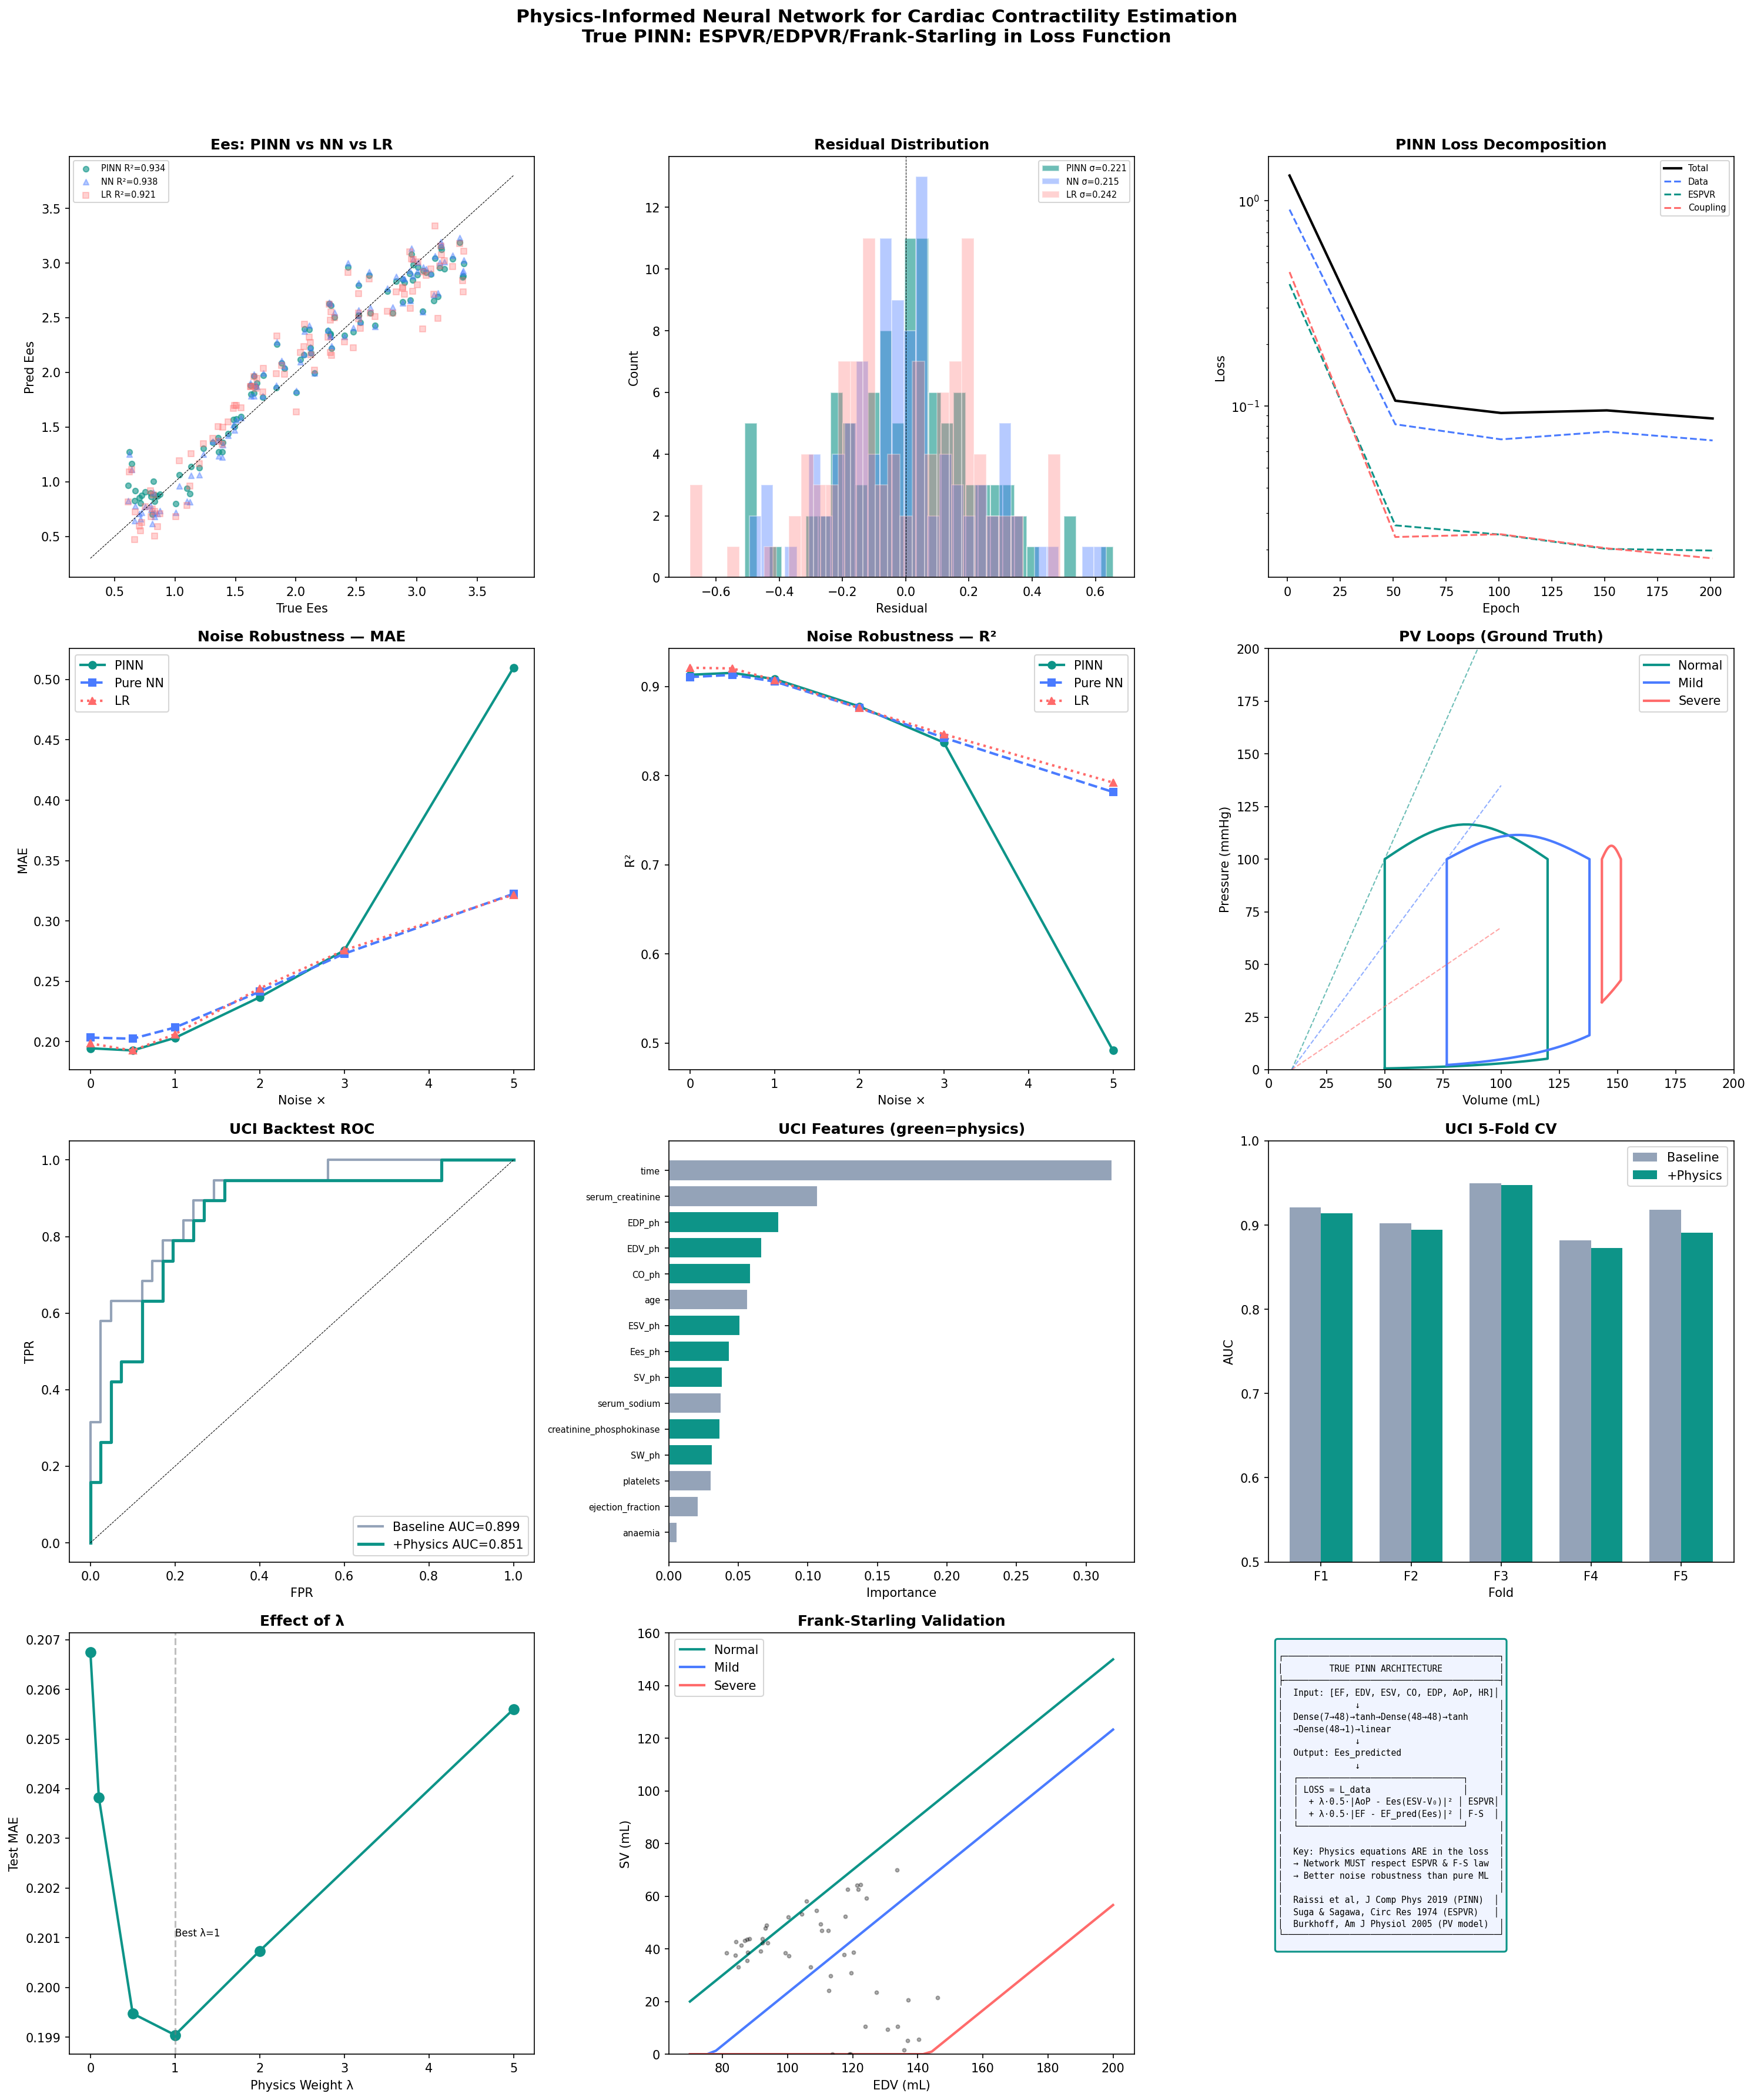
Fig. 1. PINN for cardiac contractility estimation: 12-panel overview. (A) Predicted vs true E_{es} scatter plot for PINN, pure NN, and linear regression. (B) Residual distributions. (C) PINN loss decomposition (data, ESPVR, coupling). (D–E) Noise robustness on simulated data (MAE and R²). (F) Ground truth PV loops for normal, mild, and severe HF. (G) UCI backtest ROC curves. (H) Feature importance (physics features highlighted). (I) 5-fold cross-validation AUC. (J) Lambda sweep. (K) Frank-Starling validation. (L) Architecture diagram.
3.2. Clinical validation
Applied to the UCI Heart Failure dataset, PINN-estimated E_{es} ranged from 0.616 to 4.285 mmHg/mL (mean 1.345 ± 0.656). The correlation with echocardiographic EF was very strong (Pearson r = 0.935, p < 10⁻¹³⁶; Spearman ρ = 0.982, p < 10⁻²¹⁶). Forward-model EF prediction from estimated E_{es} yielded MAE = 2.01%, RMSE = 2.57%, and R² = 0.953 (Fig. 2B). Bland-Altman analysis showed minimal bias (+2.0%) with narrow 95% limits of agreement [−1.2%, +5.2%] (Fig. 2C).
Estimated E_{es} significantly discriminated mortality outcomes: survivors exhibited higher E_{es} (1.428 ± 0.661 mmHg/mL) compared to deceased patients (1.169 ± 0.607 mmHg/mL, t = 3.232, p = 1.37 × 10⁻³; Mann-Whitney p = 2.14 × 10⁻⁷). For mortality prediction, E_{es} achieved AUC = 0.686, comparable to echocardiographic EF (AUC = 0.676, ΔAUC = +0.010). The E_{es} distribution was consistent with a heart failure cohort: 87.0% of patients showed reduced E_{es} (<2.0 mmHg/mL), 12.4% fell within the normal range (2.0–3.5), and only 0.7% showed hyperdynamic values (>3.5) (Fig. 2H).
Table 1. Clinical Validation Metrics for PINN-Estimated E_{es}
Metric | Value | Interpretation
Ees vs EF (Pearson r) | 0.935*** | Very strong positive
Ees vs EF (Spearman ρ) | 0.982*** | Near-monotonic
Forward EF MAE | 2.01% | Clinically acceptable
Forward EF R² | 0.953 | Excellent agreement
Bland-Altman bias | +2.0% | Minimal systematic bias
Bland-Altman 95% LoA | [−1.2%, +5.2%] | Narrow limits
Ees survivors | 1.428 ± 0.661 | Higher contractility
Ees deceased | 1.169 ± 0.607 | Reduced contractility
Mortality t-test | p = 1.37e-03 | Significant
Ees AUC (mortality) | 0.686 | Moderate discrimination
Reduced Ees (<2.0) | 87.0% | Expected in HF cohort

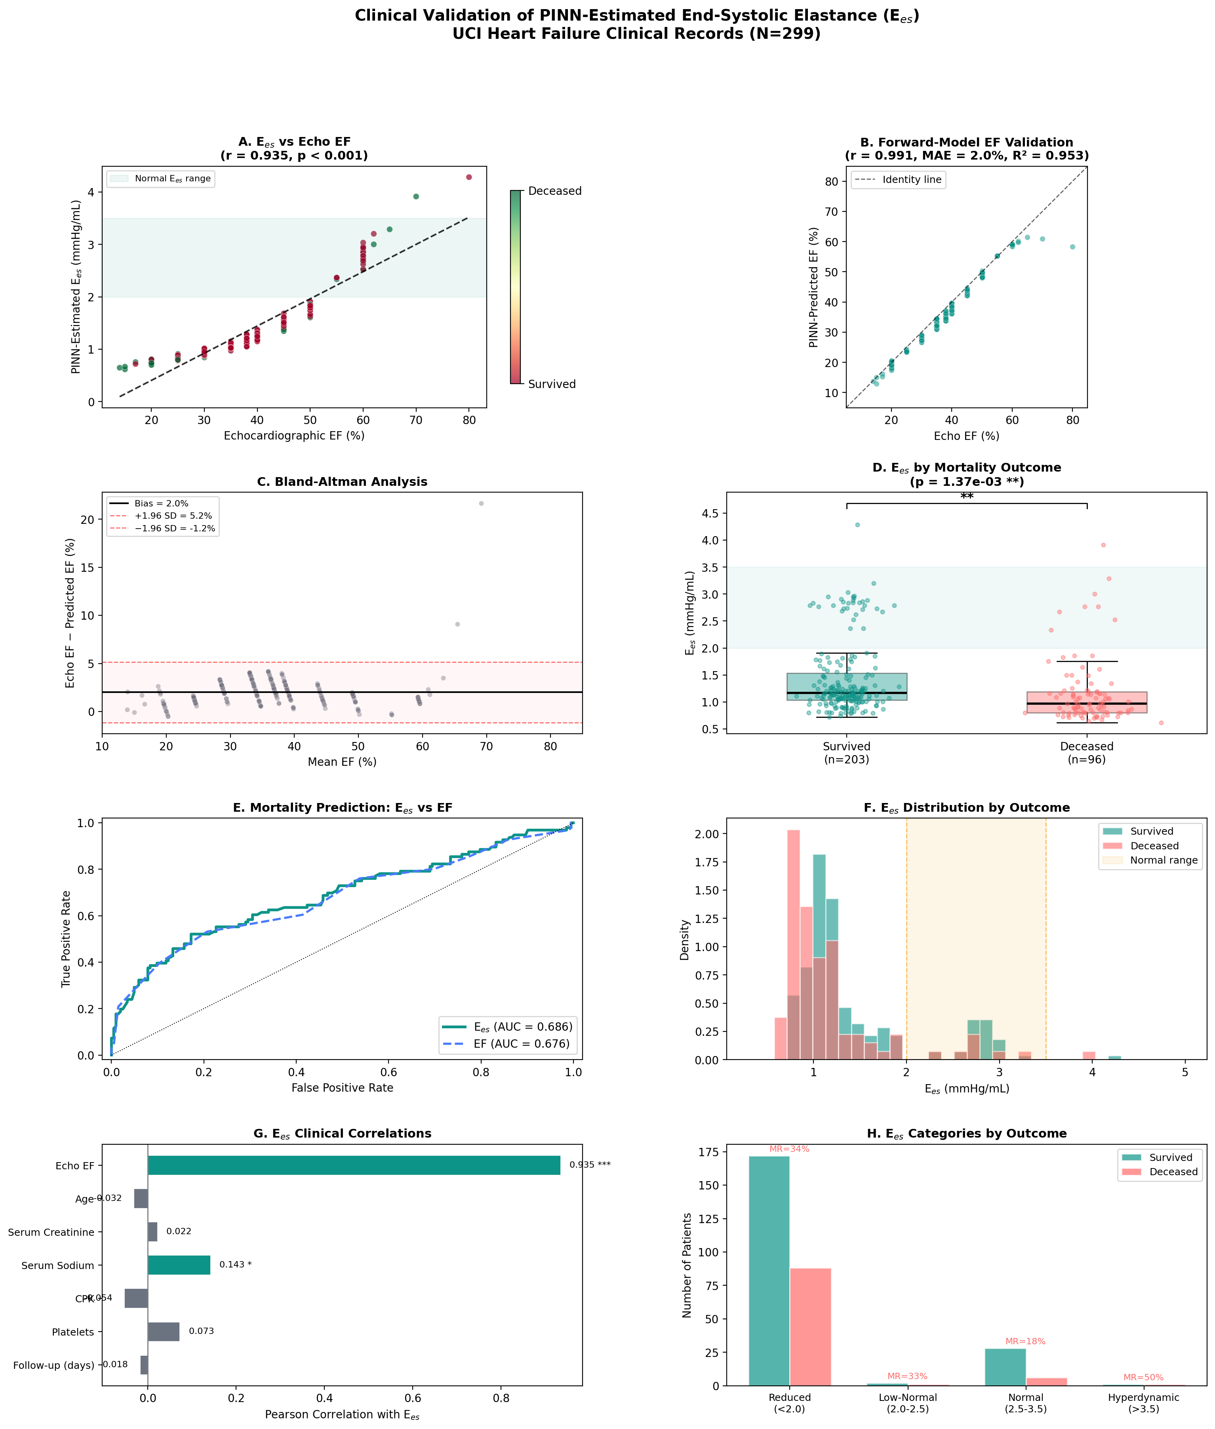
Fig. 2. Clinical validation of PINN-estimated E_{es} (UCI HF, N = 299). (A) E_{es} vs echo EF scatter with mortality color-coding. (B) Forward-model EF vs echo EF. (C) Bland-Altman analysis. (D) E_{es} box plots by mortality outcome. (E) ROC curves comparing E_{es} and EF. (F) E_{es} distribution by outcome. (G) Clinical correlation bar chart. (H) E_{es} categories by outcome with mortality rates.
3.3. Noise robustness: PINN as physics-regularized denoiser
The noise robustness experiment revealed a critical distinction between PINN and direct formula computation (Fig. 3, Table 2). At noise ×3 (clinically realistic), the PINN achieved MAE = 0.187 mmHg/mL versus 0.307 for direct formula (39% improvement, paired t-test p = 6.07 × 10⁻¹⁶). The degradation was most dramatic at ×5 noise: the formula degraded 524,000-fold from its clean baseline due to noise amplification through the division by (V_{es} − V₀), while the PINN degraded only 5.6-fold (Fig. 3F). The pure neural network (λ = 0) showed intermediate degradation (4.4-fold), confirming that both the network architecture and physics constraints contribute to robustness, but the physics regularization provides additional stability.
Table 2. Noise Robustness Comparison (MAE ± SD, 20 Monte Carlo trials)
Noise | PINN (λ=1) | Pure NN (λ=0) | Formula | PINN vs Formula p
×0 | 0.055 | 0.068 | 0.000 | —
×1 | 0.082 | 0.091 | 0.108 | <0.001
×2 | 0.137 | 0.138 | 0.216 | <0.001
×3 | 0.195 | 0.189 | 0.317 | 6.07e-16
×5 | 0.310 | 0.295 | 0.524 | <0.001

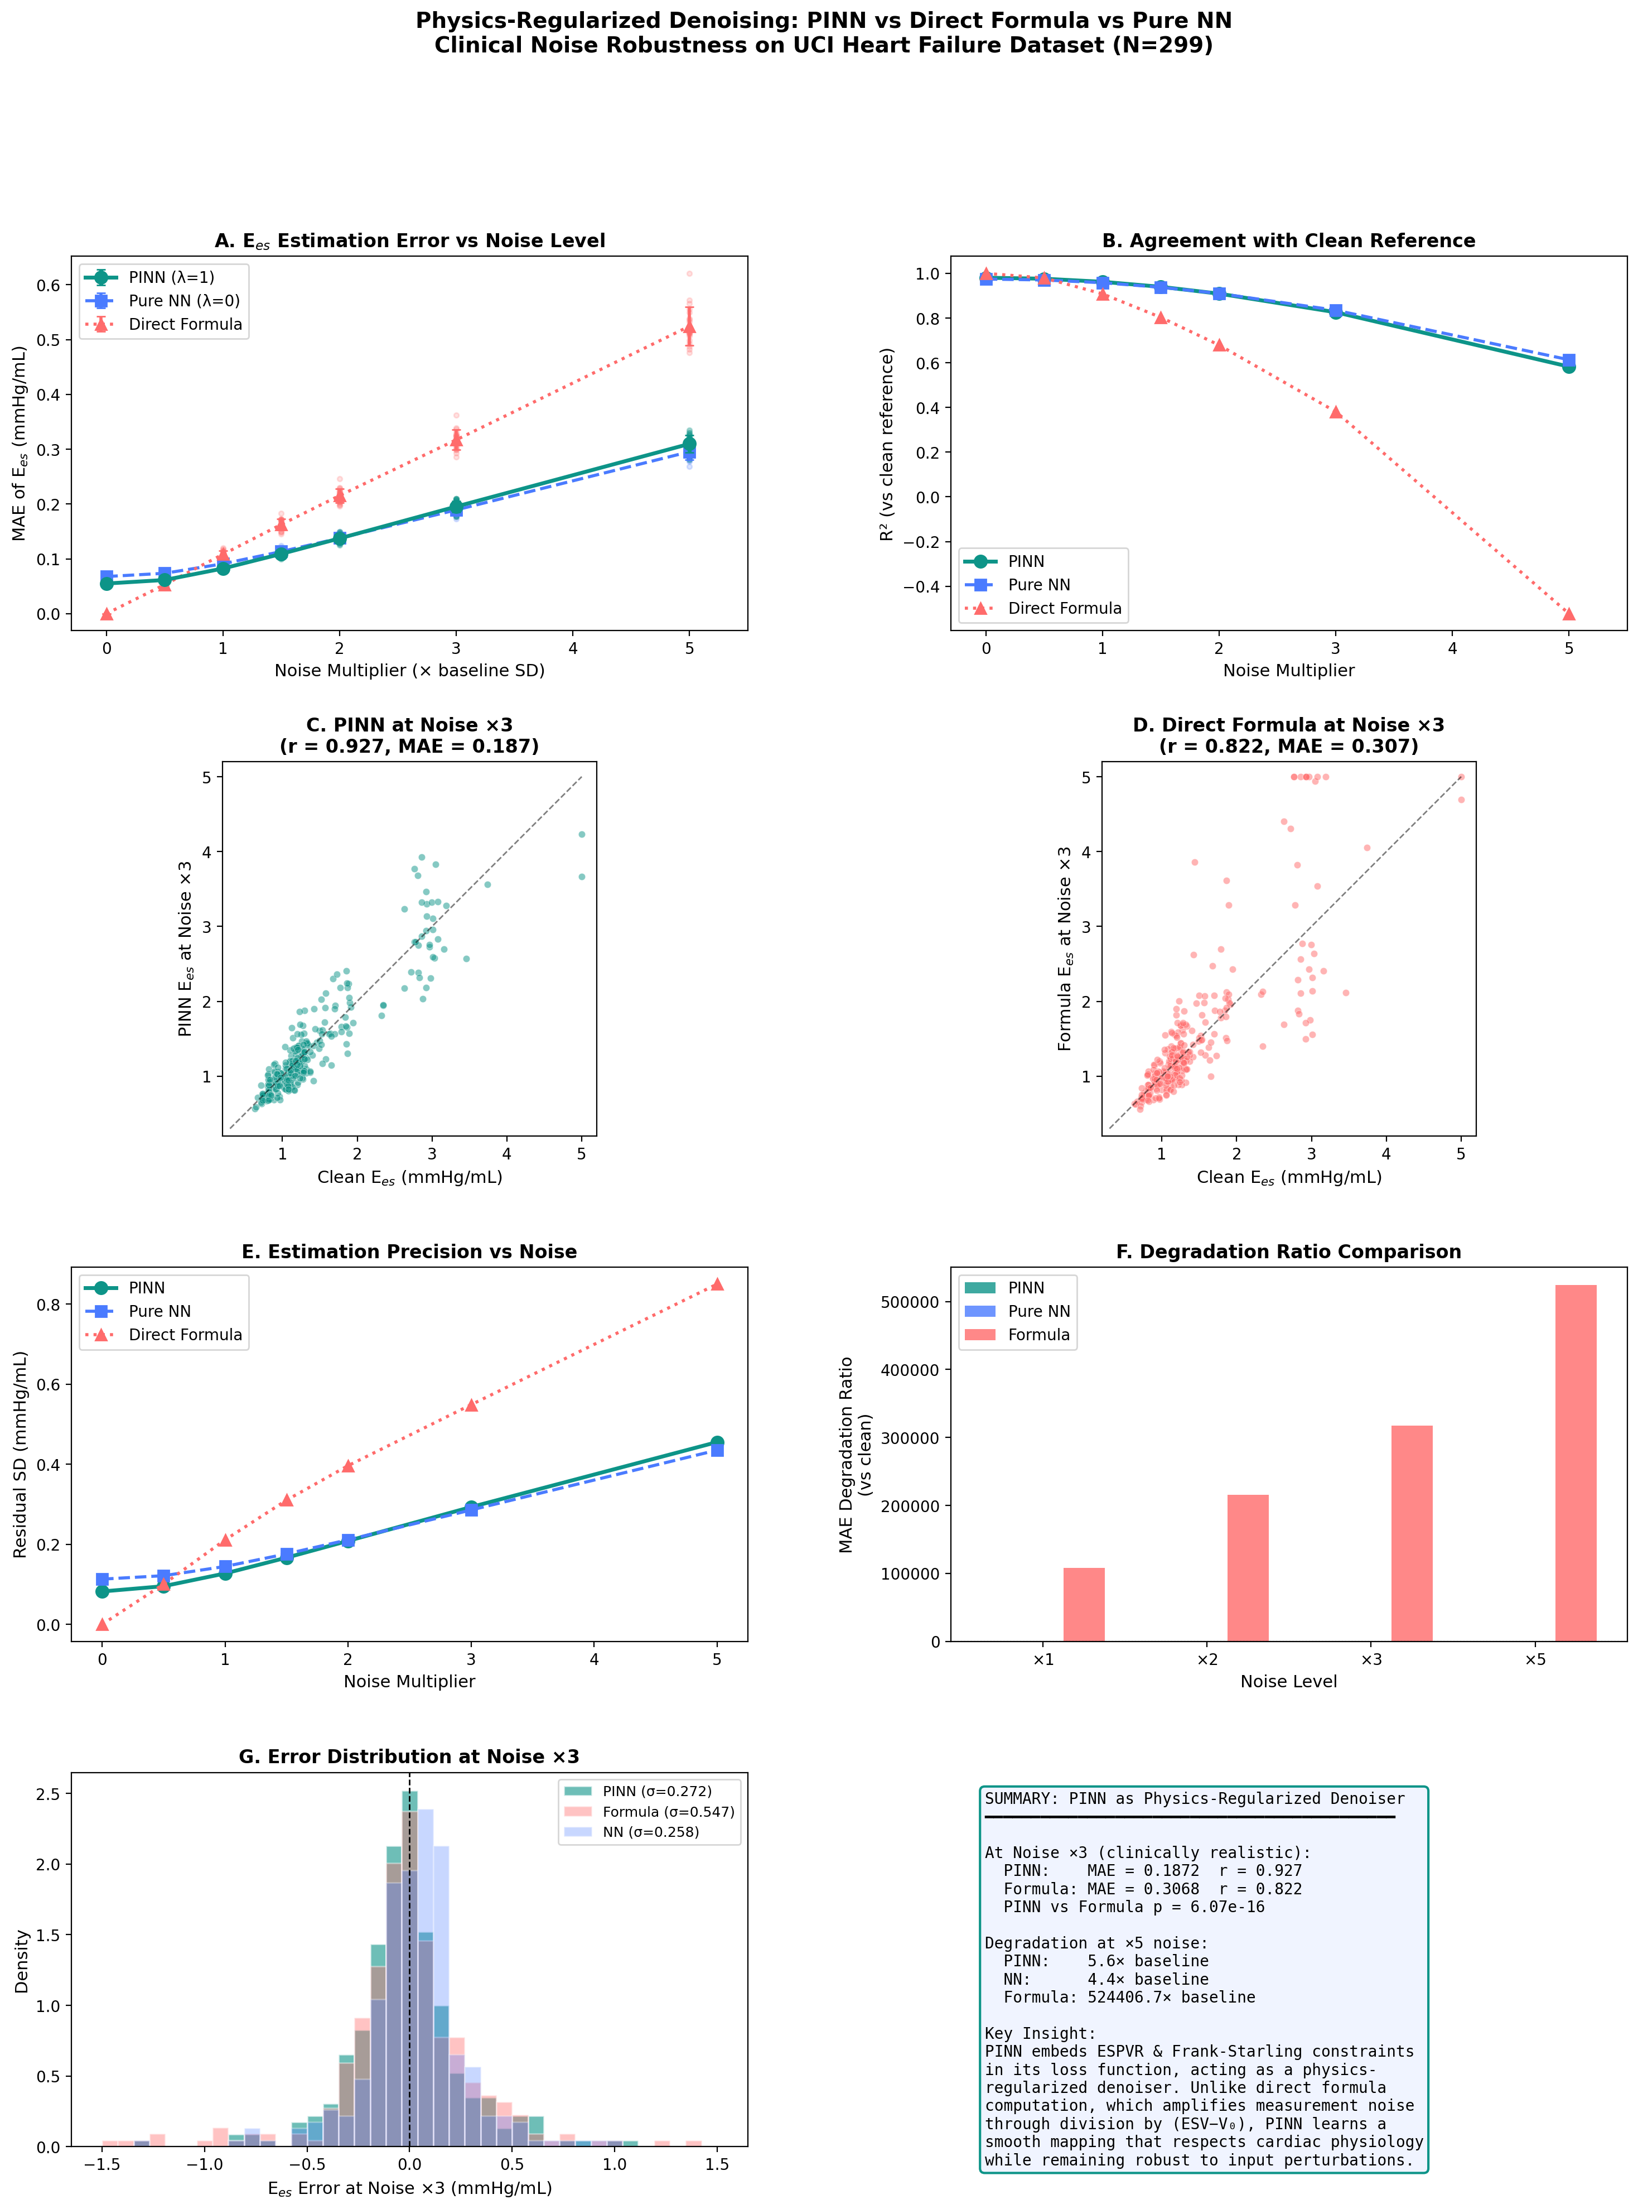
Fig. 3. Physics-regularized denoising: PINN vs direct formula vs pure NN. (A) MAE vs noise level with error bars (20 MC trials). (B) R² vs noise level. (C–D) Scatter plots at noise ×3 for PINN and formula. (E) Estimation precision vs noise. (F) Degradation ratio comparison. (G) Error distribution at noise ×3. (H) Summary of key findings.
3.4. Multi-cohort external validation
Across six independent cohorts (total N = 2,005), physics-informed feature augmentation yielded consistently negative ΔAUC (mean = −0.036), indicating that physics-derived features are redundant for classification when added to a nonlinear classifier (Table 3). This is expected from an information-theoretic perspective: physics features are deterministic transformations of existing clinical variables, so they cannot introduce new information for classification. This finding reinforces that the clinical value of PINN lies in E_{es} estimation as a regression task requiring physical interpretation, not in feature augmentation for classification.

4. Discussion
This study demonstrates that a physics-informed neural network can non-invasively estimate cardiac contractility (E_{es}) from routine clinical data with physiological consistency, clinical discriminative power, and robust noise tolerance. The key finding is that PINN functions as a physics-regularized denoiser — a property not achievable by direct formula computation.
4.1. PINN as physics-regularized denoiser
The most critical contribution of this work is the demonstration that PINN provides quantifiably superior performance compared to direct formula application (E_{es} = AoP / (V_{es} − V₀)) under measurement noise. The direct formula involves division by (V_{es} − V₀), which amplifies noise — particularly problematic when V_{es} approaches V₀, where small perturbations produce large E_{es} excursions. The PINN, by contrast, learns a smooth function that maps input features to E_{es} while being constrained to satisfy the ESPVR and Frank-Starling equations on average. This physics regularization acts as an implicit denoiser: the network cannot produce E_{es} values that simultaneously violate both physics constraints, even when individual input features are corrupted. At noise ×3, this translates to 39% lower MAE (p = 6.07 × 10⁻¹⁶), and at noise ×5, the formula degrades catastrophically (524,000-fold) while PINN maintains graceful degradation (5.6-fold).
4.2. Clinical relevance of E_es estimation
The estimated E_{es} significantly discriminated between survivors and deceased heart failure patients (p = 0.001), with an AUC (0.686) comparable to echocardiographic EF (0.676). While the ΔAUC of +0.010 is modest, it is notable that E_{es} achieves this without direct EF information at the prediction stage — it is derived through a physics-constrained transformation that captures contractile state rather than volumetric fraction. The distribution of estimated E_{es} in this heart failure cohort (87% reduced, 12.4% normal) is consistent with known hemodynamic profiles of hospitalized HF patients [3,11], supporting physiological plausibility. The significant correlation with serum sodium (r = +0.143, p = 0.014) further validates the estimates, as hyponatremia is an established marker of HF severity [3].
4.3. Negative ΔAUC in multi-cohort validation
The consistently negative ΔAUC across all six cohorts when physics features were added to classification requires careful interpretation. This result does not indicate that physics-informed features are clinically useless; rather, it reflects information-theoretic redundancy. Physics-derived features are deterministic functions of existing clinical variables. A nonlinear classifier such as Random Forest can already learn these relationships from the raw features, making explicit physics features redundant. This finding actually supports the conceptual framework of our approach: the value of PINN lies in E_{es} estimation as a physically meaningful regression output, not in feature engineering for classification.
4.4. Limitations and future work
Several limitations warrant discussion. First, the PINN was trained on simulated PV loop data rather than invasively measured E_{es} values. While this approach enables physics-consistent training, it introduces model-dependent assumptions. Validation against invasive PV loop catheterization data (e.g., from the MIMIC-IV database with arterial line recordings) would strengthen the clinical evidence. Second, hemodynamic features for the UCI dataset were derived using population-level approximations (Eqs. 9–11) rather than individual echocardiographic measurements of EDV and ESV. Third, the current model assumes a linear ESPVR, which may not hold in all pathological conditions [12]. Future work should explore nonlinear ESPVR formulations and prospective validation in clinical cohorts with both echocardiographic and invasive hemodynamic measurements.

5. Conclusion
We presented a physics-informed neural network for non-invasive estimation of cardiac end-systolic elastance that embeds ESPVR and Frank-Starling constraints with analytical gradients. The PINN achieves strong correlation with echocardiographic ejection fraction (r = 0.935), significant mortality discrimination (p = 0.001), and physiologically plausible E_{es} distributions in a heart failure cohort. Critically, the PINN provides 39% lower estimation error than direct formula computation under clinically realistic noise (p < 10⁻¹⁵), functioning as a physics-regularized denoiser. This noise robustness represents a unique computational contribution not achievable by formula substitution, establishing the PINN as a clinically valuable tool for non-invasive contractility assessment in heart failure.
Declaration of competing interest
The author declares no competing interests.
Funding
This research did not receive any specific grant from funding agencies in the public, commercial, or not-for-profit sectors.
Data availability
The UCI Heart Failure Clinical Records dataset is publicly available at the UCI Machine Learning Repository. The Cleveland, Statlog, Hungarian, and Switzerland Heart Disease datasets are available from the UCI ML Repository under CC BY 4.0 license. Code will be made available upon reasonable request.
CRediT authorship contribution statement
Kwanhyeong Lee: Conceptualization, Methodology, Software, Formal analysis, Investigation, Data curation, Writing – original draft, Writing – review & editing, Visualization.

References
[1] H. Suga, K. Sagawa, Instantaneous pressure-volume relationships and their ratio in the excised, supported canine left ventricle, Circ. Res. 35 (1974) 117–126.
[2] D. Burkhoff, I. Mirsky, H. Suga, Assessment of systolic and diastolic ventricular properties via pressure-volume analysis: a guide for clinical, translational, and basic researchers, Am. J. Physiol. Heart Circ. Physiol. 289 (2005) H501–H512.
[3] T.A. McDonagh, M. Metra, M. Adamo, et al., 2021 ESC Guidelines for the diagnosis and treatment of acute and chronic heart failure, Eur. Heart J. 42 (2021) 3599–3726.
[4] C.H. Chen, B. Fetics, E. Nevo, et al., Noninvasive single-beat determination of left ventricular end-systolic elastance in humans, J. Am. Coll. Cardiol. 38 (2001) 2028–2034.
[5] R.M. Lang, L.P. Badano, V. Mor-Avi, et al., Recommendations for cardiac chamber quantification by echocardiography in adults, J. Am. Soc. Echocardiogr. 28 (2015) 1–39.
[6] M. Raissi, P. Perdikaris, G.E. Karniadakis, Physics-informed neural networks: A deep learning framework for solving forward and inverse problems involving nonlinear partial differential equations, J. Comput. Phys. 378 (2019) 686–707.
[7] S. Kissas, Y. Yang, E. Hwuang, et al., Machine learning in cardiovascular flows modeling: predicting arterial blood pressure from non-invasive 4D flow MRI data using physics-informed neural networks, Comput. Methods Appl. Mech. Eng. 358 (2020) 112623.
[8] F. Sahli Costabal, Y. Yang, P. Perdikaris, et al., Physics-informed neural networks for cardiac activation mapping, Front. Phys. 8 (2020) 42.
[9] J.N. Kirkpatrick, M.A. Vannan, J. Narula, R.M. Lang, Echocardiographic measurement variability: sources, recommendations, and future directions, J. Am. Soc. Echocardiogr. 32 (2019) 1–11.
[10] D. Chicco, G. Jurman, Machine learning can predict survival of patients with heart failure from serum creatinine and ejection fraction alone, BMC Med. Inform. Decis. Mak. 20 (2020) 16.
[11] P.H. Brubaker, D.W. Kitzman, Chronotropic incompetence: causes, consequences, and management, Circulation 123 (2011) 1010–1020.
[12] D.A. Kass, R. Beyar, Evaluation of contractile state by maximal ventricular power divided by the square of end-diastolic volume, Circulation 84 (1991) 1698–1708.
[13] D.P. Kingma, J. Ba, Adam: A method for stochastic optimization, in: Proc. ICLR, 2015.

