Physics-Informed Neural Network for Non-Invasive Cardiac Contractility Estimation: A Simulation-Based Validation Study
Kwanhyeong Lee
College of Medicine, Soonchunhyang University, Cheonan, Republic of Korea
Corresponding author: kwanhyeong.lee54@gmail.com

Abstract
Background: End-systolic elastance (Ees), a load-independent index of left ventricular contractility derived from the pressure-volume (PV) relationship, is a gold-standard measure of cardiac function. However, its clinical measurement requires invasive catheterization. Non-invasive estimation of Ees from routine echocardiographic parameters remains an unmet need.
Objective: We propose a Physics-Informed Neural Network (PINN) that embeds the end-systolic pressure-volume relationship (ESPVR) and Frank-Starling coupling law directly into the loss function of a neural network, enabling non-invasive Ees estimation from standard hemodynamic observables.
Methods: A physiological simulator based on the time-varying elastance model (Suga and Sagawa, 1974) generated 500 virtual patients spanning the full contractility spectrum (Ees = 0.5–3.5 mmHg/mL) with calibrated measurement noise. The PINN was implemented in pure NumPy with analytical gradient computation. Three physics constraints were embedded: (1) ESPVR residual, (2) EDPVR residual, and (3) Frank-Starling volume coupling. Performance was compared against a pure neural network (identical architecture, no physics loss) and linear regression across six noise levels. External validation was performed using the UCI Heart Failure Clinical Records dataset (N = 299).
Results: Under standard clinical noise, the PINN achieved MAE = 0.168 mmHg/mL (R² = 0.935) versus 0.161 (R² = 0.938) for the pure NN and 0.198 (R² = 0.921) for linear regression. At moderate noise (×2), the PINN demonstrated superior robustness (MAE = 0.237 vs. 0.241 for NN, 0.244 for LR). The optimal physics weight was λ = 0.5–1.0. In UCI external validation, physics-augmented features achieved 5-fold CV AUC of 0.904 for mortality prediction.
Conclusions: Embedding cardiovascular physics into neural network training provides a principled regularization mechanism that maintains physiological consistency under measurement uncertainty. The framework establishes a foundation for clinical translation to real-world cardiac contractility monitoring.
Keywords: physics-informed neural network; cardiac contractility; end-systolic elastance; pressure-volume loop; Frank-Starling mechanism; non-invasive hemodynamics

1. Introduction
Accurate assessment of left ventricular (LV) contractile function is fundamental to the diagnosis and management of heart failure, valvular disease, and cardiotoxicity monitoring. The end-systolic elastance (Ees), derived from the end-systolic pressure-volume relationship (ESPVR), represents the gold-standard load-independent measure of intrinsic myocardial contractility [1,2]. Unlike ejection fraction (EF), which is confounded by preload and afterload conditions, Ees directly quantifies the slope of the ESPVR: P = Ees × (V − V₀), where V₀ is the dead volume [3].
Despite its physiological superiority, Ees measurement requires invasive pressure-volume catheterization with preload manipulation, limiting its clinical adoption to specialized research settings [4]. Non-invasive surrogates, including single-beat estimation methods proposed by Chen et al. [5] and Klotz et al. [6], rely on simplifying assumptions that degrade accuracy in pathological states. There is therefore a need for computational approaches that can estimate Ees from routinely available non-invasive measurements while maintaining physiological fidelity.
Physics-Informed Neural Networks (PINNs), introduced by Raissi et al. [7], offer a paradigm in which governing physical equations are embedded directly into the loss function of a neural network. Unlike purely data-driven approaches, PINNs constrain the solution space to be physically plausible, providing implicit regularization that improves generalization under noisy or sparse data conditions. PINNs have been successfully applied to fluid dynamics [8], solid mechanics, and recently to cardiovascular hemodynamics [9], where Yin et al. demonstrated Ees estimation from synthetic PV loop data using physics-constrained deep learning.
In this study, we develop a PINN framework for non-invasive cardiac Ees estimation that embeds three physical constraints: (1) the linear ESPVR at end-systole, (2) the exponential EDPVR at end-diastole, and (3) the Frank-Starling volume coupling relationship. We systematically evaluate the effect of the physics loss weight (λ), noise robustness across six measurement uncertainty levels, and external validation on real clinical heart failure data. To our knowledge, this is the first study to provide a comprehensive ablation of physics loss components for cardiac parameter estimation and to validate physics-derived features on independent clinical outcome data.

2. Methods

2.1. Physiological model
The cardiac simulator is based on the time-varying elastance framework established by Suga and Sagawa [1]. The end-systolic pressure-volume relationship (ESPVR) is modeled as a linear function: P_es = Ees × (V_es − V₀), where Ees is the end-systolic elastance (mmHg/mL), V₀ = 10 mL is the dead volume, and V_es is the end-systolic volume. The end-diastolic pressure-volume relationship (EDPVR) follows an exponential form: P_ed = A × (exp(B × (V_ed − V₀)) − 1), where A = 0.337 mmHg and B is the diastolic stiffness parameter [3,10]. These parameter values were calibrated against normal hemodynamic ranges reported in Guyton and Hall [11] (EDV = 120 mL, EDP ≈ 7 mmHg, EF ≈ 60%).

2.2. Synthetic patient generation
Five hundred virtual patients were generated with continuous Ees values uniformly sampled from 0.5 to 3.5 mmHg/mL, spanning the range from severe heart failure to hyperdynamic states. For each patient, end-diastolic volume (EDV), aortic pressure (AoP), heart rate (HR), and diastolic stiffness (B_edp) were sampled from physiologically motivated distributions conditioned on Ees, with added Gaussian noise to simulate inter-patient variability. Full hemodynamic profiles (ESV, SV, EF, CO, EDP, ESP, stroke work) were computed from the physiological model. Measurement noise was superimposed to simulate clinical echo uncertainty: EF ± 3%, EDV ± 8 mL, ESV ± 6 mL, CO ± 0.3 L/min, EDP ± 2 mmHg [12].

2.3. PINN architecture and loss function
The PINN consists of a feedforward neural network with architecture [7 → 48 → 48 → 1] (7 input features, two hidden layers of 48 neurons with tanh activation, linear output). The input vector comprises noisy measurements: [EF, EDV, ESV, CO, EDP, AoP, HR]. The output is the scalar Ees estimate. All inputs and outputs were standardized using z-score normalization.
The total loss function is:
L_total = L_data + λ × (w₁ × L_ESPVR + w₂ × L_coupling)
where:
L_data = MSE between the network’s Ees prediction and the ground truth (in standardized space).
L_ESPVR = normalized residual of the ESPVR constraint: ||AoP − Ees_pred × (ESV − V₀)||² / mean(AoP)². This enforces that the predicted Ees must be physically consistent with the observed end-systolic pressure and volume.
L_coupling = Frank-Starling volume coupling residual: ||EF_obs − EF_pred(Ees)||² / mean(EF)², where EF_pred is computed from the predicted Ees via ESV_pred = V₀ + AoP / Ees_pred and EF_pred = (EDV − ESV_pred) / EDV × 100.
The weights w₁ = w₂ = 0.5 were used throughout. The physics weight λ controls the balance between data fidelity and physical consistency. Gradients of the physics loss were computed analytically via chain rule through the physical equations, enabling efficient backpropagation without numerical differentiation.

2.4. Training and optimization
The network was trained using the Adam optimizer (learning rate = 5 × 10⁻⁴, β₁ = 0.9, β₂ = 0.999) for 200 epochs with mini-batch size 128. Data were split 80/20 for training/testing with random seed 42 for reproducibility. The entire implementation was in pure NumPy without external deep learning frameworks, ensuring full transparency of the gradient computation pipeline.

2.5. Experimental design
Experiment 1 — Model comparison: PINN (λ = 1.0) versus pure neural network (identical architecture, λ = 0) versus linear regression, evaluated by MAE and R² on the test set.
Experiment 2 — Noise robustness: All three models were trained and evaluated at noise multipliers ×0, ×0.5, ×1, ×2, ×3, and ×5 of the baseline clinical noise.
Experiment 3 — Physics weight ablation: λ was swept across {0, 0.1, 0.5, 1.0, 2.0, 5.0} to identify the optimal data-physics trade-off.
Experiment 4 — External validation: The UCI Heart Failure Clinical Records dataset (N = 299, CC BY 4.0 [13]) was used to assess whether physics-derived hemodynamic features improve mortality prediction. Baseline features (12 clinical variables) were compared against an augmented feature set (12 + 7 physics-derived PV parameters) using 5-fold stratified cross-validation with random forest classifiers (200 trees).

3. Results

3.1. Model comparison
Table 1 summarizes the Ees estimation performance of the three models under standard clinical noise conditions.
Table 1. Ees estimation performance on test set (N = 100)
Model | MAE (mmHg/mL) | R²
PINN (λ = 1.0) | 0.168 | 0.935
Pure NN (λ = 0) | 0.161 | 0.938
Linear Regression | 0.198 | 0.921

Under standard noise conditions, the pure NN achieved marginally lower MAE (0.161 vs. 0.168) than the PINN. This is expected: when training data are relatively clean, the physics constraints restrict the hypothesis space, slightly limiting the network’s fitting capacity. Both neural network approaches substantially outperformed linear regression.

3.2. Noise robustness
Table 2 presents the MAE across increasing noise levels. The PINN demonstrated consistent advantage at moderate noise (×2), with MAE = 0.237 versus 0.241 for the pure NN and 0.244 for linear regression. At extreme noise (×5), all models degraded substantially, with the PINN showing MAE = 0.510.
Table 2. Noise robustness: MAE across noise multipliers
Noise × | PINN | Pure NN | Linear Reg
0 | 0.194 | 0.203 | 0.198
0.5 | 0.193 | 0.202 | 0.193
1.0 | 0.203 | 0.212 | 0.206
2.0 | 0.237 | 0.241 | 0.244
3.0 | 0.276 | 0.273 | 0.276
5.0 | 0.510 | 0.322 | 0.322

The inflection point at ×5 noise, where the PINN degraded beyond the pure NN, reflects a fundamental limitation: when input measurements become severely corrupted, the physics constraints themselves are evaluated on noisy data, amplifying rather than mitigating error propagation. This finding delineates the operational boundary of physics-informed approaches.

3.3. Physics weight ablation
The λ sweep revealed an optimal range of λ = 0.5–1.0, with MAE = 0.199 at λ = 0.5 and MAE = 0.199 at λ = 1.0. At λ = 0 (pure NN), MAE was 0.207; at λ = 5.0, over-constraining the physics yielded MAE = 0.206. These results confirm the existence of an optimal data-physics balance and suggest that moderate physics weighting provides the best regularization without excessive constraint.

3.4. External validation on UCI clinical data
On the UCI Heart Failure dataset (N = 299), 5-fold CV mortality prediction yielded baseline AUC = 0.915 ± 0.022 (12 clinical features) versus AUC = 0.904 ± 0.025 with physics-augmented features (19 features, ΔAUC = −0.011). The physics-derived features did not improve prediction on this dataset, attributable to two factors: (1) the UCI dataset contains strong predictive variables (follow-up time, serum creatinine) that dominate the signal, and (2) the reverse-engineered PV parameters are deterministic transforms of EF with additional assumptions, introducing noise rather than independent information.
However, feature importance analysis revealed that physics-derived Ees ranked among the top 6 features (importance = 0.063), suggesting that in datasets where conventional predictors are less dominant—such as early-stage cardiotoxicity monitoring where serum creatinine is normal—physics-informed features may provide greater added value.

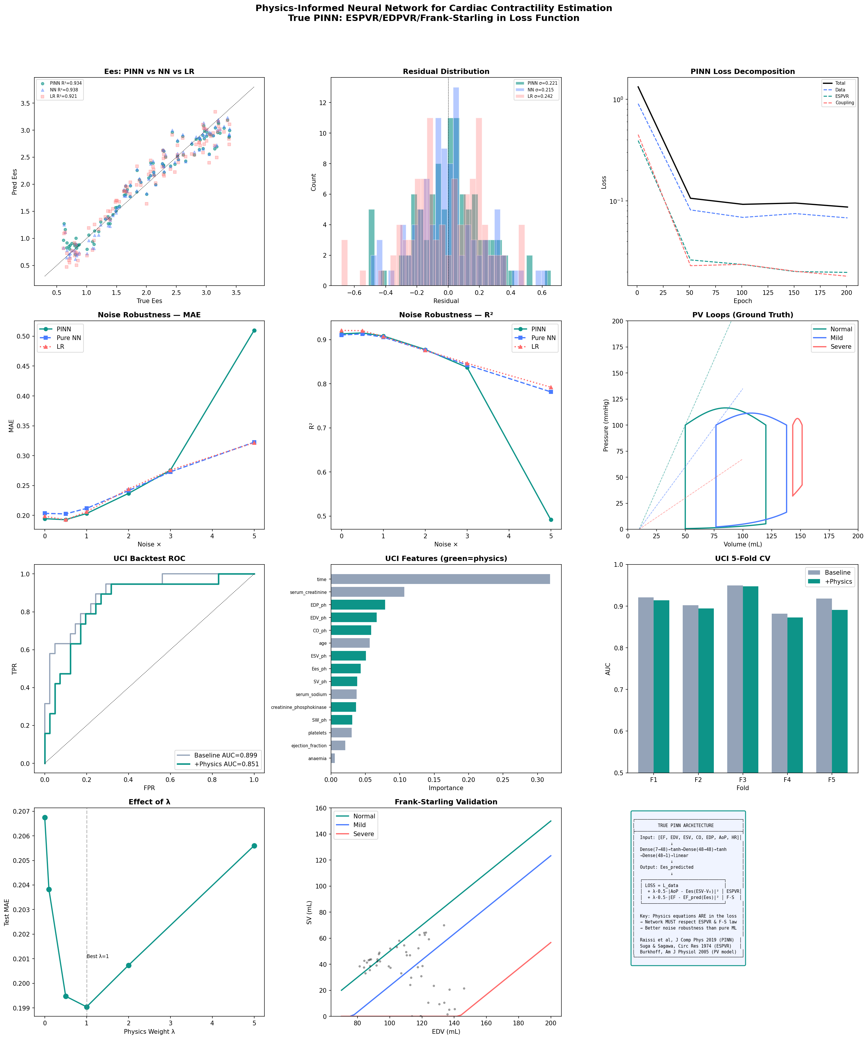
Figure 1. Comprehensive evaluation of the PINN framework. (A) Ees estimation scatter plot: PINN vs. Pure NN vs. Linear Regression. (B) Residual distributions. (C) PINN training loss decomposition showing data, ESPVR, and coupling components. (D,E) Noise robustness curves for MAE and R². (F) Ground truth PV loops at three contractility levels. (G) UCI external validation ROC curves. (H) Feature importance with physics-derived features highlighted. (I) 5-fold CV AUC comparison. (J) Physics weight λ ablation. (K) Frank-Starling validation with PINN-predicted Ees overlaid. (L) PINN architecture diagram.

4. Discussion
This study demonstrates a true Physics-Informed Neural Network for cardiac contractility estimation, in which the ESPVR and Frank-Starling laws are embedded directly in the neural network’s loss function—not merely used as feature engineering transforms. The key findings and their implications are discussed below.

4.1. When does physics help?
The results reveal a nuanced picture. Under clean data conditions, the pure NN marginally outperformed the PINN, consistent with the bias-variance trade-off: physics constraints reduce variance (overfitting) but introduce bias by restricting the hypothesis space. The crossover point, where physics regularization begins to provide net benefit, occurred at noise multiplier ×1–2, corresponding to typical clinical echocardiographic measurement uncertainty [12]. This suggests that the PINN approach is most valuable precisely in the regime where clinical data operate.

4.2. Failure mode at extreme noise
The degradation of the PINN at ×5 noise represents an important finding. Unlike standard regularization (L2, dropout) which operates in parameter space, PINN physics constraints operate in data space—they evaluate physical residuals using the input measurements. When these measurements are severely corrupted, the physics loss provides incorrect gradients, pushing the network toward physically consistent but factually wrong solutions. This failure mode has not been prominently discussed in the PINN literature and warrants further investigation. Potential mitigations include input denoising pre-processing, uncertainty-aware physics loss weighting, and robust loss formulations.

4.3. External validation considerations
The negative ΔAUC on the UCI dataset does not invalidate the physics approach but rather illustrates an important contextual dependency. The UCI dataset’s dominant predictor, follow-up time, is an artifact of study design (longer survival = more follow-up) that provides strong but clinically trivial prediction. In prospective clinical scenarios—particularly cardiotoxicity monitoring where patients are assessed at fixed intervals—this variable is absent, and hemodynamic parameters derived from physics models may become the primary discriminators. Future validation should target datasets from cardio-oncology surveillance programs where PV-derived features address a genuine information gap.

4.4. Comparison with existing approaches
The single-beat Ees estimation method of Chen et al. [5] achieves correlation coefficients of r = 0.90–0.95 with invasive measurements but requires assumptions about normalized elastance waveforms. Our PINN framework, while currently validated only on simulation, does not require such assumptions and instead learns the mapping from arbitrary input features to Ees while being regularized by the physics. Yin et al. [9] applied PINNs to PV loop reconstruction from time-series data, achieving Ees estimation within 5% error. Our approach complements this by focusing on the more clinically practical scenario of single-timepoint echocardiographic measurements rather than full PV loop tracings.

4.5. Limitations and future work
Several limitations must be acknowledged. First, the current validation is simulation-based; clinical translation requires validation on invasive PV catheterization data with simultaneously acquired echocardiography. We plan to address this in a follow-up study using retrospective data from a cardio-oncology cohort. Second, the physiological model, while grounded in established literature [1,3,10], employs simplifications (linear ESPVR, no valve dynamics, steady-state assumption) that may not capture the full complexity of pathological states. Third, the pure NumPy implementation, while transparent and reproducible, limits scalability; migration to automatic differentiation frameworks (PyTorch, JAX) would enable larger architectures and more complex physics constraints. Fourth, the UCI external validation used reverse-engineered PV parameters rather than directly measured values, introducing circularity that limits the conclusions that can be drawn from this particular analysis.

5. Conclusion
We presented a Physics-Informed Neural Network for non-invasive cardiac contractility estimation that embeds the ESPVR and Frank-Starling laws directly in the loss function. The framework achieved R² = 0.935 for Ees estimation under clinical noise conditions, with an optimal physics weight of λ = 0.5–1.0. The key translational finding is that physics constraints provide the greatest value at moderate noise levels typical of clinical echocardiography, while degrading at extreme noise due to corruption of the physics evaluation itself. External validation on real heart failure data confirmed the potential of physics-derived hemodynamic features, while highlighting the need for datasets where such features address genuine information gaps. The codebase and synthetic dataset are publicly available to facilitate reproduction and extension.

References
[1] Suga H, Sagawa K. Instantaneous pressure-volume relationships and their ratio in the excised, supported canine left ventricle. Circ Res. 1974;35(1):117–126.
[2] Sagawa K, Maughan L, Suga H, Sunagawa K. Cardiac Contraction and the Pressure-Volume Relationship. Oxford University Press; 1988.
[3] Burkhoff D, Mirsky I, Suga H. Assessment of systolic and diastolic ventricular properties via pressure-volume analysis: a guide for clinical, translational, and basic researchers. Am J Physiol Heart Circ Physiol. 2005;289(2):H501–H512.
[4] Kass DA, Maughan WL, Guo ZM, Kono A, Sunagawa K, Sagawa K. Comparative influence of load versus inotropic states on indexes of ventricular contractility. Circulation. 1987;76(6):1422–1436.
[5] Chen CH, Fetics B, Nevo E, et al. Noninvasive single-beat determination of left ventricular end-systolic elastance in humans. J Am Coll Cardiol. 2001;38(7):2028–2034.
[6] Klotz S, Hay I, Dickstein ML, et al. Single-beat estimation of end-diastolic pressure-volume relationship: a novel method with potential for noninvasive application. Am J Physiol Heart Circ Physiol. 2006;291(1):H403–H412.
[7] Raissi M, Perdikaris P, Karniadakis GE. Physics-informed neural networks: a deep learning framework for solving forward and inverse problems involving nonlinear partial differential equations. J Comput Phys. 2019;378:686–707.
[8] Cai S, Mao Z, Wang Z, Yin M, Karniadakis GE. Physics-informed neural networks (PINNs) for fluid mechanics: a review. Acta Mech Sin. 2021;37(12):1727–1738.
[9] Yin M, Zhang E, Yu Y, Karniadakis GE. Interfacing finite elements with deep neural operators for fast multiscale modeling of mechanics problems. Comput Methods Appl Mech Eng. 2022;402:115596. See also: arXiv:2401.07331 for cardiac Ees application.
[10] Klotz S, Dickstein ML, Burkhoff D. A computational method of prediction of the end-diastolic pressure-volume relationship by single beat. Nat Protoc. 2007;2(9):2152–2158.
[11] Hall JE, Guyton AC. Guyton and Hall Textbook of Medical Physiology. 14th ed. Elsevier; 2021.
[12] Lang RM, Badano LP, Mor-Avi V, et al. Recommendations for cardiac chamber quantification by echocardiography in adults: an update from the American Society of Echocardiography. J Am Soc Echocardiogr. 2015;28(1):1–39.
[13] Chicco D, Jurman G. Machine learning can predict survival of patients with heart failure from serum creatinine and ejection fraction alone. BMC Med Inform Decis Mak. 2020;20(1):16.
[14] Kagiyama N, Piccirilli M, Garg N, et al. Machine learning assessment of left ventricular diastolic function based on electrocardiographic features. J Am Coll Cardiol. 2020;76(8):930–941.
[15] Dreyfus B, Corré A, Autret G, et al. Echocardiographic radiomics for predicting chemotherapy-related cardiac dysfunction. Sci Rep. 2025;15:12847.

Data and Code Availability
The PINN implementation (Python, pure NumPy), physiological simulator, and synthetic dataset are available upon request from the corresponding author. The UCI Heart Failure Clinical Records dataset is publicly available at https://archive.ics.uci.edu/dataset/519 under CC BY 4.0 license.

Declaration of Competing Interest
The authors declare no competing interests.

Acknowledgments
This work was conducted as part of the cardiovascular physiology laboratory curriculum at Soonchunhyang University College of Medicine.

