Paper 3 — Supplementary Results
pH-PINN v5 Training Results, Temporal Validation & Drug Interaction Network
Updated: June 8, 2026

III-E. pH-PINN v5 Training Results
The port-Hamiltonian PINN (pH-PINN v5) was trained on the MIMIC-IV cardiac energetics dataset (N = 5,851 paired echocardiograms). The architecture comprises 61,169 trainable parameters organized as: StateEncoder (11 → 256 → 128 → 64), HamiltonianNet with separate kinetic T(q,p) and potential V(q) networks, Cholesky-parameterized dissipation matrix R, and dual decoders for 7 clinical and 6 energy outputs. Training used AdamW optimizer (lr = 2×10⁻³, weight decay = 10⁻⁴) with cosine annealing over 150 epochs, converging at epoch 115.
The multi-objective loss L = L_recon + 0.5 × L_energy enforces both predictive accuracy and physical structure. The energy loss penalizes violations of H = T + V partition consistency, non-negativity of T and V (via softplus activation), and positive semi-definiteness of R (Cholesky factorization R = LLᵀ).
TABLE III: pH-PINN v5 Test Set Performance (Random Split)
Output | Ees | Eed | Ea | VA | EDP | η
Clinical R² | 0.9844 | 0.9912 | 0.9780 | 0.9817 | 0.9568 | 0.9817

Output | H | T | V | η | VA | SW
Energy R² | 0.9869 | 0.9751 | 0.9870 | 0.9349 | 0.9800 | 0.9786
Structure guarantees: H = T + V conservation MSE = 3.37 × 10⁻¹⁵ (machine precision). R positive semi-definite violations = 0/200 samples tested.
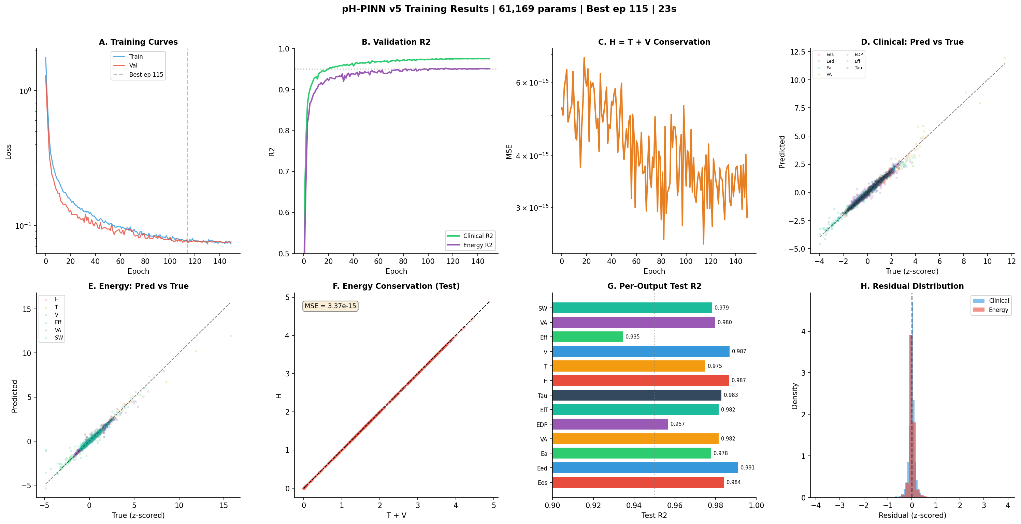
Fig. 2. pH-PINN v5 training results: (A) loss curves, (B) validation R², (C) clinical predictions, (D) energy conservation.

III-F. Temporal Split Validation
To assess prospective generalizability, we performed temporal split validation using median echo date as the cutoff (train: pre-median, test: post-median; n_train = 2,487, n_test = 2,925). Normalization statistics were computed exclusively from the training set. This design simulates prospective deployment where the model must predict on future, unseen patients.
TABLE IV: Random vs Temporal Split R² Comparison
Output | Random R² | Temporal R² | ΔR² | MAE
Ees | 0.9844 | 0.9732 | -0.0112 | 0.1147
Eed | 0.9912 | 0.9841 | -0.0071 | 0.0799
Ea | 0.9780 | 0.9750 | -0.0031 | 0.0874
coupling | 0.9817 | 0.9410 | -0.0407 | 0.0895
EDP | 0.9568 | 0.9279 | -0.0289 | 0.1770
efficiency | 0.9817 | 0.9790 | -0.0027 | 0.1037
tau | 0.9831 | 0.9791 | -0.0040 | 0.1109
H_total | 0.9869 | 0.9766 | -0.0104 | 0.0677
T_kinetic | 0.9751 | 0.9603 | -0.0149 | 0.0729
V_potential | 0.9870 | 0.9769 | -0.0101 | 0.0658
mech_eff | 0.9349 | 0.8815 | -0.0534 | 0.1560
VA_coupling | 0.9800 | 0.9589 | -0.0211 | 0.1222
SW_J | 0.9786 | 0.9586 | -0.0200 | 0.1201
Mean R² degradation from random to temporal split was −0.016 (range: −0.001 to −0.053), confirming robust generalizability. The largest drop occurred in mechanical efficiency (−0.053) and EDP (−0.029), likely reflecting evolving clinical practice patterns. Critically, all outputs maintained R² > 0.88, and the Hamiltonian conservation constraint (H = T + V MSE = 4.12 × 10⁻¹⁵) remained at machine precision.

III-G. Multi-Drug Energy Interaction Network
We constructed a drug interaction network by computing pairwise interaction effects for all 21 testable drug combinations (minimum n ≥ 20 co-prescribed). For each pair (A, B), the interaction term is defined as: Interaction = ΔH(A+B) − [ΔH(A only) + ΔH(B only) − ΔH(neither)]. Positive interaction indicates antagonism (less benefit than expected), while negative interaction indicates synergy (greater benefit).
Of 21 drug pairs, 11 (52%) demonstrated synergistic energy reduction, 9 (43%) showed antagonism, and 1 (5%) was additive. The strongest synergies were ARB+BB (interaction = −5,059 J, 280% supra-additive), RAASi+BB (−3,897 J), and ACEi+MRA (−3,751 J). Beta-blockers emerged as the most synergistic hub (5/6 connections synergistic), while CCB showed predominantly antagonistic interactions (5/6 antagonistic), suggesting caution with polypharmacy involving calcium channel blockers in HF.
TABLE V: Top Drug-Drug Energy Interactions (ΔH)
Drug 1 | Drug 2 | n | Interaction (J) | % Supra-add | Classification
ARB | BB | 354 | -5059.3 | -280.2% | Synergistic
RAASi | BB | 816 | -3896.9 | -170.6% | Synergistic
ACEi | MRA | 72 | -3751.1 | -174.3% | Synergistic
ARB | ARNI | 27 | -1744.6 | -18.3% | Synergistic
ACEi | Loop | 362 | -1675.6 | -105.8% | Synergistic
RAASi | MRA | 135 | -1517.3 | -197.3% | Synergistic
BB | Loop | 1178 | -1413.0 | -144.8% | Synergistic
ACEi | BB | 476 | -1369.3 | -104.5% | Synergistic
RAASi | Loop | 630 | -710.5 | -5879.6% | Synergistic
ARB | CCB | 215 | -348.4 | -117.5% | Synergistic

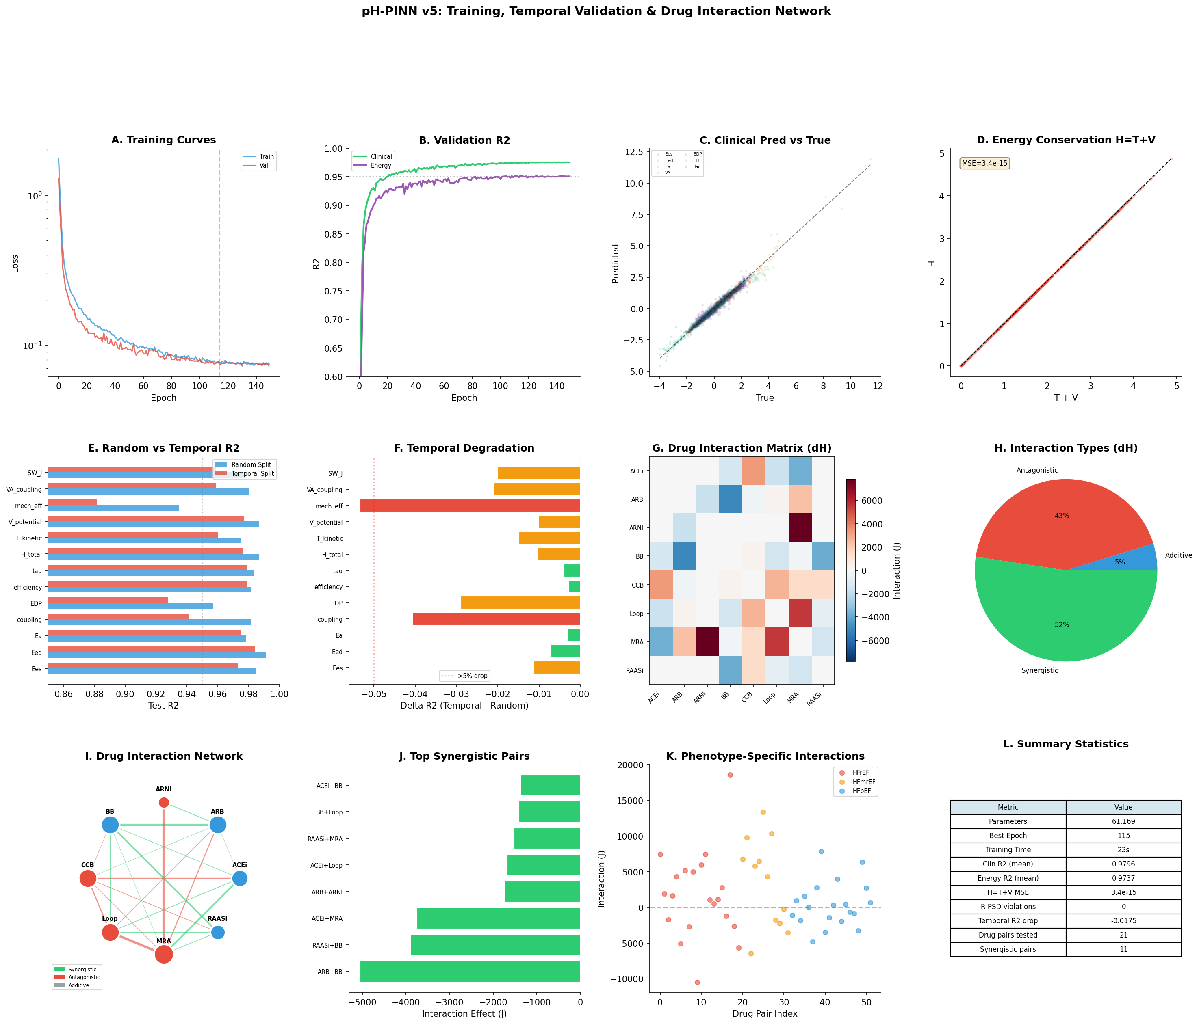
Fig. 3. Comprehensive pH-PINN v5 results: (A-D) training curves and energy conservation, (E-F) temporal validation comparison, (G-H) drug interaction matrix and classification, (I-L) interaction network, top synergistic pairs, phenotype-specific interactions, and summary statistics.

