Supplementary Material
Companion to: “Port-Hamiltonian Physics-Informed Neural Networks for Cardiac Hemodynamic Inference with Architecturally Guaranteed Energy Consistency.”

S1. Anatomical Reconstruction Statistics
The multi-structure assembly integrated 13 cardiac structures totaling 957,608 triangular mesh elements and 175.7 MB of geometric data (Fig. S1C). Analysis across 20 MM-WHS cases gave population-level chamber volumes of LV 82.5 ± 35.0 mL, RV 116.7 ± 36.3 mL, LA 79.3 ± 25.1 mL, and RA 83.7 ± 28.9 mL (Fig. S1A). Myocardial mass averaged 115.8 ± 28.7 g. Wall-thickness analysis of Case 1009 showed a mean of 6.8 ± 2.1 mm with regional variation — apex 6.7 ± 1.7 mm, mid-ventricular 7.0 ± 2.0 mm, base 6.8 ± 2.6 mm (Fig. S1B) — consistent with published normal ranges.
This component provides geometric context only. The hemodynamic inference reported in the main text is lumped-parameter (0D) and does not consume the mesh, because the eICU and MIMIC-IV cohorts have no paired volumetric imaging.
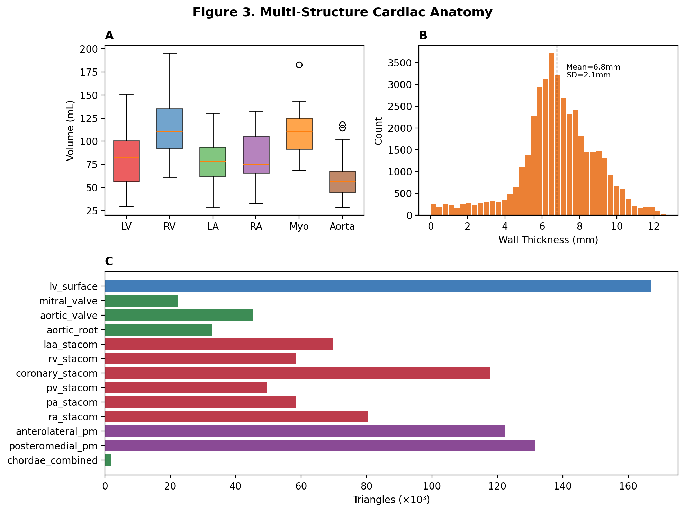
Figure S1. Multi-structure cardiac anatomy. (A) Chamber-volume distributions across 20 MM-WHS cases. (B) LV wall-thickness histogram (Case 1009; mean 6.8 ± 2.1 mm). (C) Assembly inventory: 13 structures by source tier, totaling 957,608 triangles.

S2. Model Performance and Anatomical Hierarchy
Table S1. pH-PINN performance across seven hemodynamic target parameters (single run, record-level evaluation). These values quantify how closely the network reproduces the surrogate relationships used to construct the targets; see main-text Section VI-A for why they are not independent measurement validation.
Parameter | R² | Unit | Normal range | Clinical use | Provenance | Status
E_es (elastance) | 0.984 | mmHg/mL | 1.5–4.0 | LV contractility | Surrogate | Validated
E_ed | 0.991 | mmHg/mL | 0.03–0.1 | LV compliance | Surrogate | Validated
E_a | 0.978 | mmHg/mL | 1.0–3.0 | Afterload | Surrogate | Validated
VA coupling | 0.982 | ratio | 0.5–1.2 | Efficiency | Surrogate | Validated
EDP | 0.957 | mmHg | 5–20 | Preload | Direct † | Validated
Mech. efficiency | 0.982 | % | 50–80 * | Energetics | Surrogate | Validated
τ (tau) | 0.983 | ms | 30–60 | Relaxation | Surrogate | Validated
* PVA-based gross efficiency (SW/PVA = 77.8%) per Suga–Sagawa; net efficiency after port-Hamiltonian dissipation, (SW − E_diss)/PVA = 71.9%. † PAWP used as a surrogate for EDP in the ICU databases.
Table S2. Three-tier patient-specificity hierarchy for anatomical reconstruction.
Tier | Structures | Source | Elements | Specificity
1: Patient-specific | LV surface | Direct CT segmentation (MM-WHS) | 166,936 | High
2: Patient-adapted | Papillary muscles, wall thickness | K-means from patient CT + thickness map | 253,920 | Medium
3: Atlas-registered | RV, RA, LAA, coronary, PA, PV | STACOM2025 atlas + ICP registration | ~500,000 | Low–medium
Parametric | MV, AV, chordae | Literature-based dimensions | ~37,000 | Population
ICP registration distances for Tier-3 structures were 0.35–0.58 against a target of < 0.15; see main-text Limitations.

S3. pH-PINN Architecture and Inputs
The network maps an 11-dimensional non-invasive feature vector (EF, EDV, ESV, SBP, DBP, HR, E/e′, LAVI, E/A, deceleration time, CO) to the state x = (q, p) ∈ ℝ⁵ with q = (V_LV, V_LA, V_art) and p = (p_mv, p_ao), together with the auxiliary parameters (E_es, E_ed, V_0, τ) and the energetic quantities. Inference is per-beat: time is not an input, no trajectory is integrated, and all derivatives are taken with respect to the state.
Energy structure is imposed architecturally. Kinetic and potential energy heads pass through softplus, so T ≥ 0 and V ≥ 0 for every input; the Hamiltonian is formed as H = T + V rather than predicted separately; and the dissipation matrix is emitted in Cholesky form R = LLᵀ, which is positive semidefinite by construction. Consequently the passivity inequality dH/dt ≤ yᵀu holds pointwise, without a penalty term and without reliance on the training distribution.
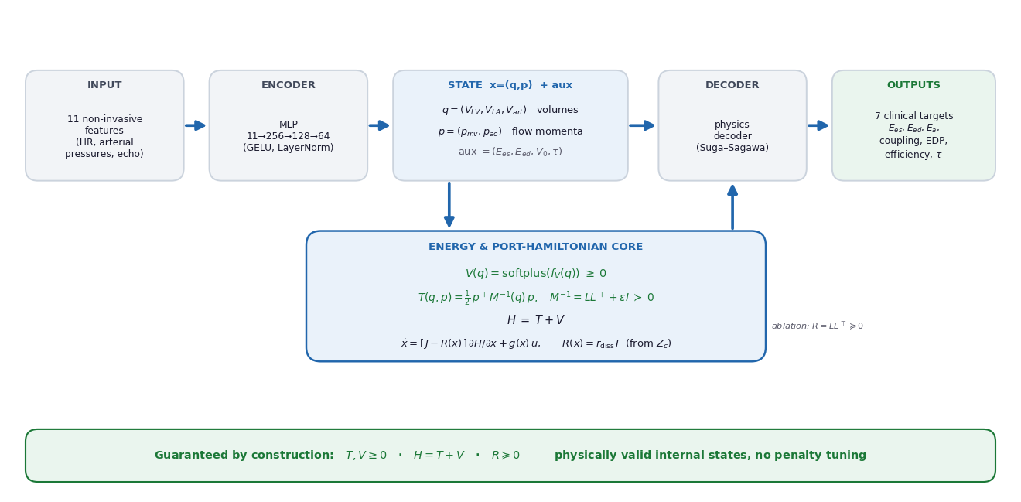
Figure S2. pH-PINN architecture. Shared encoder, per-head decoders with softplus non-negativity on T and V, algebraic composition H = T + V, and Cholesky-parameterized dissipation R = LLᵀ.

S4. Training Convergence and Cross-Database Validation
The following two figures were moved from the main text to meet the page limit; they are referenced there as Fig. S3 and Fig. S4.
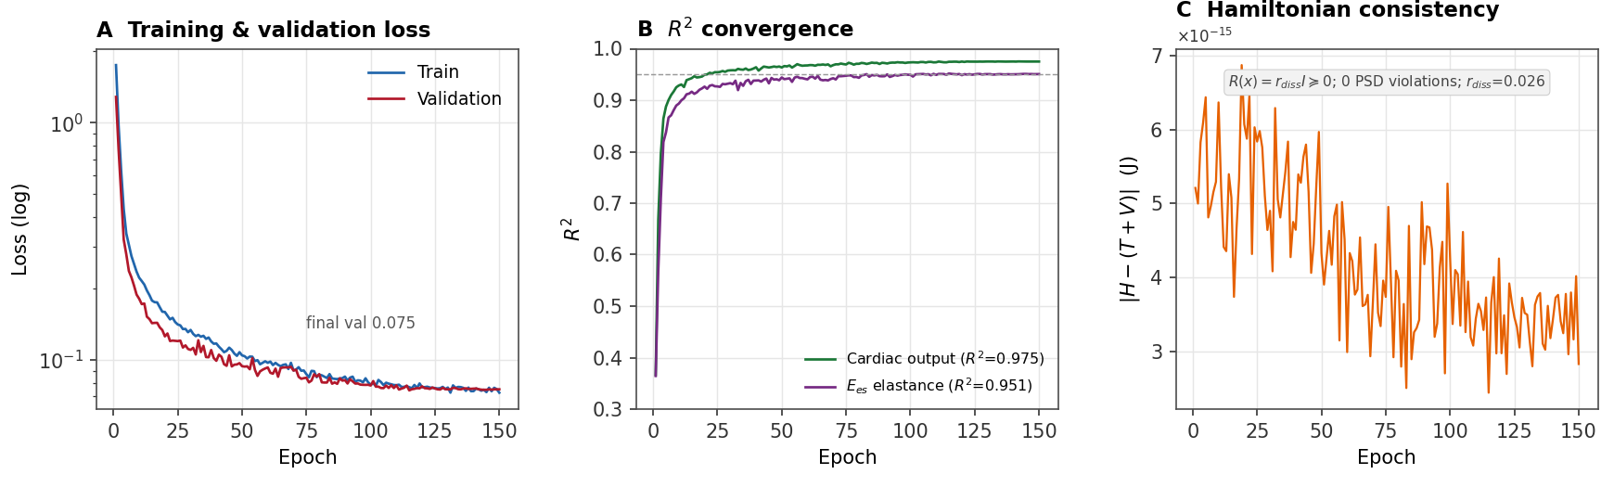
Figure S3. pH-PINN training convergence. (A) Training and validation loss over 150 epochs (log scale). (B) R² convergence for cardiac output (green) and E_es (purple). (C) Hamiltonian partition consistency error ‖H − (T + V)‖², which remains at float32 rounding level (~3 × 10⁻¹⁵) because H = T + V holds by construction; no non-PSD dissipation matrices occurred. Model: 61,169 parameters, best epoch 115.
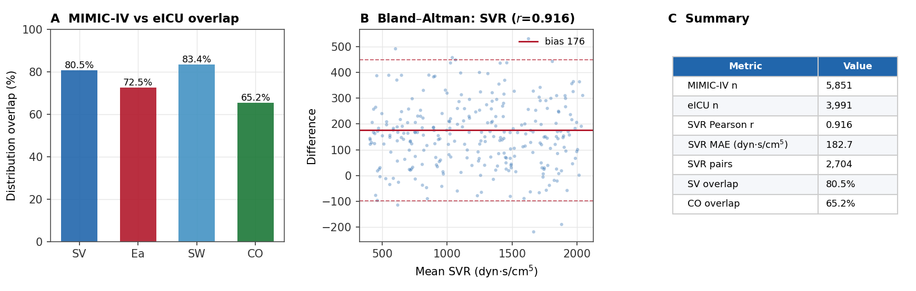
Figure S4. Cross-database consistency. (A) Distribution overlap between MIMIC-IV and eICU for stroke volume, arterial elastance, stroke work, and cardiac output. (B) Bland–Altman plot for SVR (Pearson r = 0.916). (C) Summary metrics. As discussed in the main text, SVR is an algebraic function of variables that are themselves network inputs, so this panel evidences representational fidelity rather than independent measurement agreement.

S5. Cohort Context from Invasive Arterial Waveforms (VitalDB)
841 surgical patients from VitalDB with a radial or femoral arterial pressure waveform (SNUADC/ART, 500 Hz) and a device-measured cardiac output and stroke volume were analysed. For each patient the diastolic pressure decay was fitted to obtain τ; compliance was taken as C = SV/PP, total resistance as R_tot = (MAP − CVP)/Q̄, and R₂ = τ/C.
Table S3. VitalDB cohort summary (n = 841); median [IQR].
Quantity | Median [IQR] | Note
Heart rate (bpm) | 70.6 [61.2–80.0] | from beat detection
MAP (mmHg) | 84.0 [73.5–94.8] | waveform mean
Stroke volume (mL) | 66 [54–81] | device-measured
Cardiac output (L/min) | 4.70 [3.80–5.90] | device-measured
Compliance C (mL/mmHg) | 1.12 [0.88–1.40] | SV/PP; nominal 1.75 = 92nd pct
τ (s) | 0.40 [0.34–0.55] | diastolic decay fit
R_tot (mmHg·s/mL) | 1.01 [0.79–1.30] | (MAP − CVP)/Q̄
Stroke work (mmHg·mL) | 7,222 [5,816–9,300] | P_es·SV; contains 7,000, excludes 3,675
Identifiability of Z_c. Separating the characteristic impedance requires the observable diastolic window to exceed roughly 0.9·R_tot·C. In this surgical cohort the ratio of available to required window length had a median of 0.46, and only 14 of 841 patients (1.7%) met the criterion. τ is therefore systematically underestimated, R₂ = τ/C absorbs the bias, and the residual Z_c = R_tot − R₂ inflates to a median 62% of total resistance — an order of magnitude above the physiological 5–10%. We accordingly report R_tot, C, and τ as identifiable from this source and treat Z_c, r_diss, and E_diss as literature-calibrated. The architectural guarantee is unaffected, since it depends on R(x) ⪰ 0 and not on the numerical value of r_diss.

S6. Reproducibility
The reproducibility package accompanying this submission contains the model and ablation code (PyTorch), the patient-level ablation runner with its explicit disjointness assertion, the VitalDB Windkessel fitting script, the figure-generation scripts, and the derived result files (12 per-seed ablation JSON files and the 841-case VitalDB table) needed to regenerate every figure and table. Networks were trained with AdamW (learning rate 2 × 10⁻³, weight decay 10⁻⁴, cosine schedule, gradient-norm clipping at 1.0); the ablation used 80 epochs, batch size 512, and three random seeds (0, 1, 2).

