Supplementary Material
Companion to: “Port-Hamiltonian Physics-Informed Neural Networks for Cardiac Hemodynamic Inference with Architecturally Guaranteed Energy Consistency.”

S1. Anatomical Reconstruction Statistics
The multi-structure assembly integrated 13 cardiac structures totaling 957,608 triangular mesh elements and 175.7 MB of geometric data (Fig. S1C). Analysis across 20 MM-WHS cases revealed population-level chamber volumes of LV 82.5 ± 35.0 mL, RV 116.7 ± 36.3 mL, LA 79.3 ± 25.1 mL, and RA 83.7 ± 28.9 mL (Fig. S1A). Myocardial mass averaged 115.8 ± 28.7 g. Wall-thickness analysis of Case 1009 showed a mean of 6.8 ± 2.1 mm with regional variation: apex 6.7 ± 1.7 mm, mid-ventricular 7.0 ± 2.0 mm, base 6.8 ± 2.6 mm (Fig. S1B), consistent with published normal ranges.
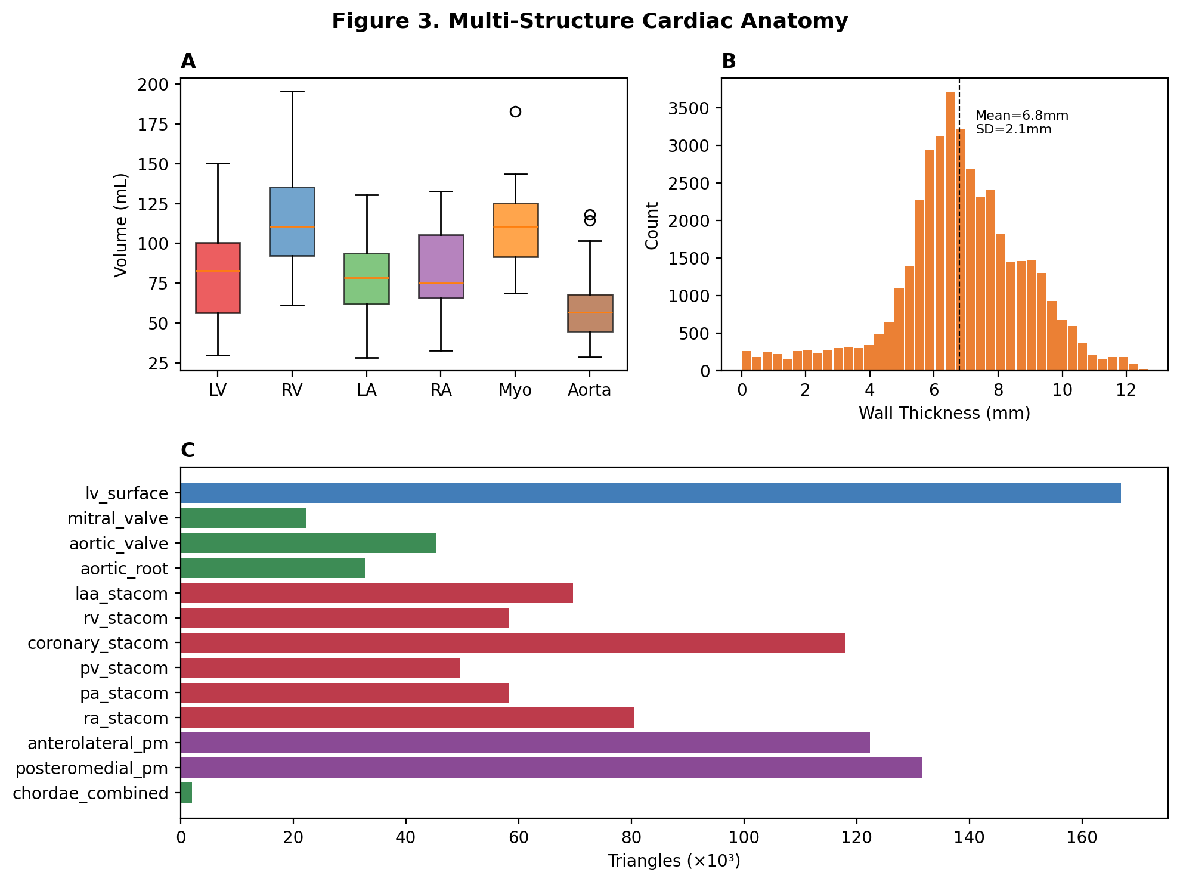
Figure S1. Multi-structure cardiac anatomy. (A) Chamber-volume distributions across 20 MM-WHS cases. (B) LV wall-thickness histogram (Case 1009; mean 6.8 ± 2.1 mm). (C) Assembly inventory: 13 structures by source tier, totaling 957,608 triangles.

S2. Model Performance and Anatomical Hierarchy
Table S1. pH-PINN model performance across seven hemodynamic target parameters (single-run metrics).
Parameter | R² | Unit | Normal Range | Clinical Use | Measurement | Status
Ees (Elastance) | 0.984 | mmHg/mL | 1.5–4.0 | LV contractility | Surrogate | Validated
Eed | 0.991 | mmHg/mL | 0.03–0.1 | LV compliance | Surrogate | Validated
Ea | 0.978 | mmHg/mL | 1.0–3.0 | Afterload | Surrogate | Validated
VA Coupling | 0.982 | ratio | 0.5–1.2 | Efficiency | Surrogate | Validated
EDP | 0.957 | mmHg | 5–20 | Preload | Direct† | Validated
Mech. Eff. | 0.982 | % | 50–70* | Energetics | Surrogate | Validated
τ (Tau) | 0.983 | ms | 30–60 | Relaxation | Surrogate | Validated
* PVA-based gross efficiency (SW/PVA = 64.8%) per Suga-Sagawa; net efficiency after port-Hamiltonian dissipation (SW − E_{diss})/PVA = 62.3%. † PAWP as surrogate for EDP in ICU databases.
Table S2. Three-tier patient-specificity hierarchy for anatomical reconstruction.
Tier | Structures | Source | Elements | Specificity
1: Patient-specific | LV surface | Direct CT segmentation (MM-WHS) | 166,936 | High
2: Patient-adapted | Papillary muscles, wall thickness | K-means from patient CT + thickness | 253,920 | Medium
3: Atlas-registered | RV, RA, LAA, coronary, PA, PV | STACOM2025 atlas + ICP registration | ~500,000 | Low–Medium
Parametric | MV, AV, chordae | Literature-based dimensions | ~37,000 | Population
ICP registration distances for Tier 3 structures: 0.35–0.58 (target < 0.15); see main-text Limitations.

S3. State Variables, Network I/O, and Energy Parameterization
The pH-PINN maps 11 non-invasive input features (heart rate, arterial pressures, and echocardiographic chamber and function indices) to the port-Hamiltonian state x = (q, p) ∈ ℝ⁵ and a small set of auxiliary elastances, and decodes 13 outputs — seven clinical targets (E_{es}, E_{ed}, E_{a}, ventricular–arterial coupling, EDP, mechanical efficiency, τ) and six internal energy quantities. The encoder is an MLP (11→256→128→64, GELU, LayerNorm) with separate coordinate, momentum, and auxiliary heads (Fig. S2).
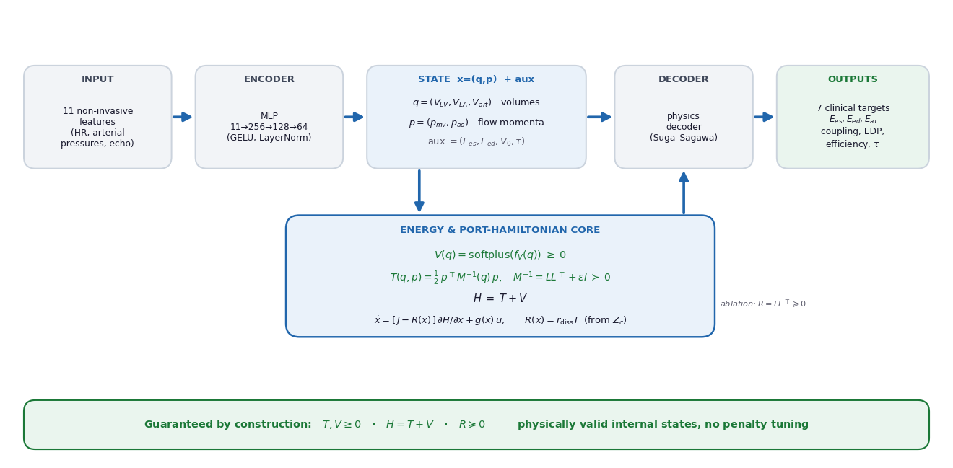
Figure S2. pH-PINN architecture. Non-invasive features are encoded to the port-Hamiltonian state x = (q, p); separate non-negative heads emit the potential and kinetic energies that form H = T + V, the dissipation R(x) enters the port-Hamiltonian dynamics, and a Suga–Sagawa decoder returns the clinical targets. Non-negativity of T, V, the partition H = T + V, and PSD R hold by construction.
Table S3. State variables and auxiliary parameters (production pH-PINN).
Symbol | Physical meaning | Network head | Constraint / range
V_LV | LV volume (generalized coordinate q1) | q-head | softplus, 20–400 mL
V_LA | LA volume (generalized coordinate q2) | q-head | softplus, 5–100 mL
V_art | Arterial volume (generalized coordinate q3) | q-head | softplus, 50–300 mL
p_mv | Mitral flow momentum (inertance × flow) | p-head | signed
p_ao | Aortic flow momentum (inertance × flow) | p-head | signed
E_es | End-systolic elastance (ESPVR slope) | aux-head | softplus, 0.5–10 mmHg/mL
E_ed | Diastolic stiffness (EDPVR) | aux-head | sigmoid, 0–0.5 /mL
V_0 | Unstressed volume | aux-head | signed
tau | Relaxation time constant | aux-head | softplus, 30–100 ms
Energy heads: V(q) = softplus(f_{V}(q)) ≥ 0 (elastic potential); T(q, p) = ½ pᵀ M⁻¹(q) p with M⁻¹(q) = L(q)L(q)ᵀ + εI ≻ 0 (kinetic; the ablation model A uses T = softplus(f_{T}) instead — both give T ≥ 0). Hence H = T + V and T, V ≥ 0 hold by construction. Dissipation is R(x) = r_{diss} I with r_{diss} calibrated from the Windkessel characteristic impedance Z_{c} (production runs), and a learned Cholesky matrix R = LL⊤ ⪰ 0 in the hard-constrained ablation model. Unconstrained baselines omit these constraints; the soft-constraint model replaces them with loss penalties.

