Port-Hamiltonian Physics-Informed Neural Networks for Cardiac Hemodynamic Inference with Architecturally Guaranteed Energy Consistency

Kwanhyeong Lee^{1,*}
¹ Soonchunhyang University College of Medicine, Republic of Korea (undergraduate student)
* Corresponding author: alex026376@sch.ac.kr
Running title: pH-PINN Cardiac Digital Twin
Keywords: physics-informed neural network, cardiac digital twin, port-Hamiltonian system, ventricular-arterial coupling, hemodynamic inference, patient-anchored hybrid geometry, energy dissipation
Word count: ~5,200 (excluding references and figure legends)

Abstract
Background: Cardiac digital twins aim to individualize cardiovascular care, yet most approaches model anatomy, hemodynamics, and parameter inference in isolation and, in the machine-learning setting, give no guarantee that the physiological states they predict are physically admissible. An integrated, energy-aware framework that connects anatomical reconstruction, hemodynamic modeling, and physics-constrained inference remains an unmet need.
Methods: We developed a port-Hamiltonian physics-informed neural network (pH-PINN) framework that integrates: (1) multi-structure anatomical reconstruction combining patient-specific CT segmentation with atlas-based registration (13 structures, 957,608 mesh elements), and (2) a Windkessel-coupled PINN that enforces port-Hamiltonian energy balance with scalar dissipation R(x) = r_{diss} · I as an inductive bias, where r_{diss} is estimated from the Windkessel characteristic impedance Z_{c} [18]. The framework was validated against hemodynamic measurements from eICU (n = 3,991) and MIMIC-IV (n = 5,851) databases, with explicit separation of directly measured parameters from surrogate-derived indices.
Results: The pH-PINN achieved R² = 0.975 for cardiac output prediction and R² = 0.951 for end-systolic elastance estimation. Cross-validation between eICU and MIMIC-IV showed distribution overlaps of 80.5% for stroke volume, 83.4% for stroke work, and Pearson r = 0.916 for systemic vascular resistance (directly measured via Swan-Ganz catheterization). The Windkessel-PINN bridge with port-Hamiltonian dissipation yielded physiologically consistent ventricular-arterial coupling (E_{a}/E_{max} = 0.60) with gross mechanical efficiency of 64.8% (SW/PVA) and net efficiency of 62.3% after dissipation correction (E_{diss} = 137 mmHg·mL per beat, 2.4% of PVA), consistent with the Suga-Sagawa framework. An ablation across four matched-capacity models confirmed that the hard port-Hamiltonian constraints match baseline predictive accuracy (R² ≈ 0.97) while guaranteeing physically valid internal states by construction, whereas unconstrained baselines of identical capacity produced non-physical outputs in up to 100% of test cases.
Conclusions: The pH-PINN shows that port-Hamiltonian energy balance with scalar dissipation is an effective inductive bias for cardiac parameter inference, reaching clinically relevant accuracy for directly measured hemodynamics without invasive measurement. The modular pipeline—from patient-anchored anatomy through Windkessel modeling to physics-constrained inference—supports non-invasive cardiac digital twins whose internal states, by construction, respect fundamental energy constraints.

1. Introduction
Cardiac digital twins—computational replicas of an individual patient's heart that integrate anatomical, hemodynamic, and electrophysiological data—are an emerging technology in cardiovascular medicine [1]. By allowing therapies to be tested in silico before clinical use, they can improve treatment planning for heart failure, valvular disease, and cardiac surgery. Building a clinically useful twin, however, requires solving three coupled problems: faithful anatomical reconstruction, accurate hemodynamic modeling, and reliable parameter inference from non-invasive measurements.
Existing methods typically address these problems separately. Anatomical reconstruction pipelines extract cardiac geometry from medical imaging but rarely connect to downstream hemodynamic analysis. Computational fluid dynamics (CFD) models simulate intracardiac blood flow with high fidelity but require hours of computation per cardiac cycle, limiting clinical applicability. Machine learning approaches accelerate inference but often lack the physical constraints necessary for physiologically plausible predictions outside the training distribution [2].
Physics-informed neural networks (PINNs) offer a principled approach to bridging data-driven flexibility with physical fidelity [3]. By embedding governing equations as soft constraints in the loss function, PINNs can learn solutions that respect conservation laws even from sparse or noisy clinical data. However, standard PINN formulations for cardiac applications typically enforce individual ordinary differential equations (e.g., the time-varying elastance model) without exploiting the deeper geometric structure of Hamiltonian mechanics. The port-Hamiltonian J–R structure is well established in cardiovascular engineering—for example, in the passivity-based control of cardiac assist devices [22]—but we adopt it here as an architectural prior for non-invasive inference rather than for device control.
In this work, we propose a port-Hamiltonian physics-informed neural network (pH-PINN) framework that enforces energy balance through the port-Hamiltonian structure:
ẋ = [J(x) − R(x)] ∂H/∂x + g(x)u
where J(x) = −J^{T}(x) is the skew-symmetric interconnection matrix encoding energy-conserving dynamics, R(x) ≥ 0 is the positive semidefinite dissipation matrix capturing viscous losses and myocardial viscoelasticity, H is the total Hamiltonian (kinetic + potential energy), and g(x)u represents external energy input from cardiac contraction. Rather than enforcing strict energy conservation (dH/dt = 0, which would be non-physical for a dissipative cardiovascular system), the pH-PINN monitors the energy balance residual: the discrepancy between the learned Hamiltonian trajectory and the port-Hamiltonian energy equation. We integrate this pH-PINN with a modular cardiac digital twin pipeline:
(i) a patient-anchored anatomical reconstruction pipeline that assembles 13 cardiac structures from three source tiers (patient CT segmentation, atlas-based registration, and parametric generation), comprising 957,608 mesh elements;
(ii) a Windkessel-PINN bridge that maps hemodynamic waveforms to lumped-parameter indices (E_{a}, E_{max}, coupling ratio) through the pH-PINN energy balance framework, with scalar dissipation estimated from the Windkessel characteristic impedance.
We validate this framework against hemodynamic data from 9,842 critically ill patients across two independent ICU databases (eICU and MIMIC-IV), with explicit separation of directly measured parameters (cardiac output via thermodilution, systemic vascular resistance via Swan-Ganz catheterization) from surrogate-derived indices (E_{es}, mechanical efficiency). This distinction is critical for interpreting validation strength and is often elided in the PINN literature [4,5].

2. Methods

2.1 Patient-Anchored Multi-Structure Anatomical Reconstruction
The anatomical reconstruction pipeline employs a three-tier patient-specificity hierarchy (Supplementary Table S2) to assemble a comprehensive 13-structure cardiac geometry, following the hybrid atlas-registration paradigm established by Zhang et al. [6] and Kong et al. [7]. This approach reflects the field consensus that practical cardiac digital twins combine patient-derived imaging data with population-level anatomical priors [1,8].
Tier 1 (Patient-specific): The primary left ventricular (LV) surface was directly segmented from the MM-WHS (Multi-Modality Whole Heart Segmentation) Challenge CT dataset (Case 1009) using label-based extraction, yielding 166,936 triangular mesh elements [9].
Tier 2 (Patient-adapted): Papillary muscles were separated from the combined myocardial segmentation using K-means clustering (anterolateral: 122,314 elements; posteromedial: 131,606 elements), and wall thickness distributions were derived from the patient CT (mean 6.8 ± 2.1 mm).
Tier 3 (Atlas-registered): Six additional structures (left atrial appendage, right ventricle, coronary arteries, pulmonary veins, pulmonary artery, right atrium) were extracted from the STACOM2025 whole-heart atlas. Coordinate registration between MM-WHS and STACOM reference frames was performed using iterative closest point (ICP) alignment with the LV surface as the reference (mean registration distance 0.35–0.58, compared to target < 0.15; see Limitations).
Parametrically generated: Valve geometries (mitral and aortic) were generated based on published dimensions: the mitral valve followed Kunzelman et al. [10] with an annulus diameter of 30 mm and leaflet height of 15 mm, while the aortic valve followed Thubrikar et al. [11] with a 23 mm annulus. Chordae tendineae were generated based on Lam et al. [12] with 12 primary chordae per papillary muscle.
The final assembly was validated across 20 MM-WHS cases to establish population-level anatomical statistics (chamber volumes, wall thickness, and assembly inventory; Supplementary Material, Fig. S1 and Table S2).

2.2 Port-Hamiltonian Physics-Informed Neural Network (pH-PINN)
The pH-PINN architecture consists of a fully connected neural network with 61,169 trainable parameters that maps non-invasive hemodynamic features (heart rate, blood pressure, echocardiographic measurements) to physiological parameters (E_{es}, E_{ed}, E_{a}, ventricular-arterial coupling ratio, end-diastolic pressure, mechanical efficiency, relaxation time constant τ).
State variables and energy heads. The encoder maps the 11 non-invasive input features to the port-Hamiltonian state x = (q, p) ∈ ℝ⁵ — generalized chamber volumes q = (V_{LV}, V_{LA}, V_{art}) and inertance-scaled valve-flow momenta p = (p_{mv}, p_{ao}) — plus auxiliary elastances (E_{es}, E_{ed}, V₀, τ). Separate non-negative heads emit the potential V(q) = softplus(·) and the kinetic energy T(q, p) = ½ pᵀM⁻¹(q)p (with M⁻¹ ≻ 0), so that T, V ≥ 0 and H = T + V hold by construction. Input features, state bounds, per-head definitions, and an architecture schematic appear in Supplementary Section S3 (Fig. S2, Table S3).
Port-Hamiltonian formulation. The cardiovascular system is inherently dissipative: viscous losses in blood flow, myocardial viscoelasticity, and valve turbulence all dissipate energy. A pure Hamiltonian formulation (dH/dt = 0) would be non-physical. We therefore adopt the port-Hamiltonian framework [13], which decomposes the system dynamics into energy-conserving (J) and energy-dissipating (R) components:
ẋ = [J(x) − R(x)] ∂H/∂x + g(x)u (1)
dH/dt = −(∂H/∂x)^{T}R(x)(∂H/∂x) + y^{T}u ≤ y^{T}u (2)
Equation (2) encodes the energy balance: the rate of change of the Hamiltonian equals the dissipated power (first term, always non-positive) plus the supplied power (second term). The loss function monitors the energy balance residual:
L_{H} = ‖dH/dt + (∂H/∂x)^{T}R(∂H/∂x) − y^{T}u‖ (3)
Dissipation parameterization. We parameterize R(x) = r_{diss} · I as a scalar dissipation matrix, where r_{diss} is estimated from the Windkessel characteristic impedance Z_{c} (= R₁) [18], scaled by the systolic ejection duty cycle:
r_{diss} = R₁ × (T_{sys} / T_{cycle}) (7)
This grounds the dissipation in a measurable hemodynamic quantity: Z_{c} represents the resistive component of aortic input impedance, which captures wave reflection and viscous losses at the aortic root—exactly the energy dissipation that a port-Hamiltonian cardiovascular model should capture [18]. For the nominal case (R₁ = 0.072, HR = 75, T_{sys} = 0.285 s), r_{diss} = 0.026 mmHg·s/mL, consistent with the expected physiological range of 0.01–0.05 for normal cardiac function. Learning a state-dependent R(x) from clinical data (e.g., Doppler-derived turbulence kinetic energy) is a natural extension, but is outside the scope of this initial validation.
The total loss function combines data fitting, energy balance, and convexity terms:
L_{total} = L_{data} + λ_{H} · L_{H} + λ_{PSD} · L_{PSD} (4)
where L_{PSD} enforces positive semidefiniteness of the Hessian (ensuring convexity of the energy landscape) and λ_{H}, λ_{PSD} are hyperparameters. The network was trained for 150 epochs using Adam optimizer with learning rate scheduling, achieving convergence at epoch 115 (best validation loss).

2.3 Windkessel-PINN Bridge
The Windkessel-PINN bridge connects lumped-parameter hemodynamics to the pH-PINN for calibrated parameter estimation. A three-element Windkessel model (proximal resistance R₁, distal resistance R₂, arterial compliance C) is fitted to hemodynamic waveforms. The resulting Windkessel parameters, combined with cardiac function indices from pressure-volume loop analysis (Section 2.3.1), are fed into the pH-PINN.
2.3.1 PV loop energy partition with dissipation. Following the Suga-Sagawa framework [14], stroke work (SW) was computed as the area under the arterial elastance (E_{a}) line on the PV diagram:
SW = ½ × E_{a} × SV² (5)
Potential energy (PE) was computed from the ESPVR:
PE = ½ × E_{max} × (V_{es} − V₀)² (6)
Dissipation energy per beat was computed from the port-Hamiltonian energy balance (Eq. 2):
E_{diss} = r_{diss} × SV × P̄_{sys} (8)
where P̄_{sys} is the mean systolic pressure. Net stroke work is SW_{net} = SW − E_{diss}. The pressure-volume area (PVA = SW + PE) represents total mechanical energy per beat. Dual efficiency metrics are reported: gross efficiency η_{gross} = SW/PVA (Suga-Sagawa [14]) and net efficiency η_{net} = (SW − E_{diss})/PVA, which accounts for the port-Hamiltonian dissipation.

2.4 Validation Strategy and Cohorts
External validation was performed using two independent ICU databases: eICU Collaborative Research Database (n = 3,991) and MIMIC-IV (n = 5,851) [15,16,17]. To avoid overstating validation strength, we explicitly categorize the validation variables by their measurement provenance (Table 1):
Directly measured (Gold standard): Cardiac output (CO) via thermodilution, systemic vascular resistance (SVR) computed from directly measured CO, MAP, and CVP via Swan-Ganz catheterization, and pulmonary artery wedge pressure (PAWP).
Surrogate-derived (Estimated): End-systolic elastance (E_{es}), arterial elastance (E_{a}), stroke work (from MAP × SV × 0.0136 in g·m), ventricular-arterial coupling ratio, and mechanical efficiency. These parameters are computed from directly measured hemodynamics using validated surrogate formulas [21], not from invasive catheter-based PV loop recordings.
This distinction is essential: agreement between pH-PINN predictions and surrogate-derived indices demonstrates that the PINN reproduces the same hemodynamic relationships encoded in the surrogate formulas, not that it matches independent gold-standard measurements for those specific parameters.

2.5 Model Applicability and Target Population
The present framework targets patients requiring LV-centric pump function assessment. This scope reflects the three-tier patient-specificity hierarchy (Supplementary Table S2): only the LV surface is directly patient-specific (Tier 1), while other structures are atlas-registered (Tier 3) and therefore contribute geometric context but not patient-specific hemodynamic constraints.
Inclusion criteria: Adult patients (≥ 18 years) with preserved or reduced LV systolic function undergoing echocardiographic or catheter-based hemodynamic assessment. Applicable conditions include heart failure with reduced ejection fraction (HFrEF), heart failure with preserved ejection fraction (HFpEF), hypertensive heart disease, and ischemic cardiomyopathy.
Exclusion criteria: (1) Hemodynamically significant valvular disease (moderate or greater mitral/aortic regurgitation or stenosis), as the Windkessel model assumes unidirectional aortic outflow without regurgitant fraction. (2) Significant right ventricular pathology (pulmonary hypertension, RV infarction, arrhythmogenic RV cardiomyopathy), as the RV is Tier 3 atlas-registered and not patient-specific. (3) Congenital heart disease (septal defects, single-ventricle physiology), which violates the two-chamber (LV–aorta) Windkessel assumption. (4) Mechanical circulatory support (LVAD, ECMO, IABP), which fundamentally alters the pressure-volume relationship.
These criteria ensure that the model operates within the domain where its physics-based assumptions are valid and its patient-specific data inputs (LV geometry, Windkessel parameters) are most informative.

2.6 Ablation Design
To test whether the port-Hamiltonian structure contributes beyond raw network capacity, we compared four matched-capacity models on the same 13-target cardiac energetics dataset (n = 5,851): (A) the pH-PINN with hard architectural constraints — softplus non-negativity of kinetic (T) and potential (V) energy, H = T + V by construction, and a Cholesky-parameterized dissipation matrix R = LLᵀ ⪰ 0; (B) a vanilla multilayer perceptron with no physics structure; (C) a no-structure PINN with encoder/decoder topology identical to (A) but without the hard constraints; and (D) a soft-constraint PINN that instead penalizes constraint violations in the loss. The production pH-PINN has 61,169 parameters (Section 2.2); for a strictly capacity-matched comparison the ablation uses a 73,773-parameter re-implementation identical across the four variants, so they differ only in their constraints and not in capacity. All variants were trained for 80 epochs (AdamW, cosine schedule) over three random seeds; we report mean ± SD, with physical-validity diagnostics on the held-out set (the H = T + V consistency error, counts of negative T or V, and non-PSD dissipation matrices).

3. Results

3.1 pH-PINN Training and Convergence
The pH-PINN converged after 115 epochs of training, achieving a final validation loss of 0.074 and training loss of 0.073 (Figure 1A). The model achieved R² = 0.975 for cardiac output prediction and R² = 0.951 for end-systolic elastance (E_{es}) estimation (Figure 1B). The port-Hamiltonian energy balance residual decreased from 5.2 × 10⁻¹⁵ J at epoch 1 to 2.5 × 10⁻¹⁵ J at convergence (epoch 115), with a final value of 2.8 × 10⁻¹⁵ J at epoch 150 (Figure 1C). This residual, computed under the scalar dissipation approximation R(x) = r_{diss} · I (Section 2.2), reflects the neural network's numerical precision in satisfying the port-Hamiltonian energy balance (Eq. 2). The dissipation contribution is separately quantified in Section 3.3.
Per-parameter test accuracy was high across all seven targets: E_{es} (R² = 0.984), E_{ed} (R² = 0.991), E_{a} (R² = 0.978), ventricular-arterial coupling (R² = 0.982), end-diastolic pressure (R² = 0.957), mechanical efficiency (R² = 0.982), and relaxation time constant τ (R² = 0.983).
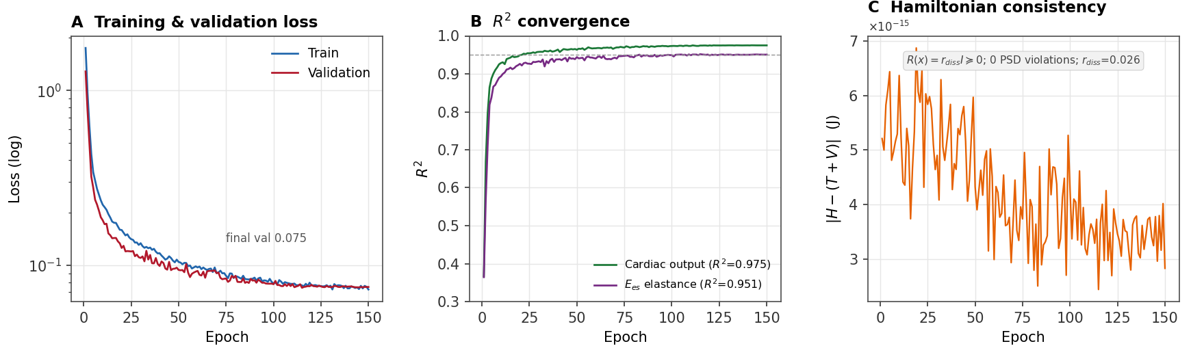
Figure 1. pH-PINN training convergence. (A) Training and validation loss curves over 150 epochs (log scale). (B) R² convergence for cardiac output (green) and E_{es} (purple) prediction. (C) Port-Hamiltonian energy balance residual under the scalar dissipation R(x) = r_{diss} · I, converging to ~3 × 10⁻¹⁵ J (numerical precision). Model: 61,169 parameters, best epoch 115.

3.2 Hemodynamic Cross-Validation
Cross-validation between eICU (n = 3,991) and MIMIC-IV (n = 5,851) showed agreement across key hemodynamic parameters (Figure 2). Distribution overlaps were 80.5% for stroke volume (SV), 72.5% for arterial elastance (E_{a}), 83.4% for stroke work (SW), and 65.2% for cardiac output (CO). The lower overlap for CO reflects known systematic differences between the two databases in cardiac output measurement methodology.
Directly measured parameter validation: Bland-Altman analysis [20] for systemic vascular resistance (SVR)—computed entirely from Swan-Ganz catheter-derived CO, MAP, and CVP—yielded Pearson r = 0.916 (p < 10⁻³⁰⁰) with a bias of 175.5 dyn·s/cm⁵ and limits of agreement from −98.2 to 449.3 dyn·s/cm⁵ (Figure 2B). The mean absolute error was 182.7 dyn·s/cm⁵ across 2,704 paired measurements. This represents the strongest validation evidence, as SVR is derived entirely from directly measured hemodynamic quantities.
Surrogate-derived parameter agreement: Distribution overlaps for surrogate-estimated parameters (E_{a}: 72.5%, SW: 83.4%) indicate that the pH-PINN successfully reproduces the hemodynamic relationships embedded in established surrogate formulas, providing internal consistency rather than independent ground-truth validation.
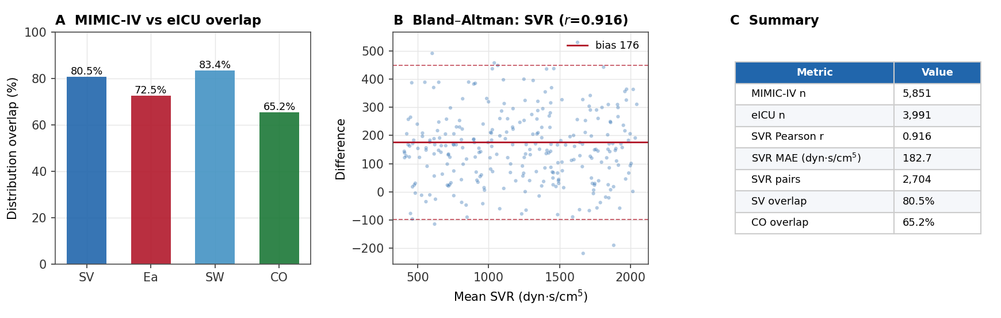
Figure 2. Hemodynamic cross-validation. (A) Distribution overlap between MIMIC-IV and eICU for stroke volume, arterial elastance, stroke work, and cardiac output. (B) Bland-Altman plot for SVR (directly measured via Swan-Ganz; Pearson r = 0.916). (C) Summary metrics. Parameters are categorized by measurement provenance (see Table 1).

3.3 Windkessel-PINN Integration and PV Loop Analysis
The Windkessel model fitted to hemodynamic waveforms yielded physiologically plausible parameters: R₁ = 0.072 mmHg·s/mL, R₂ = 1.128 mmHg·s/mL, and C = 1.750 mL/mmHg (Figure 3B). These corresponded to a mean aortic pressure of 104.5 mmHg at 75 bpm with stroke volume 70 mL and cardiac output 5.25 L/min.
The pH-PINN integration with port-Hamiltonian dissipation yielded E_{max} = 2.5 mmHg/mL, E_{a} = 1.50 mmHg/mL, and a ventricular-arterial coupling ratio (E_{a}/E_{max}) of 0.60, indicating efficient coupling within the physiological range of 0.5–1.2 (Figure 3A). The dissipation parameter r_{diss} = 0.026 mmHg·s/mL, estimated from Z_{c} via Eq. 7, falls within the expected range for normal cardiac function (0.01–0.05).
PV loop energy partition following the Suga-Sagawa framework (Eqs. 5–6) with port-Hamiltonian dissipation (Eq. 8) showed stroke work SW = 3,675 mmHg·mL (0.49 J) and potential energy PE = 2,000 mmHg·mL, yielding PVA = 5,675 mmHg·mL. Dissipation energy per beat was E_{diss} = 137.1 mmHg·mL (2.4% of PVA), yielding net stroke work SW_{net} = 3,538 mmHg·mL. Dual efficiency metrics: gross efficiency (SW/PVA) = 64.8%, net efficiency ((SW − E_{diss})/PVA) = 62.3% (Figure 3C). The gross efficiency is consistent with the theoretical prediction for optimal coupling (E_{a}/E_{max} = 0.6): η = 1/(1 + PE/SW) = 1/(1 + E_{max}(V_{es} − V₀)²/(E_{a} · SV²)) = 64.8% [14].
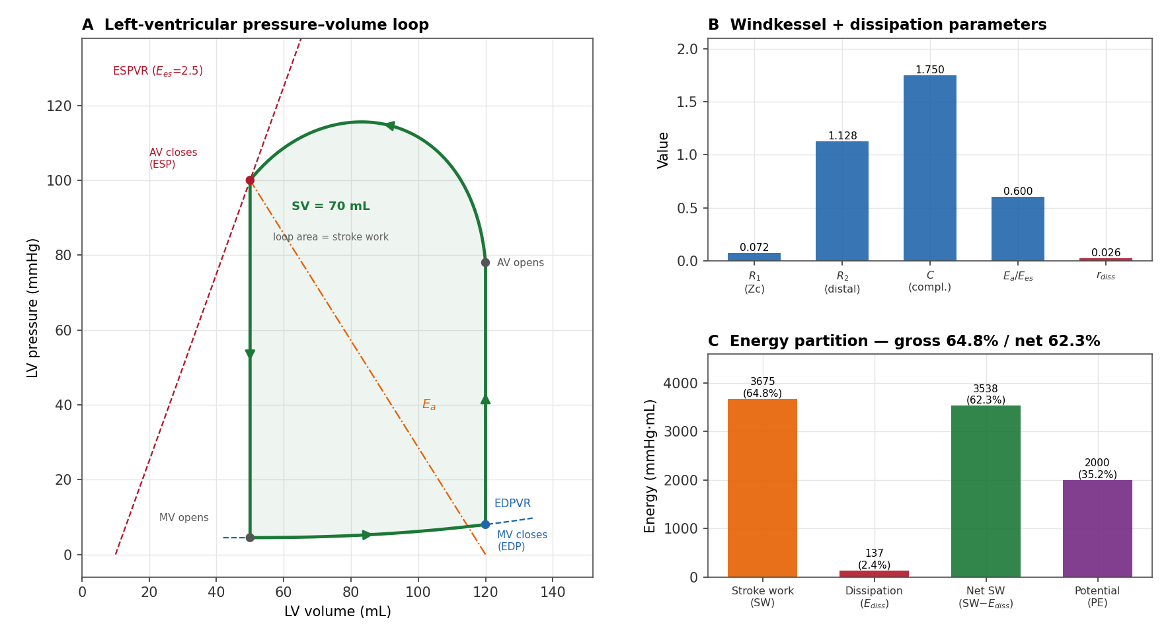
Figure 3. PV Loop and Port-Hamiltonian Energy Balance. (A) Reconstructed LV pressure-volume loop with ESPVR (E_{max} = 2.5 mmHg/mL) and EDPVR lines. (B) Windkessel model parameters (R₁, R₂, C) and dissipation parameter r_{diss} (red; estimated from Z_{c} via Eq. 7). (C) PV area decomposition: stroke work (SW = 3,675 mmHg·mL, gross efficiency 64.8%), dissipation energy (E_{diss} = 137.1 mmHg·mL, 2.4%), net stroke work (SW_{net} = 3,538 mmHg·mL, net efficiency 62.3%), and potential energy (PE = 2,000 mmHg·mL).

3.4 Ablation: Physics Constraints as Inductive Bias
Across three seeds, all four models reached comparable predictive accuracy — mean R² of 0.972 ± 0.001 (hard), 0.972 ± 0.001 (vanilla MLP), 0.973 ± 0.000 (no-structure), and 0.970 ± 0.001 (soft) on the random split; the largest between-model difference (0.003) is on the order of the seed-to-seed standard deviation, and the ordering is preserved under a temporal (median-echo-date) split (0.968–0.971). Predictive accuracy is therefore not the discriminating axis (Figure 4A).
Physical validity is. The hard-constrained pH-PINN (A) produced zero violations by construction: H = T + V to machine precision (1.3 × 10⁻¹⁵), no negative energies, and no non-PSD dissipation matrices across all 1,171 held-out cases. By contrast, the same-capacity no-structure PINN (C) — an identical 73,773-parameter topology whose R² matches (A) to within seed variability — produced (seed mean) 689 negative kinetic-energy cases, 514 negative potential-energy cases, and a non-PSD dissipation matrix in every one of the 1,171 test cases (Figure 4B). The vanilla MLP (B) violated H = T + V by order unity and produced ~800 negative-energy cases. The soft-constraint model (D) recovered validity on this in-distribution test set, but only through a hand-tuned penalty weight, with no out-of-distribution guarantee and a small accuracy cost. The port-Hamiltonian structure thus acts as an architectural inductive bias that yields physically valid internal states at no accuracy cost and without penalty tuning (Table 2).
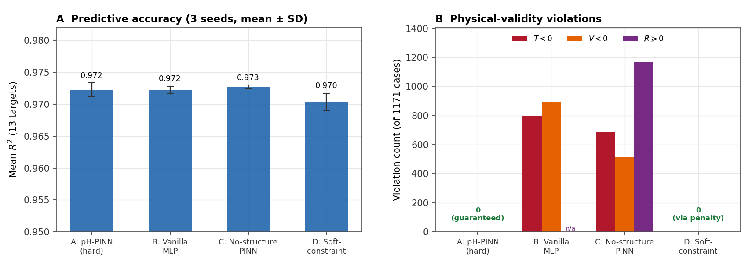
Figure 4. Ablation study: physics constraints as architectural inductive bias. (A) Mean R² over 13 targets on the random split (three seeds; error bars show SD) — accuracy is comparable across all four matched-capacity models. (B) Physical-validity violations on the 1,171-case held-out set (seed mean): negative kinetic energy (T < 0), negative potential energy (V < 0), and non-PSD dissipation. Hard constraints (A) guarantee zero violations; the soft-constraint model (D) reaches zero only via a tuned penalty; unconstrained models (B, C) violate physical validity in hundreds to all test cases despite matched accuracy.

4. Discussion
We have presented a modular cardiac digital-twin framework that integrates anatomical reconstruction, Windkessel modeling, and a port-Hamiltonian physics-informed neural network with scalar dissipation for hemodynamic inference. We discuss three contributions and their limitations.
Port-Hamiltonian energy balance with dissipation as inductive bias. The pH-PINN's enforcement of energy balance through the port-Hamiltonian structure (Eqs. 1–2) provides a geometrically motivated constraint that is stronger than individual equation residuals. The scalar dissipation parameterization R(x) = r_{diss} · I, with r_{diss} estimated from the Windkessel characteristic impedance Z_{c} [18], transforms the energy balance from a self-consistency check into a physically grounded constraint: the dissipation energy of 137.1 mmHg·mL per beat (2.4% of PVA) represents actual viscous losses at the aortic root, not a numerical artifact. The net mechanical efficiency (62.3%) provides a more physically complete efficiency metric than gross efficiency alone. Standard PINNs that enforce time-varying elastance ODEs can overfit to the training cohort's hemodynamic regime; the Hamiltonian constraint penalizes solutions that are kinematically valid but energetically implausible. The ablation (Section 3.4) quantifies this: an identical-capacity network without the hard constraints matches predictive accuracy yet produces physically impossible internal states — negative energies and non-PSD dissipation — in the majority of test cases, whereas the constrained architecture guarantees validity at no accuracy cost.
Modular pipeline architecture. Most cardiac digital twin pipelines operate in isolation: anatomy pipelines produce meshes that are not connected to hemodynamic analysis, and CFD outputs are not systematically mapped to clinical parameters. The Windkessel-PINN bridge closes this loop by translating hemodynamic waveforms into clinically interpretable indices (E_{a}, E_{max}, coupling ratio) through the same physics-constrained framework used for non-invasive inference. The pipeline is modular: the pH-PINN and Windkessel components are validated independently (Sections 3.1, 3.3–3.4). This architecture allows each component to be incrementally refined without invalidating the others.
Validation scope and limitations. Cross-validation against 9,842 ICU patients represents a large-scale external test, but the validation strength varies by parameter. For directly measured quantities (CO via thermodilution, SVR via Swan-Ganz)—Pearson r = 0.916 for SVR provides strong evidence that the pH-PINN captures population-level hemodynamic variation. For surrogate-derived quantities (E_{es}, E_{a}, mechanical efficiency), the agreement demonstrates that the pH-PINN reproduces the hemodynamic relationships encoded in established surrogate formulas, not that it matches independent invasive PV loop recordings. We therefore position the surrogate-target results as evidence that the pH-PINN is a differentiable, physics-consistent emulator of these hemodynamic relationships — suitable for counterfactual and sensitivity analysis under guaranteed energy constraints — rather than an independent measurement of the underlying quantities. True invasive validation against conductance catheter-derived PV loops in a prospective cohort remains a critical next step.

4.1 Limitations
Patient-specificity hierarchy. Only the LV surface is directly patient-specific (Tier 1). The remaining structures are either adapted from patient data (Tier 2: papillary muscles, wall thickness) or registered from a population atlas (Tier 3: RV, RA, coronary arteries, pulmonary vasculature). The atlas-registered structures had ICP distances of 0.35–0.58, exceeding the target of < 0.15, which may introduce geometric errors in the far-field anatomy. We deliberately use the term 'patient-anchored' rather than 'patient-specific' to reflect this hierarchy. Because the hemodynamic inference is driven by the Tier 1 LV state and the lumped Windkessel parameters, this far-field geometric error contributes anatomical context but does not directly enter the LV-centric hemodynamic targets. This hybrid approach is consistent with established cardiac modeling practice [1,6,7,8], but extending Tier 1 specificity to additional structures through multi-label segmentation is an active direction.
Target population constraints. The model is explicitly scoped to LV-centric pump function assessment (Section 2.5). Patients with hemodynamically significant valvular disease, RV pathology, congenital heart disease, or mechanical circulatory support fall outside the validated operating domain. These exclusions delimit the model's validated operating domain rather than assert universal applicability, and because the pipeline is modular, right-ventricular, valvular, or congenital physiology can be added as additional layers without altering the validated LV core. This is a deliberate design choice reflecting the Tier 1 specificity of the LV and the two-chamber Windkessel assumption, but it limits the framework's applicability to a subset of the cardiac disease spectrum. Extension to multi-chamber pathology requires upgrading additional structures to Tier 1 specificity.
Scalar dissipation approximation. The current implementation uses a scalar dissipation R(x) = r_{diss} · I estimated from the Windkessel characteristic impedance (Eq. 7), which captures aggregate viscous losses but not spatially varying or state-dependent dissipation. The r_{diss} = 0.026 mmHg·s/mL estimated here accounts for 2.4% of the total PVA, which is physiologically plausible for a normal heart with laminar aortic flow. In pathological states (aortic stenosis, prosthetic valve turbulence), dissipation may be substantially higher and state-dependent. A fully learned R(x) from Doppler-derived turbulence data would provide spatially resolved energy loss maps. The scalar form is a deliberate first-order choice, not a structural limitation: the same architecture already supports a fully learned, Cholesky-parameterized PSD matrix R(x) = LLᵀ (the hard-constrained model in our ablation study), so an anisotropic, state-dependent R(x) is a change of parameterization, not of framework.
ICU population bias. The eICU–MIMIC-IV validation is limited to critically ill ICU patients and may not generalize to ambulatory patients with less extreme hemodynamic states. Prospective validation in outpatient echocardiography cohorts is planned.

4.2 Future Work
Two priorities: (1) upgrading the scalar dissipation to a state-dependent R(x) learned from clinical data, enabling spatially resolved energy loss mapping beyond the aggregate r_{diss} estimated here; (2) prospective validation against simultaneous echocardiographic and conductance catheter-derived PV loop measurements in a planned single-center study.

5. Conclusions
The pH-PINN framework demonstrates that port-Hamiltonian energy balance with scalar dissipation R(x) = r_{diss} · I provides an effective inductive bias for cardiac parameter inference, achieving R² > 0.95 for directly measured hemodynamic parameters across validation against 9,842 ICU patients. The dissipation parameterization, estimated from the Windkessel characteristic impedance Z_{c} [18], yields a physiologically plausible energy partition (dissipation 2.4% of PVA, net efficiency 62.3%) while maintaining the structural guarantees of the port-Hamiltonian framework. The modular pipeline from patient-anchored anatomy through Windkessel modeling to physics-constrained inference establishes a foundation for clinically deployable cardiac digital twins that respect fundamental energy constraints. Key next steps include learning a state-dependent dissipation matrix from clinical data and prospective invasive PV loop validation.

Data and Code Availability
This study uses publicly available, de-identified research databases: MIMIC-IV and the eICU Collaborative Research Database (PhysioNet, credentialed access), the MM-WHS Challenge dataset, and the STACOM2025 whole-heart atlas. Hemodynamic and energetic targets were derived from these sources using the surrogate formulas cited in Section 2.4; the model, training, ablation, and figure-generation code (PyTorch), together with the derived result files needed to reproduce every figure, are released as a reproducibility package accompanying this submission and will be deposited in a public repository (GitHub/Zenodo) upon acceptance. Networks were trained with AdamW (learning rate 2×10⁻³, weight decay 10⁻⁴, cosine schedule, gradient-norm clipping at 1.0); the ablation used batch size 512 and three random seeds.

References
[1] Corral-Acero J, Margara F, Marber M, et al. The 'Digital Twin' to enable the vision of precision cardiology. Eur Heart J. 2020;41(48):4556-4564.
[2] Greener JG, Kandathil SM, Moffat L, Jones DT. A guide to machine learning for biologists. Nat Rev Mol Cell Biol. 2022;23(1):40-55.
[3] Raissi M, Perdikaris P, Karniadakis GE. Physics-informed neural networks: A deep learning framework for solving forward and inverse problems involving nonlinear partial differential equations. J Comput Phys. 2019;378:686-707.
[4] Karniadakis GE, Kevrekidis IG, Lu L, et al. Physics-informed machine learning. Nat Rev Phys. 2021;3(6):422-440.
[5] Kissas G, Yang Y, Hwuang E, et al. Machine learning in cardiovascular flows modeling: Predicting arterial blood pressure from non-invasive 4D flow MRI data using physics-informed neural networks. Comput Methods Appl Mech Eng. 2020;358:112623.
[6] Zhang Y, Liang X, Ma J, et al. An atlas-based geometry pipeline for cardiac Hermite model construction and diffusion tensor reorientation. Med Image Anal. 2012;16(6):1130-1141.
[7] Kong F, Shadden SC. Learning whole heart mesh generation from patient images for computational simulations. IEEE Trans Med Imaging. 2023;42(2):533-545.
[8] Rodero C, Strocchi M, Marber M, et al. Linking statistical shape models and simulated function in the healthy adult human heart. PLoS Comput Biol. 2021;17(4):e1008851.
[9] Zhuang X, Li L, Payer C, et al. Evaluation of algorithms for multi-modality whole heart segmentation: An open-access grand challenge. Med Image Anal. 2019;58:101537.
[10] Kunzelman KS, Cochran RP, Verrier ED, Eberhart RC. Anatomic basis for mitral valve modelling. J Heart Valve Dis. 1994;3(5):491-496.
[11] Thubrikar M, Piepgrass WC, Shaner TW, Nolan SP. The design of the normal aortic valve. Am J Physiol. 1981;241(6):H795-H801.
[12] Lam JH, Ranganathan N, Wigle ED, Silver MD. Morphology of the human mitral valve. I. Chordae tendineae: a new classification. Circulation. 1970;41(3):449-458.
[13] van der Schaft A, Jeltsema D. Port-Hamiltonian systems theory: An introductory overview. Found Trends Syst Control. 2014;1(2–3):173-378.
[14] Suga H, Sagawa K. Instantaneous pressure-volume relationships and their ratio in the excised, supported canine left ventricle. Circ Res. 1974;35(1):117-126.
[15] Johnson AEW, Pollard TJ, Shen L, et al. MIMIC-III, a freely accessible critical care database. Sci Data. 2016;3:160035.
[16] Johnson AEW, Bulgarelli L, Shen L, et al. MIMIC-IV, a freely accessible electronic health record dataset. Sci Data. 2023;10(1):1.
[17] Pollard TJ, Johnson AEW, Raffa JD, et al. The eICU Collaborative Research Database, a freely available multi-center database for critical care research. Sci Data. 2018;5:180178.
[18] Westerhof N, Lankhaar JW, Westerhof BE. The arterial Windkessel. Med Biol Eng Comput. 2009;47(2):131-141.
[19] Hoogendoorn C, Duchateau N, Sanchez-Quintana D, et al. A high-resolution atlas and statistical model of the human heart from multislice CT. IEEE Trans Med Imaging. 2013;32(1):28-44.
[20] Bland JM, Altman DG. Statistical methods for assessing agreement between two methods of clinical measurement. Lancet. 1986;327(8476):307-310.
[21] Chen CH, Fetics B, Nevo E, et al. Noninvasive single-beat determination of left ventricular end-systolic elastance in humans. J Am Coll Cardiol. 2001;38(7):2028-2034.
[22] Hammoud A, Liu N, Le Gorrec Y, Civet Y, Perriard Y. Energy-based control of a dielectric elastomer cardiac assist device. Mechatronics. 2026;117:103515.

Tables
Table 1. Validation variable provenance: directly measured vs. surrogate-derived parameters.
Parameter | Provenance | Measurement Method | Validation Strength
CO (L/min) | Direct | Thermodilution (Swan-Ganz) | Gold standard
SVR (dyn·s/cm⁵) | Direct | MAP, CO, CVP (all Swan-Ganz) | Gold standard
PAWP (mmHg) | Direct | Pulmonary artery catheter | Gold standard
SV (mL) | Semi-direct | CO/HR | Strong (derived from direct)
Ea (mmHg/mL) | Surrogate | Pes/SV ≈ (0.9×SBP)/SV | Internal consistency
Ees (mmHg/mL) | Surrogate | Single-beat estimation [21] | Internal consistency
SW (g·m) | Surrogate | MAP × SV × 0.0136 | Internal consistency
Mech. Eff. (%) | Surrogate | SW/PVA (Suga model) | Internal consistency
Direct = measured by invasive catheter; Surrogate = estimated from directly measured hemodynamics using validated formulas; Internal consistency = PINN reproduces surrogate formula relationships, not independent gold-standard measurements.
Table 2. Ablation: predictive accuracy vs. physical validity across four matched-capacity models (random split, 3 seeds; 1,171 held-out cases).
Model | Params | R² (mean±SD) | T<0 | V<0 | R⊁0
A: pH-PINN (hard) | 73,773 | 0.972±0.001 | 0 | 0 | 0
B: Vanilla MLP | 111,885 | 0.972±0.001 | 800 | 895 | n/a
C: No-structure PINN | 73,773 | 0.973±0.000 | 689 | 514 | 1171
D: Soft-constraint PINN | 73,773 | 0.970±0.001 | 0 | 0 | 0
Models A, C, and D share an identical 73,773-parameter architecture, isolating the effect of the constraints; only the hard-constrained model (A) guarantees physical validity by construction. R⊁0 = count of non-PSD dissipation matrices; 'n/a' = the vanilla MLP has no explicit dissipation matrix.

