Data specification navigator  
(pilot study)

# Introduction

This is a report on the small-scale pilot study conducted as part of the research project for the Data Specification Navigator tool. The goal was not to establish definitive results, but to gain initial insights into efficiency, correctness, and usability.

## Objective of the study

The study aims to evaluate whether the Data Specification Navigator tool enables users to efficiently create SPARQL queries that would help them get data to answer specific questions. The study compares the time it takes users to create SPARQL queries to the time it takes experts to write the queries without using the Data Specification Navigator.

# Methodology

## Participants

A total of ten participants were recruited and divided into two groups.

* Group A: People who are proficient in SPARQL (4 people).
* Group B: People who do not have experience with SPARQL (5 people).
* Group C: People who do not have experience with SPARQL (1 person).

## Materials

**Natural-language questions:** Three questions in natural language for which corresponding SPARQL queries were required from the participants. The questions were identical for all participants. The questions were:

* List all tourist destinations that have a capacity of at least 100 people.
* List all barrier-free tourist destinations that have an elevator at the main entrance.
* List all barrier-free tourist destinations that have an elevator in the interior. For each destination, optionally list whether smoking is allowed or not.

**Data specification:** A file containing the description of the data.

**Software:** The Data Specification Navigator tool.

## Tasks

**Group A:** Study the data specification and write SPARQL queries for the three given questions.

**Group B:** Use the Data Specification Navigator tool to create SPARQL queries for the three given questions.

**Group C:** Learn about RDF and SPARQL, study the data specification and write SPARQL queries for the three given questions.

## Procedure

**Group A:** This group received the data specification and the three natural-language questions. Their task was to study the given data specification and write a SPARQL query for each of the given questions.

**Group B:** This group received the Data Specification Navigator tool and the three natural-language questions. Participants were given the motivation behind the tool and instructions on how to use it. For each natural-language question, they were instructed to use the tool and start with the message "Show me all tourist destinations". Their task was to utilize the features of the Data Specification Navigator tool to get to the SPARQL queries that would answer the given questions.

**Group C:** The single participant in this group was introduced to RDF and the SPARQL language (not a deep dive, only enough information for them to complete this study). They then received the data specification and the natural-language questions. Their task was the same as group A, which was to study the data specification and write a SPARQL query for each of the given questions.

## Data Collected

Time per question per participant and correctness of queries. In group C, the time for introduction to RDF and SPARQL was also noted.

# Results

## Time per question

Table 1 shows the average times per group for each question (rounded to seconds). There was only one participant in group C so the values reflect that individual’s times. All groups take the least amount of time on question 1. For groups A and C, the time for question 3 was faster than for question 2, whereas for group B the times for question 2 and question 3 were similar.

Table 1: Average time for each question.

|  |  |  |  |
| --- | --- | --- | --- |
| Question | Group A (experts) | Group B (tool users) | Group C (novice learner) |
| Q1 | TODO | 6m52s | 5m11s |
| Q2 | TODO | 8m21s | 10m43s |
| Q3 | TODO | 11m01s | 6m47s |

Chart 1: Time distribution for question 1 per group. Group C consisted of only one participant; therefore, the boxplot shows a single value without variability.

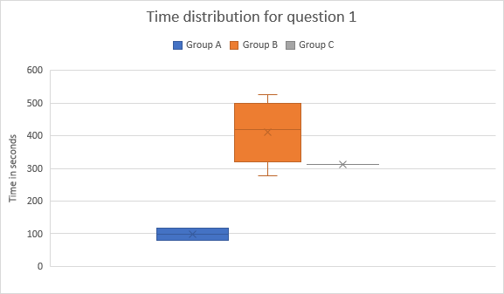

Chart 2: Time distribution for question 2 per group. Group C consisted of only one participant; therefore, the boxplot shows a single value without variability.

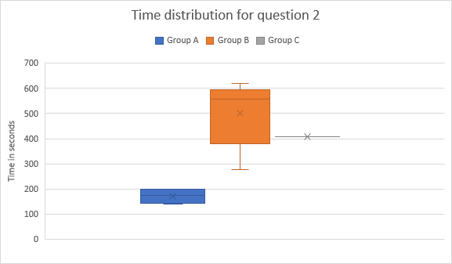

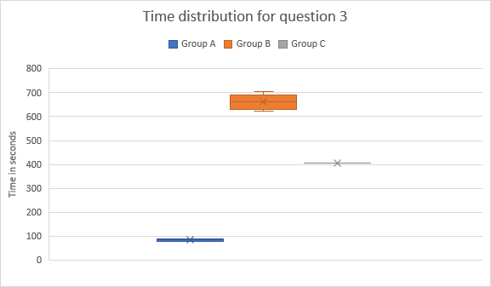

## Correctness of queries

**Group A (experts):** All queries correct.

**Group B (tool users):** Q1 and Q2 correct for all participants. Q3 incorrect for all participants.

**Group C (novice learner with brief training):** All queries correct.

## Qualitative feedback

One user has noted that the color of the UI is not suitable for color-blind people.

Users shared the sentiment that the SPARQL query in the chatbot's answer is taking too much space when they do not understand it because they are not familiar with SPARQL. It would be better to move it elsewhere or add a "show/hide SPARQL" button.

Users noted that the data specification exploration part of the tool is interesting.

# Discussion

TODO: add – the fast q2 guy was lucky to get the suggestion immediately. Others had to deal with it in various ways. Send again. Start from the beginning.

The study compared three groups:

* **Group A (experts):** Fast, consistent, and accurate.
* **Group B (tool users):** Slower, more variable, and struggled with the most complex query (Q3).
* **Group C (novice learner with brief training):** Correct in all cases but required more time.

## Efficiency and correctness

Experts (group A) outperformed both other groups in speed and correctness. The tool (Group B) enabled non-experts to produce correct queries for Q1 and Q2 but failed on Q3. The single novice learner in Group C achieved correctness on all queries but at the cost of longer times.

## Insights into the tool

Group B made the same two mistakes in the query for question 3:

* Missing property "elevator in interior". This is because the tool did not suggest this property to the users and users eventually gave up.
* Missing the OPTIONAL modifier. This is likely because users are not familiar with SPARQL so they do not know what the button "add as OPTIONAL" means.

However, compared to group C, tool users were on average still faster on Q2 and Q3, even if their final results were incomplete. This suggests that the tool lowers the entry barrier for novices, though it must be improved to be more user-friendly.

## Educational approach

The Group C participant demonstrated that with roughly 30 minutes of introduction, a novice can successfully produce correct queries for simple questions. However, the time cost was higher, especially for Q2 and Q3. In contrast, Group B participants required no SPARQL training and were faster overall, though their accuracy dropped in complex cases. This suggests a trade-off:

* Training users in SPARQL yields higher accuracy but demands time investment.
* Providing a tool yields quicker onboarding but may fail on complex questions.

# Limitations

The design of the user study had several limitations.

* **Number of participants**: The study involved only 10 respondents, which limits the generalizability of the results.
* **Number of tasks**: Only three questions were used, which may not fully capture the variety of real-world querying scenarios.
* **Focus of evaluation**: The study setup focused on having users start with the question “Show me all tourist destinations” and then build towards a predefined question. This does not fully reflect the main purpose of the software, which is to support *data specification exploration*. In real use cases, users would typically come with a question, and the tool would help them discover relevant classes and properties by suggesting possible extensions. By constraining the tasks to predefined targets, the study may have underestimated the exploratory strengths of the tool.

# Future work

Several directions remain for future studies.

* **Larger-scale evaluation**: Increasing the number of participants, particularly in Group C, would provide more robust insights into how novice training compares to tool usage.
* **Task realism**: The current study required users to reach predefined queries. Future experiments should allow more open-ended exploration to better reflect the actual purpose of the tool: assisting users in *discovering and exploring* data specifications.
* **Usability testing**: Collecting systematic usability feedback (e.g., via questionnaires or open-ended interviews) could help identify UI issues and improve user experience.

# Conclusion

This pilot study compared three groups: SPARQL experts (group A), non-experts using a tool (group B), and a novice with a short training session (group C).

The findings show that:

* Experts remain the most efficient and accurate in constructing SPARQL queries.
* The tool allowed non-experts to produce correct queries for simple and moderately complex tasks, though it failed on a more complex query involving an OPTIONAL modifier.
* A novice learner, after roughly 30 minutes of training, was able to construct all queries correctly, but required more time than experts and tool users.

In conclusion, while experts remain unmatched in efficiency, the study demonstrates the potential of the Data Specification Navigator tool to help retrieve data for users‘ questions.

# Appendices

TODO: Add the task group a tasks file. Add the test dataset. Add the data specification (HTML).