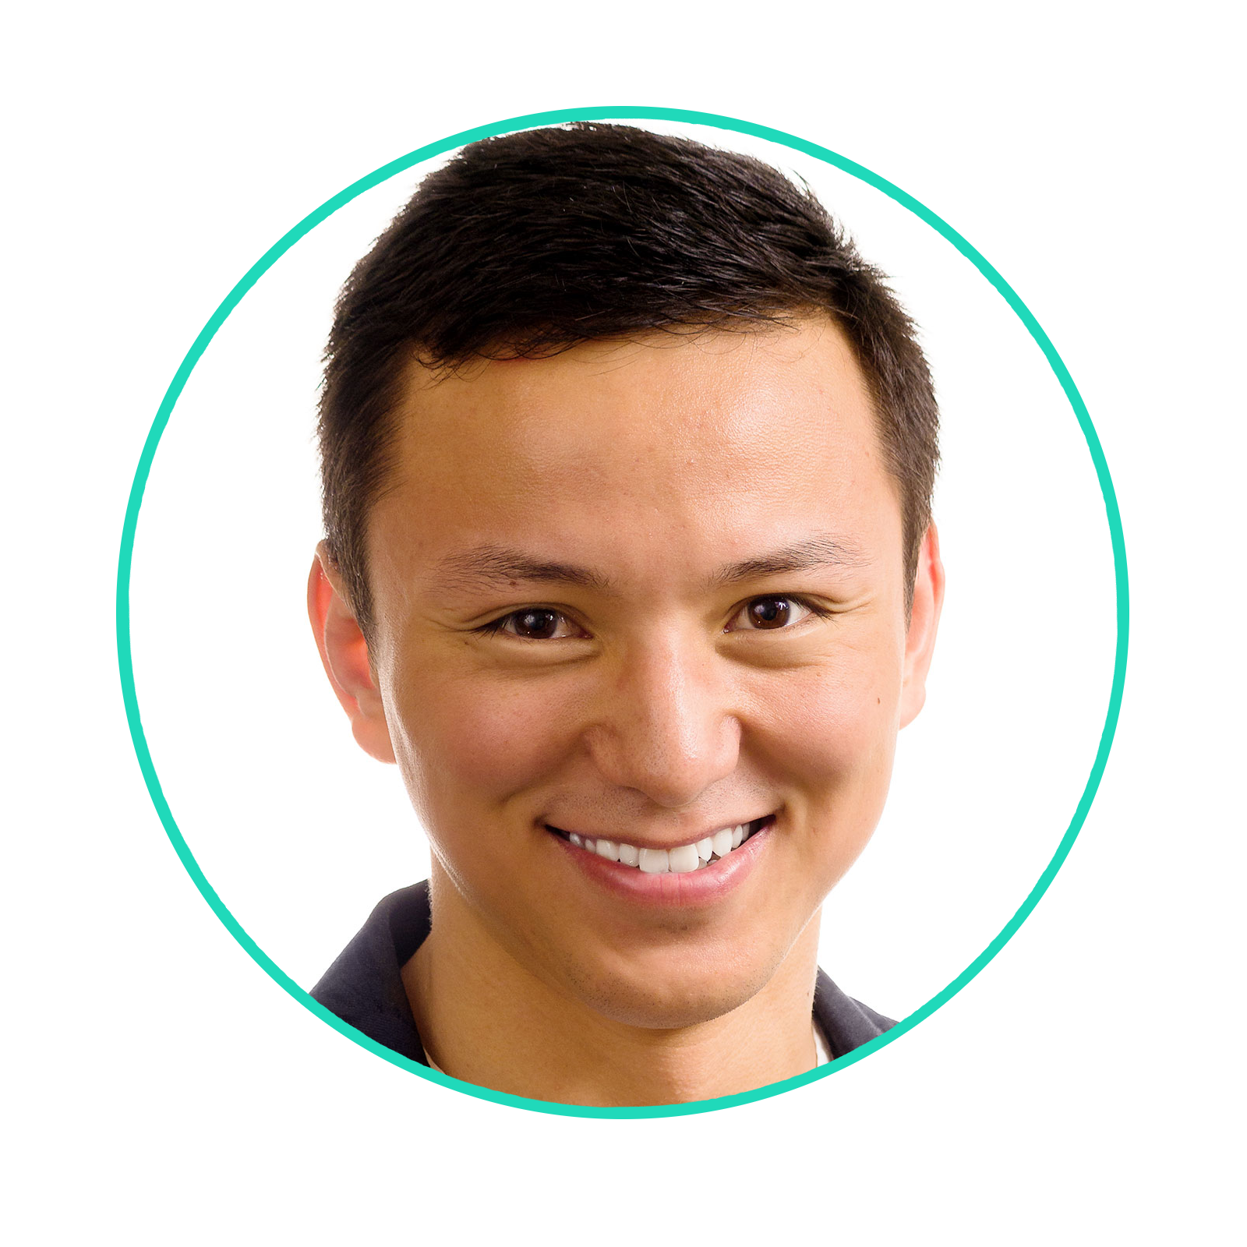

Huwate Yeerna (Kwat Medetgul-Ernar)

MD/PhD Candidate

[kwat@stanford.edu](mailto:kwat@stanford.edu)

<http://web.stanford.edu/people/kwat>

# Mission

My mission in life is to maximize the cure rate for kids with cancer and their quality of life after treatment.

# Skill

**Computational Mathematics**

**Information Analysis**

**Cancer**

# Education

## 2011/09 - 2016/06

BS, Bioengineering & Bioinformatics @ University of California, San Diego

## 2019/08 - Present

MD, Medicine @ Stanford University

## 2019/08 - Present

PhD, Computational & Mathematical Engineering (ICME) @ Stanford University

# Work

## 2010/06 - 2011/09 and 2014/06 - 2014/09

Kristina Bostrom Lab @ UCLA Cardiology

## 2013/05 - 2013/09

Stuart Lipton Lab @ Sanford Burnham Prebys Medical Discovery Institute

## 2013/06 - 2013/10

Subramaniam Shankar Lab @ UCSD Bioengineering

## 2013/09 - 2016/05

Trey Ideker Lab @ UCSD Medicine

## 2018/10 - 2019/06

Schreiber Lab @ The Broad Institute of MIT and Harvard

## 2015/06 - Present

Guardiome @ San Diego, CA

## 2015/10 - Present

Pablo Tamayo Lab @ UCSD Moores Cancer Center

# Publication

## 2015

Effect of diabetes mellitus on adipocyte‐derived stem cells in rat @ Journal of Cellular Physiology

Chemogenetic profiling identifies RAD17 as synthetically lethal with checkpoint kinase inhibition @ Oncotarget

## 2016

A network of conserved synthetic lethal interactions for exploration of precision cancer therapy @ Molecular Cell

## 2017

Decomposing oncogenic transcriptional signatures to generate maps of divergent cellular states @ Cell Systems

## 2018

Assembly and activation of the Hippo signalome by FAT1 tumor suppressor @ Nature Communications

## 2019

Comprehensive Genomic Profiling Reveals Diverse but Actionable Molecular Portfolios across Hematologic Malignancies: Implications for Next Generation Clinical Trials @ Cancers

APOBEC-related mutagenesis and neo-peptide hydrophobicity: implications for response to immunotherapy @ OncoImmunology

A Platform of Synthetic Lethal Gene Interaction Networks Reveals that the GNAQ Uveal Melanoma Oncogene Controls the Hippo Pathway through FAK @ Cancer Cell

Illuminating the Onco-GPCRome: Novel G protein-coupled receptor-driven oncocrine networks and targets for cancer immunotherapy @ The Journal of Biological Chemistry

Community assessment to advance computational prediction of cancer drug combinations in a pharmacogenomic screen @ Nature Communications

Metformin inhibits progression of Head and Neck Squamous Cell Carcinoma by acting Directly on Carcinoma Initiating Cells. @ Cancer Research

## Submitted

STRIPAK directs PP2A activity to promote oncogenic transformation @ eLife

Cannabinoids promote progression of HPV positive head and neck squamous cell carcinoma via p38 MAPK activation @ Journal of Clinical Investigation

The triple action CDK4/6-PI3K-BET inhibitor SRX3177 harnesses synthetic lethality relationship to abrogate cancer cell signaling @ Nature Chemical Biology

DNA Methylation Identifies Genetically and Prognostically Distinct Subtypes of MDS @ Blood

Role of Ultra-Violet Mutational Signature versus Tumor Mutation Burden in Predicting Response to Immunotherapy @ OncoImmunology

Ribosome composition varies significantly in different normal and malignant tissues. @ Cell Theory

# Presentation

Oral presentation = *

## 2013

UCSD Summer Training Academy for Research Success Symposium *

Society for Advancement of Hispanics/Chicanos and Native Americans in Science (SACNAS) Annual Meeting

## 2014

UC Leadership Excellence through Advanced Degrees (LEADS) Annual Symposium

American Association for Cancer Research (AACR) Annual Meeting

UCSD Bioengineering Day Symposium

UCLA Summer Programs for Undergraduate Research Symposium *

SACNAS Annual Meeting

International Genetically Engineered Machine (IGEM) Giant Jamboree *

## 2015

UC LEADS Annual Symposium

AACR Annual Meeting

UCSD Bioengineering Day Symposium

## 2016

AACR Annual Meeting

UCSD Bioengineering Day Symposium *

UCSD Faculty Mentor Program Symposium

San Diego Entrepreneur Night *

Y Combinator *

## 2017

AACR Annual Meeting

National Cancer Institute (NCI) Cancer Target Discovery and Development (CTD2) Meeting *

## 2018

UCSD Campus-Wide Cancer Genomics Meeting *

AACR Annual Meeting

NCI CTD2 Meeting *

UCSD Campus-Wide Cancer Genomics Meeting *

AACR Artificial Intelligence, Big Data, and Prediction in Cancer

## 2019

AACR Advances in Pediatric Cancer Research

# Recognition

## 2011

The Most Improved Student Award

UCSD Revelle College Provost Award

## 2012

UCSD Revelle College Provost Award

## 2013

UCSD Revelle College Provost Award

UC LEADS Fellowship

The UCSD Summer Training Academy for Research Success Fellowship

SACNAS Fellowship

## 2014

AACR Thomas J. Bardos Science Education Award

UCSD Revelle College Provost Award

UCLA Summer Programs for Undergraduate Research Fellowship

SACNAS Fellowship

IGEM Gold Medal

## 2015

UCSD Revelle College Provost Award

Phi Beta Kappa

Kathryn Lane Alumni Scholarship

F. Thomas Bond Revelle College Scholarship

## 2016

UCSD Moores Cancer Center Staff Award

## 2017

UCSD Moores Cancer Center Staff Award