**Opening Keynote:**

**Sandy Markowitz, MD, PhD**

**Case Western Reserve University**

**Title: Genetic Lessons from GI Cancers**

Dr. Markowitz is recognized as a national leader in studies of the genetics and epigenetics of GI cancers. He is the Markowitz-Ingalls Professor of Cancer Genetics, a Distinguished University Professor at Case Western Reserve University, co-leader of the GI Cancer Genetics Program at the Case Comprehensive Cancer Center, an NCI Outstanding Investigator (R35) Awardee, and Principal Investigator of the Case GI SPORE.

**Closing Keynote:**

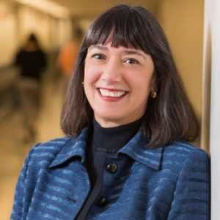**Monica M. Bertagnolli, MD**

**Dana Farber Cancer Institute**

**Title: TBD**

Dr. Bertagnolli is the Richard E. Wilson Professor of Surgery in the Field of Surgical Oncology at Harvard Medical School and chief of the Division of Surgical Oncology at Brigham and Women's Hospital and Dana-Farber Cancer Institute. She has served or currently serves as president of the American Society of Clinical Oncology (ASCO), vice president of Coalition of Cancer Cooperative Groups, chair of Alliance for Clinical Trials in Oncology, president of the Alliance for Clinical Trials in Oncology Foundation, and CEO of Alliance Foundation Trials, LLC. Since 2012 she has served on the National Academy of Medicine’s National Cancer Policy Forum. Dr. Bertagnolli’s laboratory studies the APC (Adenomatous Polyposis Coli) gene, an important factor in colorectal carcinogenesis and in the development of desmoid tumors.

**Christina Curtis, PhD**

**Stanford University**

**Title: Towards quantifying and forecasting tumor progression**

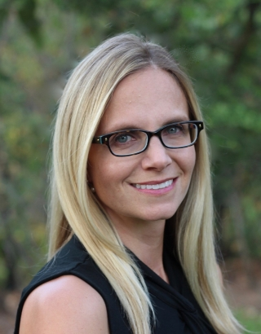Christina Curtis, PhD, MSc is an Associate Professor and Endowed Faculty Scholar in the Departments of Medicine and Genetics at Stanford University where she leads the Cancer Computational and Systems Biology group and serves as Co-Director of the Molecular Tumor Board at the Stanford Cancer Institute. The Curtis laboratory leverages multi-omic data coupled with computational modeling and iterative experimentation in order to define the molecular determinants and dynamics of tumor progression and to identify robust biomarkers. Her research has helped to redefine the molecular map of breast cancer and led to new paradigms in understanding how human evolve and metastasize. She is the recipient of the NIH Director’s Pioneer Award, a Kavli Fellow and Susan G. Komen Scholar amongst other awards.

**Luis Diaz, MD**

**Memorial Sloan Kettering Cancer Center**

**Title: The evolving paradigm of PD-1 blockade in mismatch repair deficient tumors**

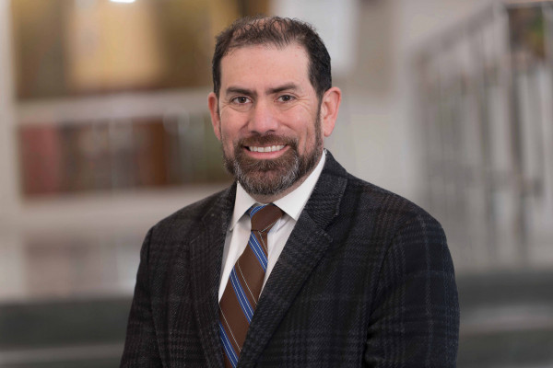Dr. Luis Diaz is a leading authority in oncology who has pioneered several genomic diagnostic and therapeutic approaches for cancer. He is head of the Division of Solid Tumor Oncology at the Memorial Sloan Kettering Cancer Center where he specializes in the treatment of advanced pancreatic and colorectal cancers. Prior to his role at MSKCC, he was a member of the Ludwig Center for Cancer Genetics and Therapeutics at Johns Hopkins and also directed the Swim Across America Lab.

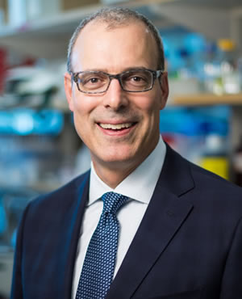**Eric R. Fearon, MD, PhD**

**University of Michigan**

**Title: “Modeling Colorectal Cancer Pathogenesis in the Mouse”**

Dr. Fearon is the Emanuel N Maisel Professor and he has served as director of the University of Michigan Rogel Cancer Center since 2016. He has pursued research in the cancer biology and cancer genetics fields, particularly investigations of selected gene defects that underlie colon and rectal tumor development and progression to advanced stages. Dr. Fearon and his laboratory have developed several novel mouse models of colon tumorigenesis, and he has authored more than 150 peer-reviewed research manuscripts and more than 65 review/editorial articles and book chapters.

**Matan Hofree, PhD**

**Broad Institute**

**Title: TBD**

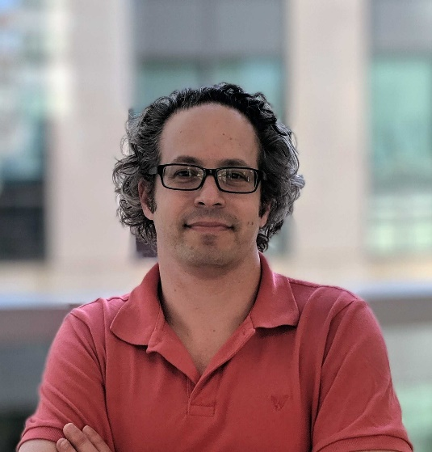Dr. Matan Hofree is a postdoctoral Associate at the Broad Institute of MIT and Harvard, a member of the Regev lab, and the Klarman Cell Observatory. Dr. Hofree is currently hosted by the Department of Biological Regulation of the Weizmann Institute of Science in Israel. He develops computational analysis techniques for studying cancer and complex genetic disease, using algorithms and ideas from machine learning and graph theory. Matan focuses on advancing our understanding of how plasticity and cellular heterogeneity drive the emergence and evolution of tumors, through analysis of single cell multi-omics measurements. Matan received his B.Sc. in Computer Science and Computational Biology from the Hebrew University of Jerusalem, in Israel. He earned his PhD from the Computer Science department of UC San Diego, working under the supervision of Prof. Trey Ideker, where he developed approaches for improved inference, classification, and clustering, using prior biological knowledge encoded in gene interaction networks.

**Zsofia K. Stadler, MD**

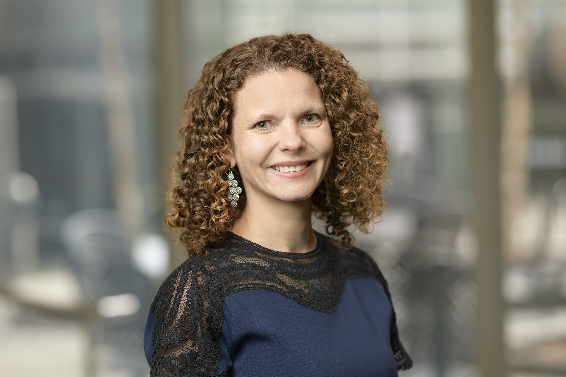

**Memorial Sloan Kettering Cancer Center**

**Title: Integrating parallel tumor-normal sequencing to inform inherited gastrointestinal cancers"**

Dr. Stadler is an Associate Attending Physician at Memorial Sloan-Kettering and is Clinic Director for the Clinical Genetics Service, with a secondary appointment in the Gastrointestinal Medical Oncology Service. Her clinical focus is on the diagnosis and treatment of patients and families with an inherited genetic predisposition to colorectal and other gastrointestinal cancers. Her research focuses on the identification and characterization of cancer susceptibility genes through the use of genomic technologies.

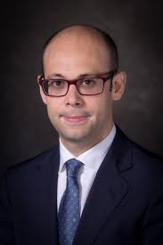**Eduardo Vilar, MD, PhD**

**MD Anderson Cancer Center**

**Title: TBD**

Dr. Vilar is an Associate Professor in the Department of Clinical Cancer Prevention at MD Anderson. His clinical expertise and practice are devoted to the care of patients and families diagnosed with hereditary cancer syndromes with a special emphasis in Lynch Syndrome and Familial Adenomatous Polyposis. He has contributed to the characterization of the genomic and transcriptomic landscape of colorectal premalignancy by both utilizing next-generation sequencing and systems biology tools. He has designed investigator-initiated clinical trials in Lynch Syndrome that have been funded by the National Cancer Institute through the N01 (now UG1) Chemoprevention Consortium for early drug development in prevention.

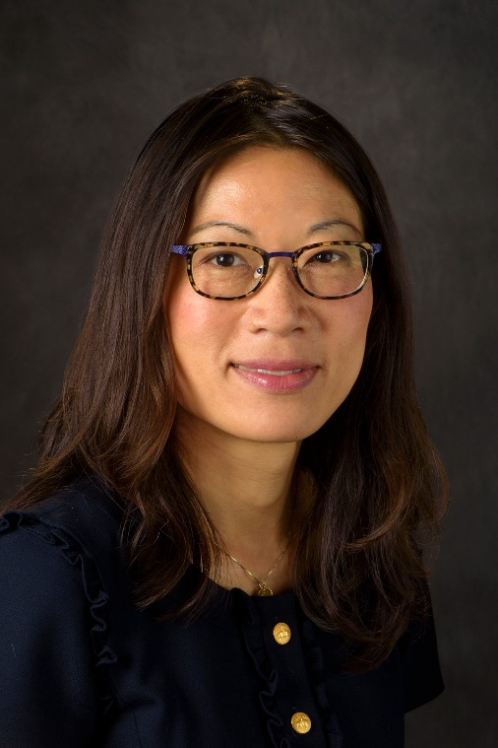**Y. Nancy You, MD, MHsc**

**MD Anderson Cancer Center**

**Title: Young age-of-onset colorectal cancer- a new unknown?**

Dr You is an Associate Professor in the Department of Colorectal Surgical Oncology. Her clinical focus is personalized surgical care for colorectal cancer that is coordinated with multidisciplinary treatments, emphasizing sphincter-preservation, quality-of-life, and long-term cancer survivorship. She is also the medical director of the Familial High-risk Gastrointestinal Cancer Clinic, providing care to patients and families with inherited cancer syndromes. Her research centers on hereditary cancer predisposition syndromes and on colorectal cancer particularly that occurring before age 50. Her research program aims to optimize the survival, the patient experience, and the quality of care of these patients, through clinical registries, treatment and quality-improvement trials, and cancer genetics translational studies.

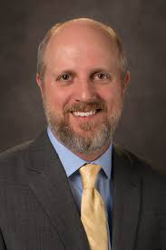**Conference Chairs:**

**Scott Kopetz, MD, PhD**

**MD Anderson Cancer Center**

**Title: Leveraging adaptive resistance for treatment of CRC**

Dr. Scott Kopetz is Professor and Deputy Chair of GI Medical Oncology at MD Anderson Cancer Center. Dr. Kopetz serves as a Program Leader for the GI Program and Colorectal Cancer Moon Shot at MD Anderson. He is chair of the NCI Colon Cancer Task Force, and is Vice-Chair for Colon Cancer in the NSABP/RTG/GOG (NRG) Cooperative Group. Dr. Kopetz has developed a translational and clinical trial program in colorectal cancer, which has resulted in FDA approval of BRAF/EGFR inhibitor combinations for patients with BRAF V600E mutated CRC, and PD1/CTLA4 inhibitor combinations for patients with MSI-H CRC. He also is an innovator in the development and implementation of circulating tumor DNA into clinical management of minimal residual disease, and jointly developed the Consensus Molecular Subtypes, an RNA- based methodology for CRC classification that is now being widely integrated in retrospective and clinical trial efforts.

**Steven Lipkin, MD,PhD**

**Weill Cornell Medical College**

**Title: Immunoprevention for Lynch Syndrome**

Dr. Lipkin is Professor of Medicine and Vice Chair of Research at Weill-Cornell Medical College in New York, as well as Director of the Adult and Cancer Genetics Clinic, where he is a practicing medical geneticist.  As a leading authority on cancer genetic syndromes, he has focused on hereditary cancer syndromes and cancer interception.   Dr. Lipkin has made significant contributions to our understanding of mismatch repair, studied genetic susceptibilities to cancer, and developed a computational tool that is now widely used to diagnose Lynch syndrome missense mutations.  He is also a standing member of the FDA Clinical and Molecular Genetics Panel and helps establish policy for genetic tests in the United States. Dr. Lipkin is helping to lead an international effort to develop and validate an immunopreventative vaccine for Lynch syndrome.  He trained in Internal Medicine at Duke University and Medical Genetics at the National Human Genome Research Institute, where he did his post-doctoral work in the lab of Francis Collins, the current NIH Director.

**Xiling Shen, PhD**

**Duke University**

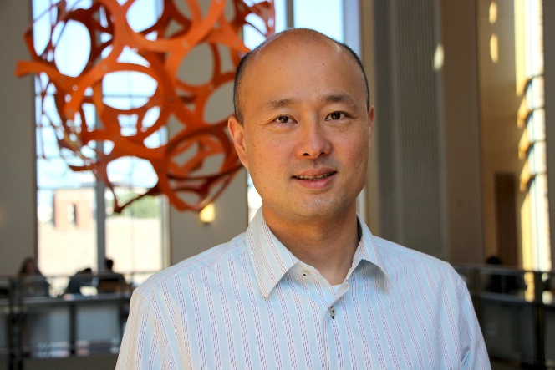**Title: Epigenetic reprogramming of colon cancer metastasis and droplet organoid guided precision medicine**

Dr. Shen is the Hawkins Family Associate Professor in the Department of Biomedical Engineering at Duke University. He is also the director of the Woo Center for Big Data and Precision Health. He received his BS, MS, and PhD degrees from Stanford University and the NSF career award. He is the steering committee chair of the NCI Patient-Derived Model of Cancer Consortium. His lab studies precision medicine from a systems biology perspective. Areas of interests include colon cancer, intestinal stem cells, and the but-brain axis.

**Organizing committee:**

**Emina Huang, MD**

**Cleveland Clinic**

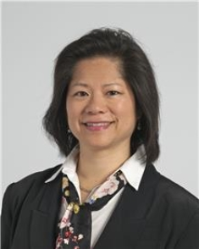**Title: Models of chronic inflammation as a harbinger to early onset colorectal cancer**

Dr. Emina Huang is a practicing colorectal surgeon in the department of colorectal surgeon and a member of the department of cancer biology at the Cleveland Clinic. She is a professor of surgery at the Cleveland Clinic Lerner College of Medicine at Case Western Reserve University since 2013. After her collegiate career at Oberlin Conservatory, she pivoted to matriculate at Stanford University School of Medicine. She completed her surgical residency at the Ohio State University. She has been funded by the NCI since 2002 when she obtained her K08 while a junior member of the faculty at Columbia University. She initiated colorectal surgery divisions at both the University of Michigan and the University of Florida. Her research focuses on the relationship between inflammation and colorectal oncogenesis.

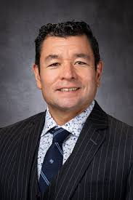**John Paul Shen, MD**

**MD Anderson Cancer Center**

**Title: Transcriptional profiling and subtyping of CRC to predict drug response**

Dr Shen is an Assistant Professor in the Department of Gastrointestinal (GI) Medical Oncology and a Cancer Prevention & Research Institute of Texas (CPRIT) Scholar in Cancer Research. A physician-scientist with a scientific background in chemical biology, functional genomics, and systems biology, and clinical training in Internal Medicine, Hematology, and Oncology, Dr Shen leads a lab of both computational and experimental scientists studying the genomics and transcriptomics of colorectal and appendiceal cancers. The overall goal of the Shen lab is to better understand the molecular features needed to support the cancer phenotype, and to leverage that understanding to better the delivery of chemotherapy. Active research projects include creating appropriate model systems to facilitate discovery of new drug targets in appendix cancer and peritoneal carcinomatosis from other malignancies, performing double knockout functional genomic screens to identify new synergist drug combinations and new chemotherapeutic drug targets; and using network-based computational methods, including machine learning, to identify genomic and/or transcriptomic biomarkers to predict what specific patients will response to a given therapy.

**Wenyi Wang, PhD**

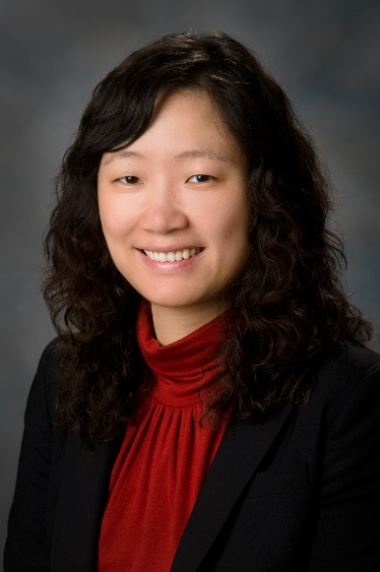**MD Anderson Cancer Center**

**title: Tumor cell total mRNA expression shapes the molecular and clinical phenotype of cancer**

Dr. Wenyi Wang is a Professor of Bioinformatics and Computational Biology at MD Anderson Cancer Center. Her lab develops deconvolution models to elucidate association of intra-tumor heterogeneity with clinical outcomes, and survival models for cancer risk counseling in individuals with deleterious germline mutations.

**Zhenghe Wang, PhD**

**Case Western Reserve**

**Title: Protein tyrosine nitration: a new signaling paradigm**

Dr. Zhenghe John Wang is Dale H. Cowan M.D. – Ruth Goodman Blum Professor of Cancer Research and vice chair for faculty development in the Department of Genetics and Genome Sciences at Case Western Reserve University (CWRU) School of Medicine. He is also a co-leader of the GI Cancer Genetics program at Case Comprehensive Cancer Center. He obtained his PhD from University of Virginia and trained as a 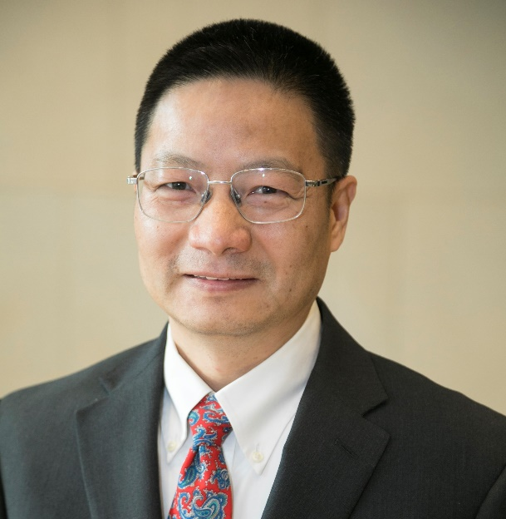postdoctoral fellow in Dr. Bert Vogelstein’s laboratory at Johns Hopkins University. He joined the faculty of school of medicine at Case Western Reserve University in August 2005. His research focuses on understanding how mutations in oncogenes and tumor suppressor genes drive colorectal tumorgenesis and translating these insights into novel therapy.