|  |  |  |
| --- | --- | --- |
| Electrical Signature Analysis | Owner: Vijay Muthukrishnan | |
| Date: 19-May-2017 | Rev: 11.0 |
| Author: Balakrishna. P |  | |

|  |  |  |  |
| --- | --- | --- | --- |
| **Revision** | **Revised By** | **Date** | **Description** |
| 0 | Balakrishna. P | 01-04-2016 | Base specification |
| 1 | Balakrishna. P | 10-04-2016 | Updated comments from Sudhanshu |
| 2 | Balakrishna. P | 01-05-2016 | Added appendix section with competitor ESA procedures and new ideas |
| 3 | Balakrishna. P | 15-05-2016 | Added scope for v180, non-scope items are mentioned as > v180. |
| 4 | Balakrishna. P | 30-05-2016 | Added review comments from Mital in data for manual section |
| 5 | Balakrishna. P | 01-Jun-2016 | Added review comments from Lubo, Umar, Mital (Spec review) |
| 6 | Balakrishna. P | 31-Mar-2017 | Updated discussion comments on 31/03/2017 |
| 7 | Dhruv Patel | 25-Apr-2017 | Updated spec formatting |
| 8 | Balakrishna P | 26-Apr-2017 | Updated discussion comments on 25/04/2017 |
| 9 | Balakrishna P | 19-May-2017 | Updated comments from Derek |
| 10 | Dhruv Patel | 23-May-2017 | 1. Updated naming of operands in the operands table. 2. Updated Note in Description for the patent number in 2nd bullet point. 3. Updated the settings menu image as per new menustructure changes on 23-may-2017. 4. Made Motor Type and Rated Input Power settings hidden by making the text color grey. 5. Changed the default for No. of Rolling Elements from 1 to 2 to match menustructure. 6. Removed the setting description for Number of Rotor Bars. 7. Changed default for Number of Stator slots setting from 0 to 2. 8. Formatted setting names to match menustructure with Proper Case. 9. Replaced all the metering menu images to remove green arrows on cells with formula error. 10. Formatted metering value names to match menustructure with Proper Case. 11. Removed the old ESA logic diagram and inserted a new one with proper formatting. 12. Removed the table for Targets and Events from Data for Design and included the same info in operands table instead. 13. Added menu list image for Records\Clear Records path to show the clear items for Baseline data and Operational Data. |
| 11 | Dhruv Patel | 24-May-2017 | Updated Logic diagram to merging the two pages into one and added stator related operands.  Updated introduction-specifications section.  Updated Step 9 in description section.  Updated step 12 and added step 13 for historical log data  Updated point B in ESA application for stator fault detection  Added a note after settings description for case where baseline mode is disabled or not available. |
| 12 | Balakrishna P | 25-May-2017 | Updated menu path for ESA Record and Bala’s Circle in the steps describing ESA implementation |
| 13 | Umar Khan | Feb 05, 2018 | Defaults values of Stage 1(2) Pickup Level and Stage 1 Pickup Delay are update for all ESA faults types. |
| 14 | Umar Khan | Feb 14, 2018 | Logic Diagram is Updated. Manual update required. No design changes. |
| 15 | Umar Khan | Jan 14, 2019 | Bug 46564   * A new setpoint “Data Quality Check” is added on page 17. All the changes in text are marked in orange. * Logic Diagram is updated as well and shown in Red.   Target 869 v2.40 |
| 16 | Umar Khan | April 10, 2019 | Modifications are made in the element ‘Run’ logic. Element is blocked when motor state is Stopped, Tripped or Starting. This change is made so that the element becomes applicable to the synchronous motor applications (with sync. motor order code selection). The changes in the logic diagram is marked with Red. |
| 17 | Balakrishna P | 20-01-2020 | Proposed Modifications (Enhancements) are added for v2.70 based on feedbacks from pilot and GRC proposed enhancements.   1. Operating quantity changed to I^2 FFT from I FFT for better fault magnitude extraction. 2. Data quality check changes to include voltage unbalance & THDv. 3. New settings Motor type, Voltage type are added. 4. Baseline period setting changed to mins from hours with default of 60 mins. Baseline data capture with outlier elimination. 5. Standard deviation computation added during baseline period. Baseline metering data adjusted accordingly. 6. Fault frequency computation, peak magnitude, energy magnitude computations are adapted as per I^2 FFT. 7. Speed estimation algorithm modifications as per Synchronous Motor, VFD requirement. 8. FFT waveform, Metering, Logs, Circle internal changes to suit I^2 FFT (with minor changes only). 9. Adjustments to search band based on voltage availability/speed estimation error & GRC inputs. 10. Decision making including additional security checks. 11. Support voltage-less ESA and 1-Ph VT option. Associated changes to ESA speed estimation. 12. Enervista changes to support I^2 FFT waveform, Baseline data retrieval from service report, PDF health report based on ESA, Historical data trending using 845 M&D screens. |
| 18 | Balakrishna P | 15-04-2020 | Added more clarity on standard deviation computation, baseline data retrieval, ESA Circle and health report based on queries from development/validation teams. |
| 19 | Balakrishna P | 18-06-2020 | Added modifications to enable voltage-less ESA for VFD application when VT is not available, or VT is on the bus side. Also enabled constant V/f region for VFD operation in terms of load. |

* 1. **Data for Manual**

**Introduction – Specifications – ESA (Electrical Signature Analysis)**

ESA (Bearing & Mechanical (Foundation looseness, Eccentricity and Mis-alignment)) Fault

Computing Parameter: Ia (square) ~~or Ib or Ic~~

Indicating Parameter: Peak Magnitude (dB), Energy (dB), Change in dB

Operating Parameter: Change in Peak and Energy magnitude (dB) or

Peak and Energy magnitude (dB)

Pickup level 1 & 2: Change in Peak and Energy magnitude > ‘X’ dB w.r.t base line dB (configurable in setup SW) or

Peak and Energy magnitude > ‘X’ dB w.r.t base line dB (configurable in setup SW)

Pickup delay 1 & 2: 5 to 60 min (multiples of 5 min) (Configurable in setup software)

**FlexLogic Operands**

|  |  |  |  |  |
| --- | --- | --- | --- | --- |
| **ELEMENT:** | ESA | | | |
| **FUNCTION ENABLE SETTINGS:**  Set points\Monitoring\ESA | | | | |
| **OPERAND CUSTOM TEXT:**  None | | | | |
| **OPERAND SYNTAX** | **E** | **F** | **T** | **OPERAND DESCRIPTION** |
| Bearing Flt PKP Stg 1 | X | X | X | Bearing fault operand stage 1 has picked up |
| Bearing Flt OP Stg 1 | X | X | X | Bearing fault operand stage 1 has operated |
| Bearing Flt PKP Stg 2 | X | X | X | Bearing fault operand stage 2 has picked up |
| Bearing Flt OP Stg 2 | X | X | X | Bearing fault operand stage 2 has operated |
| Mech Flt PKP Stg 1 | X | X | X | FEM fault operand stage 1 has picked up |
| Mech Flt OP Stg 1 | X | X | X | FEM fault operand stage 1 has operated |
| Mech Flt PKP Stg 2 | X | X | X | FEM fault operand stage 2 has picked up |
| Mech Flt OP Stg 2 | X | X | X | FEM fault operand stage 2 has operated |
| Stator Flt PKP Stg 1 | X | X | X | Stator T-T fault operand stage 1 has picked up |
| Stator Flt OP Stg 1 | X | X | X | Stator T-T fault operand stage 1 has operated |
| Stator Flt PKP Stg 2 | X | X | X | Stator T-T fault operand stage 2 has picked up |
| Stator Flt OP Stg 2 | X | X | X | Stator T-T fault operand stage 2 has operated |
| Baseline Data Capture Start | X | X | X | Capturing of baseline data has started |
| Baseline Data Capture End | X | X | X | Capturing of baseline data has ended |
| Data Quality Check Fail | X | X |  | The quality check of data has failed |

**Column T –** Show as Target message

**[X]** - Refers to the element number. The table on page 1 shows how many elements each product has of this feature.  
**{Alarm,Trip,etc}** – Extra text added to Targets/Events depending on the option chosen for the Function enable setting. Not added to FlexLogic operands (format FC142).  
**^^** - If applicable, content between the two **^** will change according to what is programmed in the noted Operand Custom Text register.  
*See the Data For Design section of this document for more information on how FlexLogic operands are used.

### Description

Rotating machines are a critical component of many industrial processes and are frequently integrated in commercially available equipment and industrial processes. The health condition of a rotating machine can be effectively monitored using a non-intrusive method called Electrical Signature Analysis (ESA). The concept is to treat the electric machine as an implicit transducer built into machine-driven equipment; the current behaviour can thus be used to show various health conditions of the machine as well as the load it is driving.

Proven ESA algorithms are implemented in 8-series to detect various failure modes in a rotating machine and its assembly. Some of the proven ESA applications are described as follows. Traditionally, machine condition can be supervised by measuring quantities such as noise, vibration and temperature. The implementation of these measuring systems is expensive and proves only to be economical in the case of large motors or critical applications. A solution to this problem can be the use of quantities that are already measured in a drive system e.g. the machine’s stator current, often required for command purposes. ESA is the tech­nique used to analyze and monitor the trend of dynamic energized systems,

ESA is monitoring stator current or voltage (more pre­cisely supply current) of the machine. Single stator current or voltage monitoring system is commonly used (monitoring only one of the three phases of the machine supply). Machine stator windings are used as transducer in ESA, picking the signals (induced currents and voltages) from the rotor (but also revealing information about the state of the stator). Various electrical and mechani­cal fault conditions present in the machine further modulate machine current and/or voltage signal and contribute to additional sideband harmonics. Faults in machine components produce corresponding anomalies in magnetic field and change the mutual and self-inductance of machine that appears in supply current and/or voltage spectrum as sidebands around line (supply, grid) frequency. Based on fault signatures motor faults can be identified and its severity can be accessed.

The following is the high-level procedure on how motor is diagnosed:

**Note**: The technology discussed in this manual has been patented (filed) with following disclosure numbers.

1. GE 73745/316350: System, method and procedure for Industrial motor electrical signature analysis.
2. US 15/489,228: An autonomous procedure for electrical signature analysis based machine M&D"

**Step 1:** ESA is part of existing Multilin 869 Protection Relay product. Hence ESA captures current signal from the same CT sensing mechanism available in 869 relay. No additional sensing or wiring mechanism is required to install or use ESA (M&D) with 869 relay.

**Step 2**: Stator phase A current measured by J1 slot is used for motor current signature analysis purpose.

**Step 3**: Before doing analysis, data quality check is performed to verify if the power quality condition is good. Voltage, frequency, THD, signal stability and voltage/current unbalance levels are checked to be within satisfactory limits. Signature analysis is performed only if data quality check is passed and an event will be generated in case failed.

**Step 4**: Once data quality check is passed, FFT is applied on J1 phase A current samples to convert time domain data into frequency domain and obtain current magnitudes at various frequency range of interest.

**Step 5**: For each fault or anomaly, fault frequencies are computed based on supply frequency, speed, harmonic factor, slip etc. depending on fault type.

**Step 6:** Normalized dB magnitudes are computed at fault frequencies (based on formulae) as the ratio of magnitude at fault frequency and rated magnitude as given below.

Magnitude in dB = 20 * Log10 (X1/Xr), where ‘X1’ is peak magnitude within fault frequency ‘f1’ vicinity range in I^2 FFT and ‘Xr’ is rated quantity^2 of motor with same unit. Rated Current of Machine in 869 is Motor Full Load Amps (FLA) in settings under System/Motor/Setup.

**Step 7:** Peak magnitude in dB is computed as the highest magnitude observed at specific fault frequency vicinity range and Energy in dB is computed as the ratio of root mean square of 3 points around the fault frequency corresponding to peak magnitude, w.r.t rated magnitude.

Energy in dB = 20 * Log10 (E1/Er), where ‘E1’ is root mean square of 3 points around peak magnitude at fault frequency ‘f1’ and ‘Er’ is rated quantity or magnitude of motor (rated current) with same unit.

**Step 8:** During baseline mode, the dB’s are computed as per steps 6&7 which are averaged over the entire configured period and then stored as averaged normalized dB w.r.t each load bin of the motor. A load bin is defined as the load interval of 10% within the 0-120% range of motor load operation, a total of 12 load bins.

Note: Relay enters baseline mode at any instant of time, if the baseline data for a load bin is not available.

**Step 9:**  During monitoring mode, the dB’s are computed every interval as per steps 6&7. These dB levels and corresponding frequencies can be analyzed using FFT spectrum analyzer shown below in the Path: Motor M&D\Records\ESA Record. This spectrum tool works like comtrade viewer available for viewing transient records (Path: Records\Transients\Transient Records) with red, black and dark pink lines indicating fault frequencies of bearing, mechanical and stator faults and its corresponding values below. FFT waveform must be visualized as per I^2 FFT format in file including fault frequencies and magnitudes.

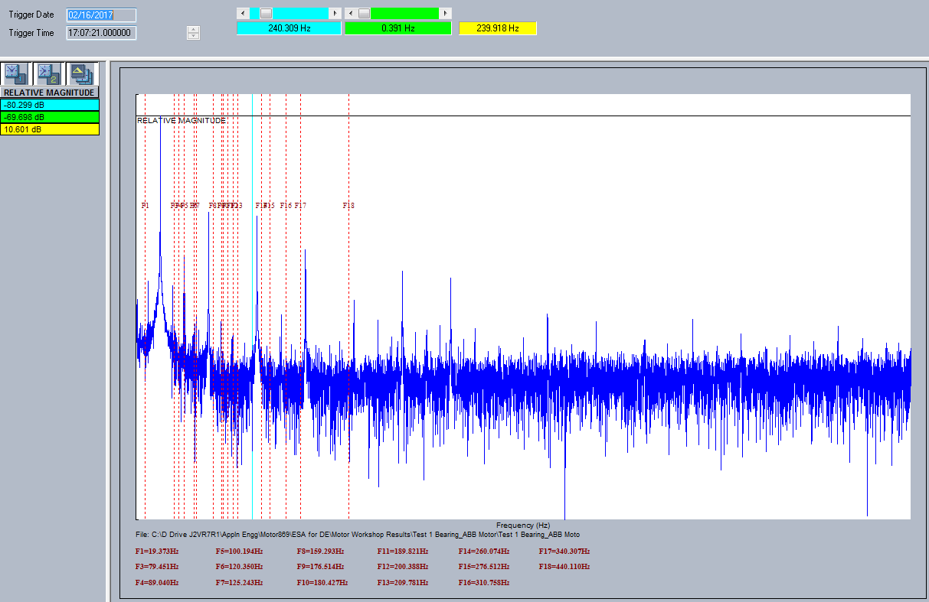

**Note:** To support event based monitoring, ~~FFT files will be captured for every fault PKP and stored in memory for a maximum of 2 files for each fault and a maximum of 6 files overall. After a maximum of 2 files reached for each fault the files will be replaced in FIFO format in case if new files trigger. All the files can be accessed from the path: Records\ESA Records in the same manner as transient records and filtered based on fault type~~ an additional FFT file is captured and saved from Motor M&D\Records\ESA Record (Last PKP). This can be used to analyze the dB values during event conditions.

**Step 10:** Based on dB’s computed in steps 8 & 9, Change in Peak magnitude and Energy dB’s are computed as the maximum difference in dB levels observed during baseline and monitoring modes at any of the fault frequencies. An example is given below indicative of how change in dB is computed at fault frequencies.

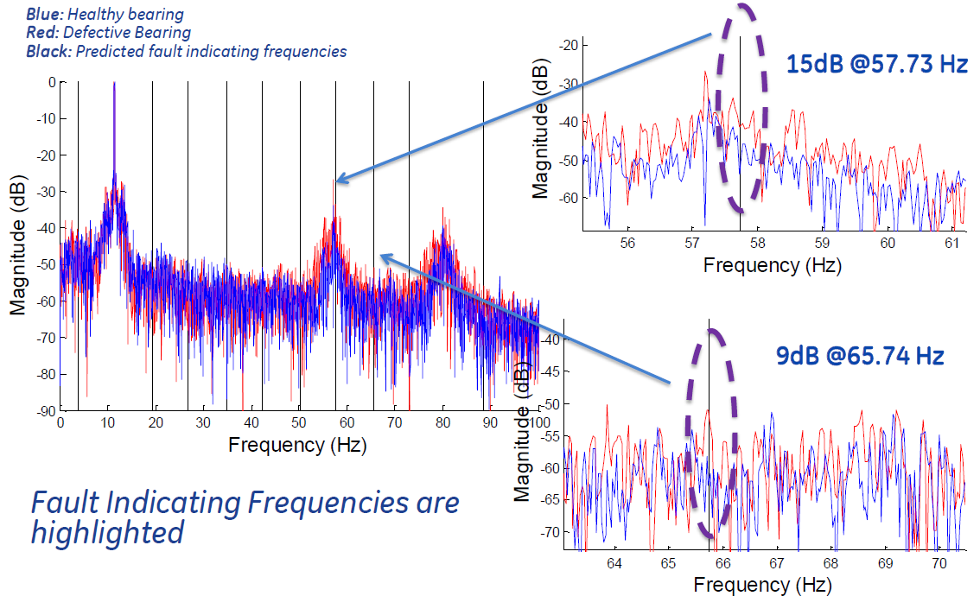

**Step 11:** If the change in dB of peak or energy magnitude is greater than pick up levels configured in ESA set points then corresponding fault element will be triggered after the delay configured and if the level sustains.

**Step 12:** The dB’s can be visualized in the form of circle under path Motor M&D\ESA Circle to know the motor status (normal, caution or alarm) as represented below,

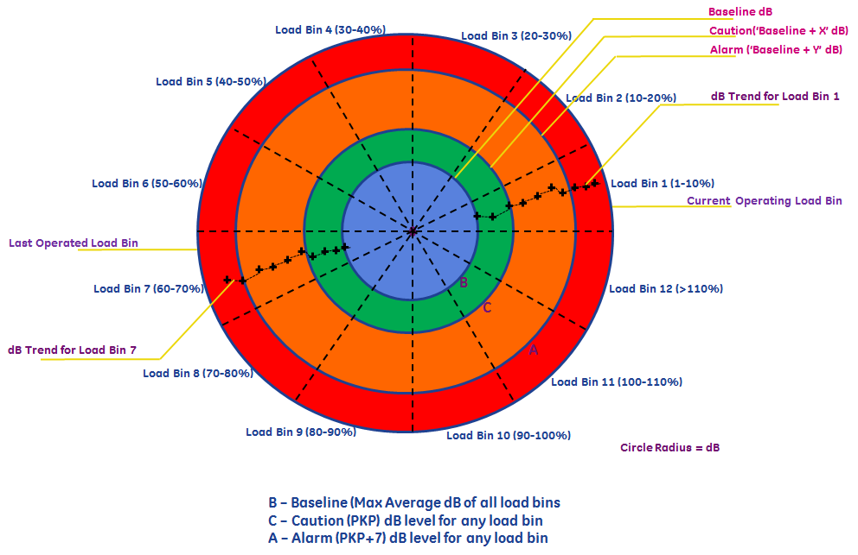

* Circle is drawn with 3 dB’s taken into consideration – baseline dB corresponding to ‘k’ value where maximum change in dB is observed, PKP level 1 dB setting and PKP level 2 dB setting as the radius of circles corresponding to baseline, caution and alarm zones. (‘k’ is harmonic factor).
* Entire circle is divided into 12 equal sections covering 30 degrees of circumference corresponding to each load bin. Load bin 1 is started at 0 degree and ended with load bin 12 at 360 degree point in anti-clockwise direction.
* Latest or last computed max change in dB at specific ‘k’ is represented as ‘dot’ in current operating load bin and as a trend in future releases w.r.t time in case of historical data availability. dB data represented in circle will correspond to maximum change in dB from baseline dB at specific ‘k’ value of formula (k = 1,2,3) related to fault. (‘k’ is harmonic factor).

Note: In case where baseline mode is disabled or baseline data is not available, user can configure bearing, mechanical and stator function elements to operate based on peak magnitude (and energy) dB’s. In such case PKP 1 and PKP 2 settings should be configured to correspond to magnitude level (i.e. an example of 75 dB and 65 dB for PKP 1 and PKP 2 settings). However, in this case circle will not plot any data.

**Step 13:** Motor M&D data will be stored as a short-term historical log with a maximum of 4800 records with data logged at every 15-minute interval and during every intermediate PKP when the motor is in monitoring mode.

* This file will be stored in local PC folder where Enervista is installed @ C:\Users\Public\Documents\GE Power Management\8SeriesPC\OnLineDevice Files\(Device Name in EnerVista). Format of file name is: log_ESA(Date_timestamp).txt, example: log_ESA20170511_162126.txt
* This file can be fetched and viewed by using Enervista software in LDR (Learned Data Record) format under the section Motor M&D\Records\Historical log as shown below in the screenshot. Details of learned data record view can be found in GE 869 manual under the section Records\Motor Learned Data.
* Additionally, the file can be converted to .csv format and opened using Microsoft excel for analysis purpose/trending of any parameter(s). To properly align data as rows/columns in excel format, open the file and delete cell A1 and select shift cells left to properly.

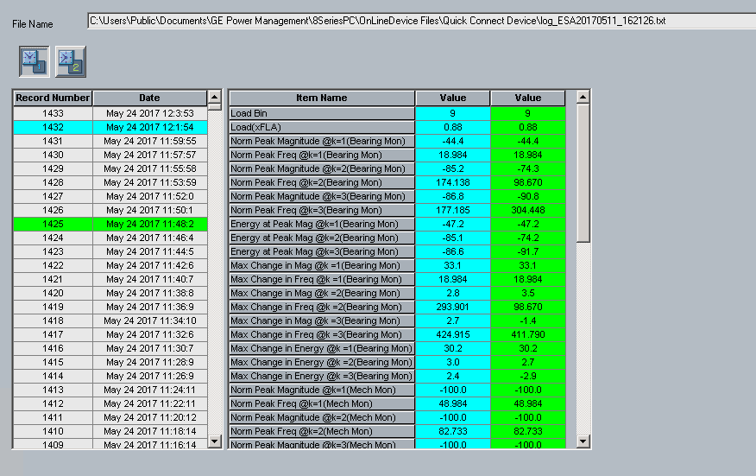

**ESA application for Rolling Element Bearing Fault Detection**:

The faults occurs in motor bearing is generally due to the excessive load, rise of temperature inside the bearing, use of bad lubricant and so on. The bearing consists of mainly of the outer race and inner race way, the balls and cage which assures equidistance between the balls. The different faults that may occur in bearing can be indicated as a single parameter based on any affected component as shown in figure 1:

* Outer raceway defect
* Inner raceway defect
* Ball defect



Figure 1: Ball bearing details

This Bearing Flt element uses FFT computation on current square signal to detect bearing failure of electrical machine. The operating condition can be defined as:

Computing vibration frequency related to bearing damage using equation (1).

 (1)

where

Nb is no. of rolling elements, see setpoint ‘No of Rolling Elements’ for more details

Dc is cage diameter, see setpoint ‘Cage Diameter’ for more details

Db is rolling ball diameter, see setpoint ‘Rolling Element Ball Diameter’ for more details

Computing stator current frequency related to bearing damage using equation (2).

*fbearing = fsupply ± k * fvib* (2)

where

*k* is any integer: 1,2,3

*fsupply*is actual supply frequency (when Frequency Tracking is Enabled), otherwise *Nominal Frequency* (programmed under System > Power System) is taken as supply frequency.

Identifying peak magnitudes or energy in dB at the stator current frequencies and calculating change in dB magnitude w.r.t baseline (healthy mode) peak magnitudes or energy at the corresponding stator current frequencies in dB and w.r.t each load bin as given by equations 3 and 4,   
Change in Energy dB = Energy dB (Latest) – Energy dB (Baseline) (3)

Change in Peak Magnitude dB = Peak magnitude dB (Latest) – Peak magnitude dB (Baseline) (4)

**Note**: Please refer to design section regarding processing of bearing fault frequencies with I^2 FFT.

**ESA Application for Mechanical [Foundation Looseness, Eccentricity & Shaft Mis-alignment (FEM)] Fault Detection**:

Although mechanical faults like Foundation looseness, Eccentricity and Mis-alignment (FEM) are different fault conditions in rotating machine, they can be identified at the same set of stator current frequencies related to eccentricity damage.

Air-gap eccentricity represents a condition when air gap distance between the rotor and the stator is not uniform. Two types of abnormal air-gap eccentricity exist: static and dynamic. In case of static eccentricity the position of minimal radial air gap is fixed, while in case of dynamic eccentricity position of minimal air gap follows turning of the rotor. Normal (concentric) state, static and dynamic eccentricities are illustrated in Figure 2. As the rotor bars recede or approach the stator magnetic fields, they cause a change to the cur­rent in the stator. In case of static eccentricity sideband components appear at frequencies.

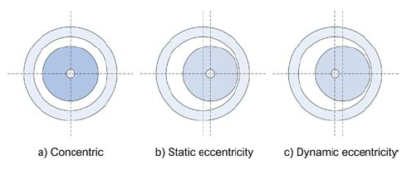

Figure 2: Eccentricity details

This Mechanical fault element uses ESA computation on current square signal to detect misalignment, eccentricity and foundation looseness failure cases of machine. The operating condition can be defined as:

Computing the ESA frequencies related to the mechanical defects (shaft misalignment, load unbalance, loose foundation, dynamic/static eccentricity) using equation (5).

 (5)

where

*k* is any integer: 1,2,3

*s* is actual motor slip computed based on rated slip and actual input power

P is number of poles programmed under System\Motor\Setup

*fsupply*is actual supply frequency (when Frequency Tracking is Enabled), otherwise *Nominal Frequency* (programmed under System > Power System) is taken as supply frequency.

Equation (5) can be further represented in simplified manner as, fs ± k*fr for using with current square signal computation,

Where, k is any integer: 1,2,3

fs is actual supply frequency

fr is rotational frequency = Nr/60, Nr is actual rotational speed of motor in rpm.

**Note**: Please refer to design section regarding processing of mechanical fault frequencies with I^2 FFT.

Identifies peak magnitudes or energy in dB at the stator current frequencies. Calculates maximum change in dB w.r.t baseline (healthy mode) peak magnitudes or energy at the corresponding stator current frequencies. This is performed w.r.t current load bin of operation as given by equations 6 & 7,

Change in Energy dB = Energy dB (Latest) – Energy dB (Baseline) (6)

Change in Peak Magnitude dB = Peak magnitude dB (Latest) – Peak magnitude dB (Baseline) (7)

**ESA Application for Stator Fault Detection**:

**Stator Faults** **Cause**: Damage to insulation, laminations, frames and winding due to various electro-mechanical and thermal stresses.

**Reasons/Effect:**

* Failure of insulation leading to turn-turn, phase-phase, coil-coil, phase to ground etc. faults.
* Rotor striking the stator due to misalignment or shaft deflection, bearing failure causing stator laminations to puncture the coil insulation leading to coil to ground fault.
* Transients in supply voltage due to power system faults, VFD's, operation of breakers leading to turn-turn or turn-ground fault.
* Thermal stress due to over current flowing due to sustained overload or fault, higher ambient temperature, obstructed ventilation, unbalanced supply voltage etc. increases winding temperature and reduces insulation life.
* Environment stress based on ambience temperature.

869 relay detects stator faults using ESA based on fault frequencies computed as:

* CF ± Supply frequency sidebands and
* CF± Supply frequency ± Rotational frequency sidebands

where,

CF is Center Frequency = Rotational frequency (rps) * Number of stator slots

Rotational frequency = Running speed in rpm/60

Sideband represents the upper and lower frequency region w.r.t stated frequency at center. For example, in figure 2a ‘fc’ represents center frequency and ‘fc+fm’ or ‘fc-fm’ represents sidebands of ‘fc’.

In case of I^2 FFT the stator fault frequencies will be shifted by fundamental frequency and the new fault frequencies will be as shown in figure 2a. i.e. fc (CF), ‘fc+fm’, ‘fc-fm’ will be the new fault frequencies.

Note: Stator ESA will not be applicable in case of no voltage or 1-Ph VT option based on voltage type setting in ESA.

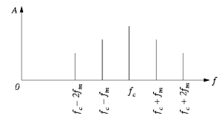

Figure 2a: Center frequency with sidebands

The algorithm for detection of Bearing, Mechanical and Stator fault comprises of two sections namely:

1. **Baseline Mode** – this mode runs once during commissioning/installation for a given setup of CTs, PTs and machine rating for default 1 hour per load bin (baseline period - configurable) of motor operational time. All the dB computations (highest normalized peak magnitude and energy at peak magnitude) with baseline data are computed and captured w.r.t each load bin. During the baseline period, dB computations are averaged continuously w.r.t each load bin and stored as averaged normalized dB’s. Apart from average (mean), standard deviation is also computed in a recurring fashion continuously w.r.t each load bin and stored as Standard Deviation[N] where N = Load bin number. There after device enters into this mode whenever there is a need to capture baseline data for a particular load bin or if the baseline data is not captured for that particular bin during initial 1-hour period per load bin (default) after installation, and enters back to operational or monitoring mode instantly once baseline data is captured and stored. FFT is run on baseline data samples to capture peak magnitude or energy for each possible harmonic factor (k = 1,2,3) related to bearing, mechanical and stator faults and averaged values are stored in internal file w.r.t each load bin. Both data quality check and ESA accuracy checks are performed prior to recording data. Baseline data is considered as healthy data of motor. User can clear baseline data using ‘Clear ESA baseline data’ command and capture data again by enabling baseline mode and configuring baseline period.
2. **Monitoring mode** – During the operational mode ESA algorithms for bearing and eccentricity are computed every 1 minute based on current square (Ia) samples. FFT is run on these current square (Ia) samples to capture peak magnitude or energy for each possible harmonic factor (k = 1,2,3) related to bearing, mechanical and stator faults and stored in internal file w.r.t each load bin. Computed ESA dB magnitudes at all fault frequencies after each interval are compared with baseline magnitudes to extract maximum change in dB. Both data quality check and ESA accuracy checks are performed prior to recording data. User can clear operational data using ‘Clear ESA operational data’ command.

**System/ Motor/Setup**

ESA computation uses some of the existing settings already available in 869. The following are the settings which needs to be configured in specific path,

1. Number of Poles from section System\Motor\Setup is used to compute synchronous speed. (Mandatory).
2. Motor Rated Horse Power and Motor Rated Efficiency from section System\Motor\ Setup are used to computed Rated input power which in turn is used for speed estimation. (Mandatory).
3. Nominal frequency from section Platform\Frequency 1-J or 2-K is used for computing frequency variation in case of data quality check. (Mandatory).
4. Frequency tracking from section Settings\Power System if enabled will be used to compute source frequency more accurately. It is encouraged to enable this setting. (Optional).
5. Rated speed from section Path: Monitoring\Tachometer is used for speed estimation. (Mandatory).

The following are the settings for ESA function in path Set points\Monitoring\ESA:

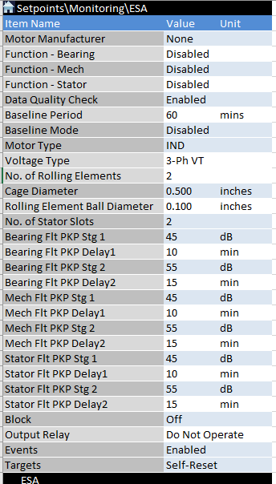

**Note:** Some of the existing settings in 869 as mentioned in the beginning of table will be re-used for ESA computation. Hence it is required to configure them. Specifically, since ESA is dependent on speed and frequency, it is mandatory to configure rated speed and frequency tracking should be enabled for accurate ESA results.

#### **Settings**

##### Motor Manufacturer

##### *Default: None Range: N/A Step: N/A*

Configure the manufacturer name of motor as character string from motor name plate data information.

##### Function - Bearing

##### *Default: Disabled Range: Disabled, Enabled*

When Enabled function is selected, the element will run and check for the Bearing (Eccentricity) Fault status as programmed.

##### Function – Mech (Mechanical)

##### *Default: Disabled Range: Disabled, Enabled*

When Enabled function is selected, the element will run and check for the mechanical (FEM) Fault status as programmed.

##### Function - Stator

##### *Default: Disabled Range: Disabled, Enabled*

When Enabled function is selected, the element will run and check for the stator Fault status as programmed.

##### Motor Type

##### *Default: IND Range: IND, VFD-IND, Synch.*

Configure the motor type as Line Fed Induction Motor (IND), Line Fed Synchronous Motor (Synch) or VFD fed Induction Motor (VFD-IND).

##### Voltage Type

##### *Default: 3-Ph VT Range: 3-Ph VT, 1-Ph VT, No VT*

Configure if the voltage input to relay is available through VT as,

3-Ph VT – If 3-phase voltage input is available.

1-Ph VT - If only 1-phase voltage input is available.

No VT – If voltage input is not available.

Setting dependency: If voltage type is chosen as No VT (either VT is not available with VFD or VT is on the bus side of the system), then VFD will be considered as voltage-less case only. 1-Ph VT option is not applicable for VFD.

##### Data Quality Check

##### *Default: Enabled Range: Disabled, Enabled*

When Enabled FFT computation on current samples is only performed when data quality checks are passed. ESA element will assert FlexLogic operand and generate event ‘Data Quality Check Fail’ in case input phase A current fails any of the following data quality checks.

* Frequency measured shall be within +/- 5% limits of nominal frequency (Except for VFD based on Motor type setting).
* Voltage measured shall be within +/- 10 % limits of nominal voltage (voltage order code). (Except for VFD based on Motor type setting).
* THD (total harmonic distortion) of phase A current and voltage computed shall be less than 5%.
* Current unbalance in system computed shall be less than 10%.
* Voltage unbalance in system computed shall be less than 5%. (Voltage unbalance as per IEC can be computed as the ratio of V2/V1 represented as % similar to current unbalance in 869, where V1 is pos seq voltage and V2 is neg seq voltage from metering).
* The total number of cycles of data collected shall be integral no. of cycles for both 50 Hz and 60 Hz systems i.e. time length shall be multiple of 20 ms and 16.67 ms for 50 Hz and 60 Hz systems respectively.

##### Baseline Period

*Default: 60 mins Range: 1 to 300 mins Step: 1 min*

Baseline period indicates the duration (motor running hours) until which relay stays in this period to capture baseline data for each load bin during installation or commissioning for extracting baseline (healthy) dB magnitudes.

##### Baseline Mode

*Default: Disabled Range: Disabled, Enabled*

Baseline mode will be disabled by default. During installation/commissioning this mode needs to be enabled along with baseline period set. 869 will capture baseline data for the time period and comes back to operational mode automatically. In case required, user can clear baseline data and start data capturing again by enabling baseline mode and setting or changing baseline period if required. .

**No. of Rolling Elements**

*Default: 2 Range: 1 to 1000 Step: 1*

Number of rolling elements (ball or cylindrical) needs to be configured from motor bearing specification information as specified by manufacturer.

##### Cage Diameter

##### *Default: 0.5 inch Range: 0.001 to 1000.000 Step: 0.001*

Cage diameter needs to be configured from motor bearing specification information as specified by manufacturer. See figure 3 ‘Dc’ for reference.

##### Rolling Element Ball Diameter

##### *Default: 0.1 inch Range: 0.001 to 1000.000 Step: 0.001*

Rolling element ball diameter needs to be configured from motor bearing specification information as specified by manufacturer. See figure 3 ‘Db’ for reference.

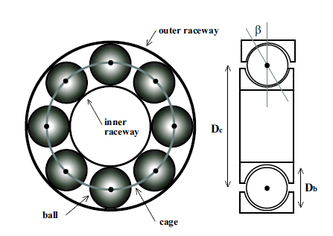

Figure 3: Ball bearing cross-sectional view

##### No. of Stator Slots

##### *Default: 2 Range: 1 to 500 Step: 1*

Configure the number of stator slots based on motor design. This information will be available with manufacturer or in motor technical manuals.

##### Bearing Flt PKP Stg 1

##### *Default: 45 dB Range: 1 to 100 Step: 1 dB*

Configure the minimum dB level above the baseline dB level (for any load bin) at which bearing fault operand level 1 will pick up. This setting is applicable for both peak magnitude and energy at peak magnitude.

ESA operates and generates an event when change in dB, dB value is greater than the pickup level in dB and is sustained for the pickup delay time for the specific load bin. Change in dB, dB is computed from actual dB level minus baseline dB.

**Example 1 - when Baseline Mode was Enabled**

Pickup level(dBpkp) is set at 25dB

Baseline dB (dBbaseline) computed by Baseline Mode equals -80dB

Actual dB level required to operate = dBbasline + dBpkp =-80dB + 25dB = -55dB

ESA operates when actual dB is equal to or greater than -55dB

**Example 2 – when Baseline Mode was not Enabled**

Pickup level(dBpkp) is set at 45dB

Baseline dB (dBbaseline) is fixed = -100 dB.

Actual dB level required to operate ESA = (dBbasline) + dBpkp = -100dB + 45 = -55dB

ESA operates when actual dB is equal to or greater than -55dB

Therefore, for the same threshold, i.e. -55dB, with baseline mode disabled, the pickup level should be higher as it is compared with -100dB, as compared to baseline enabled. The pickup level can be adjusted to get threshold around -55dB to -45dB for Caution, and -45dB to -35dB for Alarm purposes.

##### Bearing Flt PKP Delay 1

##### *Default: 10 min Range: 5 to 60 min Step: 5 min*

Configure the delay in minutes after which bearing fault operand pickup level 1 will operate if the level sustains.

##### Bearing Flt PKP Stg 2

##### *Default: 55 dB Range: 1 to 100 Step: 1 dB*

Configure the minimum dB level above the baseline dB level (for any load bin) at which bearing fault operand level 2 will pick up. This setting is applicable for both peak magnitude and energy at peak magnitude.

##### Bearing Flt PKP Delay 2

##### *Default: 15 min Range: 5 to 60 min Step: 5 min*

Configure the delay in minutes after which bearing fault operand pickup level 2 will operate if the level sustains.

##### Mech Flt PKP Stg 1

##### *Default: 45 dB Range: 1 to 100 Step: 1 dB*

Configure the minimum dB level above the baseline dB level (for any load bin) at which bearing fault operand level 1 will pick up. This setting is applicable for both peak magnitude and energy at peak magnitude.

##### Mech Flt PKP Delay1

##### *Default: 10 min Range: 5 to 60 min Step: 5 min*

Configure the delay in minutes after which bearing fault operand pickup level 1 will operate if the level sustains.

##### Mech Flt PKP Stg 2

##### *Default: 55 dB Range: 1 to 100 Step: 1 dB*

Configure the minimum dB level above the baseline dB level (for any load bin) at which bearing fault operand level 2 will pick up. This setting is applicable for both peak magnitude and energy at peak magnitude.

##### Mech Flt PKP Delay2

##### *Default: 15 min Range: 5 to 60 min Step: 5 min*

Configure the delay in minutes after which bearing fault operand pickup level 2 will operate if the level sustains.

##### Stator Flt PKP Stg 1

##### *Default: 45 dB Range: 1 to 100 Step: 1 dB*

Configure the minimum dB level above the baseline dB level (for any load bin) at which bearing fault operand level 1 will pick up. This setting is applicable for both peak magnitude and energy at peak magnitude.

##### Stator Flt PKP Delay1

##### *Default: 10 min Range: 5 to 60 min Step: 5 min*

Configure the delay in minutes after which bearing fault operand pickup level 1 will operate if the level sustains.

##### Stator Flt PKP Stg 2

##### *Default: 55 dB Range: 1 to 100 Step: 1 dB*

Configure the minimum dB level above the baseline dB level (for any load bin) at which bearing fault operand level 2 will pick up. This setting is applicable for both peak magnitude and energy at peak magnitude.

##### Stator Flt PKP Delay2

##### *Default: 15 min Range: 5 to 60 min Step: 5 min*

Configure the delay in minutes after which bearing fault operand pickup level 2 will operate if the level sustains.

##### Block

*Default: Off Range: Off, FlexLogic operands*

The ESA element will be blocked, when the selected operand is asserted.

##### Output Relay

##### *Default: Do Not Operate Range: Do Not Operate, Operate*

Any or all the output relays 3 to 6 can be selected to operate, upon ESA operation.

**Events**

*Default: Enabled Range: Enabled, Disabled*

The selection of Enabled setting enables the events of ESA function.

**Targets**

*Default: Latched Range: Self-reset, Latched, Disabled*

The selection of Self-reset or Latched settings enables the targets of ESA fault function. Targets of ‘Baseline Data Capture Start’ and ‘Baseline Data Capture End’ are self-reset regardless of Self-reset or Latched selection.

Note: In cases where baseline mode is disabled or baseline data is not available, the PKP related settings of bearing, mechanical and stator for dB levels should correspond to peak magnitude and not change in dB magnitude (Example: a default of 75dB for Flt PKP Stg 1 and 65dB for Flt PKP Stg 2).



Figure xx.xx: ESA Logic Diagram

~~~~

~~Figure xx.xx: ESA Logic Diagram Page~~

* 1. **MOTOR M&D/BEARING, Mechanical and STATOR FAULT**

**Path:** *Metering > Motor > Bearing Fault Baseline*

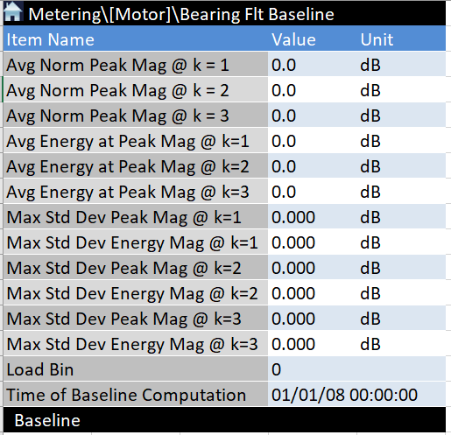

**Path:** *Metering > Motor > Bearing Fault Monitoring*

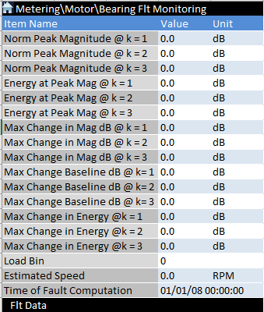

**Path:** *Metering > Motor > Mech Fault Baseline*

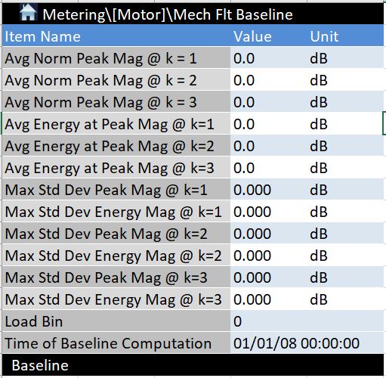

**Path:** *Metering > Motor > Mech Fault Monitoring*

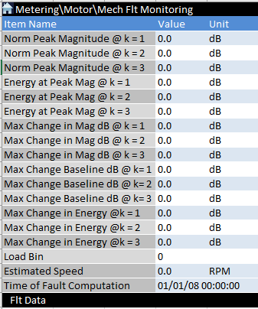

**Path:** *Metering > Motor > Stator Fault Baseline*

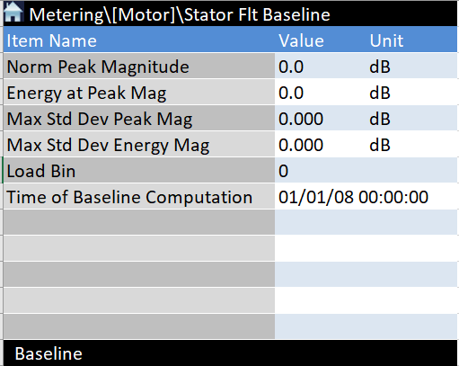

**Path:** *Metering > Motor > Stator Fault Monitoring*

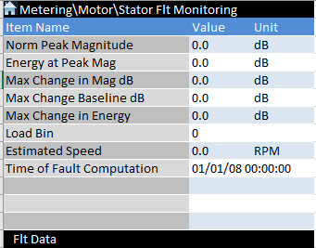

#### **Description**

**Avg Norm Peak Mag @ k = 1, Avg Norm Peak Mag @ k = 2, Avg Norm Peak Mag @ k = 3**

Normalized peak magnitude in dB at each frequency is calculated as the ratio of FFT magnitudes at specific frequency w.r.t rated magnitude of same quantity (rated current^2 in this case) for each k-factor. These normalized peak magnitude values are computed and stored continuously during baseline mode w.r.t each load bin and k-factor. All the dB values are averaged w.r.t each load bin and k-factor and stored as Avg. Norm Peak Mag @ k=1,2,3 in a file at the end of baseline period.

**Avg Energy at Peak Mag @ k=1, Avg Energy at Peak Mag @ k=2, Avg Energy at Peak Mag @ k=3**

Energy magnitude in dB is extracted as the ratio of root mean square of 3 frequency components (for each k-factor) including & around highest normalized peak magnitude w.r.t rated magnitude of same quantity (rated current^2 in this case). These energy values are computed and stored continuously during baseline mode w.r.t each load bin. All the dB values are averaged w.r.t each load bin values and stored as Avg. Energy at Peak Mag @ k=1,2,3 in a file at the end of baseline period.

**Max Std Dev Peak Mag [N]**

Std Dev Peak Mag represents the recurring standard deviation of peak dB magnitudes computed from data samples collected during baseline period for a specific load bin N (1 to 12). Std Dev is computed for peak dB data corresponding to k=1,2 and 3 (fault frequencies) for bearing, mechanical and at fault frequencies for stator.

**Max Std Dev Energy Mag [N]**

Std Dev Energy Mag represents the recurring standard deviation of energy dB magnitudes computed from data samples collected during baseline period for a specific load bin N (1 to 12). Std Dev is computed for energy dB data corresponding to k=1,2 and 3 (fault frequencies) for bearing, mechanical and at fault frequencies for stator.

**Load Bin**

Load bin (1 to 12) represents at which loading condition of motor, bearing or mechanical or stator faults are computed from 1 to >110 % range with each bin comprising 10% load interval and 100% representing rated load,

**Time of Baseline Computation**

Time of baseline computation is the time extracted when the Avg. highest normalized peak magnitude (base line) and Avg. energy at peak magnitude (base line) values are computed at the end of base line period.

**Normalized Peak Magnitude @k=1, Normalized Peak Magnitude @k=2, Normalized Peak Magnitude @k=3**

Normalized Peak Magnitude is calculated as the ratio of FFT magnitudes at specific frequency w.r.t rated magnitude of same quantity (rated current^2 in this case as I^2 FFT is used) for each k-factorand load bin.

**Energy at Peak Mag @ k=1, Energy at Peak Mag @ k=2, Energy at Peak Mag @ k=3**

Energy at Peak Magnitude in dB is extracted as the ratio of root mean square of 3 frequency components (for each k-factor) including & around highest normalized peak magnitude w.r.t rated magnitude of same quantity (rated current^2 in this case as I^2 FFT is used).

**Max Change in Mag dB @ k=1, Max Change in Mag dB @ k=2, Max Change in Mag dB @ k=3**

Max Change in Mag in dB, represents the difference between normalized peak magnitude calculated w.r.t baseline normalized peak magnitude dB (for all k-factors) for specific load bin.

**Max Change in Energy @ k=1, Max Change in Energy @ k=2, Max Change in Energy @ k=3**

Max Change in Energy in dB, represents the difference between energy magnitude calculated w.r.t baseline energy dB (for all k-factors) for specific load bin.

**Estimated Speed**

869 relay estimates speed based on rated input power, rated speed and power input to the motor. This field displays estimated speed.

**Time of Fault Computation**

This time represents the 8-series local time at which Highest normalized peak and energy magnitudes are computed within each ESA cycle.

* 1. **ESA APPLICABILITY**:

Applicability of ESA to motor must be verified during sales enquiry, commercialization phases and solution will be offered only when following conditions are satisfied,

* Motor should have rolling element bearings.
* Bearing specifications shall be available.
* Nameplate data shall be available.

No separate FW, SW or order code check will be performed to verify the applicability of solution.

Please see ESA applicability matrix below:

|  |  |  |  |
| --- | --- | --- | --- |
| **VT type / Motor type -->** | **IND** | **SYNCH** | **VFD-IND** |
| 3-Ph VT | Yes | Yes (Except BRB) | Yes |
| 1-Ph VT | Yes  (Except Stator ESA) | Yes  (Except Stator ESA, BRB) | No |
| No VT or None | Yes  (Except Stator ESA) | Yes  (Except Stator ESA, BRB) | Yes  (Except Stator ESA) |

|  |  |  |  |
| --- | --- | --- | --- |
| **Function/ Motor type -->** | **IND** | **SYNCH** | **VFD-IND** |
| Bearing | Roller Ball Type Bearing Only | Roller Ball Type Bearing Only | Roller Ball Type Bearing Only |
| Mechanical | Yes | No. of poles > 2 | Yes |
| Stator ESA* | Fault Freq < 1600 Hz for 50 Hz system &  Fault Freq < 1920 Hz for 60 Hz system  3-Ph VT Input is available | Fault Freq < 1600 Hz for 50 Hz system &  Fault Freq < 1920 Hz for 60 Hz system  3-Ph VT Input is available | Fault Freq < 1600 Hz for 50 Hz system &  Fault Freq < 1920 Hz for 60 Hz system  3-Ph VT Input is available |
| Stator T-T | Yes, 3-Ph VT Input only | Yes,3-Ph VT Input only | Yes, 3-Ph VT Input only |
| BRB | Yes | No | Yes |

* To identify stator ESA applicability with 869, multiply no. of stator slots (SS) with Fr in Hz (Fr = rated speed in rpm/60). This factor [SS* Fr] known as Center Frequency should be less than 1500 for 50 Hz system and less than 1800 for 60 Hz system.

**Installation**:

During installation or commissioning of 869 it is recommended to check health of the motor (in case its old motor) using offline testing or prior checks or through manual inspection. This helps in capturing base line data during motor healthy condition.

## Data for Design/Implementation

ESA algorithms are dependent on motor load and to take different load types (continuous, intermittent or combination) into account load binning concept is introduced. In this concept entire motor operational load is divided into bins of each 10% range. Baseline data is captured for each load bin to evaluate the rate of change in operational mode w.r.t baseline (healthy) mode and identify faults in motor based on the amount of rate of change. The following load bins are defined,

1. Load bin 1 – 0 to 10% of rated load.
2. Load bin 2 – 10% to 20% of rated load.
3. Load bin 3 – 21% to 30% of rated load.
4. Load bin 4 – 31% to 40% of rated load.
5. Load bin 5 – 41% to 50% of rated load.
6. Load bin 6 – 51% to 60% of rated load.
7. Load bin 7 – 61% to 70% of rated load.
8. Load bin 8 – 71% to 80% of rated load.
9. Load bin 9 – 81% to 90% of rated load.
10. Load bin 10 – 91% to 100% of rated load.
11. Load bin 11 – > 100% to 110%of rated load.
12. Load bin 12 -> Greater than 110% of rated load.

**Note:** Load binning concept is not applicable for synchronous motors since speed doesn’t vary with load. dB values need to be computed continuously in each cycle without any load binning concept.

### Baseline Mode

##### Once relay is installed and commissioned successfully, 869 relay will be in baseline mode for default of 1 operational hour per load bin (baseline period). During this mode relay will capture baseline data corresponding to load bins (% load). Baseline dB magnitudes of highest normalized peak magnitude and energy at peak magnitude are computed during each ESA cycle or interval w.r.t load bin and stored in NVRAM. During the baseline period, all the dB magnitudes are averaged (mean), standard deviation is extracted w.r.t each load bin and stored as baseline data in a file. Data during baseline mode shall be computed and captured in the same manner as mentioned for operational mode. Baseline data (considered as healthy data) stored in file w.r.t load bin is used for comparison with data computed during operational mode. There after device enters this mode whenever there is a need to capture baseline data for a load bin or if the baseline data is not captured for that bin during initial baseline period after installation and returns to operational mode once base line data is captured. Speed and frequency at which baseline data is computed shall be captured in file for all load bins. Baseline data can be cleared by using “Clear ESA baseline data” command.

**Imp Note:** During processing of baseline data samples outliers must be eliminated by checking if the magnitude of new sample collected (after first 10 samples) is greater than +/- 5 dB of recursive mean computed till that point of time. In case of violation, the data sample must be discarded for computing recurring mean & standard deviation of baseline data and next sample must be considered for processing. The baseline period for a specific load bin should end by the criteria of collecting required no. of samples as per baseline period setting in mins (1 sample/min) or time duration of double the baseline period setting in mins whichever is earlier. (Due to unavailability of proper baseline data from site/lab to validate outlier elimination range and considering its associated risk in variability of data from motor to motor and fault type, team felt to consider it for next release and not in v2.70).

Recursive computation of mean per load bin can be done using below equation,



Where, ut is current mean, xt is current measurement, ‘t’ ranges from 1-N (no. of samples) and u(t-1) is previous mean. Final ut can be stored as mean (base) of each data.

Recursive computation of variance per load bin can be done using below equation,



Where, ut is current mean, xt is current measurement, ‘t’ ranges from 1-N (no. of samples), sigma (t-1) is previous variance and sigma (t) is current variance. Standard deviation can be computed as square root of variance and final standard deviation can be stored as sigma (base) of each data.

**Design of Standard Deviation:** For example, Bearing has 3 fault frequency formulas (IRF, ORF, BD) at k=1 in I^2 FFT which requires three standard deviation computations in parallel for both peak and energy dB and finally the max of all three standard deviations will be updated in metering screen AV of bearing baseline data. Similarly, stator has 3 fault frequency formulas in I^2 FFT and requires three standard deviation computations in parallel for both peak and energy dB and finally the max of all three standard deviations will be updated in stator baseline metering screen AV. However, for mechanical fault there is only single fault frequency formula and requires single peak and energy dB computation at k=1 in I^2 FFT and updated in mechanical baseline metering screen AV.

**Note for SW**: It shall be possible to retrieve baseline data of all load bins related to ESA function as part of service report which constitutes 2 files (ESA_baseline metering data.csv and ESA_detailed baseline data.csv).

ESA_baseline metering data.csv file consists of all normalized average peak and energy baseline dB data for each fault corresponding to k=1,2,3 (where applicable) w.r.t all load bins. It will also have max standard deviation peak/energy dB values. These data as per operating load bin is also available as Modbus registers and shown as AV’s in baseline metering screens for each fault type.

ESA_detailed baseline data.csv file consists of average peak and energy magnitude dB data for each applicable fault frequency computation (F1 to F15) in FFT corresponding to k=1,2,3 (where applicable) w.r.t all load bins and fault types. It will also have corresponding standard deviation peak/energy dB values. These are internal computed average values used to extract normalized peak and energy baseline magnitudes, maximum standard deviation values which are updated in metering AV’s. The individual fault frequency baseline values in this file must be captured in the same order of F1 to F15 as represented in FFT visualization screen where F1 to F9 corresponds to bearing, F10 to F12 corresponds to mechanical and F13 to F15 corresponds to stator.

### Operational Mode

After completing initial baseline mode period, 869 relay enters operational or monitoring mode for the load bins where baseline data is captured successfully. During this mode FFT on current square samples is computed every 1-minute w.r.t load bin, magnitudes are captured in dB for fault related frequencies and compared with baseline FFT magnitudes of the same load bin to report rate of change or variation. Determine load bin first and then start processing the data for FFT during every computation interval. Operational data can be cleared by using “Clear ESA operational data” command.

1. **Data quality check**: Before computing FFT on current samples following data quality checks shall be performed on data for good quality data – pass/fail.

* Frequency measured shall be within +/- 5% limits of nominal frequency (Except for VFD based on Motor type setting).
* Voltage measured shall be within +/- 10 % limits of nominal voltage (voltage order code). (Except for VFD based on Motor type setting).
* THD (total harmonic distortion) of phase current and voltage computed shall be less than 5% of nominal frequency.
* Current unbalance in system computed shall be less than 10%.
* Voltage unbalance in system computed shall be less than 5%. (Voltage unbalance as per IEC can be computed as the ratio of V2/V1 represented as % similar to current unbalance in 869, where V1 is pos seq voltage and V2 is neg seq voltage from metering).
* The total number of cycles of data collected shall be integral no. of cycles for both 50 Hz and 60 Hz systems i.e. time length shall be multiple of 20 ms and 16.67 ms for 50 Hz and 60 Hz systems respectively.

Note:

Voltage, Freq, THD, voltage unbalance and current unbalance shall be used from 869 latest metering computation.

FFT computation on current square samples shall be performed only when data quality check is passed.

1. **Design Inputs**:

* In case during any computation cycle, if Bearing, Mechanical and Stator functions peak or energy magnitude dB in monitoring mode is less than corresponding baseline magnitudes captured, then ESA function must be blocked from picking up and metering/logs should not be updated. (Manual Note).
* In case if any of the fault frequency including its vicinity check zone is matching with zero (DC) freq, fundamental or matching with harmonic frequencies up to 25th harmonic (multiple of supply freq) then that particular fault frequency and corresponding magnitude shall be omitted from dB computation or decision making.
* Vicinity check for stator ESA will be same as that of bearing/mechanical with voltage option. Stator ESA is not applicable in case of voltage less and 1-Ph VT option.
* To avoid spurious PKP events during monitoring, PKP delay configured shall be used for both PKP and OP Stg 1/Stg 2 events. i.e. If bearing/mechanical & stator elements see PKP event condition then PKP event will be raised only if the condition causing PKP event is consistent till the PKP delay period configured for that stage. Once PKP event is triggered, OP event timer will start and OP event will be raised if the condition causing OP event is consistent till the PKP delay period configured for that stage (NA for v 270).

1. **FFT Computation**: FFT on current square samples shall be performed as per below steps,

Capture voltage and current samples at 64 or 128 samples/cycle rate and up to N samples and store in a buffer.

**Step 1 – Speed Estimation**: A: Estimate motor speed as using equation 4 below (**In case of Induction Motor as per motor type setting and 3-Ph VT in voltage type setting**),

 (4)

Computational parameter details for estimating motor speed are given below,

|  |  |  |  |  |
| --- | --- | --- | --- | --- |
| **Symbol** | **Quantity** | **Unit** | **Method** | **Formula** |
| *f* | Motor fundamental frequency | Hz | From static data | Path: Platform\Frequency 1-J or 2-K |
| *P* | number of poles | no unit | From motor Name plate | Path: System\Motor\Setup |
| *Prated* | Rated input power | watt | From motor Name plate or computed | Path: Motor M&D\ESA| Setup |
| *ωr_rated* | Rated rotor speed | rpm | From motor Name plate | Path: Monitoring\Tachometer |
| *srated* | Rated slip | No unit | To be calculated |  |
| *Pinput* | Total input power | Watt | To be calculated from metering data samples of voltage & current |  |
| *ωs* | Synchronous speed | r.p.m. | To be computed | Path: Platform\Frequency 1-J or 2-K  Path: System\Motor\Setup |
| *s* | Slip | no unit | To be computed |  |
| *ωr* | Motor speed | r.p.m. | To be computed |  |

B: **In case of synchronous motor (as per motor type setting)** speed (Nr) is directly equal to computed synchronous speed = (120*Tracking Freq)/No. of Poles. Nr in rpm or Fr = Nr/60 in Hz must be directly substituted in fault frequency formulas.

C: **In case of VFD fed induction motor and 3-Ph VT at motor terminals only (as per motor type/voltage type setting)**, speed estimation can be done as per the steps below,

Check if the load>= 0.40 x FLA and <= 1.00 x FLA (Rated FLA as per name plate setting) and frequency < rated system frequency (50 or 60 Hz). If the conditions specified is valid (to ensure constant V/f operation) proceed to steps below for speed computation else mark all dB values as default.

Step 1: Compute Synchronous Speed in rpm as, Ns = (120 * Fs/P) where ‘Fs’ is tracking frequency and ‘P’ is No. of poles.

Step 2: Compute Normalized input power (Pin_norm) based on the operating frequency as, where ‘Pin’ is computed input power of the motor in metering, Tracking Freq. is from metering and Rated Freq. is nominal frequency from name plate.

Pin_norm = Pin * (Rated Freq./Tracking Freq.)

Step 3: Motor speed in rpm = Ns – [abs (Pin_norm/ Pin_rated)* Rated slip speed],where,

‘Pin_rated’ is rated input power of motor computed as [rated output/rated efficiency], where rated output in kW = Motor HP * 0.746 and rated efficiency is from name plate.

Rated slip speed = [Ns – Nr], where Nr is rated speed from name plate and Ns is rated synchronous speed (120*Frated/P).

D: **In case of 1-Ph VT Option:** With 1Ph-VT option (only one phase measured voltage is available to relay configured at System-->Voltage Sensing--> Phase VT Connection), voltages of other phases and there by power is computed considering balanced 3-phase system. This feature is currently supported in 850 case and needs to be extended to 869 so that power computed with 1-VT option can be used as input to speed estimation algorithm as mentioned in case A above for induction motors. Once speed estimation is done, the remaining ESA procedure is same.

All the metering values related to k= 1,2,3 of IND with 1-Ph VT case will be shown but the PKP decision for ESA events will be taken from only those fault frequency magnitudes corresponding to k=1.

**Note:** There is no change to synchronous motor speed estimation/ESA logic with this option and is not applicable for VFD-fed machine.

E: **In case of Voltage less Option (No-VT Option) with IND motor type**: No voltage option is identified based on ESA setting (Voltage Type). In case of no voltage option or no VT input to relay, speed estimation is done using the equation below,

Motor Speed in rpm = (Synch Speed in rpm) – ((xFLA/1.00) * (Rated Slip speed in rpm)), where

* Synch Speed in rpm = 120*Fs/P (Fs is measured/tracking frequency and ‘P’ is no. of poles from motor nameplate settings).
* xFLA – Load factor (< 1.00) computed in metering.
* Rated Slip speed in rpm = [(Rated Synch Speed in rpm) – (Rated speed in rpm)], Rated Synch Speed is computed as 120*Frated/P, and Rated speed is from motor nameplate settings.

Once the speed in rpm is computed, it needs to be rounded off to the nearest integer (Ex: If speed computed is XXXX.YY, and if YY < 0.50 then speed should be rounded off to XXXX and if YY ≥ 0.50 then speed should be rounded off to XXXX+1). Once speed estimation is done, the remaining ESA procedure is same.

In case of motor overload condition where xFLA > 1.00 or in cases when xFLA factor is found to be greater than one, then motor speed must be considered as “rated speed” itself (No need to apply as we are directly considering load current in xFLA)

All the metering values related to k= 1,2,3 of IND with No VT case will be shown but the PKP decision for ESA events will be taken from only those fault frequency magnitudes corresponding to k=1.

**Note:** There is no change to synchronous motor speed estimation/ESA logic with this option.

Please refer to ESA applicability section 3 for more clarity.

F: **In case of Voltage less Option (No-VT Option) with VFD motor type**: No voltage option is identified based on ESA setting (Voltage Type). In case of no voltage option or no VT input to relay or VT on bus side of VFD, speed estimation is done using the equation below,

Check if the load (xFLA) is >= 0.40x FLA and <= 1.00 x FLA (Rated FLA as per name plate setting) and tracking frequency < nominal rated frequency of system (50 to 60 Hz), proceed to speed computation if conditions are true. If the specified conditions are not satisfied then dB’s will be marked as default values. This is to ensure constant V/f operation.

Motor Speed in rpm = (Synch Speed in rpm) – ((xFLA/1.00) * (Rated Slip speed in rpm)), where

* Synch Speed in rpm = 120*Fs/P (Fs is measured/tracking frequency and ‘P’ is no. of poles from motor nameplate settings).
* xFLA – Load factor (< 1.00) computed in metering.
* Rated Slip speed in rpm = [(Rated Synch Speed in rpm) – (Rated speed in rpm)], Rated Synch Speed is computed as 120*Frated/P, and Rated speed is from motor nameplate settings.

Once the speed in rpm is computed, it needs to be rounded off to the nearest integer (Ex: If speed computed is XXXX.YY, and if YY < 0.50 then speed should be rounded off to XXXX and if YY ≥ 0.50 then speed should be rounded off to XXXX+1). Once speed estimation is done, the remaining ESA procedure is same.

All the metering values related to k= 1,2,3 of VFD with no VT case will be shown but the PKP decision for ESA events will be taken from only those fault frequency magnitudes corresponding to k=1.

**Step 2- FFT Computation**: Compute vibration frequencies related to bearing damage using equation (5) using bearing specification data configured in path - Motor M&D\Bearing & Eccentricity Setup. Store these frequencies in a buffer.

 (5)

Step 3: Compute stator current frequencies related to bearing damage using equation (6) and vibration frequencies computed in step 1.

(6)

k is any integer: 1,2,3,…up to 10. Store these frequencies in a file as bearing frequencies of interest. (k = 1 to 3 for v180)

Computational parameter details for bearing fault frequencies are given below,

|  |  |  |  |  |
| --- | --- | --- | --- | --- |
| **Symbol** | **Quantity** | **Unit** | **Method** | **Formula** |
| *fbearing* | Stator current frequency related to bearing damage | Hz | To be calculated |  |
| *f* | Motor fundamental frequency | Hz | From metering computation | Path: Platform\Frequency 1-J or 2-K |
| *fvib* | Vibration frequency related to bearing damage | Hz | To be calculated |  |
| *Nb* | Number of rolling elements |  | From bearing datasheet | Path: Motor M&D\Bearing & Eccentricity Setup |
| *Dc* | Cage diameter | inch | From bearing datasheet | Path: Motor M&D\Bearing & Eccentricity Setup |
| *Db* | Rolling element (ball) diameter | inch | From bearing datasheet | Path: Motor M&D\Bearing & Eccentricity Setup |
| *ωr* | Motor speed | r.p.m. | To be computed | Refer step 1 |

For v 2.70, as we use current square FFT instead of current FFT the fault frequencies corresponding to bearing fault must be processed as below (Note: With current square FFT operation original fundamental (Fs) shifts to DC and new fundamental will be 2*Fs).

Fault frequency formula for bearing function is, [Fs±k*Fvib]. Fvib can be further represented as, Fvib (ORF), Fvib (IRF), Fvib (BF) where ORF – Outer Race Fault, IRF – Inner Race Fault and BF – Ball Fault (Defect).

From equation (5) above, Fvib can be further simplified and represented as:

Fvib (ORF) = C1 * Fr, C1 is constant based on bearing parameters, Fr is machine speed in Hz (Nr/60).

Fvib (IRF) = C2 * Fr, C2 is constant based on bearing parameters, Fr is machine speed in Hz (Nr/60).

Fvib (BF) = C3 * Fr, C3 is constant based on bearing parameters, Fr is machine speed in Hz (Nr/60).

In case of I^2 FFT as fundamental moves to DC the fault frequencies corresponding to outer race, inner race and ball defect can be simply k*Fvib (ORF), k*Fvib (IRF) and k* Fvib (BF) and k = 1,2,3.

**Search Band for Peak Magnitude (Bearing)**:

**For v2.80**, Vicinity check is configurable as factory setting with default value at 2*FFT resolution in Hz with voltage option and without voltage or 1-Ph VT is defaulted to 2+1 = 3*FFT resolution in Hz. For bearing 2 & 3 times FFT resolution in Hz will be applied for voltage and no-voltage options. For v2.70 only they are fixed at default values of 2 and 3 times FFT resolution with and without voltage. After validation vicinity check factory setting for 1) voltage-based ESA, 2) voltage less ESA and 3) 1-VT based ESA will be modified if required.

**1-VT Option to support ESA (Bug 47414) in v2.70**:

In case if only single-phase VT connection is available as per the Voltage Type setting in ESA and at System-->Voltage Sensing--> Phase VT Connection , pseudo voltages of other phases considering balanced system is computed and there by power is also computed considering the actual measured currents from CT (Refer to 8-Series-System Spec). The power computed with 1-VT option will be used as input to the speed estimation algorithm mentioned in above section (for induction only). The rest of the ESA computation mechanism will be same. The vicinity check factory setting for 1-VT option will be same as that of no voltage case and will be chosen/suggested appropriately after validation and comparing with voltage-based ESA results.

Due to the errors possible in frequency measurement and speed estimation, the FFT magnitudes later has to be looked at near vicinity range () of fault frequencies of interest computed.

The vicinity range (> v180) for bearing fault frequencies () can be computed onetime or during every FFT computation as,

In case, for onetime computation,

, which is frequency measurement error can be approximated to 0.001 Hz.

k, has to be taken maximum value of 10.

, can be considered as rated speed of motor.

In case, during every FFT computation,

, frequency measurement error can be considered based on current magnitude (x CT) as per 8-series specification.

k has to be taken from 1 to 10 based on frequency of interest.

has to be considered as the latest estimated speed of motor.

Note: Vicinity range is fixed as 0.5 Hz for v180.

Step 4: Compute the vibration frequencies related to the defects (shaft misalignment, load unbalance, loose foundation, dynamic/static eccentricity) using equation (7).

 (7)

k=1, 2, 3, 4….up to 10 (k = 1 to 3 for v180). Store these frequencies in a file as eccentricity frequencies of interest.

Computational parameter details for eccentricity fault frequencies are given below,

|  |  |  |  |  |
| --- | --- | --- | --- | --- |
| **Symbol** | **Quantity** | **Unit** | **Method** | **Formula** |
| *fmisalignment* | Stator current frequency related to misalignment | Hz | To be calculated |  |
| *F* | Motor fundamental frequency | Hz | From metering computation | Path: Platform\Frequency 1-J or 2-K |
| *s* | Slip | no unit | To be computed | Refer step 1 |
| *P* | number of poles | no unit | From motor settings data | Path: System\Motor\Setup |
| *p* | number of pole-pairs | no unit | To be computed from number of poles |  |

For v 2.70, as we use current square FFT instead of current FFT the fault frequencies corresponding to mechanical fault must be processed as below (Note: With current square FFT operation original fundamental (Fs) shifts to DC and new fundamental will be 2*Fs.

Fault frequency formula for mechanical function is, [Fs±k*Fr]. Hence in case of I^2 FFT, fault frequency will simply be ‘k*Fr’, k = 1,2,3.

**Search Band for Peak magnitude (Mechanical)**:

**For v2.80**, Vicinity check is configurable as factory setting with default value at 1*FFT resolution in Hz with voltage option and without voltage or 1-Ph VT is defaulted to 1+1 = 2*FFT resolution in Hz. For mechanical function, 1 & 2 times FFT resolution in Hz will be applied for voltage and no-voltage options. For v2.70 only they are fixed at default values of 2 and 3 times FFT resolution with and without voltage. After validation vicinity check factory setting for 1) voltage-based ESA, 2) voltage less ESA and 3) 1-VT based ESA will be modified if required.

**Search Band for Peak magnitude (Stator)**:

**For v2.80**, Vicinity check is configurable as factory setting with default value at 4*FFT resolution in Hz with voltage option and without voltage or 1-Ph VT its not applicable. For stator function, 4 times FFT resolution in Hz will be applied as vicinity check. For v2.70 only they are fixed at default values of 2 and 3 times FFT resolution with and without voltage.

Due to the errors possible in frequency measurement and speed estimation, the FFT magnitudes later has to be looked at near vicinity range ( ) of fault frequencies of interest computed.

The vicinity range (> v180) for bearing fault frequencies () can be computed onetime or during every FFT computation interval as,

In case, for onetime computation,

, which is frequency measurement error can be approximated to 0.001 Hz.

k, has to be taken maximum value of 10.

, can be considered as rated speed of motor.

In case, during every FFT computation interval,

, which is frequency measurement error can be considered based on current magnitude as per 8-series specification.

K, has to be taken from 1 to 10 based on frequency of interest.

, has to be considered as the latest estimated speed of motor.

Store the frequency bands for each frequency of interest in a file for use during FFT magnitudes computation in step 6.

Note: Vicinity range is fixed as 0.5 Hz for v180.

Step 5: Perform FFT computation on current samples and note the following data for bearing and eccentricity fault computation w.r.t each load bin separately,

For bearing fault computation,

|  |  |  |  |  |
| --- | --- | --- | --- | --- |
| **Frequency of interest (Hz)Name of frequency of interest** | **Frequency in HzFrequency** | **Peak Magnitude in vicinityClosest Bins in Frequency Domain Data\*** | **Area within vicinity** (> v180) (> v180) **Magnitude** | **Normalized Peak Magnitude (dB) in vicinity** |
| Frequency related to inner raceway defect, k=±1 |  |  |  |  |
| Frequency related to inner raceway defect, k=±2 |  |  |  |  |
| Frequency related to inner raceway defect, k=±3 |  |  |  |  |
| Frequency related to inner raceway defect, k=±4 |  |  |  |  |
| Frequency related to inner raceway defect, k=±5….. up to 10 |  |  |  |  |
| Frequency related to rolling element defect, k=±1 |  |  |  |  |
| Frequency related to rolling element defect, k=±2 |  |  |  |  |
| Frequency related to rolling element defect, k=±3 |  |  |  |  |
| Frequency related to rolling element defect, k=±4 |  |  |  |  |
| Frequency related to rolling element defect, k=±5…..up to 10 |  |  |  |  |
| Frequency related to outer raceway defect, k=±1 |  |  |  |  |
| Frequency related to outer raceway defect, k=±2 |  |  |  |  |
| Frequency related to outer raceway defect, k=±3 |  |  |  |  |
| Frequency related to outer raceway defect, k=±4 |  |  |  |  |
| Frequency related to outer raceway defect, k=±5…..up to 10. |  |  |  |  |

For eccentricity fault computation,

|  |  |  |  |  |
| --- | --- | --- | --- | --- |
| **Frequency of interest (Hz)Name of frequency of interest** | **Frequency in HzFrequency** | **Peak Magnitude in vicinityClosest Bins in Frequency Domain Data\*** | **Area within vicinity Magnitude** | **Normalized Peak Magnitude (dB) in vicinity** |
| Frequency related to eccentricity defect, k=±1 |  |  |  |  |
| Frequency related to eccentricity defect, k=±2 |  |  |  |  |
| Frequency related to eccentricity defect, k=±3 |  |  |  |  |
| Frequency related to eccentricity defect, k=±4 |  |  |  |  |
| Frequency related to eccentricity defect, k=±5….. up to 10 |  |  |  |  |

Speed and frequency at which FFT is computed on data samples w.r.t load bin shall be captured after every FFT computation to compute difference with baseline.

From baseline and operational modes data based on load bin, compute the ratios of “peak magnitude in vicinity” and “Area in vicinity” captured during baseline and operational modes as dB for each fault frequency of interest.

Step 6: Perform supervisory check on data samples captured to verify if the ESA algorithm output can be computed or trusted. Following three parameters and its threshold levels has to be checked if the ESA output can be displayed as trustworthy. In case of supervisory check fail for more than 2 parameters, an event “Bearing & eccentricity supervisory check fail” has to be logged in event log.

1. THD ratio of current & voltage: Currently in 8-series platform THD of current is computed including up to 25 harmonics in metering. THD of voltage (> v180) can also be computed in a similar fashion from voltage samples. Then compute the ratio of current THD with voltage THD (voltage order code).

If, > X (limit?), then supervisory check is pass.

If, < X (limit?), then supervisory check is fail.

In case of no VT input, check if < 4% then supervisory check is pass.

1. Negative sequence impedance: Currently in 8-series platform negative sequence impedance is not computed in metering.

If, < Y (limit?) Ohms, then supervisory check is pass.

If, > Y (limit?) Ohms, then supervisory check is fail.

1. Triplen impedance (> v180): From FFT data or metering computation of current and voltage samples capture the magnitude of voltage and current at triplen (3*f) frequency. Then triplen impedance is computed as the ratio of magnitude of voltage and current at triplen (3*f) frequency.

If, < Z (limit?) Ohms, then supervisory check is pass.

If, > Z (limit?) Ohms, then supervisory check is fail.

**Note**: 1. If supervisory check limits are not available in standards or known readily, then they need to be computed from baseline data and stored as thresholds.

2. Negative sequence impedance has to be computed using operator ‘a’ as shown below. Where, 

Further negative sequence voltage (Va2) and current (Ia2) are computed using ‘a’ operator from unbalanced voltage and current phasors as shown below,

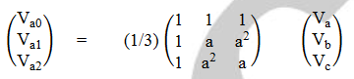

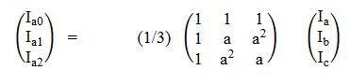

Finally, negative sequence impedance can be computed as, Z2 = Va2/Ia2.

1. **Data for Software representation and data logs in FW:**

* ESA will be renamed or branded as “MCM ESA – Motor Condition Monitoring ESA” in the main path of Enervista software/Local HMI.

1. **Data table representation:**

Software shall represent bearing, eccentricity and stator fault latest computations as table shown in section 1 under Path: Metering\Motor\Bearing, Eccentricity and Stator Fault baseline and monitoring computations. Software shall also show last bin result as table until the next load bin transition occurs where the process repeats again.

1. **FFT Waveform Visualization:**

Software shall represent FFT computations in dB of current samples for latest computation as shown below (example) under Path: Records\ESA Records.

* FFT waveform shall represent the FFT waveform for each fault (bearing, Mechanical and stator) in the manner shown below.

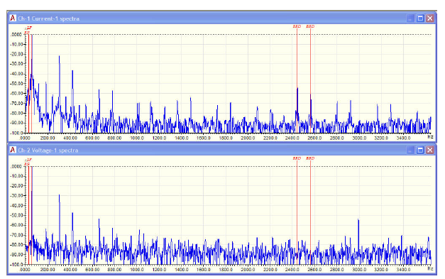

Figure 5: Current FFT waveforms

* FFT waveform shall indicate the fault frequencies and corresponding dB magnitudes as red lines on the plot.
* In case of combined FFT waveform display for each fault, all the data must be clearly differentiated for each fault through color codes. It should be self explanatory as which data corresponds to which fault.
* Max change in dB for each computation (specific to load bin) shall be displayed along with the waveform with PKP levels configured in settings.
* User shall be able to save and retrieve the FFT waveforms in a local folder for future references.
* In case if any fault monitoring is disabled, then FFT waveform shall be captured and displayed for faults that are enabled.
* In case if the FFT waveform is taking too long (> 1 minute) to retrieve from relay or if the file does not exist, then “File could not be retrieved” message shall be displayed to the user.
* For every PKP condition related to ESA event and/or critical motor events (configurable in future), FFT waveform shall be taken as backup along with timestamp and stored in the relay (For pilot scope in v180 – this can be captured for only ESA events). These waveforms can be retrieved from software for later analysis like transient records. 869 shall support up to last 5 ESA records in FIFO mode.
* In case of no voltage order code option, only motor current FFT shall be plotted. In future if voltage FFT is added then both the plots must be displayed with current FFT on top and voltage FFT waveform in the bottom section against same frequency points and its dB values.

COMTRADE can be used as the resource for plotting the FFT waveform in Enervista software.

1. **Bala’s Circle:**

Software shall represent ESA computed data w.r.t each load bin in the form of circular fractal representation as shown below,

For v2.70, Circle should consider the data corresponding to only k=1,2,3 for plotting the radius of baseline in circle where corresponding change in dB is maximum. FW should give data input accordingly to SW for plotting circle. Circle should plot last 10 samples of data per load bin as shown below.



* Circle is drawn with 3 dB’s taken into consideration – baseline dB corresponding to ‘k’ value with maximum change in dB, PKP setting dB and ‘PKP+7’ dB as the diameters of circles corresponding to baseline, caution and alarm zones.
* Entire circle is divided into 12 equal sections covering 30 degrees of circumference corresponding to each load bin. Load bin 1 is started at 0 degree and ended with load bin 12 at 360 degree point in anti-clockwise direction.
* Latest or last computed dB is represented as ‘dot’ in case of single data and as a trend w.r.t time in case of multiple dB data. dB data represented will correspond to maximum change in dB at specific ‘k’ value of formula (k = 1,2,3).
* At any point of time, 2 load bins data is represented. One is current load bin (active color – little dark segment) in which motor is operating and second is last load bin in which motor operated.
* In case of multiple load bins data representation, baseline dB whichever is lower among the considered load bins is taken as baseline circle dB. (A note can be mentioned to user on the screen)
* A user can select any load bin by mouse click or touch (App) in that section and data corresponding to that load bin will be displayed. In case of data unavailable “no data” message will be displayed.
* “Plot all load bins” option shall be given to user in which all load bins data will be plotted at a time.
* In case of multiple data available for each load bin (historical data), data is trended w.r.t 30-degree angle view corresponding to that load bin.

1. As ESA circle data is plotted with baseline data corresponding to fault frequency where maximum change in dB observed rather than taking normalized peak baseline data shown in metering AV’s it may cause confusion to user. To avoid this, a note mentioning “The latest point in ESA circle corresponds to baseline data of ‘X’ dB observed at specific YYYY fault frequency where change in dB from baseline is observed to be maximum” where X = dB value, YYYY = Bearing, Mechanical or Stator based on fault type, has to be added below the circle.
2. **Historical Data Support**

* Firmware should support historical data for ESA in a file which can retrieved by SW as a csv file or for trending purposes based on v180 timelines.
* The following data shall be logged in a file at every 30-minute interval for last 100 days (100*48 = 4800 records) or every 15-minute interval for last 50 days (50*96 = 4800 records) along with date/timestamp.

**Bearing faults:**

1. Norm Peak Magnitude @ k=1(Bearing Mon) – BPM @ k=1(dB)
2. Norm Peak Magnitude @ k=2(Bearing Mon) - BPM @ k=2(dB)
3. Norm Peak Magnitude @ k=3(Bearing Mon) - BPM @ k=3(dB)
4. Max Change in Mag @ k=1(Bearing Mon) - BCM @ k=1(dB)
5. Max Change in Mag @ k=2(Bearing Mon) - BCM @ k=2(dB)
6. Max Change in Mag @ k=3(Bearing Mon) - BCM @ k=3(dB)
7. Max Change in Energy @ k=1(Bearing Mon) - BCE @ k=1(dB)
8. Max Change in Energy @ k=2(Bearing Mon) - BCE @ k=2(dB)
9. Max Change in Energy @ k=3(Bearing Mon) - BCE @ k=3(dB)
10. Load bin

**Mechanical faults:**

1. Norm Peak Magnitude @ k=1(Mech Mon) - MPM @ k=1(dB)
2. Norm Peak Magnitude @ k=2(Mech Mon) - MPM @ k=2(dB)
3. Norm Peak Magnitude @ k=3(Mech Mon) - MPM @ k=3(dB)
4. Max Change in Mag @ k=1(Mech Mon) - MCM @ k=1(dB)
5. Max Change in Mag @ k=2(Mech Mon)- MCM @ k=2(dB)
6. Max Change in Mag @ k=3(Mech Mon)- MCM @ k=3(dB)
7. Max Change in Energy @ k=1(Mech Mon)- MCE @ k=1(dB)
8. Max Change in Energy @ k=2(Mech Mon)- MCE @ k=2(dB)
9. Max Change in Energy @ k=3(Mech Mon)- MCE @ k=3(dB)
10. Load bin

**Stator fault:**

1. Norm Peak Magnitude (Stator Mon) – SPM @ k=1(dB)
2. Energy at Peak Magnitude (Stator Mon) - SPE @ k=1(dB)
3. Max Change in Mag (Stator Mon) - SCM @ k=1(dB)
4. Max Change in Energy (Stator Mon) - SCE @ k=1(dB)
5. Load bin
6. Operating quantity (SITF) – SITF OP

**BRB:**

1. Component level (BRB) – BRB M(dB)
2. Component frequency (BRB) – BRB F(Hz)
3. Motor load at BRB calculation (x FLA) – BRB L(xFLA)

**Supply:**

1. Voltage Unbalance - VUB(%)
2. Current Unbalance – CUB(%)
3. J1 Phase A THD – J1 PhA THD(%)
4. J1 Phase B THD - J1 PhB THD(%)
5. J1 Phase C THD - J1 PhC THD(%)
6. Frequency – Freq(Hz)
7. Average voltage – Avg Volt(V)

**Load:**

1. Motor overload factor– Mot OF(x FLA)
2. Average load current – Avg Load(A)
3. Speed – Speed (rpm)
4. Thermal capacity used – TCU(%)

For v2.70, the above historical data consisting of last 50 days data must be trended group-wise as per the grouping information below,

1. Bearing (parameters as above)
2. Mechanical (parameters as above)
3. Stator (parameters as above)
4. Broken Rotor Bar (parameters as above)
5. Power Supply (parameters as above)
6. Load (parameters as above)
7. Data correlation

The following parameters will be available to user to select as ‘check box’, and at any point of time up to ‘6’ parameters can be chosen by user for trending & correlation;

1. Norm Peak Magnitude @ k=1(Bearing Mon) – BPM @ k=1(dB)
2. Max Change in Mag @ k=1(Mech Mon) - MCM @ k=1(dB)
3. Max Change in Energy @ k=1(Bearing Mon) - BCE @ k=1(dB)
4. Norm Peak Magnitude @ k=1(Mech Mon) - MPM @ k=1(dB)
5. Max Change in Mag @ k=1(Mech Mon) - MCM @ k=1(dB)
6. Max Change in Energy @ k=1(Mech Mon)- MCE @ k=1(dB)
7. Norm Peak Magnitude (Stator Mon) – SPM @ k=1(dB)
8. Max Change in Energy (Stator Mon) - SCE @ k=1(dB)
9. Max Change in Mag (Stator Mon) - SCM @ k=1(dB)
10. Operating quantity (SITF) – SITF OP
11. Component level (BRB) – BRB M(dB)
12. Load bin
13. Frequency – Freq(Hz)
14. Voltage Unbalance - VUB(%)
15. Speed – Speed (rpm)
16. Motor overload factor– Mot OF(x FLA)

The following will be default parameters for Data correlation model –

1. Max Change in Mag @ k=1(Bearing Mon) - BCM @ k=1(dB)
2. Max Change in Energy @ k=1(Bearing Mon) - BCE @ k=1(dB)
3. Max Change in Mag @ k=1(Mech Mon) - MCM @ k=1(dB)
4. Max Change in Energy @ k=1(Mech Mon)- MCE @ k=1(dB)
5. Max Change in Mag (Stator Mon) - SCM @ k=1(dB)
6. Max Change in Energy (Stator Mon) - SCE @ k=1(dB)
7. Component level (BRB) – BRB M(dB)
8. Operating quantity (SITF) – SITF OP
9. Load bin

For trending this data, 845 M&D screens implemented for electrical models has to be reused as shown below,

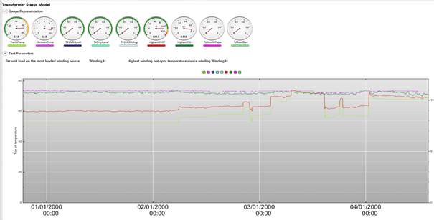

1. Motor Health Report (PDF)

Currently in 869, we have motor health report which consists of details about motor start records, event statistics etc. This content is not justifiable to call it as Motor health report especially in the context of 869 relay supporting ESA algorithms. Hence it is suggested to change existing motor health report to ‘motor operational report’. The following will be the new content proposed for motor health report (based on order code supported),

1. Motor nameplate details from settings [Path: System\Motor\Setup] & standard GE motor/869 relay image.
2. Report details including date/time of report generation, date/time range between which data is presented, relay name (device id/serial no), FW version.
3. Last snapshot of BRB, Stator inter-turn metering data as table (at the time of report generation using Modbus registers read) and corresponding settings.
4. Last snapshot of Bearing, Mechanical and Stator ESA baseline & monitoring data as table (at the time of report generation using Modbus registers read) and corresponding settings.
5. Last generated FFT waveform snapshot under Motor records with fault freq’s and dB levels and ESA circle for enabled functions.
6. **FFT Waveform:** Existing FFT waveform must be visualized as per I^2 FFT format. Below the FFT waveform a table showing dB values corresponding to each F1 to F15 fault frequency should be retrieved from ESA.csv file of FFT and displayed with S.No, Fault Freq (F1 to F15), Magnitude (dB) as headers of table.



1. **Baseline data of load bins shall be part of service report as a file (ESA baseline data.txt).**

### Events & Records

### Execution Rate

Every 1 minute

### Target Messages:

See Operands Table

### Event Recorder:

See Operands Table

**Factory Settings:**

Data Quality Check – Enable/Disable – Default (Enable)

Vicinity Check – Value (0.3 to 1.0 Hz) – Default (0.5 Hz)

**Path:** Setpoints\Factory\ESA



**Commands**

**Records/Clear Records**

**PATH:** Records\Clear Records



### HYSTERESIS

Dropout from Bearing & Eccentricity OP: 2%

### SECURITY COUNTS

2 counts for the Bearing & Eccentricity OP operand

### LEDs:

N/A

### Display Messages:

N/A

1. **Data for Validation:**
2. Baseline data capturing & process has to be screened properly including unavailability of data for particular load bin.
3. Load bin transition has to be verified accurately.
4. Data representation in software has to be checked with background FW files in the device.
5. Rate of change computation w.r.t baseline data has to be verified accurately.
6. FW results in device can be cross checked with MATLAB computation results.

**Data for implementation/pilot testing in v180:**

* Compute ESA in a cyclic manner at every 5 minutes.
* Fix operating frequency and compute speed for current cycle.
* Compute look-up table with target frequency list based on operating frequency and speed. Fix frequency vicinity as 0.5Hz (say).
* Perform data quality check based on available platform computed data.
* Use BRB FFT computation itself to compute bearing and Mechanical fault FFT computation in low priority task.
* Check for highest magnitude at target frequencies vicinity.
* Compute maximum (fault) dB and capture w.r.t frequency, speed and % load.
* For Pilot testing (w.r.t machine rating and application):

1. Workshop/lab – Capture ESA dB magnitudes during fault before repair and after repair. Make reference list.

2. Industrial Site – Compute ESA dB magnitudes, monitor rate of change over a period along with speed variation based on GRC suggested thresholds.

**Functional Block diagram for ESA – Bearing & Eccentricity (Not to exact scale)**

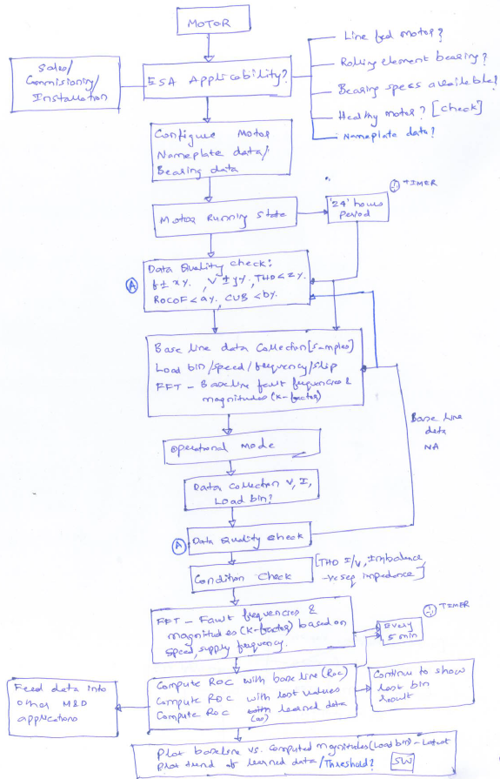

**Nomenclature**

- Number of rolling elements or ball bearings

- Rotor speed

- Ball diameter

- Cage diameter

- Vibrational frequency corresponding to bearing or eccentricity fault

- Bearing fault frequency

- Supply frequency

- Integer

- Energy computed at fault frequency during operational mode

- Energy computed at fault frequency during baseline mode

- Peak magnitude computed at fault frequency during baseline mode

- Peak magnitude computed at fault frequency during operational mode

- Frequency corresponding to mis-alignment or eccentricity fault

- Frequency corresponding to bearing fault

- slip

- Number of poles

- Number of pole pairs

- Rate of Change

- Rated input power

- Rated speed

- Rated slip

- Total input power

- Synchronous speed

- THD of current

- THD of voltage

- Negative sequence impedance

- Impedance at triplen frequency

- Supply frequency error

- Vicinity frequency range for bearing & eccentricity faults

**Appendix: Possible Enhancements or Product Differentiators for Future**

1. **Relation between ESA algorithms**

* ESA algorithms are interlinked. Correlating output of one algorithm with other algorithm and learning the correlation in assessing motor condition in a systematic manner.
* ESA analysis interlinking sub-systems condition for accurate health monitoring.

1. **Evaluating Rate of Change**

In section 2, we discussed about computing ESA output as a ratio of current value to its baseline value and converting that to dB indicating rate of change w.r.t baseline. Following options can also be considered in addition,

1. Storing last 50 values of peak magnitudes (dB) with time stamps in a file and computing rate of change recursively using the formula given below,



Where:

n = number of valid data points available in the time window

ti.pi = (time, unit) data pairs

The number of data points to be used for each ROC calculation depends on the time window. It shall be possible to configure a time window between 1 and 96 hours.

1. Alternately, difference in peak magnitude (dB) from latest computation to the baseline computation at the same fault frequency can be shown as deviation in dB.
2. **Fault Confidence Index (FCI)**

While computing ESA it is very important to evaluate how accurate the fault is and whether it can be trusted 100%. Due to the errors induced from the power supply side it is required to check whether the fault is really initiated due to mechanical wear & tear. Performing FFT on both voltage and current signals helps in coming up with ‘fault confidence index’ as shown below,

At each fault frequency of interest, compute the magnitude of voltage and current in dB w.r.t fundamental component.

|  |  |  |
| --- | --- | --- |
| **Fault  Frequency (Hz)** | **Voltage FFT Magnitude (dB)** | **Current FFT Magnitude (dB)** |
| f1 | V1 | I1 |
| . | . | . |
| . | . | . |
| . | . | . |
| . | . | . |
| . | . | . |
| . | . | . |
| fn | Vn | In |

For each computed magnitude of voltage and current in dB at specific fault frequency of interest, assuming that current FFT dB magnitude as equivalent to 1 dB compute equivalent normalized voltage FFT dB magnitude as,

Vn dB normalized = (Vn/In) * 1 dB = ‘Xn’

Fault confidence index (FCI) = X1 + X2 +……. + Xn, where n = number of fault frequencies

Ideally for ESA output to be 95-100% confident, FCI value should be much less than ‘n’ i.e. approximately < (0.1*n). If the value is in the range of (0.1*n) to (0.5*n) then it is better to check rate of change of ESA output from last 50 samples and wait for the computation of next few ESA outputs. However if the value is greater than (0.5*n) and closer to n, then ESA output cannot be trusted.

Where,

n = number of fault frequencies

Vn = Voltage magnitude at frequency ‘n’ from FFT computation

Fn = nth frequency value

In = Current magnitude at frequency ‘n’ from FFT computation

Xn = normalized Voltage magnitude at frequency ‘n’ w.r.t current magnitude at same frequency from FFT computation

FCI = Fault confidence index

1. **Fault Severity Index (FSI)**

As mentioned in section 3 it is important to know the confidence level of ESA algorithm output but at the same time it is very much important to know severity level of ESA algorithm output. Severity of ESA algorithm output can be computed using baseline and fault computed values as shown below,

|  |  |  |
| --- | --- | --- |
| **Fault  Frequency (Hz)** | **Baseline Current FFT Magnitude (dB)** | **Latest Current FFT Magnitude (dB)** |
| f1 | Ib1 | I1 |
| . | . | . |
| . | . | . |
| . | . | . |
| . | . | . |
| . | . | . |
| . | . | . |
| fn | Ibn | In |

For each computed magnitude of current in dB at specific fault frequency of interest during baseline and normal conditions, assuming that baseline current FFT dB magnitude as equivalent to 1 dB compute equivalent normalized current FFT dB magnitude as,

In dB normalized = (In/Ibn) * 1 dB = ‘Yn’

Fault severity index (FSI) = Y1 + Y2 +……. + Yn, where n = number of fault frequencies

Motor is said to be in 100% healthy condition if the value of FSI is equal to or less than ‘n’. If the value of FSI is in the range of ‘2n’ to ‘5n’ then it is caution condition and any value > ‘5n’ needs to be considered as alarm condition.

Where,

n = number of fault frequencies

Fn = nth frequency value

In = Current magnitude at frequency ‘n’ from FFT computation

In = Current magnitude during baseline at frequency ‘n’ from FFT computation

Yn = normalized current magnitude at frequency ‘n’ w.r.t current magnitude during baseline at same frequency from FFT computation

FSI = Fault severity index

1. **Literature analysis on ESA**

In literature ESA is computed for all faults based on center frequency identification. Almost all faults are identified w.r.t center frequency computed based on number of rotor bars or number of stator slots except for bearing fault. This method helps in implementing ESA in a more generic fashion for all types of mechanical, electrical faults and helps in distinguishing sub-categories of fault very easily. In 8-series we have different methods for broken rotor bar, stator inter-turn fault, bearing fault and mis-alignment fault. This is something which we need to look at aggressively and improve to have smoother implementation.

1. **BRB fault detection:**

Broken bars are generally found as slip frequency sidebands around the fundamental frequency. The rule of thumb is that faults are detected when these sidebands meet or exceed -35dB.

Slip frequency is computed as (Ns-Nr/Fs) where Ns is synchronous speed, Nr is rotational speed and Fs is supply frequency.

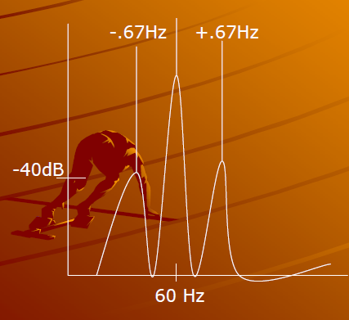

1. **Eccentricity:**

**Static eccentricity** can be found in the high frequency spectrum. Static eccentricity is calculated as running speed times the number of rotor bars with line frequency time’s N sidebands, where N is an odd integer.

Center frequency (CF) = fr * RB, where RB = no. of rotor bars and fr = rotational frequency = Nr/Fs.

Static eccentricity can be observed at frequencies, [CF +/- (k*Fs)], where ‘k’ is an integer.

**Dynamic eccentricity** differs from static eccentricity only in that there will also be running speed sidebands around the static eccentricity sidebands of the base frequency.

Center frequency (CF) = = fr * RB, where RB = no. of rotor bars and fr = rotational frequency = Nr/Fs.

Dynamic eccentricity can be observed at frequencies, {[CF+/- (N*Fs)] + /- Fr}.

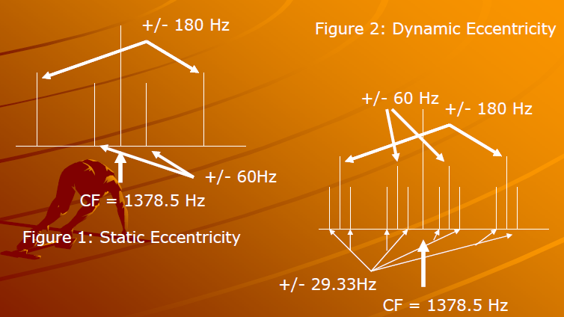

1. **Stator faults:**

Stator winding problems are found by first identifying stator slot passing frequencies. Stator frequencies are found by multiplying the number of stator slots by the running speed.

Center frequency (CF) = = fr * SS, where SS = no. of stator slots and fr = rotational frequency = Nr/Fs.

Stator faults can be observed at, [CF +/- Fr].

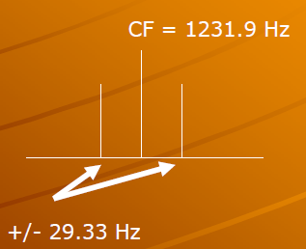

1. **Bearing faults:**

Bearing frequencies of interest can be computed as,

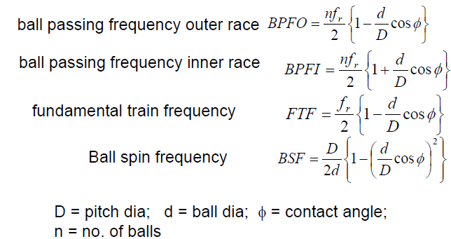

Fundamental bearing frequencies can be computed as,

1. (BPFO * Fr)
2. (BPFI * Fr)
3. (2 * BSF * Fr)
4. (FTF * Fr)

Fault frequencies of interest for bearing can be computed as,

1. {k*[BPFO*Fr]} +/- Fs
2. {k*[BPFI*Fr]} +/- Fs
3. {k*[2*BSF*Fr]} +/- Fs
4. {k*[FTF*Fr]} +/- Fs

Where, ‘k’ is an integer.

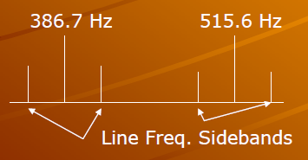

1. **Mechanical unbalance:**

Mechanical unbalance is found by determining the rotor bars times running speed. There will be line frequency sidebands around the center frequency, then a space of 4 times line frequency, then two twice line frequency peaks.

Center frequency (CF) = fr * RB, where RB = no. of rotor bars and fr = rotational frequency = Nr/Fs.

Mechanical unbalance can be found at, [CF + Fs], [CF + (5*Fs)], [CF + (7*Fs)]

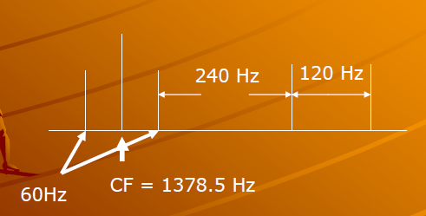

**Generic ESA Implementation:**

In this section, generic ESA implementation is discussed where in ESA is proposed as a platform feature to cater any fault and any asset type being monitored.

**Step 1**: Configure the fault type being monitored in the text box. Example – gear box failure.

**Step 2**: Identify the equation or formula which can be used to compute the frequencies at which fault can be monitored and the parameters used in the equation. Example - --- (1).

**Step 3:** Re-write or expand the equation in such a way that all the parameters in the equation should be either configured as constant, range or chosen from 869 internal metering computations and analog I/O channels. For example equation 1 in step 2 needs to be expanded as, Fe = (F1 ± m * (Nr/F1)), where rotational frequency, Fr = (Nr/F1) = Rotational speed/fundamental frequency.

In case of conditional equation like, 



Each equation has to be configured separately by describing the fault type as bearing – inner race, bearing – outer race and bearing – ball damage.

**Step 4:** Configure the equation using the equation editor in Enervista software, forming the equation by choosing appropriate symbols depicting the mathematical equation. Equation editor should support advanced scientific features as supported by generic windows calculator. All the parameters entered in the equation can be further configured as constant (number), range (min, max and increment) and/or assigned to any of the 869 internal computed metering parameter or measured analog channel parameter or asset configuration parameter.

For example, equation 1 in step 2 needs to be configured as,

Fe = gear box fault frequency

F1 = fundamental frequency – chose from supply frequency computed in 869

m = harmonic factor – configure as range with min = 1, max = 2, increment = 1

Nr = Rotational speed – chose from measured or estimated speed in 869

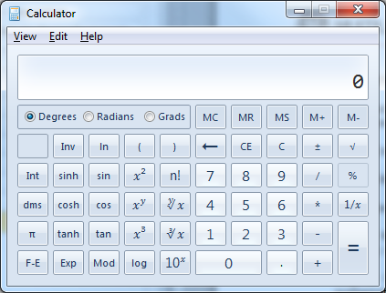

**Step 5:**  Configure the application as “constant speed/frequency” or “variable speed/frequency” type. In case of “constant speed/frequency”, compute the look-up table using steps 2-4 in software and load the table into device (firmware). In case of “variable speed/frequency”, compute the look-up table using steps 2-4 in device firmware during every ESA computation cycle (5 minutes).

The look-up table needs to be computed first with ‘+’ sign and then with ‘-‘ sign in the formula for each possible ‘m’ value in the range.

**Step 6:** Configure CT/PT analog channel based on order code, signal on which sampling and FFT needs to be performed.

**Step 7**: Compute FFT and extract the dB magnitudes at the frequencies specified in look-up table as a ratio of fault frequency magnitude and fundamental frequency magnitude. Extract the highest dB magnitude and corresponding fault frequency, load bin, supply frequency and speed.

**Step 8**: Log last 200 values of computed dB magnitudes in historical log along with corresponding fault frequency, load bin, supply frequency and speed.

**Step 9**: Compute Rate of Change (RoC) in the dB magnitude as standard deviation of data from historical data and represent as a trend chart.

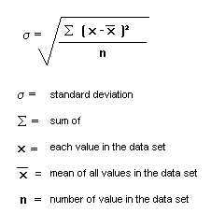

**Software Implementation:**

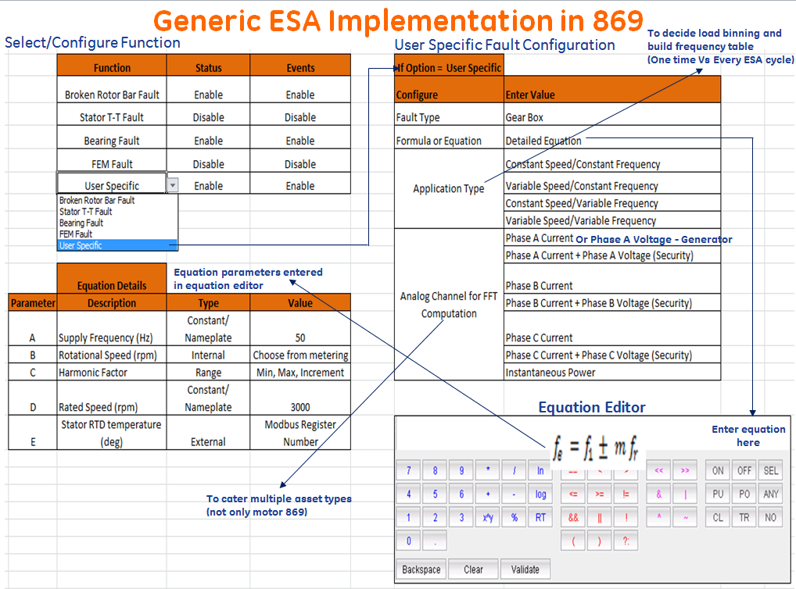

**ESA as a platform feature (Reverse computation):**

In this section, ESA as a platform feature is discussed. ESA is computed in a generic fashion as per the steps given below,

1. Choose or identify the metering channel on which FFT needs to be computed or applied.
2. Estimate the frequency range based on maximum possible sampling rate window, device frequency resolution computing capability, FFT width and possible fault frequencies, its range in general.
3. Compute the FFT in each ESA computation interval by applying band pass filter on the frequency range.
4. Extract the dB’s at all possible frequencies computed as the ratio of magnitude at that frequency (fn) w.r.t magnitude at the fundamental frequency.

FFT_normalized (fn) = FFT (fn)/FFT (fundamental frequency)

FFT_dB(fn) = 20logFFT_normalized(fn)

1. Filter all those frequencies and corresponding magnitudes which are induced due to the supply side harmonics by performing voltage FFT or those which represent harmonic frequencies (n * fundamental frequency, where n = 1, 2, 3…).
2. From the remaining frequencies extract three frequencies which has highest dB magnitude computed and represent in the metering as shown below,

|  |  |  |  |
| --- | --- | --- | --- |
| **Generic ESA frequency** | **Fault Frequency (Hz)** | **FFT Magnitude (dB)** |  |
| Generic ESA frequency 1 | F1 | X1 |  |
| Generic ESA frequency 2 | F2 | X2 |  |
| Generic ESA frequency 3 | F3 | X3 |  |

1. Represent these three frequencies with associated dB magnitudes as flex analog elements in the platform,

|  |
| --- |
| Generic ESA frequency 1 |
| Generic ESA frequency 2 |
| Generic ESA frequency 3 |

1. These flex analog elements can be used to create the flex logic with timer and security counts to identify if any of the particular frequency is continuously showing higher dB magnitude (Greater than configurable ‘X’ dB) for the time delay configured in timer.