Single Image Haze Removal Using Dark Channel Prior

*11510223 Wu Weipeng*

*Communication Engineering, Department of Electrical & Electronic Engineer, Southern University of Science and Technology*

*Abstract*—The aim of this project is to implement a novel approach for haze removal using dark channel prior. The referenced paper [1] raised a new kind of statistics of haze-free images—Dark Channel Prior. The paper thought that most local patches in outdoor haze-free images contain some pixels whose intensity is low in at least one color channel. According to this prior, it is possible to estimate the thickness of the haze and recover a high-quality haze-free image based on a general atmospheric model. Furthermore, I tried three methods to improve the performance. Firstly, I replaced the soft matting method with a guided filter to decrease run time. The second one is to implement the auto color gradation method and auto contrast method to enhance the saturation. Thirdly, I added a threshold for the system to recognize some components like airlight, which can improve the haze removal process on this part.

*Index Terms*—Haze Removal, Dark Channel Prior (DCP), Guided filter, Auto Color Gradation, Auto Contrast, Depth Estimation.

1. Introduction

The particles and water droplets in the atmosphere usually have a bad influence on the image of the outdoor scenes. The resulting atmospheric absorption and scattering attenuate the irradiance of the light. What’s more, the atmospheric degradation in recent years causes more ashes, haze and smokes as well, more outdoor images lose contrast and color fidelity. These degraded images affect related graphic works like photography, aerial surveying and so on. Therefore, haze removal[1] (dehazing) is of vital significance in computer vision and photography application.

However, the concentration of the haze is different from place to place in the hazy image and it’s hard to detect that. Thus, hazy removal is a challenging problem. Theoretically, because haze component decreases contrast of the image, the traditional dehazing methods in [2]-[4] is based on the contrast enhancement like global histogram equalization or local adaptive histogram equalization. However, these methods are limited if the input is only a single hazy image. The information in the single hazy image is not enough, so the researchers proposed some methods with multiple images as input. In [5], [6], [7] researchers raised polarization-based methods using multiple images. In [8], [9], [10], different weather conditions in a same scene were regarded as more constraints. [11] and [12] used the given depth information to remove haze in the hazy image.

With the development of image processing, some novel methods have been proposed recently in single image haze removal. These approaches are mostly based on the stronger prior or assumptions. In [13], Tan maximized the local contrast of the image based on the Markov random Field (MRF). However, the dehazing is successful but the output image is slightly over-saturated. In [14], Fattal used Independent Component Analysis (ICA), but the method is time-consuming and is not suitable for grayscale image. What’s more, a color attenuation prior [15] has been proposed to restore the scene radiance. They created a linear model for modeling the scene depth of the hazy image to estimate the transmission and use it to remove the hazy in the hazy image via the atmospheric scattering model.

In 2009, He *et al.* discovered and raised the principle of Dark Channel Prior based on a big number of experiment [1]. They thought that in most of the non-sky patches in an image at least one color channel has some pixels whose intensities are very low or close to zero. With this prior and a general atmospheric model, they estimate the thickness of haze and restore the haze-free image.

The novelty and efficiency of this method is impressive. Therefore, I choose this paper as my research project. I aim to implement this method to remove haze and improve the performance with more literature reviews. In this paper, I finally succeed in removing haze in the hazy image using the Dark Channel Prior. However, I found that it’s hard for the method to handle the edge of the hazy patch and sky region in the image. Then I reviewed some literatures for improvement. I applied a guided filter to preserve the edge of the hazy patch and add a parameter to distinguish sky region form the hazy patch in the image. Besides, I also used the auto contrast method to enhance the saturation of the result. In the end, the result showed a good performance in comparison with the result in the original paper.

The remainder of this paper is organized as follows: Section II are three literature reviews. Section III presents the basic principle of the Dark Channel Prior and the deprivation to the dehazing image. Section IV is the experimental result. I also show some improvements I’ve implemented and the related discussion. Finally, I present a conclusion in the section V.

1. Literature review

In recent years, most of the methods for single image dehazing were based on some stronger priors and assumptions. The following parts are two literature reviews using the albedo of the scene and color attenuation prior for haze removal.

In [14], this paper formulated a refined image formation model to estimate the optical transmission, which can eliminate the scattered light in hazy image to increase scene visibility and recover haze-free scene contrasts. They firstly interpreted the image through a model that accounts for surface shading in addition to the scene transmission. According to the refined image model, the input image is broken into regions of a constant albedo. For the constant albedo, they proposed an additional constraint which requires the surface shading and medium transmission functions to be locally statistically uncorrelated. Therefore, by depriving the constraint, the airlight-albedo ambiguity can be resolved, which requires the shading component to vary significantly compared to the noise present in the image. A graphical model is proposed to propagate the solution to pixels in which the signal-to-noise ratio falls below an admissible level. Besides, the deprivation of airlight color is from this uncorrelation principle. In comparison with traditional method for haze removal, this new method is passive; it does not require multiple input images of the scene, any light-blocking based polarization, any form of scene depth information, or any specialized sensors or hardware. In fact, the minimal requirement is just a single image acquired by an ordinary consumer camera. For an input image, the haze layer can be discontinuous in the scene depth or medium thickness, whose results can also achieve a significant reduction of the airlight and restores the contrasts of complex scenes. What’ more, the recovered transmission can help for the estimation of scene depths and more other applications. Nevertheless, this method is easy to be affected by insufficient signal-to-noise ratio or the absence of multiplicative variation in significant portions of the image like some heavily hazy image. Besides, the accuracy of the statistical estimation is also reduced by too few pixels in the image.

[15] proposed a color attenuation prior for the single image haze removal. Under this prior, the researcher raised a linear model for modeling the scene depth of the hazy image, whose related parameters are deprived by a supervised learning method. As a result, it can recover a significant depth information and restore the corresponding scene radiance via the atmospheric scattering model. According to the observation of a number of hazy images, it can be found that the intensity of each pixel in a hazy image is higher than the intensity of the pixel in real scene, but the saturation of the hazy image is much lower than the one of real scene. In the opinion of the researcher, it is hard to meet such a coincidence. They tested a lot of hazy images and did some related statistical analyses, which finally found an interesting novel prior—color attenuation prior. The color attenuation prior concludes that the thickness of haze is positively correlated with the difference between the intensity and the saturation of the pixel. The prior was primarily recognized as a linear correlation. Then it was configured as a corresponding linear model with multiple unknown parameters. With the method of supervised learning, researchers used about 500 hazy images and 120 million pixels with 517 generations as the training samples to determine these parameters. After the deprivation of these parameters, the linear model and correlation can be used to obtain the value of the depth information of the scene. Also, the estimation of the atmospheric light can be deprived from the depth mapping. The top 10% pixels with the highest intensity were recognized as the value of atmospheric light. Finally, based on the depth information and the atmospheric light, it can recover the scene radiance and restore the corresponding haze-free image. In conclusion, this method used a novel linear color attenuation prior to deprive the scene depth information based on the relation between the brightness and the saturation of the pixels, which presented a good performance in the experimental result. However, the scattering coefficient β in the atmospheric scattering model cannot be regarded as a constant in inhomogeneous atmosphere conditions. As a result, it’s easier for the dehazing algorithms to underestimate the transmission based on the atmospheric scattering model, which has a bad effect on the recovered scene depth information and the haze removal.

1. Principle

In this paper, I implement haze removal referring to [1] based on Dark Channel Prior. This part is going to narrate the related backgrounds and principles.

*ATMOSPHERIC MODEL*

For haze removal in computer vision and computer graphics, there is a widely-used atmospheric model:

where **I** is the observed intensity in the hazy image, **J** is the scene radiance, **A** is the global atmospheric light and t is the medium transmission. This medium transmission is the portion of light which is not scattered and reached the camera directly. Most of the haze removal method aim to deprive **J**, **A** and t from **I**. According to the equation of the atmospheric model, it can be recognized that the hazy image consists of the scene radiance with decays in the medium and the airlight results from previously scattered light. The challenge of this method is to obtain or estimate the corresponding J, **A** and t from **I** based on the proposed prior.

*DARK CHANNEL PRIOR*

In the observation on outdoor haze-free images, the author discovered an interesting phenomenon: In most of the nonsky patches, at least one color channel has some pixels whose intensity are very low and close to zero, which means that the minimum intensity in such a patch is close to zero. The reason of these low intensities are mainly shadows, colorful objects of surfaces with low reflectance in any color channel and other dark objects or surfaces. According to this observation, the author proposed a novel concept: Dark Channel. The dark channel of an image, is given as:

where is a color channel of **J** and is a local patch centered at x. The expression includes two minimal operators: is a minimum filter for a fixed window and is performed on each pixel for three color channels. Base on this concept, the author raised a prior: If **J** is an outdoor haze-free image, except the sky region, the intensity of **J** ‘s dark channel is very low and tends to be zero:

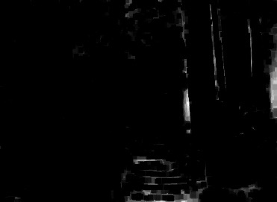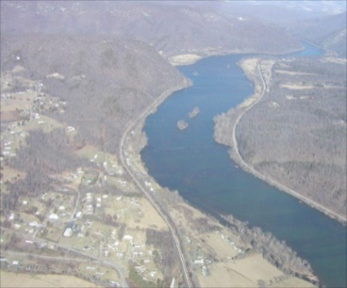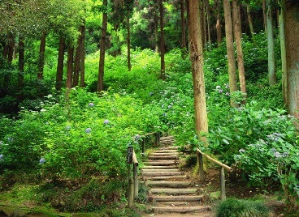which is the dark channel prior.

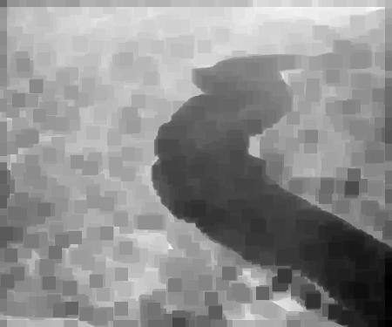(a) (b)

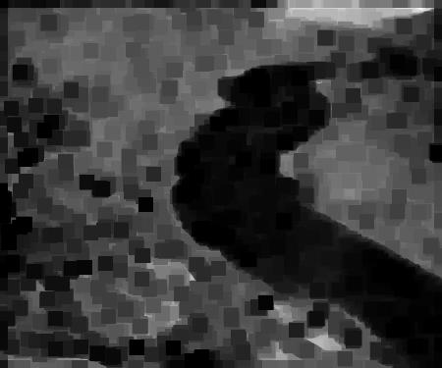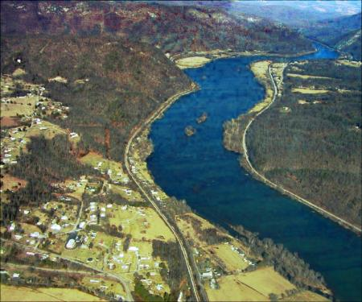(c) (d)

(e) (f)

Fig. 1. (a) Haze-free image. (b) Dark channel of haze-free image. (c) Hazy image. (d) Dark channel of (d). (e) Dehazing image of (c). (f) Dark channel of dehazing image of (e)

In [1], the researcher selected 5000 images with 500 pixels and manually cut out the sky region. Then they used these images to compute the dark channels using a patch size , which obtained a number of results corresponding to the dark channel prior and verified the significant performance of it. Fig.1 (a-d) shows serval outdoor hazy and haze-free images and the corresponding dark channels. Fig.1 (e) is the dehazing image of (c) and (f) is the dark channel of (e). It can be see that for a single image, the intensity of the dark channel of the hazy one is lower than the intensity of haze-free image.

*HAZE REMOVAL USING DARK CHANNEL PRIOR*

According to the atmospheric model (1), we can normalize the haze imaging equation on each color channel independently:

The transmission in each local patch is assumed as constant, which is denoted as . For equation (4), we calculate the dark channel on both sides:

Because the dark channel of J tends to zero,

is always positive, then

Therefore, we can obtain the estimation of :

In practice, there are always some particles in the atmosphere even on clear days. Therefore, haze cannot be removed completely considering some distant objects and the performance of scene depth. Therefore, the author proposed a parameter to maintain a small fraction of haze to improve the fidelity of the haze removed image:

It is obvious that the estimation of also derived from the global atmospheric light and the input hazy image. The estimation of the global atmospheric light is regarded as the most haze-opaque, which is the only illumination source of the scene. In this paper, the maximum value of top 10% pixels with the highest intensity in all three channels are estimated as the atmospheric light.

With the atmospheric and transmission map, the scene radiance can be recovered according to (1). However, when the value of transmission is too small, the intensity of J (the dehazing image) will increase too much, which is prone to noise. To solve this problem, the author set a threshold to restrict the transmission by a lower bound . The final scene radiance is recovered by:

1. Experimental Results

The following is the experimental results and some related improvements, which derives from window size in dark channel. The value of in the estimation of transmission is 0.95 and is 0.1. All the results are performed on an Intel PC (core i5-7200U @2.50GHz CPU, 8GB RAM).

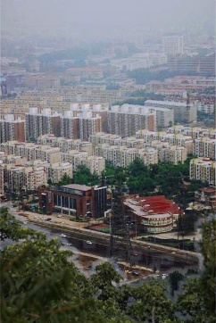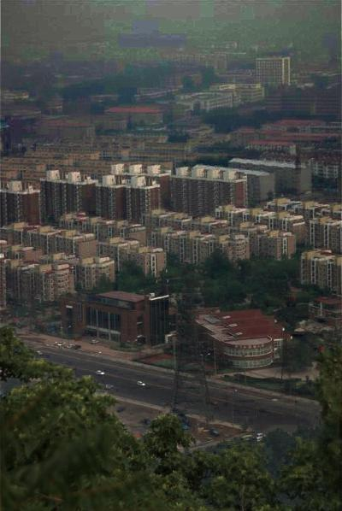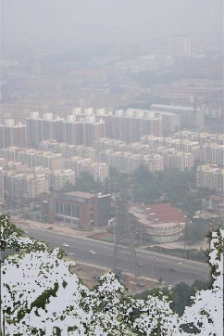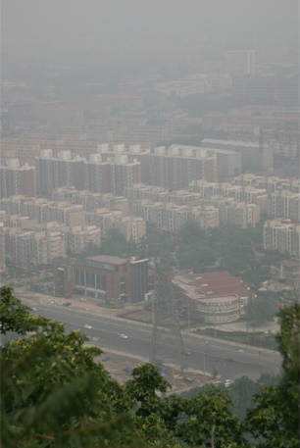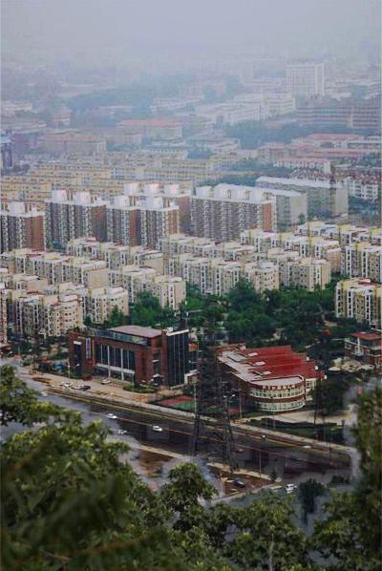Figs. 2 shows a primary result and its related dark channel and transmission map. The dark channel is computed based on (2), while the transmission map is estimated by (9). As the comparison shows, most of the haze in the original hazy image has been removed. However, it can be seen that there is some haze remained in the edge between hazy portion and haze-free portion in the image. In the original paper, the author used soft matting to improve the result, which can implement a good performance [1]. Nevertheless, the process of soft matting is time-consuming, which is not suitable for many real-time image processing in practice.

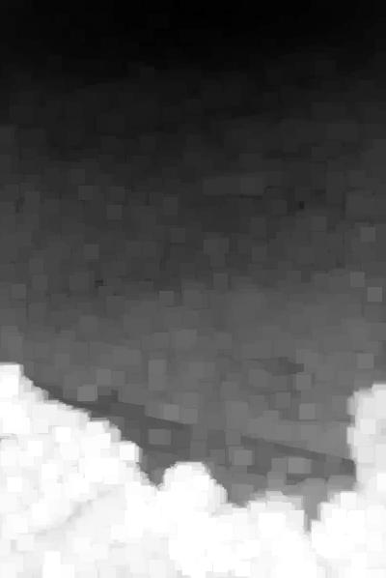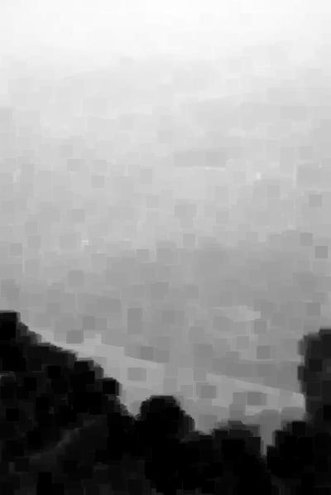(a) (b)

(c) (d)

Fig. 2 (a) Hazy Image. (b) Primary Result. (c) Dark Channel. (d) Transmission Map.

To solve this problem, I reviewed more literature and tried to find some method to process the edge of hazy image. After more learning about the haze removal, I understood that the remained haze came from the accuracy of the transmission map. When the transmission map is more accurate, the edge process of the recovered scene radiance can be more excellent. Then I learned that He *et al.* published a paper about the guided filter [16] in 2013. This filter is also an edge-preserving filter which is similar to bilateral filter. Derived from a local linear model, the guided filter computes the filtering output by considering the content of a guidance image, which can be the input image itself or another different image. Compare with the traditional edge-preserving filter, the guided filter is one of the fastest edge-preserving filters. Therefore, we can use the original hazy image as guidance image to improve the estimation of transmission map. Furthermore, I also learned that another guided filter—fast guided filter can be more efficient than the guided filter. Therefore, I implement both of two methods and did a comparison among all the results. Figs. 3 is the comparison among the result of no guided filter, guided filter and fast guided filter and the corresponding transmission map. In the comparison, we can see that with the help of guided filter, the transmission can be more accurate, which is more suitable to recover the scene radiance. The time consumption of fast guided filter is lower than the guided filter, but it cannot reach a performance as the guider filter can achieve. The difference in the recovering performance is much bigger than the comparison in time-consuming. As a result, I selected the guided filter as the improvement for edge processing in haze removal.

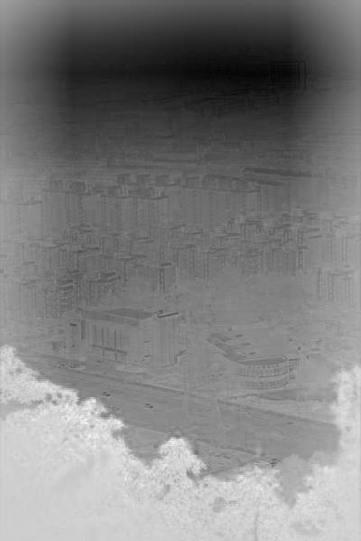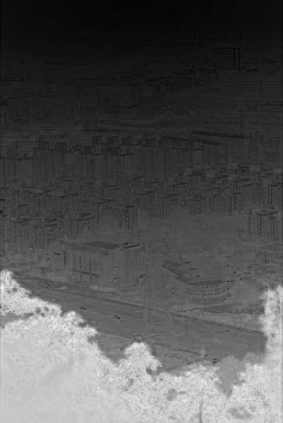(a) (b) (c)

(d) (e) (f)

Fig. 3 (a) Primary Result. (b) Guided Filtered Result. (c) Fast Filtered Result. (d) Transmission Map of Primary Result. (e) Transmission Map of Guided Filtered Result. (f) Transmission Map of Fast Filtered Result.

As for me, the result of guided filter is still flawed. The dehazing image seems dimmer than the original hazy image. Firstly, I tried the histogram equalization to enhance the result. What’s more, for more improvement, I also reviewed some websites and other literatures, and find two methods—auto color gradation and auto contrast to enhance the image [17]. According to the input ratio, the auto color gradation can automatically select a portion of pixels of all pixels in each channel. Then it recognizes two values in the range as the brightest and the darkest intensity and rearrange all the pixels in the channel based on the original distribution. Similarly, the auto contrast does the same adjustment but rearrange the pixels in all the channel field, which can avoid color shift in the result. Figs. 4 shows the comparison among the histogram equalization, auto color gradation and auto contrast. Compare with other results, the result of histogram equalization loses too much details. Besides, there are some color shifts appeared in the result of auto color gradation, which looks bluish in the image. As a result, the auto contrast is regarded as the further 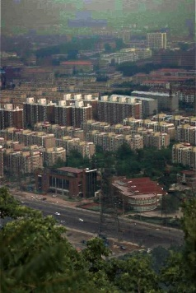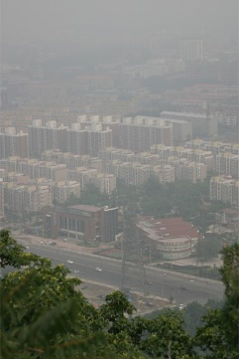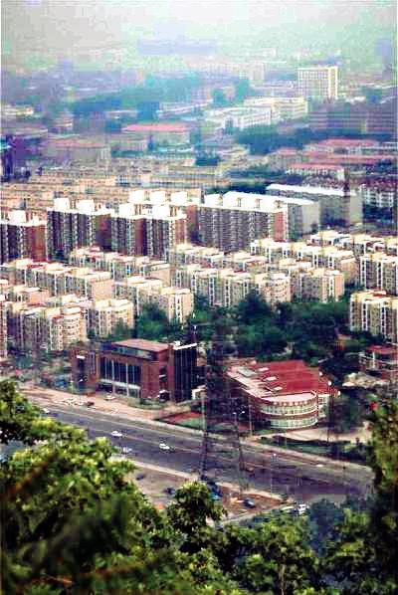step for improvement.

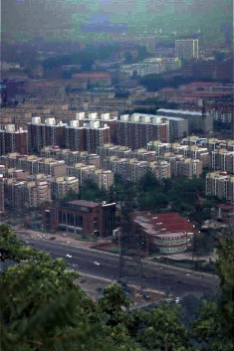(a) (b)

(c) (d)

Fig. 4 (a) Original Result. (b) Histogram Equalization. (c) Auto Color Gradation. (d) Auto Contrast.

With the help of auto contrast, it’s obvious that the dehazing image was enhanced. However, I noticed that in the sky region, there are some color fringes, which affects the result. As the author says, when the scene objects are inherently similar to the atmospheric light and no shadow is cast on them (such as the marble or snow), the performance of dark channel prior will be influenced badly. Then it will underestimate the transmission of these objects and overestimate the haze region. To sum up, it’s very easy for the dark channel prior to confuse the sky-like objects with haze. To overcome this difficulty, I reviewed other literature [18] and found that we can add a parameter to distinguish sky-like region from haze. Then we can respectively process this region and recover the desired scene radiance. With the addition of K, the equation (10) can be transformed into:

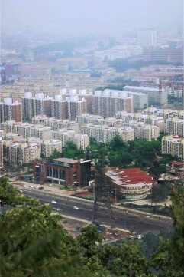In practice, the addition of K creates a comparison between the and . If the difference between them is larger than K, this region will be recognized as a normal region with haze. If the difference is smaller than K, it means that the observed intensity of this region is similar to the global atmospheric light, which can be recognized as a sky region. When the region is sky, then the value of the current recovered scene radiance is the same as the hazy image without haze removal. The comparison is shown in Fig. 5. It can be seen that the haze in the distant area with sky is kept partly, which improves the performance in the sky-like region and remains the scene depth information.

(a) (b) (c)

Fig. 5 (a)Hazy Image. (b) Original Result. (c) Improved Result.

In the end, Fig.6 will show more comparisons among the hazy image, our results and the results from MATLAB example. As the result shows, our method can remove more haze than the result from MATLAB example.

1. Conclusion

As the requirement of outdoor scene images is increasing, haze removal is highly desired in nowadays. According to some literature reviews, the referred paper [1] leverages the concept of dark channel prior to implement haze removal. In this paper, I implemented the related method, which uses the dark channel prior to estimate the transmission map and recover the scene radiance so as to remoze haze. However, there were still some aspects for this method to be improved. Therefore, I firstly tried a guided filter to obtain a more accurate transmission, which can efficiently decrease the haze in the edge. Then I implemented an auto contrast method to enhance the output image. At last, I added a parameter in the deprivation of the recovered scene radiance to distinguish the sky-like region with the haze. In the comparison among previous results and the results in MATLAB example, it’s obvious that the method gradually performs a better haze removal with good fidelity. In the future work, I may try to find more efficient filters to optimize the runtime and implement a higher quality of the haze removal.

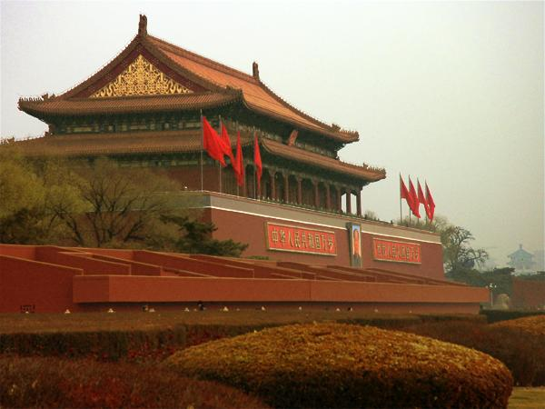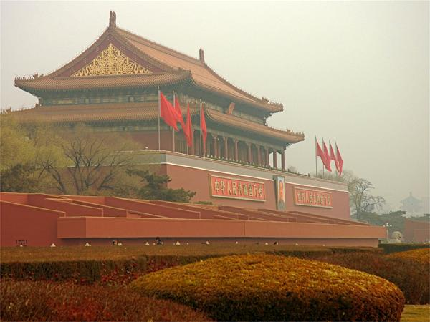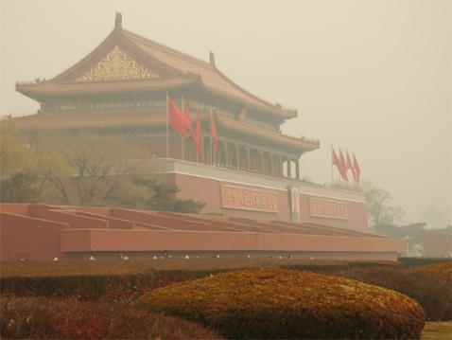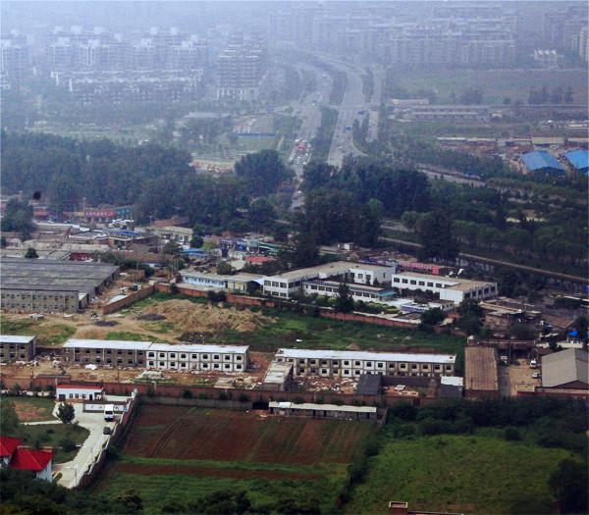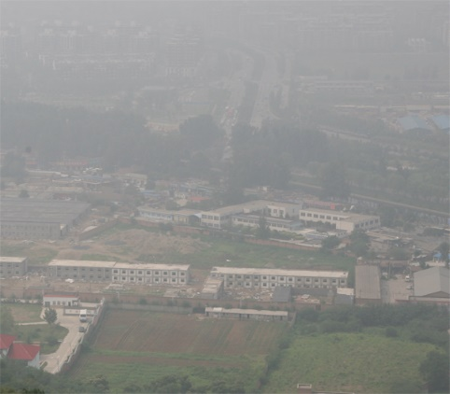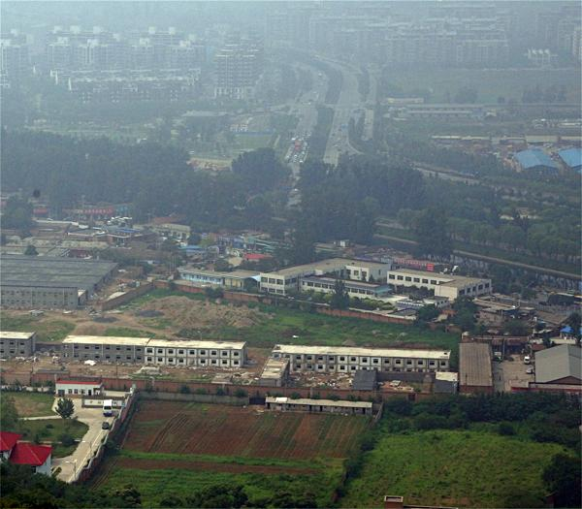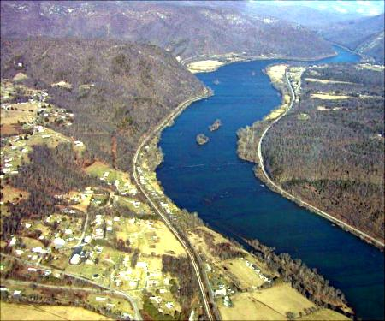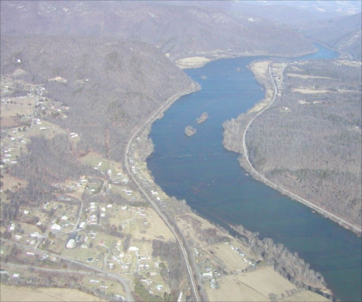(a) (b) (c)

Fig.6 (a)Hazy Image of. (b) MATLAB Result. (c) My Result.

References

[1] Kaiming He, Jian Sun and Xiaoou Tang, "Single Image Haze Removal Using Dark Channel Prior", IEEE Transactions on Pattern Analysis and Machine Intelligence, vol. 33, no. 12, pp. [2] Maurice Clerc, “Discrete Particle Swarm Optimization, illustrated by the Traveling Salesman Problem”, New Optimization Techniques in Engineering Studies in Fuzziness and Soft Computing Volume 141, pp 219-239, 2004.

[3] J. A. Stark, “Adaptive image contrast enhancement using generalizations of histogram equalization,” IEEE Trans. Image Process., vol. 9, no. 5, pp. 889–896, May 2000.

[4] J. -Y. Kim, L.-S. Kim, and S.-H. Hwang, “An advanced contrast enhancement using partially overlapped sub-block histogram equalization,” IEEE Trans. Circuits Syst. Video Technol., vol. 11, no. 4, pp. 475–484, Apr. 2001.

[5] Y. Y. Schechner, S. G. Narasimhan, and S. K. Nayar, “Instant dehazing of images using polarization,” in Proc. IEEE Conf. Comput. Vis. Pattern Recognit. (CVPR), 2001, pp. I-325–I-332.

[6] S. Shwartz, E. Namer, and Y. Y. Schechner, “Blind haze separation,” in Proc. IEEE Conf. Comput. Vis. Pattern Recognit. (CVPR), vol. 2. 2006, pp. 1984–1991.

[7] Y. Y. Schechner, S. G. Narasimhan, and S. K. Nayar, “Polarization-based vision through haze,” Appl. Opt., vol. 42, no. 3, pp. 511–525, 2003.

[8] S. G. Narasimhan and S. K. Nayar, “Chromatic framework for vision in bad weather,” in Proc. IEEE Conf. Comput. Vis. Pattern Recognit. (CVPR), Jun. 2000, pp. 598–605.

[9] S. K. Nayar and S. G. Narasimhan, “Vision in bad weather,” in Proc. IEEE Int. Conf. Comput. Vis. (ICCV), vol. 2. Sep. 1999, pp. 820–827.

[10] S. G. Narasimhan and S. K. Nayar, “Contrast restoration of weather degraded images,” IEEE Trans. Pattern Anal. Mach. Intell., vol. 25, no. 6, pp. 713–724, Jun. 2003.

[11] S. G. Narasimhan and S. K. Nayar, “Interactive (de) weathering of an image using physical models,” in Proc. IEEE Workshop Color Photometric Methods Comput. Vis., vol. 6. France, 2003, p. 1.

[12] J. Kopf et al., “Deep photo: Model-based photograph enhancement and viewing,” ACM Trans. Graph., vol. 27, no. 5, p. 116, Dec. 2008

[13] R. T. Tan, “Visibility in bad weather from a single image,” in Proc. IEEE Conf. Comput. Vis. Pattern Recognit. (CVPR), Jun. 2008, pp. 1–8.

[14] R. Fattal, “Single image dehazing,” ACM Trans. Graph., vol. 27, no. 3, p. 72, Aug. 2008.

[15] Qingsong Zhu, Jiaming Mai and Ling Shao, "A Fast Single Image Haze Removal Algorithm Using Color Attenuation Prior", IEEE Transactions on Image Processing, vol. 24, no. 11, pp. 3522-3533, 2015.

[15] Kaiming He, Jian Sun and Xiaoou Tang, "Guided Image Filtering", *IEEE Transactions on Pattern Analysis and Machine Intelligence*, vol. 35, no. 6, pp. 1397-1409, 2013.

[17] "局部自适应自动色阶/对比度算法在图像增强上的应用。 - Imageshop - 博客园", *Cnblogs.com*, 2018. [Online]. Available: http://www.cnblogs.com/Imageshop/p/3395968.html. [Accessed: 05- Jun- 2018].

[18] 蒋建国，侯天峰，齐美彬，改进的基于暗原色先验的图像去雾算法[A]，安徽，合肥工业大学，2011，07-16.

1. Haze, fog and smoke differ mainly in the material, size and concentration of the atmospheric particles. In this paper, we do not distinguish these similar phenomena and use the term *haze removal* for simplicity.