Supplementary information

Table S1. Number of sites per habitat type included in the study, and the subset in which bee-friendly management was implemented in 2022.
 | Field margin | Hedge | Pasture | Road verge | Water retention site | Species-rich grassland | Total
Total sites | 33 | 24 | 32 | 30 | 31 | 10 | 160
Managed sites | 9 | 8 | 10 | 10 | 10 | 0 | 47

Table S2. Global model formulas for bumblebee and solitary bee abundances.*
Response | Fixed effects | Random effects | Dispersion formula | Family | Temporal correlation structure
Bumblebee abundance | DegreeDays + FlowerCover + FlowerCover:DegreeDays + FlowerCover:LandscapeFC + LandscapeFC + LandscapeFC:DegreeDays + CumulativeLFC + CumulativeLFC:DegreeDays + LastYearLFC + LastYearLFC:DegreeDays + LastYearCLFC + LastYearCLFC:DegreeDays + ForestCover + HabitatType | (1 | Year) +  (1 | Transect) | DegreeDays + FlowerCover + ForestCover + HabitatType | Nbinom2 | Ou(timestep + 0 | ID)
Solitary bee abundance | DegreeDays + FlowerCover + FlowerCover:DegreeDays + FlowerCover:LandscapeFC + LandscapeFC + LandscapeFC:DegreeDays + CumulativeLFC + CumulativeLFC:DegreeDays + LastYearLFC + LastYearLFC:DegreeDays + LastYearCLFC + LastYearCLFC:DegreeDays + ForestCover + HabitatType | (1 | Year) +  (1 | Transect) | DegreeDays + FlowerCover*HabitatType + CumulativeLFC | Nbinom2 | Ou(timestep + 0 | ID)
*DegreeDays = temperature sums for days ≥ 5 °C since Jan 1; FlowerCover = transect flower cover (%); LandscapeFC = landscape flower cover (%); CumulativeLFC = cumulative landscape flower cover (%); LastYearLFC = average landscape flower cover of the previous year (%); LastYearCLFC = cumulative landscape flower cover of the previous year (%); ForestCover = landscape forest cover (%); HabitatType = transect habitat type; Nbinom2 = negative binomial family with quadratic parameterization; Ou = Ornstein-Uhlenbeck correlation structure; timestep = days passed since Jan 1, 2018; ID = dummy grouping variable (same for all observations, single time series).

Table S3. Model-averaged beta coefficients and 95% confidence intervals for bumblebee and solitary bee abundances.*
Predictor | Bumblebee abundance | Solitary bee abundance
Intercept | 0.3119 (-0.0683 - 0.6922) | 0.5038 (0.187 - 0.8206)
Degree days | 0.3344 (0.0721 - 0.5966) | 0.1867 (0.0303 - 0.343)
Flower cover | 1.2683 (1.1438 - 1.3928) | 0.8139 (0.6997 - 0.9281)
Flower cover * Degree days | 0.1556 (0.0403 - 0.2709) | 0.1012 (0.0114 - 0.191)
Flower cover * Landscape FC | 0.1004 (-0.0053 - 0.2061) | 0.0639 (-0.0372 - 0.1651)
Landscape FC | 0.0707 (-0.0611 - 0.2024) | 0.0024 (-0.1257 - 0.1305)
Landscape FC * Degree days | 0.0168 (-0.0723 - 0.1059) | 0.0186 (-0.0588 - 0.096)
Cumulative LFC | 0.1304 (-0.0103 - 0.271) | -0.0098 (-0.1505 - 0.1309)
Cumulative LFC * Degree days | -0.0301 (-0.1193 - 0.0591) | 0.0206 (-0.0538 - 0.0949)
Last year average LFC | 0.1167 (-0.0132 - 0.2466) | -0.0225 (-0.1579 - 0.1128)
Last year average LFC * Degree days | 0.0175 (-0.0695 - 0.1044) | 0.025 (-0.0487 - 0.0986)
Last year cumulative LFC | 0.074 (-0.0569 - 0.2049) | 0.0266 (-0.1098 - 0.163)
Last year cumulative LFC * Degree days | 0.0115 (-0.0674 - 0.0904) | 0.0148 (-0.0539 - 0.0835)
Forest cover | 0.0417 (-0.0826 - 0.166) | -0.0272 (-0.1537 - 0.0992)
Hedge | -0.1844 (-0.6638 - 0.295) | 0.2452 (-0.1959 - 0.6863)
Pasture | -0.2626 (-0.6449 - 0.1197) | 0.221 (-0.1707 - 0.6127)
Road verge | -0.2089 (-0.568 - 0.1502) | -0.0182 (-0.4057 - 0.3693)
Species rich grassland | 0.4923 (-0.0064 - 0.9911) | 0.2237 (-0.2998 - 0.7472)
Water retention site | -0.1144 (-0.4659 - 0.2372) | 0.7673 (0.4001 - 1.1345)
*Bold text indicates that beta coefficient confidence intervals do not overlap zero. FC = Flower cover; LFC = Landscape flower cover. Field margin habitat type is represented in the intercept.

Model | Degree days | Flower cover | Flower cover * Degree days | Flower cover * LFC | LFC | LFC * Degree days | CLFC | CLFC * Degree days | LYLFC | LYLFC * Degree days | LYCLFC | LYCLFC * Degree days | Forest cover | Habitat type | ΔAICc | ω_{m}
1 | 0.2921 | 1.2650 | 0.1412 | - | - | - | 0.1291 | - | - | - | - | - | - | + | 0.00 | 0.10
2 | 0.3548 | 1.2577 | 0.1603 | 0.0921 | 0.0579 | - | - | - | - | - | - | - | - | + | 0.31 | 0.09
3 | 0.3686 | 1.2662 | 0.1440 | - | - | - | - | - | 0.1118 | - | - | - | - | + | 0.44 | 0.08
4 | 0.3412 | 1.2780 | 0.2005 | 0.1116 | 0.0700 | - | - | - | - | - | - | - | - | - | 1.20 | 0.06
5 | 0.3567 | 1.2656 | 0.1440 | - | 0.0916 | - | - | - | - | - | - | - | - | + | 1.25 | 0.06
6 | 0.3449 | 1.2772 | 0.1432 | - | - | - | - | - | - | - | - | - | - | + | 1.34 | 0.05
7 | 0.2842 | 1.2631 | 0.1520 | - | - | - | 0.1283 | -0.0302 | - | - | - | - | - | + | 1.62 | 0.05
8 | 0.2961 | 1.2640 | 0.1405 | - | - | - | 0.1204 | - | - | - | - | - | 0.0292 | + | 1.84 | 0.04
9 | 0.2654 | 1.2847 | 0.1755 | - | - | - | 0.1565 | - | - | - | - | - | - | - | 1.98 | 0.04
10 | 0.3467 | 1.2711 | 0.1437 | - | - | - | - | - | - | - | 0.0755 | - | - | + | 2.08 | 0.04
11 | 0.3556 | 1.2582 | 0.1555 | 0.0927 | 0.0612 | 0.0136 | - | - | - | - | - | - | - | + | 2.29 | 0.03
12 | 0.3703 | 1.2663 | 0.1372 | - | - | - | - | - | 0.1172 | 0.0175 | - | - | - | + | 2.35 | 0.03
13 | 0.3597 | 1.2856 | 0.1785 | - | - | - | - | - | 0.1400 | - | - | - | - | - | 2.36 | 0.03
14 | 0.3596 | 1.2545 | 0.1536 | 0.0971 | 0.0475 | - | - | - | - | - | - | - | 0.0488 | + | 2.51 | 0.03
15 | 0.3388 | 1.2741 | 0.1988 | 0.1092 | 0.0546 | - | - | - | - | - | - | - | 0.0488 | - | 2.63 | 0.03
16 | 0.3018 | 1.2623 | 0.1348 | - | - | - | 0.1185 | - | - | - | - | - | 0.0412 | + | 2.75 | 0.03
17 | 0.3430 | 1.2786 | 0.1919 | 0.1126 | 0.0756 | 0.0259 | - | - | - | - | - | - | - | - | 2.90 | 0.02
18 | 0.3561 | 1.2643 | 0.1428 | - | 0.0829 | - | - | - | - | - | - | - | 0.0375 | + | 2.94 | 0.02
19 | 0.3714 | 1.2632 | 0.1373 | - | - | - | - | - | 0.1005 | - | - | - | 0.0455 | + | 3.17 | 0.02
20 | 0.3573 | 1.2659 | 0.1402 | - | 0.0943 | 0.0105 | - | - | - | - | - | - | - | + | 3.26 | 0.02
21 | 0.3509 | 1.2719 | 0.1356 | - | - | - | - | - | - | - | - | - | 0.0675 | + | 3.38 | 0.02
22 | 0.2882 | 1.2621 | 0.1511 | - | - | - | 0.1199 | -0.0297 | - | - | - | - | 0.0282 | + | 3.47 | 0.02
23 | 0.2727 | 1.2813 | 0.1749 | - | - | - | 0.1382 | - | - | - | - | - | 0.0431 | - | 3.56 | 0.02
24 | 0.3457 | 1.2872 | 0.1788 | - | 0.1183 | - | - | - | - | - | - | - | - | - | 3.57 | 0.02
25 | 0.3368 | 1.2723 | 0.1649 | - | - | - | - | - | - | - | 0.0802 | 0.0115 | - | + | 3.68 | 0.02
26 | 0.3437 | 1.2634 | 0.1814 | 0.0937 | 0.0536 | 0.0177 | - | - | - | - | - | - | 0.0357 | + | 3.70 | 0.02
27 | 0.3471 | 1.2695 | 0.1424 | - | - | - | - | - | - | - | 0.0643 | - | 0.0403 | + | 3.71 | 0.02
Table S4. Beta coefficients, delta AICc, and model weights for candidate models predicting bumblebee abundance.

*LFC = landscape flower cover; CLFC = cumulative landscape flower cover; LYLFC = average landscape flower cover of the previous year; LYCLFC = cumulative landscape flower cover of the previous year; ω_{m} = model weight.

Table S5. Beta coefficients, delta AICc, and model weights for candidate models predicting solitary bee abundance.
Model | Degree days | Flower cover | Flower cover * Degree days | Flower cover * LFC | LFC | LFC * Degree days | CLFC | CLFC * Degree days | LYLFC | LYLFC * Degree days | LYCLFC | LYCLFC * Degree days | Forest cover | Habitat type | ΔAICc | ω_{m}
1 | 0.1845 | 0.8126 | 0.1014 | - | - | - | - | - | - | - | - | - | - | + | 0.00 | 0.23
2 | 0.1845 | 0.8137 | 0.1018 | - | - | - | - | - | - | - | - | - | -0.0261 | + | 1.90 | 0.09
3 | 0.1841 | 0.8113 | 0.1017 | - | - | - | - | - | - | - | 0.0255 | - | - | + | 1.93 | 0.09
4 | 0.1812 | 0.8139 | 0.1010 | - | - | - | - | - | -0.0236 | - | - | - | - | + | 1.95 | 0.09
5 | 0.1856 | 0.8118 | 0.1016 | - | 0.0080 | - | - | - | - | - | - | - | - | + | 2.05 | 0.08
6 | 0.1858 | 0.8096 | 0.1112 | 0.0639 | -0.0141 | - | - | - | - | - | - | - | - | + | 2.57 | 0.06
7 | 0.2229 | 0.8259 | - | - | - | - | - | - | - | - | - | - | - | + | 2.99 | 0.05
8 | 0.1898 | 0.8170 | 0.1028 | - | - | - | -0.0133 | - | - | - | - | - | - | + | 3.21 | 0.05
9 | 0.1815 | 0.8183 | 0.0920 | - | - | - | - | - | -0.0237 | 0.0250 | - | - | - | + | 3.58 | 0.04
10 | 0.1839 | 0.8123 | 0.1024 | - | - | - | - | - | - | - | 0.0346 | - | -0.034 | + | 3.73 | 0.04
11 | 0.1842 | 0.8142 | 0.0959 | - | - | - | - | - | - | - | 0.0209 | 0.0148 | - | + | 3.83 | 0.03
12 | 0.1923 | 0.8171 | 0.0944 | - | - | - | -0.0125 | 0.0206 | - | - | - | - | - | + | 3.83 | 0.03
13 | 0.1851 | 0.8147 | 0.0945 | - | 0.0083 | 0.0186 | - | - | - | - | - | - | - | + | 3.90 | 0.03
14 | 0.1818 | 0.8146 | 0.1015 | - | - | - | - | - | -0.0185 | - | - | - | -0.0225 | + | 3.90 | 0.03
15 | 0.1864 | 0.8124 | 0.1021 | - | 0.0144 | - | - | - | - | - | - | - | -0.0292 | + | 3.92 | 0.03
16 | 0.1851 | 0.8138 | 0.1018 | - | - | - | -0.0018 | - | - | - | - | - | -0.0257 | + | 3.97 | 0.03
*LFC = landscape flower cover; CLFC = cumulative landscape flower cover; LYLFC = average landscape flower cover of the previous year; LYCLFC = cumulative landscape flower cover of the previous year; ω_{m} = model weight.

Table S6. All bee species recorded and their total abundances.
Species | Abundance
Andrena angustior | 3
Andrena bicolor | 35
Andrena bimaculata | 1
Andrena carantonica | 2
Andrena chrysosceles | 37
Andrena cineraria | 34
Andrena clarkella | 1
Andrena denticulata | 1
Andrena dorsata | 97
Andrena flavipes | 296
Andrena florea | 442
Andrena fulva | 5
Andrena fulvago | 22
Andrena fulvata | 5
Andrena gravida | 75
Andrena haemorrhoa | 98
Andrena hattorfiana | 70
Andrena humilis | 23
Andrena labialis | 147
Andrena labiata | 63
Andrena lathyri | 13
Andrena minutula | 92
Andrena minutuloides | 60
Andrena mitis | 4
Andrena nigroaenea | 5
Andrena nitida | 44
Andrena nitidiuscula | 7
Andrena ovatula | 196
Andrena pandellei | 2
Andrena polita | 1
Andrena proxima | 61
Andrena rosae | 3
Andrena scotica | 11
Andrena semilaevis | 3
Andrena sp. | 9
Andrena strohmella | 2
Andrena subopaca | 26
Andrena tibialis | 4
Andrena trimmerana | 1
Andrena vaga | 3
Andrena varians | 1
Andrena ventralis | 1
Andrena viridescens | 23
Andrena wilkella | 63
Anthidiellum strigatum | 7
Anthidium manicatum | 4
Anthidium oblongatum | 15
Anthidium punctatum | 10
Anthophora aestivalis | 1
Anthophora furcata | 5
Anthophora plumipes | 2
Anthophora retusa | 90
Bombus bohemicus | 4
Bombus campestris | 38
Bombus hortorum | 347
Bombus hypnorum | 57
Bombus lapidarius | 3787
Bombus lucorum (male) | 20
Bombus pascuorum | 2656
Bombus pratorum | 128
Bombus rupestris | 6
Bombus sp. | 20
Bombus sylvarum | 3
Bombus sylvestris | 12
Bombus terrestris complex | 1728
Bombus vestalis | 182
Ceratina cyanea | 21
Chelostoma campanularum | 51
Chelostoma distinctum | 8
Chelostoma florisomne | 34
Chelostoma rapunculi | 22
Coelioxys elongata | 1
Coelioxys inermis | 2
Coelioxys mandibularis | 1
Coelioxys rufescens | 1
Colletes cunicularius | 7
Colletes daviesanus | 56
Colletes similis | 11
Dasypoda hirtipes | 1
Epeolus variegatus | 4
Eucera longicornis | 9
Eucera nigrescens | 19
Halictus maculatus | 3
Halictus quadricinctus | 442
Halictus rubicundus | 18
Halictus scabiosae | 1229
Halictus sp. | 2
Halictus tumulorum | 187
Heriades truncorum | 64
Hoplitis adunca | 2
Hoplitis leucomelana | 33
Hylaeus brevicornis | 10
Hylaeus communis | 36
Hylaeus confusus | 11
Hylaeus cornutus | 1
Hylaeus difformis | 5
Hylaeus dilatatus | 39
Hylaeus gredleri | 31
Hylaeus hyalinatus | 8
Hylaeus incongruus | 2
Hylaeus paulus | 2
Hylaeus pictipes | 1
Hylaeus punctulatissimus | 3
Hylaeus signatus | 3
Hylaeus sp. | 3
Hylaeus styriacus | 4
Lasioglossum albipes | 4
Lasioglossum calceatum | 120
Lasioglossum fratellum | 1
Lasioglossum fulvicorne | 22
Lasioglossum laticeps | 47
Lasioglossum lativentre | 87
Lasioglossum leucopus | 1
Lasioglossum leucozonium | 223
Lasioglossum lineare | 1
Lasioglossum lucidulum | 1
Lasioglossum malachurum | 217
Lasioglossum minutissimum | 24
Lasioglossum morio | 158
Lasioglossum nitidiusculum | 5
Lasioglossum nitidulum | 1
Lasioglossum pallens | 11
Lasioglossum parvulum | 11
Lasioglossum pauxillum | 1693
Lasioglossum punctatissimum | 9
Lasioglossum pygmaeum | 2
Lasioglossum semilucens | 6
Lasioglossum sexnotatum | 8
Lasioglossum sexstrigatum | 1
Lasioglossum sp. | 27
Lasioglossum villosulum | 243
Lasioglossum xanthopus | 1
Lasioglossum zonulum | 5
Macropis europaea | 1
Macropis fulvipes | 4
Megachile centuncularis | 14
Megachile ericetorum | 36
Megachile lapponica | 3
Megachile ligniseca | 4
Megachile pilidens | 1
Megachile rotundata | 2
Megachile sp. | 2
Megachile versicolor | 41
Megachile willughbiella | 34
Melecta luctuosa | 1
Melitta haemorrhoidalis | 4
Melitta leporina | 142
Nomada bifasciata | 28
Nomada conjungens | 12
Nomada distinguenda | 40
Nomada fabriciana | 14
Nomada femoralis | 4
Nomada ferruginata | 1
Nomada flava | 107
Nomada flavoguttata | 23
Nomada flavopicta | 47
Nomada fucata | 65
Nomada fulvicornis | 1
Nomada goodeniana | 57
Nomada guttulata | 1
Nomada integra | 4
Nomada lathburiana | 19
Nomada marshamella | 33
Nomada mutica | 1
Nomada panzeri | 13
Nomada ruficornis | 48
Nomada sexfasciata | 2
Nomada sheppardana | 9
Nomada signata | 3
Nomada sp. | 15
Nomada stigma | 17
Nomada striata | 4
Nomada succincta | 3
Nomada villosa | 1
Nomada zonata | 8
Osmia aurulenta | 11
Osmia bicornis | 34
Osmia caerulescens | 7
Osmia cornuta | 2
Osmia leaiana | 7
Osmia niveata | 14
Osmia spinulosa | 8
Panurgus banksianus | 1
Panurgus calcaratus | 18
Sphecodes albilabris | 11
Sphecodes crassus | 17
Sphecodes ephippius | 49
Sphecodes geoffrellus | 3
Sphecodes gibbus | 12
Sphecodes majalis | 17
Sphecodes miniatus | 17
Sphecodes monilicornis | 55
Sphecodes niger | 3
Sphecodes puncticeps | 5
Sphecodes reticulatus | 8
Sphecodes rubicundus | 8
Sphecodes sp. | 1
Stelis breviuscula | 3
Stelis ornatula | 3
Stelis phaeoptera | 4
Trachusa byssina | 1
Unidentified | 70
Total | 17788

Table S7. All flower species recorded.

Achillea millefolium
Aegopodium podagraria
Aethusa cynapium
Agrimonia eupatoria
Agrostemma githago
Ajuga reptans
Alliaria petiolata
Allium cepa
Allium vineale
Ammi majus
Anacamptis morio
Anagallis arvensis
Anchusa arvensis
Anthemis arvensis
Anthemis tinctoria
Anthriscus sylvestris
Anthyllis vulneraria
Aquilegia vulgaris
Arabidopsis thaliana
Arctium minus
Arenaria leptoclados
Arenaria serpyllifolia
Aronia melanocarpa
Astragalus glycyphyllos
Barbarea intermedia
Barbarea vulgaris
Bellis perennis
Berberis vulgaris
Berula erecta
Borago officinalis
Brassica napus
Brassica nigra
Brassica rapa
Bryonia dioica
Bunium bulbocastanum
Camelina sativa
Campanula rapunculoides

Campanula rapunculus
Campanula rotundifolia
Campanula trachelium
Capsella bursa-pastoris
Cardamine hirsuta
Cardamine pratensis
Carduus crispus
Carduus nutans
Carum carvi
Centaurea cyanus
Centaurea jacea
Centaurea scabiosa
Centaurium erythraea
Cerastium arvense
Cerastium fontanum
Cerastium glomeratum
Cerastium semidecandrum
Chaemerion angustifolium
Chaenorhinum minus
Chaerophyllum temulum
Chelidonium majus
Cichorium intybus
Cirsium arvense
Cirsium palustre
Cirsium vulgare
Clematis vitalba
Clinopodium acinos
Clinopodium vulgare
Conium maculatum
Convolvulus arvensis
Convolvulus sepium
Conyza canadensis
Coriandrum sativum
Cornus mas
Cornus sanguinea
Cosmos bipinnatus
Crataegus laevigata
Crataegus monogyna
Crepis biennis
Crepis capillaris
Crepis vesicaria
Cruciata laevipes
Cytisus scoparius
Dactylorhiza fuchsii
Daucus carota
Dianthus armeria
Dipsacus fullonum
Dipsacus pilosus
Draba verna
Echium vulgare
Epilobium ciliatum
Epilobium hirsutum
Epilobium parviflorum
Epilobium tetragonum
Epipactis muelleri
Erigeron acer
Erigeron annuus
Erigeron canadensis
Erigeron sumatrensis
Erodium cicutarium
Erysimum cheiranthoides
Euonymus europaeus
Eupatorium cannabinum
Euphorbia helioscopia
Euphrasia stricta
Fagopyrum esculentum
Fallopia convolvulus
Ficaria verna
Filipendula ulmaria
Fragaria vesca
Fumaria officinalis
Galeopsis tetrahit
Galinsoga parviflora
Galinsoga quadriradiata
Galium mollugo
Galium palustre
Galium pumilum
Galium verum
Genista tinctoria
Geranium columbinum
Geranium dissectum
Geranium molle
Geranium pusillum
Geranium pyrenaicum
Geranium robertianum
Geum urbanum
Gilia capitata
Glebionis segetum
Glechoma hederacea
Gymnadenia conopsea
Gypsophila muralis
Helminthotheca echioides
Heracleum sphondylium
Hieracium aurantiacum
Hieracium pilosella
Hieracium sabaudum
Hieracium sect. Tridentata
Hyacinthus sp.
Hypericum humifusum
Hypericum maculatum
Hypericum perforatum
Hypochaeris radicata
Ilex aquifolium
Jacobaea aquatica
Jacobaea erucifolia
Jacobaea vulgaris
Knautia arvensis
Lactuca serriola
Lamium album
Lamium galeobdolon
Lamium purpureum
Lapsana communis
Lathyrus aphaca
Lathyrus latifolius
Lathyrus pratensis
Leontodon autumnalis
Leontodon hispidus
Leontodon saxatilis
Leucanthemum vulgare
Ligustrum vulgare
Linaria vulgaris
Linum catharticum
Linum usitatissimum
Lithospermum arvense
Lonicera periclymenum
Lotus corniculatus
Lotus pedunculatus
Lysimachia nummularia
Malva alcea
Malva moschata
Malva neglecta
Malva sylvestris
Matricaria chamomilla
Matricaria discoidea
Medicago lupulina
Medicago sativa
Melilotus albus
Melilotus altissimus
Melilotus officinalis
Melissa officinalis
Mentha arvensis
Mentha suaveolens
Moehringia trinervia
Myosotis arvensis
Myosotis discolor
Myosotis ramosissima
Myosotis scorpioides
Myosotis stricta
Myosotis sylvatica
Neottia ovata
Oenothera glazioviana
Onobrychis viciifolia
Ononis spinosa
Ophrys apifera
Orchis militaris
Orchis purpurea
Origanum vulgare
Orlaya grandiflora
Ornithogalum umbellatum
Ornithopus sativus
Orobanche minor
Oxalis stricta
Papaver dubium
Papaver rhoeas
Pastinaca sativa
Persicaria maculosa
Phacelia tanacetifolia
Phytolacca acinosa
Phytolacca esculenta
Picris echiodes
Picris hieracioides
Pilosella aurantiaca
Pilosella officinarum
Pilosella piloselloides
Pimpinella major
Pimpinella saxifraga
Pisum sativum
Plantago lanceolata
Plantago media
Platanthera bifolia
Polygala comosa
Polygala vulgaris
Polygonatum multiflorum
Polygonatum odoratum
Polygonum aviculare
Potentilla anserina
Potentilla reptans
Potentilla sterilis
Potentilla tabernaemontani
Primula veris
Prunella vulgaris
Prunus avium
Prunus padus
Pulicaria dysenterica
Ranunculus acris
Ranunculus bulbosus
Ranunculus repens
Ranunculus sceleratus
Raphanus raphanistrum
Reseda lutea
Reseda luteola
Rhamnus cathartica
Rhinanthus alectorolophus
Rhinanthus angustifolius
Rhinanthus minor
Robinia pseudo-acacia
Rosa arvensis
Rosa canina
Rubus caesius
Rubus fruticosus
Sagina procumbens
Salvia verticillata
Sambucus nigra
Sambucus racemosa
Sanguisorba minor
Scabiosa columbaria
Scorzoneroides autumnalis
Scrophularia nodosa
Selinum carvifolia
Senecio inaequidens
Senecio sylvaticus
Senecio vulgaris
Sherardia arvensis
Silene dioica
Silene flos-cuculi
Silene latifolia
Silene vulgaris
Sinapis alba
Sinapis arvensis
Sisymbrium officinale
Solanum dulcamara
Solanum nigrum
Solanum tuberosum
Sonchus arvensis
Sonchus asper
Sonchus oleraceus
Stachys arvensis
Stachys palustris
Stachys sylvatica
Stellaria graminea
Stellaria holostea
Stellaria media
Tanacetum vulgare
Taraxacum officinale
Thlaspi arvense
Thymus pulegioides
Torilis japonica
Tragopogon pratensis
Trifolium arvense
Trifolium campestre
Trifolium dubium
Trifolium hybridum
Trifolium incarnatum
Trifolium pratense
Trifolium repens
Tripleurospermum maritimum
Valeriana officinalis
Valerianella locusta
Verbascum densiflorum
Verbascum nigrum
Verbascum thapsus
Verbena officinalis
Veronica agrestis
Veronica arvensis
Veronica beccabunga
Veronica chamaedrys
Veronica filiformis
Veronica hederifolia
Veronica officinalis
Veronica persica
Veronica polita
Veronica serpyllifolia
Viburnum opulus
Vicia cracca
Vicia faba
Vicia hirsuta
Vicia sativa
Vicia sepium
Vicia tetrasperma
Vicia villosa
Viola arvensis

Table S8. The top ten flower species that contribute most to midsummer (July) flower cover, in order from greatest to least.
Daucus carota
Achillea millefolium
Trifolium repens
Heracleum sphondylium
Trifolium pratense
Centaurea jacea
Origanum vulgare
Papaver rhoeas
Medicago sativa
Fagopyrum esculentum

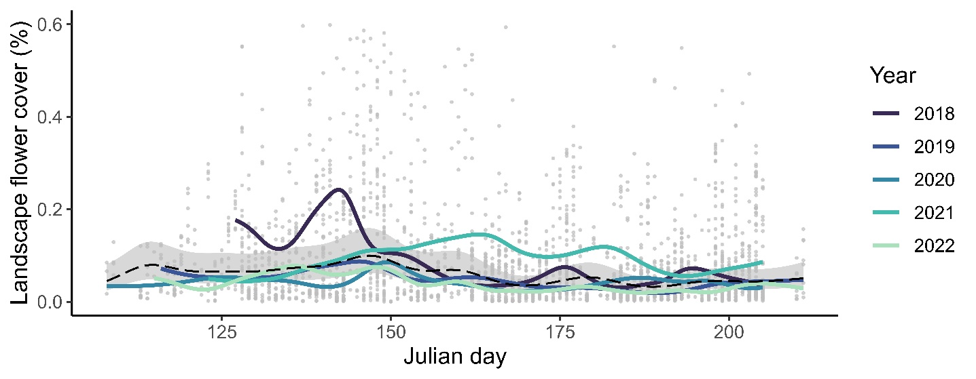
Fig S1. Predictions for landscape flower cover (%) from May through July (plotted against Julian day), back-transformed from the log scale. Dashed line represents mean values across all years, with 95% confidence interval. Points represent raw data; some high value points (> 0.6%) have been obscured for considerations of scale.

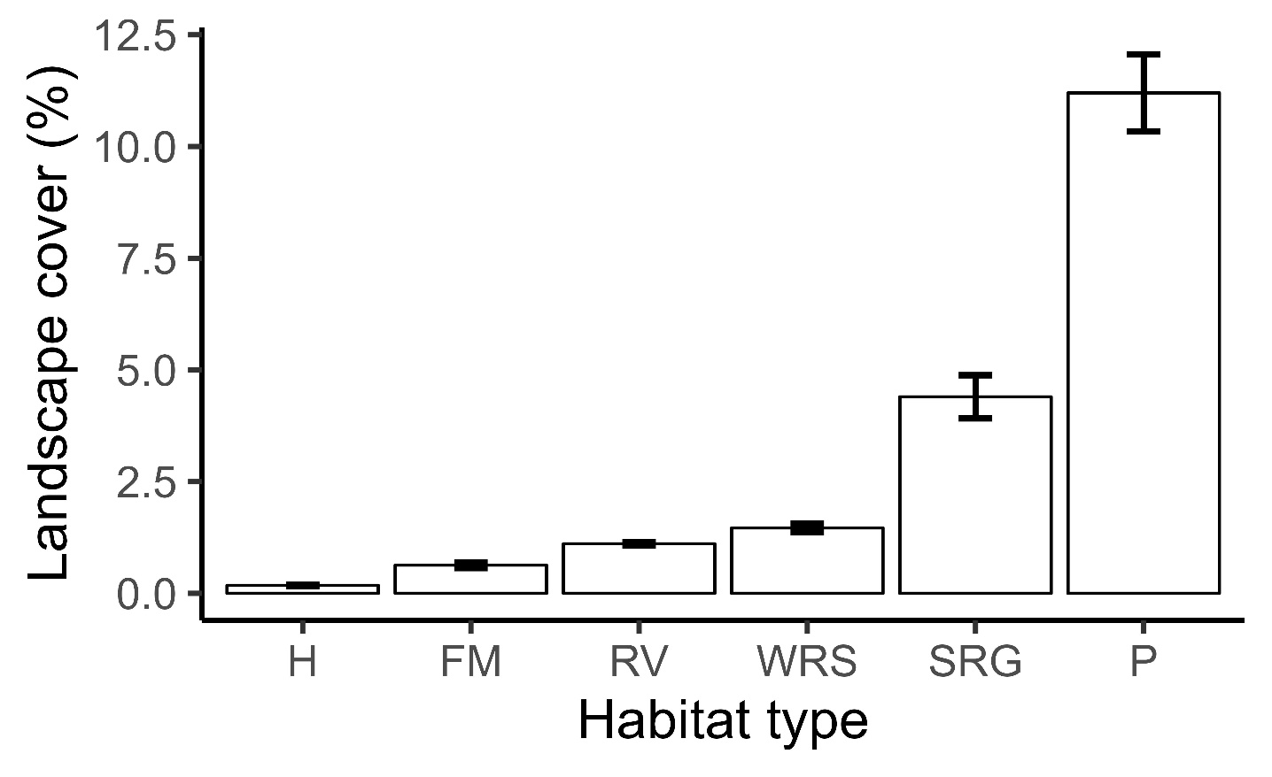
Figure S2. Coverage of habitat types in the surrounding 500 m radius of each study site, ordered from smallest to largest. The remaining land cover includes forest, arable, intensive grassland, and urban land uses. H = hedge, FM = field margin, RV = road verge, WRS = water retention site, SRG = species-rich grassland, P = extensive pasture.

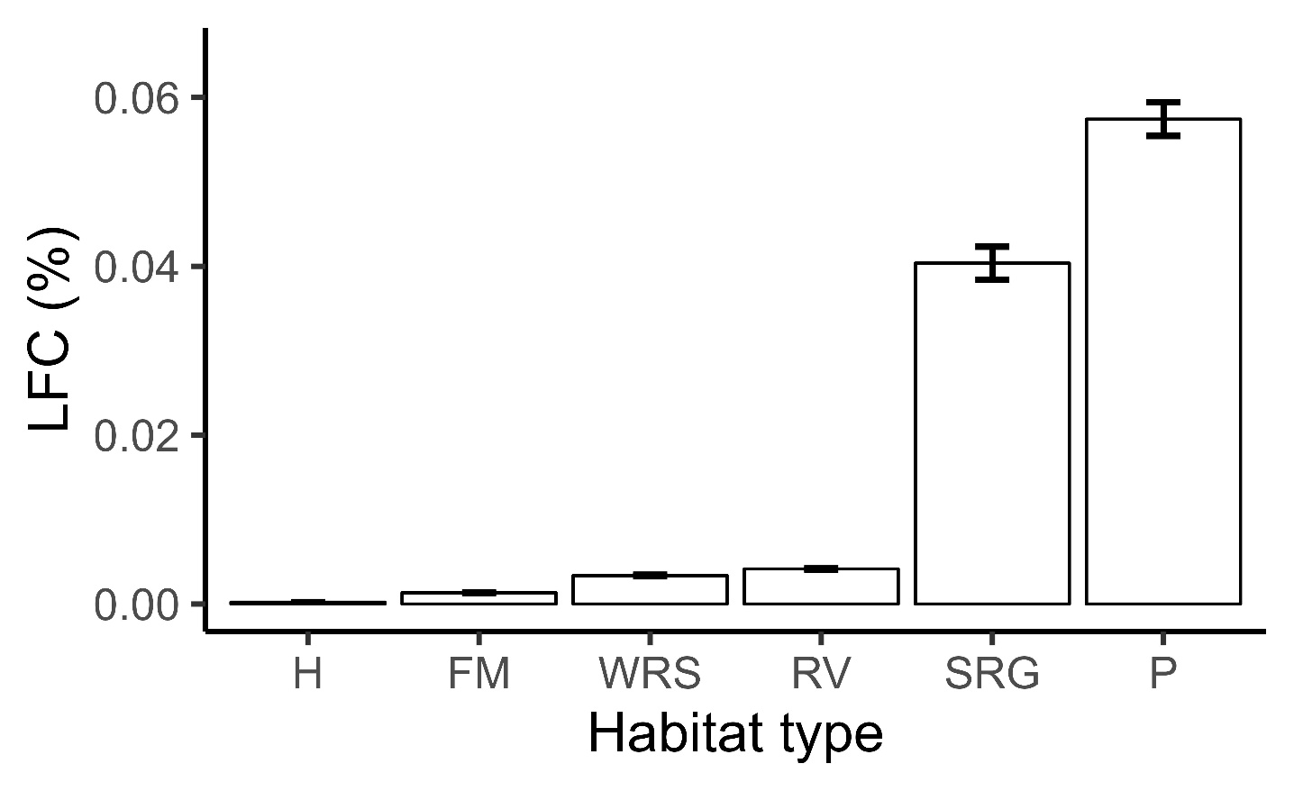
Figure S3. Contribution of habitat types to landscape flower cover (LFC) in the surrounding 500 m radius of each study site, ordered from smallest to largest (mean ± SE). H = hedge, FM = field margin, RV = road verge, WRS = water retention site, SRG = species-rich grassland, P = extensive pasture.

