Habitat heterogeneity helps to mitigate pollinator nectar sugar deficit and discontinuity in an agricultural landscape
Jacek Jachuła¹, Bożena Denisow^{1*}, Małgorzata Wrzesień²
¹Department of Botany and Plant Physiology, Subdepartment of Plant Biology, University of Life Sciences, 15 Akademicka St., 20-950 Lublin, Poland
JJ: jacekjachula@wp.pl
BD: bozena.denisow@up.lublin.pl
²Department of Botany, Mycology, and Ecology, Maria Curie-Sklodowska University, 19 Akademicka St., 20-033 Lublin, Poland
MW: malgorzata.wrzesien@ poczta.umcs.lublin.pl
*Corresponding author
Corresponding author e-mail address: bozena.denisow@up.lublin.pl

Supplementary Data
Habitat sub-types
Two sub-types of NFWV were distinguished: (i) tree rows and (ii) woodlots (sensu Plieninger et al., 2012). Only tree rows that were at least 50 m long and had crown closure (sensu Günlü et al., 2016) of at least 70% were subjected to the analyses. Trees that occurred singly, e.g., on field margins or formed only small groups (2-5 trees) on road verges, were included in the calculations made for particular corresponding habitats. Road verges were sub-divided according to the traffic volume, expressed as the number of vehicles per hour into: (i) low ca. 30/h, (ii) medium ca. 150/h, (iii), medium-high ca. 350/h and (iv) high ca. 500/h. Railway embankments were sub-categorized by the traffic volume, recorded as the number of trains per day into: (i) low ca. 5/day, (ii) medium ca. 20/day and (iii) high ca. 50/day. The sub-types of field margins were defined based on the acreage of adjacent crop fields as follows: (i) small 1-5 ha, (ii) medium 6-10 ha, (iii) and large 11-15 ha. The fallows were sub-divided according to the abandonment period into: (i) abandonment for 1-2 years, (ii) 3-5 years, (iii) 6-10 years and (iv) 11-15 years. The information on the traffic volume on roads was based on data available from the General Directorate for National Roads and Motorways, and data on railway traffic volume was provided by the Office of Rail Transport. The data on field size and length of the tree rows were collected from detailed digital cadastral data and high-resolution IR orthophotographs (pixel resolution 1 m). The period of abandonment of the fallows was determined by comparing orthophotographs taken between 2003 and 2016, and using data collected from field owners and personal observations made by the authors.

Fig. S1. Proportion of forests, meadows/pastures, orchards, crop fields, fallows and other lands within study areas (1-7) and within Lublin Upland, Poland.
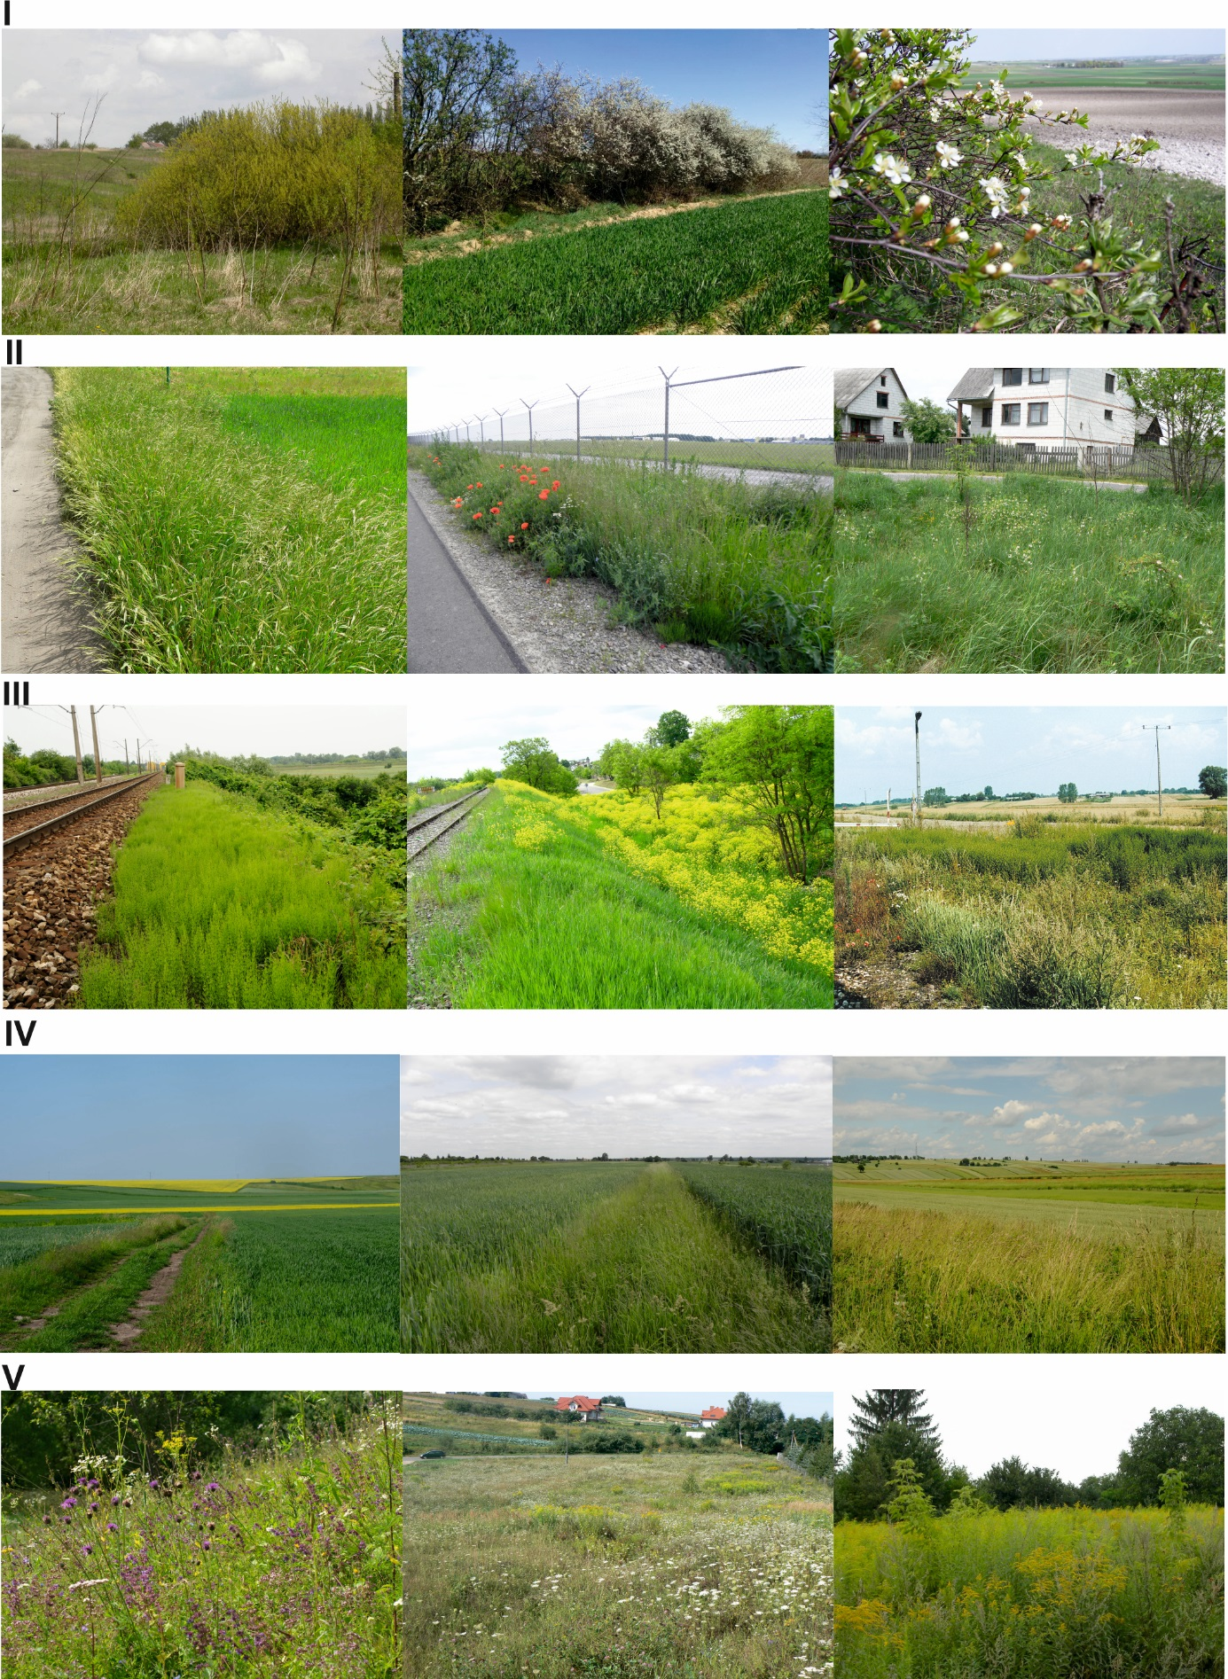
Fig. S2. Flora growing in: I NFWV (non-forest woody vegetation), II road verges, III railway lines, IV field margins, and V fallows across study areas in an agricultural landscape within the Lublin Upland, Poland.
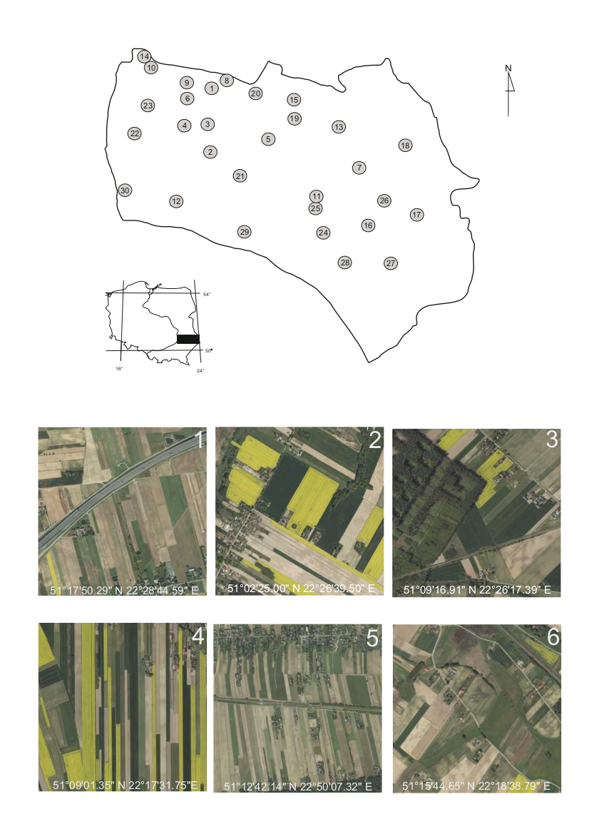
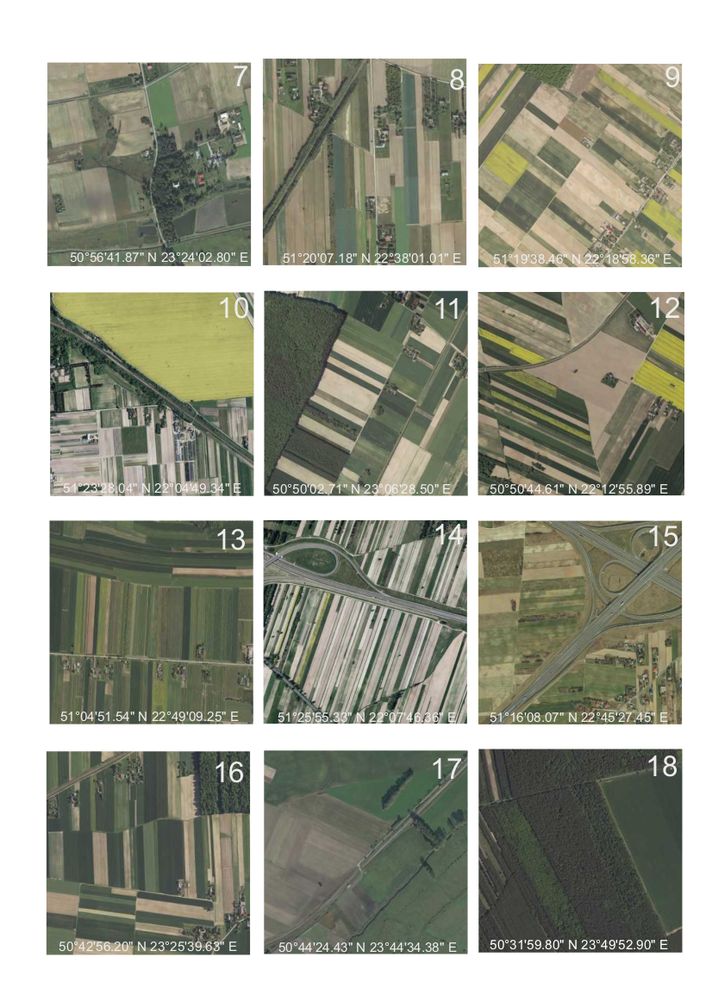

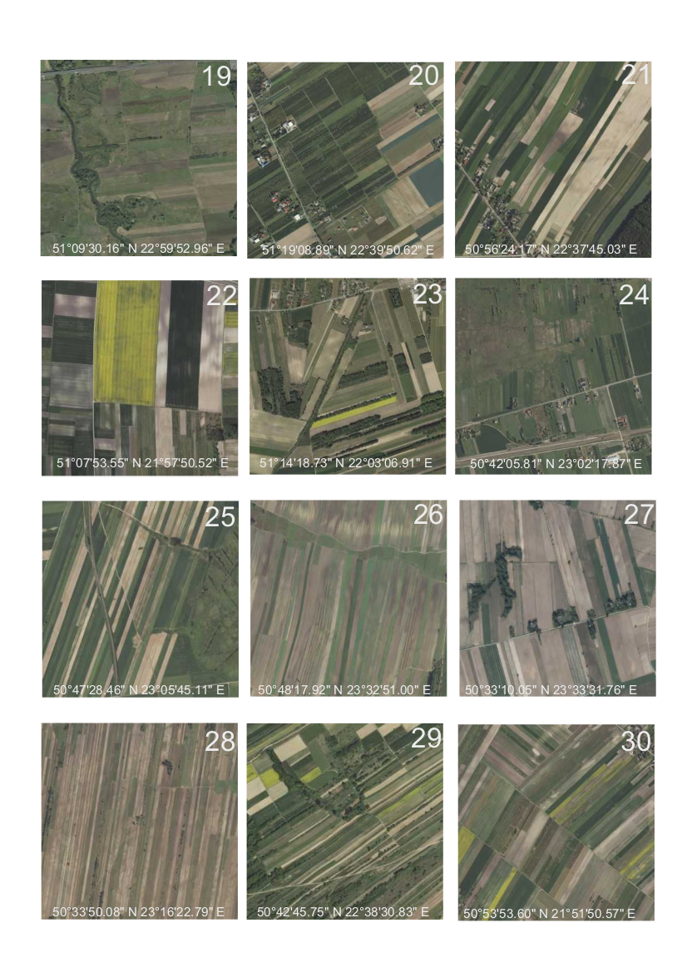
Fig. S3. Location of the quadrate areas (1-30) within the Lublin Upland (SE Poland) randomly selected for the assessment of contribution of particular habitat types

Fig. S4. Ordination diagram showing the results of the PCA for the relationships between man-made, non-cropped habitats and flora composition. Eigenvalues: Axis 1 – 19.3, Axis 2 – 11.2.
NFWV- non-forest woody vegetation; RV- road verges; RE- railway embankments; FM- field margins; FL- fallows
Abbreviations: Ace.pla- Acer platanoides; Ach.mil- Achillea millefolium; Aeg.pod- Aegopodium podagraria; Ant.syl- Anthriscus sylvestris; Bal.nig- Ballota nigra; Ber.inc- Berteroa incana; Bun.ori- Bunias orientalis; Cen.cya- Centaurea cyanus; Cha.ang- Chamaenerion angustifolium; Cic.int- Cichorium intybus; Cir.arv- Cirsium arvense; Cir.vul- Cirsium vulgare; Con.arv- Convolvulus arvensis; Cra.mon- Crataegus monogyna; Dau.car- Daucus carota; Ech.vul- Echium vulgare; Eup.cyp- Euphorbia cyparissias; Fra.ves- Fragaria vesca; Gal.mol- Galium mollugo; Gal.ver- Galium verum; Gle.hed- Glechoma hederacea; Hie.pil- Hieracium pilosella; Hie.umb- Hieracium umbellatum; Kna.arv- Knautia arvensis; Lam.alb- Lamium album; Lam.pur- Lamium purpureum; Leo.aut- Leontodon autumnalis; Lin.vul- Linaria vulgaris; Lot.cor- Lotus corniculatus; Med.lup- Medicago lupulina; Med.sat- Medicago sativa; Ori.vul- Origanum vulgare; Pas.sat- Pastinaca sativa; Pru.div- Prunus divaricata; Pru.spi- Prunus spinosa; Rap.rap- Raphanus raphanistrum; Ror.syl- Rorippa sylvestris; Rub.cae- Rubus caesius; Rub.ida- Rubus idaeus; Sal.cap- Salix caprea; Sed.acr- Sedum acre; Sin.arv- Sinapis arvensis; Sol.can- Solidago canadensis; Sol.gig- Solidago gigantea; Son.arv- Sonchus arvensis; Son.ole- Sonchus oleraceus; Sta.pal- Stachys palustris; Tan.vul- Tanacetum vulgare; Tar.off- Taraxacum officinale; Til.cor- Tilia cordata; Tri.hyb- Trifolium hybridum; Tri.med- Trifolium medium; Tri.pra- Trifolium pratense; Tri.rep- Trifolium repens; Tus.far- Tussilago farfara; Vic.ang- Vicia angustifolia; Vic.cra- Vicia cracca; Vic.sep- Vicia sepium

Table S1. Comparison of species richness (S), ground cover (%) and values of diversity indices (H′, J′) calculated for nectar-producing flora in five types of man-made, non-cropped habitats in an agricultural landscape of SE Poland
Habitat type | Sub-type | Species richness (S) (mean ± SD) | Ground cover (%) (mean ± SD) | Shannon-Wiener index (H’) (mean ± SD) | Evenness index (J’) (mean ± SD)
Non-forest woody vegetation | structure
Non-forest woody vegetation | tree rows | 22.5 ± 3.1^{b} | 52.7 ± 10.1ª | 1.33 ± 0.06^{b} | 0.985 ± 0.005^{b}
Non-forest woody vegetation | woodlots | 20.0 ± 2.9ª | 49.1 ± 7.4ª | 1.27 ± 0.07ª | 0.982 ± 0.004ª
Non-forest woody vegetation | Mean | 21.2 ± 3.2^{AB} | 50.9 ± 9.1^{C} | 1.30 ± 0.07^{AB} | 0.984 ± 0.006^{B}
Road verges | traffic volume
Road verges | low | 29.2 ± 4.3^{c} | 39.6 ± 9.8^{c} | 1.45 ± 0.07^{c} | 0.994 ± 0.002^{c}
Road verges | medium | 20.0 ± 3.8^{b} | 37.8 ± 9.6^{c} | 1.28 ± 0.10^{b} | 0.991 ± 0.002^{b}
Road verges | medium high | 18.2 ± 2.3^{b} | 23.4 ± 5.4^{b} | 1.24 ± 0.05^{b} | 0.988 ± 0.003^{ab}
Road verges | high | 11.6 ± 2.2ª | 13.8 ± 3.4ª | 1.04 ± 0.08ª | 0.982 ± 0.009ª
Road verges | Mean | 19.8 ± 7.1^{A} | 28.7 ± 10.0^{A} | 1.25 ± 0.17^{A} | 0.989 ± 0.007^{C}
Railway embankments | traffic volume
Railway embankments | low | 60.3 ± 21.1^{b} | 44.8 ± 8.3ª | 1.75 ± 0.17^{c} | 0.998 ± 0.001ª
Railway embankments | medium | 79.2 ± 20.7^{c} | 56.5 ± 7.6^{b} | 1.88 ± 0.10^{b} | 0.998 ± 0.001ª
Railway embankments | high | 37.2 ± 16.1ª | 42.8 ± 8.4ª | 1.52 ± 0.22ª | 0.998 ± 0.001ª
Railway embankments | Mean | 58.9 ± 25.9^{C} | 48.0 ± 11.5^{C} | 1.72 ± 0.23^{C} | 0.998 ± 0.001^{D}
Field margins | crop area
Field margins | small | 68.2 ± 19.7^{b} | 41.8 ± 10.3^{c} | 1.78 ± 0.11^{b} | 0.981 ± 0.003^{b}
Field margins | medium | 53.3 ± 15.7ª | 34.8 ± 6.7^{b} | 1.67 ± 0.13ª | 0.978 ± 0.004^{ab}
Field margins | large | 45.1 ± 7.1ª | 25.3 ± 8.5ª | 1.61 ± 0.07ª | 0.976 ± 0.005ª
Field margins | Mean | 55.5 ± 17.9^{C} | 34.0 ± 12.1^{B} | 1.69 ± 0.13^{C} | 0.978 ± 0.005^{A}
Fallows | time of abandonment
Fallows | 1 - 2 yrs | 36.9 ± 5.8^{b} | 60.7 ± 7.3^{b} | 1.53 ± 0.06^{b} | 0.981 ± 0.004^{b}
Fallows | 3 - 5 yrs | 35.5 ± 6.5^{b} | 55.2 ± 7.9^{ab} | 1.51 ± 0.10^{b} | 0.979 ± 0.008^{b}
Fallows | 6 - 10 yrs | 21.5 ± 3.3ª | 50.3 ± 9.3ª | 1.28 ± 0.06ª | 0.967 ± 0.007ª
Fallows | 10 - 15 yrs | 16.9 ± 2.6ª | 48.6 ± 6.4ª | 1.17 ± 0.07ª | 0.957 ± 0.009ª
Fallows | Mean | 27.7 ± 9.9^{B} | 53.7± 9.6^{C} | 1.37 ± 0.17^{B} | 0.971 ± 0.012^{A}

Different small letters indicate significant differences between habitat sub-types and different capital letters indicate significant differences between habitat types according to Kruskal-Wallis test

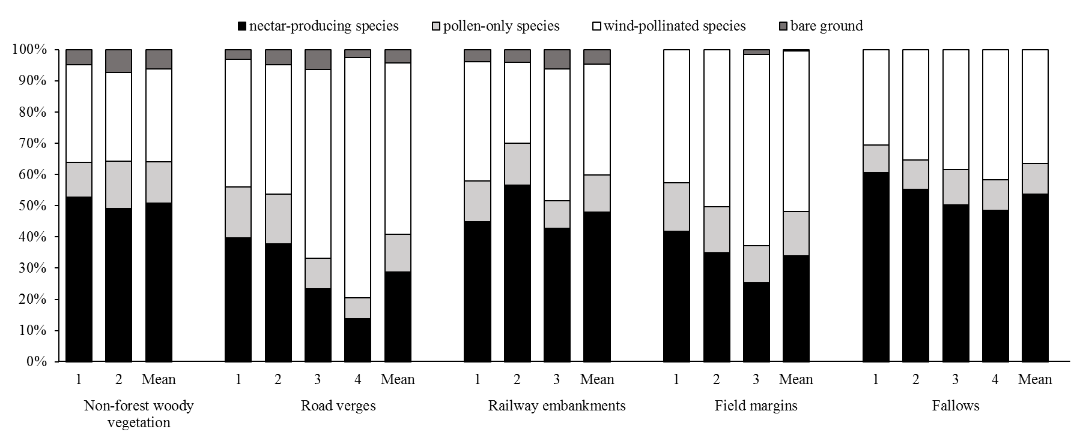
Fig. S5. Cover of nectar-producing species, pollen-only species, wind-pollinated species and bare ground noted in five types of man-made, non-cropped habitats.
Explanation for habitat sub-types: Non-forest woody vegetation (according to the structure): 1- tree rows, 2- woodlots; Road verges (acc. to the traffic volume = number of vehicles per hour): 1- low ca. 30/h, 2- medium ca. 150/h, 3- medium-high ca. 350/h, 4- high ca. 500/h; Railway embankments (acc. to the traffic volume = number of trains per day): 1- low ca. 5/day, 2- medium ca. 20/day, 3- high ca. 50/day; Field margins (acc. to the acreage of adjacent crop fields): 1- small 1-5 ha, 2-medium 6-10 ha, 3- large 11-15 ha; Fallows (acc. to the period of abandonment): 1- 1-2 years, 2- 3-5 years, 3- 6-10 years, 4- 11-15 years

