Robotic Arm Project Report

Handling goods with RFID tags

## Introduction

The project is aimed to investigate the usage of the Dobot Magician Robotic Arm, and develop a prototype for presenting the idea.

## Objectives

In this approach, it is aimed to perform recognition tasks with RFID tags and handle the tags (with the goods) to the destinated position.

## Methodology

In this project, the objectives will be done one by one, and will be combined once they are finished.

### RFID tags recognition

RFID tags are popular goods management technology these days, they are passive storage tags that can store information about the products inside and can be read and modified (depending on the type of tags) by the RFID readers.

To perform the recognition tasks, there are two possible approaches, high-power readers that can scan the tags in a certain space and low-power readers that can be mounted on and powered by the Arm.

In this project, low-power readers are considered as they are cheaper in price, while they can perform the recognition tasks we want.

So, in the project, MFRC-522 RFID reader modules and RFID tags under the ISO14443A protocol are purchased for tag recognition, and ESP32 Arduino MCUs are bought to control the modules (Originally, I want to control the module with MCU in the Arm, but found too difficult).

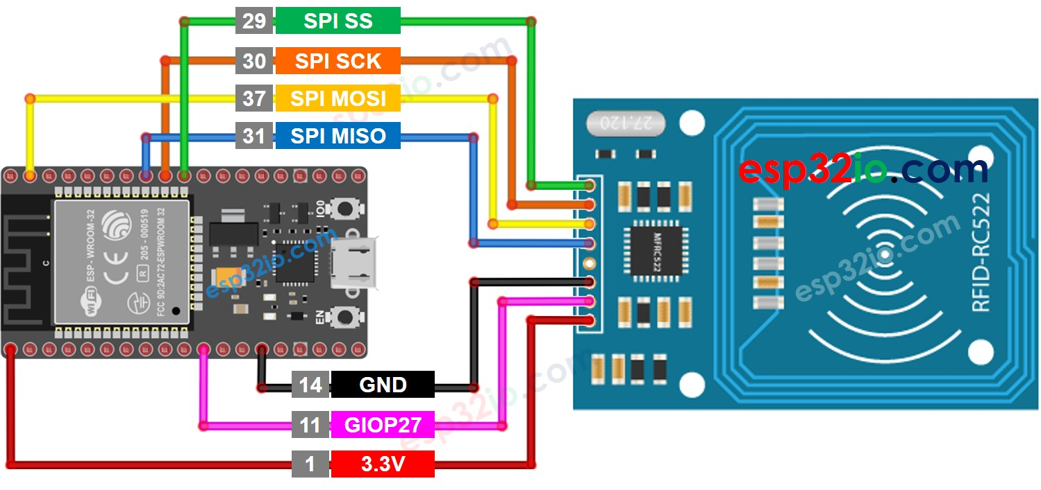

*The wiring diagram of the reader and ESP32*

Based on the library that comes with the MFRC-522 module, two programs are coded with respect to the content writing function and content reading function(noted that never touches the access).

| *RFIDwriting* | *RFIDreading* |
| --- | --- |

### Handling tags (goods)

the Dobot Magician Robotic Arm is assigned to the project. Some movements are needed to be programmed for grabbing and placing the tags (goods).

There are two possible approaches to performing the grab function, using the clamp and using the suction cup.

As the clamp included in the pack is way too small, so the suction cup is used for performing the tasks.

To ‘grab’ the tags (goods), the suction cap creates the suction when the suction cap is sealed against the tag’s (goods’) surface and the air is pumped out of the cup, a low-pressure region is then created inside the suction area.

To release the tags (goods), the pump stop working, and air flows back to the cup, the pressure inside and outside the cup is balanced, then the suction cup stops working.

To handle the tags (goods), in this approach, they are found, grabbed, and released in a line of a sequence of the time they are grabbed, which can be modified for more difficult tasks (like finding the specific tags, placing them in specific positions, patterns).

### Combining

To build communication between the MCU (that is responsible for the RFID reader) and the Dobot robotic arm, one of the extended I/O (EIO) pins allocated on the arm is connected to the analog pin [D22] of the ESP32.

To ease the development, the ESP32 is programmed to send ‘1’ via the analog pin once the reader is triggered. The arm will keep ‘searching’ for the tags by scanning the region, and once the Arm received ‘1’ from the EIO pin, the Arm will grab the tag (good), transfer, and release the tag in the destinated position.

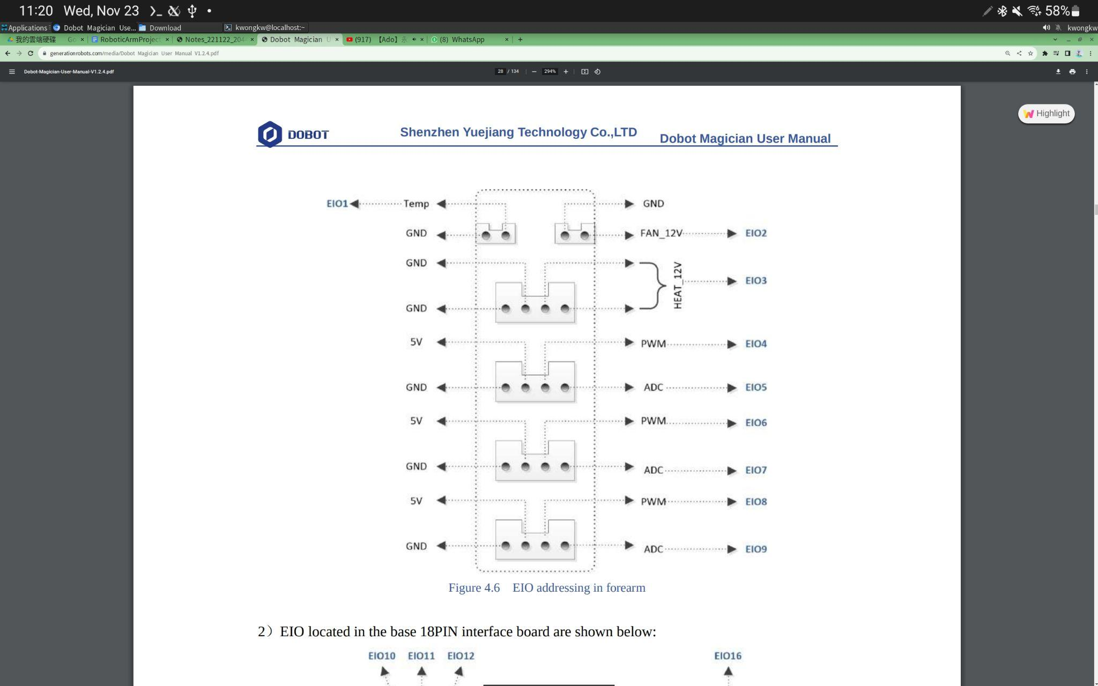

## Advancement

It is a very simple prototype that demonstrates the idea of using a Robotic Arm to search for RFID tags (or products with RFID tags on them). There are several improvements that can be made in the future,

* Searching tags with reference to the content of the tags (like picking water instead of juice)
* Classifying the tags with and putting them separately with respect to the contents (like separating tags to columns of water and juice)
* Display the currently selected tag with a display monitor
* Synchronise the tags database to cloud servers
* Drilling a hole on the reader that can let the suction cup pass through, thus enhance the performance of searching the tags.