EIE4105 Lab1

Step 9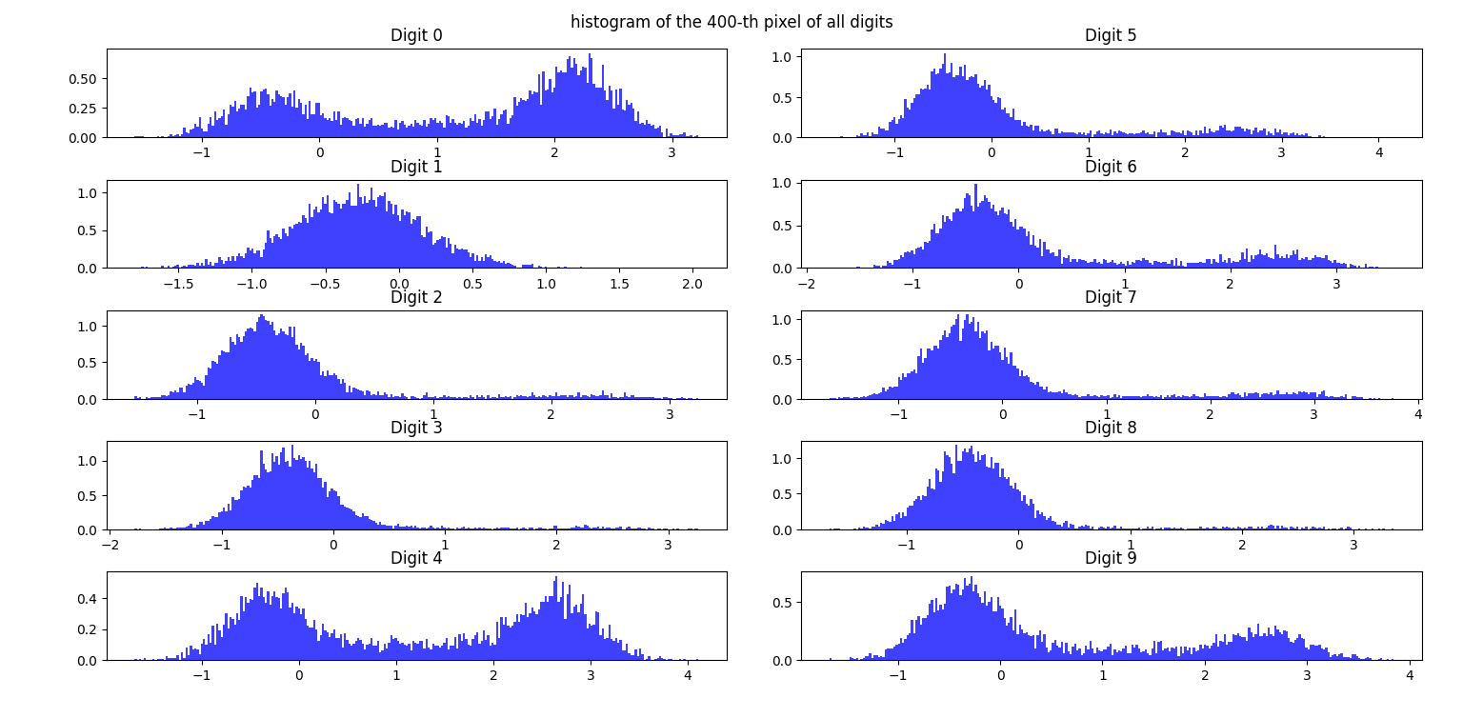

They are not identical, so we should use gaussian model, as the peaks are separated. We can train the classifier by adding testing and training data while monitoring its accuracy.

Step10

|  |
| --- |
| For digit 0  (5923, 2)  (5923, 2)  [[1.01667877e-01 1.20494637e-03]  [1.20494637e-03 1.45611486e+00]]  [[1.45611486 0.60542267]  [0.60542267 1.27947404]]  For digit 1  (6742, 2)  (6742, 2)  [[ 1.91336521e-01 -1.54604263e-04]  [-1.54604263e-04 1.93019203e-01]]  [[0.1930192 0.00758907]  [0.00758907 0.20769295]]  For digit 2  (5958, 2)  (5958, 2)  [[0.11196845 0.00674365]  [0.00674365 0.52027204]]  [[0.52027204 0.4301734 ]  [0.4301734 0.73201762]]  For digit 3  (6131, 2)  (6131, 2)  [[0.12002703 0.00218469]  [0.00218469 0.38498026]]  [[0.38498026 0.30800715]  [0.30800715 0.80870503]]  For digit 4  (5842, 2)  (5842, 2)  [[0.13264849 0.01035635]  [0.01035635 1.99506544]]  [[1.99506544 1.10550376]  [1.10550376 1.67988821]]  For digit 5  (5421, 2)  (5421, 2)  [[0.134667 0.0027364 ]  [0.0027364 1.04523738]]  [[1.04523738 0.853019 ]  [0.853019 1.60023438]]  For digit 6  (5918, 2)  (5918, 2)  [[ 0.12659583 -0.00190949]  [-0.00190949 1.27742925]]  [[1.27742925 0.87003865]  [0.87003865 1.73552905]]  For digit 7  (6265, 2)  (6265, 2)  [[1.37884260e-01 7.07626490e-04]  [7.07626490e-04 8.86151329e-01]]  [[0.88615133 0.61652835]  [0.61652835 0.99363936]]  For digit 8  (5851, 2)  (5851, 2)  [[ 0.1148002 -0.00157084]  [-0.00157084 0.3856925 ]]  [[0.3856925 0.2954013 ]  [0.2954013 0.65611398]]  For digit 9  (5949, 2)  (5949, 2)  [[ 0.13222952 -0.01115438]  [-0.01115438 1.71004882]]  [[1.71004882 0.97528234]  [0.97528234 1.89007707]] |

The covariance between Pixel 400 and 401 is larger. It maybe the edge of the line which make the covariance larger than that of Pixel 1 to 400.

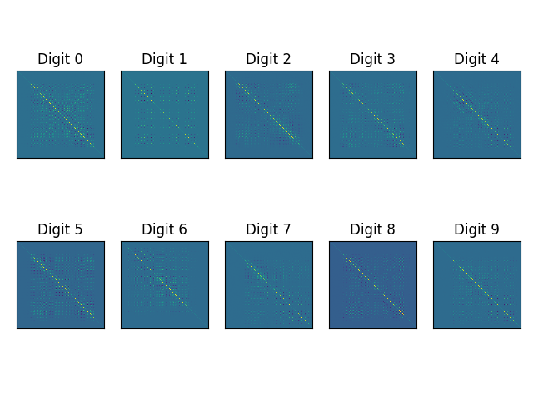

From the values and diagram, we can find that the covariance of each digit is different from each other, so even if the mean of individual digits are zero, it is possible tp use covariance to differentiate different digits.

Step 14

Diagonal covariance matrices

The accuracy of diagonal covariance matrix is 0.891 in training data and 0.8146 in the testing data

The accuracy of full covariance matrix is 1 in training data and 0.9309 in the testing data

So Full covariance matrix is superior in accuracy.

Step 14

Diaginal covariance matrices GMM classifier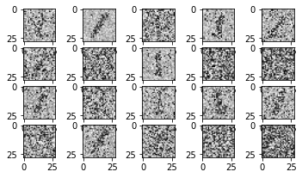

Full covariance matrices GMM classifier 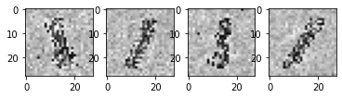

The accuracy of diagonal covariance matrix GMM classifier is 0.2786 in the testing data

The accuracy of full covariance matrix GMM classifier is 0.098 in the testing data

Step 16

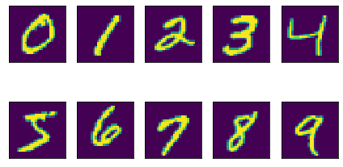

Step 17

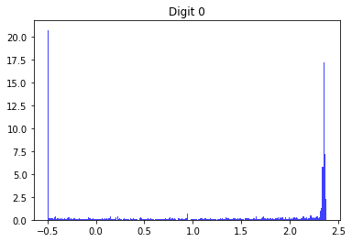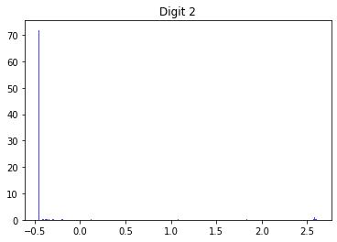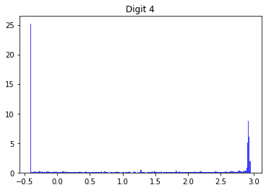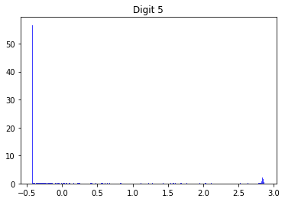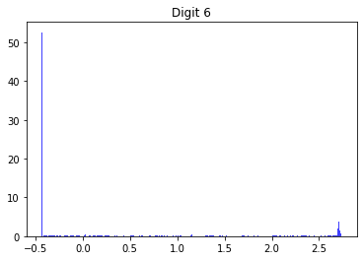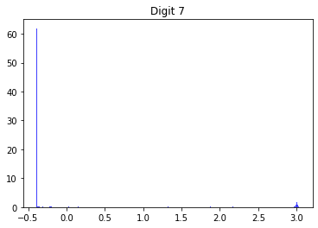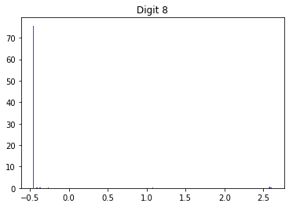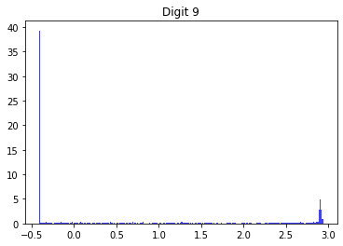

The histogram is sharpened in the clean image, as the classifier is too accurate.