**EIE4105 Multimodal Human Computer Interaction Technologies**

**Lab 2: SVM, PCA and LDA for HCI**

E.1.4.

***How many SVMs in this Handwritten Digit Recognizer? Draw a block diagram illustrating the architecture of the recognizer.***

We can see that the SVM output depends on the number of classes of the train data, which is 10.

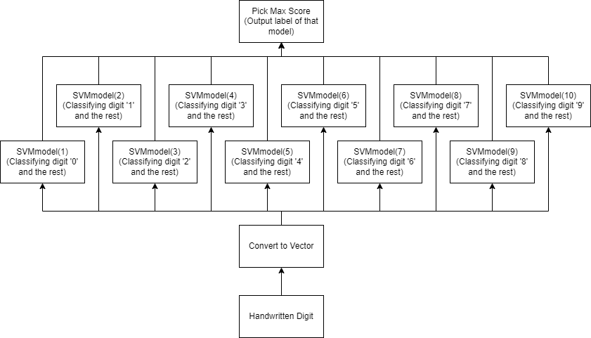

E.1.5.

***Report the accuracy for both ‘clean’ and ‘noisy’ digits. How many training samples have been used for training each of the SVMs? Explain why the linear SVMs can work (at least they can be trained) even if the number of training samples per SVM is much smaller than the feature dimension, whereas the Gaussian classifier will fail under such situation.***

For the accuracy of ‘clean’ and ‘noisy’ digits with 100 samples per digits with linear kernel.  
[clean]: 82.50%, [noisy]: 82.70%  
For the accuracy of ‘clean’ and ‘noisy’ digits with 10 samples per digits with linear kernel.  
[clean]: 60.90%, [noisy]: 62.00%  
For the accuracy of ‘clean’ and ‘noisy’ digits with 1 sample per digits with linear kernel.  
[clean]: 40.30%, [noisy]: 39.40%

For the accuracy of ‘clean’ and ‘noisy’ digits with 100 samples per digits with poly kernel.  
[clean]: 90.30%, [noisy]: 89.80%  
For the accuracy of ‘clean’ and ‘noisy’ digits with 10 samples per digits with poly kernel.  
[clean]: 67.60%, [noisy]: 67.50%  
For the accuracy of ‘clean’ and ‘noisy’ digits with 1 sample per digits with poly kernel.  
[clean]: 32.80%, [noisy]: 32.10%

SVM uses a subset of training points in the decision function (support vectors), and regularized to prevent overfitting with high-dimensional data.

E.1.6.

***Report the accuracy for both ‘clean’ and ‘noisy’ digits. In theory, polynomial SVMs are more powerful than linear SVM because they can produce non-linear decision boundaries. However, you properly observe that the performance of poly-SVMs is poorer than that of linear SVMs. Explain why poly-SVMs are not suitable for such extreme case.***

For the accuracy of ‘clean’ and ‘noisy’ digits with 1 sample per digits with poly kernel.  
[clean]: 32.80%, [noisy]: 32.10%

Since in this case, the number of samples provided is too little, SVMs decision boundaries cannot be clearly determined by the samples provided, the polynomial SVMs may overfit because of the lack of data and leading to the poor performance.

E.1.7.

***Report your observation for linear SVMs and report the accuracy for poly-SVMs. Explain your observation for linear SVMs. How does the performance of poly-SVMs compared with that of the Gaussian classifier that uses the same number of training samples per class in Lab1? Briefly explain your observations.***

For the accuracy of ‘clean’ and ‘noisy’ digits with 785 sample per digits with poly kernel.  
[clean]: 30.70%, [noisy]: 37.60%

For the accuracy of ‘clean’ and ‘noisy’ digits with 785 sample per digits with poly kernel.  
[clean]: .%, [noisy]: .% (Error, timeout)

E.1.8.

***What are the vectors whose corresponding***  ***are zero? Do they contribute to the SVM scoring function? Explain your answer. Does the most influential support vector from Digit ‘0’ look like a ‘0’? Does the most influential support vector from Digits ‘1’ to ‘9’ look like a ‘0’? Explain your observation.***

For the accuracy of ‘clean’ and ‘noisy’ digits with 785 sample per digits with poly kernel.

[clean]

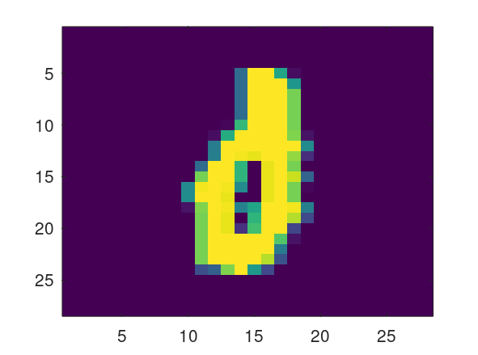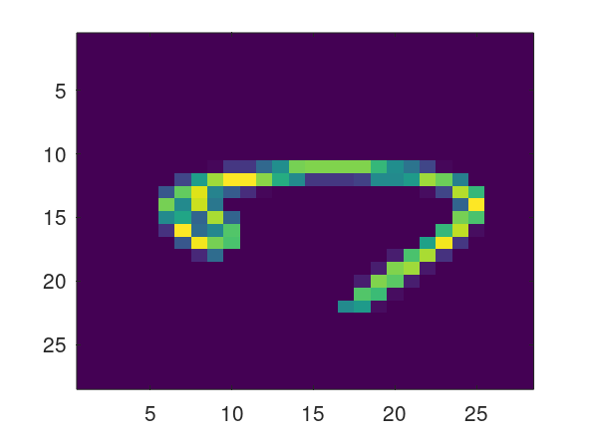

[noisy]

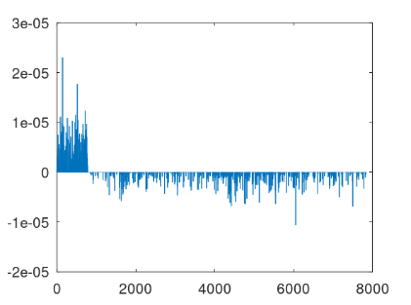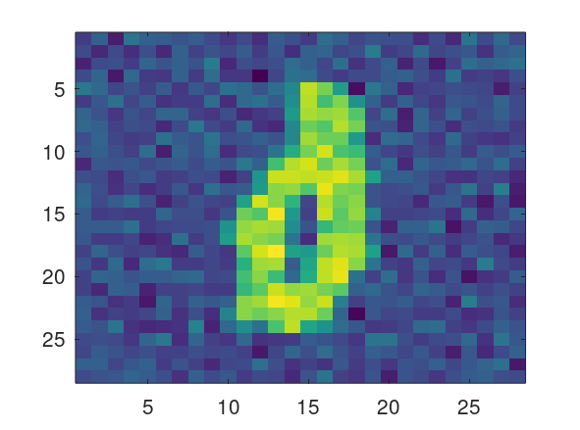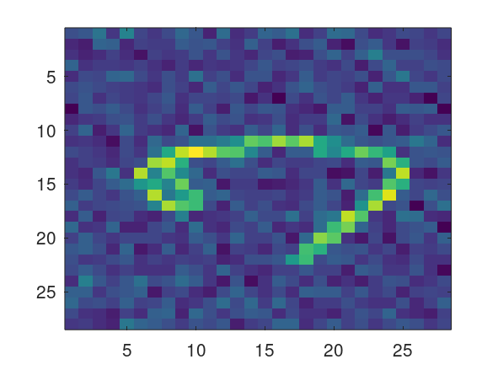

E.1.9.

***Report the results and your observations.***

(I can’t run rbf, keep running but no response…)

E.2.10.

***Report the results and your observations. Plot the eigenvalues. Based on your plot, explain why we only need the first few eigenvectors to represent the digits.***

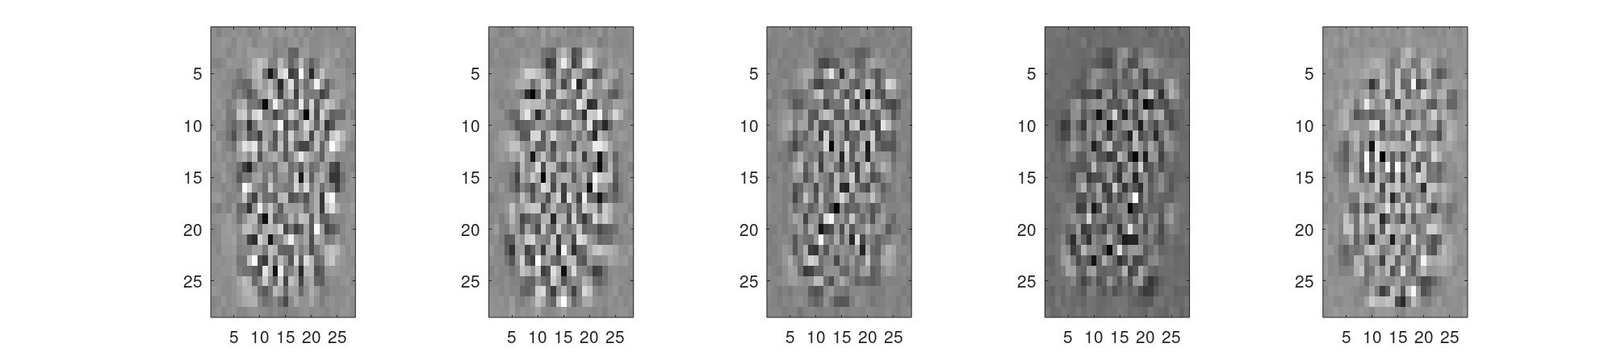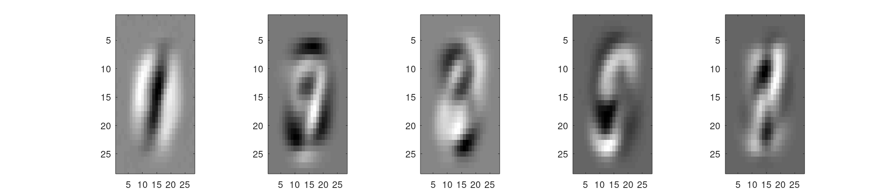

From the third plot, we can clearly see that the clusters of eigenvalues differently indicated has their own direction of the principal components (eigenvectors), the data is then multiplied with the eigenvectors to re-orient onto the principal components. By studying the distance of the re-orient data to the axes (score), we can determine the digit the data is and so that eigenvectors can be used to represent digits in this case.

E.2.11.

***Report the results and your observations. How many principal components are required to represent a facial image.*******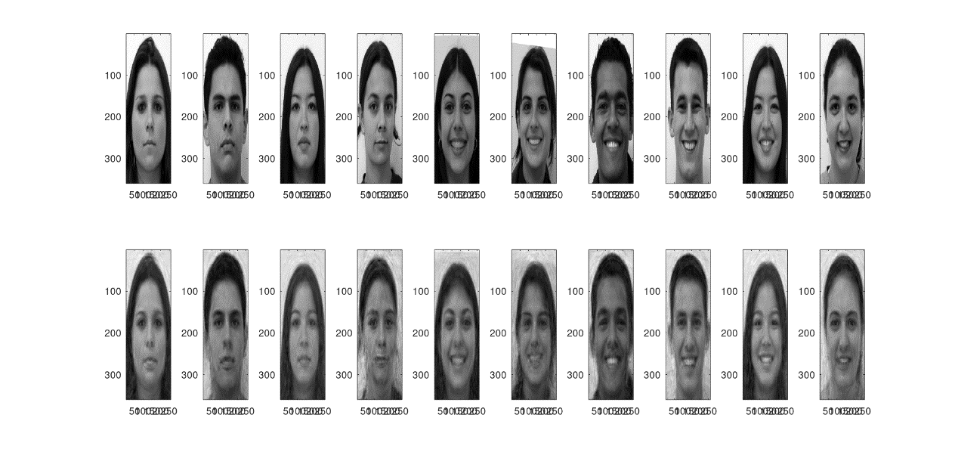*

E.2.12.

***Display some reconstructed face when setting  in the above equations (use the maximum number of eigenfaces). Also display the reconstructed faces using different numbers of eigenfaces. Report the results and your observations. Why is it necessary to remove the mean when performing projection and to add back the mean during reconstruction?***

When mean = 0

E.2.13.

***Report the results and your observations. By setting the number of principal components (PC) to 9, compare the images reconstructed by PCA and LDA. Which one looks better? Can the LDA-reconstructed image be improved by increasing the number of PC?*** 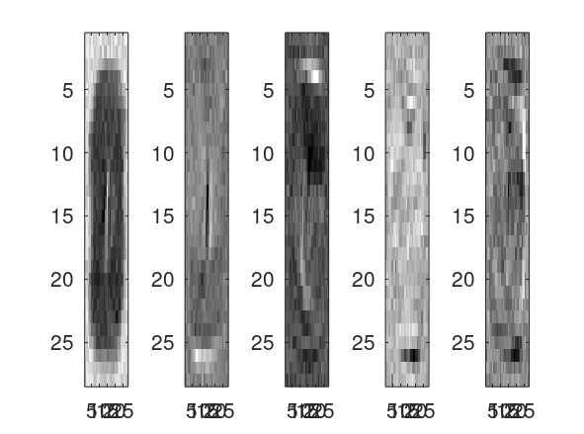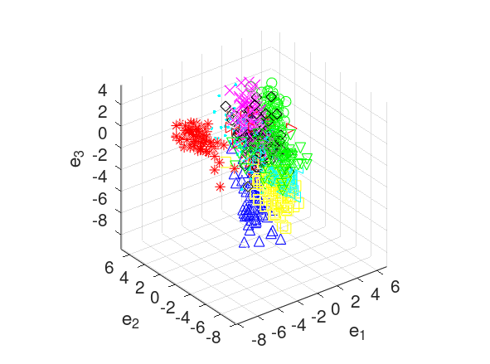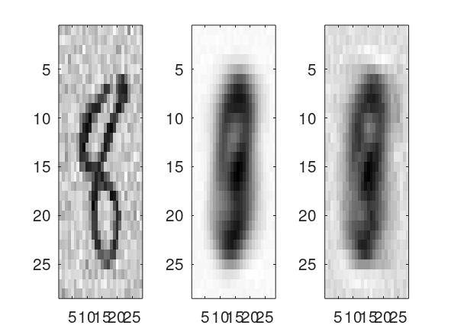

PCA looks better.

Yes, the recognition rate of LDA can increase with more principal components.

E.2.14.

***Report the results and your observations. How does the performance of LDA + Gaussian Classifier compare with that of the Gaussian Classifier?***

The accuracy is 86, better than that of the Gaussian Classifier.

E.2.15.