The Hong Kong Polytechnic University

Department of Electronic and Information Engineering

Final Year Project Proposal

Self-Balance Reuleaux Triangle

Wong Keith

19067393d

Ka-Hong Loo

14-10-2022

Abstract

This project examines the self-balance Reuleaux triangle project, which can jump and balance itself on a corner (Fig. 1) [1].

A reaction wheel is embedded between two PCBs designed in the shape of a Reuleaux triangle; the reaction wheel provides a sudden force for the system to jump by braking a high-speed rotating momentum wheel suddenly; when the system reaches its unstable equilibrium state (standing with its corner), the reaction wheel is controlled to provide adjustment force for the system to prevent the system from falling.

The project aims to reproduce the design and research the performance of different control systems acting on the model.

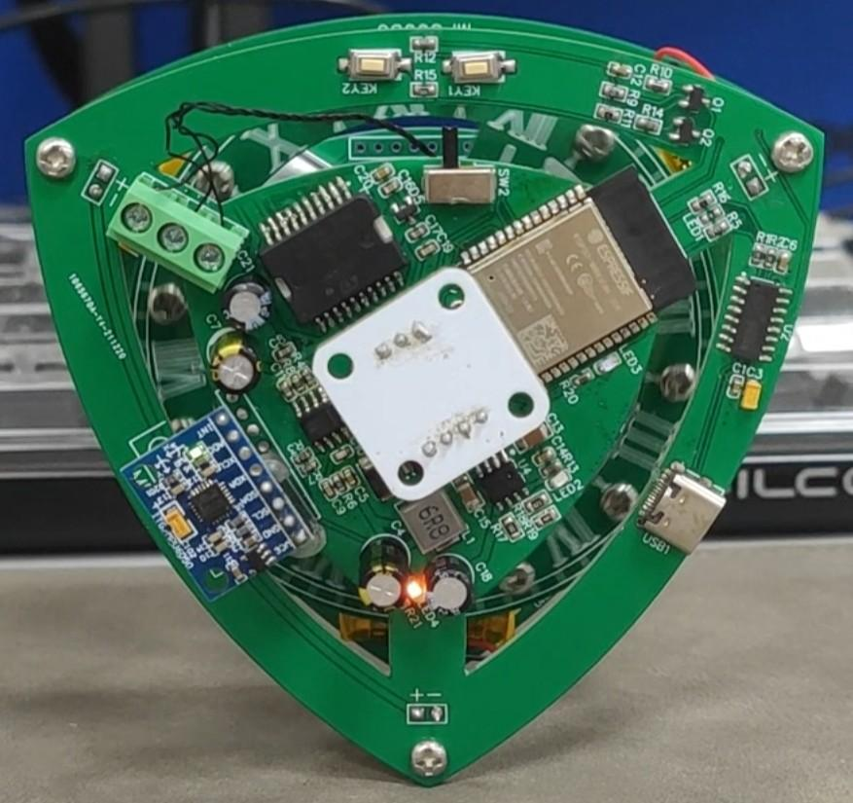

(Fig. 1)  
*Video:* ﷟HYPERLINK "https://www.reddit.com/r/ElectroBOOM/comments/styhj0/selfbalanced_reuleaux_triangle/"https://www.reddit.com/r/ElectroBOOM/comments/styhj0/selfbalanced_reuleaux_triangle/ *[1]*

Introduction

Inverted pendulum plants are nonlinear systems widely used for testing different control algorithms [2]. The algorithm can be implemented in various fields which require stability, including vehicles (E.g., Rocket, Drone, Hoverboard, Segway), robotics (Postural controls, like walking, single leg stand) development, and even seismic control of building structures.

Reaction wheels are commonly used in the space industry; they are flywheels that can store rotational energy by rotation and trigger momentum exchange to supply rotational force for the vehicle [3][4]. Due to the high pointing accuracy provided by the wheels, the space vehicles can perform precise angle adjustments to implement exact tasks like satellite orientations and pointing the telescope at a star. Although using reaction wheels effectively reduces the need for thrusters and fuel to load onboard, the wheel can only perform rotational adjustments with respect to the center of mass.

The model concatenated both concepts mentioned above, and it is a prototype proving the use of reaction wheels on stabilizing inverted pendulum plants. There are similar projects which also demonstrate the idea, the Cubli [5], a three dimension balancing cube system on a corner.

The project will focus on implementing the product and investigating how the control systems differ in the product's

Objective

It is a project based on reproducing the product of the Self-Balance Reuleaux Triangle. The project aims to perform an unstable equilibrium with the aid of different control systems on the model.

Methodology

1. PCB Design

The contour of the PCB, which is also the main structure of the model, would be designed in the shape of the Reuleaux triangle to ease the rotation of the model. As the locus of the Reuleaux triangle is more smooth than that of ordinary triangles and squares, the sudden force needed for lifting the system can be smaller, easier the design of the reaction wheel.

The PCB design will then be sent to companies for manufacturing boards or passed to the Industrial Center for production.

* 1. MCU

Computing unit for obtaining sensors' value, adjusting PWM for the motor, and the control system of the product. The following commonly used MCUs are considered.

Arduino series MCUs own a wide variety of well-developed libraries for implementing the project.

ESP series MCUs provide numerous wireless features to ease the project's development, including wireless programming, control, and system monitoring via Bluetooth and WiFi connection and relatively well-developed libraries.

STM series MCUs included a Low Layer (LL) library and hardware abstraction layer (HAL) that would have a higher degree of freedom in controlling the MCU and the hardware components. However, the ecosystem of STM lags behind the others, making the project complicated to implement.

* 1. Sensors

Tilt angles need to be detected to perform the feedback control. The following are sensors to be considered.

Accelerometers are used to detect the tilt angle.

Ultrasonic sensors can also be used to help detect the distance from the corner to the ground, hence calculating the angle of rotation.

* 1. Motor

To provide rotational force for the system. The motor with enough torque, which is required to be calculated after the PCB production, for driving the momentum wheel is needed.

* 1. Charging Circuit (Optional)

To prevent wires from affecting the system's mobility. The power supply is better to be embedded into the system.

1. Control System

To enhance the system's performance. Different control systems (E.g., Proportional Integral Derivative (PID), Linear Quadratic Regulator (LQR) controller, and Model Predictive Control (MPC) [6]) will be tested to keep the unstable equilibrium system.

1. Calibration

To tune the system, collect and interpret data extracted from the system, and make improvements to the system.

Research Fields

1. PCB Designing

Designing a workable PCB and implementing it on a workable product.

1. MCU

System control and IOs via MCUs.

1. Control System

Research how different control systems (e.g., PID, LQR, *MPC*) act differently on this system, studying improvements and optimizations that can be performed on the system based on the data extracted.

Schedule

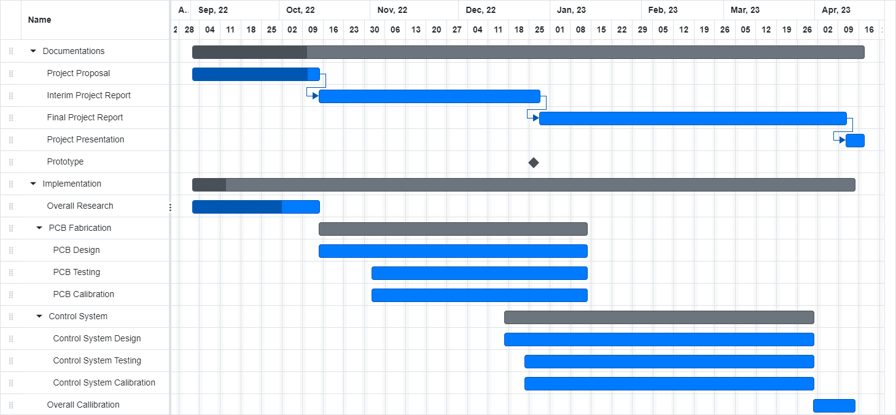

Reference

[1] "R/electroboom - self-balanced Reuleaux triangle!!!!!(),” Reddit. [Online]. Available: https://www.reddit.com/r/ElectroBOOM/comments/styhj0/selfbalanced_reuleaux_triangle/. [Accessed: 14-Oct-2022].

[2] E. Acurio, 'Mechanical redesign and control with a PLC of an inverted pendulum,' Congreso de Ciencia y Tecnología (ESPE), vol. 33, pp. 188, 2015.

[3] F. L. Markley, R. G. Reynolds, F. X. Liu, and K. L. Lebsock, "Maximum torque and momentum envelopes for reaction wheel arrays," Journal of Guidance, Control, and Dynamics, vol. 33, no. 5, pp. 1606–1614, 2010.

[4] M. Adetoro, COMPARATIVE DESIGN OF ATTITUDE STABILIZATION AND CONTROL SCHEMES FOR THREE AXES SPACE VEHICLE. Master Thesis on the direction "Instrumentation," 2010.

[5] M. Gajamohan, M. Merz, I. Thommen, and R. D'Andrea, "The Cubli: A cube that can jump up and balance," 2012 IEEE/RSJ International Conference on Intelligent Robots and Systems, 2012.

[6] S. Dani, D. Sonawane, D. Ingole, and S. Patil, "Performance evaluation of PID, LQR and MPC for DC Motor Speed Control," 2017 2nd International Conference for Convergence in Technology (I2CT), 2017.