IC382 Report Phase 1

Mobile Platform of Autonomous Tool Cart

# 

# Objective

## Final Approach

A mobile platform with a top module that would be able to perform certain missions, such as follow me, remote navigation, autonomous tasks execution etc.

## Semester Approach

## In this semester, and in this report. The target of the project would be mainly focused on the design, fabrication and manipulation of the mobile platform of the autonomous tool cart.

# Design

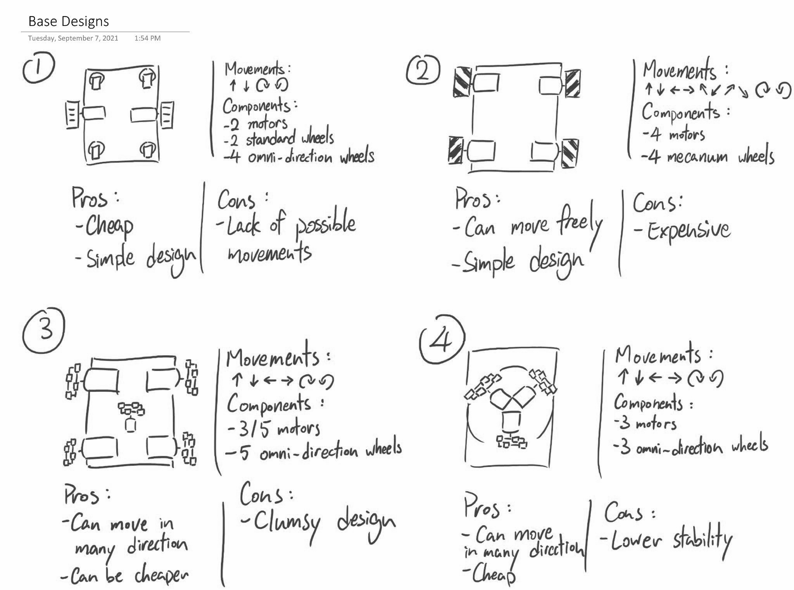

We have designed four approaches which perform well in different aspects, like we can use omni-wheels for enhancing mobility, and further increase mobility by using mecanum wheels.

## 

In order to perform mobile control and automations, two control boards will be used in our design, which are Raspberry pi and STM32. Raspberry pi is mainly used as the main control unit which controls other control boards, like STM32 used in our mobile platform. Raspberry pi has a high calculating power and wifi module that is suitable for processing sensor datas and remote control. STM32 will act as a bridge for Raspberry pi to control the motors in an easier way.

# Implementation

We are separated into mechanical and electronic parts to implement the project. Mechanical part is required to fabricate the kart frame which is able to load and move around smoothly. Electronic part needs to design the program which is used to control the motors.

In the following section, this report will focus on the electronic part of the project, as it is the part which the author is in.

## Electronic Part

In order to perform what we are designing to do, we seperate the program into two parts, STM program and ROS program.

## STM Program

The objective of the program is to receive the control signal from Raspberry pi and transfer the signal to what the motors required to work. Here is the basic logic of the program: subscribe twist_keyboard (linear and angular value) from the ROS program, and determine the direction of each motor to perform the corresponding direction of the kart. The Pwm value of each wheel is then determined to control the speed of each motor.

## ROS program

It is a part where our tutor has done most of the work for us, like translating keyboard inputs to linear and angular values, which will be read by the STM board for controlling the motors. In the future, we need to fine tune the odometry of the feedback of the kart, so we can use the odometry values to design our PID control system, which will helps us on automations of the kart control

By combining the two programs, we are able to control the motors with our keyboard wirelessly.

# Results

With the effort of the two disciplinary teams, we are able to assemble a kart which can be controlled by keyboard and is able to have a 100kg load on it.

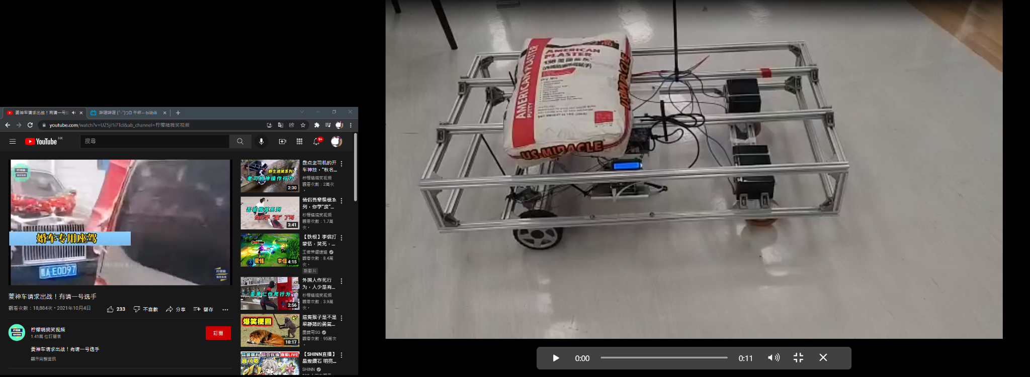

# Reflection

In this semester, I have learned a lot from this practical project. It is not ideal problems which we would encounter in theory lectures, but some real existing problems. In this semester, our group encountered two unpredictable errors that would change our thoughts while we face a similar problem next time.

Both errors are came from the motor shield, the first error we faced the problem that there's a serious difference in the turning speed on the two motors although we set two pwm values the same, we thought that it was a program bug, but finally, we fixed the problem by changing the board to a new one.

The second error we faced is that the motor didn't turn after we assembled our kart. A burnt smell came out from our motor shield, and of course, it was broken. We fixed the problem by changing a new motor shield.

These errors taught me that components are not always ideal, we always need to take an eye on the condition of the component.