**个人简历**

|  |  |
| --- | --- |
| 姓名: name_content  专业: major_content  学校: school_content  入学时间: admission_time_content  毕业时间: graduation_time_content  年龄: 0 |  |

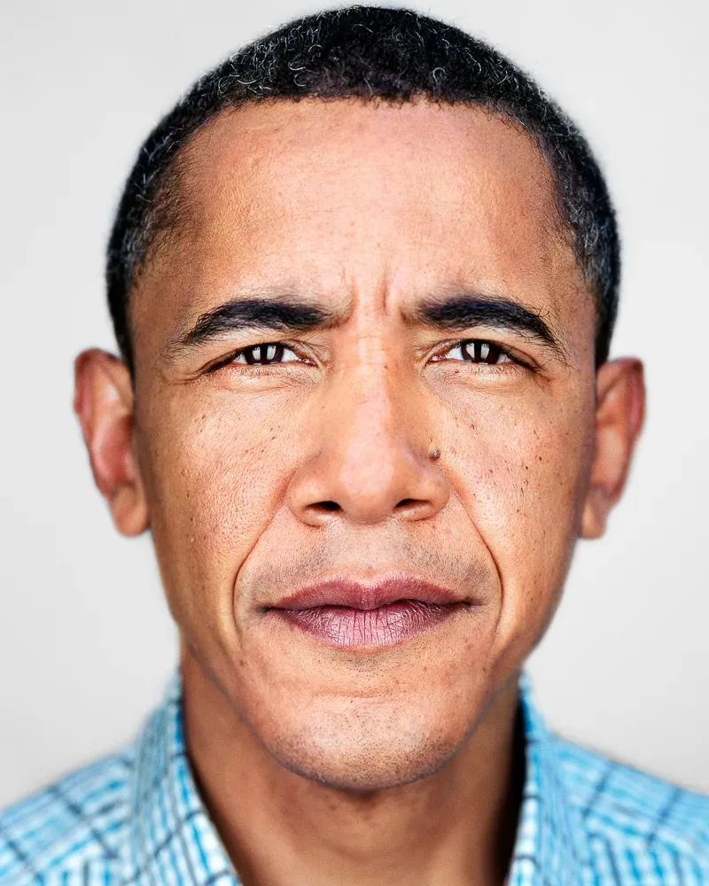

**技能**

project: java(for example)
  
title: title_content
  
content: content_content
  
proficiency: Advanced(for example)

project: java22
  
title2: hahahaha22
  
content: conten22
  
proficiency: Advanced

**活动**

responsibility: beijing
  
time: xxxx-xx-xx
  
team: 111(for example)
  
title: title_content
  
content: content_content

responsibility: beijing(example)
  
time: xxxx-xx-xx
  
team: 222(example
  
title: title_content
  
content: content_content

**角色**

time: xxxx-xx-xx
  
title: title_content
  
content: content_content

time: xxxx-xx-xx
  
title: title_detail
  
content: content_content

**成就**

location: beijing
  
time: xxxx-xx-xx
  
title: title_content
  
type: type_detail
  
content: content_detail

location: beijing(for example)
  
time: xxxx-xx-xx
  
title: title_content
  
type: type_detail
  
content: content_detail