Assignment 4: Surfaces

CS 4361.001 Computer Graphics

Instructor: Dr. Xiaohu Guo
Teaching Assistant: Alireza Khatami

Fall 2026
University of Texas at Dallas

• This is an independent assignment. You must finish it on your own
• Please make sure submitting your assignment on eLearning before deadline

Overview
In this assignment, you will implement a 3D rendering system for visualizing surfaces generated from a grid of control points. The goal is to understand how smooth curves and surfaces can be constructed using interpolation and Bézier techniques.
You are provided with a C++ framework that generates a grid of 3D control points and renders them using perspective projection. The program supports two rendering modes:
- Linear mode: straight-line interpolation between control points
- Bézier mode: smooth curves generated using the De Casteljau algorithm
Your task is to complete the missing parts of the pipeline so that both rendering modes function correctly.

Provided Code Framework
The provided code includes a configurable grid of 3D control points that define the structure of the surface, along with a perspective projection pipeline that maps these 3D points onto the 2D screen. It also supports interactive controls that allow the user to rotate and zoom the scene in real time for better visualization. Additionally, the system provides two rendering modes: a linear interpolation mode implemented in precompute_lines, which generates straight-line segments between control points, and a Bézier curve mode implemented in precompute_bezier_curves, which produces smooth curves using the De Casteljau algorithm.
Interactive Controls
You can rotate and zoom the 3D view using the keyboard:
Table 1 Keyboard mapping for interaction with the application
Key | Action
W/S | Pitch up / down
A/D | Yaw left / right
Q/E | Roll counterclockwise / clockwise
ESC | Exit program

You can optionally specify grid density and initial rotations:
Command Line Usage
The program is executed as follows:
./program [curve_mode] [num_points] [rotationX] [rotationY] [rotationZ]
Parameters:
- curve_mode:
  - linear → straight-line interpolation
  - bezier → Bézier curve rendering
- num_points: number of control points per axis
- rotationX, rotationY, rotationZ: initial rotation angles (in degrees)
Example:
. /program bezier 8 90 0 0

Your Initial Outputs
When you compile and run the program without modifying the TODO, the output window displays:
- A 3D grid of white control points.
This confirms that the projection, rotation, and rendering pipeline work correctly.

Initial Output
Before completing the TODOs, the program will:
- Display control points in 3D space
- Show incomplete or missing curve rendering
- No interaction (rotation)
Once completed, the program should display:
- Smooth Bézier curves in Bézier mode
- Straight interpolated lines in linear mode
- A continuous and visually correct surface structure
- Should be able to rotate around Y, X, Z axis.
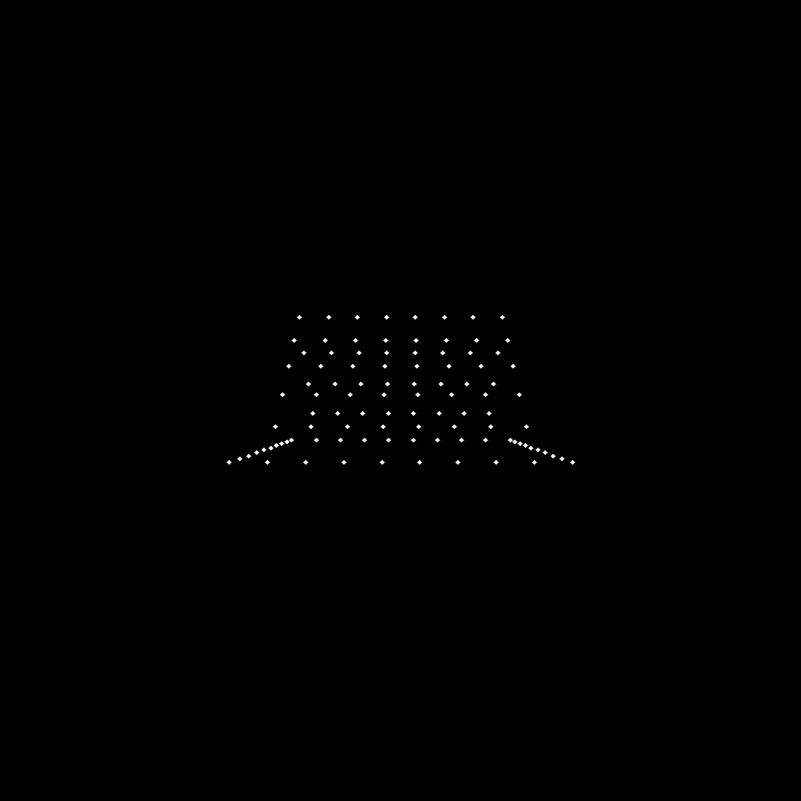
Figure 1 if you were to able to build the provided template code, you should be able to get something like this. You should not be able to rotate around any of the axises.

What You Need to Do

1. Implement Rotation Matrices
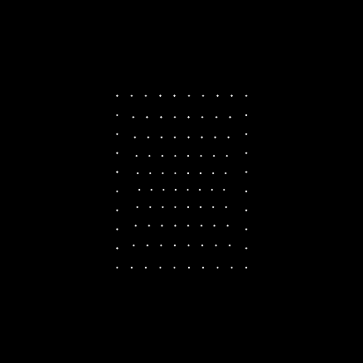
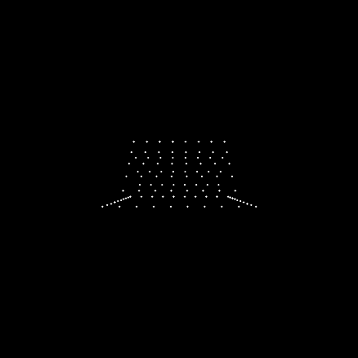
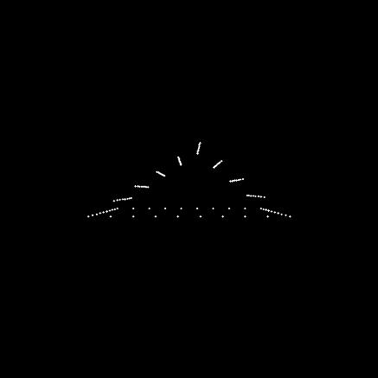
In this step, you will implement the rotation matrices for the functions rotX(float a), rotY(float a), and rotZ(float a), which represent rotations around the X, Y, and Z axes, respectively. Each function should return a correct 3×3 matrix that rotates a point in 3D space by the given angle $a$(in radians). These matrices are essential for transforming the control points before projection, allowing the user to view the surface from different orientations through interactive rotation.
Figure 2 After implementing the rotations you should be able to rotate around the axis and see the point grids from different angles. Your next step would be to implement the linear interpolations

2. Implement De Casteljau Algorithm
Eigen::Vector3f de_casteljau(std::vector<Eigen::Vector3f> pts, float t)
In this step, you will implement the De Casteljau algorithm in the function de_casteljau(...) to evaluate a Bézier curve at a given parameter $t$. Starting with the full list of control points, you iteratively interpolate between each pair of consecutive points using linear interpolation. This process produces a new, smaller set of points, which is then used as the input for the next iteration. By repeatedly applying this interpolation step, the number of points is reduced at each level until only a single point remains. This final point represents the position on the Bézier curve corresponding to the parameter $t$, and it should be returned as the output of the function.
3. Implement Linear Interpolation
void precompute_lines(const std::vector<Eigen::Vector3f>& control_points_3d,int num_points_per_axis, float step_t,std::vector<Eigen::Vector3f>& vertical,std::vector<Eigen::Vector3f>& horizontal,std::vector<Eigen::Vector3f>& diagonal)
In this step, you will implement linear interpolation within the precompute_lines(...) function to generate straight-line segments between control points. For each pair of adjacent points $p_{0}$and $p_{1}$, compute intermediate points using the interpolation formula $(1-t)p_{0}+tp_{1}$, where $t∈[0,1]$. By sampling multiple values of $t$, you create a sequence of points that form a straight line between the two control points. Repeat this process for all pairs of points along each row, column, and diagonal, and store the resulting sampled points in their respective containers (vertical, horizontal, and diagonal) for rendering.4. Implement Bézier Curve Evaluation
4. Bezier interpolation
void precompute_bezier_curves(const std::vector<Eigen::Vector3f>& control_points_3d,int num_points_per_axis, float step_t, std::vector<Eigen::Vector3f>& vertical,std::vector<Eigen::Vector3f>& horizontal, std::vector<Eigen::Vector3f>& diagonal)
For each row, column, and diagonal of control points, you will construct a Bézier curve by evaluating points along the curve using the de_casteljau() function. This is done by sampling the parameter $t$ over the interval $\left[0 , 1\right]$, where each value of $t$ produces a point on the curve through recursive interpolation of the control points. By iterating over a sufficient number of $t$values, you generate a smooth set of points that approximate the curve. These computed points should then be stored in their respective containers (vertical, horizontal, and diagonal) for later rendering.

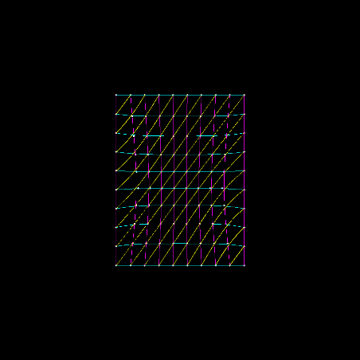 | 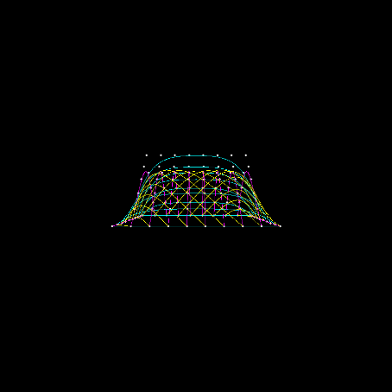 | 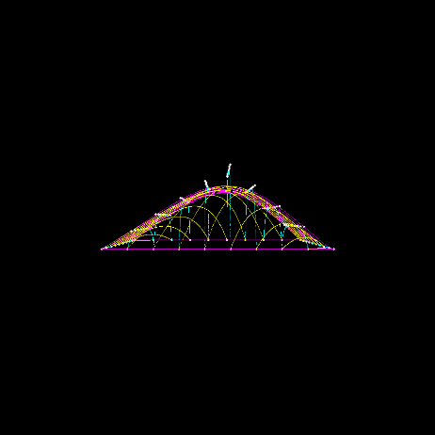
a | b | c
Figure 3 The results that you you should get after you have implemented the De Casteljau Algorithm, and used in the precompute_bezier_curves( the command line inputs are as follows:
a) /Bezier bezier 10 90 0 0
b) /Bezier bezier 10 0 0 90
c) /Bezier bezier 10 0 90 0

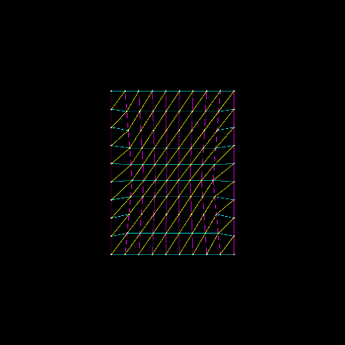 | 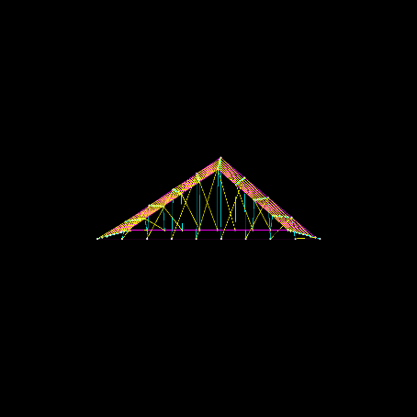 | 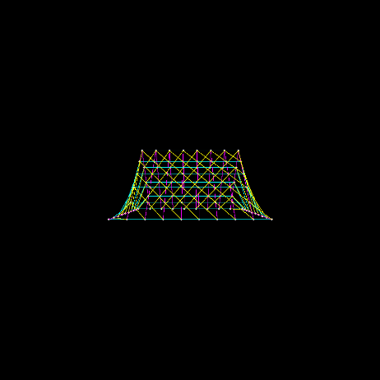
a | b | c
Figure 4 The results that you should get after you have completed the precompute_lines( the command line inputs are as follows:
a) /Bezier linear 10 90 0 0
b) /Bezier linear 10 0 0 90
c) /Bezier linear 10 0 90 0

Execution and Verification
Make sure:
- The surface appears smooth in Bézier mode
- The structure remains stable under rotation
- Control points are correctly positioned
- Curves pass through the first and last control points
Run the program in both modes:
- Linear mode → should produce straight grid lines
- Bézier mode → should produce smooth curves
What you need to Deliver
- Completed source code:
  - All .cpp, .hpp, .h, and CMakeLists.txt files
- Output images:
  - Bézier mode results for both linear, and Bezier:( 6 cases):
    - (90, 0, 0)
    - (0, 90, 0)
    - (0, 0, 0)

Grading Total: 10 points
- (4 points) Correct implementation of rotation matrices
- (3 points) Correct implementation of De Casteljau algorithm
- (2 points) Correct linear and Bézier curve generation
- (1 point) Correct output and submission format
Submission Guidelines
- Submit a single .zip file named:
YOUR_NAME_netID_Assignment4.zip
- Include only necessary files:
  - Source code
  - Output images
- Do NOT include:
  - /Build
  - .vs
  - Other unnecessary files
- Submit via eLearning only

