Assignment 3: Rendering pipeline, Shading, and texture sampling

CS 4361.001 Computer Graphics

Spring 2026

Professor: Dr. Xiaohu Guo
Teaching Assistant: Alireza Khatami

University of Texas at Dallas

• This is an independent assignment. You must finish it on your own
• Please make sure submitting your assignment on eLearning before deadline

Overview

In this programming assignment, we'll go a step further by simulating modern graphics technology. We added Object Loader (for loading 3D models), Vertex Shader and Fragment Shader in the code, and supported texture mapping.
In this experiment, the tasks you need to complete are:
- Modify the ‘obj_path’ in main () in main.cpp to your own path, either absolute path or relative path.
- Modify the function rasterize_triangle(const Triangle& t) in rasterizer.cpp: Implement the interpolation algorithm like homework 2, and implement the interpolation of normal vector, color, and texture color.
- Modify the function get_projection_matrix() in main.cpp: Copy the projection matrix implementation from your previous assignments.
  - You can run `./Rasterizer output.png normal` to test the normal vector implementation result, as the function normal_fragment_shader() is already given.
- Modify the function texture_fragment_shader() in main.cpp:
  - Implement Blinn-Phong shading.
  - Use the texture color as the diffuse term $k_{d}$.
  - Perform texture sampling using getColorBilinear() (not getColor()).

Code and Run

Execute the file:
For the command line, the second argument is the path(absolute or relative|| for relative path, please pay attention that the path is relative to your executable) to your model file (.obj file ) . and the third one can be as follows:
- normal: using normal shader in the codebase:
./Rasterizer ../models/spot normal (this is just for debugging your normal)
- texture: using texture shader in the codebase. (this is the default mode for the fragment)
./Rasterizer ../models/spot texture
The default directory for the output save location is going to be next to your executable with the name “output.png”
Codebase:

Compared with the last experiment, we made the following modifications to the framework:
- We have introduced a third-party .obj file loading library to read more complex model files. This part of the library file is in the OBJ_Loader.h file. You don't need to understand its working principle in detail, just know that this library will be passed to us a Vector named TriangleList, where each triangle has a corresponding point normal vector and texture coordinates. Additionally, textures associated with the model will also be loaded. Note: If you want to try loading other models, you can currently only modify the model path manually.
- A new texture class has been introduced to generate textures from images.
The class provides two sampling interfaces:
  - Vector3f getColor(float u, float v) – nearest neighbor sampling (for reference only).
  - Vector3f getColorBilinear(float u, float v) – bilinear interpolation sampling (to be implemented by you).
- Shader.hpp header file had been added and defined fragment_shader_payload, which includes the parameters that Fragment Shader may use. There are currently three Fragment Shaders in main.cpp, among which fragment_shader is a sample Shader that is colored according to the normal vector, and the other two will be implemented by you.
- The main rendering pipeline starts with rasterizer::draw(std : : vector<Triangle>& TriangleList). We perform a series of transformations again, which are generally done by Vertex Shader. After this, we call the function rasterize_triangle().
- The rasterize_triangle() function is like what you’ve implemented in Homework 2. The difference is that the set value will no longer be a constant, but will interpolate the normal vector, color, texture color and shading color according to Barycentric Coordinates. Recalling the [alpha, beta, gamma] we provided last time to calculate the z value, this time you will need to apply it to the interpolation of the other parameters.[Remember that for the previous assignment all the vertices had the same z value, but this time the depth of the vertices of the faces might differ, so when interpolating you need to somehow include this for some features|| for more info on this please refer to perspective correction, from the slides] What you need to do is to calculate the interpolated color, and write the color calculated by the Fragment Shader to the framebuffer, which requires you to first use the interpolated result to set the fragment shader payload and call the fragment shader to get the result.
Bilinear Texture Sampling
Bilinear interpolation improves texture sampling quality by interpolating between the four nearest texels surrounding a continuous texture coordinate $\left(u , v\right)$. Unlike nearest-neighbor sampling, which selects a single texel, bilinear interpolation produces smoother results by performing linear interpolation in both directions.
et the continuous texture coordinate map to image space:
$$u^{'}=u(W-1),v^{'}=v(H-1)$$
where $W$and $H$are the texture is width and height.
Define:
$$x=⌊u^{'}⌋,y=⌊v^{'}⌋ \\ s=u^{'}-x,t=v^{'}-y$$
The four neighboring texels are:
$$C_{00}=C(x,y) \\ C_{10}=C(x+1,y) \\ C_{01}=C(x,y+1) \\ C_{11}=C(x+1,y+1)$$
Bilinear interpolation is computed as:
$$C(u,v)=(1-s)(1-t)C_{00}+s(1-t)C_{10}+(1-s)tC_{01}+stC_{11}$$
Interpretation:
- First, interpolate horizontally between $C_{00}$and $C_{10}$, and between $C_{01}$and $C_{11}$.
- Then interpolate vertically between those two intermediate results.
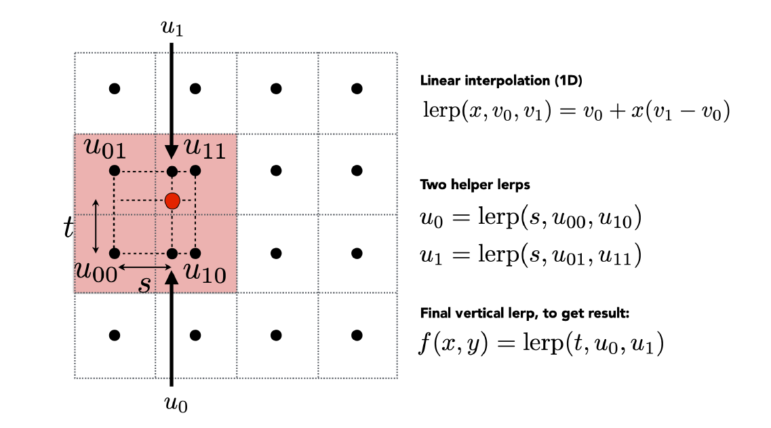
This produces a smooth transition between texels and reduces aliasing artifacts compared to nearest-neighbor sampling.
Figure 1 adapted from Lecture 4: Shading, slide 70, CS 4361.001 Computer Graphics. spring of 2026

Result:

- Run with normal(just in case you want to check your normals):
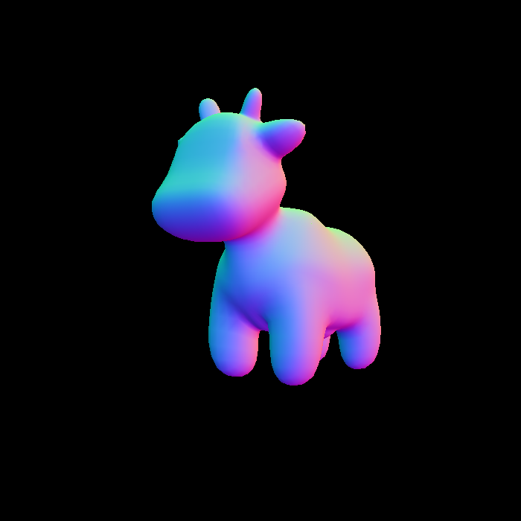

- Run with texture:
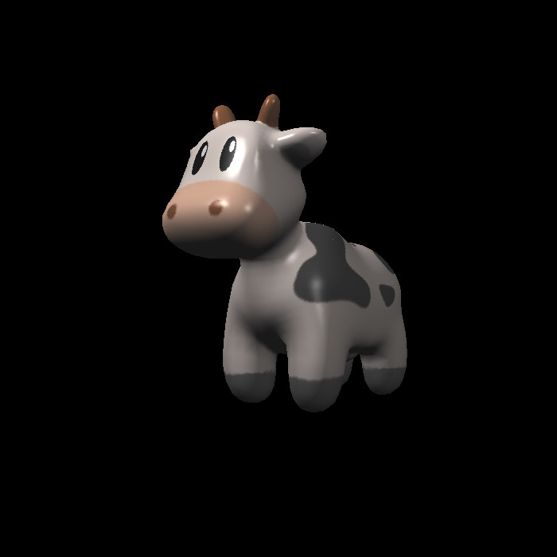

Grading and Submission

The grading criteria are as follows:
- [1 point] Submission is properly formatted and includes all required documentation. The code can be compiled and run correctly under set environment.
- [1 point] for the correct projection matrix (if your code had been working in assignment 1, depending on your implementation, you might need to change some parts of the projection matrices to be able to get the correct view)
- [2 points] Parameter Interpolation: Correctly interpolate colors, normals, texture coordinates, positions (Shading Position) and pass them to fragment_shader_payload.
- [5 points]: [3 points] Correct implementation of Blinn-Phong shading inside texture_fragment_shader(). [3 points] Correct implementation of bilinear texture sampling using getColorBilinear(). Texture mapping must use bilinear interpolation. Submission:
All you need for submission are:
- All .cpp , .hpp, .h files and CmakeLists.txt
- Add the output image of the result (should be the same as the sample that is provided)
- Do NOT include the `models’ folder

And please compress said files in ONE .zip file and named as “YOUR_NAME_NETID_Assignment3.zip”
** Do NOT include your whole project in the submission. You will lose points for not deleting unnecessary files, like /.vs, /build, etc.
** all assignments must be submitted on eLearning on time. Submitting by Email or other ways are NOT acceptable.
** Texture sampling must use bilinear interpolation via getColorBilinear().
**
- The function getColor() is provided as a helper function for debugging purposes only. You may use it temporarily to verify that other parts of your pipeline (e.g., interpolation or shading logic) are working correctly.
- However, for the final submission, getColorBilinear() must be fully implemented and used for all texture sampling. The output image must be generated using bilinear interpolation. Submissions that rely on getColor() instead of getColorBilinear() will receive point deduction.

