Environment setup for Windows
Professor: Dr. Xioahu Guo
Teaching Assistant: Ningna Wang
- Install OpenCV
go to OpenCV official website (https://opencv.org/releases/), download the latest version of OpenCV for Windows
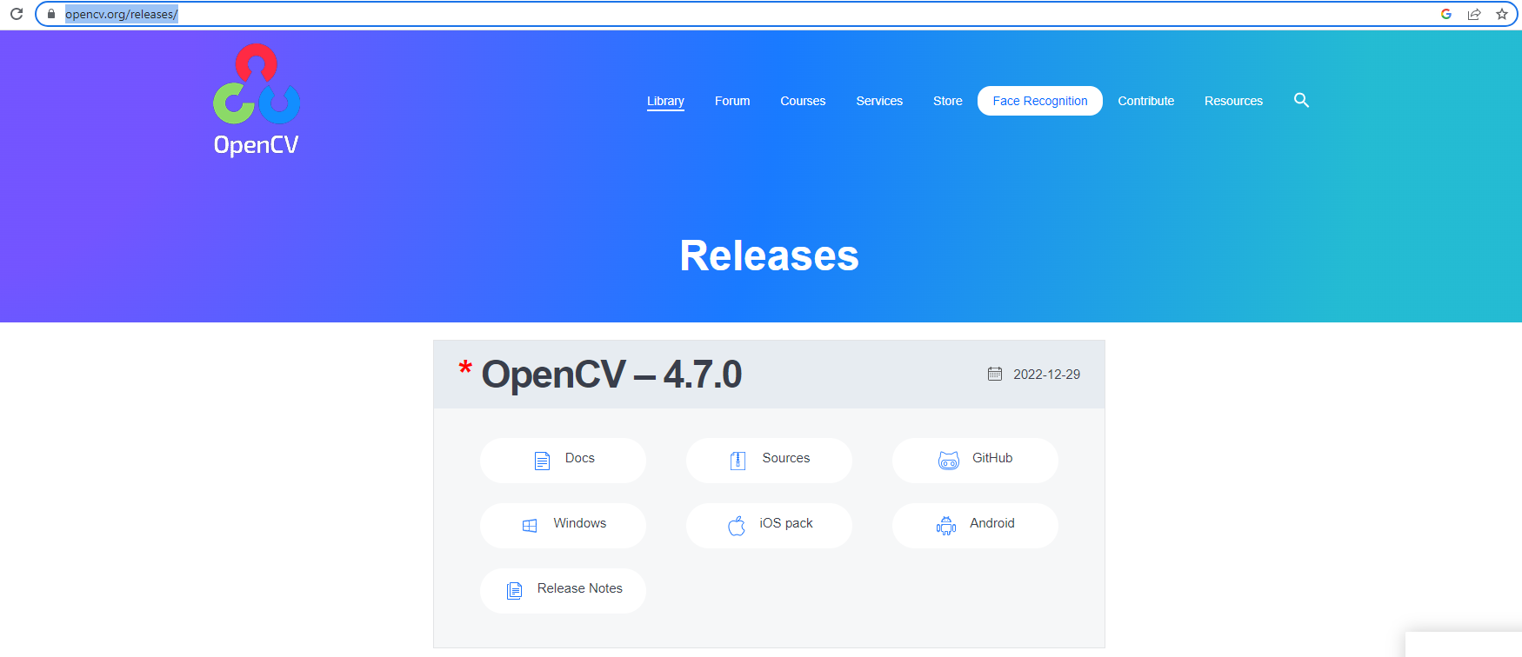

Open download file and select Extract Path (make sure you remember this location)
C:\Users\junanita\Downloads\

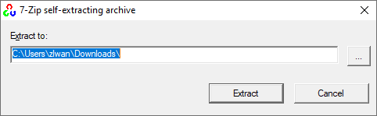
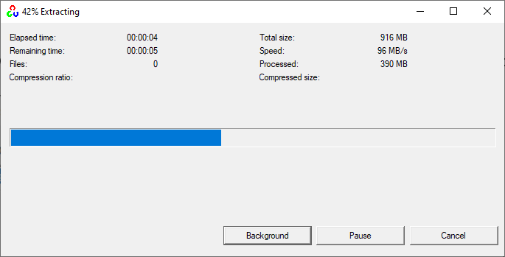

Add environment variable. Setting-> Advanced system setting
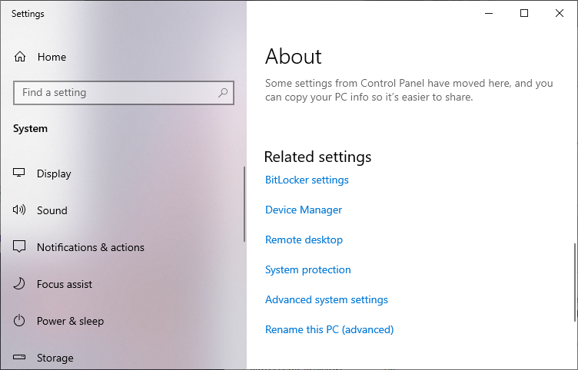

Advanced-> Environment Variables
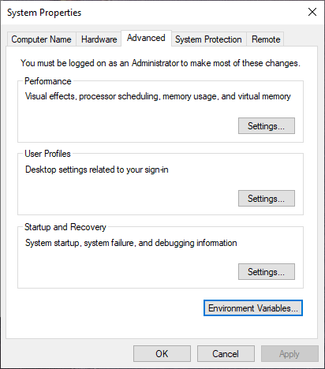

System Variables -> select “Path” -> Click “Edit”
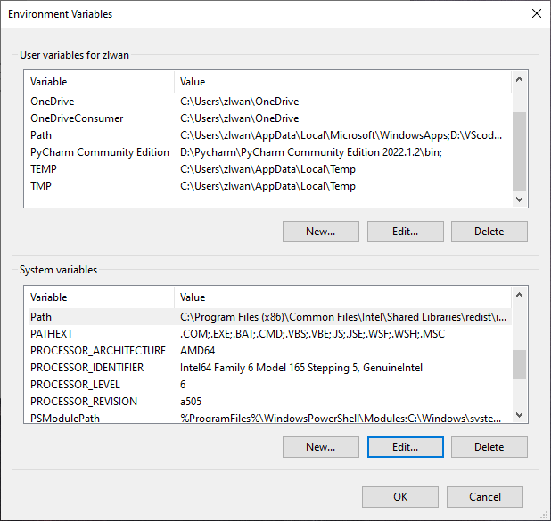

Click “New”-> Add the path for bin folder of OpenCV.
E.g. /*path of OpenCV*/build/x64/vc16/bin
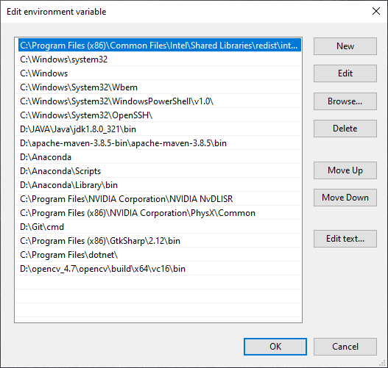

- Download Eigen
Go to office website of Eigen (https://eigen.tuxfamily.org/index.php?title=Main_Page), download the latest version with the format you preferred.
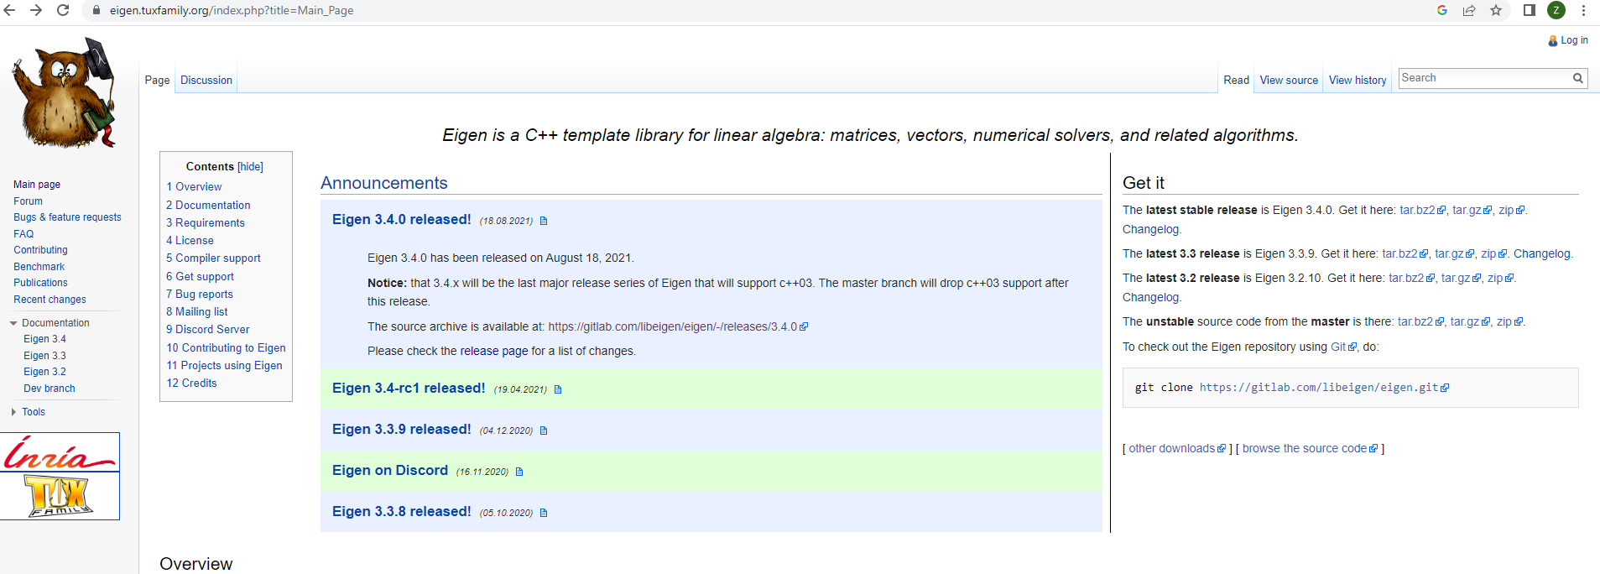

Extract files and make sure you remember this location

- Run on Visual Studio
If you don’t have VS, go to their website (https://visualstudio.microsoft.com/) download the VS2022 Community version (Free)
After downloading installer, make sure you have selected Desktop Development with C++, which includes CMAKE

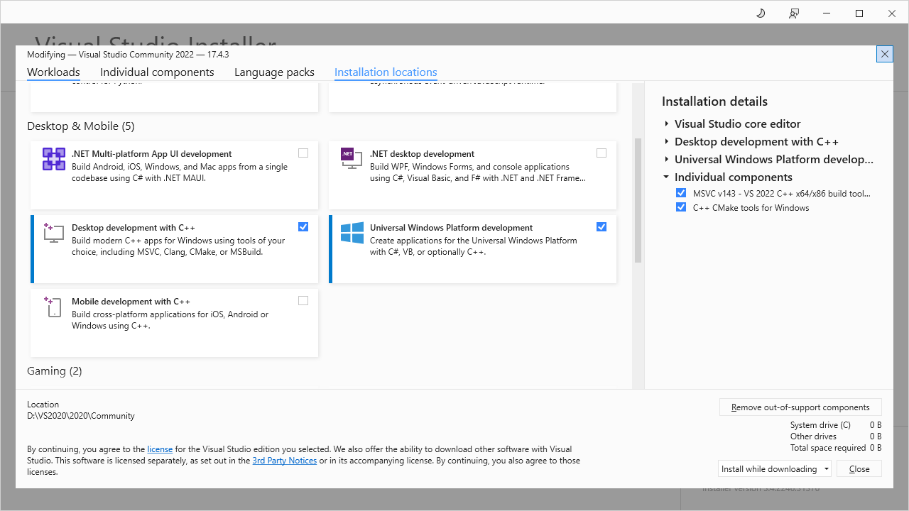

Then, open the assignment code folder (the subfolder ‘Assignment 1’ contains CMakeLists.txt file directly):
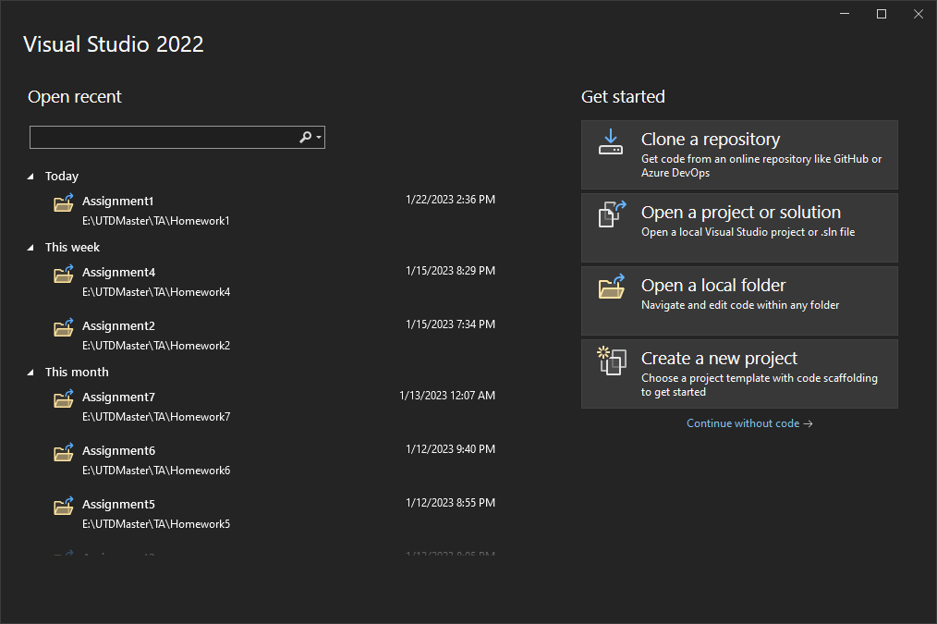

On the left side, you will find a CMAKEList.txt, change the include_directories() to the path of Eigen, remember to replace all “\” by “/” in your path!!!!
e.g. C:/Users/xxx/Downloads/eigen-3.4.0/eigen-3.4.0/
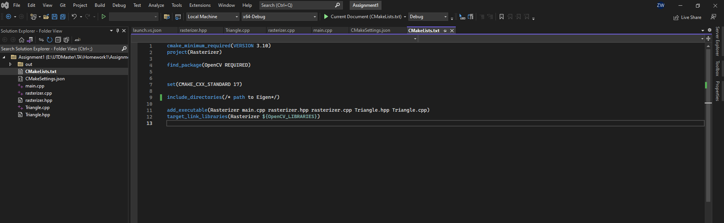

Now, we need to add OpenCV in configuration. Go to Project -> CMake Setting
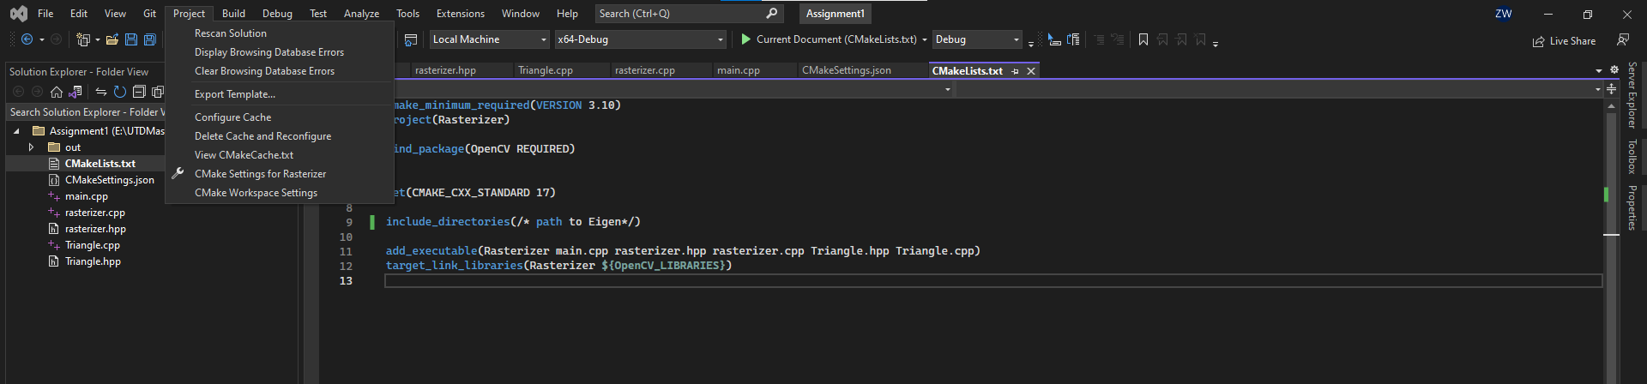
VS will automatically create and open a CMakeSetting.json file. Scrolling down to the last section, CMake variables. Fill the OpenCV_DIR with the path for the build folder in opencv.
e.g. xxxx\*path to opencv*\build
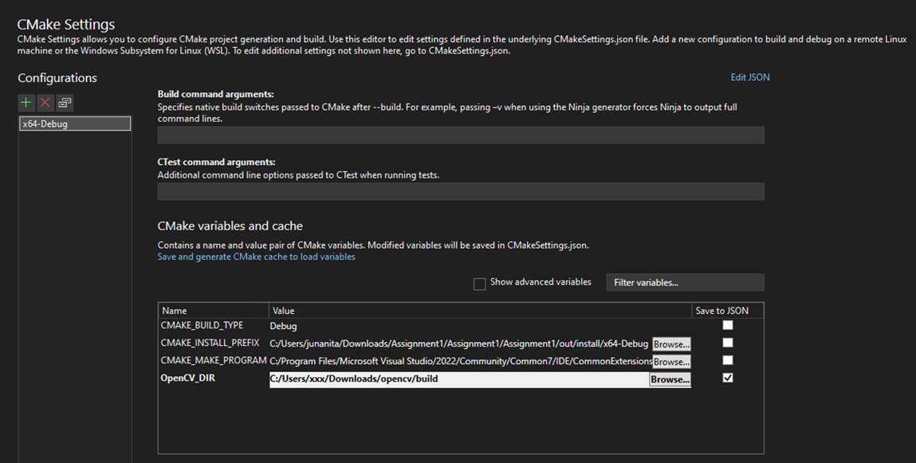

Running and Debugging
Of course, you can directly debug without arguments for assignment 1.
But for future assignments, you will require to provide specific outputs with arguments, so here are two ways to running program with argument:
- Run in Terminal
The executable file is located in “out” folder: e.g. /*path to assignment*/out/build/x64-debug

Open this folder in Terminal, and run executable file with arguments:
e.g. > Rasterizer.exe
or > Rasterizer.exe -r 20 image.png

- Debugging in Visual Studio
Right click main.cpp-> add debug configuration -> default debugger.
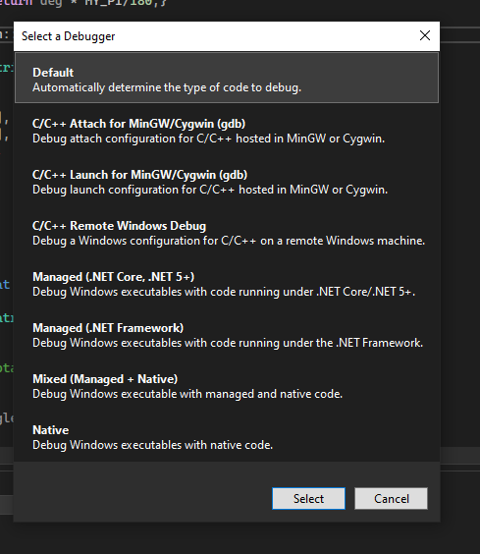
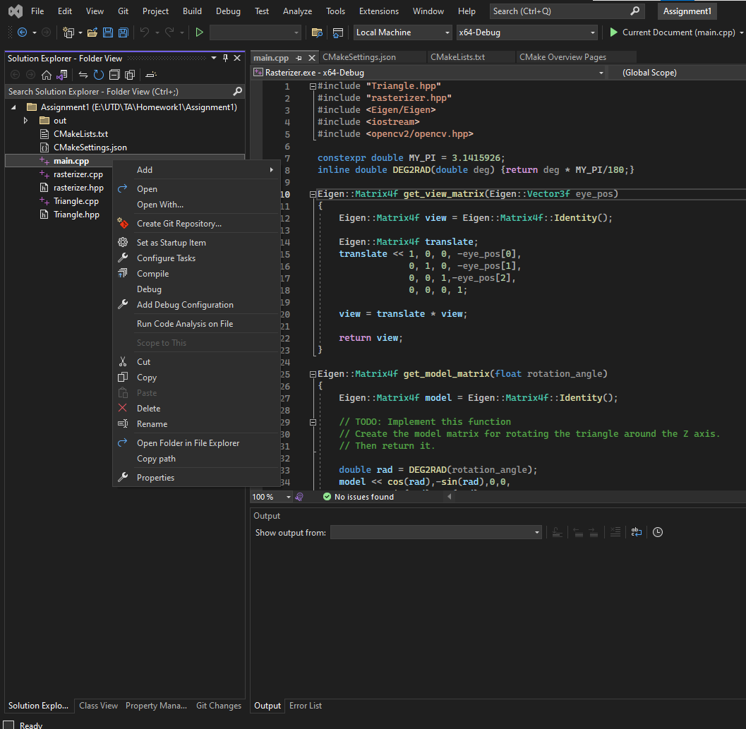
It will create a launch.vs.json file. And then, add one line in “configuration” section:
“args”: [“/* arguments */”]
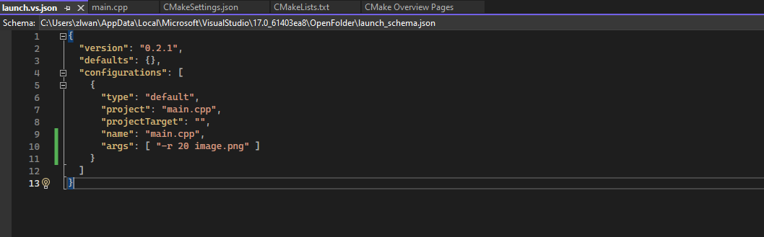
After you run the main.cpp, the output image will be created in same folder as executable file.
