Assignment 2: Triangles, z-buffering, Alpha Blending, and Culling

CS 4361.001 Computer Graphics

Spring 2026

Professor: Dr. Xiaohu Guo
Teaching Assistant: Alireza Khatami

University of Texas at Dallas

• This is an independent assignment. You must finish it on your own
• Please make sure to submit your assignment on eLearning before deadline

Overview
In the last assignment, we rendered a wireframe triangle on the screen, but it wasn’t very visually interesting. This time, we’ll take it a step further drawing a solid triangle by rasterizing it.
Previously, after applying the viewport transformation, we called rasterize_wireframe(const Triangle& t). Now, you will implement the rasterization process yourself and call rasterize_triangle(const Triangle& t) to fill the triangle with color.
The function rasterize_triangle follows this workflow:
- Computing the bounding box
  - Determine the smallest axis-aligned rectangle (bounding box) that contains the current triangle.
- Iterate over all pixels in the bounding box
  - For each pixel (x, y), check whether its center lies inside the triangle using the insideTriangle() function.
- Perform barycentric interpolation
  - If the pixel is inside, compute its barycentric coordinates (α, β, γ).
  - Use these to calculate the interpolated reciprocal weight (w_reciprocal) and depth value (z_interpolated).
- Depth test
  - Look up the current depth value from the depth buffer at this pixel.
  - If the interpolated depth is closer to the camera than the stored depth, the pixel passes the test.
- Set pixel color with blending
  - If blending mode is depth_test, directly set the pixel color to the triangle’s color and update the depth buffer.
  - If blending mode is set to any other mode, call the alpha_blend() function to combine the source color (triangle color) with the existing destination color (frame buffer) according to the chosen blend mode.

Two functions you need to modify are (in the rasterizer.cpp):
- rst::rasterizer::rasterize_triangle(): execute triangle rasterization algorithm
- static bool insideTriangle(): Tests whether the point is inside a triangle. You can modify the definition of this function, which means you can update the return type or function parameters according to your own way.
- Complete the rst::rasterizer::alpha_blend function for case rst::blendmode::src_alpha, and case rst::blendmode::one( right now it is just returning the source color)

Case 1: Source Alpha Blending (src_alpha)
$$C_{dst}=α_{src}⋅C_{src}+\left(1-α_{src}\right)⋅C_{dst}$$
$$α_{dst}=α_{src}+\left(1-α_{src}\right)⋅α_{dst}$$
- $C_{src}$: source RGB color (new fragment)
- $C_{dst}$: destination RGB color (framebuffer)
- $α_{src}$: source alpha
- $α_{dst}$: destination alpha
This is the standard alpha blending equation.

Case 2: Additive Blending (one)

$$C_{dst}=C_{src}+C_{dst}$$

$$α_{dst}=min\left(1.0, α_{src}+α_{dst}\right)$$
- $C_{src}$: source RGB color
- $C_{dst}$: destination RGB color
- $α_{src}$, $α_{dst}$: source and destination alphas
This mode simply adds the source color to the destination, clamping alpha to 1.
Because we only know the depth values at the three vertices of the triangle, we need to use interpolation to obtain the depth values of the pixels inside the triangle. We've already taken care of this part for you, as it hasn't been covered in the course yet. The interpolated depth value is stored in the variable z_interpolated.
Notice how we initialized the depth buffer and the sign of the z values. All the triangles have negative z values, which means that the smaller the value, the farther away from the viewpoint.
Also, note that only the two triangles in the middle have high transparency, and the two triangles on the sides are completely opaque [you can check these values in main.cpp line 145]
Also notice that both triangles have transparency of 0.5( with 1 indicating an opaque object)
To test your implementation, we provide two hard-coded triangles. If your program is correct, the output image should match the example shown below:

Back-Face Culling
In this assignment, you will also implement back-face culling as part of the rendering pipeline.
Back-face culling removes triangles that are facing away from the camera before rasterization. This improves rendering efficiency and mimics how modern graphics pipelines operate.
The orientation of a triangle can be determined in screen space using the sign of its signed area. If the triangle vertices are ordered counterclockwise, the triangle is ` facing. If they are ordered clockwise, the triangle is back-facing. It is on you to figure out how to determine whether the triangle is facing forward or backwards.
If a triangle should be discarded under the active culling mode, it must not be rasterized.
You need to modify the following functions
rasterizer.cpp
- is_back_facing() — implement the orientation test
  - This function receives three screen-space vertices of a triangle.
  - Compute the signed area of the triangle using the 2D cross product of two of its edge vectors.
  - Return true if the triangle is back-facing, false if it is front-facing.
  - You only need to determine the sign of the area — you do not need the actual area value.
- draw () implement the two TODO steps in the culling block
  - Step 1: Call is_back_facing() to determine the triangle's orientation in screen space.
  - Step 2: Check the active cull_mode. If the triangle should be discarded under the current mode, skip it using continue. Otherwise, allow it to proceed to rasterize_triangle().
- main.cpp
  - No implementation is required here, but this file is where you configure culling before rendering. Call set_cull_mode() once before the render loop
  - // Disable culling (render all triangles):
r.set_cull_mode(rst::CullMode::None);
// Cull back-facing triangles (standard usage):
r.set_cull_mode(rst::CullMode::Back);
// Cull front-facing triangles (e.g., to see inside a mesh):
r.set_cull_mode(rst::CullMode::Front);
  - The three modes are defined in rasterizer.hpp under enum class CullMode

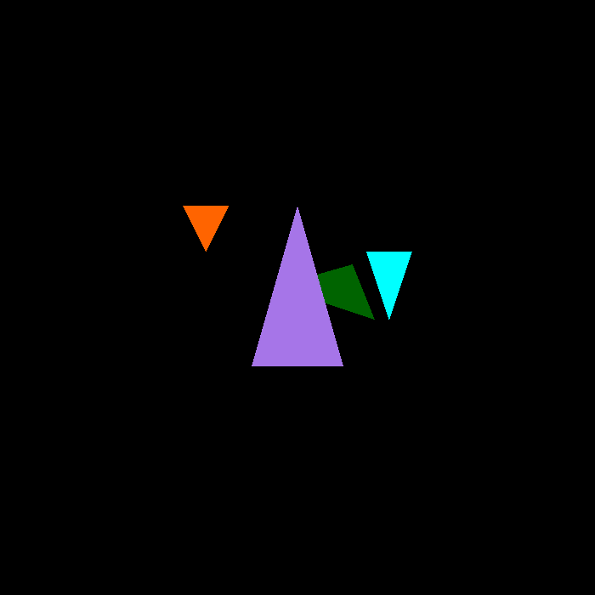
Figure 1 This is the rendering done in depth_test mode ( notice that the green triangle is behind the purple one, the z param of the coordinates is smaller – the smaller the z value, the further away it is, because of the negative z. The culling mode is None in this setting since those triangles are visible.

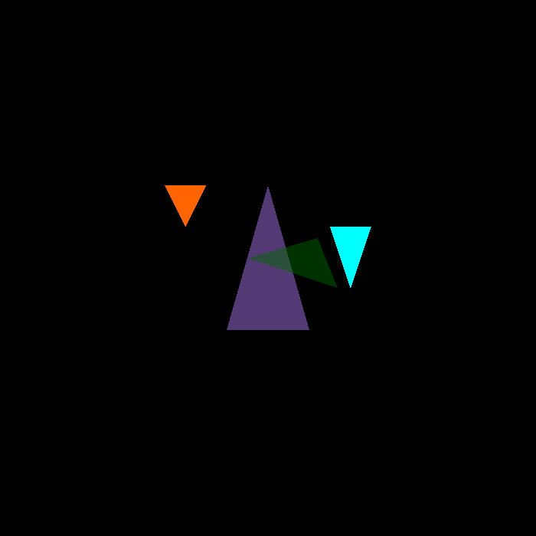
Figure 2 The result when the option for blend mode is source_blend, and culling mode is None

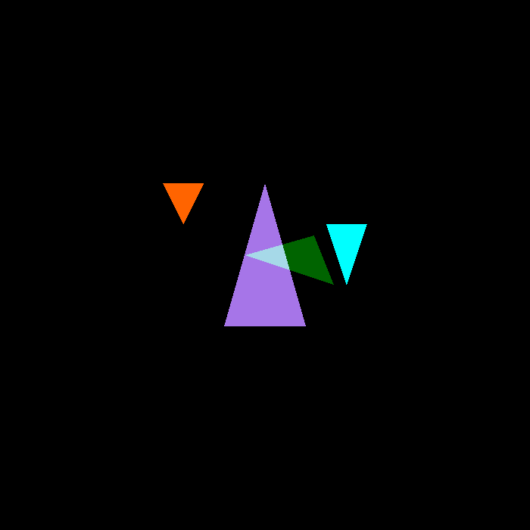
Figure 3 This is going to be the result of one-blending (If you have used Adobe Photoshop this is equivalent to additive layer), and culling set to None.

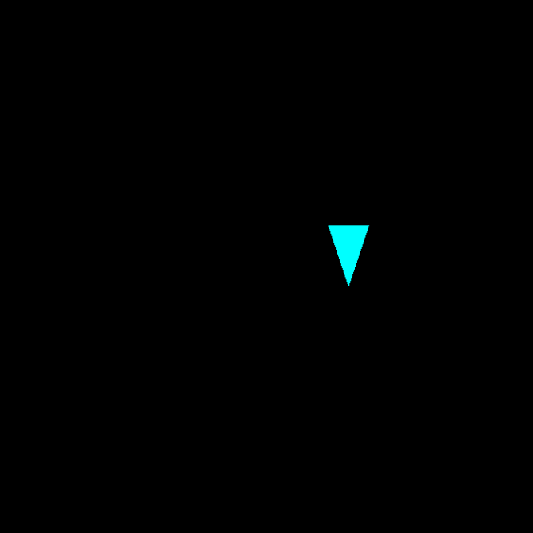
Figure 4 If you were to set culling to BACK only this triangle would be visible. Since it is heading backward (the orientation of the vertices is counterclockwise.

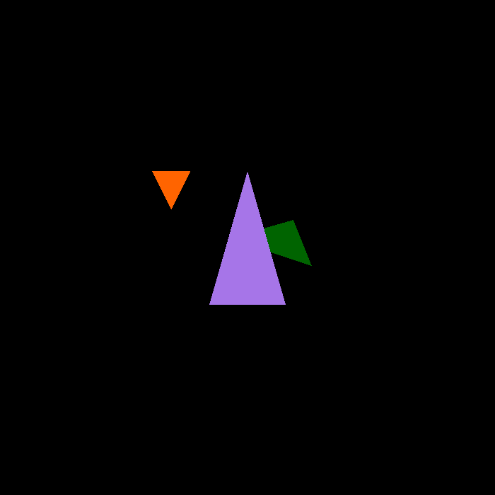
Figure 5 And finally, if you set alpha blending to depth-test and culling to front this should be the result that you would get, Notice that the triangle with the CYAN color is not visible, since the orientation of its vertices is clockwise- it is facing the camera-s

Coding
The blend mode is selected from the command line using an integer argument, the second argument. The mapping is defined in set_alpha_blend_mode(int mode) as follows:
- 0 → depth_test (no blending, only depth testing is applied)
- 1 → src_alpha (classic alpha blending)
- 2 → one (additive blending)
The culling mode is selected from the command line using an integer argument, the third argument. The mapping is defined in set_cull_mode(int mode) as follows:
- 0 → None (all triangles should be visible)
- 1 → FRONT (only triangles facing the camera should be visible)
- 2 → BACK (only triangles facing away from the camera should be visible)
To run the program with a specific mode, use:
./Rasterizer <mode> <output_file>
Examples:
- ./Rasterizer 0 0 none-depth-test.png # no culling -depth test
- ./Rasterizer 1 0 none-src-alpha.png # no culling - source alpha blending
- ./Rasterizer 2 0 none-one.png # no culling - additive blending
- ./Rasterizer 0 1 back-depth-test.png # back culling - depth test
- ./Rasterizer 0 2 front-depth-test.png # front culling- depth test
If you enter an invalid number (not 0, 1, or 2), the program will keep the previous mode and print a warning.

Grading and Submission
Grading Criteria
- [1 point] All required files are submitted correctly (all source files, 5 screenshots, and CMakeLists.txt). The code compiles and runs correctly in the specified environment.
- [1 point] Correct implementation of source-alpha and additive blending.
- [1 point] Correct implementation of front and back culling.
- [3 points] Correct implementation of the triangle rasterization algorithm.
- [2 points] Correct implementation of the inside-triangle test.
- [2 points] Correct implementation of the z-buffer algorithm for sequential triangle rendering.
Submission:
- Compress all required files into a single .zip archive named:
YOUR_NAME_Assignment2.zip
- Include:
  - CMakeLists.txt
  - All .cpp files
  - All .hpp / .h files
  - An output image or screenshot of your result
Do not include the entire project directory. You will lose points for including unnecessary files such as /build, /.vs, etc.
All assignments must be submitted on eLearning on time. Submissions by email or other methods are not accepted.
Late submissions will result in point deductions (per-day penalty).

