Assignment 1: Model, view, and Projection
Transformations

CS 4361 Computer Graphics

Spring 2026

University of Texas at Dallas

Professor: Dr. Xiaohu Guo
Teaching Assistant: Alireza Khatami

• This is an independent assignment. You must finish it on your own
• Please make sure submitting your assignment on eLearning before deadline
Overview

Assignment 1: Model, view, and Projection Transformations
Overview
So far, we have explored how matrix transformations can be used to position and manipulate objects in 2D and 3D space. Now, it's time to apply this knowledge through hands-on implementation. In the next three assignments, you will build a simplified CPU-based rasterizer, gaining practical experience with transformation matrices and their role in rendering.
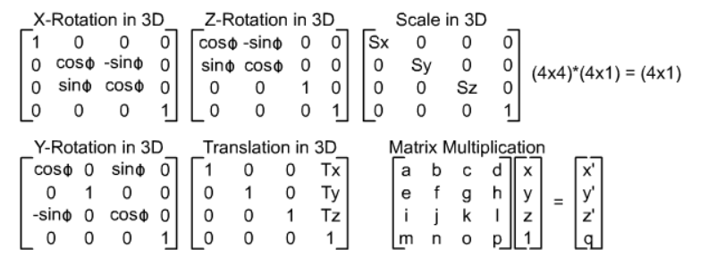
The scene contains two triangles with different roles. The green triangle is rendered as a fixed reference and will remain unchanged throughout the assignment. The blue triangle is the primary object of interest and will be transformed by your implementation of object-space (model) transformations, as well as view and projection transformations. You will also construct translation and scaling matrices and investigate the effect of different transformation orders (e.g., $T⋅R⋅S$, $S⋅R⋅T$, $S⋅T⋅R$) on the result.
Figure 1 source : https://www.c-jump.com/bcc/common/Talk3/Math/Matrices/W01_0100_3d_transformations.htm
- Projection transformation
Implement a perspective projection matrix using the given field-of-view, aspect ratio, and near and far clipping planes. Zooming functionality should be achieved by modifying the field-of-view parameter during execution.
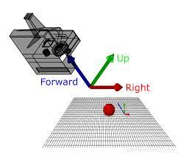
- View transformation (LookAt matrix)
Implement view transformation using a LookAt matrix. This includes computing the camera coordinate frame(up, right direction), constructing the corresponding rotation and translation matrices, and combining them to obtain the final view matrix ( for further information about look at matrix formation, please refer to this link)
Figure 2 source https://carmencincotti.com/2022-04-25/cameras-theory-webgpu/
Additionally, you will extend your code to implement zooming by changing the field-of-view (FOV).

The provided triangle vertices are:
For triangle 1 :
V0 ( 1, -1.5, -2)
V1 ( 0, 1.5, -2)
V2 (-1, -1.5, -2)
For triangle 2:
V0 ( 4, -1.5, -2)
V1 ( 3, 1.5, -2)
V2 (2, -1.5, -2)

If you were to first run the code, your output would look like something like this:
Figure 3 The output of the code provided in the assignment as initial state

Tasks
1. Model Transformation (Blue Triangle Only)
Implement the function:
Eigen::Matrix4f get_model_matrix_transformation(float scale, float rotation_angle, Eigen::Vector3f translation);
- Construct the model transformation matrix for the blue triangle.
- Implement rotation around the z-axis.
- Extend the model transformation to include translation and scaling.
- Experiment with different matrix multiplication orders:
  - Translation → Rotation → Scaling $(S⋅R⋅T)$
  - Scaling → Rotation → Translation ($T⋅R⋅S)$
  - Rotation → Translation → Scaling $(S⋅T⋅R)$
  - Scaling → Translation → Rotation $(R⋅T⋅S)$
  - Rotation → Scaling → Translation $(T⋅S⋅R)$
- Observe how each ordering affects the behavior of the blue triangle and determine which ordering produces the expected transformation.
- The blue triangle controls for transformations are as below [this is already done you don’t need to worry about it ]:
  - Press O / I to rotate the triangle clockwise / counterclockwise.
  - Press K / J to scale the triangle up / down.
  - Press M / N to translate the triangle right / left along the x-axis.

2. Projection Transformation
Implement the function:
Eigen::Matrix4f get_projection_matrix(float eye_fov,
float aspect_ratio,
float zNear,
float zFar);
- Construct the perspective projection matrix .
- Inputs include field-of-view (in degrees), aspect ratio, and near and far clipping planes.
- The function currently returns an identity matrix and must be fully implemented.
- Projection parameters should correctly map the scene into normalized device coordinates. If to be implemented correctly, you should be able to zoom in and out with W/S

3. View Transformation (LookAt Matrix)
Implement the function:
Eigen::Matrix4f get_view_matrix_lookat(Eigen::Vector3f eye,
Eigen::Vector3f target,
Eigen::Vector3f up);
- Implement a LookAt camera transformation (similar to glm::lookAt).
- Compute the camera’s forward, right, and up vectors.
- Construct the rotation matrix from the camera basis.
- Construct the translation matrix from the camera position.
- Return the product of the rotation and translation matrices.
- The function currently returns an identity matrix and must be fully implemented. If implemented correctly, you should be able to rotate around the origin with D/A

Code frame
In this assignment, you will not need the Triangle class. Instead, focus on rasterizer.hpp and main.cpp. The file rasterizer.hpp defines the renderer interface and is responsible for rasterization and framebuffer management. The Rasterizer class is a core component of the system, with the following key variables and functions.
Key Variables
- Matrix4f model, view, projection
Transformation matrices representing the model, view, and projection stages of the graphics pipeline.
- std::vector<Eigen::Vector3f> frame_buf
Framebuffer used to store the final color values of pixels to be displayed on the screen.
Key Functions
- set_model(const Eigen::Matrix4f& m)
Sets the model transformation matrix used for object-space transformations.
- set_view(const Eigen::Matrix4f& v)
Sets the view transformation matrix that represents the camera transformation.
- set_projection(const Eigen::Matrix4f& p)
Sets the projection matrix used to map view-space coordinates into clip space.
- set_pixel(Eigen::Vector2f point, Eigen::Vector3f color)
Writes the color value (r, g, b) to the framebuffer at screen position (x, y).
In main.cpp, the graphics pipeline is simulated explicitly. An instance of the Rasterizer class is first created, and the required transformation matrices are set using the provided interface functions.
Two triangles with hardcoded vertex positions are defined in the scene. One triangle serves as a fixed reference (green) and should not be modified. The second triangle (blue) is the transformable object and is affected by the model, view, and projection matrices implemented by the student.
Three functions are defined in main.cpp to compute the model, view (LookAt), and projection matrices. Each function returns a 4×4 matrix, which is then passed to the rasterizer using set_model(), set_view(), and set_projection() respectively. The rasterizer applies these transformations and displays the final result on the screen.
After applying the model, view, and projection transformations, vertex coordinates are mapped into normalized device coordinates (NDC), where each component lies in the range $\left[-1,1\right]$. The final viewport transformation, which maps NDC to screen coordinates $\left(\text{window_width} , \text{window_height}\right)$, is handled internally by the rasterizer. Although this step is implemented for you, understanding its role in the pipeline is essential.

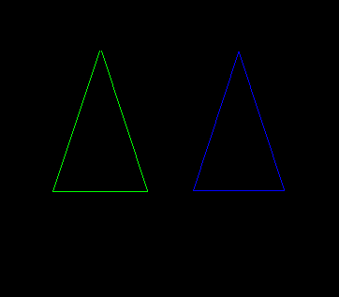
Figure 5 starting configuration of the triangles when you run the program
Figure 4 The result of scaling*2, rotating 180 degrees clockwise, and moving 4.5 units to the right
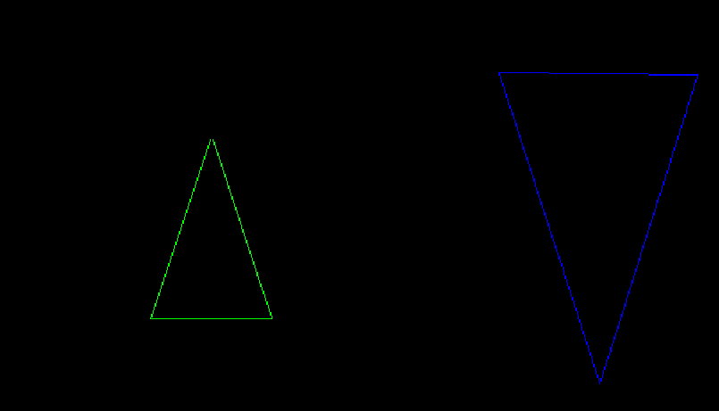

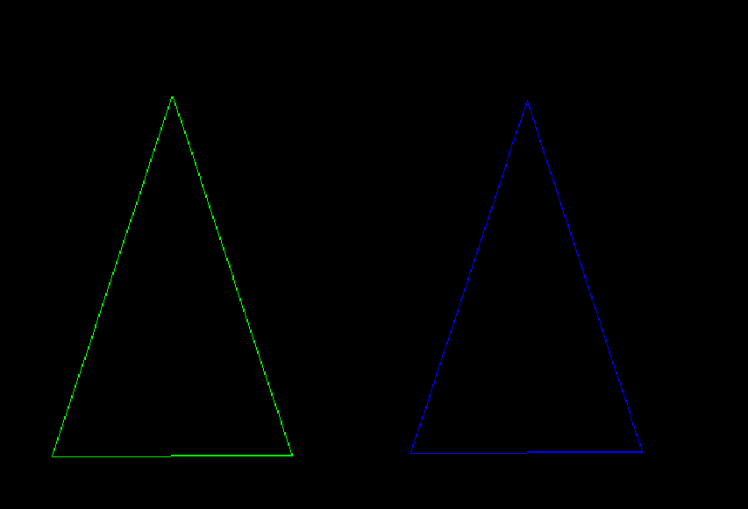
Figure 6 The result of zooming in and out using W/S. This is achieved within the get_projection_matrix function

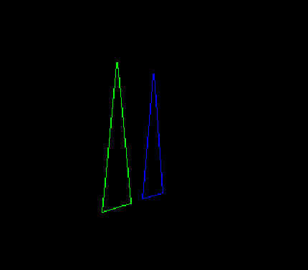
Figure 7 The result that you would get if you were to rotate the camera around the origin( this is achieved within the get_projection_matrix function

Grading and Submission

Submission:
- Please compress all the following files into a single .zip archive named YOUR NAME- YOUR STUDENT NETID_Assignment1.zip.
  - CMakeLists.txt
  - All *.cpp files
  - All *.hpp/*.h files
  - Output screenshot image.png or recordings in .mp4 format
- 5 Screenshot of your output where the blue triangle’s transformations (rotation, scale, translation) are applied by the following case:
  - Translation → Rotation → Scaling. Save this screenshot as TRS.png
  - Scaling → Rotation → Translation. Save this screenshot as SRT.png
  - Rotation → Translatioas SRT.png. Save this screenshot as RTS.png
  - Scaling → Translation → Rotation. Save this screenshot as STR.png
  - Rotation → Scaling → Translation. Save this screenshot as RST.png
** Do NOT include your whole project in the submission. You will lose points for not deleting unnecessary files, like /.vs, /build, etc.
** all assignments must submit on eLearning on time. Submitting by email or other ways are NOT acceptable.
** Any violation of the instructions would cause point deductions.

The grading criteria are as follows:
- [1 point] correct submission format
- [1 point] The model matrix is constructed correctly.
- [3 points] The perspective projection matrix is constructed correctly. The view-look at matrix is constructed correctly. We can zoom in and out with W/S and rotate around the origin with D/A
- [2 points] Transformation matrices are implemented and applied correctly, and the code can work correctly with the controls (O/I, K/J , M/N)
- [3 points] 5 pictures of the outputs based on the ordering configurations specified in the previous sections

