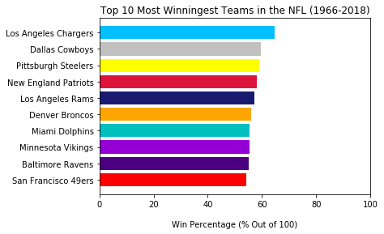

Made with: top_10_winningest_teams.py

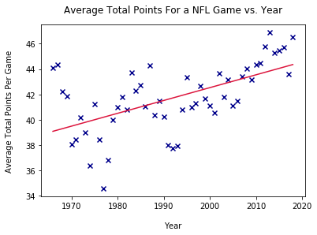

Made with: points_by_year.py

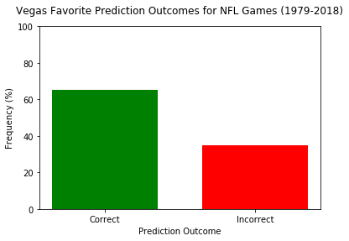

Made with: vegas_predictions.py