考试方式： 闭卷
学院 系 专业班级 姓名 学号

(密封线外不要写姓名、学号、班级、密封线内不准答题，违者按零分计)

…………………………………………密…………………………封……………………………………线…………………………………
太原理工大学Discrete Mathematic 试卷

适用专业：计算机留学生 考试日期：2024.12.4 时间：120分钟 共8页
题 号 | 1 | 2 | 3 | 4 | 5 | 6 | 7 | 8 | 9 | 10 | 11 | 12 | 总 分
得 分
- Construct a truth table for the compound propositions 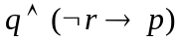.（10 points）
Scores | 评卷人

Scores | 评卷人

- Verify that is a tautology. （8 points）

Scores | 评卷人

- Find the full conjunctive normal form for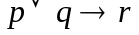using standard logical equivalences. You are not allowed to use truth table for this question.（8 points）

Scores | 评卷人

- Establish the validity of the argument 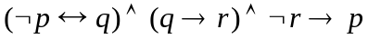.（8 points）

Scores | 评卷人

- Show the equivalences .（8 points）

Scores | 评卷人

- Put the wffs in prenex normal form .（8 points）

Scores | 评卷人

- Show that the premises “A student in this class has not done the homework”, and “Everyone in this class passed the first exam” imply the conclusion “Someone who passed the first exam has not done the homework”. （7 points）

Scores | 评卷人

- Let 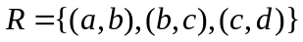 be a relation on the set 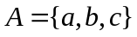, what is the transitive closure of ? （8 points）

Scores | 评卷人

- Write out the handshaking theorem. How many edges does a graph have if it has vertices of degree 4, 3, 3, 3, 2, 1?（10 points）

Scores | 评卷人

- In the simple graph G shown in the following figure, find the number of walks of length 3 from a to b.（10 points）
d
c
b
a

Scores | 评卷人

- Use any of the algorithms you've learned to find a minimum spanning tree of the weighted graph below.（8 points）
a
b
c
a
1
3

2
3
2
2
d
e
2
f
1
1
1
2
3

g
h
i
2
4

Scores | 评卷人

- If an equivalence relation on 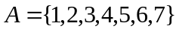 induces the partition 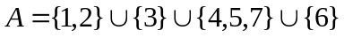, what is ? （7 points）

