考试方式： 闭卷
学院 系 专业班级 姓名 学号

(密封线外不要写姓名、学号、班级、密封线内不准答题，违者按零分计)

…………………………………………密…………………………封……………………………………线…………………………………
太原理工大学 离散数学 试卷（A卷）

适用专业：计算机专业实验班 考试日期：2025.5.26 时间：120分钟 共8页
题 号 | 一 | 二 | 三 | 四 | 总 分
得 分
得 分 | 评卷人
I. Choose the corresponding letter of the best answer that best completes the statements or answers the questions among A, B, C and D and fill the blanks(2 points each, 30 points in all).
1. From the perspective of truth values, all types of propositional formulas are ( ).
A. tautology B. contradiction C. tautology, contradiction D. tautology, contradiction, satisfiable
2. Let 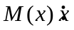is a human; 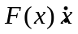needs to eat. Express the following proposition with a predicate formula: Everyone needs to eat. The wrong expression is ( ).
A. 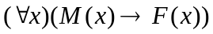 B. 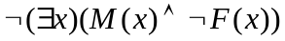
C. 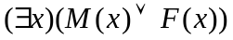 D. 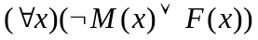
3. Let the universe of discourse be the set of integers. The formula with a truth value of true is ( ).
A. 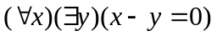 B. 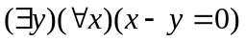
C. 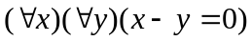 D. 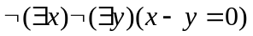
4. Suppose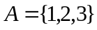, there are ( ) binary relations on .
A. 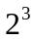 B. 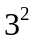 C. 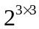 D. 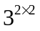
5. The set that is closed under an operation is ( ) .
A. The division operation on the set of non-zero integers 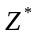.
B. The operations of matrix addition and multiplication on the set of all invertible n×n real matrices 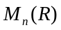.
C. The operations of matrix addition and multiplication on the set of all n×n real matrices.
D. is the least common multiple of x and y.
6. Let G be an undirected simple graph with n nodes. If there exists a Hamiltonian path in G , then the relationship between the sum of the degrees of every pair of nodes in G and n-1 is ( ).
A. Not less than. B. Not less than or equal to.
C. Equal to. D. Not not less than (i.e., At least).
7. Let G be a connected planar graph with n vertices, e edges, and r faces. The formula proved by Euler is ( ).
A. 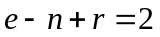 B. 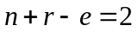 C. 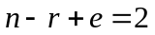 D. 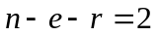
8. In the graph, there are ( ) paths of length 3 from to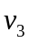.
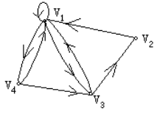
A. 0 B. 1 C. 2 D. 3
9. The following functions that are bijective is ( ).
A.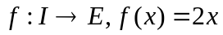 B.
C. 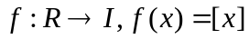 D. 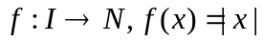
D. The graph G has loops that pass through each vertex at least once.
10. Let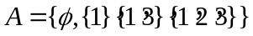, the Hasse diagram of the inclusion relation “ ”on is ( ).
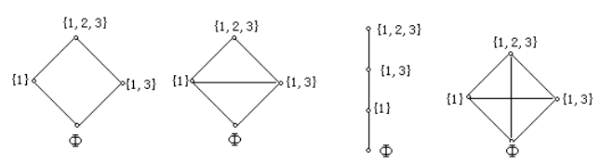
A B C D
- The following formulas that are tautologies is ( ).
A.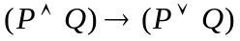 B.
C. 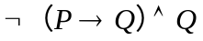 D. 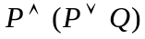
12. The number of minterms contained in the principal disjunctive normal form of formula 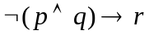 ( ).
A. 2 B. 3 C. 5 D. 0
13. The following correct equivalence relations are ( ).
A. B.
C. 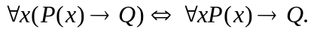 D. 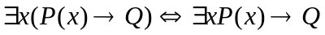
14. The mistake in the following reasoning steps is ( ).
①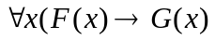 P
② 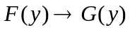 US①
③ 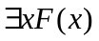 P
④ 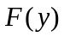 ES③
⑤ 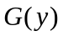 T②④I
⑥ 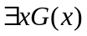 EG⑤
A. ② B. ④ C. ⑤ D. ⑥
15. Let 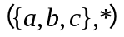is a Algebric systerm, the operation * is defined as follows ( ),
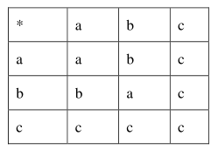
then the zero element is ( ).
A. a B. b C. c D. No

得 分 | 评卷人
II. Fill the best answer in the blanks(2 points for each black, 18 points in all).

- Let P: you work hard, Q: you may fail. The translation of "Unless you work hard, you will fail." is______________________.
- Let then 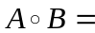________________________, 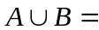_______________________________________________________.
- In propositional calculus, the conjunction, disjunction, conditional, and biconditional of two __________________ are all _________________.
- In an n-order complete graph, the degree 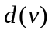 of node v is equal to______________________.
- In any (n, m) graph G=(V, E), the relationship between the edges and the vertices is _____________________________________________________________.

- A tree is a ______________ graph that does not contain ________________.

III. Calculation questions: with a full score of 32 points.
得 分 | 评卷人

- Find the full disjunctive normal form of 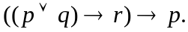 [7 points]

- Let 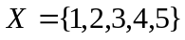, the relation 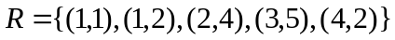on . Find the transitive closure 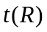of the relation with Warshall’s Algorithm. [10 points]

- In a binary tree, find the optimal binary tree with weights 2, 3, 5, 7 and 8.[5 marks]
(Hint: The Huffman method can be used.)

- As shown in the weighted graph below, it represents seven cities 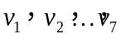and some pre-calculated direct communication cost (unit: ten thousand yuan) between them. Try to provide a scheme that enables communication between cities and minimizes the total cost. [10 marks]
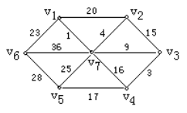

IV. Logical deduction questions. (10+10=20 points)
得 分 | 评卷人

- Show that is tautology.

- Show that the following reasoning is valid. Babies are illogical. Nobody is desired who can manage a crocodile. Illogical persons are despised. Therefore babies cannot manage crocodiles.

