Initial Project Run Welcome to ATM Java project below are the artifacts for the project

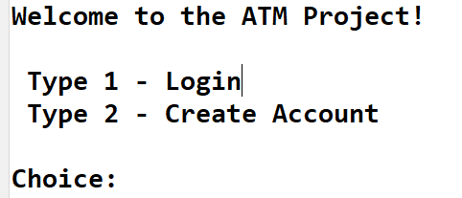

**Case 1: Login with wrong account number**

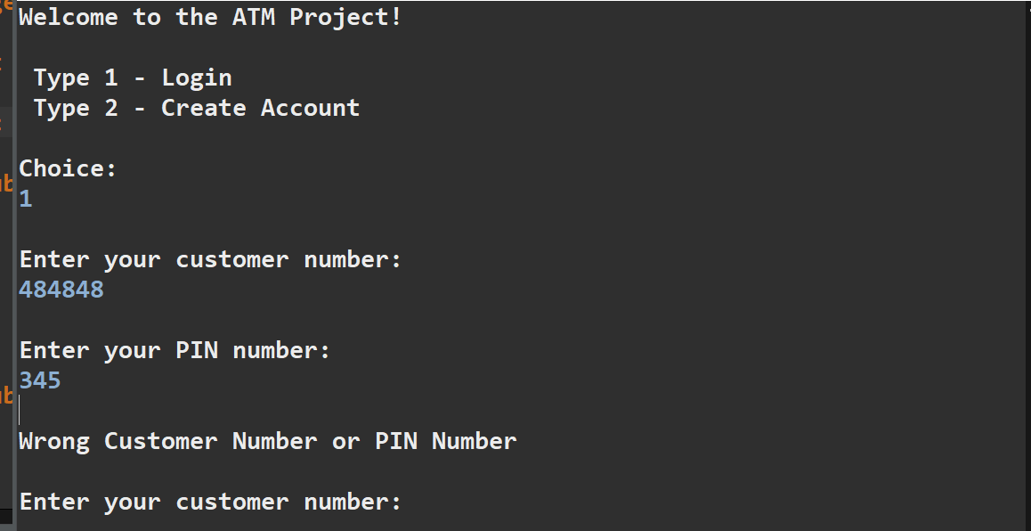

**Case 2: Entering wrong character**

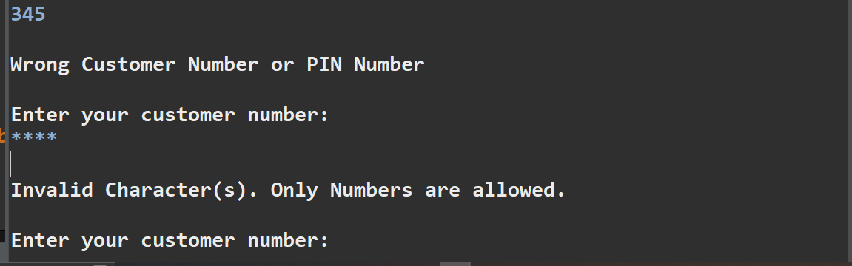

**Case 3: entering first customer credentials**

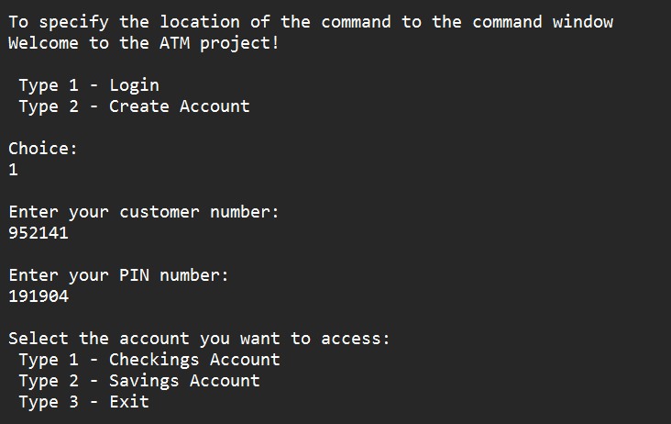

**Case 4: first customer checking account**

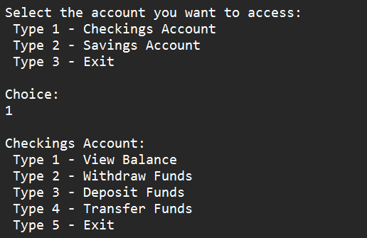

**Case 5: 1st customer account balance**

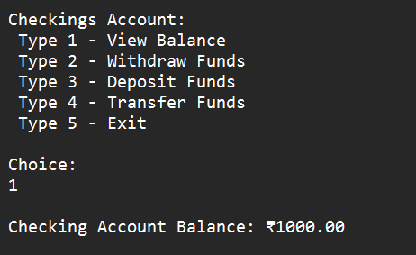

**Case 6: 1st customer Transfer Funds**

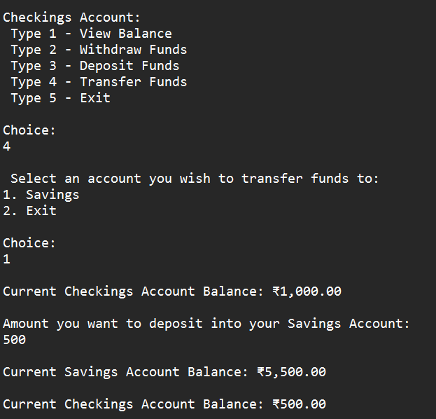

**Case 7:  1st customer check- Withdraw Funds**

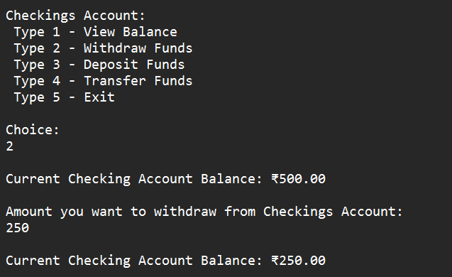

**Case 8 1st customer check Deposit Funds**

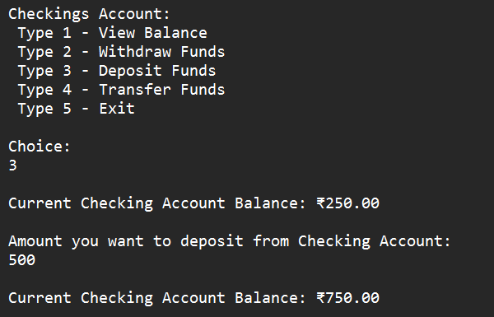

**Case 9: 1st customer check – Exit**

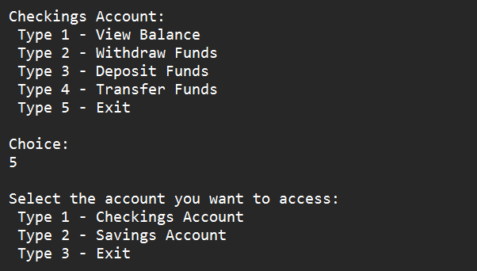

**Case 10: 1st customer saving acc view balance**

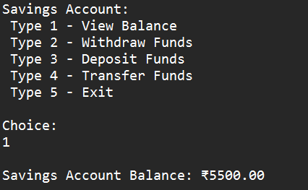

**Case 11: 1st customer saving acc withdrawfunds**

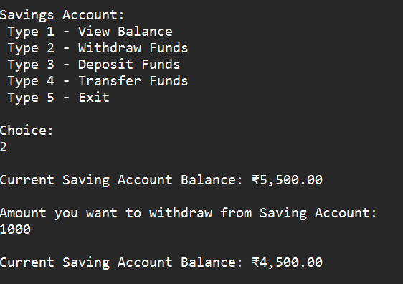

**Case 12: 1st customer saving accDeposit Funds**

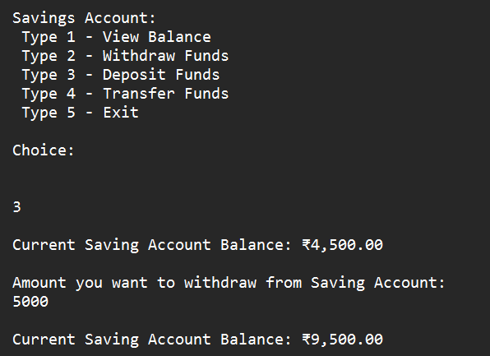

**Case 13: 1st customer saving acc Transfer Funds**

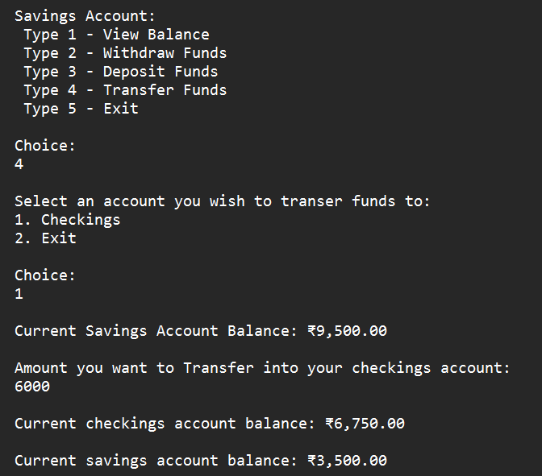

**Case 14: 1st customer saving acc exit**

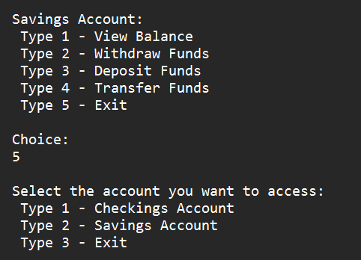

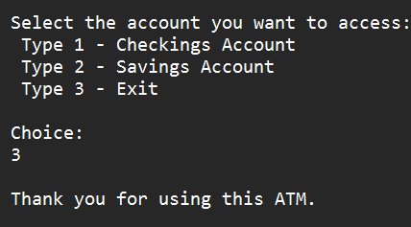

**Case 14: for 2nd customer**

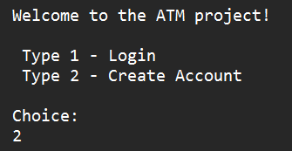

**Case 15: 2nd Create Account**

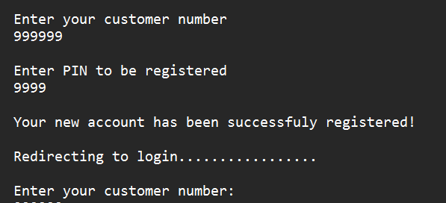

**Case 16: 2nd Login with wrong account number**

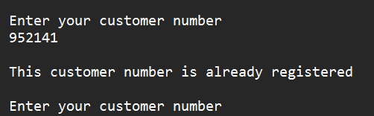

**Case 17: 2nd Entering wrong character**

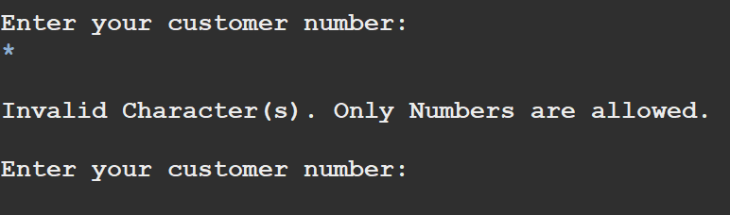

**Case 18: 2nd entering second customer credentials**

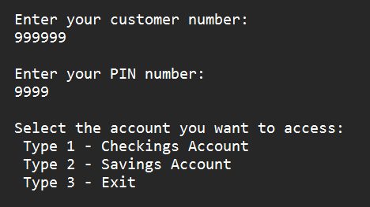

**Case 19: 2nd customer checking account**

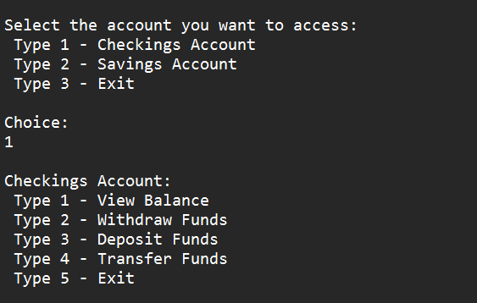

**Case 20: 2nd customer account balance**

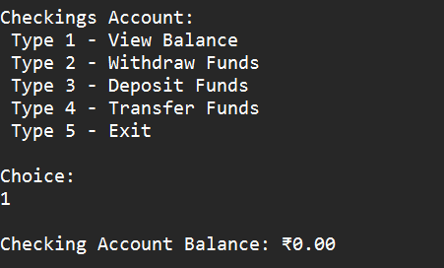

**Case 21: 2nd customer check Deposit Funds**

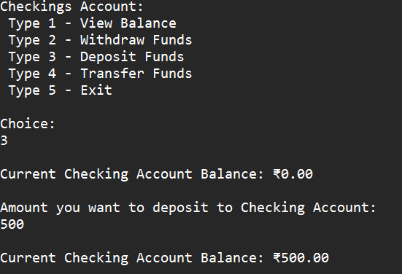

**Case 22:  2nd customer check- Withdraw Funds**

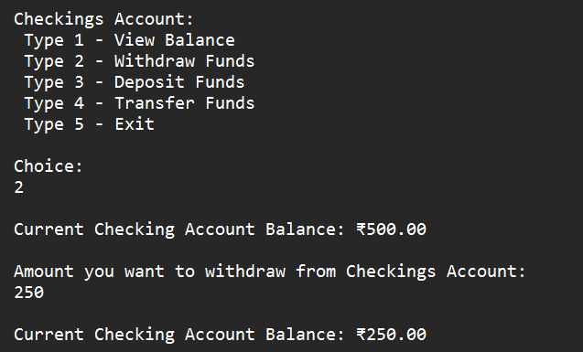

**Case 23: 2nd customer Transfer Funds**

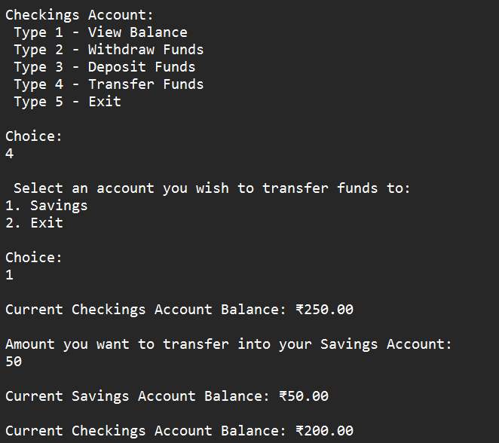

**Case 24: 2nd customer check – Exit**

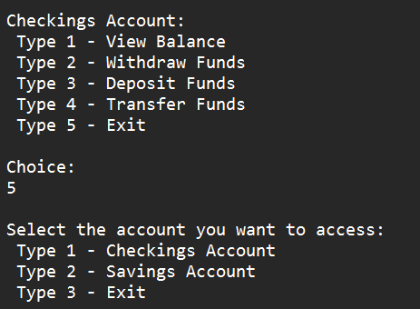

**Case 25: 2nd customer saving acc view balance**

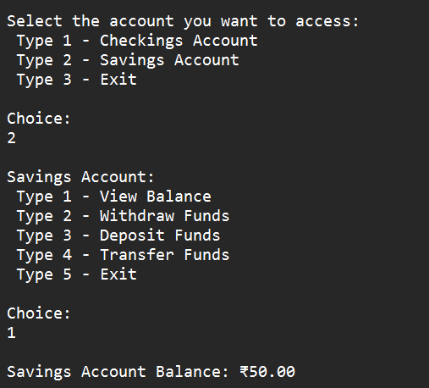

**Case 26: 2nd customer saving acc withdrawfunds**

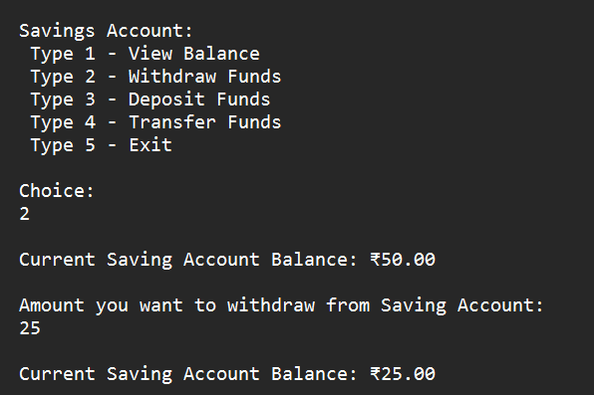

**Case 27: 2nd customer saving accDeposit Funds**

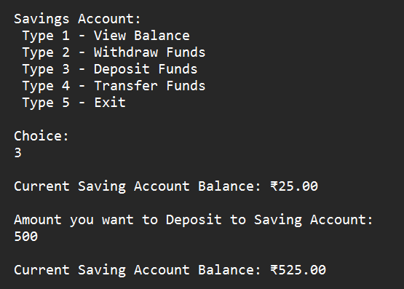

**Case 28: 2nd customer saving acc Transfer Funds**

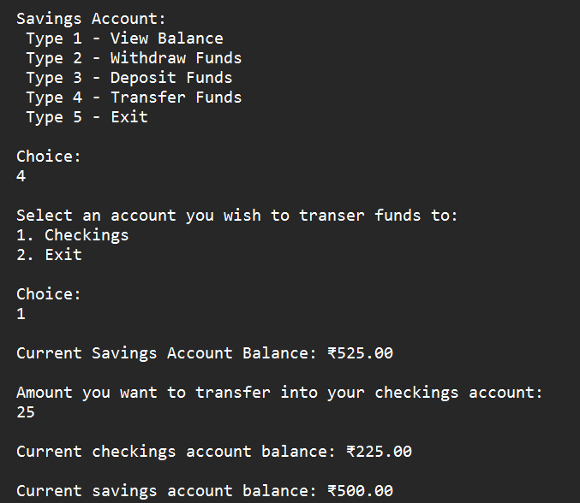

**Case 29: 2nd customer saving acc exit**

