**DOCKER PROJECTS**

**1.Multi-Container Flask Application with PostgreSQL Using Docker Compose**

**Step 1: Create a GitHub Repository and add files into it**

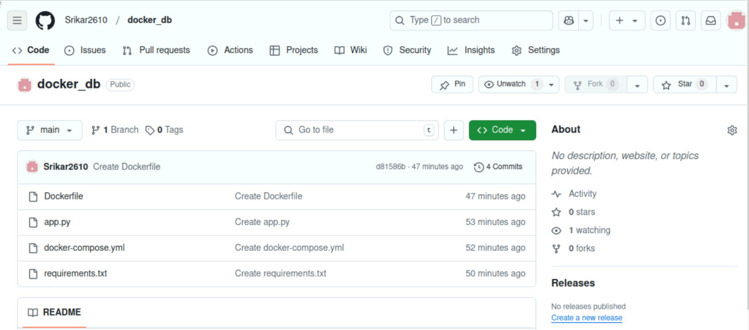

**Step 2: Build and Start the Containers**

**Step 3: Verify the running Container**

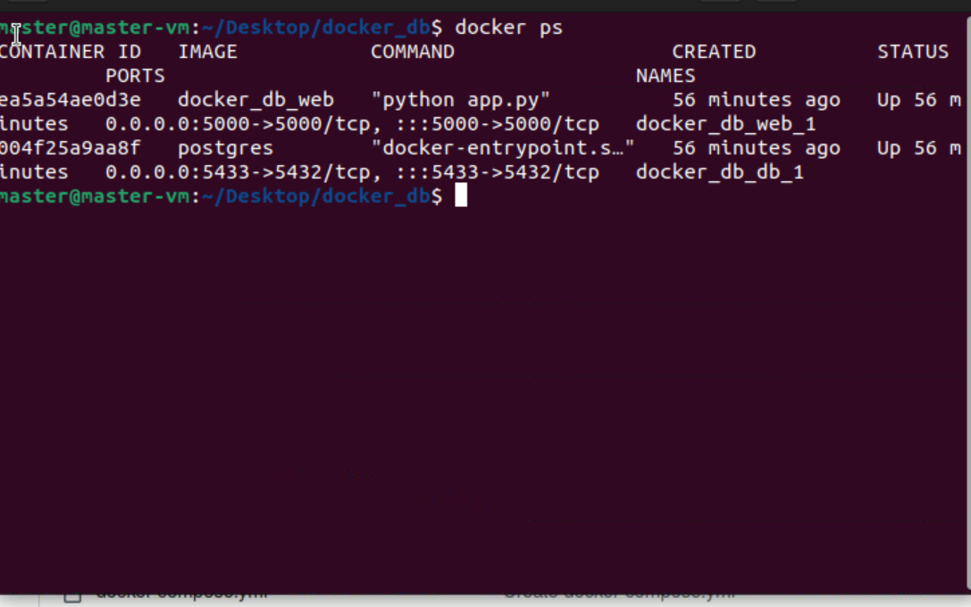

**Step 4: Test the application**

**OUTPUT**

